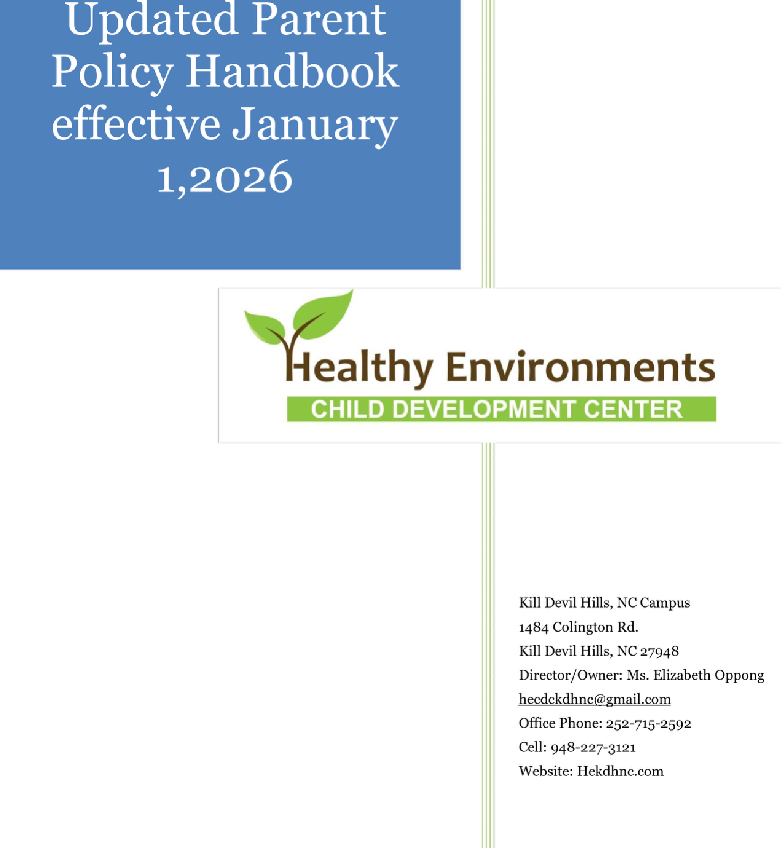
Administrator /Co- Owner: Priya Cobbah
HR/Co- Owner: Emmanuel Lopez

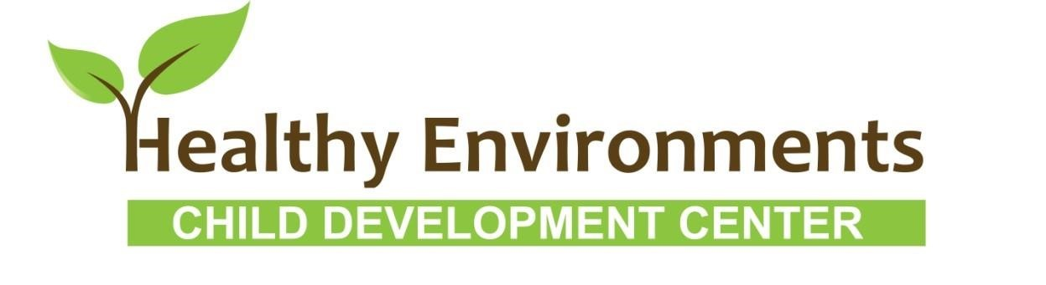

Center Philosophy
Healthy Environments Child Development Center Kill Devil Hills’ mission is to combine research based best practices sprinkled with love and kindness necessary to grow happy healthy children in an Early Educational Environment. We want to be an extension of the home environment with emphasis on what is best for each individual child. Your children will be our first priority for their growth and development. We use a curriculum enhanced by many outside physical opportunities and engineered individualized learning experiences to help each child reach their full potential including socio-emotional and self-concept development. The Healthy Environments’ way is to provide each child with a healthy environment, safe, diverse, and a highly qualified caring staff.

Ms. Elizabeth Oppong
“Your child is our first priority”

Hours of Operation and Closure Days:

Parents and Guardians are welcome at the center any time during operational hours.
Healthy Environments Child Development Center, LLC is now open from 7:00 a.m. to 6:00 pm Monday through Friday

****There is no cut off time. Children can be dropped off at any time. However, pick up time must be no later than 6:00pm to avoid late fees. Children can ONLY be at the center for 10 hours per day ****

.***Effective June 6th, 2026 HE will be offering Saturday services.***

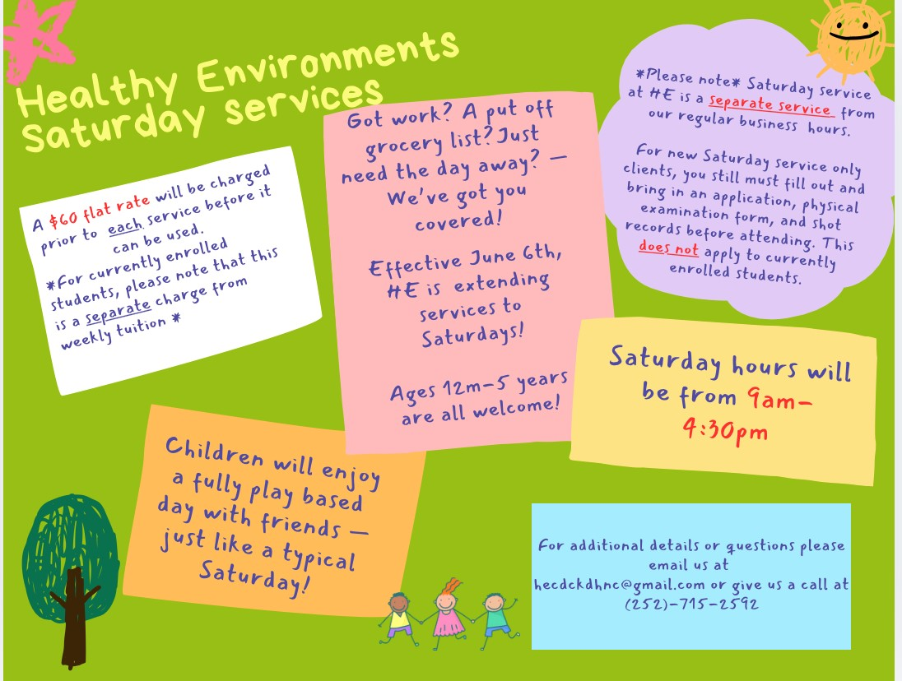

*Payments for Saturday services must be received by 6:00pm on Fridays. *

Healthy Environments Child Development Center, LLC will be closed or closing early on the following Days:

(New Year’s Day);
(Presidents’ Day for meetings & trainings );
(Memorial Day);
(Independence Day);
(Labor Day);
(October 31st—closing at 3pm);
(Veteran’s Day for meetings & trainings);
(Thanksgiving Day);
(A Day after Thanksgiving);
(A Day before Christmas);
(Christmas Day);
(A Day after Christmas).

Severe Weather: Effective January 1st, 2026, Healthy Environments will no longer follow Dare County Schools closing procedures. We will be following late openings for severe weather conditions. Please check Brightwheel and emails for all up-to-date information. Make sure HE has an updated email addresses to receive all emergency closures and updates.

****There is no reimbursement for closure days or time lost due to illnesses*****

Full Payment is due for all partial weeks. Remember you are paying a yearly tuition. We break it down into weekly/monthly amounts to hold your child’s spot, not your attendance or closures.

Services Offered:

We provide full-time care for children 12 months to first day of Kindergarten.
Our program combines experienced, professional teachers, developmentally appropriate planning, quality programming, positive behavior support, and a diverse range of social, educational, and physical activities.

We also offer:
***Annual parent teacher conferences for any parents with questions or developmental concerns.

***Annual opportunities for families to share cultural heritage in their child’s classroom. (We allow parents to bring food on designated days for cultural expansion for the children and teachers.)

***Annual volunteer opportunities to families. (The option for parents to help when parties are being thrown or to volunteer to dress up as Santa or the Easter bunny for the children.)

*** Quick communication to families to aid their questions and concerns via Brightwheel, Email, text, and telephone.

***Communication with families regarding community resources and services that are open and available upon request.

Updates to our Parents:

We provide our parents updates regarding our center's business news, reminders, Curriculum Highlights, calendar dates, notes from each class, and other general information.

Our curriculum:

We feel that the child’s environment is important in the learning process. Our classrooms are small and personalized by the individual teacher and children in that class. Emphasis is put on socio-emotional development skills at each age level and throughout our curriculum.

Healthy Environments Child Development Center’s educational program will be changing to the Abeka Curriculum effective January 1st, 2026. This is a Christian based curriculum with literature for a diverse range of physical and cognitive activities all planned around unit themes. Themes can last from one to four weeks. Each teacher will follow the same lesson plan adapted only for each individual age group and developmental levels of the children in her classroom.

Through the Abeka curriculum, we will concentrate on letter activities such as phonics, Long/Short Vowels, art projects, printing the letter, sounds of letters, words that begin with each letter, etc., all individualized to the developmental level of the children in each class. Other areas of our curriculum include: number lessons, counting, color identification, shape recognition, name spelling and writing, learning phone numbers and addresses, sight word identification and using the calendar, including naming months, days and seasons. Music and Physical Education are also incorporated in our weekly activities.

Areas of study for the Pre-School class (3 year old and up) are geared toward meeting Kindergarten prerequisites and transitioning. We incorporate children’s favorite literature into the program by having a featured author or character of the month. These books may be simply read at story time or our teachers may plan classroom lessons around them.

Daily schedule:

Below is our basic daily schedule. This is a sample schedule to help each parent get to know their child's day and activity times. A schedule specific to your child's age group is posted in each classroom and available upon request.

7:00-8:00 am Arrivals, Free Choice Centers
8:00-8:30 am Transition to classrooms as needed, Free choice centers
8:30-8:45 am Diapering/ Potty Time and Hand washing
8:45-9:30 am Circle Time, Art, Story Time, Songs
9:30-10:00 am Free choice Centers, Sensory Activity
10:00-10:15 am Diapering/ Potty Time and Hand washing
10:15-11:00 am Gross Motor, Outside or organized playground games
11:00-11:15 am Diapering/ Potty Time and Hand washing
11:15- 11:30am Table Activity (matching cards, story, etc.)
11:30-12:00pm Lunch, Diapering/ Potty Time and Hand washing as needed
12:00-2:30pm Quiet/Naptime
2:30-2:45pm Diapering/ Potty Time and Hand washing,
Reading, Quiet Play, Start of Parent Pick ups
2:45-3:00pm Afternoon Snack

3:00 –4:00pm Outdoor Play or Free Play in Classroom
4:00-6:00pm Free Play and outside time, Parent Pick Up
Sometimes it will be necessary to change or alter the schedule for maximum flexibility or extended hours.

Free play:

There are times during the day when the children are at "Free Play". This means that the children may self-select from a variety of activities and all the learning centers. These periods tend to be good for each child to learn how to self-regulate and experience new creativity and express their emotions.

Quiet time:

Quiet time is a part of the day's schedule. It is approximately from 12:00pm to 2:30pm each day. The center must remain quiet during this time. If you must pick up your child early, please let us know ahead of time so we can help you get your child as quietly as possible and not disturb other classrooms’ down time. Each child is required to rest quietly at least one hour. Those who are not able to sleep are given books to read quietly.

Share days:

We will announce "Share Days" which are days when the children may bring a toy from home for show and tell purposes only. The children are not allowed to bring toys on any other day and any type of weapon or shooting toy should not be brought on Share Days.

Discipline:

Praise and positive reinforcement are effective methods of behavior management of children. When children receive positive, non-violent, and understanding interactions from adults and others, they develop good self-concepts, problem solving abilities, and self-discipline. Based on this belief of how children learn and develop values, this facility will practice the following discipline and behavior management policy:

We: 1. DO praise, reward, and encourage the children. 2. DO reason with and set limits for the children. 3. DO model appropriate behavior for the children. 4. DO modify the classroom environment to attempt to prevent problems before they occur. 5. DO listen to the children. 6. DO provide alternatives for inappropriate behavior to the children. 7. DO provide the children with natural and logical consequences of their behaviors. 8. DO treat the children as people and respect their needs, desires, and feelings. 9. DO ignore minor misbehaviors. 10.DO explain things to children on their levels. 11. DO stay consistent in our behavior management program. 12. DO use effective guidance and behavior management techniques that focus on a child’s development. 13. DO use short supervised periods of reflective time away from other children sparingly.

We: 1. DO NOT spank, shake, bite, pinch, push, pull, slap, or otherwise physically punish the children. 2. DO NOT make fun of, yell at, threaten, make sarcastic remarks about, use profanity, or otherwise verbally abuse the children. 3. DO NOT shame or punish the children when bathroom accidents occur. 4. DO NOT deny food or rest as punishment. 5. DO NOT relate discipline to eating, resting, or sleeping. 6. DO NOT leave the children alone, unattended, or without supervision. 7. DO NOT place the children in locked rooms, closets, or boxes as punishment. 8. DO NOT allow discipline of children by children. 9. DO NOT criticize, make fun of, or otherwise belittle children’s parents, families, or ethnic groups.

Our goal here at Healthy Environments Child Development Center Kill Devil Hills is to help each child become a well-adjusted happy adult by enforcing a message with love, build on strengths not weaknesses, hold children accountable with self- respect intact, teach children how to think issues through, and win cooperation at home, as well as at the school.
All licensed childcare facilities are required by law to report any suspected child abuse to the proper authorities. Accordingly, any such suspicions will be brought to the attention of the Manager and/or Owner. After evaluating the circumstances, the decision will be made whether a formal report to Child Protective Services
are warranted.

Parent conferences:

Conferences and communications are extremely important. Anytime you have questions or inquiries, please feel free to ask. We do reserve the right to call a conference with any of our parents concerning the progress, behavior, adjustment, etc. of their child at any time. The better the communications, the better child
care service we can provide you and your child. We always reserve the months of November and April as our conference months for our entire program. While we can offer these scheduled opportunities twice a year to discuss the progress of the children, we welcome the opportunity to meet with parents anytime. If a child has behavior issues, we will work with the parents and the child to correct the behavior. If the issues continue after working with the child and parent, the parent will be asked to keep the child at home until the behavior is under control.

Progress evaluations:

We will be providing progress evaluations for each toddler and preschool child twice a year during parent conferences. These are formal written records of your child's developmental progress (milestones, any upcoming transitions, etc).

In addition, the toddler parents will be receiving a daily log each day at pick-up of what their child did throughout the day.

Registration:

Each child must have a completed and up to date application on file. As per the Department of Health regulations, we will need an age appropriate health assessment signed by a doctor and an up to date record of your child's immunizations prior to your child attending Healthy Environments Child Development Center, KDH NC, LLC. We will also provide you with our emergency plan, child pick-up authorization, dismissal policy, and photo/video release forms that must be signed and included in your child's file. Everything you will need is included in the enrollment packet we will provide you. You will be asked to update and sign your child's emergency contact information every 6 months.

*****We are no longer accepting religious exempt. Every child must be up to date on his or her immunization to attend the daycare****

A non refundable annual registration fee of $65.00 is required per child to process the paperwork and hold your child's spot for the year. The first payment is due prior to the child’s enrollment date.

Wait List

When the center is full, we offer a waiting list for families that would like to obtain a place at Healthy Environments Child Development Center, LLC for any of our programs. A $65.00 non-refundable fee is required to be placed on the list. The order of the list will be determined by the date we receive the reservation fee. The family should provide an estimated date that they would like their child(ren) to begin attending. Healthy Environments Child Development Center, LLC will make every attempt to accommodate those on the waiting list and will advise families as early as possible when we can accommodate their request. If a space opens up for your family at Healthy Environments, the $65.00 waiting list fee will be used as your registration fee. We must receive a completed application, the shot records, and a physical examination form/medical report to have your child be placed on the waitlist.

Tuition

Weekly tuition is $252 and monthly tuition is $1061. Our weekly and monthly tuition fees apply to weeks with closure days, snow days, sick days, and/or days that you choose not to send your child to the center. Weekly tuition fees are due the first day of every week (MONDAYS) that the child is enrolled in the program. Monthly tuition fees, as well as monthly parent fees are due on the 1st of each month. Tuition will need to be paid prior to the service week or month. Tuition rate is based upon a maximum of 10 hours per day. For safety purposes, cash is not allowed in the center. Payments can be made through Brightwheel, Cash App, or Zelle regardless of any closure days. If you must drop off a check at the center, it must be dropped off prior to the due date if it falls on a weekend, closure day, or holiday. Late Fees
A fee of $20 will be charged when a payment is not made by the due date. Be sure to make your payment prior to a holiday or closure day. An additional fee of $20 will be charged each week that a payment is late. Children will not be allowed to attend if payments are not received on time. If no payment is received by the 15th day, your account will be forwarded to the local magistrate. A $35 fee will be charged for any returned checks.
LATE PICK UPS
If your child is not picked up by 6:00pm, a $15.00 fee will be charged after the first 5 minutes per child. After that, a fee of $1.00 per minute will be added. This charge should be paid at pick up time. If it is expected that your child will not be picked up by 6:00pm, you must call and inform the Center. If not informed, Healthy Environments will begin calling parents and/or other emergency contacts for the child(ren).

Medication policy:

*****For safety purposes, we are not accepting or administering any medications at the center at this time. This includes topical medications and over-the-counter medications****
The only acceptable medications are Emergency Medications such as Epipen, Inhaler and Diazepam for seizures. Staff members may not administer medication to any child unless a parent has completed a Medication Authorization Form. All forms and medications must be given to and approved by the director (Ms Elizabeth) or the Administrator.

Medications must be stored in a locked box while in use at HECDC. The Medication Authorization Form must remain with the medication at all times. Unused medications must be immediately returned to the family and will not be stored at HECDC.

Medications may be administered only by Lead Teachers, the Director, or administrator. When a medication is given, the teacher will document the type of medication administered, the dosage, and the time it was given as well as any unusual reactions or circumstances.
Health and safety issues:

We must maintain up-to-date immunization and physical information on all the children. Please be sure to ask us for a physical form each time you take your child to the doctor for a “well” check-up and have the doctor fill it out. We will need a new health assessment every year for the 1-yr-olds, Twos and pre-schoolers.

Any injuries that happen at the center or while in Healthy Environments’ care will be written up on an accident/incident report form. We will notify you of minor accidents at pick up and provide you with written documentation of the accident in addition to keeping a record in your child's file. We will call parents right away for injuries that are more serious or if medical attention is needed.

Safe Procedures for Delivery and Pick Up of Children:

The purpose of this policy is to ensure the safety and security of every child during arrival and departure. Children will remain under staff supervision at all times and will only be released to authorized individuals. Brightwheel serves as the center’s
official attendance record, and all children must be signed in and out each day.

Arrival Procedures: Children must be accompanied into the building by a parent, legal guardian, or responsible adult. The responsible adult must sign the child in using Brightwheel each day and ensure a staff member is aware of the child’s arrival. Children must be taken directly to their assigned classroom. Children must never be left unattended inside or outside the facility.

Pick-Up Procedures: Parents or authorized adults must enter
the building to pick up their child. Parents or authorized adults must notify a staff member before leaving with their child. The responsible adult must sign the child out using Brightwheel each day before leaving the center. Children must be personally escorted from the building by the authorized adult. Parents should notify the center if their child will be picked up earlier than their usual pick-up time.

Authorized Pick-Up: Children will only be released to a parent, legal guardian, or individuals listed on the child’s enrollment forms. Written and/or verbal authorization from the parent or legal guardian must be provided if someone not listed on the child’s enrollment forms is picking up the child. The center requires verification of the parent’s identity before releasing the child. Any individual who is not recognized by staff must present a valid government-issued photo ID before the child will be released. If authorization or identification cannot be verified, the child will not be released.

Late Arrival/ Departure/Locked Door: If Parents/guardians arrive after doors have been locked, please allow the staff time to open the door(depending on the time of day, it may take a few minutes). If you arrive during recess and there is no one to let you in the front door, please come to the back gate to your
left to check your child in or out.

Safety Procedures: Staff will provide close supervision during arrival and departure. Once the child is released to the parent, they should hold their child’s hand or provide other appropriate supervision while walking through the parking lot when necessary.
Center doors and gates will remain closed and secured during operating hours. Children must never be left unattended during arrival, departure, or transitions.

Sick policy

Morning Inspection / Daily Health Observation:
In order to prevent the spread of infectious illnesses, the center is required to conduct daily health checks on the children as they arrive at the center. Every staff member is trained on how to perform morning inspections. Staff in every classroom shall perform the morning health inspection of each child, which takes a few minutes, preferably, while parents are present.
Notice to Parents
Infection Control Policy
It is inevitable that children will get sick, no matter where they are. As children begin to contact the world outside that of their own families, they are exposed to viruses and bacteria that are foreign to their bodies. This is the way they build immunities. We cannot, nor do we want to shield a child completely from the outside world. If we did, the natural immunities as children gain through contact with others would not develop and a simple cold could become a serious illness. However, we do not want to protect a child from an unusually high exposure to germs all at once. In a childcare setting, children come into contact with groups of other children outside of their families. It is in this situation that the illness of one child can spread rapidly through the group to other children and staff members if stringent measures to prevent this spread are not taken. For this reason, the staff members at the center will take constant precautions to prevent the spread of disease. Many common childhood diseases are contagious. They are caused by germs, which may be spread in several ways. intestinal tract infections are spread through stools. Respiratory tract infections are spread through coughs, sneezes, and runny noses. Other diseases are spread through direct contact. Careful hand washing by staff members and children can eliminate approximately 75 percent of the risk of spreading these illnesses. Other precautions include separating sick children from those who are well, taking extra precautions with diapering or toilet training children, and working to maintain sanitary throughout the center.

You, the parents, can help us in our effort to keep your children healthy. We ask for your cooperation in the following ways:
- If your child shows any of the following symptoms, you will be called and asked to come immediately. Please help us to protect the other children by responding promptly. If your child has any of the following symptoms at home, we ask that you keep him/her out of the daycare center until the symptoms are gone or until your physician says it is alright to return. For fever, diarrhea and vomiting, the child must stay out of the center for 24 hours.

Symptoms of Infection:
- Fever greater than 101 degrees Fahrenheit.
- Severe coughing - child gets red or blue in the face. ➢ High-pitched croupy or whooping sounds after coughing.
- Difficult or rapid breathing -
- Yellowish skin or eyes
- Pinkeye- tears, redness of eyelid lining, followed by swelling and discharge of pus.
- Unusual spots or rashes.
- Sore throat or trouble swallowing.
- Infected skin patches
- Crusty, bright, yellow, dry of gummy areas of skin- possibly accompanied by fever.
- Unusually dark, tea colored urine - especially with a fever.
- Gray or white stool/ Diarrhea.
- Headache and stiff neck.
- Vomiting.
- Severe itching of body or scalp or scratching the scalp.
- Uncontainable running nose/Constant, Excessive runny nose

Parents must inform us within 24 hours or the next business day after the child or any member of the immediate household has developed any reportable communicable disease, as defined by the State Board of Health. Life threatening diseases must be reported immediately.

*** We know how difficult it is for you to miss work; however, it is imperative that we all work together to keep our children as healthy as possible. We thank you all for your cooperation***

Reporting Changes
Healthy Environments Child Development Center should be able to contact you at any time during the day. The necessary information is given at the time of enrollment; however, you are required to inform the center if you encounter any type of address change, phone number change, change of employment, doctor’s information, etc.

Shaken Baby Policy:

Procedure/Practice Recognizing:
- Children are observed for signs of abusive head trauma including irritability and/or high pitched crying,
- Difficulty staying awake/lethargy or loss of consciousness, difficulty breathing, inability to lift the head, seizures, lack of appetite, vomiting, bruises, poor feeding/sucking, no smiling or vocalization, inability of the eyes to track and/or decreased muscle tone. Bruises may be found on the upper arms, rib cage, or head resulting from gripping or from hitting the head. Responding to:
If SBS/ABT is suspected:
- Staff will Call 911 immediately upon suspecting SBS/AHT and inform the director. Call all the parents/guardians.
- If the child has stopped breathing, trained staff will begin pediatric CPR
- Instances of suspected child maltreatment in child care are reported to Division of Child Development and Early Education (DCDEE) by calling 800859-0829 or by emailing webmasterdcd@dhhs.nc.gov.
- Instances of suspected child maltreatment in the home are reported to the county Department of Social Services.
The five goals and developmental indicators in the 2013 North Carolina Foundations for Early Learning and Development, ncchildcare.nc.gov/PDF_forms/NC_Foundations.pdf
How to Care for Toddlers in Groups, the National Center for Infants, Toddlers and families, www.zerotothree.org/resources/77howtocareforinfantsandtoddlersingroups
Including Relationship Based Care Practices in Toddler Care: Implications for Practice and Policy, the Network of Toddler Researchers, pages 79,
www.acf.hhs.gov/sites/default/files/opre/nitr_inquire_may_2016_070616_b508compliant
.pdf

Prohibited behaviors
- Behaviors that are prohibited include (but are not limited to): shaking or jerking a child; tossing a child into the air or into a crib, chair, or car seat; pushing a child into walls, doors, or furniture.

Biting Policy:

Biting is a behavior that usually appears between the ages of one and three years. While biting is an age-appropriate behavior, it is important to remember it is also an unacceptable behavior in a childcare environment. Children bite for a variety of reasons: teething, sensory exploration, cause and effect, imitation, crowding, seeking attention, frustration and stress. Biting is not something to blame on children, their parents or their teachers. There are a variety of strategies we implement at HECDC to prevent and stop biting. This is the process followed when a child bites:
- The biting child is stopped and told, “Stop biting. Biting hurts” in a firm voice. People are not food.
- Teachers remain calm, being careful not to show anger or frustration towards the child. The biting child is removed from the situation. Depending upon the observed motive for the bite, the separation may include redirection or meeting the child’s needs.
- As little attention as possible will be placed on the biting child, to avoid reinforcing the behavior.
- Appropriate first aid will be provided to the child who was bitten. Bite will be washed with soap and water; cold compress will be applied to reduce pain and swelling. A bandage will be applied if necessary.

It is important to explore the reasons for biting when it occurs. Teachers will work with parents to gather information about the child’s behavior and begin observations to determine the reasons for biting. Examples of triggers would be: communication deficits, transitions, hunger, lack of sleep, need for oral stimulation or teething pain. Once triggers are identified, staff and parents can work on prevention strategies and start teaching replacement skills.

Below are the steps the teacher will take to identify triggers and replace the behavior:
- The teacher will examine the context in which the biting is occurring and look for patterns. The following questions should be asked:
  - Was the space too crowded?
  - Were there too few toys?
  - Was there too little to do or too much waiting?
  - Was the child who bit getting the attention and care he/she deserved at other times?
- The teacher will change the environment, routines or activities if necessary. 3. The teacher will work with the child who is biting to resolve conflicts and frustrations in more appropriate ways
- The teacher will observe the child, to get an idea of why and when they are likely to bite.
- The teacher will identify children likely to be bitten and make special efforts to reduce their chance of being bitten.
- The teacher, parent and Director and/or Administrator will meet regularly to regulate an action plan and measure outcomes.
- If biting continues the teacher will observe the group more closely and work with the parents to seek out additional resources as necessary to shadow the child who is biting. All information is confidential and names of the children involved in the incident are not shared between parents. In addition, biting is always documented on an Incident/Accident Report which is completed and signed by a teacher. A copy is provided to the parent and the original kept in the child’s permanent enrollment file in the office.
- After working with the child and the parent, if the biting continues, we will ask the parent to keep the child at home, work with the child until such behavior stops in order to keep other children safe.

Reporting Abuse and Neglect:

Healthy Environments Staff are obligated by law to report any suspected abuse or neglect to the Dare County Dept. of Social Services.

Peanut /Tree Nut-Free Daycare Policy
Our Center may have children with severe peanut allergies. We understand that many of our children are not old enough to make sound decisions when it comes to what should go into their mouths and are less able to manage their allergies. While our staff members do an amazing job of cleaning and wiping down playing surfaces, toys, and chairs, there are some children who are in our center who could have a serious allergic reaction from contact with even a microscopic amount of peanuts. As we work on transition with the little ones, there are many instances where children use common space within our building, and it is because of this that we have decided to make our center a Peanut/ Tree Nut-Free Daycare Center. We ask that no peanuts or tree nuts are to be brought into our center. Food sent in for snack, lunch, or any class event (including parties) should be carefully checked to make sure they are peanut/ tree-nut free. Families can help ensure that our center stays peanut tree-nut free by reading packaging labels and reminding children not to share food with other children at the daycare center. We need to make sure that there is little opportunity for a child to be exposed to foods that could harm him/her.
****Due to cross contamination, please be sure not to bring food items that are made from
factories that produce nut/tree nut products****
Meals and Snacks:

HE does not provide any meals or snack to the children in the center. Parents must provide snacks and cooked meals with the children everyday. The lunch boxes go straight to the fridge at arrival after being checked for proper labeling and nut free items. If an item in your children’s lunch is seen to contain and or be made in a nut factory, you will be asked to take it back home. Please keep in mind that the center is not allowed to warm up any food, so please be sure to pack meals accordingly.

Children's Supplies:

Here at Healthy Environments Child Development Center, each child has a "cubbie" or space in a cabinet which contains their personal items. Below is a list of articles that should remain at the center at all times:
- A clean change of seasonal clothing which has been labeled. If your child's clothing becomes soiled, it is up to each parent to pick them up and return them clean and labeled.
- Seasonal accessories such as winter hats and mittens are necessary as our children are outside all year long. We will be going outside each day weather permitting for physical activity.
- For Toddlers: Your child will need labeled cooked food & snacks(with the name and date), water bottles, change of clothes, and a box of diapers and wipes.
- For 2-year-olds and children who are not potty trained: Your child will need labeled box of pull ups, box of wipes, water bottles, cooked food & snacks(with the name and date), and change of clothes
- For Children who are completely potty trained: Your child will need labeled change of clothes, cooked food & snacks(with the name and date), and water bottles
- We will notify you when we are running low, so your child doesn't run out.

****Please label all clothing and items you send in. Food must have child’s name and date every day****

***Please keep in mind that the children are very active and or potty training. Please refrain from dressing them in clothing that is hard to pull down or that can be easily tripped on***

***No outside toys, bags, or blankets are permitted in the center. You will be asked to take the items home or they will be left on the porch if brought in until pick up.***
***We insist on a good quality pair of sneakers or sturdy closed toed shoes to be on your child’s feet as they need to have a good structured shoe to avoid injury and maintain your child’s proper growth and development. We do not want dressy shoes, sandals, crocks or shoes with holes regardless of it being closed toe that might cause your child injury while inside or on playground***

Requesting Transition Information:
When you leave the center for any reason, you may request paperwork (ie physical, immunization forms etc.) from your child’s file as well as any assessments, behavior logs and work sampling done by your child’s teachers while enrolled at Healthy
Environments. There is a $5 fee for requested paperwork. Please allow up to a week for the office to make copies of your child’s file.

Staff Development:

Each HE staff member complies with the recommended 10 hours yearly of staff development training hours. We focus on compliance with NC regulations trainings, but also add items each year to add to our curriculum and build on each teacher’s strengths while bolstering their weaknesses. Coaching is also provided as needed to make sure each teacher has the support they need to shine!

Transportation:

We do not transport children off premise.

Notice of Withdrawal

Give us at least 14 days written notice prior to any withdrawal. If you do not give proper written notice, understand that you will owe the tuition for the 14 days after your child leaves. Ex.] If a notice is given on the 4th of the month, you are responsible for tuition until the 18th.

In case of Injury or Illness

In case of injury or illness, I authorize Healthy Environments Child Development Center, LLC to obtain immediate medical care if any emergency occurs when I cannot be located immediately. If there is an objection to seeking medical emergency care (OBX Hospital), I must give Healthy Environments Child
Development Center a written statement that states my objection and the reason for the objection. I hereby understand and agree that any expenses incurred are my responsibility as the parent or legal guardian. OBX Hospital will be your choice for emergency care unless otherwise specified in the paperwork.

Termination of Services

Healthy Environments Child Development Center, LLC has the right to immediately dismiss any child for reasons we deem necessary, (i.e. noncooperation of the parent, Behavior Issues, maladjustment of a child, failure to provide necessary or correct enrollment information, etc.)

***There is no smoking or vaping on the premises as per NC regulations*** License Number:28000267

This agreement to receipt of HE Parent Policy Book is for the protection of the parents, children and Healthy Environments Child Development Center KDH NC, LLC. It is essential that the financial condition of this center remain such that services can be provided for your child. Our expenses are not reduced due to absenteeism; therefore, when you read and sign the Parental Agreement and Receipt of the Parent Policy Book upon enrollment, it will be your guarantee that you will abide by and support its contents and policies.
Please initial all policies separately and then sign and date at the bottom.
HE Discipline policy__________________
NC Summary of Laws receipt__________
HE Shaken Baby____________________
HE Biting Policy_____________________
HE Supervision Policy_________________
HE Sick Policy_______________________
HE Medication Policy__________________
HE Tuition, Renewal_____________
HE No Smoking Policy__________________

Child Name _______________________________________

Child Birthday _______________________________________

Date of Enrollment _______________________________________

Parent Name _______________________________________

Parent Signature_______________________________________

Date____________________

Director Name__________________________________

Director Signature__________________________________

Date_________________________

