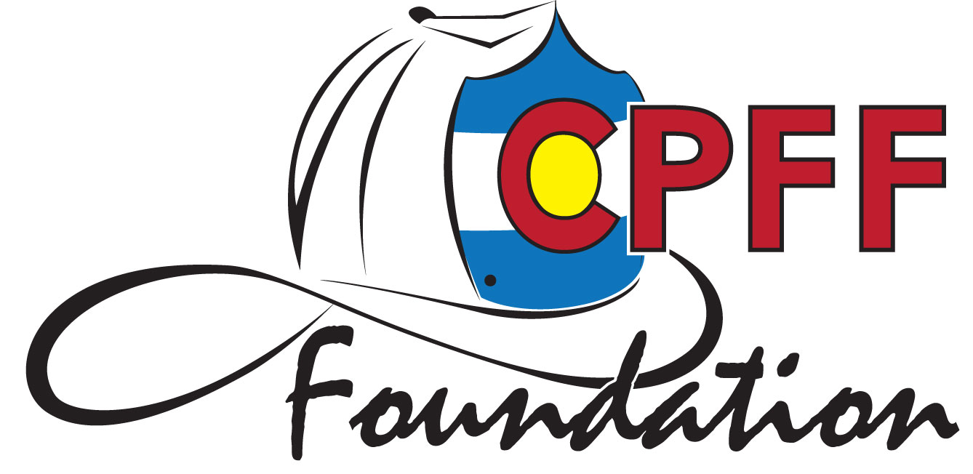

Colorado Professional Fire Fighters Foundation
12 Lakeside Ln, Denver, CO 80212

To: Colorado Professional Fire Fighters

From: Dave Foster, CPFF Foundation President

Date: July 31, 2026

Re: 2023 – 2024 Randy Atkinson Memorial Scholarship

The CPFF Foundation will be offering ten one-time scholarships of $5,000 each for the 2023 - 2024 academic school year.

The scholarship program is designated for the children and grandchildren of all active members of the CPFF.

The deadline for applications is by midnight July 31, 2023.

Please review the pages following for specific information regarding the application.

Thank you!

Randy Atkinson Memorial Scholarship Information

What: Ten Scholarships - $5,000 each

Qualifications:

- Applicant’s parent/guardian or grandparent (or active retired) must be a member in good standing of the Colorado Professional Fire Fighters.
- Applicants must be entering an institution of higher learning (Junior College, College, University or Technical/Trade School) in the Fall of 2023 or Spring of 2024. The applicant may also be a current student of an institution of higher learning.
- Applicants must-
  - Submit this application
  - Resume
  - High School or College Transcripts
  - Two letters of recommendation
  - A 1–2-page essay answering the topic below (should be between 500 to 1000 words)
    - “Firefighting requires firefighters to learn and apply firefighting techniques, follow policies and procedures developed by their fire departments and follow the directions given to them by their Officers (supervisors). All these items must be carried out simultaneously all while working together with as a team and with other teams to mitigate the emergency scene. Provide an example of a time in your life where you had to follow procedures, rules and or policies while under the direction of a supervisor to accomplish a task or goal while working as a team. Discuss your role in the team and how that role helped improve the performance of the team in completing the task/goal.”

The application, resume, transcripts, letters of recommendation, and essay must be combined into a single .pdf document and submitted electronically to cpfffoundationscholarship@gmail.com Applications not submitted on a single .pdf document will be disqualified.
- The top 15 candidates will be required to participate in an interview with C.P.F.F. Foundation Board Members to determine the final award recipients. Interviews will take place in September via Zoom.

Deadline: Midnight of July 31, 2023

Scholarship Committee – The Board of Directors of the CPFF Foundation.

2023-2024 Randy Atkinson Memorial Scholarship Application

Please complete the following:

Name: Home Phone:

Mailing Address:

Email:

Parent/Guardian/Grandparent Name(s):

Parent/Guardian/Grandparent CPFF Local Affiliation Name and Local #

Current School Name and Location:

Grade Point Average (GPA) and Scale:

List Extracurricular Activities and Community Service you have participated in:
(Or attach a resume)

List all High School or Community Awards or Honors you have received:
(Or attach a resume)

Junior Colleges/Colleges/Universities you have applied to:
College/University you are planning to attend:

When do you plan to enter (Select One) Fall 2023 Spring 2024

Have you applied for admission? Yes No

Have you been accepted? Yes No

What will be your intended major or area of study?

Have you received and/or accepted other scholarships? What kind and how much?

Number of persons dependent upon family income. Please include: parents, dependent children, aged relatives, or others reported on tax returns:

State your need/plan for financial assistance for your post high school area of study:

Have you ever been suspended or expelled from school or charged in accordance with the law for an act of vandalism, assault, possession of narcotics, alcoholic beverages, a controlled drug, or possession of a dangerous weapon on a school campus?
Yes No I decline to answer

If you answered “Yes” please explain:

Signature of Applicant verifying the above information and submitted information is true and accurate:

Student Signature Date

Applicant must submit an electronic copy of this application, resume, transcripts, two letters of recommendation from teachers and/or community members and a one/two-page, single spaced essay answering the following questions. "Discuss and cite the history of labor unions and how unions have impacted your family. Discuss the challenges faced by firefighter labor unions in the future" in a single pdf document. Applications not submitted in a single .pdf document will be disqualified.

Applications are due by midnight July 31, 2023
Emailed to cpfffoundationscholarship@gmail.com

The CPFF Foundation is proud to announce that the Randy Atkinson Scholarship is now open. The Foundation was started under his presidency and his impact on Colorado’s Firefighters and their families will never be forgotten. The Foundation this year will be offering ten $5,000 scholarships thanks to a generous donation and request that the amount be doubled for 2023-2024. The scholarships are available to children/dependents or grandchildren of all active and active retired members of the Colorado Professional Fire Fighters.

Please visit cpfffoundation.com and go to programs -> scholarships or https://cpfffoundation.com/?page_id=23

