Dussich Dance Studio 2026- 68th Recital Tee Shirts-“A Night Under The Stars”
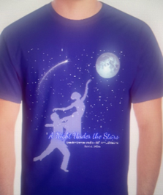

Order your Dussich Dance Studio Recital T-Shirt. Complete this form to pre-order your shirt today

Name: ______________________________________________ Phone #: ________________________________
# Shirts: _______ Pre-Sale Price: $20.00 (18.70 PLUS $1.30 TAX) *Additional Fee for all Credit/Debit Payments*
Child Sizes: X-Small: _____ Small: _____ Medium: _____ Large: _____
Adult Sizes: Small: _____ Medium: _____ Large: _____ X-Large: _____ XXL: _____ XXXL: _____
Check: ______ Cash: ______ Charge: _____ Total Paid $____________ Date_________
Studio Copy
----------------------------------------------------------------------------------------------------------------------------------------------------------
Dussich Dance Studio 2026- 68th Recital Tee Shirts
“A Night Under The Stars”

Name: ______________________________________________ Phone #: ________________________________
# Shirts: ______ Pre-Sale Price: $20.00 (18.70 PLUS $1.30 TAX) *Additional Fee for all Credit/Debit Payments*
Child Sizes: X-Small: _____ Small: _____ Medium: _____ Large: _____
Adult Sizes: Small: _____ Medium: _____ Large: _____ X-Large: _____ XXL: _____ XXXL: _____
Check: ______ Cash: ______ Charge: _____ Total Paid $____________ Date_________
Customer Copy *Retain this portion for your records

