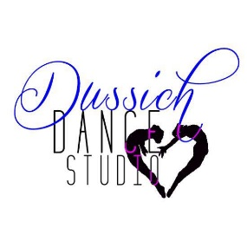
Advertisement and/or Congratulatory Form
Thank you for considering advertising in our June Digital Recital Program. You may promote your business or favorite dancer. You may send us your business card and /or wording & photos for your add. If you have any questions please email us at Dussichdancestudio@gmail.com or call the studio at 321-452-2046
Sponsor Opportunities
______I’d like to donate an item/service to the silent auction
_____I’d like to buy Advertisement/Congratulatory space in your program. $25 business card, $50 half page (4 x 5 1/2), $100 full page ( 8 x 5 1/2)

Total Amount Sponsored: $__________
Company/Sponsor name: _____________________________________________________
Address: ___________________________________________________________________
Phone Number: _____________________________________________________________
Email and Website URL: ______________________________________________________
Dancer’s Name: _________________________________________________

Please make checks payable to Dussich Dance Studio. ​
​﻿ Mail Forms and Donations to: Dussich Dance Studio
125 Imperial Street Merritt Island, Fl 32952
Thank you for your support.

