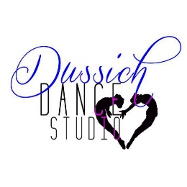AUGUST ANNOUNCEMENTS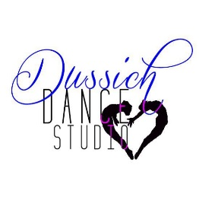
We are so excited for our new dance season. This will be our 66th year and we are so happy you have decided to join us. Be sure to get the word out to your friends and community about Dussich Dance Studio. We offer a wide variety of classes for everyone from ages 2 to Adults. For a copy of our schedule as well as other information visit our website at http://www.dussich.com.

Our December Performance will be “Nutcracker & Beyond”. All students registered at Dussich will be able to be in this production. It will be excerpts from the Nutcracker plus other Christmas numbers. The show is Tentatively Scheduled for December 10th.

Our Annual Recital will be “Route 66 ”. This show will be held at Merritt Island High school Tentatively on June 8th. Costume Payments are due by November 1st. Multiple costumes may be paid for
one at a time , but all must be paid in-full by November 1st. Preschool and Combo class costumes are $60.00 per costume and all other classes are $75.00 per costume

All Tuition payments are due by the 2nd lesson of the month. First Semester payments may be made by September and Second Semester by February, to receive your 10% discount. A $15 late fee will be added on any account NOT paid within the month due. Please try to be on time and ready for class. Proper dancewear, hair up and secured. We will dismiss 5 minutes early to allow for class room changes and restroom breaks. We encourage students to try different classes. The teacher will let them know if they are in the right level.

Do not forget to purchase your Dance Merchandise and Dussich Drawstring Backpack to ensure you are always ready for class: only $10 per in stock item for a limited time. If you would like your dancer to be Part of the Imperial Dance Corp please take an application on the Company Board by the front door. Company rehearsals are every Friday from 7-9pm This gives your dancer more opportunities to perform in the Charity Show in March “ Trolls”.

Thank you for being a part of our Dance Family.

Upcoming Dates
AUGUST
19th (Sat) Studio Open House 10am – 2pm-
21th (Mon) First Day of Dance Classes at Dussich
28th (Sat) Nutcracker Auditions 10am-12
SEPTEMBER
4th (Mon) Labor Day – STUDIO CLOSED
23rd-24^{h}- FDM Intensive Teacher Seminar and Scholarship (23rd) Auditions, Dr Phillips High School, Orlando

Rev 7/28/23

