Attendance:

Audua Pugh (Executive Director - JACC), Jordan Wanat (Office Administrator - JACC), Phillip Nwameme (Recovery Corps Navigator - JACC), Pierre Bowdry (Recovery Corps Navigator - JACC), Camia Carruthers (Prospective BOD Member), Camia Carruthers (Prospective BOD Member)

Board of Directors: Tina Blount (Board Chair), Michael Pugh, Anthony Meinders, Chauncey Jackson

- 6:00 – 6:20 pm Dinner

- 6:20 – 6:25 pm Welcome
6:10 pm - Meeting officially started

- 6:25 – 6:30 pm Approve/Change Agenda/Meeting Minutes - August
6:11 pm - Changing position of agenda, number IV to be Financials, number V to address Gunnar and Secretary role of BOD.

6:13 pm - Check-in question (“How are you doing?”) Everyone in the room checked in and said what is going well and what is stressful lately; Check-in questions discussed as being a good idea to continue every single month.

6:30 pm - BOD members looked over August minutes and no issues brought up

- 6:30 – 6:35 pm Financials

6:34 pm - Financial report reviewed by BOD members by reading a printed copy of our most recent financial records produced, and monthly records for August 2026
- 6:35 – 6:40 pm Gene Harvey
6:36 pm - Gene Harvey talked about why he would like to be on the Board of Directors, his history of living in the Jordan neighborhood, and his interest. Board members asked him questions about why he wanted to be on BOD Michael voted to approve his BOD membership, Tina seconded, unanimously approved.

- 6:40 - 7:00 pm Executive Team Seats
6:40 pm - Executive Director brought up why BOD needs positions on the Board, we lost our Secretary last month, we need a new Vice Board Chair. Tina is stepping down as the Interim Board Chair, but staying on the BOD. All Executive roles were defined, and BOD members discussed what positions they may be interested in taking. Chauncey brought up his interest in taking that role, and why he is interested.
6:44 pm - Discussion started about Chauncey being BOD Chair, vote was decided to be postponed until the Annual Meeting next month, in hopes that every Board Member will be present to vote on the position.
6:48 pm - Annual Meeting and bylaws discussed, as well as where to find clearly defined roles of the Executive JACC roles on the Board.

- 7:00 – 7:25 pm JACC Garden
6:52 pm - The Community Garden caretaker was found to not be doing an adequate job, as the garden was found to be in disarray, with overrun weeds, no compost collected, or trash picked up. Brittni, a Jordan resident, has been doing a lot of work in the garden for free. JACC is looking for a new caretaker, and has let go of the previous worker. In the meanwhile, there has been work done to put up a new fence, get rid of the rotting apples and bad soil, and fix the condition of the garden before the snow comes.

- 7:25 – 7:40 pm JACC Updates
- AmeriCorps Interns
- JACC Bylaws
- Community Unite Final Event
- Motion Lights Project
- Rebranding Jordan
- Jordan Streets
- JACC Annual Meeting
- Forrest Heights Historical District
- Board Recruitment
7:02 pm - Updates started being reviewed.
7:05 pm - Recovery Corps members were introduced and told the BOD about what AmeriCorps and Recovery Corps does. Both members introduced themselves and explained what they will be doing for their 10 month-long service year.
7:13 pm - Bylaws were re-sent to all BOD members by email, and everyone was encouraged to review them so they can be updated if needed, as they haven’t been updated and overhauled completely in a number of years. The process of voting on changes was brought up, and all BOD were asked to do so before the Annual Meeting

7:15 pm - Last event of the year will be hosted at Jordan Park on 10/1/26, and details were discussed. Everyone was sent flyers and information on this event.
7:16 pm - Audua discussed the rebranding of the Jordan neighborhood with street light banners, cleaning up the neighborhood, and other programs through the NRP program. Public Works has not responded about changing residential neighborhood streets in Jordan to alternating one way streets, but a meeting has been scheduled with Pearll Warren next Friday to discuss this exact issue.
7:19 pm - Annual Meeting details, including guests that have been invited
7:21 pm - Forrest Heights historical district is in Jordan neighborhood (the blue dots on the map below), and the Blue Line construction could be going through a lot of it, and there is an application for registering the historical neighborhood registration in the western part of the Jordan neighborhood.
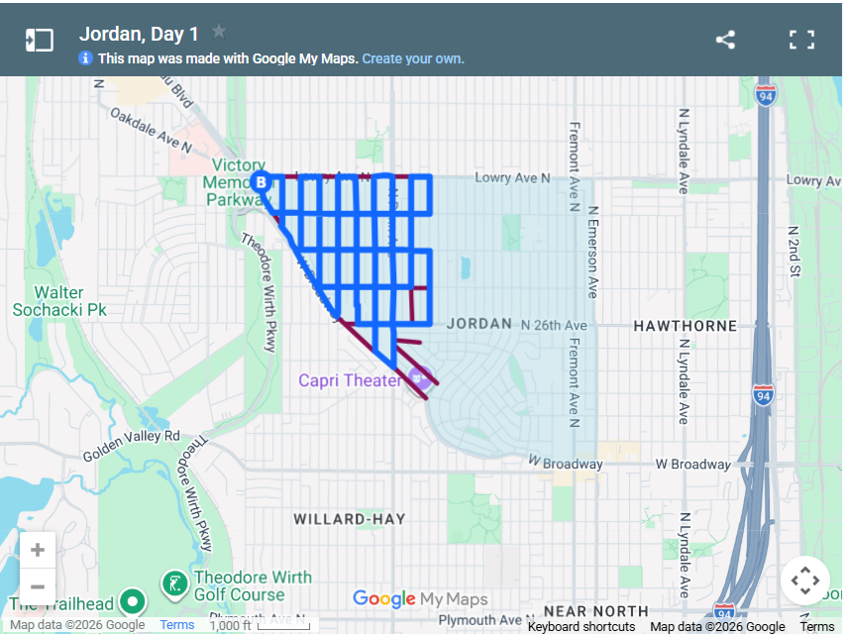

7:25 pm - Gunnar was contacted about his dismissal on the BOD and it all went well.
- 7:40- 7:55 pm Audua’s raise?
7:27 pm - Audua’s raise in wages was brought up in discussion to be changed. She was dismissed early for the BOD to discuss the change in pay.

- 7:32 pm - BOD private meeting started. All BOD members discussed their point of view, Tina motioned it, Chauncey seconded, unanimously approved.

- 7:55 – 8:00pm Last comments

- 8:00pm Adjourn
7:34 pm - Meeting officially adjourned.

