Silymarin is the mixture of flavonolignans (silybin, isosilybin, silychristin, and siliandrin) and a flavonoid (taxifolin).
From: Histone Modifications in Therapy, 2020

Related terms:
- Antioxidant
- Flavonoid
- Serositis
- Programmed Cell Death
- Therapeutic Procedure
- Inpatient
- Silibinin
- Malignant Neoplasm
- Nonalcoholic Fatty Liver
- Chemotherapeutic Agent
View all Topics
Add to Mendeley
Set alert
About this page

Phytonanoconjugates in oral medicine
L. Bharathi Priya, ... V. Vijaya Padma, inNanostructures for Oral Medicine, 2017

6.4 Silymarin
Silymarin is a flavonolignans extracted from the milk thistle Silybum marianum (L.) gaernt. Silymarin has been shown to possess various pharmacological properties like hepatoprotective, antioxidant, antiinflammatory, anticancer, and cardioprotective activities. Although it has been proved by clinical trials that silymarin is safe at high doses (>1500 mg/day) in humans, pharmacokinetic studies revealed poor absorption, rapid metabolism, and ultimately poor oral bioavailability of silymarin (Javed et al., 2011, p. 239). El-Sherbiny et al. (2011, p. 1345) had developed a biodegradable pH-responsive alginate-poly (lactic-co-glycolic acid) nano/microhydrogel matrix for oral delivery of silymarin conferring sustained oral release of silymarin with enhanced overall dissolution and oral bioavailability. Nanosilymarin showed protection against γ-radiation-induced oxidative stress evaluated by the reduction in micronucleus frequency and ROS generation, microscopy analysis, and cell-cycle estimation in cultured human embryonic kidney cells (Adhikari and Arora, 2015, p. 792). Oil-based nanocarrier for silymarin improved the oral efficacy of silymarin in vitro and in vivo studies exhibiting hepatoprotection (Parveen et al., 2011, p. 245). Silymarin-loaded SLNs by cold homogenization method than hot homogenization was found to highly efficient with the relative bioavailability at 2.79-fold higher compared to free silymarin solution (He et al., 2007, p. 195). Lu and Park (2013, p. 198) improved oral bioavailability of silymarin with binary lipids-based NLCs. Chen et al. (2015, p. 2403) successfully developed silymarin-loaded SNEDDS, which improved the dissolution, permeability, and oral bioavailability of silymarin. Oral delivery of silymarin loaded SLNs in Beagle dogs showed enhanced bioavailability. Bile-salt containing liposomes loaded with silymarin developed by supercritical fluid technology improved the dissolution and bioavailability compared of silymarin powder (Yang et al., 2015). Maryana et al. (2015) developed silymarin-loaded phytosomes with the aim of increasing the stability and oral bioavailability of silymarin. SNEDDS developed was found to improve the drug malabsorption in rats with roux-en-Y gastric bypass surgery (Chen et al., 2015).Gupta et al. (2014, p. 156) showed enhanced activity of silymarin when loaded in chitosan NPs in passive targeted therapy in its hepatoprotective action against CCl4 induced hepatotoxicity in Swiss albino mice. Silymarin-loaded SLNs enhanced the oral bioavailability of silymarin in Beagle dogs as experimental model compared to free silymarin (Jun et al., 2005, p. 19).

Volume 1
Michael T. Murray ND, inTextbook of Natural Medicine (Fifth Edition), 2020

Viral Hepatitis
Silymarin is useful in helping reverse virally induced liver damage. It is effective in both acute and chronic viral hepatitis. In one study of acute viral hepatitis, 29 patients treated with silymarin showed a definite therapeutic influence on the characteristic increased serum levels of bilirubin and liver enzymes compared with a placebogroup.²² The laboratory parameters had regressed more in the silymarin group than in the placebo group by the fifth day of treatment. The number of patients attaining normal liver values after 3 weeks of treatment was significantly higher in the silymarin group than in the placebo group.
In a double-blind study of various causes of acute hepatitis, patients were given either a standard recommended dose of 140 mg of silymarin or a placebo three times daily for 4 weeks. Patients randomized to the silymarin group had a quicker resolution of symptoms related to biliary retention: dark urine, jaundice, and scleral icterus. There was a reduction in indirect bilirubin among those assigned to silymarin, but other variables, including direct bilirubin, ALT, and AST, were not significantly reduced.²³
In a study of chronic viral hepatitis, silymarin was shown to result in dramatic improvement. Used at a high dose (420 mg) for periods of 3 to 12 months, silymarin resulted in a reversal of liver cell damage (as noted on biopsy), a rise in protein level in the blood, and a lowering of liver enzyme values. Common symptoms of hepatitis (e.g., abdominal discomfort, decreased appetite, and fatigue) were all improved.²⁴
Silymarin has been studied in hepatitis C, with little evidence of efficacy. In a meta-analysis of five double-blind, placebo-controlled trials, 389 patients were randomly treated with silymarin or placebo. Silymarin was well tolerated in chronic HCV-infected patients, but there was no evidence of positive effects for oral silymarin, although intravenous silybin did show some benefits.²⁵

Role of herbal products as therapeutic agents against ultraviolet radiation-induced skin disorders
Sajeeda Archoo, ... Sheikh A. Tasduq, in Herbal Medicines, 2022

16.3.1 Silymarin
Silymarin is a standardized flavonolignan extract derived from the seeds of Silybum marianum, a milk thistle. Silybin, silidianin, silychristin, and isosilybin are the major components of silymarin. Silybin is thought to be the most physiologically active component of silymarin extract in terms of antioxidant and anti-inflammatory activity [7]. Topical application of silymarin prevents skin from edema and sunburn and prevents the cells from UVR induced apoptosis and has shown a remarkable antitumor effect in mice [8]. Topical application of silymarin was found to provide protection from UVB induced DNA damage as it attenuated the production of cyclobutane-pyrimidine dimers in mice skin. Further, inducible nitric oxide synthase-expressing cells and the number of UVB radiation induced hydrogen peroxide-producing cells were also markedly reduced. In cultured human keratinocytesSilymarin inhibited the activation of NF-κB and demonstrated a dose-dependent protective effect against UV radiation-induced skin damage.

Polyphenols in the Prevention of Ulcerative Colitis
Elroy Saldanha, ... Manjeshwar Shrinath Baliga, inDietary Interventions in Gastrointestinal Diseases, 2019

10 Silymarin
Silymarin isolated from the milk thistle (Silybum marianum) is arguably the most commonly used medication for various liver diseases.⁶⁵ It is a mixture of flavonolignans, consisting of silibinins A and B, isosilibinins A and B, silicristin, and silidianin⁶⁵ (Fig. 23.3). Preclinical studies by Varshosaz and coworkers⁶⁶ have shown that silymarin reduced MPO activity, TNF-α, and IL-6 levels in colon tissues, thereby ameliorating the histopathological features. Further a randomized double-blinded placebo-controlled clinical trial has also shown that administering silymarin (140 mg) once daily for 6 months along with their standard therapy was effective.^{66,67} Most of the volunteers receiving silymarin had improved levels of hemoglobin and erythrocyte sedimentation rate. The disease activity index decreased in the silymarin group. 35 out of 38 patients in the silymarin group were in complete remission with no flare-up after 6 months as compared with 21 out of 32 patients in the placebo group.⁶⁷
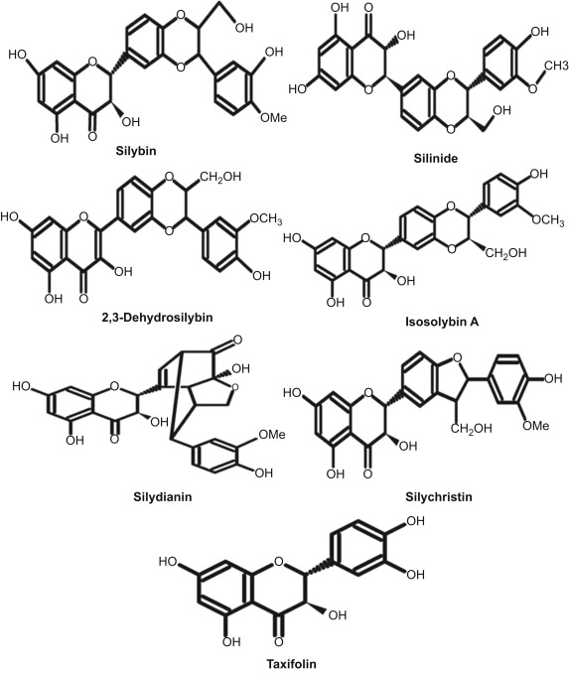
Sign in to download full-size image
Figure 23.3. Polyphenols of silymarin.

Polyphenols in Chronic Diseases and their Mechanisms of Action
Manjeshwar Shrinath Baliga, ... Raja Fayad, inPolyphenols in Human Health and Disease, 2014

10 Silymarin
Silymarin isolated from the milk thistle (Silybum marianum) is arguably the most commonly used medication for various liver diseases.⁴⁸ It is a mixture of flavonolignans, consisting of silibinin A and B, isosilibinin A and B, silicristin, and silidianin⁴⁸ (Figure 50.4). Recently, Rastegarpanah and co-workers⁴⁹ conducted a randomized double-blind placebo-controlled clinical trial, and observed that silymarin (140 mg) once daily for 6 months along with their standard therapy was effective. Most of the volunteers receiving silymarin had improved levels of hemoglobin and erythrocyte sedimentation rate. The disease activity index (DAI) decreased in the silymarin group. Thirty-five out of 38 patients in the silymarin group were in complete remission with no flare-up after 6 months as compared to 21 out of 32 patients in the placebo group.⁴⁹
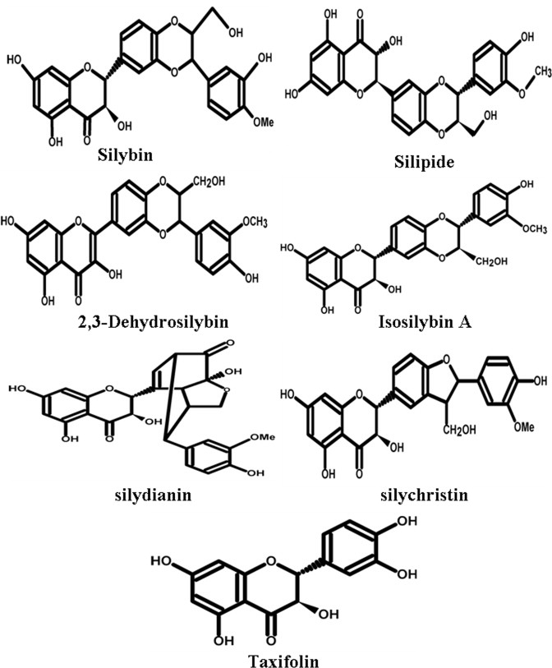
Sign in to download full-size image
Figure 50.4. Polyphenols present in silymarin.

Role of natural products as therapeutic option against nonalcoholic fatty liver disease
Bhat M. Aalim, ... Sheikh A. Tasduq, in Herbal Medicines, 2022

13.3.6 Silyamarin
Silymarin is the extract of Silybum marianum, milk thistle plant, which is used in the treatment of liver diseases [76]. Silyamarin consists of the many flavonoids and flavonolignans. One of the most important biologically active component of silymarin is silybin [77]. Silymarin/silybin is used to treat various liver disorders and has displayed a hepatoprotective role in suppressing NAFLD. The hepatoprotective activity of silymarin/silybin is attributed to its potential in attenuating mitochondrial dysfunction, oxidative stress, liver fat accumulation and insulin resistance. In addition to that, silybin is considered to act via inhibition of intrahepatic gluconeogenesis and glycolysis and regulation of apoptosis, fibrogenesis, and inflammation [76,77]. Due to the low solubility of silymarin in water, intestinal absorption, and bioavailability is very low. Therefore, a complex of phosphatidylcholine with silymarin is used to enhance water solubility [77]. Experimental studies have analyzed efficacy of silymarin in animal as well as in human subjects. It has been reported that treatment of silymarin for six months have significantly reduced WC and hip circumference, TG, total cholesterol, and fatty hepatic index in comparison to normal (control) group. However, there were no significant changes between the two groups in other biochemical parameters, including ALT, AST, GGT, LDL-C, and HDL-C [78–82].

Antioxidant Treatment and Alcoholism
Camila S. Silva PhD, ... Helio Vannucchi MD, PhD, inMolecular Aspects of Alcohol and Nutrition, 2016

Silymarin
Silymarin is a flavonoid derived from Silybum marianum, a plant commonly known as milk thistle. Silymarin exhibits hepatoprotective and regenerative properties,^{126,127} and is one of the most widely used natural compounds for the treatment of hepatic diseases worldwide, due to its antioxidant, anti-inflammatory, and antifibrotic activities. Silymarin also increases hepatic levels of glutathione by raising cysteine availability, while inhibiting its catabolism to taurine that may enhance the antioxidant defense in liver.¹²⁸
Ferenci et al.¹²⁹ reported a slight increase in survival of patients with alcoholic cirrhosis, after silymarin treatment; however, in another study, no effect on survival or on the course of the disease was observed in alcoholic patients with liver cirrhosis.¹³⁰ Silymarin was found to oppose oxidative stress, and to slow the progression of hepatic fibrosis in alcohol-fed baboons.¹³¹
The potential benefit of silymarin in liver diseases therapy remains a controversial issue.¹²⁷ In spite of substantial evidence suggesting that this treatment represents a promising approach to attenuate liver diseases, there are some contradictory data. It is known, though, that silymarin is innocuous. Additional molecular and clinical studies investigating this compound are needed in order to find out an effective intervention.

Silybum marianum, antioxidant activity, and cancer patients
Sepideh Elyasi, in Cancer (Second Edition), 2021

Cardioprotectant
Silymarin and its constituents protected rat heart microsomes and mitochondria against doxorubicin-induced lipid peroxidation, so it seems that silymarin may prevent doxorubicin-mediated cardiotoxicity.⁶⁰ It has emerged from animal models that silymarin can protect the heart against ischemia reperfusion injury, perhaps by preconditioning. The evidence seems to indicate that the ingredients of silymarin reduce the activity of both the Erk/MEK and IP3K/Akt pro-survival pathways, whose activation is central to ACh, bradykinin, and ouabainpreconditioning. At the same time, it is important that stimulation of estrogen receptors, inhibition of MMPs, phosphodiesterases, and mitochondrial ROS generation by silymarin’s components could help preconditioning. Additionally the antiinflammatory properties of certain components may play a role in protecting tissue. While major silybin is the usual suspect for these effects, other minor components of the extract have also been shown to possess an important cardioprotective activity.⁶³

Detoxification
Mario L. Salguero MD, PhD, inIntegrative Medicine (Second Edition), 2007

Milk Thistle (Silybum marianum)
Silymarin, the active component of milk thistle, contains four flavolignans.²⁹ The most remarkable is silybin (up to 70%), which is an antioxidant, consumes free radicals, and inhibits lipid peroxidation. The whole silymarin enhances ribosomal protein synthesis in a way that can stimulate liver regeneration. There is also evidence that milk thistle protects against kidney damage, in particular from nephrotoxic drugs (e.g., acetaminophen, vincristine, cisplatin). The suggested dose containing 70% to 80% of silymarin is 140 to 210 mg 3 times/day.

Polyphenols in Chronic Diseases and their Mechanisms of Action
Nathalie Janel, Christophe Noll, inPolyphenols in Human Health and Disease, 2014

4.1.5 Silymarin
Silymarin is a polyphenolic flavonoid derived from milk thistle (Silybum marianum). It consists of three phytochemicals, silybin, silidianin, and silicristin, and has a long tradition as an herbal remedy. Silybin is its most active phytochemical and is largely responsible for the proclaimed benefits of silymarin. Silymarin was introduced as a hepatoprotective flavonoid a few years ago. It protects animals against multiple types of experimental liver injury such as CCl₄- or alcohol-induced hepatic fibrosis. The proposed beneficial mechanisms of action of silymarin (50 mg/kg/day or 200 mg/kg/every other day) are multiple, including antioxidant activities, anti-inflammatory and antifibrotic effects determined by histopathological observations in rats (shown by Azan or Masson staining for collagen fibers), hydroxyprolinecontent, and α-SMA and TGF-β expression.^{84,85} Silymarin administration in baboons prevents increased hepatic collagen type I content and mRNA for type-I procollagen-α1 and retards the development of alcohol-induced hepatic fibrosis.⁸⁶ The possible protective effect of silymarin on hepatic fibrosis is by suppressing the activation of hepatic stellate cells.

