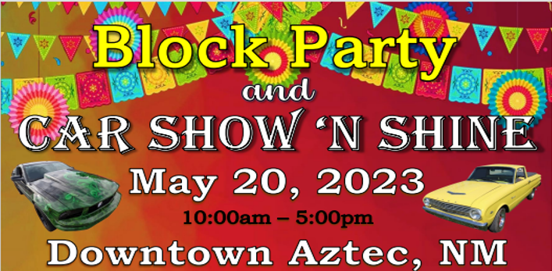 | Car Show ‘n Shine  Sponsored by  Soaps of Katie Elder  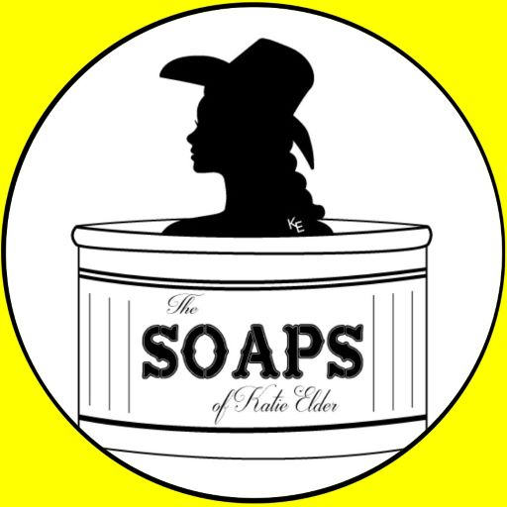
Aztec’s Block Party-Car Show ‘n Shine  Saturday, May 20, 2023  Main Ave Plaza @Main Ave & Chuska, Aztec, NM  9:00-10:00am Day of Registration $10 (cash only)  CarShow lineup @East Chuska & Rubia’s parking lot  10:00am-3:00pm Car Show ‘n Shine  3:30pm Trophies Presented on Main Ave Plaza | You be the Judge!  For each vehicle registered you  will be able to enter one vote  for each category winner  Live Music, Karaoke  Vendors and Food  On Main Ave Plaza  10:00am till it’s over!
Vehicle Owner Name: |  | Address:
Email: |  | City, State Zip:
Contact number: |  | Signature
Category |  | # of Vehicles | Year | Make | Model
1 | American Muscle Car (1964-1973)
2 | Classic Car (1950-1989)
3 | Classic Truck & SUV (1950-1989)
4 | Modern Car (1990-Present)
5 | Modern Truck & SUV (1990-Present)
6 | Lowrider
7 | Vintage Cars & Trucks (1959 & Older)
8 | Tuners
9 | Under Construction < 80%
10 | Best of Show
11 | Motorcycle - Overall
12 | UTV’s, Rock Crawler, Buggies & Jeeps
A First Place collectible Trophy will be awarded for each category! Trophy awards will be selected by YOU! During the event, be sure to enter you ballots for each Category. Ballots provided at registration. Winners announced at 3:30 pm at Main Stage.
For more information contact Rhonda @ 505.609.7230.
Disclaimer/hold harmless: This event will proceed in the case of inclement weather. Proceeds will be used to pay for event costs. The City of Aztec, Sponsors and NMDOT and their employees or affiliates do not accept responsibility for loss, theft or damage to any participant’s person or possessions. Likewise, the participant holds harmless the above named and its entities.

