   February | 2020
Sunday | Monday | Tuesday | Wednesday | Thursday | Friday | Saturday
 | Author of the Month: David Shannon  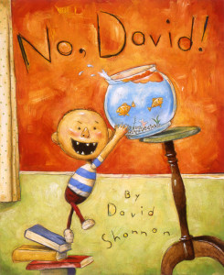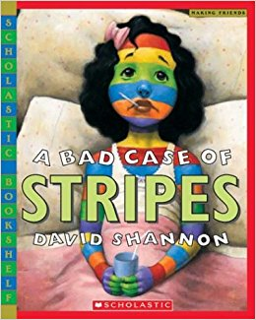  Shannon grew up in Spokane, Washington. He graduated from the Art Center College of Design and now lives in Los Angeles. In 1998 he won the Caldecott Honor for No, David!. He has also written A Bad Case of Stripes, How Georgie Radbourn Saved Baseball, and The Amazing Christmas Extravaganza. |  |  |  |  | 1
Create a
Solar System Hat
Groundhog Day 2 | 3 | 4 | 5 | 6 | 7 | 8
Dental  Week | The 100th Day of School  Dress like a  100 year old | Good for Teeth vs. Not Good for Teeth |   The Dentist Visits | Tooth Art | February  Family Project  Decorate a heart with the things you love
9 | 10 | 11 | 12 | 13 | 14 | 15
Friendship  Week | What does it mean to be a friend? | Card Creation   | Abraham Lincoln’s Birthday  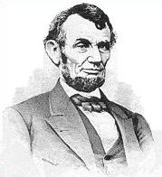 | Color  Mixing  Activities | Friendship Party   | 
16 | 17 | 18 | 19 | 20 | 21 | 22
Farm Animals | 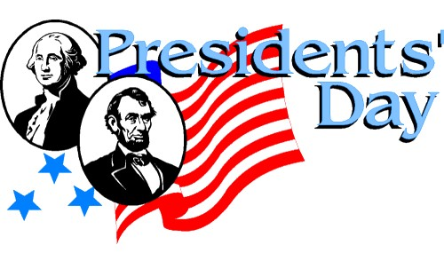  PSA Closed | Exploring  Money  (Arts & Crafts) |   Build Your Dream Home Activity with Maggie Damgaard of Coldwell Banker | 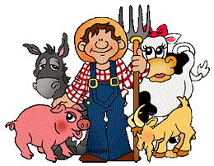  Create your Favorite Farm Animal | Farm Bingo (VPK)  Farm Animals vs. Jungle Animals | 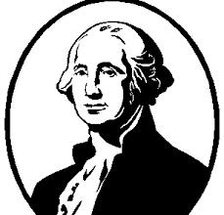  George Washington’s Birthday
23 | 24 | 25 | 26 | 27 | 28 | 29
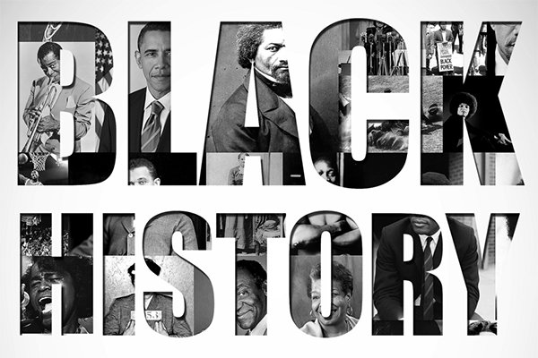 | President Barack Obama  First African American President  Dress like a President | Garret Morgan  Invented the traffic light  Traffic Light Art   | Mae Jemison  First African American Women in space  Create an astronaut | George W. Carver  Invented Shaving Cream  Shaving Cream Art   | “We have before us the glorious opportunity to inject a new dimension of LOVE into the veins of our civilization”  -Martin Luther King Jr.

