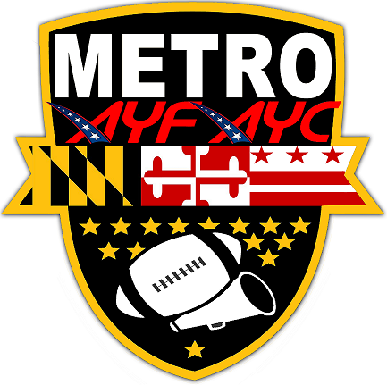
METROPOLITAN AMERICAN YOUTH FOOTBALL & CHEERLEADING CONFERENCE (METRO AYF/AYC)
ASSOCIATION REGISTRATION FORM

**PRINT CLEARLY AND FILL OUT ENTIRE FORM**

ASSOCIATION NAME:

TEAM COLORS:

CITY/COUNTY PRACTICE BASE IN:

PROPOSED TEAM(s) & DIVISION(s):
All - American | # of Teams |  | # of Teams
6u (core team) |  | 10u (core team)
7u |  | 11u
8u (core team) |  | 12u or 13u (core team)
9u |  | 14u

National | # of Teams |  | # of Teams
Tiny Mite (core team) |  | PeeWee (core team)
Mitey Mite (core team) |  | Jr Midget
Cadet
Jr PeeWee (core team)

Do You Have Cheerleading?

Contact Name:

HOME PHONE: |  | CELL: |  | WORK:

E-MAIL ADDRESS:

ASSOCIATION WEBSITE (if applicable):

ARE YOU A NON-PROFIT 501(C) 3:? |  | YES |  | NO
If yes:
PRESIDENT: |  | VICE PRESIDENT:
SECRETARY: |  | TREASURER:

ASSOCIATION ACCEPTANCE REQUIRES a $500 Annual Membership Fee in accordance to Metro AYF by-laws. Fourteen (14) calendar days after acceptance into the METRO AYF $250 (half of annual membership fee) will be due to the league. The balance of $250 will be due on May 1st of the current calendar year. Associations joining the league after May 1st will be required to pay the full $500 Annual Membership fee seven (7) calendar days after receiving acceptance from the league.

NOTE: THE BELOW SIGNATURE IDENTIFIES THE ABOVE TEAM or ASSOCIATION AS REQUESTING TO PARTICPATE IN THE METRO AMERICAN YOUTH FOOTBALL AND CHEERLEADING CONFERENCE.

Team Official: |  | Signature: |  | Date:

