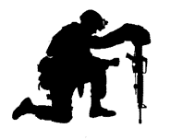
Dear Friend(s) of Veterans,

It is with reverence and honor that we announce the 2023 SFC Charles A. Judge, Jr. Memorial Stand Down.
As you may know already, this event honors our outstanding hero, Charles Judge. A Landrum native, Charles served 21 years in the SC National Guard, including a tour in Iraq. He was decorated numerous times for extraordinary military service and bravery.

Charles was one of the original founders and coordinators of Stand Downs in the Upstate. His passion for and covenant to Stand Down were relentless! He was a key leader in the growing number of veterans served each year and the outstanding outcomes resulting from his diligent work. Charles main goal was to always make life better and brighter for every veteran he encountered.

While stationed at Fort Jackson in July of 2016, Charles was tragically killed as he went to the aid of a young woman escaping violence. He sacrificed his life to fulfill his ultimate duty to serve and protect. We are honored to hold our 2023 Stand Down in tribute to his undeniable valor and life’s service to our country and our veterans.

The Stand Down will be held Friday, March 10, 2023 at the USC Upstate Readiness Center in Spartanburg from 9:00-2:00 pm. (Doors close at 1:00 pm.) We will offer a day of cost-free services, goods and resources to homeless veterans, veterans at risk of homelessness, and veterans in need (self-defined as to the need) as well as their families. Our purpose and mission is to: 1-Connect veterans to targeted resources, information and service agencies, 2-Provide opportunities and avenues for veterans to reintegrate into their community, and 3-Display appreciation and gratitude for their military service in an atmosphere of dignity, respect, warmth and welcome.

Our veterans have come from counties throughout upstate SC and contiguous counties of NC. All veterans are welcome regardless of where they live.

Sponsorships play a critical role in the success of the Stand Down. They help cover costs of the event to ensure maximum goods, benefits and services for our veterans. 100% of proceeds go to serving them. Your gift is tax deductible through our 501(c)(3) non-profit. Checks are made out to SFC Charles A Judge Jr Memorial Stand Down. Please call or text Anne Ring, Event Coordinator, at (864) 670-5139 if you have questions or need more information regarding sponsorship opportunities. You can also visit our website at www.CharlesAJudge.com.

We hope you will consider supporting and/or participating in the SFC Charles A. Judge, Jr. Memorial Stand Down – whether as a sponsor, donor, or volunteer - as we honor Charles’s lifetime of patriotic service and commitment serving all veterans in need.

Warmest Regards,
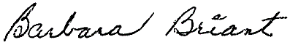
Barbara Briant, Mother of Charles Judge
Member, 2023 Steering Committee
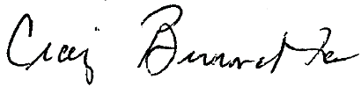
Dr. Craig Burnette, Vietnam Veteran 1969-1970

