**RABBIS & VOWELS**

The ideal for Natsarim is to **not** be contentious. One might ask, *“how’s that workin’ out for ya?”.*

Not many are conscious of behavioral patterns that people of the past made-up out of thin air, and as we see them expressed today, we accept them as being completely normal.

In fact, some behavior is expected, and even imposed;  and yet are not instructions found in Torah; they are human traditions!

For this short study, we’re going to consider just two things:  **rabbis**, and **vowels**.

No, they’re not related, but very interesting when considering how traditions develop.  First, let’s think **outside the box** about vowels.

The Hebrew language is often explained using Greek and Latin letters which evolved into our English letters, like the letters you’re reading here.

The letters U, V, and W all stand next to one another in our alphabet "list" for a reason. The SOUNDS of **V** & **W** are rather NEW, but still the U, V, & W are closely-related to each other.  They are derived from ONE SOURCE; inherited by the modern world directly from the **sixth letter** of the ancient Hebrew alef-beth (alpha-bet).  This sixth letter of Hebrew is commonly expressed today as **WAW or VAV**.  Some of us refer to as a **UAU**;  you’ll understand why in just minutes.

You hear this letter when you say hallel**u**Yah, Yah**u**dah, and Yah**u**ah. It’s in many words, and is even used as an article, much as we use the word “and”.

The letters **V** & **W** are new developments derived through **mutations** of this Hebrew letter going into Greek, and finally Latin.  The original Hebrew **shape** was **Y** (but not the letter we associate with that shape today).  The Greek **shape** was also **Y**, and called **UPSILON**;  the Latin dropped the lower stem, and became the shape **V**, but still was sounded as a double "O" (oo) as in "school", and better understood as the sound of the modern English letter, **U**.

Page 1

To the Orthodox Chasidim, the word for school is SHUL (Yiddish, a fusion of Hebrew and German).

Languages continue to evolve through use, and corrupting influences creep into them.  The Yisharalites (Israelites, all the tribes) are dispersed like fine grain among the nations, and have adopted some distortions from the foreign language groups.  The Masoretes, a Kariate sect which split from the Prushim (Pharisees) over differences between traditions and the written Torah, began to develop written diacritical markings called niqqud.  They were developed to influence the pronunciation of Hebrew words, fixing their vocalization and cantillation (accenting) so there would be uniformity.  Another agenda **concealed within their plan** was to alter vowels so that no one would utter the Name "**Yahuah**" properly, thus protecting it from being profaned.  Their Masorah (tradition) guides all orthodox, and even Christian scholars look to the Masoretes when trying to understand and validate their own teachings.  These invented Masoretic niqqud/vowel markings were developed between the 7th and 11th centuries at Babylonia and Yerushalayim;  it didn't happen overnight.  Due to these Masoretic (traditionalists) influences, we see words in Strong's Concordance (based on the KJV) such as "**YEHOSHUA**".

Which is correct:  JEHO, YEHO, or **YAHU**? Modern Hebrew has several consonant problems also.  Abraham lived approximately 20 centuries prior to the birth of Yahushua, and the Masoretes began their work on the language 700 years after that.  We can find some solid hints on properly uttering Hebrew if we look in the right places;  but it is highly unlikely the Masoretes are one of those places.

Rabbis are not found in the Torah, Nabi’im, or the Kethubim (TaNaK).  They seem to pop out of nowhere, answering the need that resulted from the failure of people to learn Torah from their parents as they were being raised.  Also, foreigners need instructions in how to walk, and engraft to the Covenant.

A professional teaching class logically fulfills such a need for instruction.  A wonderful plan someone had evolved into various full-blown sects.  Divisions among the once unified body of Yisharal (Israel) became prominent, and rivalry, strife, and hypocrisy grew as the fruit out of the rottenness of human hearts.  It proceeds today, infecting the Natsarim, spreading like gangrene in the body of Yahushua’s followers.

  Page 2

**THE OUTCOME**

Now let’s consider how rabbis and vowels relate to **hearts** and **lips**, and attempt to comprehend why things are so disjointed.

The modern Hebrew term for "father" is **AV**, but the Arabic word is **AB**.  How could the Arabs have it more correct? Abraham’s son Yishmaal was Hebrew, was given a Hebrew name, spoke Hebrew, and was not a Muslim. Islam happened in the early 7th century CE, He and his mother Hagar were sent away when he was 13 years old, and 12 tribes descended from him also.  Abraham had six more sons through Keturah after his wife Sarah died, so there are “Hebrews” woven into the middle east that were never scattered peoples, and maintained the language of Abraham.  The Arabs, or more specifically the descendants of Yishmaal, speak a language rich in Hebrew, and it is far less influenced by foreign corruptions.  They name their children Adam, Abram, Daud, Yusef, and so on.  Widening our view of the descendants of Abraham, we begin to perceive more than our former narrow view gave us. In the “other side of the family”, the descendants of Yisharal (Israel), we find altered letters, and we hear folks saying "Avraham" today.  These were the inheritors of the Covenant, but were scattered among the nations to live among people who spoke in strange languages.  There is no letter "V" as we know it in the ***original*** Hebrew, nor a "W" (double-U).

Yahushua told us to love our enemies, in part because He knows things we don’t know.  We attack one another over differences in spelling words, or over doctrinal disputes, and even racial lines.  Our blindness and confusion is largely at fault for these circumstances.

It's difficult at first, but we need to accept those who are "weak" in knowledge, even put them above ourselves and our needs.  Rab in Hebrew means "exalt, lift up".  It is a term used as a title among Prushim, and Paul was a Prushite (Pharisee).  After Yahushua's example and instruction for us, none of us exalt ourselves, but we learn to become servants.  We are to consider ourselves lower than others, for the sake of helping them. When we do this, be show ourselves to be the opposite of an exalted one, and prove it by serving all.  This is the evidence of what is in the heart.  Seeking a title or position among the Natsarim leads to no reward from Yahushua.  The recognition of men becomes the only reward to be received.

Page 3

Hebrew Ponetic Sound Chart …………………………………………….The Sound 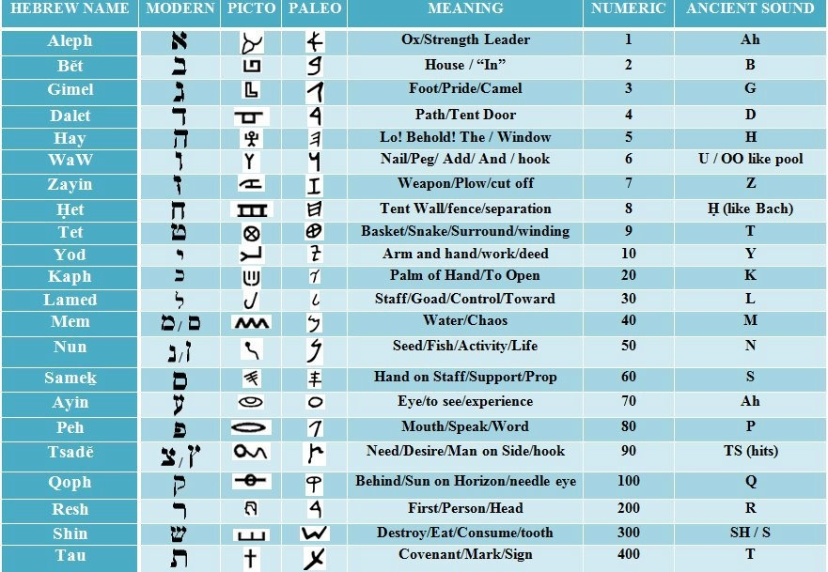

Page 4.

