**The Australian Budgerigar Society Inc.**

**2019 PRESTIGIOUS**

**BUDGERIGAR AUCTION**



**Sunday 13th January 2019**

**Community Hall**

**94/112 Fryar Road, Eagleby Qld.4207**

**Visit us on the web at www.absbudgieclub.org.au**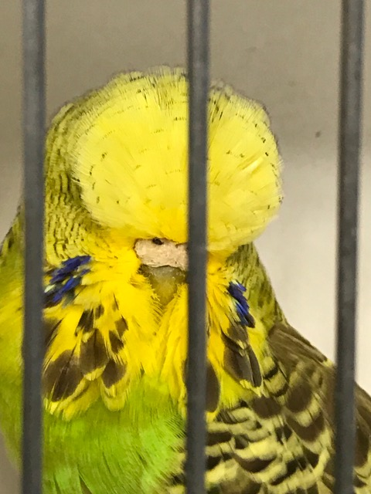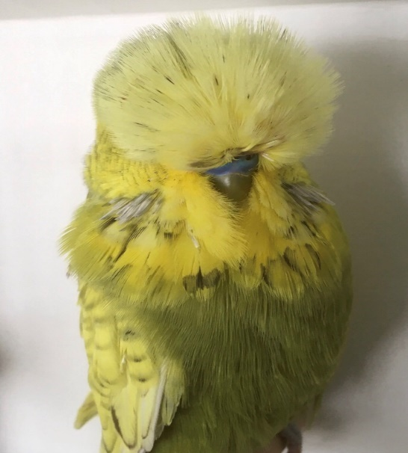 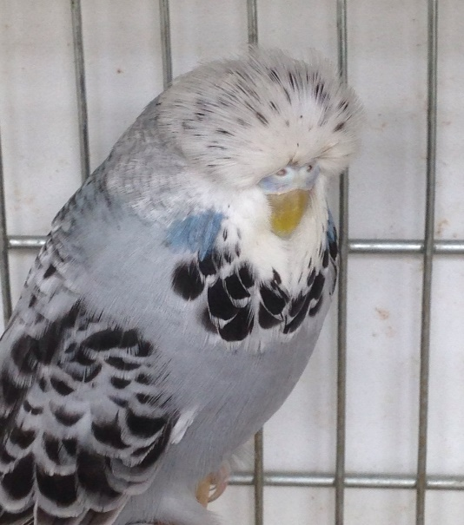

George Lot # 264 Barnett Lot # 111 Gazzard Lot # 228

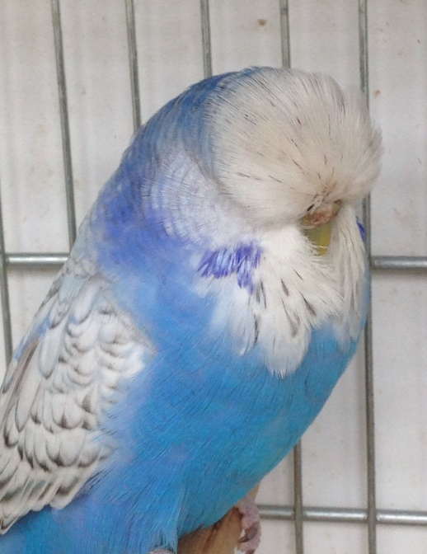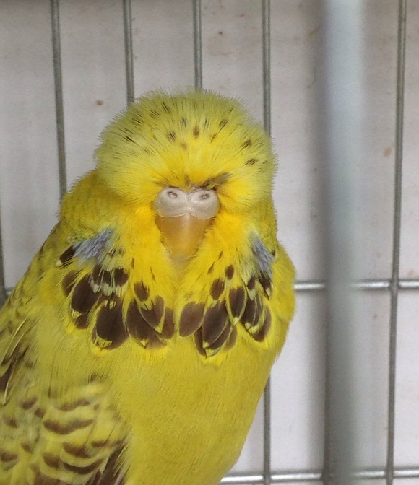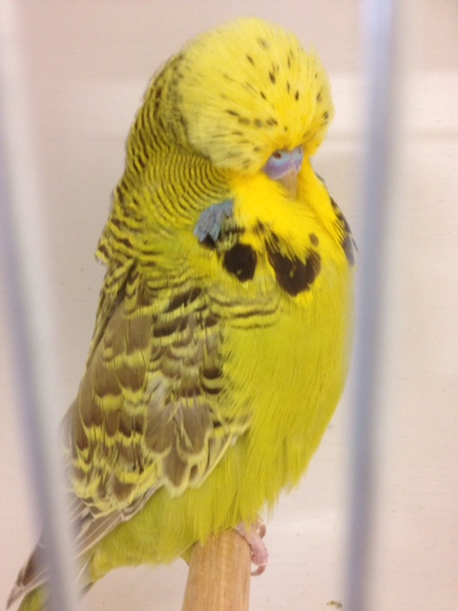

Gazzard Lot # 292 Gazzard Lot # 229 Gazzard Lot # 100

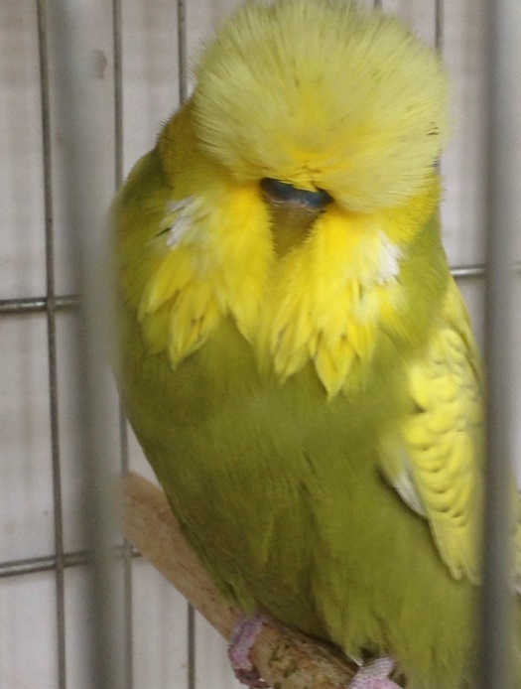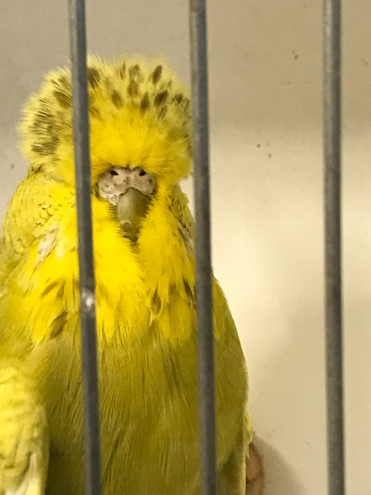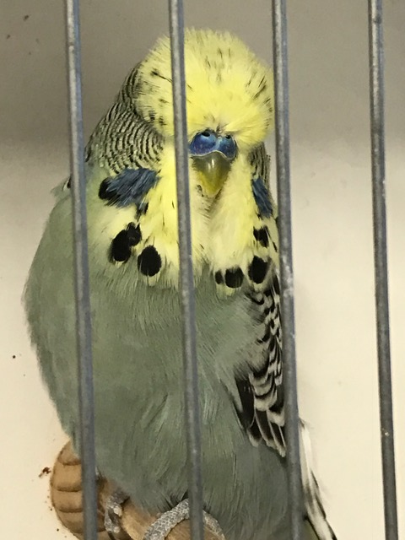

Gazzard Lot # 48 George Lot # 200 George Lot # 303

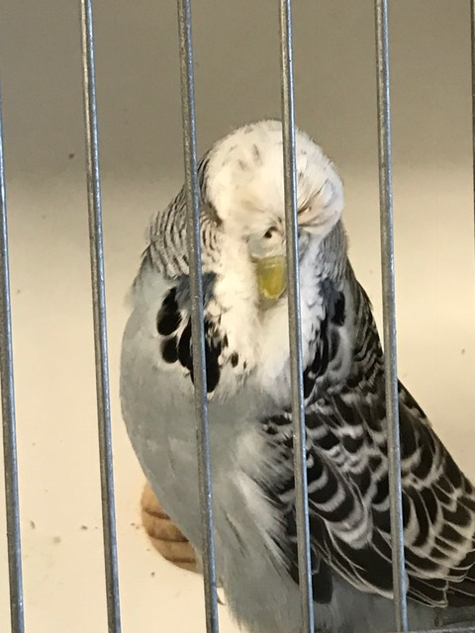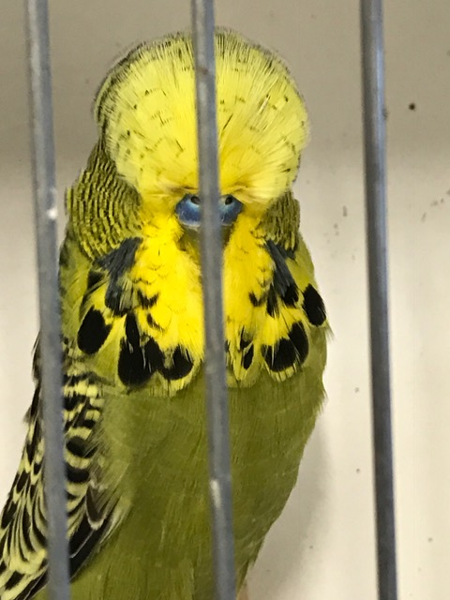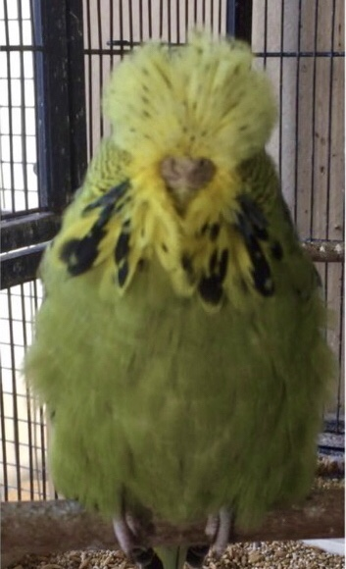

George Lot # 71 George Lot # 70 Barnett Lot # 47

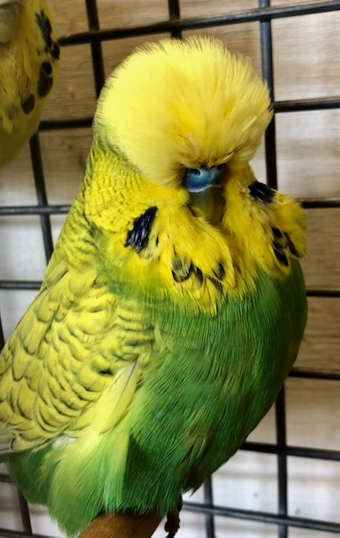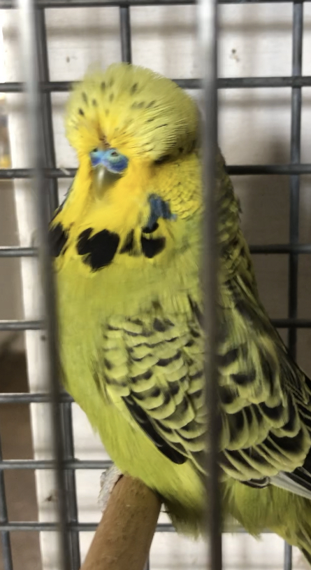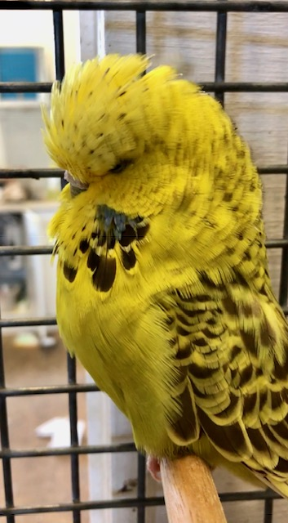

Barnett Lot # 291 Barnett Lot # 176 Barnett Lot # 240

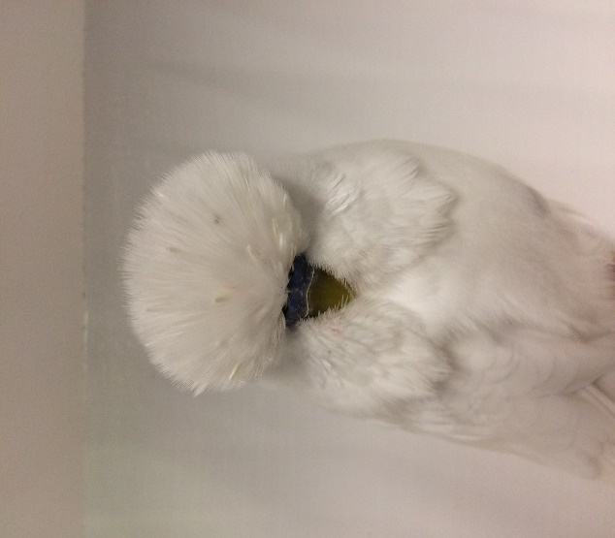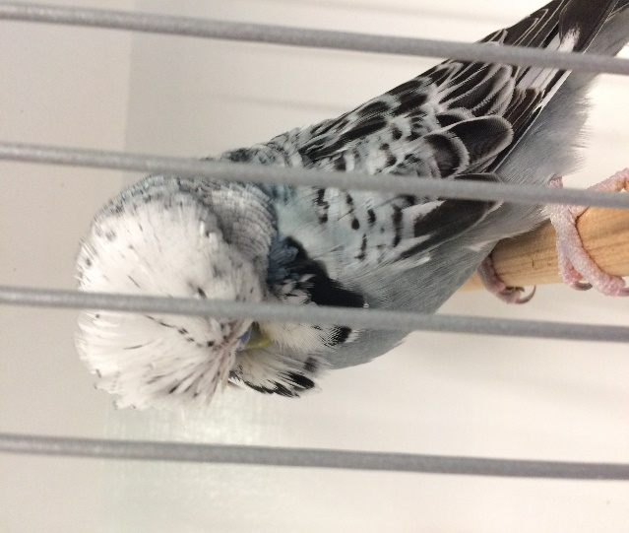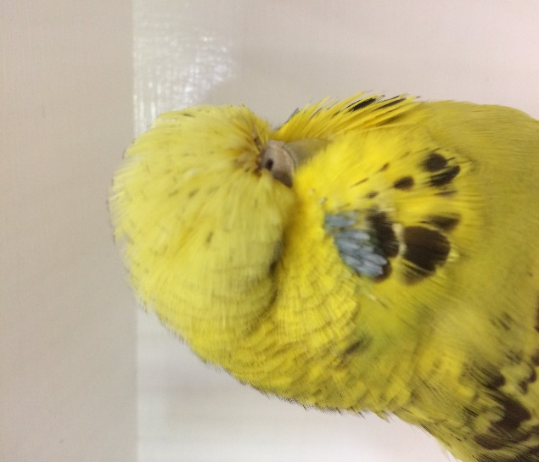

Hammond Family Lot # 241 Hammond Family Lot # 300 Hammond family Lot # 51

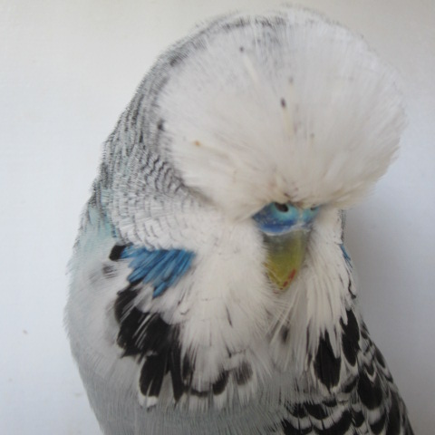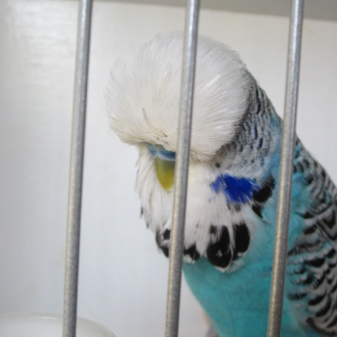 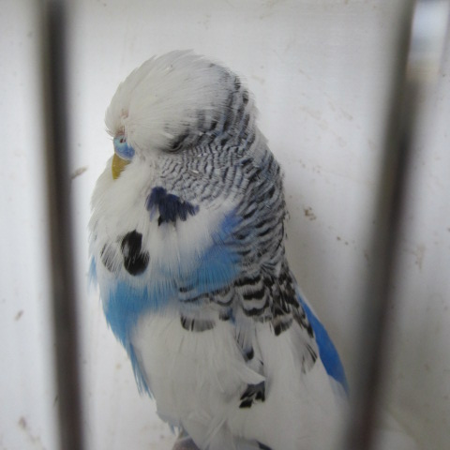

O’Callaghan Family Lot # 33 O’Callaghan Family Lot # 158 O’Callaghan Family Lot # 222

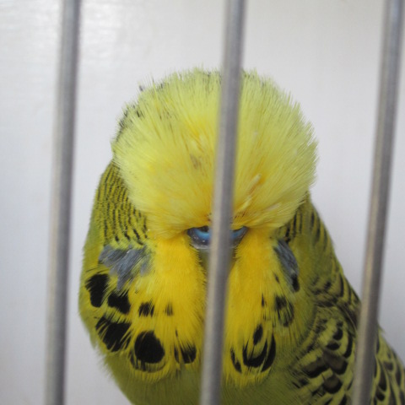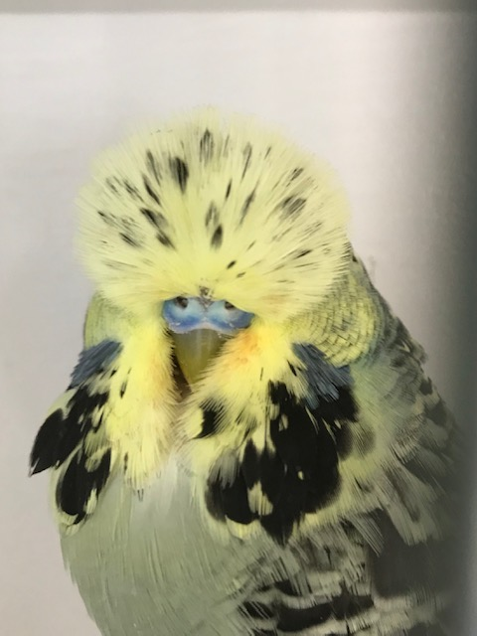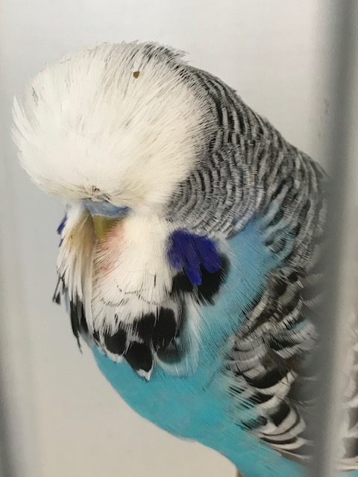

O’Callaghan Family Lot # 93 Edwards Lot # 260 Edwards Lot # 66

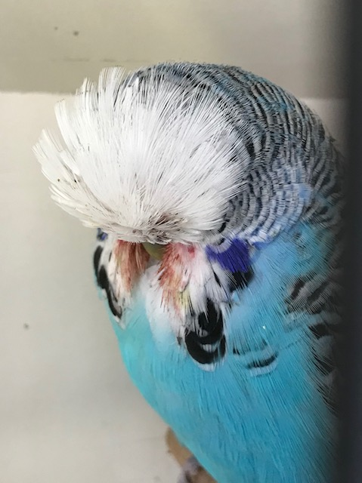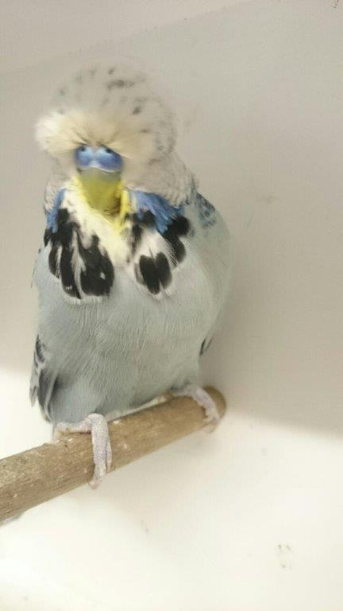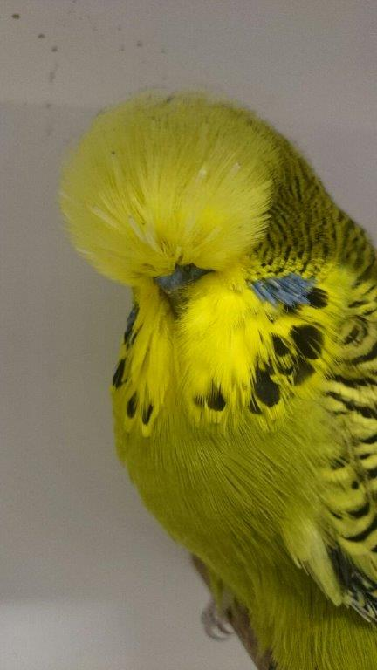

Edwards Lot # 196 Harms Lot # 76 Harms Lot # 142

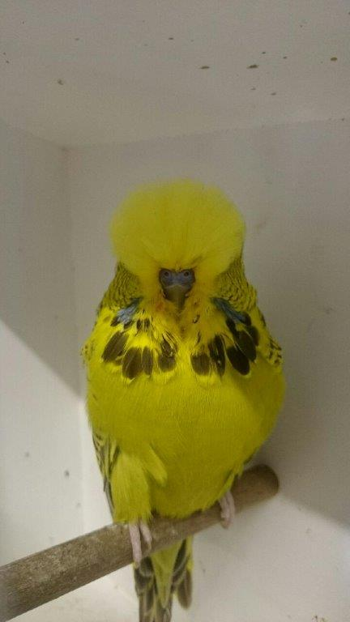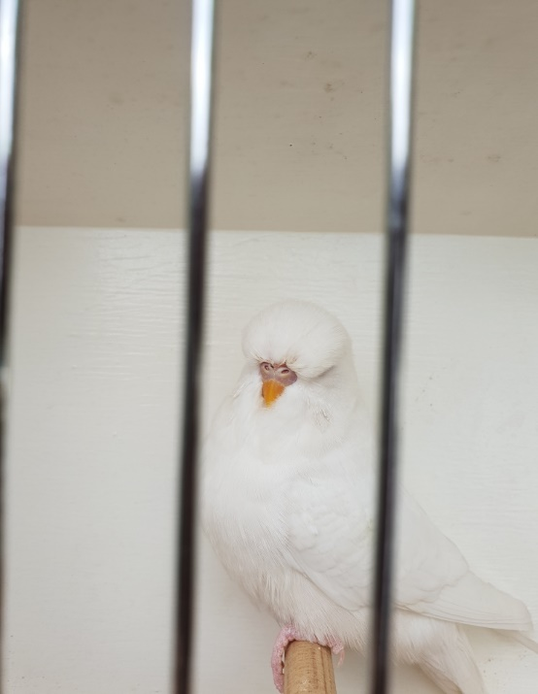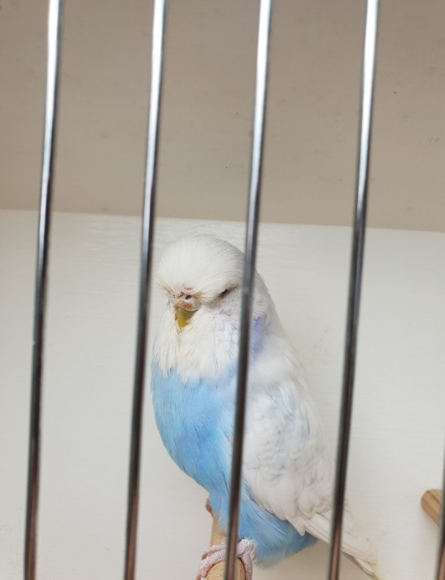

Harms Lot # 205 Hendry Lot # 161 Hendry Lot # 162

**Stephan Elliott Budgies from Anthony Lahood**

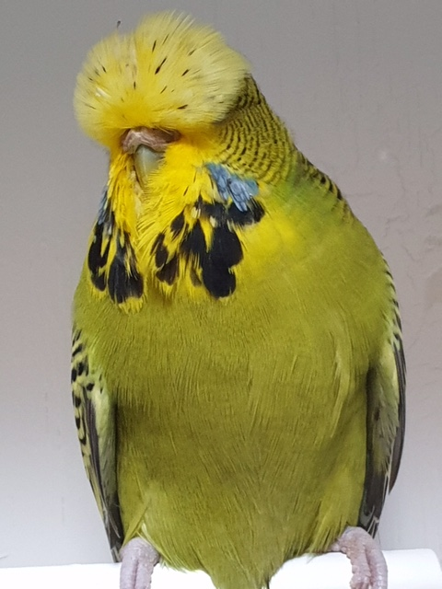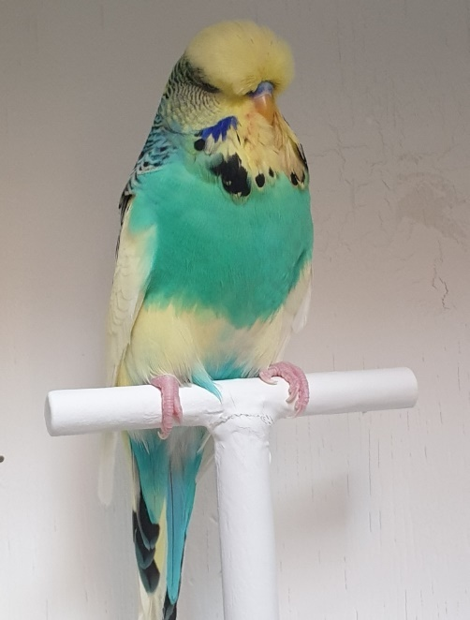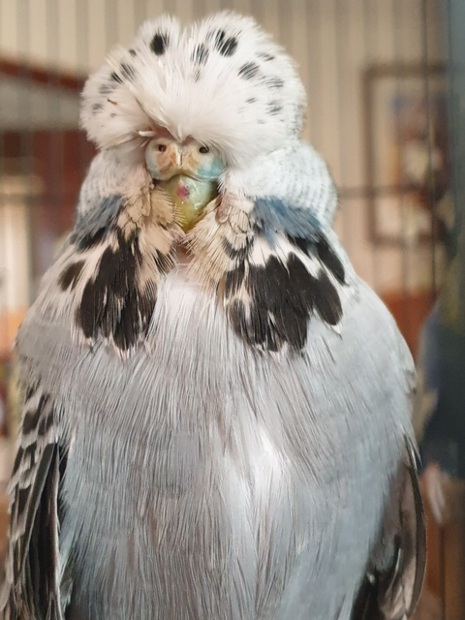

Lot # 114A Lot # 53A Lot # 241A

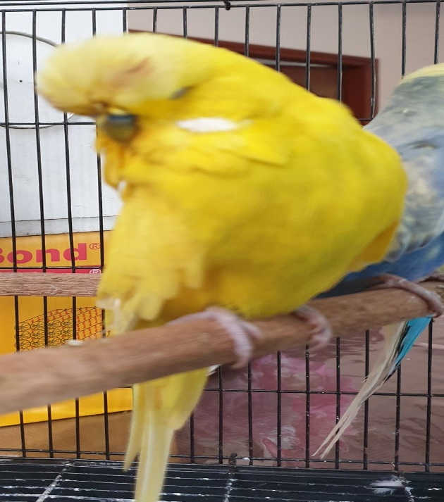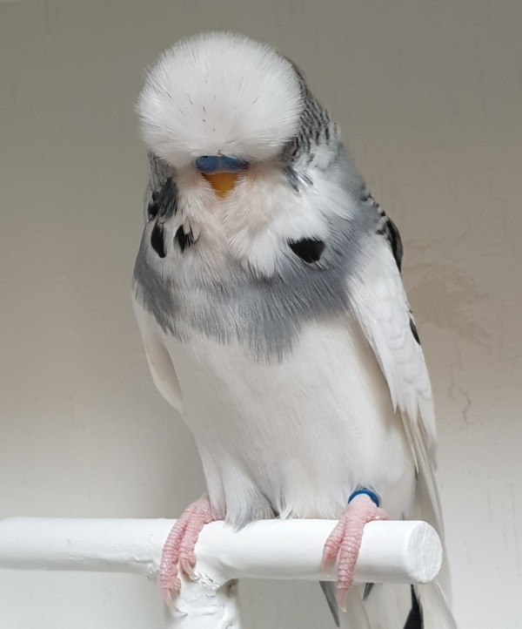

Lot # 53B Lot # 114B

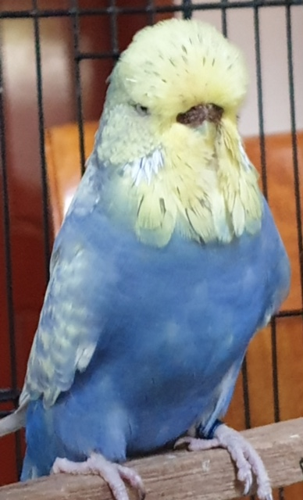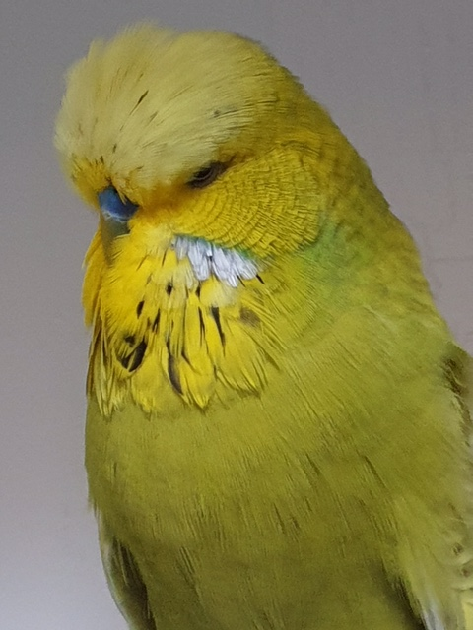

Lot # 299A Lot # 180A

**Directions for getting here**

**Map 1 Map 2**

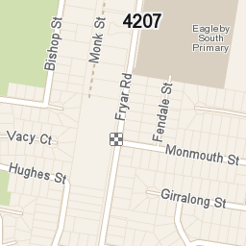

Eagleby Community Hall

Exit 34 off the Pacific Highway

94/112 Fryar Rd, Eagleby, QLD 4207

For more information or auction location details please contact:

Wayne Robinson M 0407 037 522 Paul or Kym Williams M 0448 030 076

Shane Beer M 0488 243 969 Lucas Hendry M 0422 072 685

**Interstate Bidders**- Are very welcomed.

If you cannot attend in person but wish to bid on any lots in the ABS Inc. Prestigious Auction Catalogue, please contact one of the above-named committee members and we will arrange a phone bidder for you at the auction.

If you are a successful interstate bidder, your birds will be sent during the week after payment has been received. Freight is at the buyer’s expense. Freighting cages will be available for purchase.

**Payment methods- Cash, Credit Card, Eftpos**

A Transaction Fee of 4% for all Credit Card and $0.40 cents on all EFT card transactions will be charged.

[](https://www.google.com.au/url?sa=i&rct=j&q=&esrc=s&frm=1&source=images&cd=&ved=0ahUKEwiuxvj9qtvJAhXiq6YKHZM9DbYQjRwIBw&url=https://www.windowssearch-exp.com/images/search?q%3DVisa%2BLogo%26FORM%3DRESTAB&psig=AFQjCNEk-7hkkWLnEyEFjzHSGuUuXFIibg&ust=1450181969160453&cad=rja)[](https://www.google.com.au/search?biw=1366&bih=647&tbm=isch&q=eftpos+logo+png&revid=1046704647&sa=X&ved=0ahUKEwiSn8HPrNvJAhVFJaYKHT8JDAcQ1QIIGw)

Please note Cheques will only be accepted by making arrangements with Mr. Glenn Berghoffer prior to the auction. Ph 0423 734 757



|  |
| --- |
|  |

*THE AUSTRALIAN BUDGERIGAR SOCIETY INC.*

EST. 1957

“**Welcomes all visitors & new members to attend”**

**Meetings held at the ABS CLUB HOUSE, - doors open 6.30pm**

**36 MARTENS STEET, BEENLEIGH (Entrance via PLANTATION STREET, Old Council Depot.)**

**Every 3rd Thursday evening of the month – except December (closed)**

**unless stated in our Calender of Events**

**Supper provided.**

**We hold bench shows, have guest speakers, discuss all subjects relating to the Exhibition Budgerigar, hold social events, we have a Library for all the members. Great hobby for the family – juniors welcome. Come along & say hello.**

**Our members are very happy to help with advice.**

**We hold 3 shows per year & are eligible to attend other club shows through the year with the opportunity to go to THE AUSTRALIAN NATIONALS Held in a different State each year.**

**President: Wayne Robinson**  **3207 4940 budgie13@netspace.net.au**

**Membership Officer: Shane Beer**

**0488 243 969 shaneb963@hotmail.com**

**Secretaries: Kym and Paul Williams**

**3372 3306** [**paulgwilliams1@optusnet.com.au**](mailto:paulgwilliams1@optusnet.com.au)

**www.absbudgieclub.org.au**

**The Australian Budgerigar Society Inc.**

**Prestigious Auction**

**Sunday 13th January 2019**

**Viewing commences at 8:00 am**

**Auction Commences at 9:30am**

**Lunch at approx. 12:00pm**

**AUCTION RULES AND TERMS AND CONDITIONS OF SALE**

* All people prior to the start of the auction intending to bid shall complete a registration form and shall receive a Bidder’s Paddle. On the fall of the hammer the purchaser shall display the Bidder Number to the auctioneer.
* The highest bidder shall be the purchaser and in the event of any dispute arising, the lot in dispute shall be put up again and the auctioneer's decision shall be final.
* After the fall of the hammer no party will be allowed to retract his or her bid.
* The auctioneer reserves the right to accept or refuse any bid without having to state any reason.
* Payments for goods and birds shall be by Cash, Credit Card or Eftpos on the day.Please make prior arrangements if you want to pay by cheque. A 4% transaction fee will apply on all Credit Card Transactions and a $0.40 Transaction fee will apply on all EFT Card Transactions.
* The birds must not be interfered with by judging sticks, pens or other objects. **No Smoking** in the hall.
* All lot numbers will be presented in order corresponding to the catalogue.
* There will be approximately 1 hour viewing time from 8:00am prior to the ABS Inc. Prestigious Budgerigar Auction commencing at 9:30am.
* Officials will provide each bidder with a sales ticket for their purchases, upon payment this ticket will be stamped and then bidders must catch and cage their purchases at the end of the auction once collected by officials.
* The Australian Budgerigar Society Inc. act as agents only in respect of the goods being auctioned and are not responsible for any faults or defects in any lot. All intending purchasers must satisfy themselves with all aspects including origin, condition and age of lots which they may be interested in.
* Show cages are not included in sale of each lot and successful bidders are expected to have their own cages for collecting purchased birds. Successful bidders will be expected to transfer each lot into their own cages; officials will not be handling purchased lots. A transfer room will be available to do this.
* All lots must be removed at the completion of the sale.
* Telephone bidding will be available, prior arrangements for purchases and payment must be made.
* Any scratching’s or substitutions are to be advised to ABS Inc. prior to 9:00am on auction day, the vendor or the organizers have the right to withdraw or substitute any lot at their discretion.
* If any successful bidder fails to pay for their purchases on the day, the vendor or his agents have the right to resell the lot in any manner they think proper.
* Purchases may be collected prior to the completion of the auction, see steps below
* Take sales slip to cashier.
* Pay for purchases and obtain receipt for your purchases.
* Proceed to ABS Inc. stewards at collection point with cages and receipt.
* Under supervision of an ABS Inc. steward the purchaser will be required to remove budgerigars from transfer sale cage in the transfer room and place into their own cage.
* The auctioneer, vendor and ABS Inc. stewards will not be touching the budgerigars. It is the sole responsibility of each purchaser to handle their own budgerigars purchased upon collection.
* The buyer taking delivery of the goods shall be conclusive in evidence that the same are in satisfactory order and condition and fit for the purposes of which they are required.
* If you do not have a catalogue, please request one. Contact Wayne Robinson Ph 0407 037 522 or email [budgie13@netspace.net.au](mailto:budgie13@netspace.net.au) OR Paul and Kym Williams Ph 0448 030 076 or email [paulgwilliams1@optusnet.com.au](mailto:paulgwilliams1@optusnet.com.au) OR Lucas Hendry Ph 0422 072 685 or email [ducashp@hotmail.com](mailto:ducashp@hotmail.com)

V**endor lots**

|  |  |  |  |
| --- | --- | --- | --- |
| **Vendor** | **Vendor Name** | **# of Budgerigars** | **Lot Numbers** |
| 1 | Henry George | 15 | 13,14,70,71,72,136,137,200,201,264,265,266,267,303,304. |
| 2 | Ken Seagrott | 17 | 11,12,67,68,69,133,134,135,169,197,198,199,261,262,263,301,  302 |
| 3 | Wayne Stephan | 12 | 3,4,59,60,125,126,127,190,191,253,254,255 |
| 4 | Steve Kilduff | 5 | 38,101,166,230,294 |
| 5 | Lucas Hendry | 11 | 35,36,95,96,160,161,162,224,225,226,288 |
| 6 | Glenn and Damen Winch | 12 | 23,24,83,84,85,148,149,150,213,214,277,278 |
| 7 | Glen Kennedy | 5 | 32,92,157,221,290 |
| 8 | Craig Barnett | 5 | 47,111,176,240,297 |
| 9 | Greg Horrobin | 10 | 5,6,61,62,120,121,185,186,249,250 |
| 10 | Don Harper | 8 | 41,42,102,103,167,168,231,232 |
| 11 | Wayne Altman | 12 | 7,8,63,64,128,129,130,192,193,194,256,257 |
| 12 | Kev Richards | 5 | 25,82,147,212,285 |
| 13 | W & G Robinson | 8 | 26,27,43,86,87,151,152,215,216,233 |
| 14 | Gary Gazzard | 9 | 48,99,100,164,165,228,229,292,293 |
| 15 | Hammond Family | 5 | 51,112,177,241,300 |
| 16 | Brian Waters | 10 | 28,29,88,89,153,154,217,218,281,282 |
| 17 | Garry Edwards | 10 | 9,10,65,66,131,132,195,196,259,260 |
| 18 | Russell & Cheryl Ogden | 10 | 17,18,74,75,139,140,203,204,268,269 |
| 19 | Brian Harms | 10 | 19,20,76,77,141,142,205,206,270,271 |
| 20 | Adam Francis | 10 | 30,31,90,91,155,156,219,220,283,284 |
| 21 | Paul Bayliss | 4 | 53,114,179,258 |
| 22 | Terry Bevan | 5 | 16,73,138,202,276 |
| 23 | Kevin O’Callaghan | 10 | 33,34,93,94,158,159,222,223,286,287 |
| 24 | Peter & Katrina Cox | 14 | 1,2,57,58,122,123,124,187,188,189,251,252,274,275 |
| 25 | Ian Schneider | 10 | 45,46,109,110,174,175,238,239,297,298 |
| 26 | Shane and Barb Beer | 5 | 52,113,178,242,299 |
| 27 | John Boss | 7 | 15,80,81,145,146,279,280 |
| 28 | Peter Jeffrey | 10 | 49,50,118,119,183,184,209,210,247,248 |
| 29 | Barbara Kelly | 10 | 39,40,107,108,172,173,236,237,295,296 |
| 30 | Bob & Glennis Henderson | 5 | 54,115,180,243,244 |
| 31 | Geoff Wood | 5 | 37,97,98,163,227,289 |
| 32 | Myles Henke | 10 | 21,22,78,79,143,144,207,208,272,273 |
| 33 | Clarrie Johnston | 7 | 44,105,106,170,171,234,235 |
| 34 | Charlesworth Family | 10 | 55,56,104,116,117,181,182,211, 245,246, |
| 35 | Anthony Lahood | 10 | 53A,53B, 114A,114B,180A,180B,241A,241B,299A,299B |

The Following Vendors have made their Quality Budgies Available to ABS.

**Henry George OAM**: ANBC Hall of fame, National Judge and Championship breeder. The first inductee into the ANBC Hall of Fame, he has achieved over 41 National winners since 1982 in the following classes Lutino, Yellow Face, Hens, Dominant Pied, Blue,Green, Spangle, Lacewing, Clearwing, Opaline AOSV, Opaline Normal, Grey and Dark Eyed Clear in a demonstration class. Winning an incredible 7 Logies in 2015 and amazing achievement probably will never be matched, he backed that up with another 3 Logies in 2016 with Cinnamon, Spangle Double factor and Spangle Normal Wing. In 2017 Henry received an amazing 2 seconds, 2 thirds and three fourths, plus more placings. Henry Judged in 2018.

**Gary Gazzard:** ANBC Hall of Fame, National Judge and Championship Breeder. A 10-time ANBC National Show Winner in the following classes Opaline, Spangle, Spangle Double Factor, Hens, and the Normal Blue and Grey Green Classes. Gary has also placed on the top row at the ANBC National Show countless times. Garry Judged in 2018.

**O’Callaghan Family**: Open Breeder and National Judge from North and Central Queensland, Kevin has been Breeding Budgerigars since a child and over his Budgerigar Journey has enjoyed success at the National Level in many classes for many years. Here are some achievements first in ANBC National Blue Class, 2008 7th Blue Class, 2009 7th and 8th in Grey Class, 6th Blue Class, 6th Cinnamonwing Class and 7th Spangle, 2010 3rd DF Spangle and 4th Greywing Classes. In 2012 first Cinnamonwing, 4th Blue, 6th Greywing and 12th DF Spangle Classes, 2013 1st in Violet, 4th and 12th in Spangle Normal plus numerous more placings. When he is not judging a National Show, he continues to accumulate ANBC National representatives totaling over 60 today which continued in 2017 with Lacewings and Violets. Kevin judged in 2018.

**Brian Walters:** Open Breeder & NSW ANBC National Representative with very strong lines of Cinnamon and Opaline Cinnamons. Brian has had 17 Budgies represent NSW since before 2011. Eleven of these Budgies have either been Cinnamon or Opaline Cinnamon with 3 First Place Winners, one second and one placed third.He has also had success at winning Champion of Show at club Annual Shows. In 2018 Brian Placed 11th in Opaline ASC, 10th in Opaline AOSV,

**Barbara Kelly:** Open Breeder possess a winning stud of budgerigars, receiving major awards at many shows with Spangles and Cinnamons. Is a high achiever in the budgerigar fancy with very good bloodlines. Has Won Champion Nest Feather of Show and many other awards at Club Shows. In 2016 at the Hobart ANBC National Championship Show Barbara won her First Logie in the Spangle AOV Class. Barbara is well known for her strong line of White Caps.

**Wayne & Gwen Robinson:** Open Breederand became a National Judge in 2018. Wayne began breeding budgerigars at 14, becoming a judge at 18 while still at High School, after university, sport and career ambitions Wayne again returned to the hobby and with the help of his mum Gwen have represented the SQBBA at National Level since 2003, including 2nd, 7th and 8th with Lutino’s at Canberra & many other varieties placings on the Top Row at Nationals such as Lt Green, D/F Spangle, Lutino, Spangle AOSV, Recessive Pied, Cinnamon & Opaline AOSV. A strong stud of budgerigars from bloodlines of Chidel, Gazzard, George and Kent. Wayne and Gwen have won the SQBBA Gold Breeder Annual Award for since its inception 7 years ago.

**Bob and Glennis Henderson**: An Intermediate Breeders winning at many shows and receiving major awards including also many Gold Breeder awards, Bob also represented SQ at the Nationals in 2014 in Fallow and Australian Golden Face Classes and again in 2016 again with Australian Golden Face Variety in Hobart. Bob once again excelled at this year’s Preselection.

**Adam & Amanda Francis**: Open Breeders – many wins on the Show Bench, excelling in Normals, Recessive Pieds and Crests. A quality budgerigar stud always improving. Adams stud is highly recognized in the Budgerigar Fancy and now his Children are also climbing the ladder of success in the budgerigar fancy.

**Ken Seagrott**: An Open Breeder from NSW that has represented his state constantly with his Quality Stud of Budgerigars at the ANBC National Championship Show for many years. In 2006 1st and 2nd in Greywing, 1st Recessive Pied and 1st in Crest and in 2007 2nd in Recessive. More recently in 2016 Ken won the Recessive Logie to add to the trophy cabinet and was placed 9th in the Spangle Normal. In Hobart Ken again won the Recessive Pied class and was placed 9th in the Spangle Normal class. His favorite variety in Recessive Pied, but Ken has Quality and Strength across all varieties. **Glen Kennedy**: Intermediate breeder and Panel Judge that has won Champion of Show at the Mt Gravatt Show in 2014, 2015 and 2018 has received many high awards attending the local budgerigar show circuit.

**Steve Kilduff:** An Intermediate Budgerigar Breeder from NSW who has received high acclaim for his quality stud of budgerigars on the Show Bench in NSW and more recently in South Queensland. In 2018 Steve Was placed 11th in the Dilute Class and 12th in the Clearwing Class, Steve loves his Clearwings.

**Glen & Damen Winch:** Open Breeders – a successful Father and Son partnership with budgies representing the SQ at the National Level for the last 6 years in the following classes Normals, Yellow Face, Dominant Pieds and Double Factor Spangles. Their stud is primarily based on the Henry George Bloodlines of Normals, Dominant Pieds and Cinnamons. An impressive stud that has produced many Champion of Show Budgerigars over recent years at club Shows.

**Garry Edwards**: SQBBA Open Breeder. Garry has been breeding budgerigars since 1980 and with good success on the show bench. Due to family commitments, he gave the hobby away in the ninety's returning 5 years ago and having good success once again. His Aviary Blood Line consist of Birds from Ken Dunk, Bob Smith, Gary Gazzard, Alan Kent, E L Miller, M. R Fellows. In ANBC Championship Show in Hobart I placed 14th in a strong class of Dominant Pieds and in 2018 placed 16th in Dilutes, 6th in Cinnamonwing and 10th in Spangle Double Factor

**Kev Richards**: An Intermediate breeder of Quality Budgerigars of Normal, Dominants, Sex-link and Lesser Varieties. He loves the lesser varieties, especially his Darkwings & Black Eyed Self budgerigars are very strong. Kev enjoys his Budgies and is achieving high awards constantly. In 2017 Kev represented the SQBBA in the Blackeye and Dilute varieties.

**Lucas Hendry**: An Open breeder and Panel Judge who is another high achiever on the show circuit. Known for his Normals, Lucas also enjoys breeding quality sex-linked; especially Clearbody’s and Albinos. Highly successful on the show bench, Lucas represented the SQBBA at the 2017 Nationals in placed 7th and 13th in Greywing, 10th in DF Spangles and 9th in Clearbody.

**Wayne Stephan**: Open Breeder who has been in birds for over 42 years and has represented SQBBA on many occasions at the Nationals. Bloodlines consist of Henry George, Gary Gazzard, Ken Dunk and Vicky and Kevin O’Reilly. In 2017 representing the SQBBA at the Nationals with Grey Green, Grey, Yellowface, Cinnamonwing, Opaline Normal and Dominant Pied, with 7 Budgies in the Team. In 2018 Wayne Placed 12th in the Normal Grey Green Class and 12th in The Yellowface class.

**Russell and Cheryl Ogden**: Open Breeders from North and Central Queensland with a highly sought-after quality stud of Budgerigars, in 2017 winning the ANBC Logie in the Normal Grey Class at the ANBC Nationals in Mackay. No less than 12 Budgerigars representing in 2017, placings including two seconds, one in the Grey Class they won. In 2018 3rd in Violet and 10th in Black Eyed Self. They focus on all Normals, Opalines, Lutino’s, Yellowface and Blackeyes.

**Craig Barnett:** Is an Open Breeder from NSW, has been breeding budgies for 13 years. He has had budgies Represent NSW National Team for the last 4 years. In 2017 Craig placed 5th in the Spangle Normal Class at the ANBC National Show and in 2018 Craig placed 2nd in Cinnamonwing, and 2nd in the Hens Class. Craig’s bloodline center primarily from the stud of Wally Capper.

**Greg Horrobin:** OpenBreeder of a quality stud of Budgerigars, who constantly has budgies receiving Major Awards at Club Shows. Greg has tallied 3 ANBC National Logies in the Fallow Class 2005, Opaline ASC 2010 and Opaline AOSV in 2013. Greg has received many placings and in 2018 was 12th in the Fallow Class.

**Brian Harms:** Toowoomba Intermediate breeder getting a reputation from the fancy as one of the next up and comers. A quality stud of budgerigars from the lines of Henry George, Mark Fellows and Gary Gazzard.

**Hammond Family**: Les and son Ryan and the family including all the Grandchildren are Open breeders. Les enjoys the fancy and particularly breeding quality budgerigars. The family has a small stud of budgerigars from the bloodlines of Alan Kent, Ken Dunk, Bob Smith, Gary Gazzard and Mark Chidel. Les travels extensively sourcing quality budgerigars to improve his stud. The Hammond Family has had a lot of recent success on the show bench winning many major awards. In 2018 the family was placed 11th in the opaline AOSV Class.

**Peter Jeffrey**: Open Breeder from Toowoomba enjoying selection into the SQBBA team with his stud of budgerigars. Peter loves good feathered birds with size and continues to base his stud on these features. His stud consists of a big base of Henry George quality budgerigars. Peter has represented the SQBBA for the past few years and was Placed 12th and 13th in the Violet Class and 9th in Lacewings at the 2018 ANBC National Show.

**Peter and Katrina Cox**: Peter and Katrina are well known Inter Breeders of high-quality Budgerigars from Toowoomba. Their stud is based primarily from the quality lines of Henry George, Alan Kent, Gary Gazzard and Ken Dunk. In the 2017 ANBC National Show they paced third in the Crest Class and in 2018 followed it up with a fourth placing. They own a quality stud of Normal, Dominants and Sex-linked Variety Budgerigars. Katrina is especially proud her crests and the depth of quality.

**Shane and Barb Beer:** Are Novice Breeders, moved from Victoria building a quality stud of budgerigars, focusing on Normals and Lacewings. They will climb the ladder sooner rather than later.

**Terry Bevan:** Has been breeding Budgerigars for many years and has a quality sought after stud. Terry has enjoyed success at Local Club Shows in NSW.

**Ian Schneider:** A National Judge and Open Breeder from North and Central Queensland. Ian Started breeding budgerigars in 1981 and is well respected breeding a quality stud of Budgerigars. Ian has won 2 ANBC National Logies first in the Normal Blue Class in 1997 followed in 1998 by the Opaline Class Win. He has had numerous other high placings. In 2017 he had 6 budgies represent at the Mackay ANBC National Show, one of his highest placing was a third in the Spangle DF Class, in 2018 placed 13th in the Normal Grey Class, 8th ,9th and 12th in Spangle Double Factor, 13th in Opaline AOSV, 16th in Spangle ASC, and 13th in the Hens Class.

**Charlesworth Family:** The Charlesworth Family, Phillip, Matthew & Catherine are Open Breeders & Exhibitors from Devonport, Tasmania.  The family have been breeding and exhibiting budgies since 2003, with birds in the Tasmanian National Championship Team each year since 2004 in a variety of classes.  Most notable placings in the ANBC Nationals were with success in the Opaline NW (1st 2007), Spanlge AOSV (2nd 2013), Golden Face (3rd2017, 3rd 2016, 4th & 5th 2015 and 2nd in 2013), Normal Green (2nd 2004), Opaline OASV (3rd 2007), Diploma (Young Birds) & Grand Champion wins in Annual Shows around Tasmania.

The family started with the bloodlines from Hall of Fame Breeders, Graeme & Marlene Tuthill, and have built upon this solid foundation, adding bloodlines to complement their stud, average breeding each year is around 150 with average of 270 birds flying in the stud at any one time.

The family have successfully exhibited at the Open Exhibitor level for past 8 years within Tasmania, maintaining a high level of quality show birds, specialising in varieties including Normal Blue, Normal Violet, Golden Face, Yellow Face, Spangles, Recessive Pied and White Caps.

**Don Harper:** Don Harper is almost a household name, an Open Breeder with an outstanding Stud of Budgerigars. Don’s passion is Recessive Pieds and Albinos. His bloodlines consist of the studs of Smith, Gazzard, Chidel and George. Don is known to be always breeding a winner.

**Wayne Altman:** Wayne has been achieving success at local Club Shows in NSW. Wayne has represented NSW at the ANBC Show placing 3rd in Albino Class 2014 and 6th in the Spangle Double Factor class in 2017. In 2018 Wayne placed 5th in the Opaline AOSV Class.

**Paul Bayliss:** Has a quality stud of Budgerigars with a total of 3 Logies. Paul has represented NSW at the ANBC National Show Winning the Cinnamon Class in 2017 than in 2018 winning the Spangle Double Factor class and placing 5th and Winning the Spangle Normal Class.

**John Boss:** John is an Open Breeder of Quality Budgerigars. He has enjoyed success winning Major Awards on the Show Bench in NSW. John has represented NSW at the ANBC Nationals receiving a 6th in the Lutino Class in 2015, then winning the Normal Green Class and Opaline Normal Class in 2017 and placing 2nd in Dominant Pied and 7th in the Hens Class.

**Geoff Wood:** Geoff is an Open Breeder of Quality Budgerigars a stud well renowned in NSW. He has enjoyed success for many years at the local Club Shows in NSW winning many Major Awards. In 2018 Geoff was placed 8th in the Dominant Pied Class at the ANBC National Show in Penrith. Geoff has had Budgies Represent NSW for many years placing in always in the top row. He is a highly respected breeder in the fancy.

**Myles Henke:** Myles is an Open Breeder of Quality Show Budgerigars winning many Major Awards at local NSW Club Shows. Myles has won 2 ANBC Logies. In 2017 Myles represe3nted NSW at the ANBC national Show and was placed 5th in Greywing but in 2018 won both the Greywing and the Cinnamon Classes also placing 4th in Greywing and 4th in Recessive Pied Class and 15th in Dark Eyed Clear Class.

**Clarrie Johnston:** Clarrie was once a judge and has had much success at the Local Club Shows winning Major Awards. He has represented the SQBBA at the ANBC National Show in Recessive Pied, Crest and Spangle. At Mackay in 2017 he received the double 2nd in both the Recessive Pied and Crest Classes. Clarrie focuses on Crests, Recessive Pied and Golden Face varieties.

**We Thank all the breeders for making their Quality Budgerigars available for our**

**ABS Inc. Prestigious Budgerigar Auction 2019**

**THANK YOU**

**The ABS Inc. Trade Table will be operating on this day with our full range of products and more available for your Budgerigar Stud at very reasonable prices.**

**You can place orders in advance and we will ensure your order is ready for collection.**

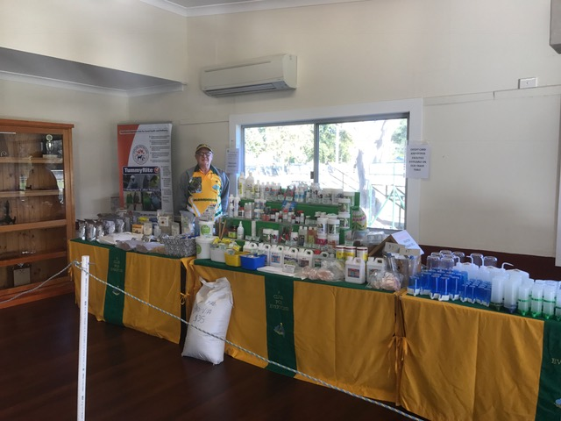

|  |  |  |  |  |  |  |  |  |  |
| --- | --- | --- | --- | --- | --- | --- | --- | --- | --- |
| **Lot #** | **Variety** | **Sex** | | **Ring #** | | **Breeding** | | **Comments** | **Vendor** |
| 1 | Opaline Grey Green | C | | COX 17 103 | | Alan Kent X  Henry George | | DOB 29/9/17  Not used (better siblings) | Peter & Katrina Cox |
| 2 | Full Circle Crest Light Green | C | | COX 18 143 | | Blair & Poole X Toombs | | DOB 21/4/18  Not used from Our Nationals Line | Peter & Katrina Cox |
| 3 | Dominant Pied Opaline | H | | SQ 18 13925 | | Gazzard/Stephan Bloodline | |  | Wayne Stephan |
| 4 | Yellow Face Grey | C | | SQ 18 13931 | | George/Stephan Bloodline. | |  | Wayne Stephan |
| 5 | Opaline Cinnamon Light Green | H | | SQ 17 12280 | | Grey Green X Opaline Cinnamon Grey Green | | Sister to Lot # 6 | Greg Horrobin |
| 6 | Grey | H | | SQ 17 12279 | | Grey Green X Opaline Cinnamon Grey Green | | Sister to Lot # 5 | Greg Horrobin |
| 7 | Opaline Cinn Light Green | H | | SWA 18 001 | | Walter/Altman | | 7 Months Old.  Clean Top End. | Wayne Altman |
| 8 | Normal Grey Green | C | | SWA 18 008 | | Seagrott/Altman | | Nice Clean Crest Bred. | Wayne Altman |
| 9 | Cinnamon Sky Blue | H | | SQ 17 14332 | | S: Cinn Grey Green  SQ 14 22587  Alan Kent Line  D: Opaline Cinn Sky Blue  SQ 14 13547  Alan Kent Line | | DOB 3/7/17  100% Alan Kent Breeding. | Garry Edwards |
| 10 | Spangle Grey Green | H | | SQ 17 14386 | | S: Spangle Opaline Light Green  SQ 15 21411  100% Bob Smith  D: Spangle Cinn Grey Green  SQ 16 12651  100% bob Smith | | DOB 9/10/17  100% Bob Smith Breeding. | Garry Edwards |
| 11 | Recessive Sky Blue | H | | KS 17 177 | |  | |  | Ken Seagrott |
| 12 | Sky Blue/  Recessive Pied | H | | KS 18 145 | |  | | Rung 14/4/18.  Split to Watson Bloodlines. | Ken Seagrott |
| 13 | Lutino | C | | 10G 16 482 | | S: Lutino  SQ 15 25363  D: Lutino  SQ 15 23816 | | Good Colour, Size and Style.  Dam one of my Best Lutino’s.  From my National Winning Line. | Henry George |
| 14 | Normal Grey | H | | SQ 15 23763 | | S: Normal Grey  10G 14 060  D: Opaline Cinn Grey  10G 12 394 | | Good Head, Balance and Deportment. Not Bred From in 2018. | Henry George |
| 15 | Spangle Cobalt | C | | BOS 18 051 | | Boss | |  | John Boss |
| 16 | Dilute Grey | H | | ANBC 17 12287 | | S: Greywing Grey Green  D: Dilute Grey | | Sire came 3rd at Interbranch  Dam is a Magnificent Dilute Grey | Terry Bevan |
| 17 | Spangle Opaline Green | C | | RCO 18 026 | | Gazzard X Ogden | | Hatched 18/4/18 | Russell & Cheryl Ogden |
| 18 | White Cap Spangle Sky Blue | C | | RCO 18 032 | | O’Callaghan X Bob Smith | | Hatched 19/4/18 | Russell & Cheryl Ogden |
| 19 | Sky Blue | C | | BH 16 118 | | George/Fellows/ Gazzard | | Has produced well for me, has the face and very nice overall bird. | Brian Harms |
| 20 | Recessive Pied Sky Blue | C | | BH 17 216 | | Kirstenfeldt/  Seagrott | | Has Produced Well, Large Bird and Good Markings. | Brian Harms |
| 21 | Fallow Opaline | H | MCH 17 117 | | S: Opaline Dilute/Fallow  BCV 15 12476  D: NSW 15 59818 | | 50% Peter Thurn | | Myles Henke |
| 22 | Texas Clearbody Grey green | C | MCH 18 035 | | S: Texas Clearbody Green AC 16 115  D: Albino  NSW 16 12032 | | 50% Clifton | | Myles Henke |
| 23 | Cinnamon Cobalt | H | GDW 17 150 | | S: Violet  SQ 14 18616  D: Cobalt  GDW 16 083 | | Stylish Hen, Good Family. | | G & D Winch |
| 24 | Violet | C | GDW 17 111 | | S: Cobalt  SQ 13 12043  D: Violet  SQ 14 7064 | | Deep Colour, Length and Spots. | | G & D Winch |
| 25 | Opaline Cinnamon Grey Green | H | KR1 17 067 | | Hollingsworth/  Horrobin | | Maiden Hen.  Sister to Lot #82. | | Kev Richards |
| 26 | Grey Green/ Cinnamon | C | R1 18 001 | |  | | Big Spot, Lovely Directional Feather. Slight Ticking. | | W & G Robinson |
| 27 | Dominant Pied Grey | C | R1 018 032 | |  | | Nice Blow and Brow. Big Spot. | | W & G Robinson |
| 28 | Cinnamon Light Green | C | BMW 17 125 | |  | |  | | Brian Walters |
| 29 | Yellow Face Cinnamon Sky | H | BMW 17 071 | |  | | Good Mother | | Brian Walters |
| 30 | Spangle Yellowface Grey | C | AAA 17 061 | | Stephan/George Line. | |  | | Adam Francis |
| 31 | Normal Green | H | SQ 17 13114 | | Henry George Line. | |  | | Adam Francis |
| 32 | Lutino | C | SQ 17 3202 | | S: Dark Green/Blue/  Opaline/Ino  Jim Parrish  D: Albino  Rod Waddington | | This Lutino won the Champion Ino at the 2018 Mt Gravatt Show | | Glen Kennedy |
| 33  PIC | Grey | C | 17 973 | |  | | Hatched June.  Good Feather. Half Brother of My Annual Show Winning Pieds. All Have produced Very Well This Year. | | O’Callaghan Family |
| 34 | Spangle Cinnamon Green | H | 17 1800 | |  | | Hatched End of 2017 and Not Used. | | O’Callaghan Family |
| 35 | Clearbody Grey Green | H | LH 16 243 | |  | | Good Length. | | Lucas Hendry |
| 36 | Spangle Double Factor | H | LH 17 037 | | Dunk/Hammond | | Good Length, Nice Feather. | | Lucas Hendry |
| 37 | Spangle Grey Green | C | ANBC 17 11875 | |  | |  | | Geoff Wood |
| 38 | Spangle Opaline Light Green | C | SKF 18 051 | | Bob Crawford  NSW. | | DOB 25/12/17 | | Steve Kilduff |
| 39 | Normal Sky Blue | C | SQ 17 1822 | | S: Opaline Cinnamon Sky Blue SQ 21443  D: Normal Sky Blue SQ 7041 | | DOB 6/11/17  Hen is Bob Smith Bred.  Brother to lot # 296. | | Barbara Kelly |
| 40 | Spangle Green | H | SQ 17 1740 | | S: Spangle Grey Green SQ 4524  D: Spangle Sky Blue SQ 4564 | | DOB 22/6/17.  Sister to lot # 236. | | Barbara Kelly. |
| 41 | Opaline Grey Green | H | 26H 18 002 | | S: Gazzard/Chidel  D: Bob Smith/ Chidel | | Width, Brow and Flecking. | | Don Harper |
| 42 | Opaline Grey Green | H | 26H 17 047 | | S: Gazzard/Chidel  D: Bob Smith/ Chidel | | Width, Brow and Flecking. | | Don Harper |
| 43 | Lutino | H | SQ 17 15030 | |  | | Good Colour, Wide Head. | | W & G Robinson |
| 44 | Spangle Double factor Yellow | H | SQ 16 18565 | | S: Spangle  2nd at Nationals  D: Spangle Double Factor Yellow  G & D Winch | | DOB 21/12/16  Sister to Lot # 105. | | Clarrie Johnston |
| 45 | Opaline Cinnamon Grey | C | CBS 17 2081 | |  | |  | | Ian Schneider |
| 46 | Grey Dominant Pied | C | CBS 17 2069 | |  | |  | | Ian Schneider |
| 47  PIC | Normal Grey Green | H | BAR 16 092 | | Barnett/Capper | | A Powerful Hen, That’s Got It All. Has Bred Well. | | Craig Barnett |
| 48  PIC | Spangle Grey Green | C | GG 18 060 | | Grandson to  15 080, The Best Grey Green I Have Ever Bred. | | DOB 2/5/18.  Cousin to Lot # 99  Nice Young Spangle Will Grow into a Nice Cock Bird.  Related to Lot #’s 165,100 and 99. | | Gary Gazzard |
| 49 | Dominant Pied Opaline Lt Green | C | SQ 17 6186 | | S: Dominant pied Sky Blue  D: Opaline Light Green | | From Top Pair.  50% Toombs.  50% Henry George.  Brother to Lot # 183. | | Peter Jeffrey |
| 50 | Yellow Face Cinnamon | H | SQ 16 1312 | | S: Cinnamon Grey  D: Yellow Face Sky | | 100% Henry George | | Peter Jeffrey |
| 51  PIC | Opaline Cinnamon Grey green | H | SQ 18 6021 | |  | | First Class Dunk Line.  Great Directional Feather. | | Hammond Family |
| 52 | Lacewing White | C | S&B 18 005 | | S: White Lacewing  G & D 16 147  D: White Lacewing  BSK 17 207 | | DOB 18/8/18.  Winch/ Kirstenfeldt.  Very Young. | | Shane & Barb Beer |
| 53 | Normal Sky Blue | H | OAS 18 229 | | 100% P Bayliss | | Only a Baby. | | Paul Bayliss |
| 53A  PIC | Dominant Pied Yellow Face | C | SE 17 014 | | Stephan Elliott | | Quality Long, Stylish Bird with Correct Markings. | | Anthony Lahood |
| 53B  PIC | Spangle Double Factor Yellow | C | SE 16 012 | | Stephan Elliott | | Nice Long Bird with Golf Ball Top End. | | Anthony Lahood |
| 54 | Clearbody | C | BGH 18 012 | | Darrell Smith Bloodline. | |  | | B and G Henderson |
| 55 | Yellow Face Sky Blue | C | B5 16 077 | | S: Spangle Sky Blue  D: Yellowface Violet - Bloodline Jamie Wright (Qld) & Charlesworth Family | | Big Bodied Cock, Good Length and Feather. | | Charlesworth Family |
| 56 | Spangle Double Factor | H | BCT 17 1327 | | Bloodlines from  K O’Callaghan  (QN&CZ) and  B Free (Tas) | | Nice Width and Good Colour. | | Charlesworth Family |
| 57 | Crest Spangle Grey Green | C | COX 17 079 | | Jansen/ Blair & Poole | | DOB 23/8/17  Not Used | | Peter & Katrina Cox |
| 58 | Opaline Grey Green | C | COX 17 022 | | Jamie Wright/ Toombs | | DOB 12/1/17 | | Peter & Katrina Cox |
| 59 | Cobalt | C | SQ 17 3082 | | George/Stephan | |  | | Wayne Stephan |
| 60 | Lacewing Yellow | C | SQ 17 3071 | | Adam Francis | |  | | Wayne Stephan |
| 61 | Grey Green | H | SQ 17 12265 | | S: Grey Green  D: Opaline | |  | | Greg Horrobin |
| 62 | Spangle Sky Blue | H | SQ 17 11615 | | S: Spangle Grey  D: Opaline Cinnamon Grey | |  | | Greg Horrobin |
| 63 | Opaline Light Green | H | SWA 17 127 | | Altman | | Never Used. | | Wayne Altman |
| 64 | Sky Blue Normal | C | SWA 17 182 | | Altman | | Big Bird Never Used. | | Wayne Altman |
| 65 | Cinnamon Grey Green | C | SQ 18 5976 | | S: Yellow Face Opaline Grey  SQ 16 12693  100% Bob Smith  D: Cinnamon Grey Green  SQ 16 12610  E & L Miller | | DOB 19/4/18 | | Garry Edwards |
| 66  PIC | Sky Blue | C | SQ 18 5927 | | S: Spangle Light Green  SQ 16 12627  Alan Kent  D: Opaline Cinnamon Sky Blue  SQ 15 21415  Alan Kent | | DOB 20/1/18  100% Alan Kent | | Garry Edwards |
| 67 | Lacewing Yellow | H | KS 16 414 | |  | |  | | Ken Seagrott |
| 68 | Lacewing Yellow | H | KS 17 329 | |  | |  | | Ken Seagrott |
| 69 | Lutino | H | KS 17 708 | |  | | Rung 1/12/17  Unused. | | Ken Seagrott |
| 70  PIC | Normal Grey Green | C | 10G 18 068 | | S: Normal Grey Green  SQ 15 25572  D: Normal Grey Green  10G 16 456 | | Stylish Bird with Blow and Good Mask and Spots. Has some Super Siblings Retained. | | Henry George |
| 71  PIC | Normal Grey | H | 10G 18 190 | | S: Yellow Face Grey  SQ 15 25641  My Best Yellow Face.  D: Normal Grey  SQ 15 23723 | | Powerful Young Hen with Good Mask and Spots.  Sister to Lot # 267 | | Henry George |
| 72 | Spangle Cinnamon Grey | C | 10G 16 485 | | S: Normal Grey Green  NSW 23W 13 047  D: Spangle Cinnamon Grey  10G 14 309 | | Quality Cock from the Famous Welshman Line Half Brother to Lot 200. | | Henry George |
| 73 | Opaline Grey | C | TB 18 022 | | S: Violet Normal  D: Opaline Grey | | Young.  Showing Direction. | | Terry Bevan |
| 74 | Normal Green | C | RCO 17 062 | | Fellows X Gazzard | | Hatched 3/10/17.  Top Bloodlines. | | Russell & Cheryl Ogden |
| 75 | Albino | H | RCO 18 044 | | Ogden X D’Costa | | Hatched 12/6/18  Very Young. | | Russell & Cheryl Ogden |
| 76  PIC | Opaline Grey | C | BH 17 222 | | George/Fellows/  Gazzard | | Has Good Depth of Mask and Spots, Directional Feather and Fertile. | | Brian Harms |
| 77 | Opaline Violet | H | BH 16 121 | | George/Winch | | Good Mother, Nice Colour. | | Brian Harms |
| 78 | Normal Grey Green | H | MCH 17 153 | | S: Sky  NSW 16 11961  D: Spangle Grey Green  SQ 15 2185 | | 50% Alan Kent | | Myles Henke |
| 79 | Dominant Pied Grey Green | C | NSW 17 7718 | | S: Dominant pied Green  DP1 16 111  D: Grey Green  WA 15 3390 | | Pymont X C & B Gearing | | Myles Henke |
| 80 | Dominant Pied Grey Green | C | BOS 18 031 | | Boss | |  | | John Boss |
| 81 | Grey Green | H | BOS 16 192 | | Boss | |  | | John Boss |
| 82 | Cinnamon Grey Green | C | KR1 17 068 | | Hollingsworth/  Horrobin | | Brother to Lot #25. | | Kev Richards |
| 83 | Yellow Face Cinnamon Sky Blue | H | GDW 17 067 | | S: Sky Blue  SQ 15 25248  D: Yellow Face Sky Blue  GDW 14 18672 | | Good Type. Great Family. Very Good Depth of Mask and Spots. | | G & D Winch |
| 84 | Cobalt | C | GDW 17 032 | | S: Yellow Face Violet  SQ 15 25143  D: Sky Blue  SQ 14 7090 | | Blow, Mask and Spots.  Brother to Lot #150. | | G & D Winch |
| 85 | Cinnamon Light Green | H | GDW 17 098 | | S: Cinnamon Grey  SQ 15 25119  D: Cinnamon Light Green  SQ 15 25201 | | Average but Sire Won 3 Champions of Show. | | G & D Winch |
| 86 | Cinnamon Sky Blue | H | R1 018 035 | |  | | Good Conformation, Deep Mask, Nice face. | | W & G Robinson |
| 87 | Grey | C | R1 018 071 | |  | | Good Spot and Blow. | | W & G Robinson |
| 88 | Opaline Cinnamon Light Green | H | BMW 17 102 | |  | | Long Bird. | | Brian Walters |
| 89 | Opaline Cinnamon Light Green | H | BMW 17 133 | |  | | Not a Good Flyer. | | Brian Walters |
| 90 | Spangle Grey | C | AAA 17 088 | | Henry George Line. | |  | | Adam Francis |
| 91 | Normal Sky Blue | H | AAA 17 083 | | Henry George Line. | |  | | Adam Francis |
| 92 | Cinnamon Grey Green | H | SQ 17 13318 | | S: Light Green/Blue/  Cinnamon  B Hollingsworth  D: Spangle Opaline Grey Green/Blue  Hammond Family | |  | | Glen Kennedy |
| 93  PIC | Grey Green | C | 17 1881 | | S: Grey Green  Ian Schneider  D: Cinnamon Grey Green  With Excellent Brow. | | Hatched September.  Excellent Style and Release of Cap Feather with Nice Brow. | | O’Callaghan Family |
| 94 | Dominant Pied Grey Green | H | OC 18 114 | | Bred From Top Grey Green Sire to Dominant Pied Cinnamon Sky. | | Hatched August, so just over 4 Months Old at Auction. Nice Brow starting to Develop. | | O’Callaghan Family |
| 95 | Cinnamon Light Green | C | LH 18 020 | | Walters/Seagrott | | Young Bird still to Grow. Brother to Lot # 96. | | Lucas Hendry |
| 96 | Cinnamon Violet Sky | C | LH 18 007 | | Walters/Seagrott | | Young Bird still to Grow. Brother to Lot # 95. | | Lucas Hendry |
| 97 | Grey | H | ANBC 17 11868 | |  | |  | | Geoff Wood |
| 98 | Spangle Opaline Green | H | ANBC 17 11871 | |  | |  | | Geoff Wood |
| 99 | Cinnamon Grey Green | C | GG 18 117 | | Cousin to Lot #48, Grandson to 15 080 The Best Grey Green I have Ever Bred. | | DOB 8/6/18.  Cousin to Lot # 48.  Still Plenty of Improvement in Him.  Related to Lot #’s 165,100 and 48. | | Gary Gazzard |
| 100  PIC | Cinnamon Grey Green | C | GG 18 179 | | Grandson of 14 026 sire of 15 080  The Best Grey Green I have Ever Bred. | | DOB 6/7/18.  Very Young Still.  Related to Lot #’s 165,99 and 48. | | Garry Gazzard |
| 101 | Greywing Grey Green | H | SKF 18 094 | | Seagrott- Greber | | DOB 30/3/18.  Don’t Breed for Greywing. | | Steve Kilduff |
| 102 | Albino | C | 26H 17 016 | | S: Albino With length  D: Lutino  Solid Hen Tight Wings. | | Neil Fraser Stock way Back. | | Don Harper |
| 103 | Albino | C | 26H 17 025 | | S: Albino 10th NSW  D: Albino Sister of Hen 4th NSW. | | Neil Fraser Stock way Back. | | Don Harper |
| 104 | Recessive Pied | C | MC1 17 013 | | Nephew to Allister Holmes Recessive Pied Cock that won at the WA ANBC Nationals in 2015. | | A Lovely Long Bird, Great Feather, Spots, Well Marked in the Body, carrying Violet Modifier. | | Charlesworth Family |
| 105 | Spangle Cinnamon Light Green | C | SQ 16 18541 | | S: Spangle  2nd at Nationals  D: Spangle Double Factor Yellow  G & D Winch | | DOB 11/12/16.  Brother to Lot # 44. | | Clarrie Johnston |
| 106 | Spangle Cobalt | C | CC 17 272 | | S: Violet  D: Whit Cap Spangle Cobalt. | | DOB 13/1/17. | | Clarrie Johnston |
| 107 | Spangle Cinnamon Green | C | SQ 17 1797 | | S: Normal Grey Green SQ 6926  D: Spangle Cinnamon Green  SQ 6944 | | DOB 25/9/17.  Cock Represented at Mackay Nationals. | | Barbara Kelly |
| 108 | Normal Grey Green | H | SQ 17 1742 | | S: White Cap Grey QNC 1620  D: Normal Green  SQ 6995 | | DOB 30/6/17  Hen by Alan Kent Cock Bird. | | Barbara Kelly. |
| 109 | Yellow Face Grey | C | CBS JS 17 7044 | |  | |  | | Ian Schneider |
| 110 | White Cap Blue | C | CBS JS 17 7075 | |  | |  | | Ian Schneider |
| 111  PIC | Spangle Grey Green | C | BAR 17 142 | | Barnett/Capper | | A lovely Young Cock with Superb Facial. | | Craig Barnett |
| 112 | Opaline Cinnamon Grey | H | SQ 18 6052 | |  | | Well Bred Bloodlines Dunk. | | Hammond Family |
| 113 | Lacewing  Yellow | C | SQ 16 19704 | | Horrobin Blood Line  Len Bartz Bred | | December Bred. | | Shane & Barb Beer |
| 114 | Normal Sky Blue | C | PBS 17 100 | | 100% P Bayliss. | | Unused. | | Paul Bayliss |
| 114A  PIC | Grey Green | H | SE 17 045 | | Stephan Elliott | | Solid Bird, Long Mask, Nice Shoulder and Blow. | | Anthony Lahood |
| 114B  PIC | Dominant Pied Grey | C | SE 17 003 | | Stephan Elliott | | Very Clean, Long Bird, Nice Wide Face. | | Anthony Lahood. |
| 115 | Clearbody | C | BGH 18 037 | | Darrell Smith Bloodline. | |  | | B and G Henderson |
| 116 | Australian Golden Face | C | BCT 17 1554 | | Charlesworth Bloodline from Successful GF Class at Nationals. | | Nice Stylist Cock Carrying Violet Modifier, Lovely Feather. | | Charlesworth Family |
| 117 | Recessive Pied | H | MC1 18 057 | | Bloodlines:  S & T Grech &  Charlesworth Family | | Very Young Hen, Plenty of Length, Well marked carrying Lovely Feather. | | Charlesworth Family |
| 118 | Grey | C | SQ 17 6183 | | S: Grey  D: Grey Green | | 100% Henry George  Bred some Very Nice Chicks. | | Peter Jeffrey |
| 119 | Clearbody Opaline Grey Green | H | SQ 16 11814 | | S: Clearbody Opaline Grey Green  D: Clearbody Grey | | 100% Mal Reid. | | Peter Jeffrey |
| 120 | Fallow Sky | C | SQ 17 11679 | | S: Fallow Sky  D: Fallow Green | |  | | Greg Horrobin |
| 121 | Light Green/Fallow | H | SQ 17 11648 | | S: Green/Fallow  D: Fallow Sky | |  | | Greg Horrobin |
| 122 | Normal Grey | C | COX 18 060 | | Toombs Line on Both Sides. | | DOB 20/1/18.  Not Used. | | Peter & Katrina Cox |
| 123 | Normal Dark Green | C | COX 18 119 | | 100% R & C Ogden  Parents bought at 2017 ABS Auction. | | DOB 28/3/18.  Not Used. | | Peter & Katrina Cox |
| 124 | Normal Dark Green | C | COX 18 127 | | Henry George Lines on Both Sides. | | DOB 22/3/18.  Not Used. | | Peter & Katrina Cox |
| 125 | Grey | H | SQ 17 2517 | | George/Stephan | | Good Breeder | | Wayne Stephan |
| 126 | Opaline Green | C | SQ 17 2564 | | Gazzard/Stephan | | Half Brother to 3 Time Champion of Show. | | Wayne Stephan |
| 127 | Violet | C | SQ 17 2571 | | George Stephan | | 12th at 2018 ANBC National Show. | | Wayne Stephan |
| 128 | Yellow Face Albino | H | SWA 17 680 | | Grandmother Yellow Face Albino  J Leong.  Father Altman Albino. | | Never Used. | | Wayne Altman |
| 129 | Albino | C | SWA 17 138 | |  | | Good Top End.  Never Used. | | Wayne Altman |
| 130 | Dominant Pied Cinnamon | H | SWA 17 031 | | Walter/Altman | | Kept as Spare. | | Wayne Altman |
| 131 | Grey | C | SQ 18 5949 | | S: Yellow Face Opaline Grey  SQ 16 12693  Bob Smith  D: Cinnamon Grey Green  SQ 16 12610  E & L Miller | | DOB 24/2/18 | | Garry Edwards |
| 132 | Spangle Light Green | C | SQ 18 5922 | | S: Cinnamon Light Green  SQ 16 12631  Alan Kent Line  D: Spangle Light Green  SQ 16 12657  Alan Kent Line | | 100% Alan Kent Bloodline. | | Garry Edwards |
| 133 | Spangle Grey Green | H | KS 16 003 | | Carro Bloodlines | |  | | Ken Seagrott |
| 134 | Cobalt | H | KS 16 570 | |  | |  | | Ken Seagrott |
| 135 | Lacewing Yellow | C | KS 16 441 | |  | | Nice Top End. | | Ken Seagrott |
| 136 | Dominant Pied Light Green | H | 10G 17 020 | | S: Normal Grey Green  10G 14 596  D: Dominant Pied Grey  SQ 15 23776 | | Solid Hen with some Directional Feather.  Good Mask and Spots. | | Henry George |
| 137 | Normal Grey/Opaline /Blue | C | 10 18 104 | | S: Normal Sky Blue  10G 16 428  D: Opaline Grey  SQ 15 23722 | | Some Directional Feather and Good Spots. | | Henry George |
| 138 | Greywing Grey Green | C | ANBC 17 12285 | | S: Greywing Grey  D: Greywing Grey Green | |  | | Terry Bevan |
| 139 | Normal Grey Green | C | RCO 18 003 | | Ogden X Fellows | | Hatched 28/2/18.  Sire is Brother to our ANBC National Winning Grey. | | Russell & Cheryl Ogden |
| 140 | Normal Green | H | RCO 17 001 | | Ogden | | Hatched 11/4/17.  From Same Family as our ANBC National 2nd Placed Green. | | Russell & Cheryl Ogden |
| 141 | Spangle Opaline Light Green | C | BH 17 164 | | Part Smith | | Unused.  Siblings have Exceptional Blow. | | Brian Harms |
| 142  PIC | Grey Green | C | BH 16 130 | |  | | Exceptional Overall Bird and Fertile. | | Brian Harms |
| 143 | Spangle Grey Green | H | NSW 17 7722 | | S: Normal Green  SQ 15 4431  D: Spangle Grey Green  NSW 15 20141 | | Bob Smith X Gary Gazzard Breeding. | | Myles Henke |
| 144 | Lutino | C | NSW 16 11931 | | S: Lutino  C & B Gearing  D: Albino  C & B Gearing | | Best of Variety Newcastle 2017. | | Myles Henke |
| 145 | Spangle Double Factor | H | BOS 16 066 | | Boss | |  | | John Boss |
| 146 | Cinnamon Sky | C | BOS 17 103 | | Boss | |  | | John Boss |
| 147 | Spangle Green | C | SQ 17 12223 | | Weidenhofer/  O’Callaghan | |  | | Kev Richards |
| 148 | Light Green | C | GDW 17 180 | | S: Opaline Light Green  SQ 15 15102  D: Sky Blue  GDW 16 121 | | Good Mask and Spots. | | G & D Winch |
| 149 | Yellowface Violet | H | GDW 17 029 | | S: Cobalt  SQ 15 25253  D: Yellowface Violet  SQ 15 25148 | | Attractive Bird.  Depth of Mask and Spots. | | G & D Winch |
| 150 | Cobalt | C | GDW 17 041 | | S: Yellowface Violet  SQ 15 25143  D: Sky Blue  SQ 14 7090 | | Length, Mask.  Brother to lot # 84 | | G & D Winch |
| 151 | Spangle Grey Green | C | R1 018 087 | |  | | Nice Blow and Brow. | | W & G Robinson |
| 152 | Sky Blue | C | R1 018 004 | |  | | Good Top End. | | W & G Robinson |
| 153 | Spangle Double Factor Yellow | C | BMW 17 001 | |  | | Directional Feather. | | Brian Walters |
| 154 | Spangle Double Factor Yellow | H | BMW 17 092 | |  | | Good Colour. | | Brian Walters |
| 155 | **PAIR**  Full Circle Crest  Crest Bred | C  H | TBA  TBA | | Francis Family Line. | |  | | Adam Francis |
| 156 | Normal Grey | H | SQ 17 15448 | | Henry George Line. | |  | | Adam Francis |
| 157 | Spangle Light Green/ Blue/Opaline | C | SQ 17 3211 | | S: Spangle Opaline Grey Campbell  D: Light Green/Blue  Lucas Hendry | | Two Uncles of the Sire have represented SQ at the ANBC Nationals. | | Glen Kennedy |
| 158  PIC | Sky Blue | C | 16 2277 | |  | | Lovely Feather. Good Skull and Structure. Has Produces Excellent Chicks. Letting Go Before Too Old. | | O’Callaghan Family |
| 159 | AWC Double Factor Sky | H | 17 1771 | |  | | Nice Bird from Top Pair, all Siblings of Even Quality. Tried once last year without success. | | O’Callaghan Family |
| 160 | Normal Light Green | C | LH 18 072 | | Miller/Burke/  O’Reilly | | Young Bird Still Developing. | | Lucas Hendry |
| 161  PIC | Albino | C | LH 17 080 | | Webber/Wise | | Nice Clean Albino.  Brother to Lot # 224 | | Lucas Hendry |
| 162  PIC | Spangle Cinnamon Violet Sky | H | LH 18 008 | | Walters/Seagrott | | Nice Young Hen. | | Lucas Hendry |
| 163 | Dilute Grey | H | ANBC 17 11894 | |  | |  | | Geoff Wood |
| 164 | Opaline Grey Green | C | GG 18 172 | | Sire was a Good Pied that went for Top Price at NBC Auction 2018 | | DOB 7/7/18.  Very Young, Still Needs to Fill Out. | | Gary Gazzard |
| 165 | Opaline Cinnamon Light Green | H | GG 18 132 | | Grand Daughter to 15 080 and 14 026.  Grandmother is Grandmother to this year’s National Winning Grey Cock. | | DOB 14/6/18.  Good Solid Hen for Age.  Related to lot #’s 100,99 and 48.  Cousin to lot # 228. | | Garry Gazzard |
| 166 | Dilute Grey Green | H | SKF 17 091 | | Own Line | | DOB 31/5/17.  Not Used. | | Steve Kilduff |
| 167 | Albino | H | 26H 17 027 | | S: Albino 10” Long  D: Albino  4th in NSW at Interbranch 2016. | | Small with Brow. | | Don Harper |
| 168 | Dilute Opaline Grey | H | 26H 17 067 | | Bobby Smith and Don Harper Blood Lines. | | Nice Outline and Brow.  Niece of Lot # 231. | | Don Harper |
| 169 | Dominant Pied Dark Green | C | KS 18 161 | |  | |  | | Ken Seagrott |
| 170 | Cinnamon Light Green | C | CC 16 038 | | S: Cinnamon Light Green  D: Cinnamon Grey | | DOB 12/12/16. | | Clarrie Johnston |
| 171 | **PAIR**  Single Factor Goldenface  Single Factor Opaline Goldenface  **Brother and Sister** | C  H | CC 18 358  CC 17 227 | | S: Goldenface  Bill Kirstenfeldt  D: Cobalt  G & D Winch | | This Pair are Brother and Sister.  Good Start to Create a Family. | | Clarrie Johnston |
| 172 | Opaline Sky Blue | H | SQ 17 1748 | | S: Normal Sky Blue  SQ 04532  D: Spangle Opaline Grey  AK 2128 | | DOB 9/7/17.  Hen is an Alan Kent Bird. | | Barbara Kelly |
| 173 | White Cap Spangle Blue | C | SQ 17 1810 | | S: White Cap Violet Sky  CBS 2315  D: Spangle Sky Blue SQ 6985 | | DOB 28/10/17.  Hen by Ken Dunk. | | Barbara Kelly. |
| 174 | Normal Grey Green | C | JS 17 2083 | |  | |  | | Ian Schneider |
| 175 | Opaline Cinnamon Green | H | JS 16 059 | |  | |  | | Ian Schneider |
| 176  PIC | Opaline Grey Green | C | BAR 17 113 | | Schiller/Barnett | | Nice Face and Blow. | | Craig Barnett |
| 177 | Opaline Cinnamon Sky Blue | H | SQ 17 14767 | |  | | Dunk, Smith, Chidel Bloodlines. | | Hammond Family |
| 178 | Lacewing Yellow | H | GDW 16 207 | | Winch Bred | | Good Colour. | | Shane & Barb Beer |
| 179 | Normal Cobalt | C | OAS 18 235 | | 100% Paul Bayliss | | Only a Baby. | | Paul Bayliss |
| 180 | Clearbody | H | BGH 18 016 | | From Darrel Smith Line. | |  | | B and G Henderson |
| 180A  PIC | Spangle Opaline Grey Green | C | SE 17 005 | | Stephan Elliott | | Excellent Deportment, Bulls Eye Spots, and Golf Ball Top End. | | Anthony Lahood |
| 180B | Spangle Double Factor White | H | BSSA 16 677 | | Stephan Elliott | | Strong Shouldered, Solid Bird, Nice Brow. | | Anthony Lahood |
| 181 | Spangle Double Factor | C | MC1 17 054 | | Bloodline of Charlesworth Family | | Good Colour, Nice Face, Bloodlines Kept close to Harris Line. | | Charlesworth Family |
| 182 | Sky Blue | C | BCT 17 2020 | | Bloodline of Charlesworth Family | | Nice Spot and Feather, Good Width, Nice Bird All Round. | | Charlesworth Family |
| 183 | Opaline Light Green | C | SQ 17 6195 | | S: Dominant pied Sky Blue  D: Opaline Light Green | | Not Used.  Kept 4 Brothers.  Brother to Lot # 49. | | Peter Jeffrey |
| 184 | Dark Green/  Clearbody | C | SQ 17 6196 | | S: Light Green  D: Clearbody Opaline Grey Green | | Has Bred Some Very Nice Birds. | | Peter Jeffrey |
| 185 | Opaline Cinn Grey Green | H | SQ 17 12278 | | S: Grey Green  D: Opaline Cinn Grey Green | |  | | Greg Horrobin |
| 186 | Opaline Grey | C | SQ 17 11665 | | S: Spangle Grey  D: Spangle Opaline Grey Mauve | |  | | Greg Horrobin |
| 187 | Crest Spangle Cinn Light Green | H | COX 17 051 | | 100% Blair and Poole Line. | | DOB 14/2/17.  Kept as a Back Up But Not Used. | | Peter & Katrina Cox |
| 188 | Full Circle  Sky Blue | H | COX 18 053 | | Blair and Poole/  Toombs | | DOB 14/1/18.  Not Used.  From Our Nationals Line. | | Peter & Katrina Cox |
| 189 | Normal Grey Green | H | COX 18 091 | | Henry George Lines on Both Sides. | | DOB 24/2/18.  Not Used. | | Peter & Katrina Cox |
| 190 | Sky Blue | C | SQ 17 3092 | | Both Parents George Blood Line. | |  | | Wayne Stephan |
| 191 | Dominant Pied Cobalt | H | SQ 17 3086 | | Both Parents George Blood Line. | |  | | Wayne Stephan |
| 192 | Normal Light Green | C | SWA 17 111 | | Altman | | Clean Bird, Good Mask. | | Wayne Altman |
| 193 | Spangle Double Factor Yellow | H | SWA 17 144 | | Bred from Two Scoble Birds. | |  | | Wayne Altman |
| 194 | Dominant Pied Sky | C | SWA 17 145 | | Altman/Seagrott | | Carrying Dark Factor Violet. | | Wayne Altman |
| 195 | Cinnamon Sky Blue | C | SQ 18 5989 | | S: Grey  SQ 16 12619  Alan Kent Line.  D: Opaline Cinn Sky Blue  SQ 16 12977  Alan Kent Line. | | DOB 22/5/18.  100% Alan Kent Bloodline.  Brother to lot # 196. | | Garry Edwards |
| 196 | Sky Blue | C | SQ 18 5963 | | S: Grey  SQ 16 12619  Alan Kent Line.  D: Opaline Cinn Sky Blue  SQ 16 12977  Alan Kent Line. | | DOB 23/3/18.  100% Alan Kent Bloodline.  Brother to Lot # 195. | | Garry Edwards |
| 197 | Violet | C | KS 17 128 | |  | | Nice Colour | | Ken Seagrott |
| 198 | Sky Blue/ Recessive Pied | C | KS 17 420 | |  | | Rung 4/12/17.  Long Bird Unused. | | Ken Seagrott |
| 199 | Tufted Spangle Yelllowface Sky | C | DPI 16 168 | | Outcross has Bred. | |  | | Ken Seagrott |
| 200  PIC | Spangle Cinnamon Grey Green | H | SQ 15 23703 | | S: Normal Grey Green  NSW 23W 13 047  A Welshman Bird.  D: Spangle Grey Green  10G 14 049 | | A Large powerful Hen with Great Head Qualities and Spangle Spots. Has Bred Very Good Quality. Young Out So Good.  Does Not Have a Tail.  Half-sister to Lot # 72. | | Henry George |
| 201 | Normal Grey Green | C | 10G 18 094 | | S: Normal Grey Green  SQ 15 23790  D: Normal grey Green  10G 14 581 | | Nice Style of Bird with Good Length above the Perch. | | Henry George |
| 202 | Cinnamon Grey | C | TB 18 001 | | S: Norma Grey.  D: Dominant Pied Violet. | | A Baby Showing Feather Direction. | | Terry Bevan |
| 203 | Normal Grey Green | H | RCO 17 061 | | Fellows X Gazzard | | Hatched 1/10/17.  Top Bloodlines. | | Russell & Cheryl Ogden |
| 204 | Albino | C | RCO 18 014 | | D’Costa X Ogden | | Hatched 16/3/18. | | Russell & Cheryl Ogden |
| 205  PIC | Cinnamon Grey Green | C | BH 17 217 | |  | | Quality Bird with Face and Feather. | | Brian Harms |
| 206 | Light Green | H | NSW SW 17 052 | |  | | Long Bird, Deep Mask Fertile. | | Brian Harms |
| 207 | Fallow Blue | C | MCH 17 030 | | S: Cobalt  OAS 14 165  D: Fallow Blue  NSW 15 59818 | | 50% Hawke | | Myles Henke |
| 208 | Normal Grey Green | C | MCH 17 098 | | S: Grey  WA C&B 14 292  D: Green  NSW 15 20219 | | C & B Gearing to Gazzard. | | Myles Henke |
| 209 | Double Factor Spangle Yellow Face | H | SVP 16 105 | | From Shane Von Pein Stud | | Has Bred Some Nice Chicks as an Outcross. | | Peter Jeffrey |
| 210 | Cinnamon Grey/  Lacewing | C | SQ 18 1434 | | S: Lacewing White  D: Cinnamon Grey | | Very Young have Kept Two Brothers. | | Peter Jeffrey |
| 211 | Lutino | H | MC1 16 121 | | Bloodline of Charlesworth Family | | Nice Long Bird, Excellent Colour. | | Charlesworth Family |
| 212 | Grey | C | KR 17 012 | | Hollingsworth/  Richards  Bloodline. | |  | | Kev Richards |
| 213 | Lacewing Yellow | H | GDW 17 092 | | S: Lacewing Yellow  SQ 15 25105  D: Lacewing Opaline Yellow  SQ 14 18637 | | Good Colour and Markings. | | G & D Winch |
| 214 | Grey | C | GDW 17 179 | | S: Cinnamon Grey  SQ 15 25259  D: Grey  SQ 15 25079 | | Blow. | | G & D Winch |
| 215 | Recessive Pied Sky Blue | H | R1 018 068 | |  | | Very Young, Powerful Recessive. | | W & G Robinson |
| 216 | Recessive Pied Dark Green | C | R1 017 068 | |  | | Good Spot, Heavy Markings. | | W & G Robinson |
| 217 | Spangle Sky | C | BMW 17 142 | |  | | Late Bred. | | Brian Walters |
| 218 | Spangle Grey Green | H | BMW 17 039 | |  | | Good Spangle Markings. | | Brian Walters |
| 219 | Spangle Double Factor | C | AAA 17 093 | | Henry George Line. | |  | | Adam Francis |
| 220 | **PAIR**  Full Circle Crest  Crest Bred | C  H | TBA  TBA | | Francis Family Line. | |  | | Adam Francis |
| 221 | Light Green/  Opaline | C | SQ 17 13321 | | S: Light Green/Blue/  Cinnamon  Hollingsworth  D: Spangle Opaline Grey Green/Blue  Les Hammond. | |  | | Glen Kennedy |
| 222  PIC | Dominant Pied Violet Sky | C | 17 1799 | | S: Grey  BS2 12 091  Bob Smith  D: Dominant Pied Opaline Sky | | Hatched November 2017.  Have Used Siblings Successfully so He can Go. Good Variety Bird Which Should Breed Well. | | O’Callaghan Family |
| 223 | Opaline Cinnamon Grey | H | OC 18 011 | | S: Cinnamon Grey Green Fellows Line  D: Opaline Cinnamon Grey Green Buffy | | Hatched May 18.  Half Sister To lot # 286 | | O’Callaghan Family |
| 224 | Albino | H | LH 17 104 | | Webber/Wise | | Nice Hen with Good Feather.  Sister to Lot # 161. | | Lucas Hendry |
| 225 | Recessive Pied Dark Green | H | LH 18 048 | | George/Huth | | Very Young Will Develop. | | Lucas Hendry |
| 226 | Sky Blue/  Cinnamon | C | LH 18 094 | | Watson Lines. | | Very Young will Develop. | | Lucas Hendry |
| 227 | Spangle Cinnamon Grey | H | ANBC 17 11904 | |  | |  | | Geoff Wood |
| 228  PIC | Opaline Grey | H | GG 18 079 | | Cousin to  GG 18 132  Lot # 165. | | DOB 15/5/18.  Good Solid Hen, My Pick of the Birds in the Auction.  Cousin to Lot # 165. | | Gary Gazzard |
| 229  PIC | Opaline Cinnamon Grey Green | H | GG 18 149 | | From My Good Opaline Cinnamon Line. | | DOB 20/6/18.  Solid Hen. Half Brother Won Grand Champion NBC Annual Show 2018.  Really Good Family. | | Garry Gazzard |
| 230 | Opaline Cobalt | H | SKF 17 237 | | Walters/Horrobin | | DOB 14/10/17.  Not Used. | | Steve Kilduff |
| 231 | Dilute Normal Grey | C | 26H 17 021 | | Bobby Smith and Don Harper Bloodlines. | | Uncle of Lot # 168. | | Don Harper |
| 232 | Normal Dark Green/  Recessive Pied | C | 26H 17 056 | | Henry George and Don Harper Bloodlines. | |  | | Don Harper |
| 233 | Lutino | C | SQ 17 15014 | |  | | Good Colour. Nice Lutino. | | W & G Robinson |
| 234 | **Pair**  Clearwing Dark Green  Clearwing Dark Green  This pair are Cousins | C  H | CC 17 300  CC 17 277 | |  | | This Pair are Cousins. | | Clarrie Johnston |
| 235 | **Pair**  Full Circle Crest Grey  Spangle Opaline Light Green Crest Bred | C  H | SQ 17 13158  CC 17 247 | | Hen Bird is Daughter of Sire that Bred Crest that Ran 2nd at ANBC Nationals. | | Hen is a Half Sister to Crest that Ran 2nd at the ANBC National Show. | | Clarrie Johnston |
| 236 | Cinnamon Green | H | SQ 17 1736 | | S: Spangle Grey Green  SQ 04524  D: Spangle Sky Blue  SQ 04564 | | DOB 18/6/17.  Sister to Lot # 40. | | Barbara Kelly |
| 237 | Spangle Green | H | SQ 17 1765 | | S: Spangle Green  SQ 5127  D: Cinnamon Sky Blue  SQ 21865 | | DOB 7/8/17.  Both Parents by Ken Dunk Birds. | | Barbara Kelly. |
| 238 | Spangle Opaline Green | H | JS 17 7074 | |  | |  | | Ian Schneider |
| 239 | Spangle Double Factor Yellow | H | JS 17 7108 | |  | |  | | Ian Schneider |
| 240  PIC | Opaline Cinnamon Grey Green | H | BAR 16 112 | | Barnett/Capper | | Nice Blow and Shoulder on This Lady. | | Craig Barnett |
| 241  PIC | Spangle Double Factor White | C | SQ 18 6008 | | 2015 Dunk Line. | | Bred Late, Directional Feather and Nice Blow. | | Hammond Family |
| 241A | Opaline Grey Green | H | SE 17 018 | | Stephan Elliott | | Solid Bird with Good Shoulder and Nice Top End. | | Anthony Lahood |
| 241B  PIC | Opaline Grey | H | SE 17 018 | | Stephan Elliott | | Very Strong, Wide Faced, Long Mask, Solid Hen. | | Anthony Lahood |
| 242 | Crest Bred Light Green | H | COX 16 167 | | Cox Bred | | Not Used. | | Shane & Barb Beer |
| 243 | Australian Goldenface  Violet | C | BGH 18 033 | |  | | From Bob and Glennis Henderson Line.  Brother to Lot # 244 | | B and G Henderson |
| 244 | Australian Goldenface  Violet | C | BGH 18 022 | |  | | From Bob and Glennis Henderson Line.  Brother to Lot # 243 | | B and G Henderson |
| 245 | White Cap | C | MC1 18 114 | | Bloodline of Charlesworth Family and  K O’Callaghan (QN&CZ) | | Very Young Bird, Lovely Feather and Spots. | | Charlesworth Family |
| 246 | Spangle Cinnamon Grey | C | BCT 17 1542 | | 50% Bob Smith  50% Kevin O’Callaghan | | Lovely Face and Clean Good Mask. | | Charlesworth Family |
| 247 | Spangle Opaline Cinnamon Yellowface Grey | H | SQ 18 1489 | | S: Spangle Cinnamon Grey  D: Yellowface Cinnamon Grey | | Not Used.  Lovely Young Hen. | | Peter Jeffrey |
| 248 | Spangle Cobalt | C | SQ 17 6133 | | S: Cobalt  D: Spangle Sky | | 50% Henry George  50% Ken Dunk  Very Nice Face. | | Peter Jeffrey |
| 249 | Fallow Green | C | SQ 17 11651 | | S: Fallow Green  D: Fallow Sky | |  | | Greg Horrobin |
| 250 | Sky | C | SQ 17 12288 | | S: Opaline Sky  D: Sky | |  | | Greg Horrobin |
| 251 | Opaline Cinnamon Sky Blue | H | COX 18 106 | | Blair and Poole/  Henry George | | DOB 9/3/18 | | Peter & Katrina Cox |
| 252 | Opaline Grey Green | H | COX 16 087 | | Alan Kent/  Henry George | | DOB 17/9/16 | | Peter & Katrina Cox |
| 253 | Grey Green | C | SQ 17 2585 | | Gazzard/Stephan | | Bred Good Birds | | Wayne Stephan |
| 254 | Yellowface Grey | H | SQ 17 2567 | | George/Stephan | | Half Sister to ANBC Nationals 2nd Yellowface. | | Wayne Stephan |
| 255 | Grey Green | H | SQ 17 2545 | | Gazzard/Stephan | |  | | Wayne Stephan |
| 256 | Albino | H | SWA 17 066 | | Altman | |  | | Wayne Altman |
| 257 | Spangle Double Factor Yellow | C | SWA 17 086 | | 100% Scoble | |  | | Wayne Altman |
| 258 | Cinnamon Light Green | C | OAS 18 204 | | 100% Paul Bayliss | | Only a Baby. | | Paul Bayliss |
| 259 | Light Green | C | SQ 17 14397 | | S: Spangle Light Green  SQ 15 21366  100% Gary Gazzard  D: Opaline Cinnamon Light Green  SQ 16 12665  100% Gary Gazzard | | DOB 21/11/17.  100% Gary Gazzard Both Sides. | | Garry Edwards |
| 260  PIC | Yellowface Grey | C | SQ 17 14376 | | S: Grey Green  SQ 15 21381  Bob Smith/Chidel  D: Opaline Yellowface Sky Blue  SQ 15 21402  Bob Smith | | DOB 6/10/17. | | Garry Edwards |
| 261 | Spangle Grey Green | C | KS 18 086 | | Watson Carro Bloodlines. | | Long Bird. | | Ken Seagrott |
| 262 | Recessive Sky Blue | H | KS 18 050 | |  | |  | | Ken Seagrott |
| 263 | Dilute Grey Green | C | KS 16 391 | |  | | Big Buffy Bird. | | Ken Seagrott |
| 264  PIC | Cinnamon Light Green | H | 10G 16 007 | | S: Cinnamon Grey Green  10G 12 104  50% Scoble  D: Cinnamon Sky Blue  10G 13 242 | | Excellent Quality with Size, Good Head, Mask and Spots.  Bred from in 2018. | | Henry George |
| 265 | Normal Grey Green/Lutino | C | 10G 18 052 | | S: Lutino  10G 16 357  D: Normal Dark Green  C2 13 067  A B & D Card Bird. | | A good Lutino Split with Style and Some Directional Feather. | | Henry George |
| 266 | Opaline Cinnamon Grey/Blue | H | 10G 18 109 | | S: Opaline Cinnamon Grey  10G 16 214  A Clean Opaline with a Massive Head.  D: Normal Sky Blue  10G 16 190 | | Nice Size with Blow and Directional Feather but Flecked. Siblings Retained. | | Henry George |
| 267 | Normal Grey | C | 10G 18 041 | | S: Yellowface Grey  SQ 15 25641  My Best Yellowface.  D: Normal Grey  SQ 15 23723 | | Good Size with Some Directional Feather.  Brother to Lot # 71 | | Henry George |
| 268 | Spangle Yellowface Grey | C | RCO 18 054 | | Ogden X  Bob Smith | | Hatched 15/7/18.  Very Young. | | Russell & Cheryl Ogden |
| 269 | Spangle Opaline Sky | C | NUT 16 038 | | Nutley family | | Purchased from Nutley Family as Outcross. | | Russell & Cheryl Ogden |
| 270 | Goldenface Cobalt | C | BSK 17 216 | | S: Double Factor Goldenface Mauve  SQ 14 22687  D: Single Factor Goldenface Sky  S1 16 001 | | DOB 23/11/16.  SQ Preselection Brother to BSK 17 215.  Has Good Length for a Goldenface. | | Brian Harms |
| 271 | Grey Green | C | BH 18 075 | | George/Gazzard/  Fellows | | Lucky Dip June Bred, one of a Dozen, can’t keep them all, should have Length. | | Brian Harms |
| 272 | Recessive Pied Grey | C | MCH 17 094 | | S: Recessive Pied Green  NSW 15 7904  D: Recessive Pied Grey  NSW 15 37568 | | Cousin to 4th Placed Recessive Pied and 15th Dark eyed clear at ANBC Nationals. | | Myles Henke |
| 273 | Texas Clearbody Grey Green | H | MCH 18 033 | | S: Texas Clearbody Green  AC 16 155  D: Albino  NSW 16 12032 | | 50% Clifton. | | Myles Henke |
| 274 | Opaline Sky Blue | H | COX 16 005 | | Henry George Lines on Both Sides. | | DOB 2/1/16.  Excellent Mother, Quiet, Produced Well.  Not Used in 2018. | | Peter & Katrina Cox |
| 275 | Opaline Grey Green | H | COX 18 108 | | Henry George Lines on Both Sides. | | DOB 11/3/18.  Not Used. | | Peter & Katrina Cox |
| 276 | Greywing Grey Green | H | TB 18 042 | | S: Greywing Grey Green  D: Greywing Light Green | |  | | Terry Bevan |
| 277 | Cinnamon Light Green | H | GDW 17 016 | | S: Cinnamon Grey Green  SQ 15 25114  D: Cinnamon Grey Green  SQ 15 25268 | | Prepotent Quality Hen. | | G & D Winch |
| 278 | Cinnamon Sky Blue | H | GDW 17 178 | | S: Sky Blue  GDW 16 190  D: Opaline Sky Blue  GDW 16 078 | | Good Size and Shoulder.  Outstanding Siblings. | | G & D Winch |
| 279 | Green | C | BOS 17 001 | | Boss | |  | | John Boss |
| 280 | Opaline Sky Blue | H | BOS 18 045 | | Boss | |  | | John Boss |
| 281 | Dilute Green | C | BMW 17 048 | |  | | Long Bird | | Brian Walters |
| 282 | Lacewing Opaline Yellow | H | BMW 18 029 | |  | |  | | Brian Walters |
| 283 | Spangle Sky Blue | H | SQ 17 13125 | | Wright/George Line. | |  | | Adam Francis |
| 284 | Cinnamon Grey Green | H | AAA 17 050 | | Stephan/George Line. | |  | | Adam Francis |
| 285 | Yellowface Opaline Cinnamon | H | KR1 17 090 | | Hollingsworth/  Richards | | Maiden Hen. | | Kev Richards |
| 286 | Cinnamon Green | C | OC 18 060 | | S: Cinnamon Grey Green Fellows Line  D: No Details | | Hatched Mid-June so a lot of growing to come. Direction of Feather, needing Buffy Mate in the Future.  Half Brother to Lot # 223. | | O’Callaghan Family |
| 287 | Grey Green | H | OC 18 008 | | From Top Pair. | | Hatched July.  From Top Pair, Hence Derby Ring. Other two Siblings Kept as more advanced at the Stage. | | O’Callaghan Family |
| 288 | Violet Dark Green/  Recessive Pied | H | LH 17 036 | | Huth/Campbell | | Lovely Hen Breeds Well. | | Lucas Hendry |
| 289 | Grey | H | ANBC 17 11841 | |  | |  | | Geoff Wood |
| 290 | Spangle Cinnamon Grey Green | H | SQ 17 3203 | | S: Light Green/Blue/  Cinnamon  Brian Hollingsworth  D: Spangle Opaline Grey Green  Les Hammond | |  | | Glen Kennedy |
| 291  PIC | Spangle Dark Green | C | BAR 17 039 | | Bob Smith/  Barnett | | Father was a Super Spangle Purchased at Bob Smith Sell Out. | | Craig Barnett |
| 292  PIC | Spangle Violet Sky | H | GG 18 113 | | From a Large Nest. | | DOB 7/6/18.  Kept a Very Nice Mauve Spangle Sister. | | Gary Gazzard |
| 293 | Dominant Pied Spangle Opaline Sky Blue | H | GG 17 176 | | Down from White Cap Hen. | | Kept as Spare Hen but Haven’t Used. | | Garry Gazzard |
| 294 | Clearbody Opaline Light Green | H | SKF 18 189 | | Jeff Hinze NSW/  Jim Parrish | | DOB 6/8/18  Still a Baby. | | Steve Kilduff |
| 295 | Normal Green | C | SQ 17 1701 | | S: Spangle Grey  KD 5320  D: Opaline Green  SQ 21866 | | DOB 15/4/17.  Cock is by a Ken Dunk Bird and Hen is by a Ken Dunk Bird. | | Barbara Kelly |
| 296 | Opaline Cinnamon Sky Blue | H | SQ 17 1828 | | S: Opaline Cinnamon Sky Blue  SQ 21443  D: Normal Sky Blue  SQ 7041 | | DOB 9/11/17.  Hen is a Bob Smith Bird.  Sister to lot # 39 | | Barbara Kelly. |
| 297 | Dominant Pied Sky Blue | H | JS 17 7101 | |  | |  | | Ian Schneider |
| 298 | Spangle Yellowface Sky Blue | H | JS 17 7007 | |  | |  | | Ian Schneider |
| 299 | Crest Bred Light Green | H | COX 16 176 | | Cox Bred | | Not Used. | | Shane and Barb Beer |
| 299A  PIC | Spangle Opaline Yellow Faced Violet | H | BSSA 17 691 | | Stephan Elliott | | Strong Coloured, Long Mask with Nice Wing Markings.  Sister to Lot # 299B | | Anthony Lahood |
| 299B | Spangle Opaline Yellow Faced Violet | H | BSSA 17 692 | | Stephan Elliott | | Strong Coloured, Long Mask with Nice Wing Markings.  Sister to Lot # 299A | | Anthony Lahood |
| 300  PIC | Opaline Grey | C | SQ 18 6044 | | Smith, Chidel, Walters Bloodlines. | |  | | Hammond Family |
| 301 | Lutino | C | KS 16 230 | |  | | Big Bird, Big Top End. | | Ken Seagrott |
| 302 | Normal Sky Blue | C | KS 17 584 | |  | |  | | Ken Seagrott |
| 303  PIC | Yellowface Grey | C | 10G 16 314 | | S: Normal Grey Green (Yellowface)  NSW 23W 13 068  A Welshman Bird.  D: Normal Sky Blue  10G 13 252 | | Stylish Bird with Good Head, Mask and Spots.  50% Welshman. | | Henry George |
| 304 | Opaline Grey | H | 10G 18 225 | | S: Normal Grey  WA 15 03464  C& B Gearing National Winning Grey Line.  D: Dominant Pied Grey Green  10G 16 133 | | Good Size, Directional Feather, Deep Mask, Large Spots but Flecked.  A Good Stock hen. | | Henry George |

**Notes:**



A Special “**THANK YOU”** to **Our Patron Federal Member for Forde Mr. Bert Van Manen** **MP** for printing our Prestigious Budgerigar Auction Catalogue, Budgie Buzz Bulletin and other documents during the year.

Mr. Bert Van Manen is located at Tenancy #4, 96 George Street, Beenleigh. You can contact him on 3807 6340.

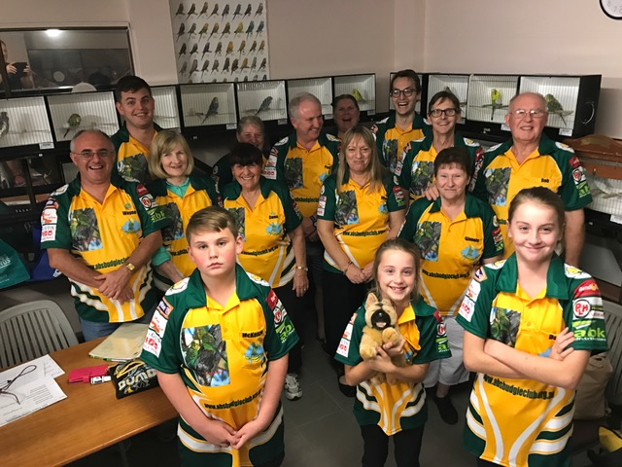

**Thank You from all of us.**