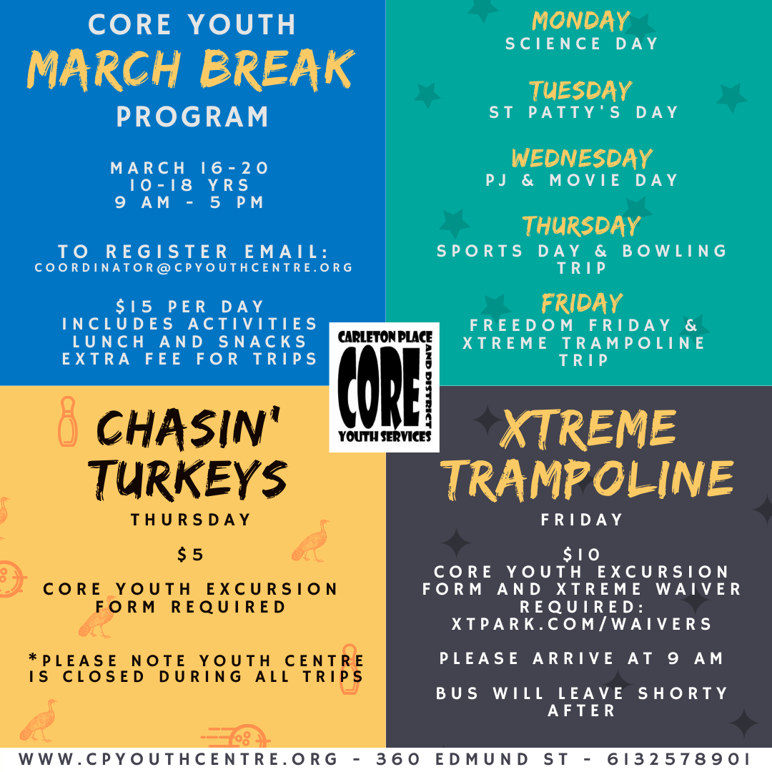


COREYOUTH MARCH BREAK PROGRAM 2020
Carleton Place CORE Youth Services at 360 Edmund Street
March Break Program 2020 Registration Form

REGISTRATION INFORMATION:
Child’s Name: _______________________________________________ Date: ___________________
Full Mailing Address: _________________________________________________________________
Name of Parent/Guardian: ____________________________________________________________
Email Address: ______________________________________________________________________
Telephone #: (H)_____________________ (C)_______________________ (W)___________________
Ontario Health Card #: ___________________________________ Date of Birth: ________________
Medical Conditions/Allergies: __________________________________________________________

EMERGENCY CONTACTS:
Name: _______________________ Relationship to child: ______________ Phone #: ______________
Name: _______________________ Relationship to child: ______________ Phone #: ______________

How did you learn about our March Break program? Please check all that apply.
☐ Our Website ☐ Facebook ☐ Instagram ☐ Twitter ☐ A friend ☐ School
School Attended: ___________________________________
Please indicate which days your child will attend:
 | MONDAY ($15) | TUESDAY  ($15) | WEDNESDAY  ($15) | THURSDAY  ($20) | FRIDAY  ($25) | TOTAL COST
March 16-20 |  |  |  |  |  | $
Name for tax reciept: ______________________________

Agreement Terms:
I _____________________________ have read and agree to the Registration and Behaviour polices attached to this form provided by Carleton Place and District CORE Youth Services.
Signature of Parent/Gaurdian:____________________________ Date:________________________

Carleton Place and District CORE Youth Services
Photo Release Form

Photos may be taken of your child while participating in programs or activities with Carleton Place and District CORE Youth Services & Youth Centre. We are requesting that parents sign a Photo Release Form to allow us to take and publish photos of your child, which could be used within our facility, on advertising or marketing material, printed in local print media or posted on any of our social media sites on the internet. Please indicate if you give your consent for us to take and use your child’s photo.

I give consent for my child ____________________________ to have photos taken and published by the Carleton Place and District CORE Youth Services & Youth Centre.

I do not give consent for my child ___________________________ to have photos taken and published by the Carleton Place and District CORE Youth Services & Youth Centre

Parent/Guardian Name (Please print) ________________________________

Parent/Guardian Signature ________________________________________

Date _____________________________


Carleton Place and District CORE Youth Services
Program Policies

REGISTRATION POLICY
1. Payment Policy
Methods of payment include CASH or CHEQUES ONLY please. Please indicate your child/rens names on the memo line of your cheque payments. A $45 administrative fee will be charged for any returned cheques.
Payment for participation is required to be paid in full at time of registration. A receipt will be issued upon completion of the program.
2. Refund Policy
After registration has been completed, there will be no refunds.
BEHAVIOUR POLICY
Violent, aggressive, disruptive and inapropriate behaviour will not be tolerated at Carleton Place CORE Youth Services and will be subject to a progressive action plan up to and including discharge.
Action Plan
Strike 1 Child will be asked to sit out or other appropriate disipline that will be implemented by the Staff. A note will also go home to the parents to inform them of the next steps to be taken.
Strike 2 Talk to the parents to discuss solutions to the problem as well as what actions can be taken during program hours and at home.
Strike 3 The child will be removed from the program

All strikes will be documented on a log sheet by the Program Staff and Executive Director
CORE Youth March Break
Excursions Consent Form
Over the course of March Break, COREYouth March Break participants will be involved a variety of excursions either walking to the location of the activity or being transported by Premier Bus Lines. We would like to receive consent from parents/guardians for your child to participate in COREYouth March Break excursions and consent to travel to the location of excursions via walking or by bus.
Waiver Form Required for Xtreme Trampoline Trip: www.xtpark.com/waivers

Name of Child: _________________________________________________________________
Birthday (dd/mm/yy): ____________________________________________________________
Health Card #: __________________________________________________________________
Medical Conditions/Allergies: _____________________________________________________
Name of Parent/Guardian: ________________________________________________________
Home Phone #: _____________________________Cell Phone #__________________________
Email: ________________________________________________________________________

A. I, the parent/guardian of the above-mentioned child, agree that my child is voluntarily participating in these excursions.
B. I hereby acknowledge that there are inherent risks, including mishaps or accidents that may occur while travelling to or from the locations.
C. I am aware that there are inherent risks in participating on the excursion whether the activity occurs indoors or outdoors.
D. I hereby absolve and release Carleton Place CORE Youth Services & Youth Centre, its employees, agents, and Board of Directors from any and all liability for any injury or loss whatsoever, no matter my child suffered it, while travelling to, participating, or returning from excursions.
E. I confirm that I am the parent/guardian and I am aware of the effect of signing this release.

Parent/Guardian Signature: _________________________________________
Date Signed: ____________________________

