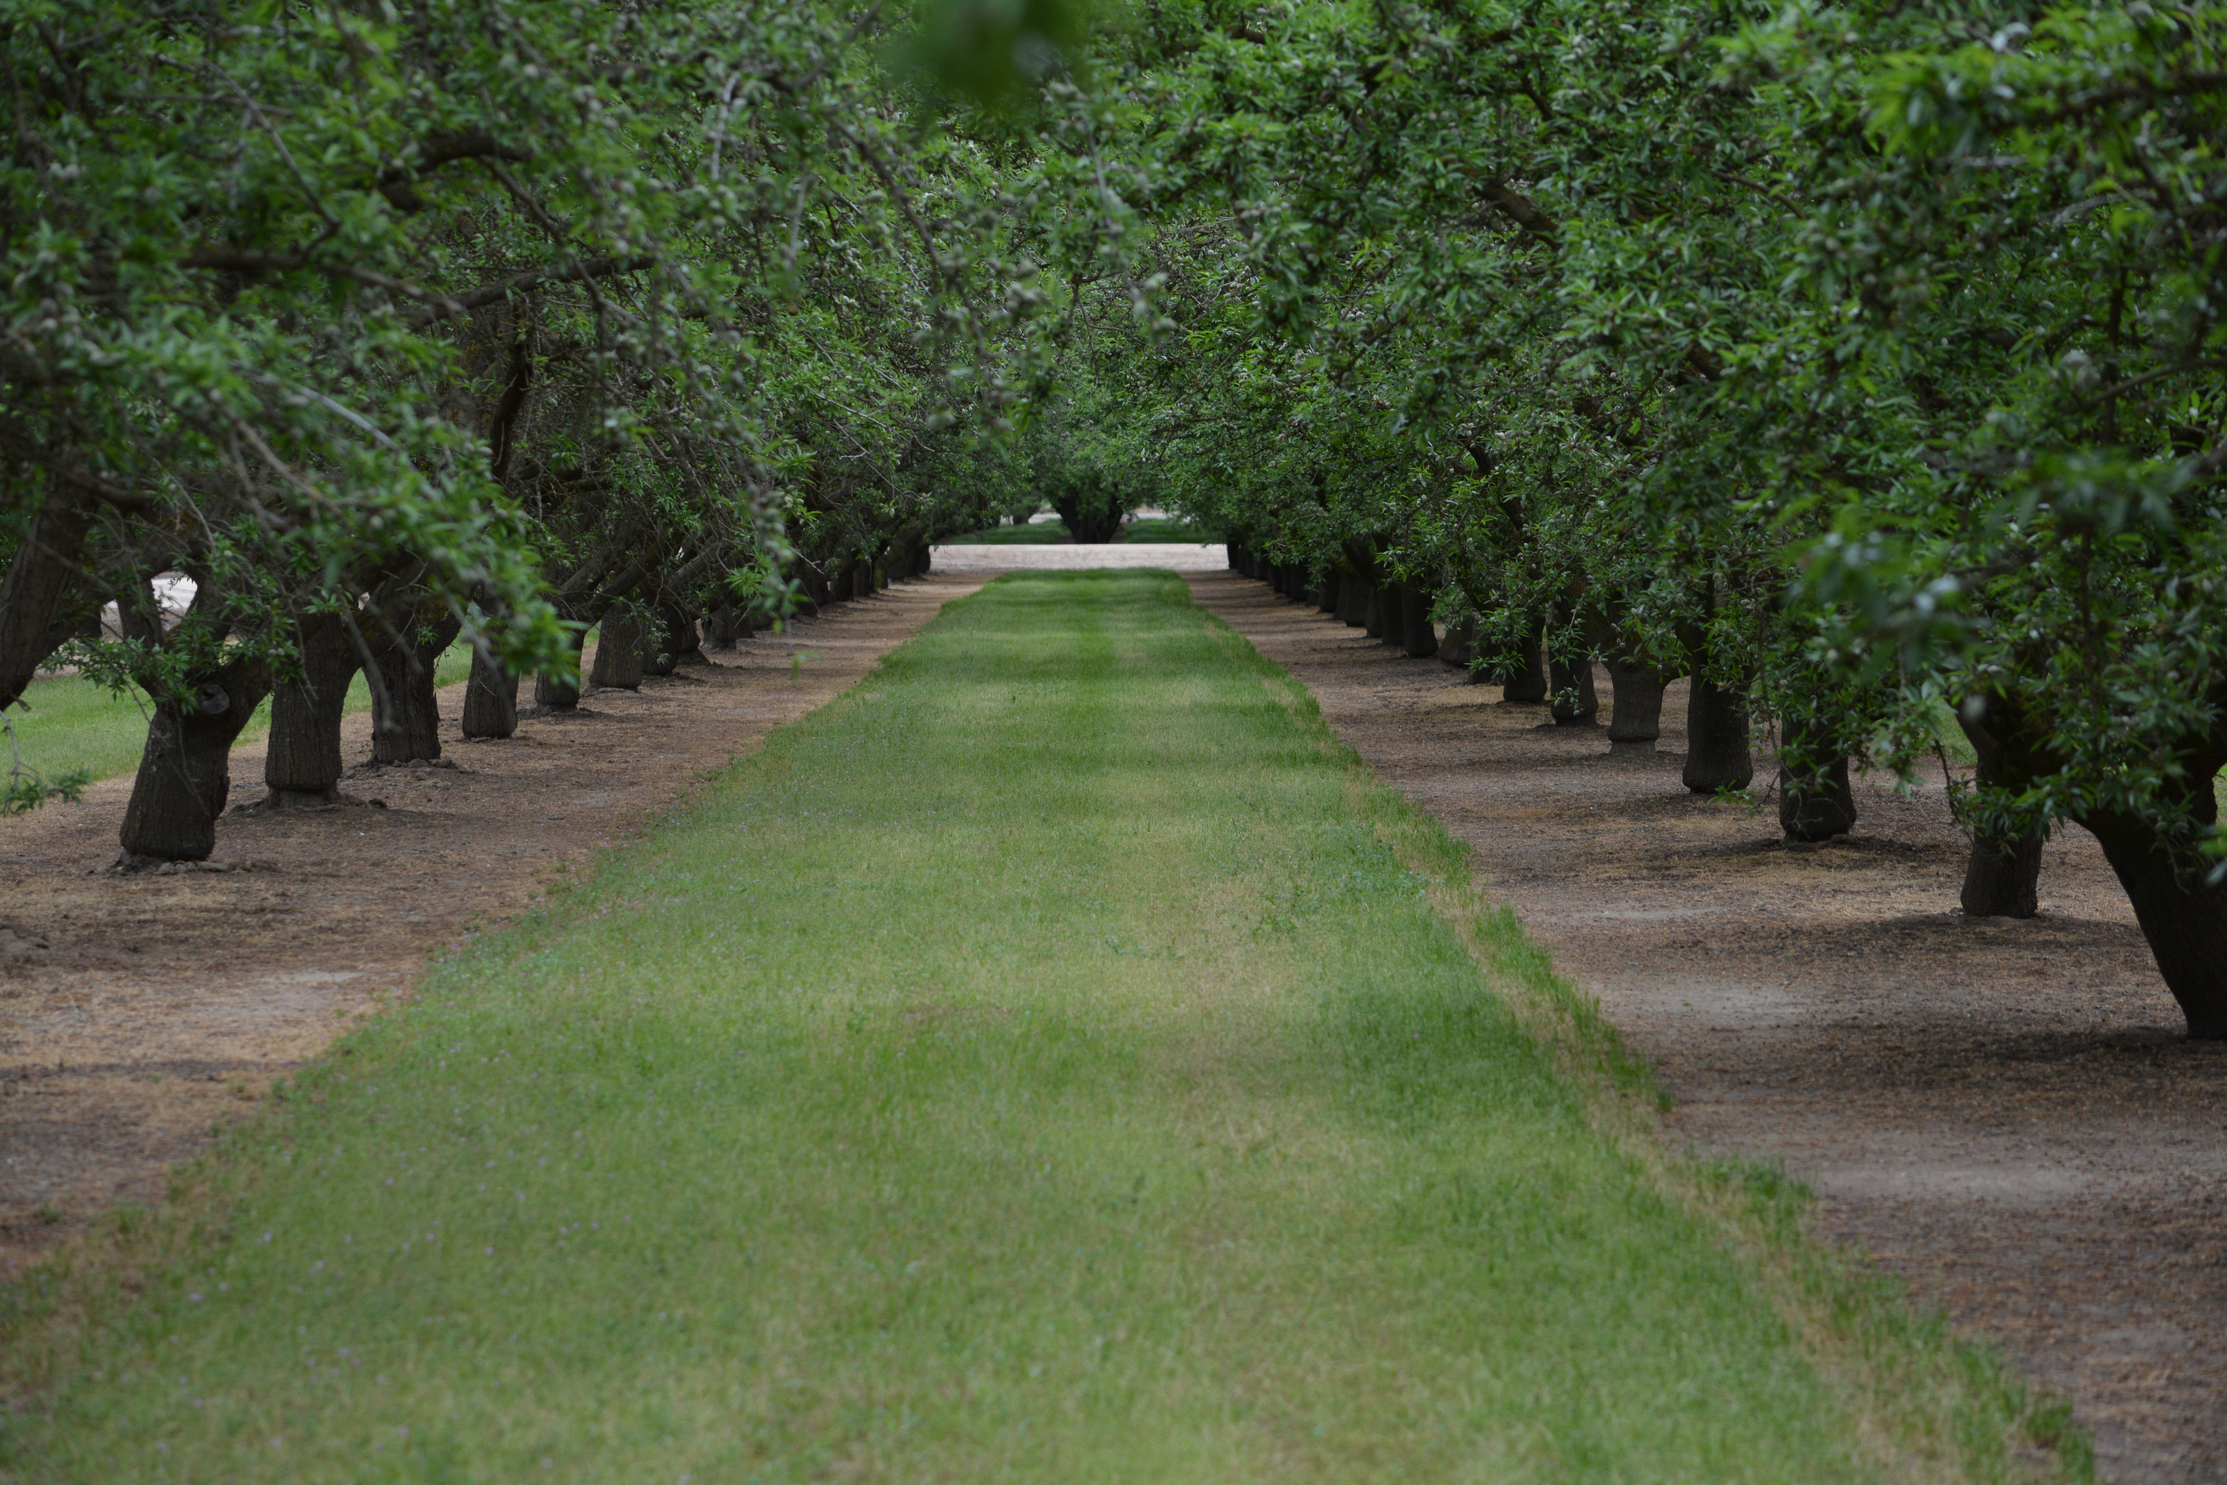
Country Road Rescue
501c3 Nonprofit Organization

EIN Number: 83-2706203

PO Box 580433 Modesto, CA 95358
(916) 996-0564

FOSTER TO ADOPT
APPLICATION

In order to assist us in successfully placing a dog with an ideal owner/family, please complete the following information. Please respond to ALL questions.
Completion of this application does not guarantee foster or adoption of a dog.

Date: Name of desired dog:

FOSTER/ADOPTER INFORMATION
Country Road Rescue

Name(s)-must be over 18:

Home address: Street City & Zip

Phone number: Home Cell Phone

Email address:

Ages of any children in the home:

ENVIRONMENT

Type of dwelling: House Condo Apartment Ranch / Acreage

Do you Rent or Own? _____________

If renting, landlord’s name: ________________________________________

Number: __________________________________________

Yard? Fenced Enclosed Patio Garage Dog Run

Where will the dog sleep at night? Garage Outside Inside the house

Approximately how many hours each day will the dog be left alone? _________

Do you have other pets or animals on the property now? Yes No

Dogs Breed _________________ Age______ Male/Female______Neutered_____

Breed _________________ Age______ Male/Female______Neutered_____

Cats # ______ Livestock # ______ Other __________________________

CONSIDERATIONS

I have considered the emotional and financial investment as well as the time and effort necessary to foster and own a dog. I have the devotion, time and money to provide the love, veterinary care, proper diet, shelter and exercise in order to ensure that my dog is well cared for. In anticipation of owning a dog, I have also considered the following:

Other household members are excited about getting a dog. Yes No

I am able to make a long-term commitment to care for my dog for its entire life span, which could be as much as 15+ years. Yes No

I have a regular vet and/or identified a veterinarian for my dog. Yes No

I have inspected my fencing, landscaping, types of plants, patio enclosure, gates etc to ensure all is appropriate and safe for my new dog. Yes No

I understand that I must register my new dog with the company who micro chipped him/her. Yes No

I am willing to live with hair on my furniture, stains on my rugs. Yes No

Please read and initial each statement below:

_____ I understand that an interview and home visit may be required prior to final placement.

____ I understand that an interview and home visit does not guarantee placement.

____ I understand there is a $200 adoption fee. This fee is non-refundable and also helps to rescue, provide medical care, spay and neuter, board and place additional homeless dogs.

__________________________________________ __________________
Signature Date

