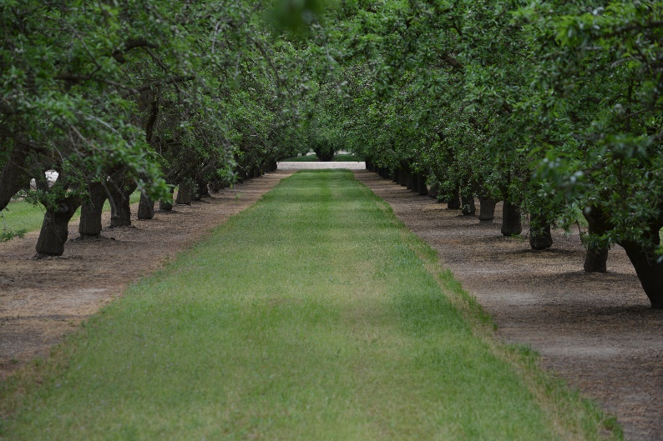
Country Road Rescue
501c3 Nonprofit Organization

EIN Number: 83-2706203

PO Box 580433 Modesto, CA 95358
(916) 996-0564

ADOPTION APPLICATION
In order to assist us in successfully placing a dog with an ideal owner/family, please complete the following information. Please respond to ALL questions.
Completion of this application does not guarantee adoption of a dog.

Date: |  | Name of desired dog:

ADOPTER INFORMATION
Adopter(s) Name(s)-must be over 18:

Home address:
 | Street | City & Zip

Phone number:
 | Home | Cell Phone

Email address:

Ages of any children in the home:

ENVIRONMENT
Type of dwelling | House | Condo | Apartment | Ranch/Acreage

If renting, landlord’s name:
Phone Number:

Yard? | Fenced | Enclosed Patio | Garage | Dog Run

Where will the dog sleep at night? | Garage | Outside | Inside the house

Approximately how many hours each day will the dog be left alone?

Do you have other pets or animals on the property now? | Yes/No

Dog Breed |  | Age |  | Male/Female | Neutered | Yes/No
 |  | Age |  | Male/Female | Neutered | Yes/No

Cats # |  | Livestock # |  | Other

considerations
I have considered the emotional and financial investment as well as the time and effort necessary to own a dog. I have the devotion, time and money to provide the love, veterinary care, proper diet, shelter and exercise in order to ensure that my dog is well cared for. In anticipation of owning a dog, I have also considered the following:
Other household members are excited about getting a dog. | Yes/No

I am able to make a long-term commitment to care for my dog for its entire life span, which
could be as much as 15+ years. | Yes/No

I have a regular vet and/or identified a veterinarian for my dog. | Yes/No

I have inspected my fencing, landscaping, types of plants, patio enclosure, gates etc to
Ensure all is appropriate and safe for my new dog. | Yes/No

I understand that I must register my new dog with the company who micro chipped him or
her. | Yes/No

I am willing to live with hair on my furniture, stains on my rugs. | Yes/No

PLEASE READ AND INITIAL EACH STATEMENT BELOW:
I understand that an interview and home visit may be required prior to final
placement.

I understand that an interview and home visit does not guarantee placement.

I understand there is a $200 adoption fee. This fee is non-refundable and also
helps to rescue, provide medical care, spay and neuter, board and place additional
Homeless dogs.

Signature | Date

