Healthcare Advocates of Florida  Meeting Minutes | Date: 1/21/2025
Agenda Items | Notes
Greetings & Conversations | - Anne opened up meeting to other professionals (i.e., case managers, Patient Advocate Foundation).  - Tammy Krack is in charge of scheduling NAHAC webinars on 3rd Tuesday of each month. Cathy Bowers is speaking in November.  - The NAHAC Ken Schuler Seminar for NAHAC March 14, 2025 12-4pm EST.  - There is a Community Health Worker training in the panhandle east to Jacksonville; it is free due to a grant. Each person will get a $3000 stipend for those who take the course. Contact Maria Vigodsky for more information.
Speaker: Dr. Malynnda (nee Johnson) Stewart, PhD, BCPA of Compassionate Navigation, LLC  Topic: Communicating with Care: A Guide to the Compassionate Approach in Healthcare  Website: CompassionateNavigation.com  Phone: 414.467.6316 | Difficult conversation: any conversation that makes us feel uncomfortable, have a physical response to ; may tend to try to put off these types of conversations. Cause emotional discomfort, uncertainty, exhaustion, conflict or resistance.  - Tension:  - Hesitation: hesitant to hurt feelings or step on toes  - Heightened Emotions: defensive, angry, crying  Goals:  - Understand the foundational principles of compassionate communication  - Learn to recognize and address barriers to effective communication  - Gain practical tools and techniques  Each person’s experiences shape their perspective and how they approach a conversation.  Strategies:  - Awareness  - Active Listening  - Creating Space  - Finding Courage  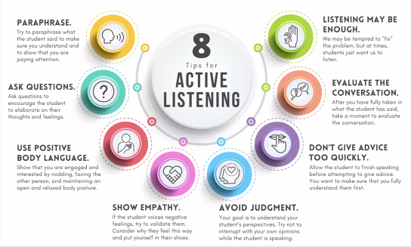  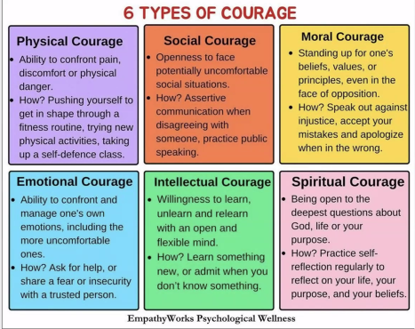  Foundations of Compassion:  - Meeting people where there are  - Listening with both our eyes and ears  - Enacting empathy over sympathy  - Keeping our own bias in check  Podcast: Diverse Voices, Real Actions by Compassionate Navigation, LLC
Communications Committee  Janet Beesting Nelson  Tammy Krack | We are planning to trial a new messaging app called Zulip. It is similar to Slack and Discord but offers some additional features like a customizable user profile and more.  We will trial it with a limited number of users before inviting all HAF members.  Zulip Community  - Organization URL: healthcareadvocatesofflorida.zulipchat.com  - Organization type: Community  No updates on the GNA Directory—still waiting for GNA to fix a bug. GNA directory : https://gnanow.org/advocates/group-florida-advocates
Education Committee  Cathy Bowers | Healthcare Advocate Summit 2024:  As of 10/29/24, recordings are not yet available.  To watch On Demand Videos, sign in to Swap Card, click on Full Agenda, and click on the course title. They will be available for one year.  Other ongoing CEU opportunities:  - Triage Cancer: https://triagecancer.org (free)  - For a list of pre-approved BCPA CEUs, visit https://www.pacboard.org/pre-approved-ce-list
Membership Committee  Anne Llewellyn  Tammy Krack  Maria Vigodsky | - Please do not complete the HAF survey if you have already done so; it just creates a duplicate record.  - If you haven’t yet completed the survey, you are not in the directory. Here is the link to complete the survey. Completing the survey will add you to our directory: https://forms.office.com/r/EKd4cVSvRH
Marketing/PR Committee:  - The committee is working to craft marketing messaging. If you have an opportunity, please ask your clients to describe in their own words what an advocate does so that we can collect some of the words consumers use. Send anything you collect to JanetNelson@BreakawayHealthSolutions.com  Marketing Committee:  Janet Beesting Nelson  Kirsty Delacheck,  Lori Schellenberg,  CarolAnn Dube,  Sheldon Britt,  Maureen Rulison | Do you know of an exhibit, conference, or trade show where the Healthcare Advocates of Florida should have a presence? Let us know so the group can evaluate if we want to support an exhibit to promote patient advocacy and the Healthcare Advocates of Florida members.  Anne Llewellyn attended the Abilities Expo in Ft. Lauderdale and found it meaningful. The next conference is October 17-19, 2025. The attendees are usually on Medicare or Medicaid.  Anne attended the Silver Tsunami Conference presented by the South Florida Regional Planning Council in November 2024.
Newletter submission parameters:  1. Please provide a 400-450 word article in a Word document that shares a successful case you had as an advocate or a topic that will help raise awareness of the value of independent patient advocates.  2. Please do not include any identifying patient/client information. Make up a name to protect patient confidentiality.  3. Include a title for the article  4. Include the author's full name and credentials. Please include your company name/website and email.  5. Include a short bio of 35-45 words.  6. Include a digital image of your professional photo  7. Please submit articles Anne Llewellyn at allewellyn48@gmail.com by Monday so we can edit and post articles each Wednesday. However, you may submit articles at any time and they will go into the queue for posting.  8. All articles will be posted on Linked In and you will be given the link to share the article and post on your website. | Healthcare Advocates of Florida Newsletter:  - Anne Llewellyn created a LinkedIn group page for Healthcare Advocates of Florida. Please join the page and invite your LinkedIn Networks and clients to join. Here is the link: https://www.linkedin.com/groups/12828311  - Anne also created LinkedIn HAF newsletter: Please write about a case study or topic that will raise awareness about the value of independent advocates and submit your article to Anne at allewellyn48@gmail.com. She will edit the article and post it on the LinkedIn site and the GNA site. Please see article and bio parameters in left column. We hope to have submissions from each of you so that we have enough articles to run one every week of the year.  - Please join the HAF Linked In group and connect with your Linked In network.  - Please connect on Linked In with other HAF members. To see a list of HAF member names, scroll to end of document.  - Please comment on and re-post HAF newsletter articles on Linked In  - Commit to writing a HAF newsletter article  Healthcare Advocates of Florida LinkedIn Group:  - Anne Llewellyn created a LinkedIn group page for Healthcare Advocates of Florida. Please join the page and invite your LinkedIn Networks and clients to join. Here is the link: https://www.linkedin.com/groups/12828311
New Business (15 minutes) | Solace Health will not be supporting independent advocates as of January 1, 2025, in favor of the Medicare Community Healthcare Worker (CHW) program.
Next Meeting: | Next meeting: February 18,2025 at 4 pm EST
Next Steps:

Attended by:  If you attended and don’t see your name here, please contact Janet Nelson at JanetNelson@BreakawayHealthSolutions.com | - Anne Llewellyn  - Janet Beesting Nelson  - Malynnda Stewart  - Susan Rawn  - Yvonne Schaefer  - Viki Freinberg  - Y. Clark  - Heidi Kummer  - Lori Schellenberg  - Darlene Christy  - Laura Hoffman  - Betty Ford  - Rosalyn Roker  - Cathy Bowers  - Tammy Krack  - Diane Grusky  - Maria Vigodsky  - Jazminn Garcia  - Kate Colandrea

