Healthcare Advocates of Florida  Meeting Minutes | Date: 7/15/2025
Agenda Items | Notes
Greetings & Conversations | Triage Cancer is hosting a webinar July 24th at 2 pm EST to help explain the health care impacts of S.1. Breaking News: What's in the “Big Bill” & How it Impacts You  is free and you can get CEUs for BCPA, RN, Social Work, and HR professionals.  If you have not completed the new member survey, please do so. Click here to complete survey.
Speaker  Mim Senft  Motivity Care  https://motivitycare.com/  mim@motivitycare.com  Phone: 646-424-4312  They provide a health concierge service and a technology platform.  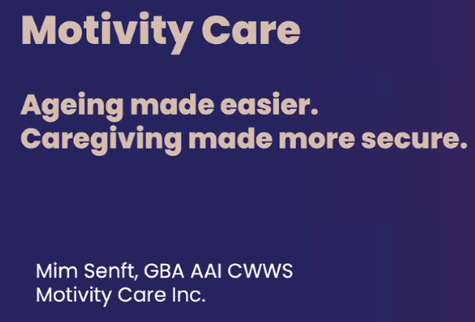 | Mim’s background is in finance and human resource systems. She had loved ones experiencing the health care system, and wanted to take what she knew about insurance and technology and create a system where health and financial information could be shared in a secure way. They provide a concierge care management service and a technology platform to organize, share and communicate care giving information.  - Motivity Care vets and establishes relationships with other professionals to help clients with care giving gaps, such as finances (i.e., financial forensics), medical, legal, other professionals.  - Whole person/whole family caregiving  - They do educational webinars and customized workshops  - Motivity Care is a benefit for Breakers Palm Beach employees and just signed deals with two national platforms that will get them in front of unions, other employer accounts.  - They are open to working with advocates who want to use their platform with their clients, and also to collaborate with advocates when their clients need help, especially when “boots on the ground” are needed. Their team are not patient advocates. If interested in how you could work with Motivity Care, contact Mim directly.  - Cost for the platform is $23/month, including webinars, workshops. If advocates upsell on price that is okay, but client must sign a contract with Motivity Care. An advocate could also pay for multiple accounts for each client at a bulk price.  - For concierge services, they do a customized scope of work for each client.  - If you refer an employer group and Motivity Care gets the contract, they will pay you a referral fee.  Technology platform helps family and caregivers stay up to date and coordinate care:  - Users can share specific information, rather than an all or nothing share.  - Nothing feeds into the system to avoid risks of exposure of data.  - Data is digitized and saved in a secure, HIPAA-compliant environment.  - Can include multiple live links for other medical portals  - Upload updated legal documents, all are date-stamped to the second  - Can upload short videos from your phone  - Allows different levels of permission for different people, user can track who logs in to the system and what they do in there  - Multiple types of contacts  - Can upload photos of prescriptions, etc.  - Highlights certain info like allergies, etc.  - Same security that Goldman Sachs has, multiple server redundancy, and hacking testers  - They provide live training for user and anyone else they have using the platform on your behalf  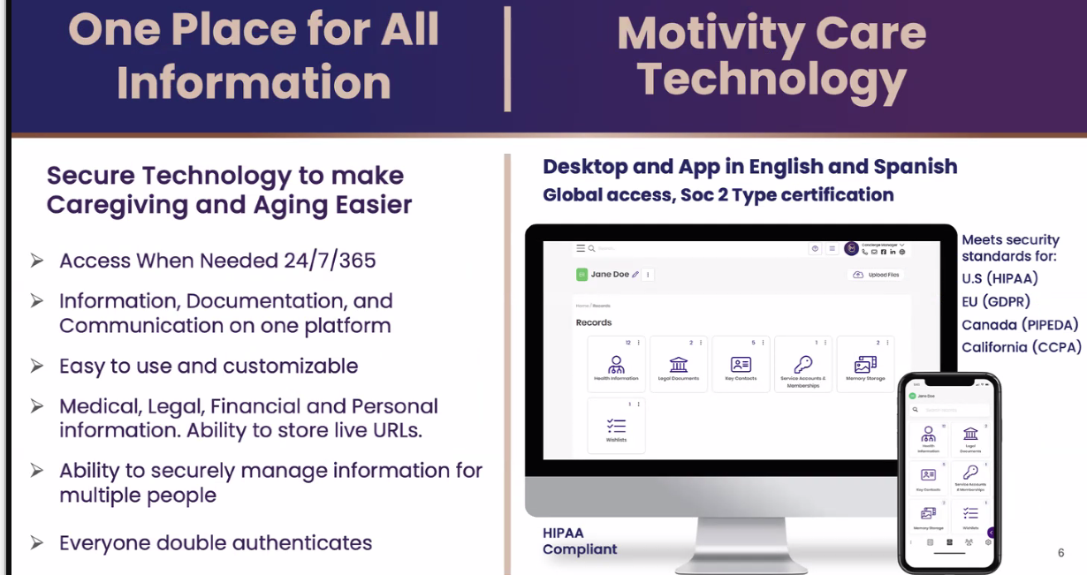  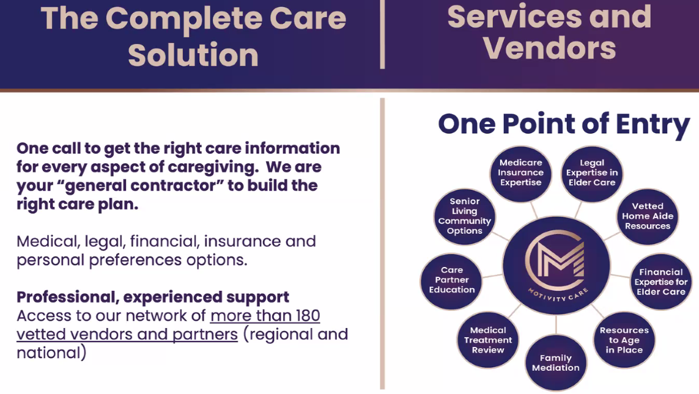
Membership Committee  Anne Llewellyn  Tammy Krack  Maria Vigodsky  New directory listing  Link to complete form  https://forms.office.com/r/DRaFVT0mbG  Please complete the from prior to June 10. | New directory listing  **If you have not completed the form yet, please do so now**  Link to complete form  https://forms.office.com/r/DRaFVT0mbG  We have revised the survey form that members complete to be listed in the HAF directory. We wanted to expand the questionnaire so that it is easier for members to find others for the purpose of making referrals and to collaborate with each other.  The new form requests some personal contact information first, as many of our members do not yet practice as independent advocates when they join. If you have a business or work for an advocacy business, you will continue to complete all sections of the questionnaire related to your business and the services you provide.  Please set aside about 15 minutes to complete the full form, as you cannot save it and go back to it to complete it.  We are going to send out a link to the full membership and ask that everyone complete the survey form.  You must complete this new form in order to be included in the HAF member directory. I would like to have everyone’s submission prior to our next meeting, which is June 17.
HAF in-person meeting | At the May meeting, we discussed the idea of holding an in-person meeting somewhere centrally located, likely in January 2026. We need to follow up to explore feedback.  The members in attendance liked the idea and are willing to travel to the Orlando area. Most of our members are located in the Tampa Bay and South Florida areas.  We will send out a survey to gauge interest among the full membership regarding interest, preferred location, and format.  We would hope to obtain some free space and have an option of a nearby hotel for those who wish to stay overnight.  Some ideas for a meeting were offered:  - Offer some CEUs for BCPA certification  - Everyone comes prepared to talk about our challenging cases to learn from each other  - Shared resources with group, and make those resources available afterward online  - Networking opportunities to get to know one another better  - Speaker
Healthcare Advocate Summit  September 2-5, 2025 | Register at https://www.healthcareadvocatesummit.com/  Do you plan to attend? If so, let us know and we will try to organize a HAF get together in Las Vegas.
Communications Committee  Janet Beesting Nelson  Tammy Krack | We are planning to trial a new messaging app called Zulip. It is similar to Slack and Discord but offers some additional features like a customizable user profile and more.  We will trial it with a limited number of users before inviting all HAF members.  Zulip Community  - Organization URL: healthcareadvocatesofflorida.zulipchat.com  - Organization type: Community  No updates on the GNA Directory—still waiting for GNA to fix a bug. GNA directory : https://gnanow.org/advocates/group-florida-advocates
Education Committee  Cathy Bowers | Triage Cancer is hosting a webinar to explain the health care impacts of S. 1 (The Big Horrible Bill). Click here to register: https://triagecancer.org/webinarreg-breakingnews  July 24, 2025  11am PT / 1pm CT / 2pm ET  Duration: 60 minutes  Course Level: Beginner  Cathy Bowers provided some links about the Florida Senior Living Institute’s conference in Ft. Lauderdale:  https://www.flseniorlivinginstitute.org/engage2025-fsla-exhibitors  https://www.flseniorlivinginstitute.org/_files/ugd/c5f87f_df42a5e56b914db2824f13b77af36528.pdf  https://www.flseniorlivinginstitute.org/event-details/engage2025-attendee-registration  CEUs from Healthcare Advocate Summit 2024:  Recordings are available for CEUs  To watch On Demand Videos, sign in to Swap Card, click on Full Agenda, and click on the course title. They will be available for one year.  Other ongoing CEU opportunities:  - Triage Cancer: https://triagecancer.org (free)  - For a list of pre-approved BCPA CEUs, visit https://www.pacboard.org/pre-approved-ce-list
New Business (15 minutes)

Next Meeting: | Next meeting: August 19 at 4 pm EST  Link to register: https://us06web.zoom.us/j/81714303014
Next Steps: | - Contact members who have not yet completed the new form to be included in the HAF directory  - Survey group regarding interest in an in-person meeting in early 2025.
Attended by:  If you attended and don’t see your name here, please contact Janet Nelson at JanetNelson@BreakawayHealthSolutions.com | - Speaker Mim Senft  - Anne Llewellyn  - Cathy Bowers  - Janet Nelson  - Ginny Moore  - Betty Ford  - Laura Hoffman  - Maureen Rulison  - Jackee Ndwaru McGlamery  - Agnes Compagnone  - Susan Rawn  - Ashley Kolb

