**Personality**

*Carlene Cow is basically extremely shy and gets so embarrassed if she thinks that anyone might be watching her! How can she possibly be the lead singer in a band? -I hear you ask!! Find out more about Carlene in the Meadow Farm Talent* *show… Carlene has a very kind heart, but she can be influenced by people around her and she has made plenty of mistakes in the past. She has learned the importance of learning from her mistakes.*

**Favourite Music**

*Her singer role models are Tina Turner and Nina Simone. Her favourite songs are I Can’t Stand the Rain, Steamy Windows, Sinnerman and I Put a Spell on you.*

**Likes**

*Singing behind closed curtains, laughing with her friends, partying and sharing funny stories.*

**Dislikes**

*Meeting animals she doesn’t know, making new friends, performing without a feather boa.*

**Job Description**

*Lead singer in The Meadow Farm Band*

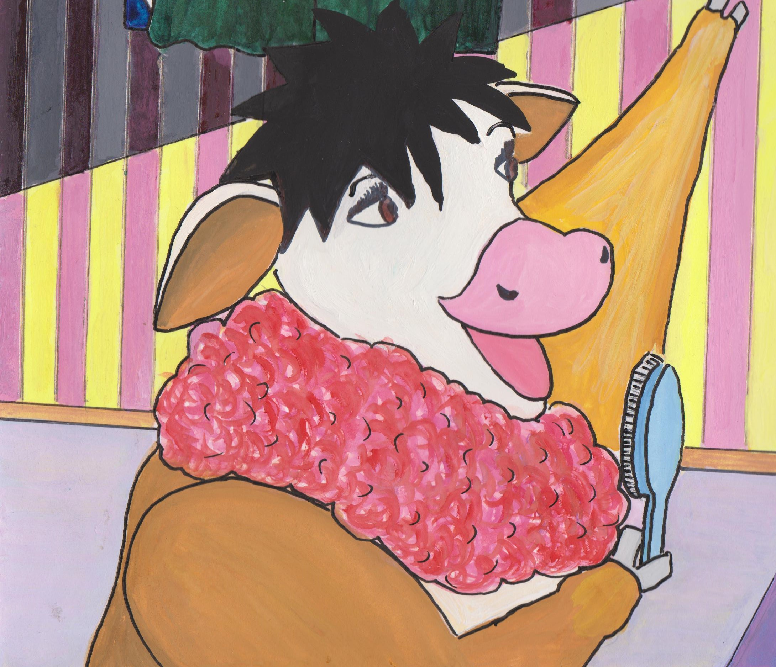

**Character Name**

*Carlene Cow*