**Favourite Music**

*Anything by Chuck Berry - Roll over Beethoven, Johnny B. Goode, Maybellene to name but a few. He loves a bit of Elvis too!*

**Likes**

*Parties, dancing, singing, having fun and playing the guitar of course!*

**Dislikes**

*Opera and classical music, sitting still for a long time, arguments and feeling guilty*

**Personality**

*Chuck Chick is a cheerful, chirpy chick and likes nothing more than to get the other chicks dancing to his guitar tunes. He has a pretty good singing voice too and boy can he move!! Chuck Chick has bags of confidence and loves to work on his rock star image. He is not totally sure of his style, but anything goes… All the other chicks think he’s cool and that is good enough for him!*

**Job Description**

*guitar player in The Meadow Farm Band*

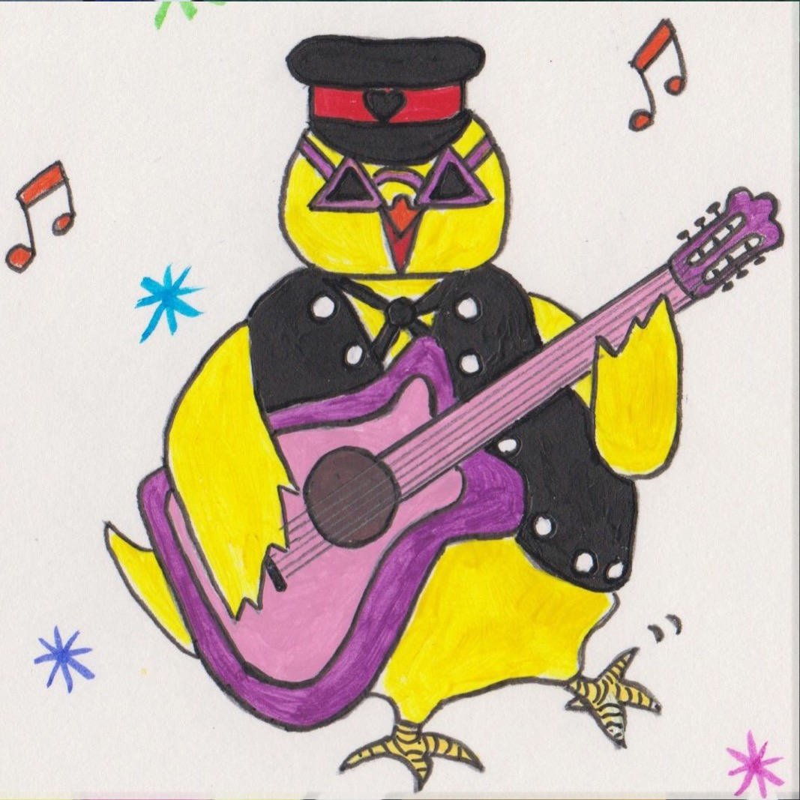

**Character Name**

*Chuck Chick*