**Favourite Music**

*Felix Fox loves to play classical music and is totally in love with anything written by the great Ludwig van Beethoven! Fortunately, Felix Fox can turn his hand to any tune from Rock ‘n’ Roll, Country Western, Blue Grass and Pop. Playing ‘Come on Eileen’ at double the speed puts such a big grin on his face! Just Watch those animals jump to the beat!*

**Likes**

*Quality family time, playing the violin, music, kindness, feeling included*

**Dislikes**

*Feeling excluded, being sad and lonely, unkindness, unfair animals.*

**Personality**

*Felix Fox is a doting husband and father to his wife, son and daughter. He is dedicated to his music and loves to play for his family in the evenings in front of their open fire. Felix Fox is misunderstood by most of the animals on Meadow Farm. He has tried to show the animals that he wants to be friends but unfortunately this looks to them as if he is spying and plotting bad things. On the contrary, Felix Fox is such a gentle, kind soul, longing to be part of a close, trusting friendship group.*

**Job Description**

*Violinist in The Meadow Farm Band*

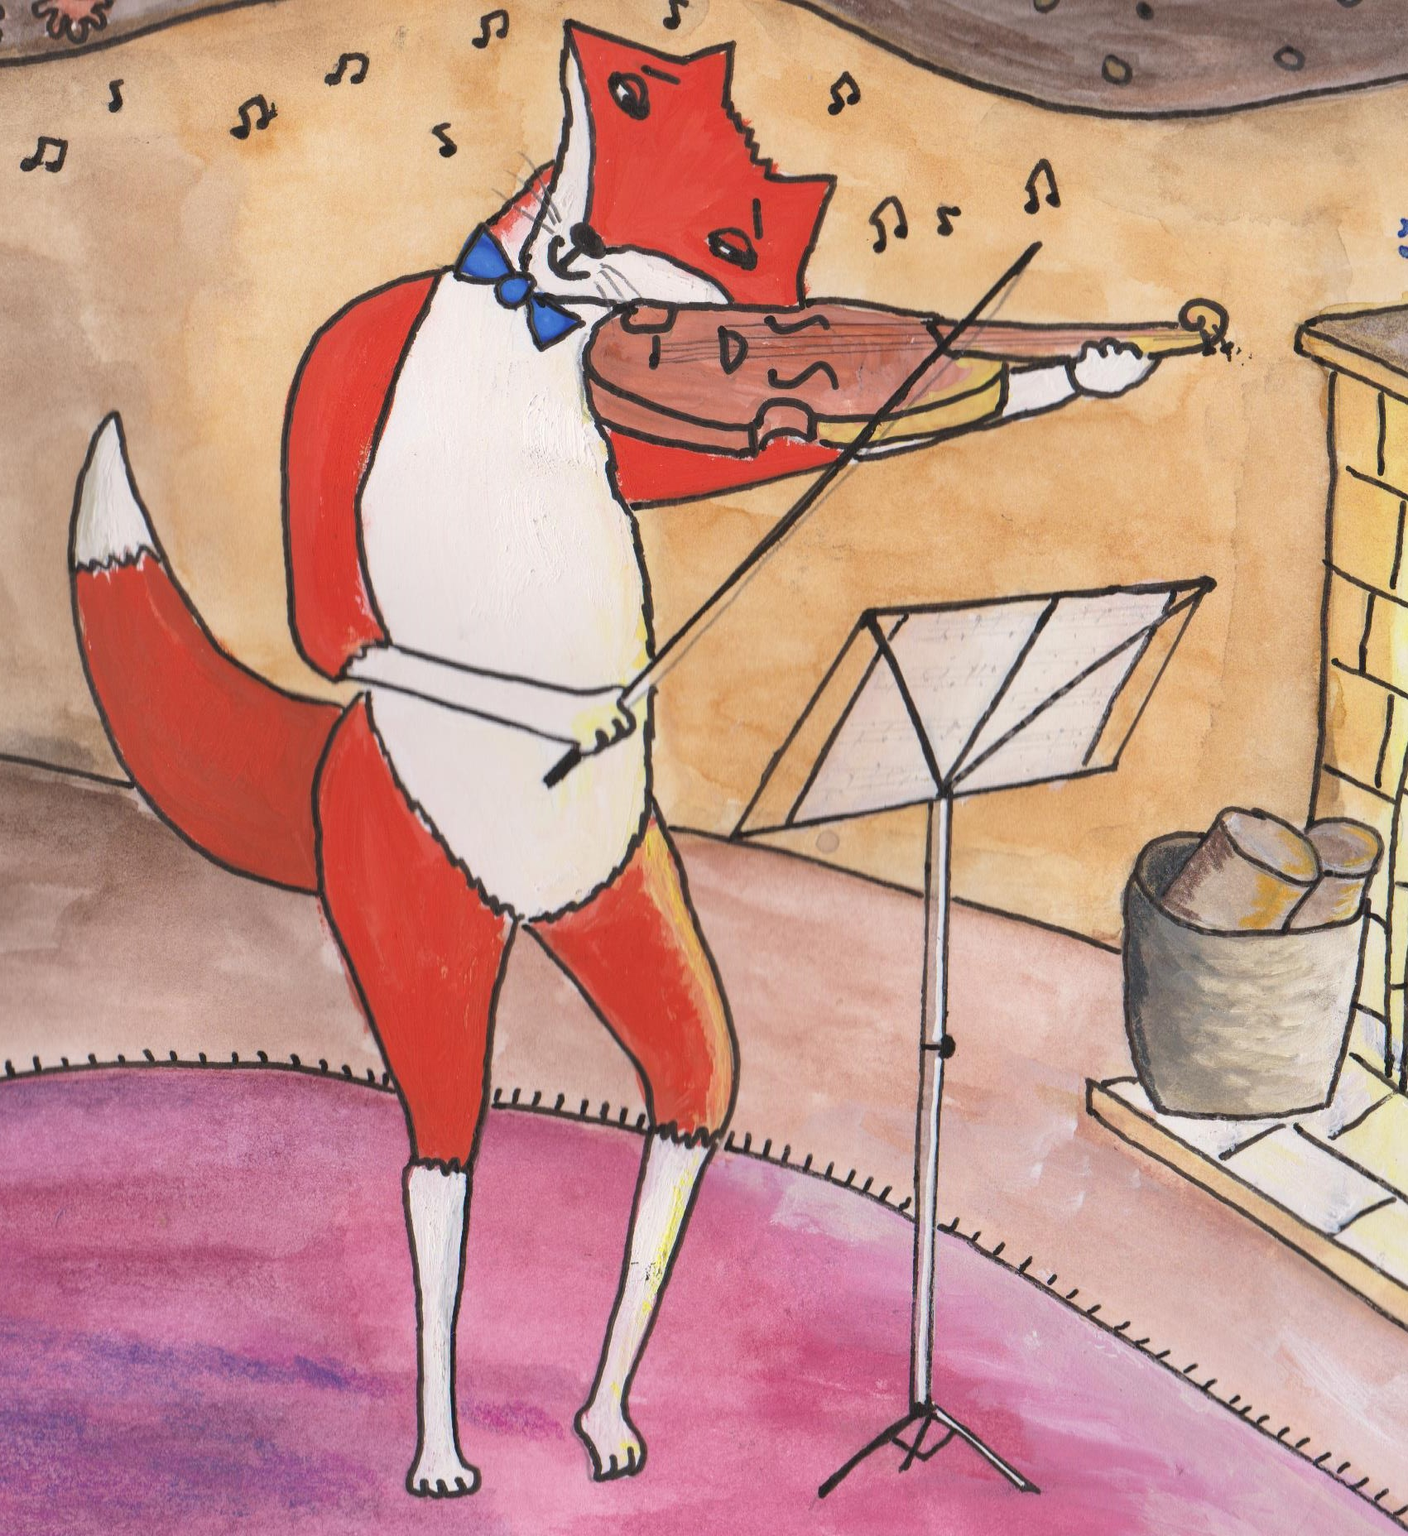

**Character Name**

*Felix Fox*