**Favourite Music**

*Bluegrass Music-if only he could be as good as Earl Scruggs-maybe one day… And then he could do a supremely polished version of Fuedin’ Banjos! Favourite songs are Blue Moon of Kentucky, Roll in my Sweet Baby’s Arms and Rocky Top.*

**Likes**

*Party food, mud pies, getting better at things and sharing jokes with friends*

**Dislikes**

*Unfamiliar farm animals, tricky banjo chords, too much healthy food and feeling guilty.*

**Personality**

*Peter Pig is not at all lazy. He just takes a long time to get anything done. Take his banjo playing for example-Peter Pig took a whole year before he could even play one tune properly!! And that was an easy tune! The good thing about Peter Pig is that he never gives up. He is a plodder and has been able to go places the other farm animals never thought possible! Peter Pig loves his pig ark home-it is a perfect place for banjo practice!*

**Job Description**

*Banjo player in The Meadow Farm Band*

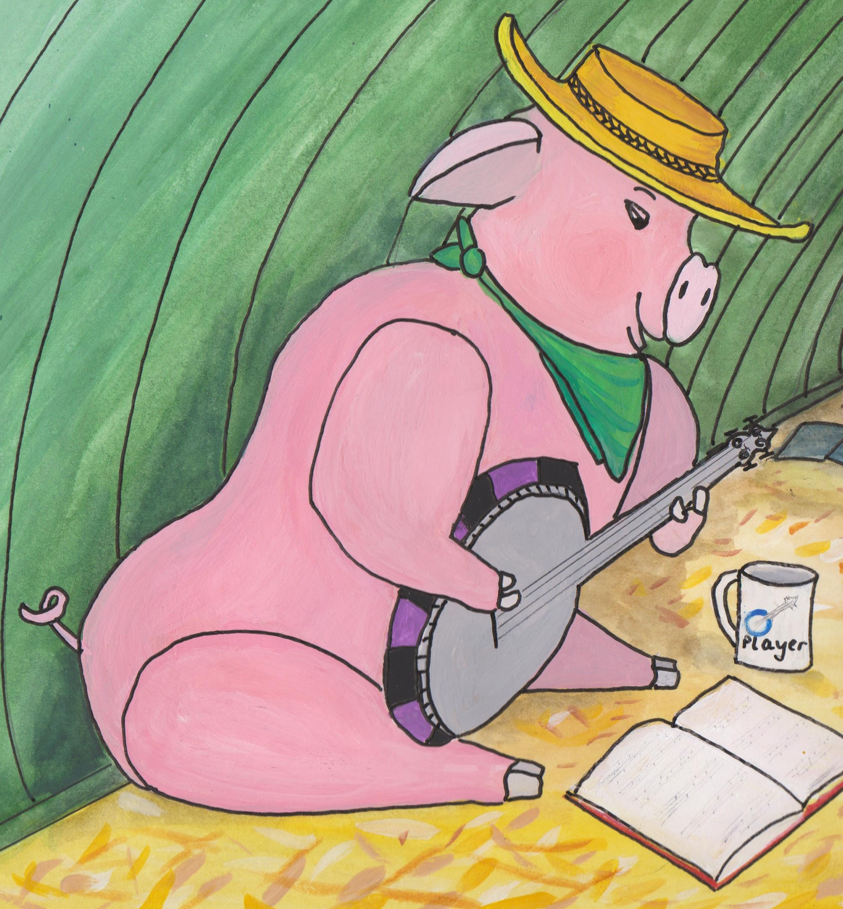

**Character Name**

*Peter Pig*