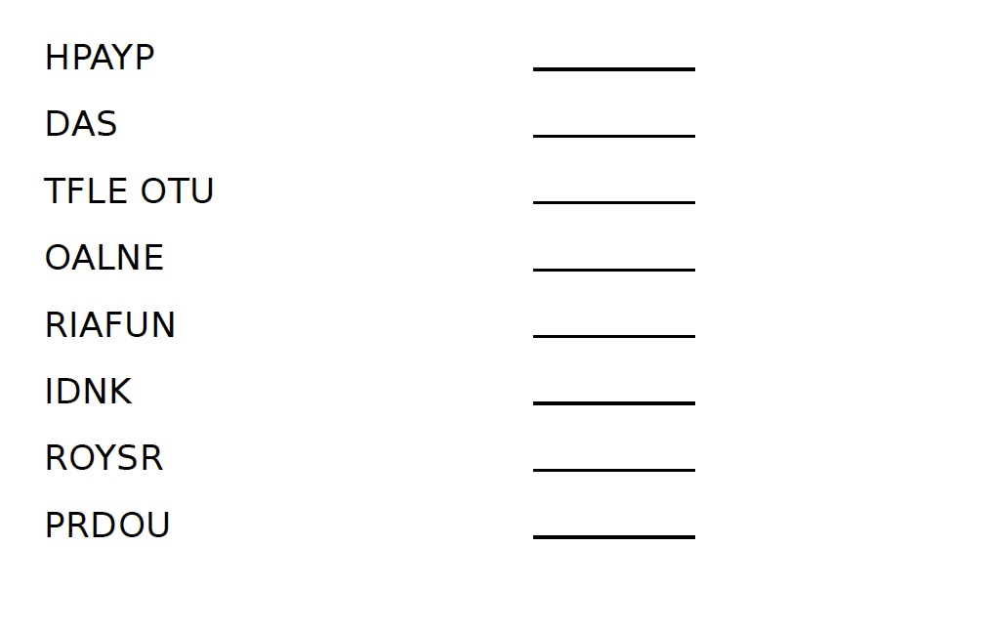

|  |  |
| --- | --- |
|  | **Draw your own picture of Felix Fox** |