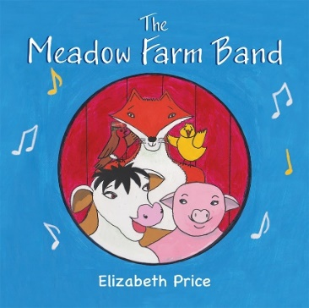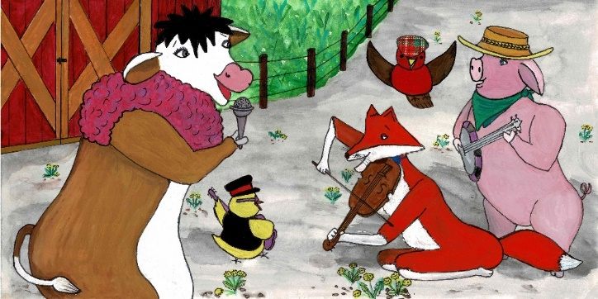
Felix Fox lives in a warm and comfortable den under an enormous tree in Bluebell Wood. Felix Fox is a superb violinist. He can play so many beautiful tunes.
Felix Fox wants to join The Meadow Farm Band but the other animals are not at all welcoming towards him. They think that Felix is a sneaky fox and they are very suspicious of him.
Robbie Robin knows that Felix is actually a really thoughtful and caring fox. He is totally harmless! Robbie can see that the animals are being unkind to Felix Fox. He stands up for what is right and tells them off for this. The animals then realise their mistake and feel guilty for excluding Felix Fox.
Felix Fox feels so much better when the animals show how sorry they are. The animals welcome Felix into the band. They practise every day and soon become everlasting friends.
After a while, their music becomes outstanding. Everyone who sees The Meadow Farm Band in concert is amazed at their tremendous talent and teamwork.

