Carlene Cow
Use white card, black and pink felt tips, black head band

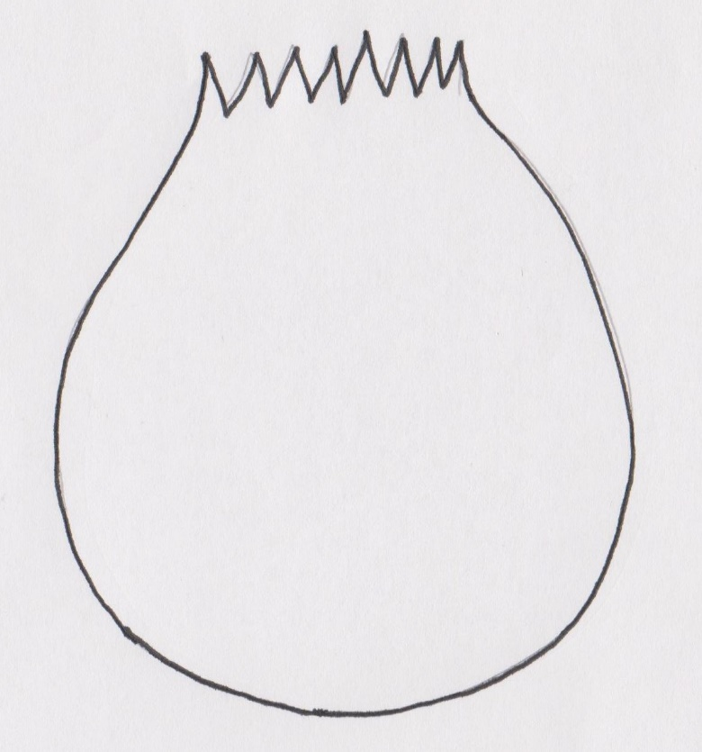

Chuck Chick
Use yellow card, purple, black card for glasses and hat, yellow card for headband.

Felix Fox
Use white card, orange and black felt tips, orange headband.

Peter Pig
Use pink card, pink headband.

Robbie Robin
Use red card, red headband.

