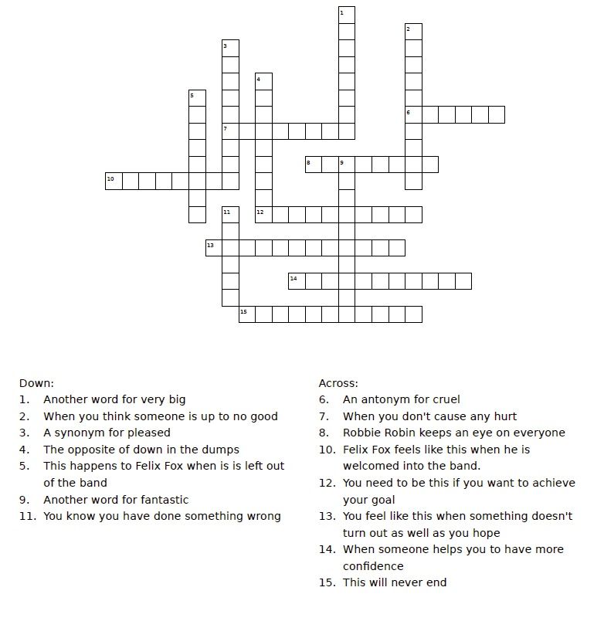

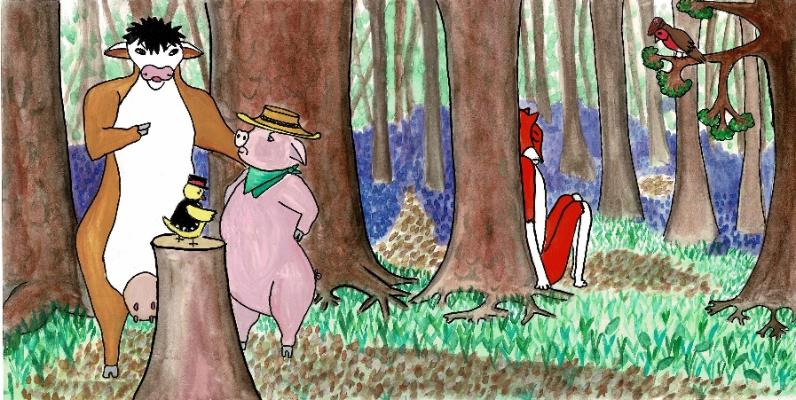

**Try writing your own story about the value of Inclusion. Have you ever felt excluded?**