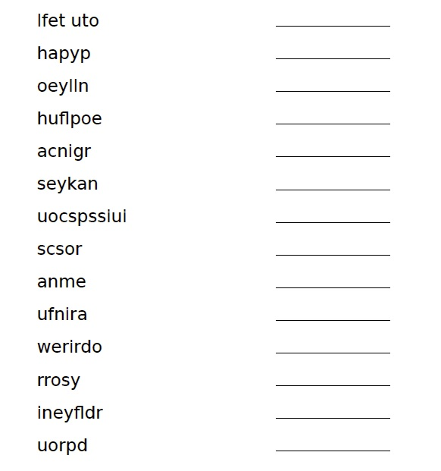
On a separate piece of paper, write your own sentences using some of these adjectives. Maybe you can even make up a story.

