Search across, down and on the diagonal to find the hidden words.

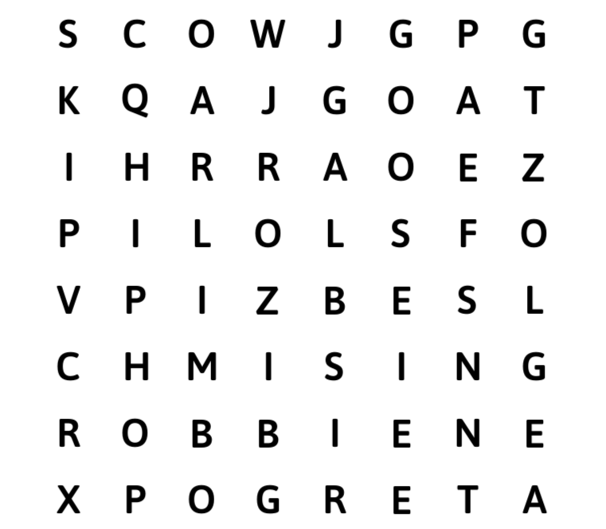
CARLENE  ROBBIE  JOE  GRETA  SHONA  SING  HIPHO | COW  ROBIN  GOAT  GOOSE  SHEEP  SKIP  LIMBO

