Meadow Farm has a secret. Behind the scenes, some of the animals are very musical. Robbie Robin wants them to form a band, but one animal feels so left out…How can Robbie put things right? The Meadow Farm Band’ teaches children the value of Inclusion and can be used as an early anti-bullying intervention. It is an ideal book for using as part of an ‘Animals’ topic in Key Stage 1, with several possible cross-curricular links in Literacy, Music, Art, Science and PSHE.
Share ‘The Meadow Farm Band’ Kindle Edition with the children on the interactive whiteboard. Buy paperback copies for children to read independently.
These resources are free to download and can be adapted to suit the needs of your children. Resources highlighted in RED are downloadable in the same section as the Teaching Resources.
YEAR ONE LITERACY
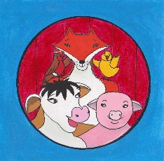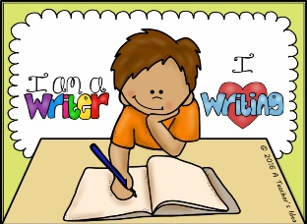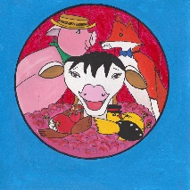
Overall Learning Aims
- To explore, interpret and respond to illustrations.
- To use role play to develop empathy for empathize with story characters.
- To write character descriptions.
- To talk story ideas through confidently and effectively.
National Curriculum Links Year 1
Speaking and Listening
- Listen and respond appropriately to adults and their peers.
- Use spoken language to develop understanding through imagining and exploring ideas.
- Participate in discussions and roleplay.
- Speak audibly with an increasing command of Standard English.
Reading-Word reading/Comprehension  - Link what they read or hear read to their own experiences.  - Make inferences on the basis of what is said and done.  - Predict what might happen on the basis of what has been read so far.  - Participate in discussion about what is read to them, taking turns and listening to what others say.  - Explain clearly their understanding of what is read to them. | Writing-Transcription/Composition  - Compose a sentence orally before writing it.  - Sequence sentences to form short narratives.  - Re-read what they have written to check that it makes sense.  - Discuss what they have written with the teacher or other pupils.
Favourite Story Character

Share ‘The Meadow Farm Band’ as eBook on interactive whiteboard. Children read the illustrations to gather more detail about the story. See story question guide to prompt class or small group discussions. Ask the children what they think the message of the story is. They discuss their ideas with a talk partner and share back to the class. Write ideas up on the whiteboard and then link this to real life experiences. Recap on the five story characters: Chuck Chick, Carlene Cow, Robbie Robin, Peter Pig and Felix Fox. What is their favourite character and why?
Children draw a picture of their favourite character using favourite character writing frame.

Character Description-Felix Fox

Children take turns to retell the story of The Meadow Farm Band in their own words, considering both the text and the illustrations. Focus on the feelings of Felix Fox. Do they think that the farm animals realised that they were being mean to the fox? Talk about how we sometimes do unkind things because we are not thinking about other people’s feelings. Sometimes we judge others before getting to know them. Link to real life examples.
Children take turns to imagine being Felix Fox for Hot Seating activity. Use a Felix Fox head band for this. As a class, draw a picture of Felix Fox on the whiteboard. Write words and phrases to describe him, recapping on GPCs learnt so far in class for spelling and rules of punctuation/handwriting.
Children write their own character description using Felix Fox writing frame.

Character Description-Robbie Robin

Children read ‘The Meadow Farm Band’ text with actions using interactive whiteboard.
Look at overview of the farm on the first double page spread. Who knows the secret on Meadow Farm? What do we know about Robbie Robin? How does he help to make things better?
Children take turns to imagine being Robbie Robin for Hot Seating activity. Use a Robbie Robin head band for this. As a class, draw a picture of Robbie Robin on the whiteboard. Write words and phrases to describe him, recapping on GPCs learnt so far in class for spelling and rules of punctuation/handwriting.
Children write their own character description using Robbie Robin writing frame.

Story Character Creation

Children read ‘The Meadow Farm Band’ text with actions using interactive whiteboard. See if they can retell the story with actions from memory. Tell the children that Robbie Robin is looking for another member to join The Meadow Farm Band. Children share ideas with a talk partner about which animal would be good to join the band. Write ideas on the whiteboard. Remind the children that it must be an animal that is found on a farm.

As a class, decide on a different farm animal e.g. goat. What is our goat going to be called? Think of alliteration for this. Explain what alliteration is e.g. Gregory Goat. What instrument is Gregory going to play? What is he going to wear? Draw a picture of Gregory Goat on whiteboard. Write word and phrases to describe him. Children work with a partner [mixed ability] to create their own new Meadow Farm Band member.

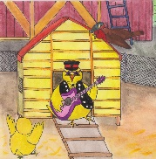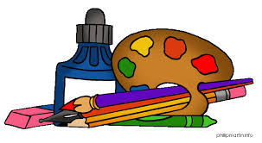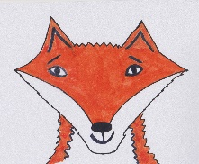
ART AND DESIGN
National Curriculum Links Key Stage 1
- To use a range of materials creatively to design and make products.
- To use drawing and painting to develop and share their ideas, experiences and imagination.
- To develop a wide range of art and design techniques in using colour, pattern, texture, line, shape, form and space.

Children make Meadow Farm Lolly stick puppets or headbands using downloadable templates.
They use their puppets and headbands to act out the story in small groups or take part in hot seating activities.

They complete Step by step drawing instructions for Felix Fox and then practise drawing Felix doing lots of different everyday things in their sketch books.

Using long strips of paper, orange , black and white paint, the children paint their own version of Felix Fox in small groups. Pictures of Felix Fox can be stuck in the middle for support.

Group collage -In groups, children complete a collage for all five Meadow Farm story characters. This can be used as a background for a Literacy, cross curricular display.

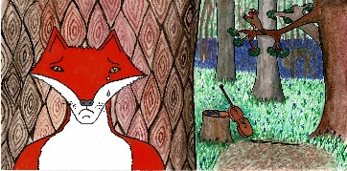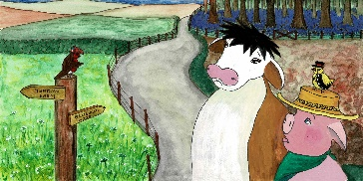
PSHE
Health and Wellbeing
- Learn about good and not so good feelings and develop a vocabulary to describe their feelings to others and simple strategies for managing feelings.
- Learn rules for and ways of keeping physically and emotionally safe.

Relationships
- To share their opinions on things that matter to them and explain their views through discussion with one other person and the whole class.
- Know that there are different types of teasing and bullying, that these are wrong and unacceptable.
- Learn how to resist teasing or bullying, if they experience or witness it, whom to go to and how to get help.

https://www.anti-bullyingalliance.org.uk/anti-bullying-week/anti-bullying-week-2019-change-starts-us
Anti-Bullying Week takes place 11th-15th November 2019. The Anti-bullying Alliance website offers excellent resources and advice on what to do if you are being bullied or if you see any bullying take place. Click on the link below for Top Tips power points.

https://www.anti-bullyingalliance.org.uk/tools-information/if-youre-being-bullied/i-am-being-bullied

What is Bullying?
Ask the children what they think the word ‘bullying’ means. Write done children’s answers and ideas on the whiteboard. Watch the BBC Bitesize video clip below, during which children explain that there are two types of bullying-emotional bullying [excluding people and unkind remarks] and physical bullying[violence].

https://www.bbc.co.uk/bitesize/clips/zqypyrd
Talk about how Carlene Cow, Chuck Chick and Peter Pig exclude Felix Fox and how this is a form of bullying. Ask the children why they think that the farm animals didn’t want Felix Fox in the band. Were they afraid because they didn’t know him? Did they think make a judgement already about all foxes? Do we do this in real life too? What are the effects of bullying and how does it make people feel? Who can Felix Fox trust in this story? Robbie Robin. What did Robbie Robin do to help put things right? We all make mistakes and we can all be guilty of being unkind, leaving someone out. It is important that we face up to our mistakes, like the animals did, say sorry and then try to put things right.

Children share their response to the story with a talk partner. Discuss thoughts as a whole class. Develop strategies to support anyone in the class who is experiencing bullying in any way. See Anti-Bullying Alliance website and follow guidance in schools regarding any follow up action.

From Bully to Best Friend
Recap on what we have learned about the word bullying. Have there been any changes in behaviour since the previous lesson? Encourage the children to share how they have been able to learn from their mistakes.
Watch the BBC Bitesize video clip below, showing how a young girl eventually found enough courage to tell her teacher that she was being bullied.
https://www.bbc.co.uk/bitesize/clips/zkhmhyc
Children discuss the video with a talk partner first. How was the teacher able to help the young girl? Why was this also good for the bully? Remind the children of the importance to tell someone you trust if you are being bullied.

RESPECT
Ask the children what the word RESPECT means. Write their ideas on the whiteboard. Listen to the Sesame Street video about RESPECT.
https://www.youtube.com/watch?v=GOzrAK4gOSo
Recap on the meaning of Respect. Treating people how you would like to be treated. Make others feel important and show that you care. Be kind and appreciate others. If someone has a different opinion to you, you should still show respect for them.

Children learn and singalong to Respect song.
https://www.youtube.com/watch?v=ZgidfFs-j4M
How can we show Respect to one another? How does Respect help us to prevent bullying?

Make a class anti-bullying poster, using the children’s ideas and phrases.
Children work in small groups to design an Anti-bullying poster.

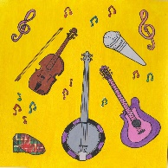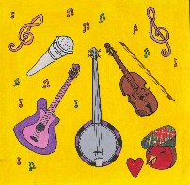
MUSIC
National Curriculum Links Key Stage 1

- Use their voices expressively and creatively by singing songs.
- Play untuned instruments musically.
- Experiment with, create, select and combine sounds using the inter-related dimensions of music.
Sing a collection of farm songs : Old MacDonald had a farm, Little Boy Blue, Five little ducks, The farmer’s in his den, Three blind mice, Little Bo Peep, Baa, Baa Black sheep.

Listen and sing along to a collection of farm songs

Rhythm game
Sit children in a circle. Clap out a very simple rhythm. Children pass on that rhythm. Increase the level of difficulty gradually. Once the children are used to this, play this as a competition. The person getting the rhythm wrong, sits with arms folded. The last child to play the game is the winner.

Class Farm Animal Sound Rap
Ask the children to think of the different sounds that farm animals make.
Write the animal name on the whiteboard with the animal sound next to it.
e.g. cow- moo, sheep -baa, pig- oink, chicken- cluck, duck-quack, horse -neigh, goat beh
Make a class sound rap out of these sounds.
e.g. Oink, oink, baa, baa, baa
Quack, quack, cluck, cluck, cluck
Neigh, Neigh, beh, beh, beh
Mooooooooooooooo!

Make different sound raps using the same farm animal sound words.
Choose different percussion instruments to represent the animal noises. Children practise and perform their composition.

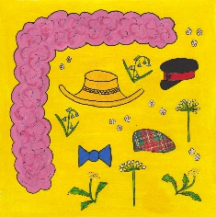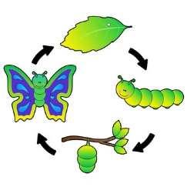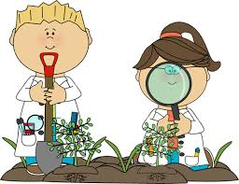
SCIENCE YEAR 1
Animals, including humans
NFU Science Farm https://education.nfuonline.com/ScienceFarm

Life Cycles Lesson Plan
Working Scientifically
Use observations and ideas to suggest answers to questions.
Animals, including humans-Year 1
- Be able to explain and order a simple life cycle.
- Identify and name a variety of common animals.
L.O. To recognise that the same animal can have several different names dependent on its age and gender.
Follow ideas in Life Cycles lesson plan.
Available resources: life cycle cards, animal and baby quiz, life cycle video clip
https://www.everyschool.co.uk/science-key-stage-1-life-cycles.html
Find out more about life cycles on this website.
Caterpillar to butterfly; tadpole to frog; life cycle of an oak tree
https://www.bbc.co.uk/bitesize/clips/zhrb4wx
Learn about the life cycle of a dandelion.

Plants-Year 1
Identify the different Spring flowers in The Meadow Farm Band- dandelion, daisy, bluebell, apple blossom, cow parsley. Go on a plant hunt in the school playground. Draw ,name and label a plant.
Carrot Diary Lesson Plan
Working Scientifically
- Observe closely
- Perform simple tests
- Use observations and ideas to suggest answers to questions.
- Gather and record data
Plants
- Identify and describe the basic structure of plants.
L.O. To have a go at growing a carrot and record my method.
Follow ideas in Carrot Diary lesson plan.
Available resources: carrot diary template, carrot diary video clip
https://www.everyschool.co.uk/science-key-stage-1-plants.html
Find more about plants on this website.
How to grow a bean plant; How to grow seeds; learn about Darwin’s discoveries; How to label a plant.

