Meadow Farm has a secret. Behind the scenes, some of the animals are very musical. Robbie Robin wants them to form a band, but one animal feels so left out…How can Robbie put things right? The Meadow Farm Band’ teaches children the value of Inclusion and can be used as an early anti-bullying intervention. It is an ideal book for using as part of an ‘Animals’ topic in Key Stage 1, with several possible cross-curricular links in Literacy, Music, Art, Science and PSHE. Share ‘The Meadow Farm Band’ Kindle Edition with the children on the interactive whiteboard. Buy paperback copies for children to read independently. These resources are free to download and can be adapted to suit the needs of your children. Resources highlighted in RED are downloadable in the same section as the Teaching Resources.
YEAR TWO LITERACY
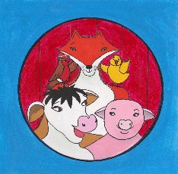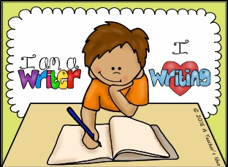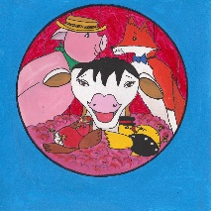
Overall Learning Aims
- To explore, interpret and respond to illustrations.
- To use role play to develop empathy for empathize with story characters.
- To write character descriptions.
- To use drawing and story maps to develop story structure skills.
- To talk story ideas through confidently and effectively.
National Curriculum Links Year 2
Speaking and Listening
- Listen and respond appropriately to adults and their peers.
- Articulate and justify answers, arguments and opinions.
- Use spoken language to develop understanding through speculating, imagining and exploring ideas.
- Participate in discussions, roleplay, performances and debates.
- Speak audibly and fluently with an increasing command of Standard English.

Reading-Word reading/Comprehension  - Link what they read or hear read to their own experiences.  - Make inferences on the basis of what is said and done.  - Predict what might happen on the basis of what has been read so far.  - Participate in discussion about what is read to them, taking turns and listening to what others say.  - Explain clearly their understanding of what is read to them. | Writing-Transcription/Composition  - Plan or say out loud what they are going to write about.  - Write down ideas and key words, including new vocabulary.  - Re-read to check that their writing makes sense and that verbs are used correctly and consistently, including verbs in the continuous form.  - Read aloud what they have written with appropriate intonation to make the meaning clear.
Character Description

Read story-use illustrations to expand on details e.g. season, expressions, predictions. See story question prompt sheet for ideas.
Ask the children what they think the message of the story is. Write ideas up on the whiteboard and then link this to their own life experiences. What is their favourite character and why? Choose a character as a class. Children write words and phrases to describe that character using a mini whiteboard and pen. Share ideas with the rest of the class.
Children write a description of their favourite Meadow Farm Band and give reasons for their choice.

Story Recount

Children read ‘The Meadow Farm Band’ text with actions using interactive whiteboard. As a class, create a very quick story map using simple drawing and sentence openers. Explain the role of a story map and how it is important to include all elements for a good story structure.
Children draw their own story map within a specific time e.g. 5 minutes. Have they included all elements?
Children write a story recount for The Meadow Farm Band using differentiated story recount writing frames.

Character Profiles

Children read ‘The Meadow Farm Band’ text with actions using interactive whiteboard and then from memory.
Look at overview of the farm on the first double page spread. Who knows the secret on Meadow Farm? What do we know about Robbie Robin? How is Robbie a quiet leader?
Read Robbie Robin’s character profile.
Children write a character profile for another Meadow Farm story character using a blank character profile writing frame.

Story Character Creation

Children recite ‘The Meadow Farm Band’ with actions from memory.
Tell the children that Robbie Robin is looking out for a new member for The Meadow Farm Band. Children suggest different farm animals that could be part of the band. Write suggestions up on the board. What instruments could they play?
Children work with a partner to create a new story character for the band. They complete a character profile for the new member using a blank character profile writing frame.

Creative Writing

Children recite ‘The Meadow Farm Band’ with actions from memory.
They take turns to share their ideas for a new band member. Discuss possible ideas for a story with the new story character.
Children draw a story map for their story and share with a talk partner. Remind the children that a story has to have a beginning, middle and end.
Children write their own story using their new story character and at least two of the original Meadow Farm characters.

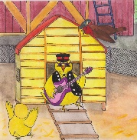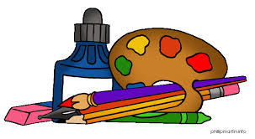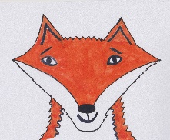
ART AND DESIGN
National Curriculum Links Key Stage 1
- To use a range of materials creatively to design and make products.
- To use drawing, painting and sculpture to develop and share their ideas, experiences and imagination.
- To develop a wide range of art and design techniques in using colour, pattern, texture, line, shape, form and space.

Children use step by step instructions to draw a chosen character for The Meadow Farm Band in their sketch books. Colour story character in. They then draw the same Meadow Farm story character doing different everyday things e.g. brushing its teeth, eating breakfast, playing football. Encourage the children to do lots of sketches and not to worry about making mistakes.

Look at 10 famous animal paintings using the link below and read out information about the ten artists. Children their response to the different famous paintings. How are they different from each other? Which painting is their favourite and why?
https://www.zippi.co.uk/thestudio/10-famous-animal-paintings/

Give children a choice of step by step instructions for drawing different farm animals-goat, sheep, mallard duck or horse.

Children practise drawing one of the above animals in a realistic way at first. They then create their own funny farm animal story character.

Possible links with Literacy.
- Write a character profile for their new story character.
- Plan and write a story about that character.
- Write a set of step by step drawing instructions for their own story character.

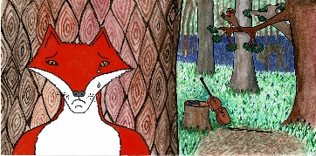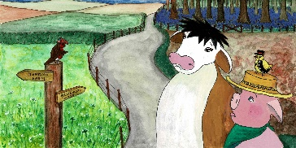
PSHE
Health and Wellbeing
- Learn about good and not so good feelings and develop a vocabulary to describe their feelings to others and simple strategies for managing feelings.
- Learn rules for and ways of keeping physically and emotionally safe.

Relationships
- To share their opinions on things that matter to them and explain their views through discussion with one other person and the whole class.
- Know that there are different types of teasing and bullying, that these are wrong and unacceptable.
- Learn how to resist teasing or bullying, if they experience or witness it, whom to go to and how to get help.

https://www.anti-bullyingalliance.org.uk/anti-bullying-week/anti-bullying-week-2019-change-starts-us
Anti-Bullying Week takes place 11th-15th November 2019. The Anti-bullying Alliance website offers excellent resources and advice on what to do if you are being bullied or if you see any bullying take place. Click on the link below for Top Tips power points.

https://www.anti-bullyingalliance.org.uk/tools-information/if-youre-being-bullied/i-am-being-bullied

What is Bullying?
Ask the children what they think the word ‘bullying’ means. Write done children’s answers and ideas on the whiteboard. Watch the BBC Bitesize video clip below, during which children explain that there are two types of bullying-emotional bullying [excluding people and unkind remarks] and physical bullying[violence].

https://www.bbc.co.uk/bitesize/clips/zqypyrd
Talk about how Carlene Cow, Chuck Chick and Peter Pig exclude Felix Fox and how this is a form of bullying. Ask the children why they think that the farm animals didn’t want Felix Fox in the band. Were they afraid because they didn’t know him? Did they think make a judgement already about all foxes? Do we do this in real life too? What are the effects of bullying and how does it make people feel? Who can Felix Fox trust in this story? Robbie Robin. What did Robbie Robin do to help put things right? We all make mistakes and we can all be guilty of being unkind, leaving someone out. It is important that we face up to our mistakes, like the animals did, say sorry and then try to put things right.

Children share their response to the story with a talk partner. Discuss thoughts as a whole class. Develop strategies to support anyone in the class who is experiencing bullying in any way. See Anti-Bullying Alliance website and follow guidance in schools regarding any follow up action.

From Bully to Best Friend
Recap on what we have learned about the word bullying. Have there been any changes in behaviour since the previous lesson? Encourage the children to share how they have been able to learn t=from their mistakes.
What the BBC Bitesize video clip below, showing how a young girl eventually found enough courage to tell her teacher that she was being bullied.
https://www.bbc.co.uk/bitesize/clips/zkhmhyc
Children discuss the video with a talk partner first. How was the teacher able to help the young girl? Why was this also good for the bully? Remind the children of the importance to tell someone you trust if you are being bullied.
RESPECT
Ask the children what the word RESPECT means. Write their ideas on the whiteboard. Listen to the Sesame Street video about RESPECT.
https://www.youtube.com/watch?v=GOzrAK4gOSo
Recap on the meaning of Respect. Treating people how you would like to be treated. Make others feel important and show that you care. Be kind and appreciate others. If someone has a different opinion to you, you should still show respect for them.

Children learn and singalong to Respect song.
https://www.youtube.com/watch?v=ZgidfFs-j4M
How can we show Respect to one another? How does Respect help us to prevent bullying?
Children work with a partner to design an Anti-bullying poster that includes the importance of showing Respect.

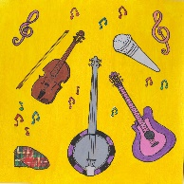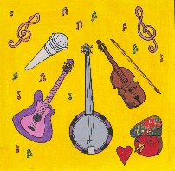
MUSIC
National Curriculum Links Key Stage 1
- Use their voices expressively and creatively by singing songs.
- Play untuned instruments musically.
- Experiment with, create, select and combine sounds using the inter-related dimensions of music.
Sing collection of farm songs.
Name different musical instruments-sort them into groups. Learn about string instruments, wind instruments and percussion instruments.

https://www.bbc.co.uk/bitesize/clips/zmqn34j
This is a fun, animated introduction to jazz music. Children learn to click out a steady pulse and add a word rhythm. They can sing along to the words of Slick City Spats and think of dance moves that could go along with the jazz feel of the music.

https://www.bbc.co.uk/bitesize/clips/zbv87ty
Once children have learned the jazz song ‘Slick City Spats, they can perform it to the animated clip shown in the link above.

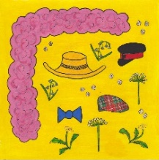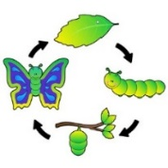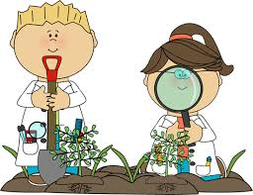
SCIENCE YEAR TWO
NFU Science Farm https://education.nfuonline.com/ScienceFarm
Hedgerow Habitats -lesson Plan
Working Scientifically
- Observe closely, using simple equipment.
- Identify and classify.
- Use observations and ideas to suggest answers to questions.
Living things in their habitats-Year 2
- Explore and compare the differences between things that are living, dead and things that have never been alive.
- Identify that most living things live in habitats to which they are suited and describe how different habitats provide for the basic needs of different kinds of animals and plants, and how they depend on each other.
- Identify and name a variety of plants and animals in their habitats, including microhabitats.
L.O. To be able to explain the definition of a habitat.
To investigate a habitat and identify different life forms within it.
Follow ideas in Hedgerow Habitats lesson plan.
Available resources: Look what I have found cards -Activity 1, I live in the hedgerow-Activity 2 Hedgerow habitats video clip
Food Chains-lesson Plan
Working Scientifically
- Observe closely, using simple equipment.
- Identify and classify.
- Use observations and ideas to suggest answers to questions.
Living things in their habitats-Year 2
- Describe how animals obtain their food from plants and other animals, using the idea of a simple food chain, and identify and name different sources of food.
L.O. To independently create a simple food chain.
Follow ideas in Food Chains lesson plan.
Available resources: Guess the animal PowerPoint, Food chains video clip
https://www.everyschool.co.uk/science-key-stage-1-animals.html
Find out more about Living things in their habitats on this website. habitats game: animal photos.
https://www.bbc.co.uk/bitesize/topics/zx882hv
This website offers video clips a wide range of habitats. Compare and contrast with habitats on the farm.

