**Likes**

*Music, happiness, laughter, kindness, forgiveness, humility, and most of all learning from mistakes! Like us all, he has made plenty!*

**Dislikes**

*Unkindness, selfishness, when animals don’t say sorry to each other, when anyone feels left out.*

**Favourite Music**

*Robbie Robin especially loves Scottish singalong songs like ‘Donald where’s yer troosers’, ‘Campbeltown Loch’ and ‘The Muckin o’ Geordie’s Byre’.*

*As he lives on an English farm now, he doesn’t get to hear those songs so much! However, Robbie Robin just loves it when he hears animals make music together!*

**Personality**

*Robbie Robin is incredibly kind and thoughtful. He is a bright light shining on Meadow farm. Robbie Robin has a really good view of what is going on at the farm. He really cares about other animals’ feelings and becomes so concerned if anyone is feeling unhappy. He knows when to stay in the background and when to stand up and take action.*

**Job Description**

*Founder and Manager of The Meadow Farm Band*

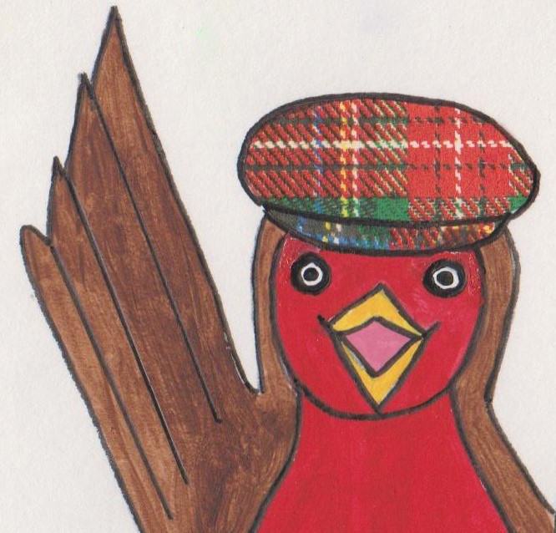

**Character Name**

*Robbie Robin*