**The Applewood Almanac**

Fall Edition – October, 2018

The James Shaver Woodsworth Homestead Foundation

450 The West Mall, Etobicoke, ON M9C 1E9

Telephone: 416-622-4124

E-mail: jswoods@bellnet.ca

Website: [www.applewoodshaverhouse.ca](http://www.applewoodshaverhouse.ca)

**Applewood’s Fall Events:**

**Famous Players Theatre Buffet & Show: Sunday April 22 at 11:30 am**

**Christmas Craft Sale: Sunday, October 20, 10am – 3 pm**

**PRESIDENT’S MESSAGE**

What a summer it has been! It one of the hottest and driest in recent memory. Oh those air-conditioning and lawn-watering bills! Applewood acquired

The old admonition, “Why wait for spring – do it now!” has been taken to heart at Applewood this year. Several projects are underway or have already been completed at ‘our old house’, and we hope you’ll drop by to appreciate the improvements.

As the photo to the right shows, our multi-talented Terry Faichnie and her helper Heidi show off the renovations they completed (well, mostly Terry) in our basement Museum Room. The culmination of a make-over project that included a new ceiling, new lighting, a paint refresh, a new wall-mounted artifact display case, and several new displays (complete with signage), this tribute to the homestead’s history is a highlight for school tours that have already started. We now have a more attractive and brighter space with extra space to show off our treasures.

Another major renovation approved by the Board is a complete replacement of the ground-floor carpeting. After a good 30-plus years of service, the venerable Eaton’s 100% wool carpet is showing significant wear. Eaton’s may be gone, but pure wool is still the best material, and we hope you’ll enjoy the new floor covering we’ve ordered for the house. Hopefully, we will be admiring it for the next three decades!

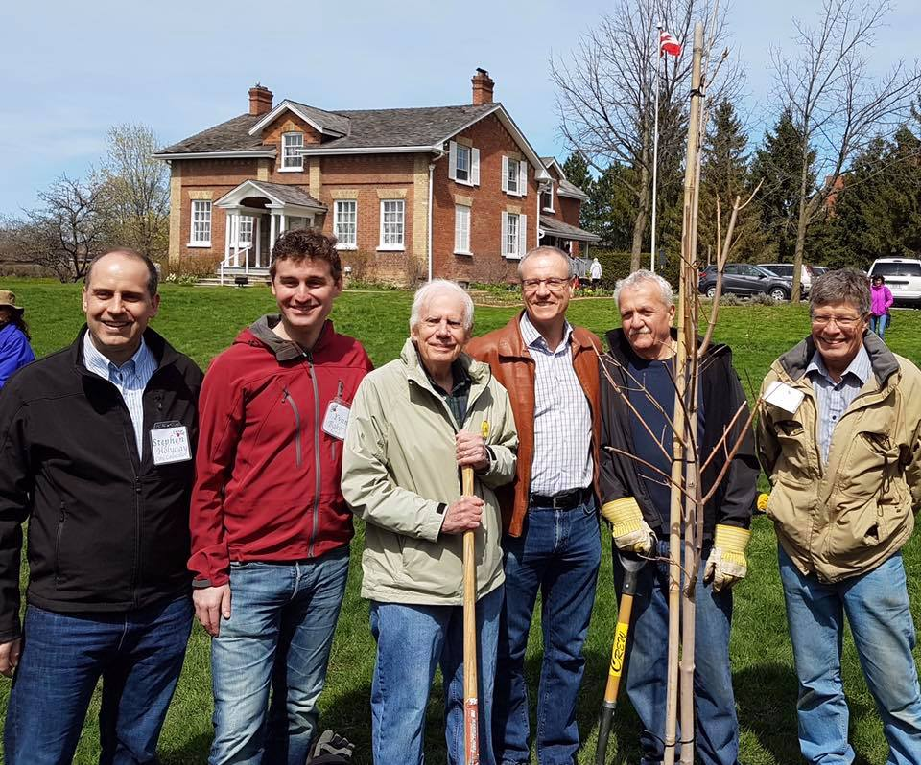Our newest Board member, Johann Fisch, is already well-known to the Applewood family as our “green” advocate and sponsor of many tree-plantings in Broadacres Park. Last summer, Metroland Media (publisher of the Etobicoke Guardian) hosted their Urban Hero awards in celebration of Canada’s 150th birthday. One of the eight categories was to recognize positive local changes to the environment, and in October, Johann received the People’s Choice award in the Environment category! As well as restoring a naturalized forest area in Broadacres over a period of three decades, Johann is active every Earth Day planting additional fruit trees, cleaning up the park, and promoting awareness of environmental issues. His concern for the planet’s future is evident every day in Johann’s words and deeds.

Johann’s “tree planting” crew on Earth Day 2017, putting in the “Willoughby Sugar Maple” on the occasion of Canada’s 150th. L-R: Stephen Holyday, Yvan Baker, Doug Willoughby, Borys Wrzesnewskyj, Johann Fisch, Dave Young

Finally, I am sad to report the retirement of one of Applewood’s long-time Directors, Molly Sutherland. Molly’s involvement with the preservation of the homestead actually predates the move of the house to its present location in 1980. Molly was secretary of the original Shaver Homestead Committee that did the “heavy lifting” to save Applewood. As well as serving in the Etobicoke Historical Society, Molly was on the Applewood Board and served as our Secretary and Almanac Editor for many years. As Molly retires for a well-deserved rest and to devote more time to her family, the JSWH Board of Directors expresses our heartfelt gratitude for her stalwart service.

Dave Young, President

**Peter Peachey Receives Community Recognition Award**

On January 14th, Applewood’s own Peter Peachey was honoured by Yvan Baker, MPP for Etobicoke Centre, at his annual Volunteer Recognition Awards event at the Plast Huculak Centre. Peter was given this award for outstanding volunteer services to the community and, in particular, his significant contributions to Applewood over the last 37 years. Peter and his wife Joyce were joined by an enthusiastic group of Applewood members and friends.

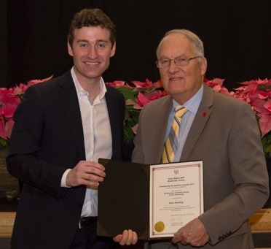Peter Peachey looms large in the history of Applewood’s preservation because he was the one that Stewart East approached in the early days to plan and execute the move of the building from 471 Burnhamthorpe to 450 The West Mall. Without Peter’s help as then-President of The Valhalla Companies Ltd, the technical and logistical problems of moving the house would have defeated the project. But the September 1980 move was a success, and Peter was elected as the first President of The James Shaver Woodsworth Homestead Foundation, serving in that role for seven years. Peter remains an honourary member of the Board and a valued participant in many Applewood proceedings.

Congratulations Peter!

- by Rob Evans

Peter receiving his award from MPP Yvan Baker

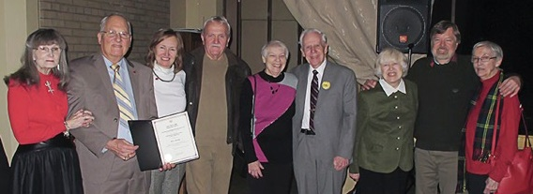

Joyce & Peter Peachey with Applewood friends: Gay, Johann, Molly, Doug, Jean, Rob, Lorraine

**A New Applewood Charity Event for Fall 2018**

Support two wonderful charities “Applewood” and “Famous People Players” at one great event on October 20, 2018. The Applewood fall event this year will be the Saturday Matinée dinner and performance at the Famous People Players Dinner Theatre, 343 Evans Ave, Etobicoke. Tickets are only $65 per person. Call Debbie at Applewood, 416-622-4124, to book.

The show is a musical fantasy that FPP presented on Broadway to rave reviews. The dinner has received its own enthusiastic reviews in the Financial Post and the Toronto Star, with a menu that includes a gourmet three-course meal that’s also been featured on the Food Network's #1 series, “Chef at Large”.

The black light performance of Famous People Players was discovered by Liberacé, and they were his opening act in Las Vegas for 10 years. Their success continued with two runs on Broadway and performances in China, Korea and Singapore, and throughout the United States. Their Dine & Dream Theatre in Etobicoke was generously sponsored by actor Paul Newman through sales of Newman’s Own products. He remained a very devoted supporter and honorary director on their board. More info about FPP can be found at <http://famouspeopleplayers.com/> .

**Our 2018 Event Schedule**

The nearest upcoming events are highlighted in the “billboard” at the front of this newsletter, and one of our convenient reference cards is included with this mailing of the Almanac for your reference. If you misplace both, just go to our web site at [www.applewoodshaverhouse.ca](http://www.applewoodshaverhouse.ca/) and look under “More > Events”.

As usual, please mark your calendars, and plan to join us at Applewood’s Twilight Concerts this summer as our wonderful musical tradition continues! ***Remember - bring your chair or a blanket to sit on***.

**The Gardeners Journal**

Nothing is showing in the gardens yet, so this is the time to look at gardens on the Internet and dream of what is to come to us ... soon, we hope!

So I found that, in the language of flowers:

**DANDELION** = Faithfulness, Happiness

**FERN** = Magic; Fascination; Confidence and Shelter

**DAFFODIL** = Regard; Unrequited Love; You're the only one; The sun is always shining when I'm with you

**COREOPSIS** = Always Cheerful

I also found one beautiful video about “Wild Sweden”, a country with natural beauty similar to Canada’s that goes from winter to spring and summer, just like us. It has gorgeous scenery and music:

<https://www.youtube.com/embed/SB8WlqfJJRE?feature=player_detailpage> .

Finally, Applewood is always looking for volunteers who can assist with tending our award-winning gardens. No experience necessary. We’ll teach you everything you need to know in our on-the-job program! And remember, honeybees need our flowers too.

- by Odile Sahl

***In closing, we remind those of you who may not yet have done so, please renew your membership in the JSWH Foundation. We depend on and greatly appreciate your continued support.***