THE JAMES SHAVER WOODSWORTH HOMESTEAD FOUNDATION
450 THE WEST MALL, ETOBICOKE, ONTARIO, M9C 1E9
TELEPHONE: 416-622-4124 FAX: 416-622-9403
E-mail: jswoods@bellnet.ca Website:
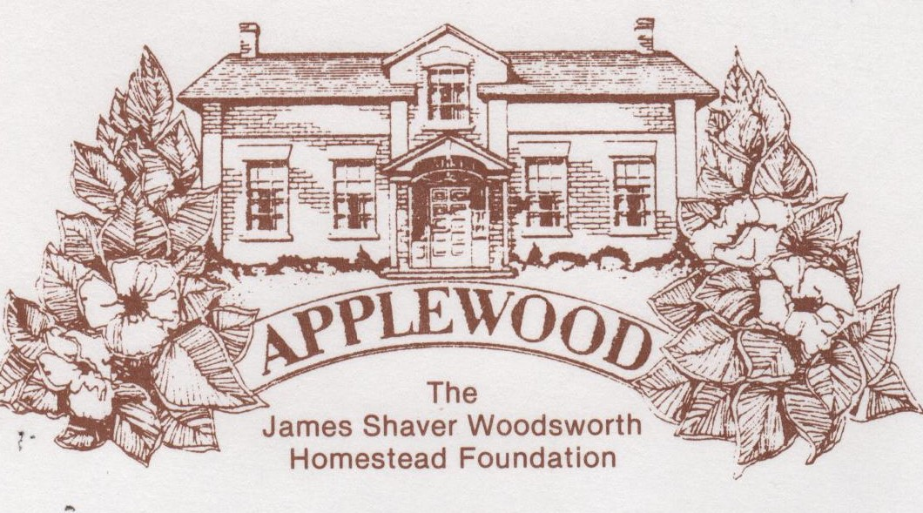

RENTAL FACILITIES AGREEMENT

Name: Phone #: ________________ Email:

Event Date: Time: _ # of Persons _

FEES: Weekends: maximum 12 pm - 5 pm $350 (flat rate)

The above fees are charged for the use of the main floor and/or the basement.

It is understood and agreed that the following conditions apply:
- A staff member will be present to assist you during the event.
- Applewood/The Shaver House closes at 5:00 pm (9:00pm if evening event).
- The applicant is responsible for cleaning the facilities and leaving them in the same condition in which they were prior to rental.
- Rental charges begin when you or your caterer enter the building to make preparations and end when clean up is completed, and everyone has left the building.
- Please remove all party or event garbage from the house and place it in the designated receptacles. Flatten all boxes and bulk trash. Please do not place these items in plastic bags as pick up will be refused.
- NO SMOKING allowed in the house. Smoking permitted outside only.
- Finger foods only
- The maximum number of persons allowed on the premises is 40.
- Free parking is available for about 14 cars. Car pooling is recommended.
- Alcohol is NOT permitted on the premises.

PAYMENTS
Full payment is due at time of booking.
LIABILITY
The applicant in whose name the facilities have been reserved shall be liable for all damage and loss to any of the facilities.

I have read and agree to the terms and conditions set out in this agreement.

Applicant’s Signature: ______________________________ Date: ____________

Payment received:_ Receipt# Date:

