Fifteenth Sunday
After Pentecost
“God Meant It for Good”
Genesis 50:15-21

September 13, 2020

Messiah Lutheran Church
Lutheran Church-Missouri Synod
4102 Trinity River Dr., Corpus Christi, Texas 78410

Pastor: Rev. Scott E. Herbert

Church Phone: 361-387-7748 Email: mlc@stx.rr.com
Church Fax: 361-767-1768 Website: www.messiahlcms-cc.org
Pastor Phone: 469-644-4772 Pastor Email: chirev59@gmail.com

WELCOME TO MESSIAH!
We are glad you are here to receive what God is doing for you during Divine Service. Please sign our Guest Book located near the front door. Feel free to converse quietly until the organ prelude begins. If you are looking for a church home, please talk to the Pastor at the door. We would love to have you join us.

Preparing for Service
Forgiving as the Lord Forgives Us
In settling His accounts with us, our Lord acts not with anger, but with compassion. He does not imprison us as we deserve, but He forgives all our debts and releases us (Matt. 18:23–27). Therefore, our Lord bids each of us to have “mercy on your fellow servant” and “forgive your brother from your heart” (Matt. 18:33, 35). By the Lord’s forgiveness of our sins, we are free to forgive those who sin against us, because He has been handed over to the jailers in our stead and He has paid our entire debt with His lifeblood. Whether we live or die, we “are the Lord’s” (Rom. 14:8). Since we all will “stand before the judgment seat of God,” we are not to despise our brother (Rom. 14:10), but gladly forgive him. By the grace of God, our brother also “will be upheld, for the Lord is able to make him stand” (Rom. 14:4). Though we daily sin against each other, the Lord intends “to bring it about that many people should be kept alive” (Gen. 50:20). Jesus speaks kindly by His Gospel and promises: “I will provide for you and your little ones” (Gen. 50:21).

Confession and Absolution
496 Holy Spirit, Light Divine
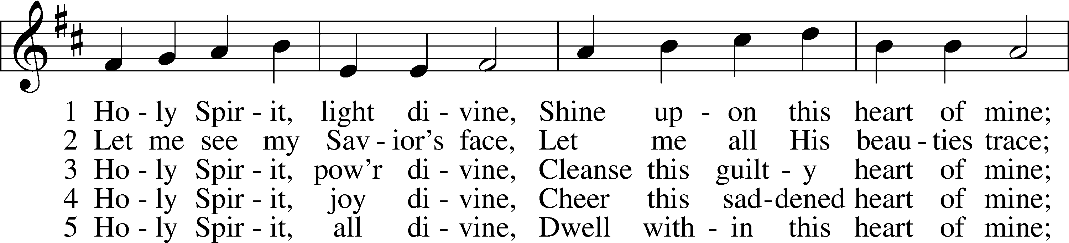
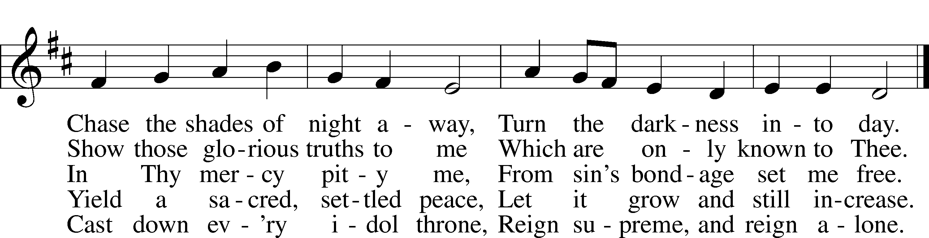
Tune and text: Public domain

P In the name of the Father and of the T Son and of the Holy Spirit.
C Amen.

P Beloved in the Lord! Let us draw near with a true heart and confess our sins unto God our Father, beseeching Him in the name of our Lord Jesus Christ to grant us forgiveness.

P Our help is in the name of the Lord,
C who made heaven and earth.
P I said, I will confess my transgressions unto the Lord,
C and You forgave the iniquity of my sin.

P O almighty God, merciful Father,
C I, a poor, miserable sinner, confess unto You all my sins and iniquities with which I have ever offended You and justly deserved Your temporal and eternal punishment. But I am heartily sorry for them and sincerely repent of them, and I pray You of Your boundless mercy and for the sake of the holy, innocent, bitter sufferings and death of Your beloved Son, Jesus Christ, to be gracious and merciful to me, a poor, sinful being.

P Upon this your confession, I, by virtue of my office, as a called and ordained servant of the Word, announce the grace of God unto all of you, and in the stead and by the command of my Lord Jesus Christ I forgive you all your sins in the name of the Father and of the T Son and of the Holy Spirit.
C Amen.

Service of the Word

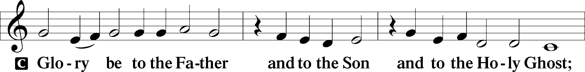
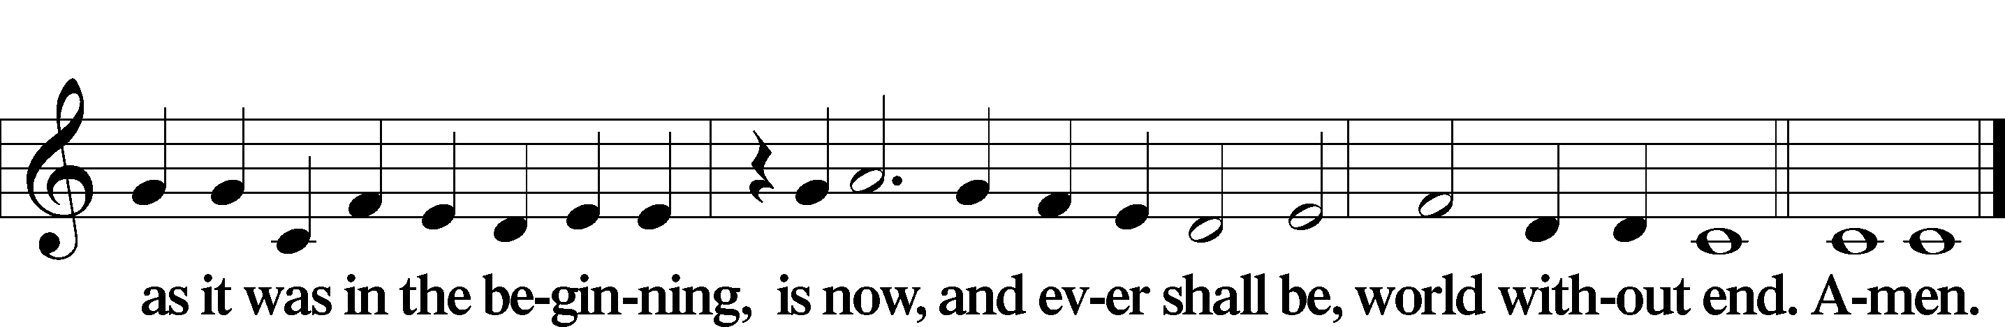

Kyrie LSB 186
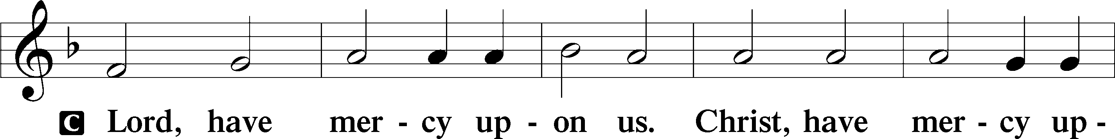
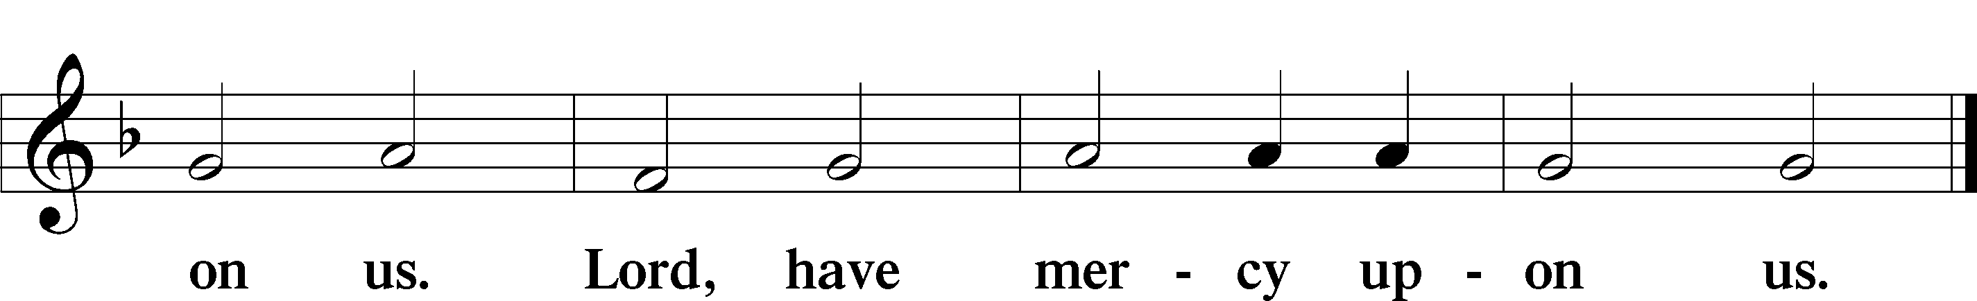

Gloria in Excelsis LSB 187
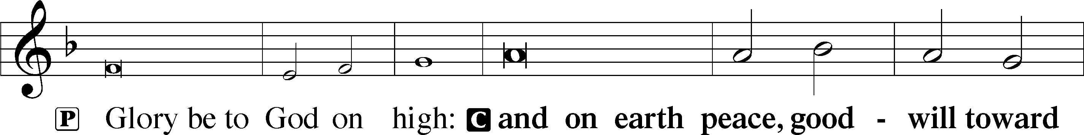
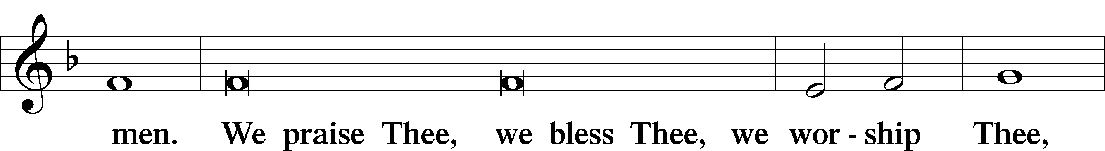
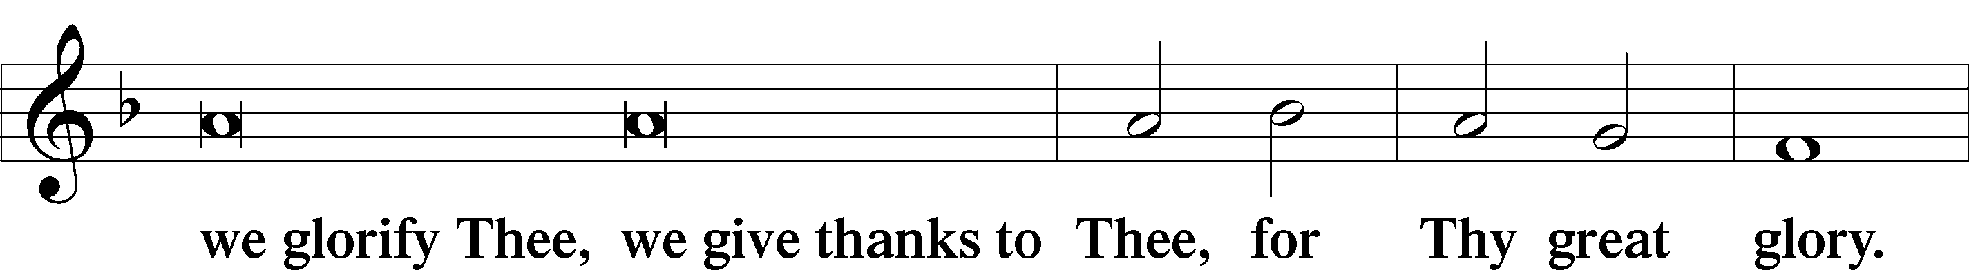
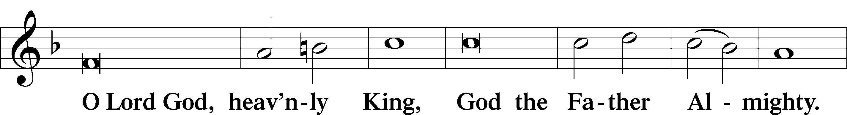
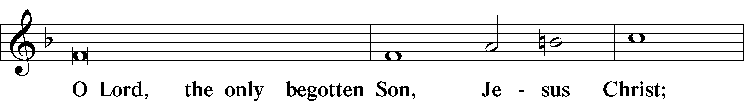
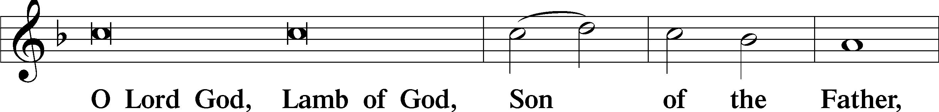
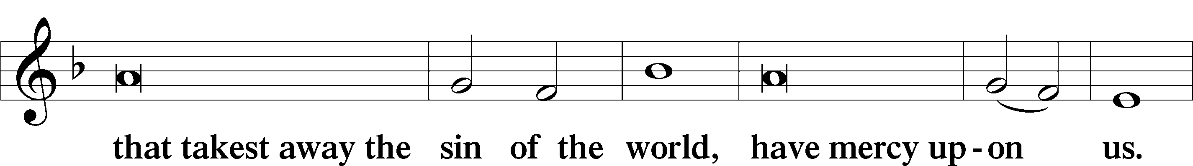
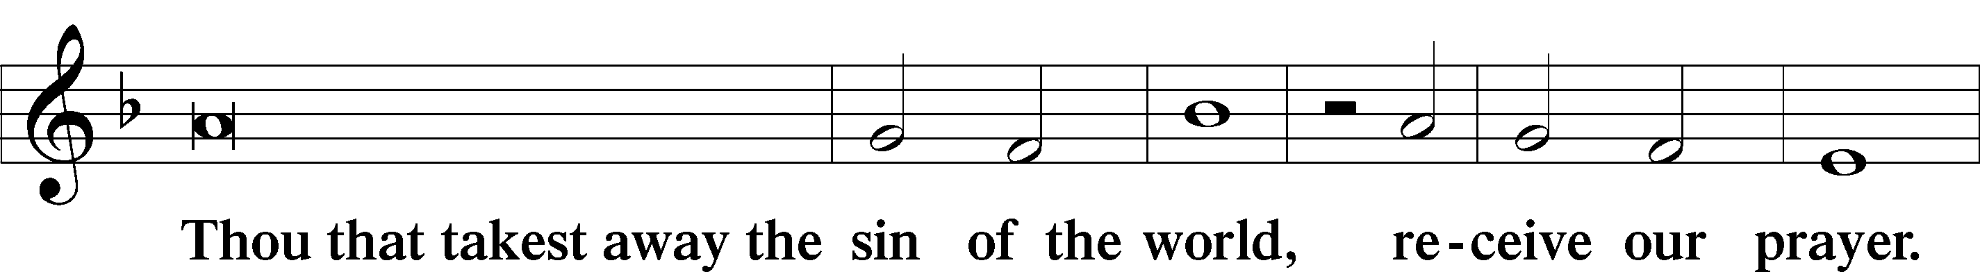
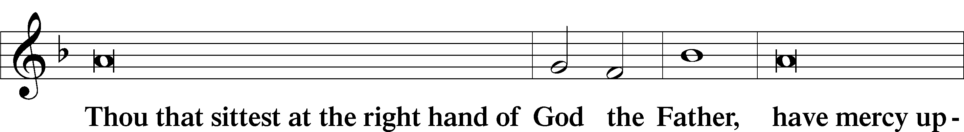
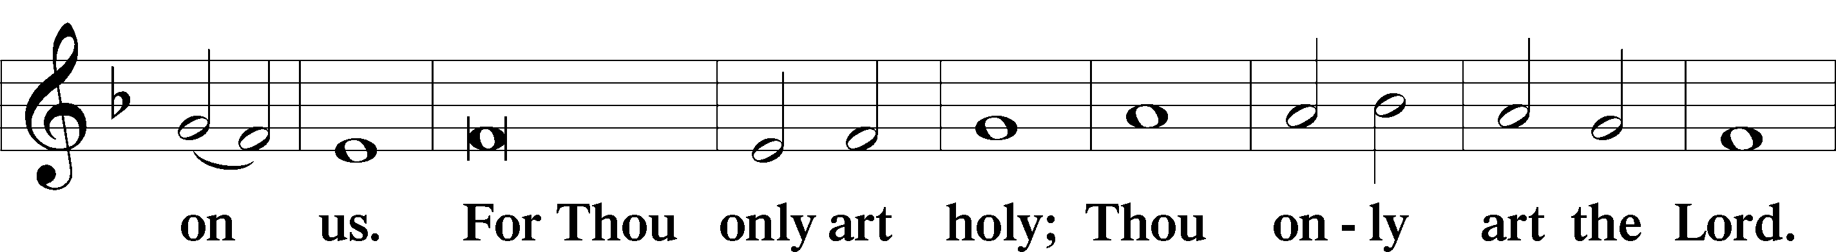
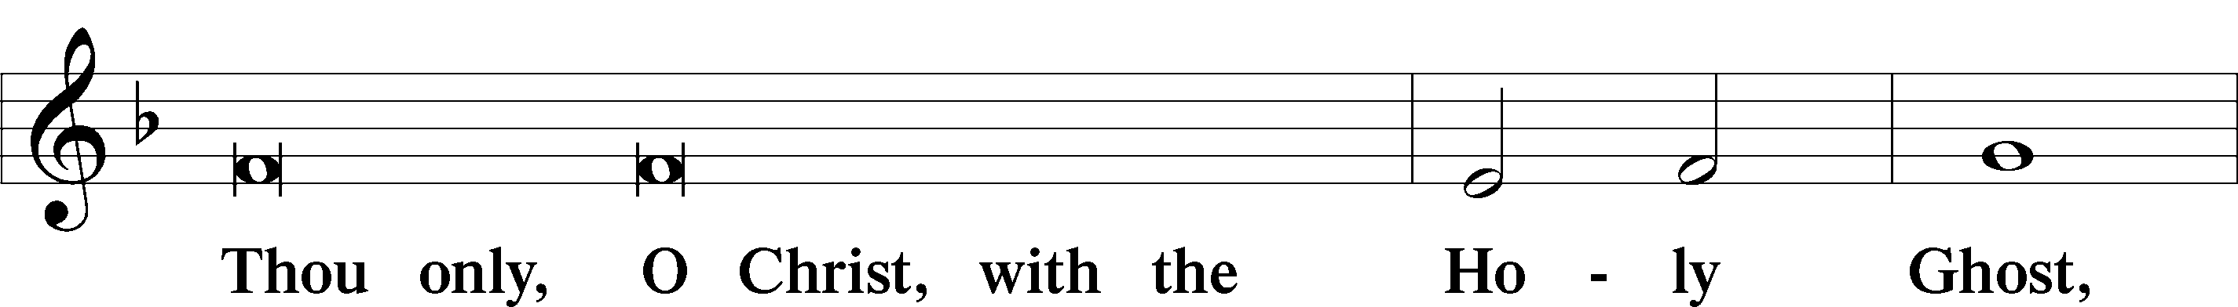
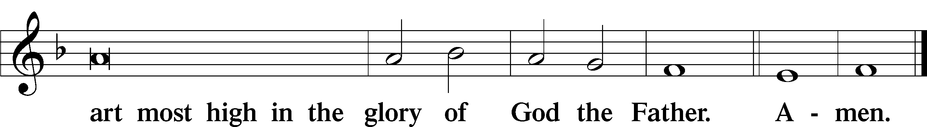
Salutation and Collect of the Day
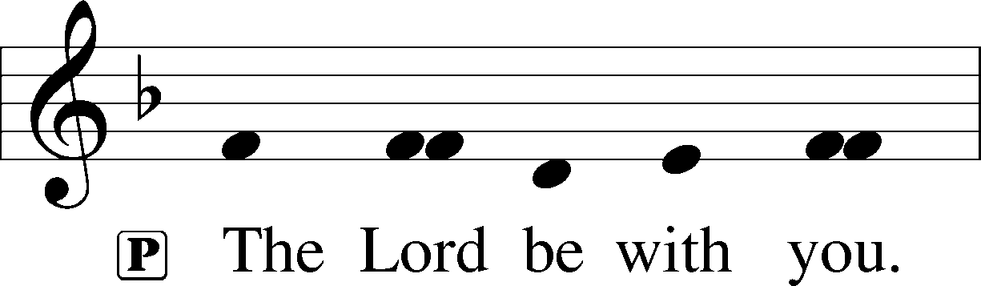
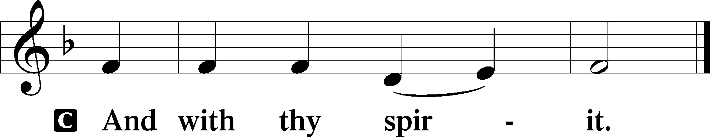
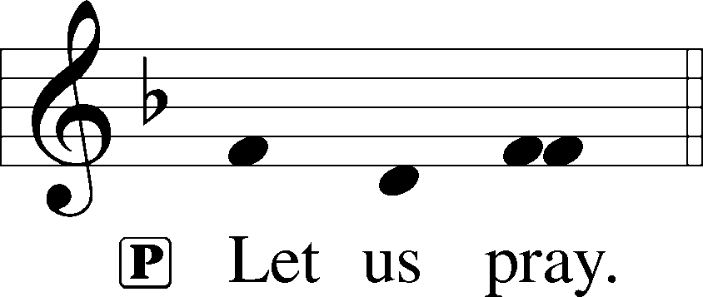

P O God, our refuge and strength, the author of all godliness, hear the devout prayers of Your Church, especially in times of persecution, and grant that what we ask in faith we may obtain; through Jesus Christ, our Lord, who lives and reigns with You and the Holy Spirit, one God, now and forever.
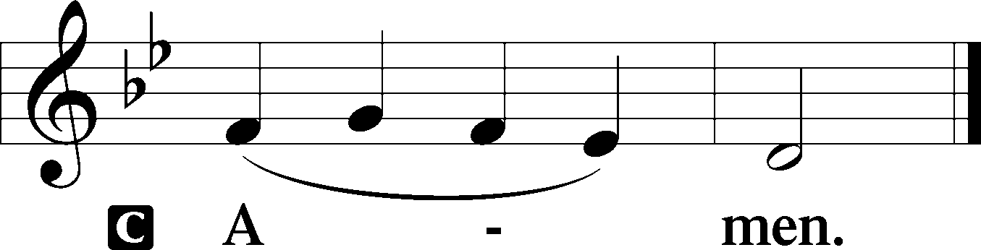

Old Testament Reading Genesis 50:15–21
15When Joseph’s brothers saw that their father was dead, they said, “It may be that Joseph will hate us and pay us back for all the evil that we did to him.” 16So they sent a message to Joseph, saying, “Your father gave this command before he died, 17‘Say to Joseph, Please forgive the transgression of your brothers and their sin, because they did evil to you.’ And now, please forgive the transgression of the servants of the God of your father.” Joseph wept when they spoke to him. 18His brothers also came and fell down before him and said, “Behold, we are your servants.” 19But Joseph said to them, “Do not fear, for am I in the place of God? 20As for you, you meant evil against me, but God meant it for good, to bring it about that many people should be kept alive, as they are today. 21So do not fear; I will provide for you and your little ones.” Thus he comforted them and spoke kindly to them.
A This is the Word of the Lord.
C Thanks be to God.
Psalm Psalm 103:1–5, 8, 10—12
1Bless the Lord, O my soul,
and all that is within me, bless his holy name!
2Bless the Lord, O my soul,
and forget not all his benefits,
3who forgives all your iniquity,
who heals all your diseases,
4who redeems your life from the pit,
who crowns you with steadfast love and mercy,
5who satisfies you with good
so that your youth is renewed like the eagle’s.
8The Lord is merciful and gracious,
slow to anger and abounding in steadfast love.
10He does not deal with us according to our sins,
nor repay us according to our iniquities.
11For as high as the heavens are above the earth,
so great is his steadfast love toward those who fear him;
12as far as the east is from the west,
so far does he remove our transgressions from us.

Epistle Romans 14:1–12
1As for the one who is weak in faith, welcome him, but not to quarrel over opinions. 2One person believes he may eat anything, while the weak person eats only vegetables. 3Let not the one who eats despise the one who abstains, and let not the one who abstains pass judgment on the one who eats, for God has welcomed him. 4Who are you to pass judgment on the servant of another? It is before his own master that he stands or falls. And he will be upheld, for the Lord is able to make him stand.
5One person esteems one day as better than another, while another esteems all days alike. Each one should be fully convinced in his own mind. 6The one who observes the day, observes it in honor of the Lord. The one who eats, eats in honor of the Lord, since he gives thanks to God, while the one who abstains, abstains in honor of the Lord and gives thanks to God. 7For none of us lives to himself, and none of us dies to himself. 8If we live, we live to the Lord, and if we die, we die to the Lord.
So then, whether we live or whether we die, we are the Lord’s. 9For to this end Christ died and lived again, that he might be Lord both of the dead and of the living.
10Why do you pass judgment on your brother? Or you, why do you despise your brother? For we will all stand before the judgment seat of God; 11for it is written,
“As I live, says the Lord, every knee shall bow to me,
and every tongue shall confess to God.”
12So then each of us will give an account of himself to God.

A This is the Word of the Lord.
C Thanks be to God.

Alleluia LSB 190
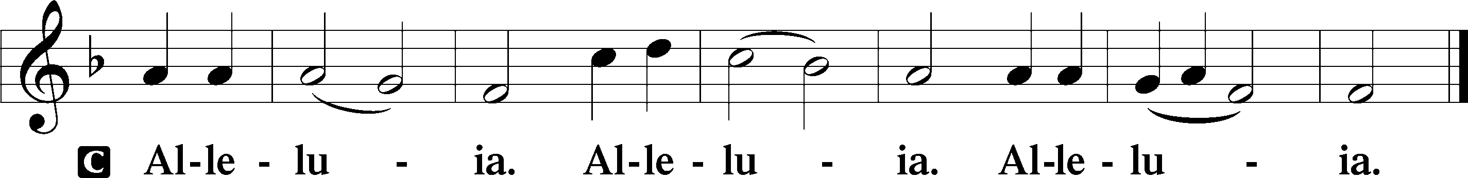

Holy Gospel Matthew 18:21–35
P The Holy Gospel according to St. Matthew, the eighteenth chapter.

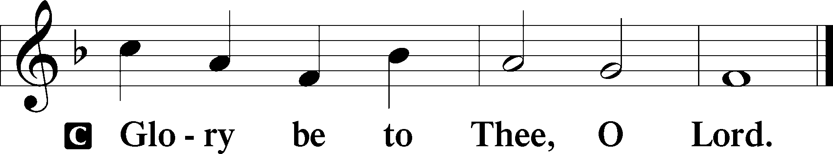

21Peter came up and said to [Jesus], “Lord, how often will my brother sin against me, and I forgive him? As many as seven times?” 22Jesus said to him, “I do not say to you seven times, but seventy times seven.
23“Therefore the kingdom of heaven may be compared to a king who wished to settle accounts with his servants. 24When he began to settle, one was brought to him who owed him ten thousand talents. 25And since he could not pay, his master ordered him to be sold, with his wife and children and all that he had, and payment to be made. 26So the servant fell on his knees, imploring him, ‘Have patience with me, and I will pay you everything.’
27And out of pity for him, the master of that servant released him and forgave him the debt. 28But when that same servant went out, he found one of his fellow servants who owed him a hundred denarii, and seizing him, he began to choke him, saying, ‘Pay what you owe.’ 29So his fellow servant fell down and pleaded with him, ‘Have patience with me, and I will pay you.’ 30He refused and went and put him in prison until he should pay the debt. 31When his fellow servants saw what had taken place, they were greatly distressed, and they went and reported to their master all that had taken place. 32Then his master summoned him and said to him, ‘You wicked servant! I forgave you all that debt because you pleaded with me. 33And should not you have had mercy on your fellow servant, as I had mercy on you?’ 34And in anger his master delivered him to the jailers, until he should pay all his debt. 35So also my heavenly Father will do to every one of you, if you do not forgive your brother from your heart.”

P This is the Gospel of the Lord.

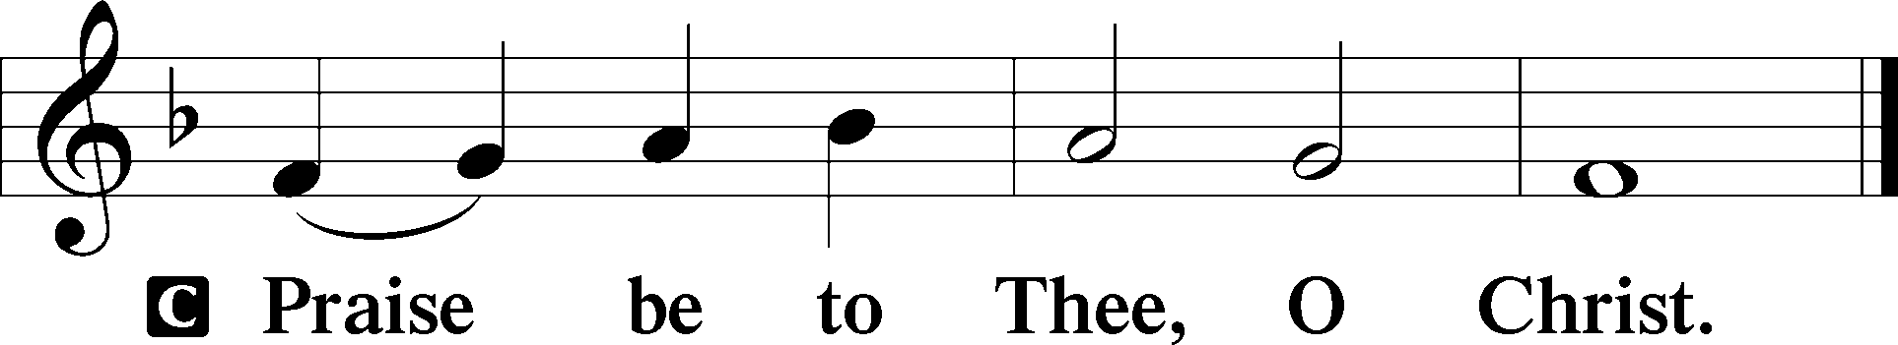

Nicene Creed
C I believe in one God, the Father Almighty,
maker of heaven and earth
and of all things visible and invisible.

And in one Lord Jesus Christ,
the only-begotten Son of God,
begotten of His Father before all worlds,
God of God, Light of Light,
very God of very God,
begotten, not made,
being of one substance with the Father,
by whom all things were made;
who for us men and for our salvation came down from heaven
and was incarnate by the Holy Spirit of the virgin Mary
and was made man;
and was crucified also for us under Pontius Pilate.
He suffered and was buried.
And the third day He rose again according to the Scriptures
and ascended into heaven
and sits at the right hand of the Father.
And He will come again with glory to judge both the living
and the dead,
whose kingdom will have no end.

And I believe in the Holy Spirit, the Lord and giver of life,
who proceeds from the Father and the Son,
who with the Father and the Son together is worshiped and glorified,
who spoke by the prophets.
And I believe in one holy Christian and apostolic Church,
I acknowledge one Baptism for the remission of sins,
and I look for the resurrection of the dead
and the life T of the world to come. Amen.

Children’s Message

765 God Moves in a Mysterious Way
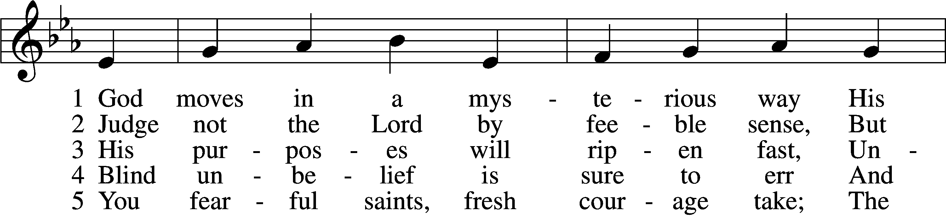
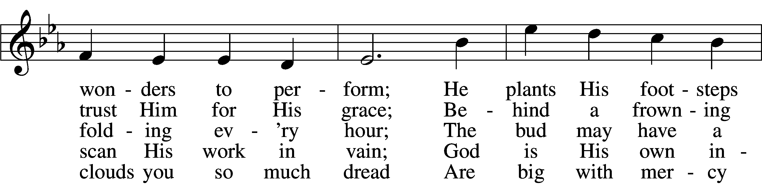
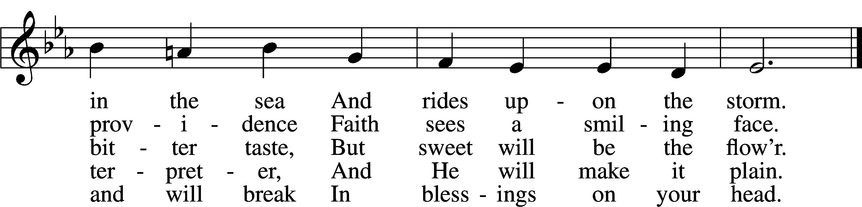
Tune and text: Public domain
Sermon “God Meant It for Good”

Offertory LSB 192
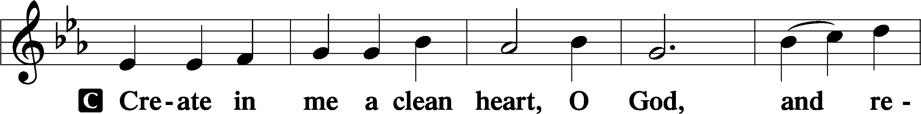
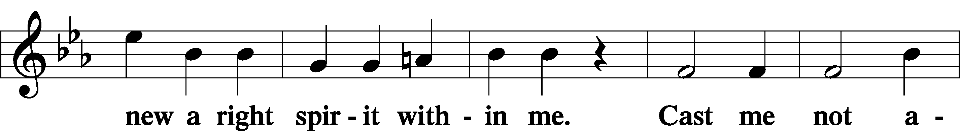
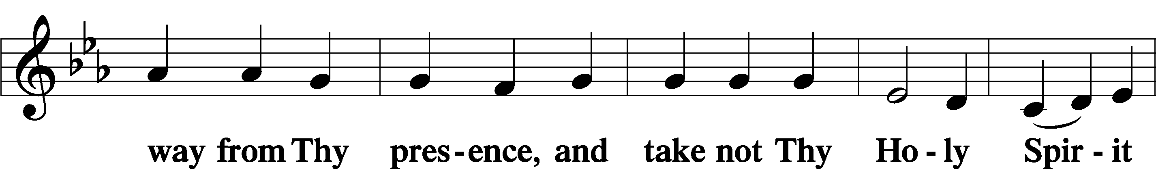
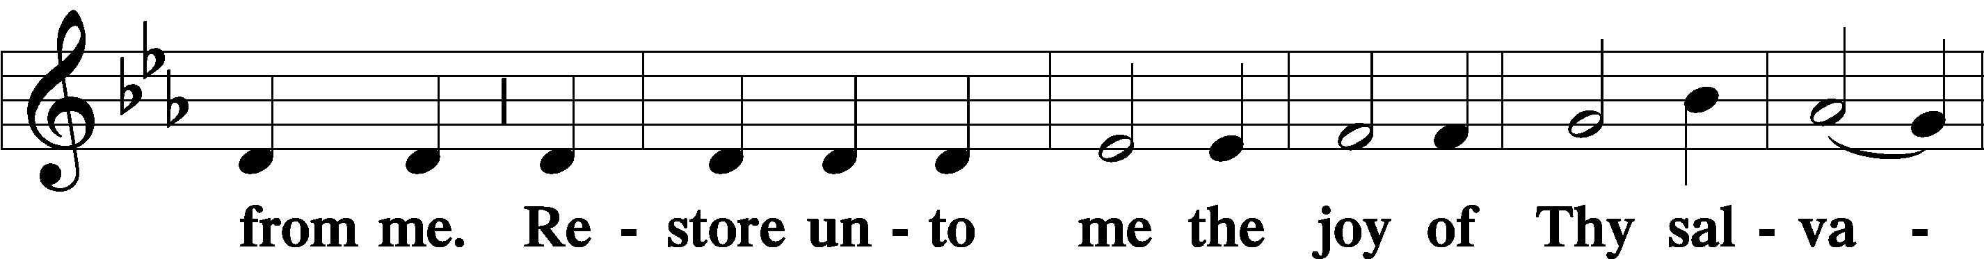
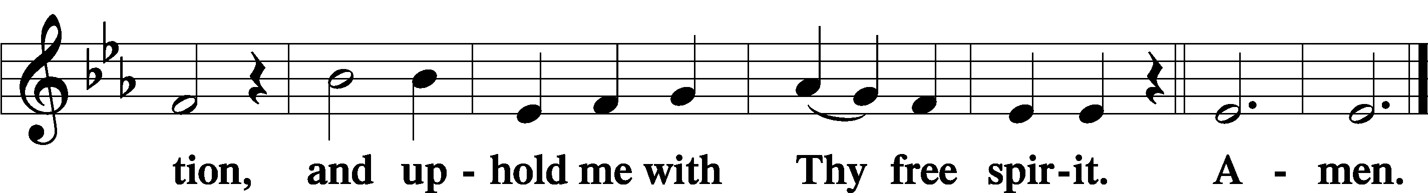

Prayer of the Church

Service of the Sacrament

Preface LSB 194
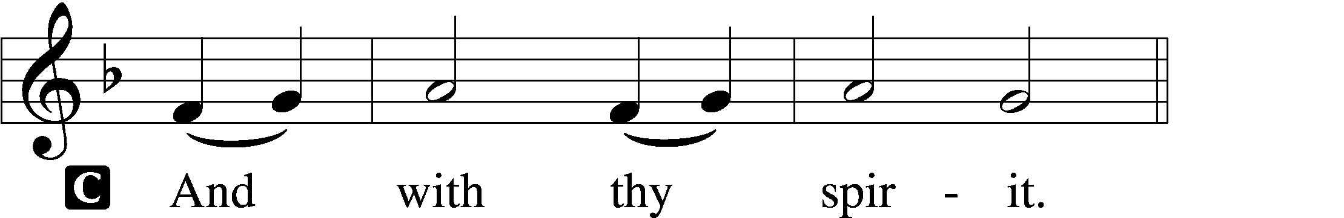

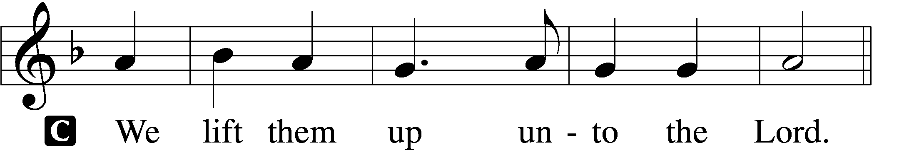

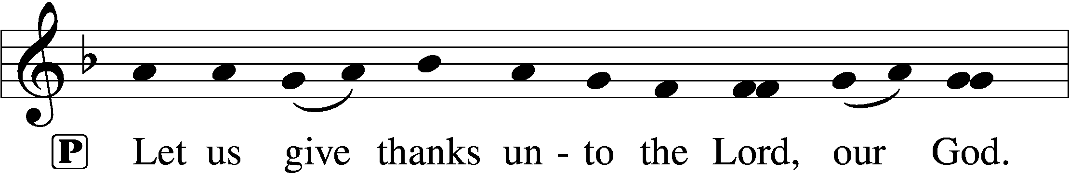
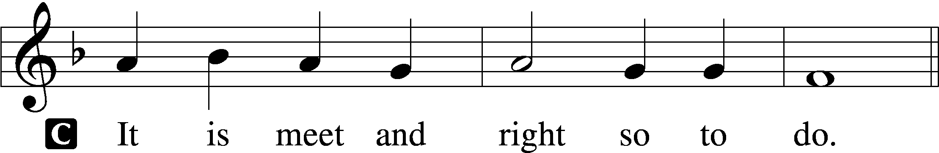

P It is truly meet, right, and salutary that we should at all times and in all places give thanks to You, holy Lord, almighty Father, everlasting God, through Jesus Christ, our Lord, who, having created all things, took on human flesh and was born of the virgin Mary. For our sake He died on the cross and rose from the dead to put an end to death, thus fulfilling Your will and gaining for You a holy people. Therefore with angels and archangels and with all the company of heaven we laud and magnify Your glorious name, evermore praising You and saying:

Sanctus LSB 195
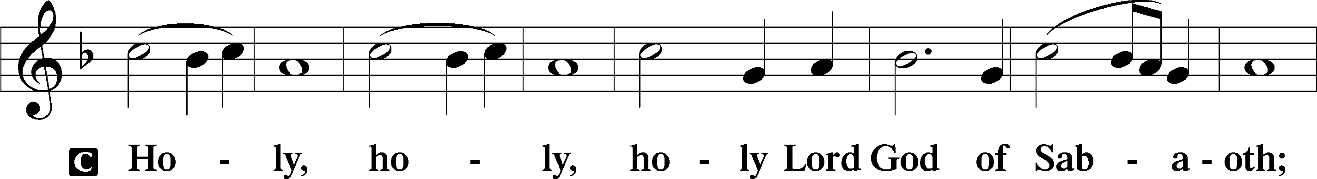
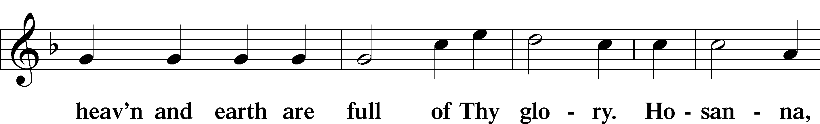
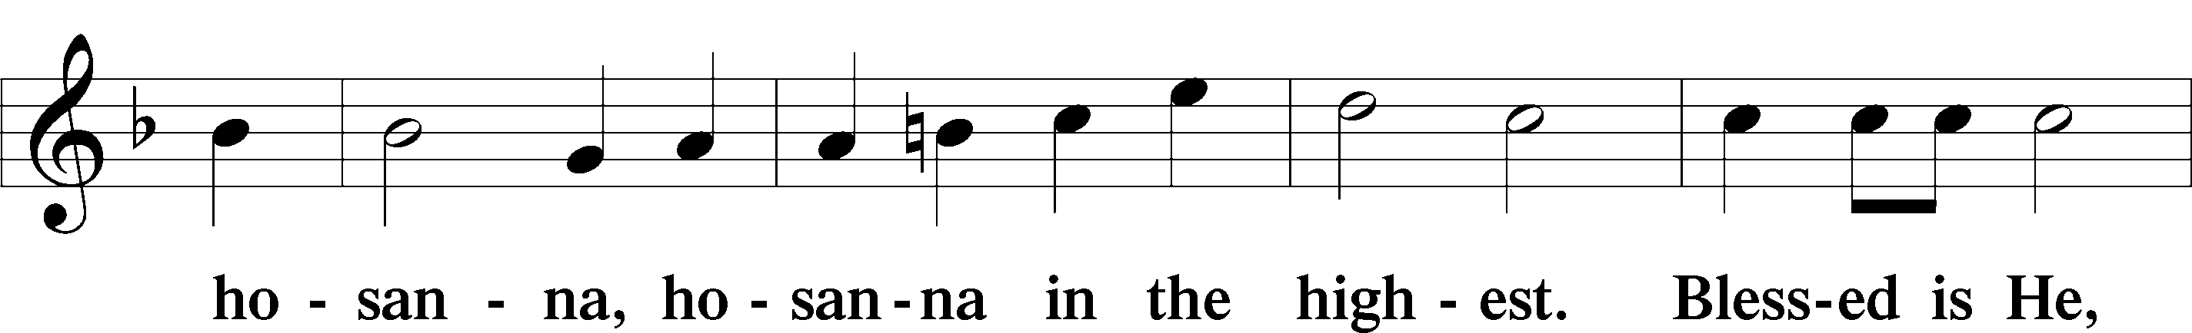
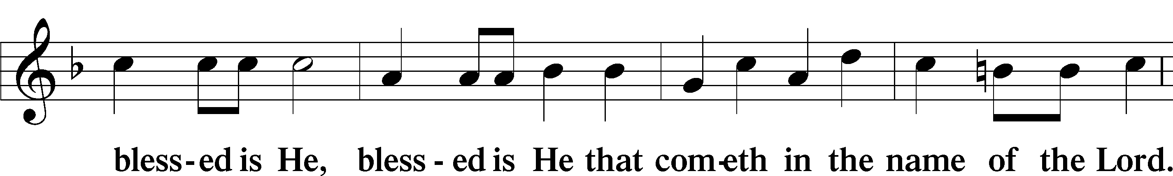
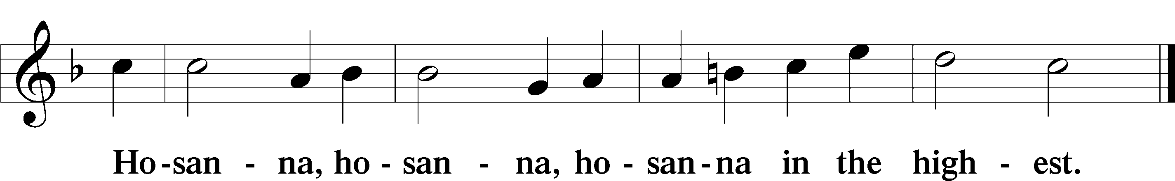
Lord’s Prayer LSB 196
C Our Father who art in heaven,
hallowed be Thy name,
Thy kingdom come,
Thy will be done on earth as it is in heaven;
give us this day our daily bread;
and forgive us our trespasses as we forgive those who trespass against us;
and lead us not into temptation,
but deliver us from evil.
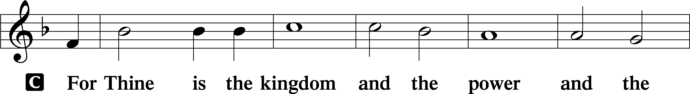
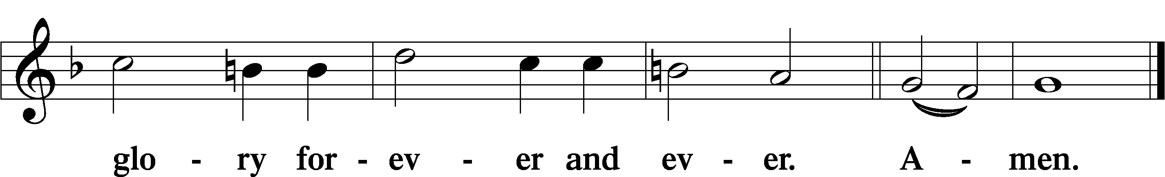

The Words of Our Lord LSB 197
P Our Lord Jesus Christ, on the night when He was betrayed, took bread, and when He had given thanks, He broke it and gave it to the disciples and said: “Take, eat; this is My T body, which is given for you. This do in remembrance of Me.”

In the same way also He took the cup after supper, and when He had given thanks, He gave it to them, saying: “Drink of it, all of you; this cup is the new testament in My T blood, which is shed for you for the forgiveness of sins. This do, as often as you drink it, in remembrance of Me.”

Pax Domini LSB 197
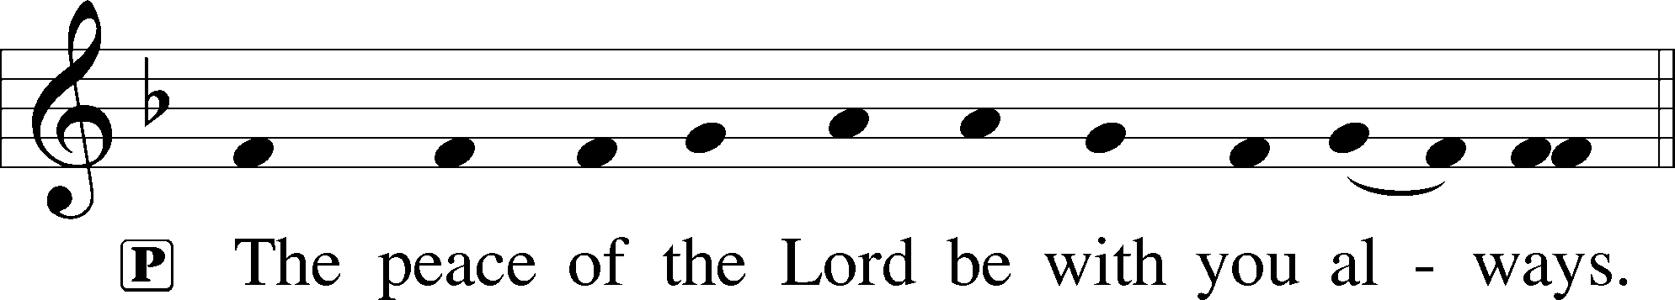

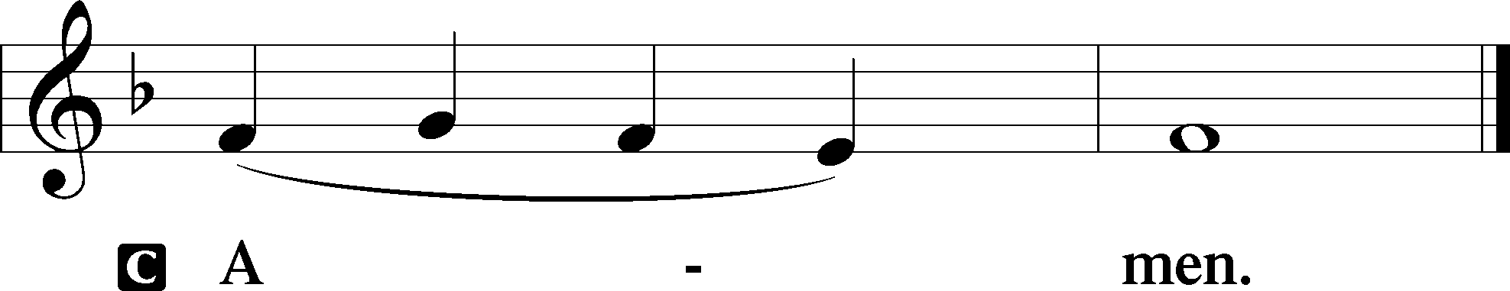
Agnus Dei LSB 198
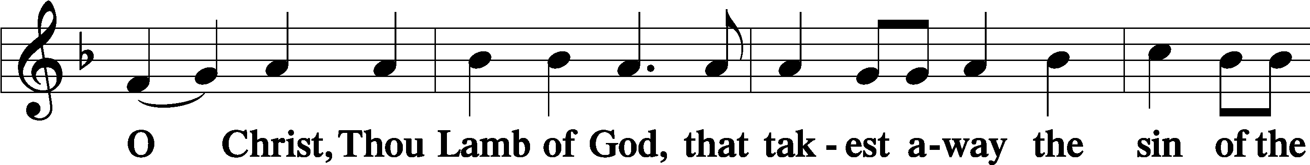
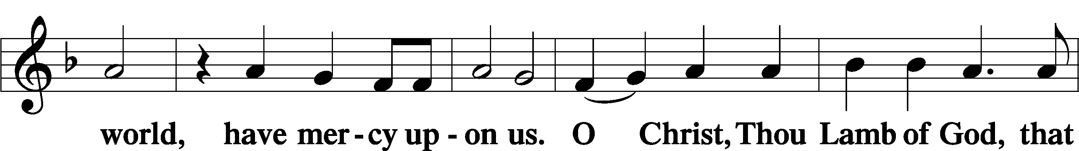
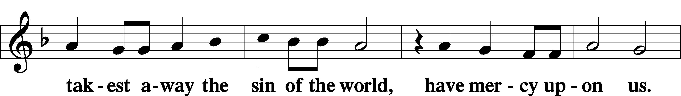
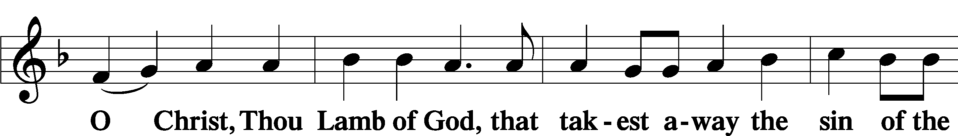
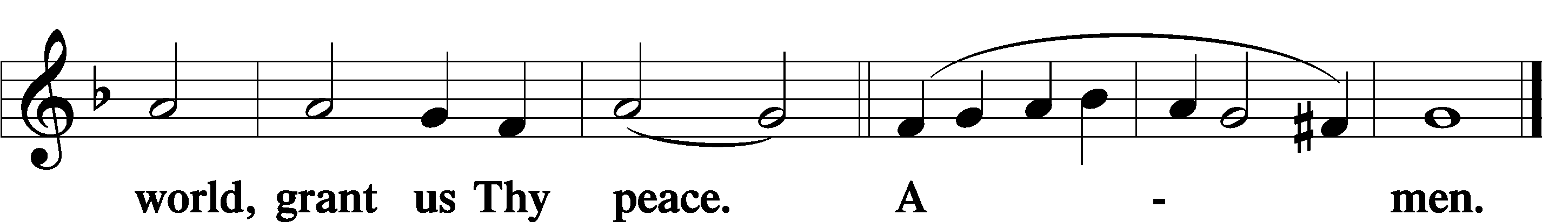

Distribution

611 Chief of Sinners Though I Be
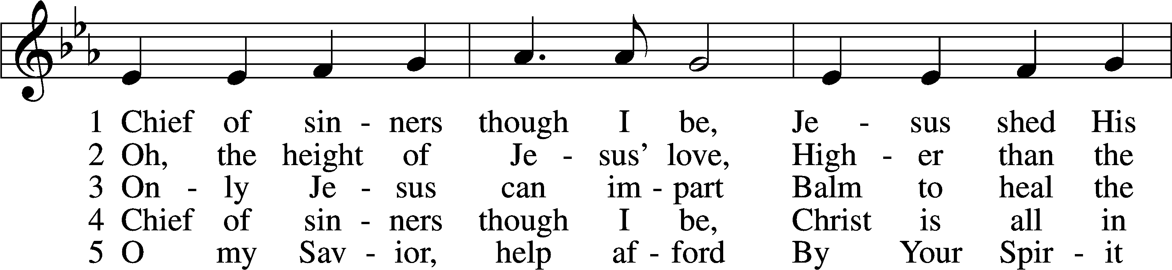
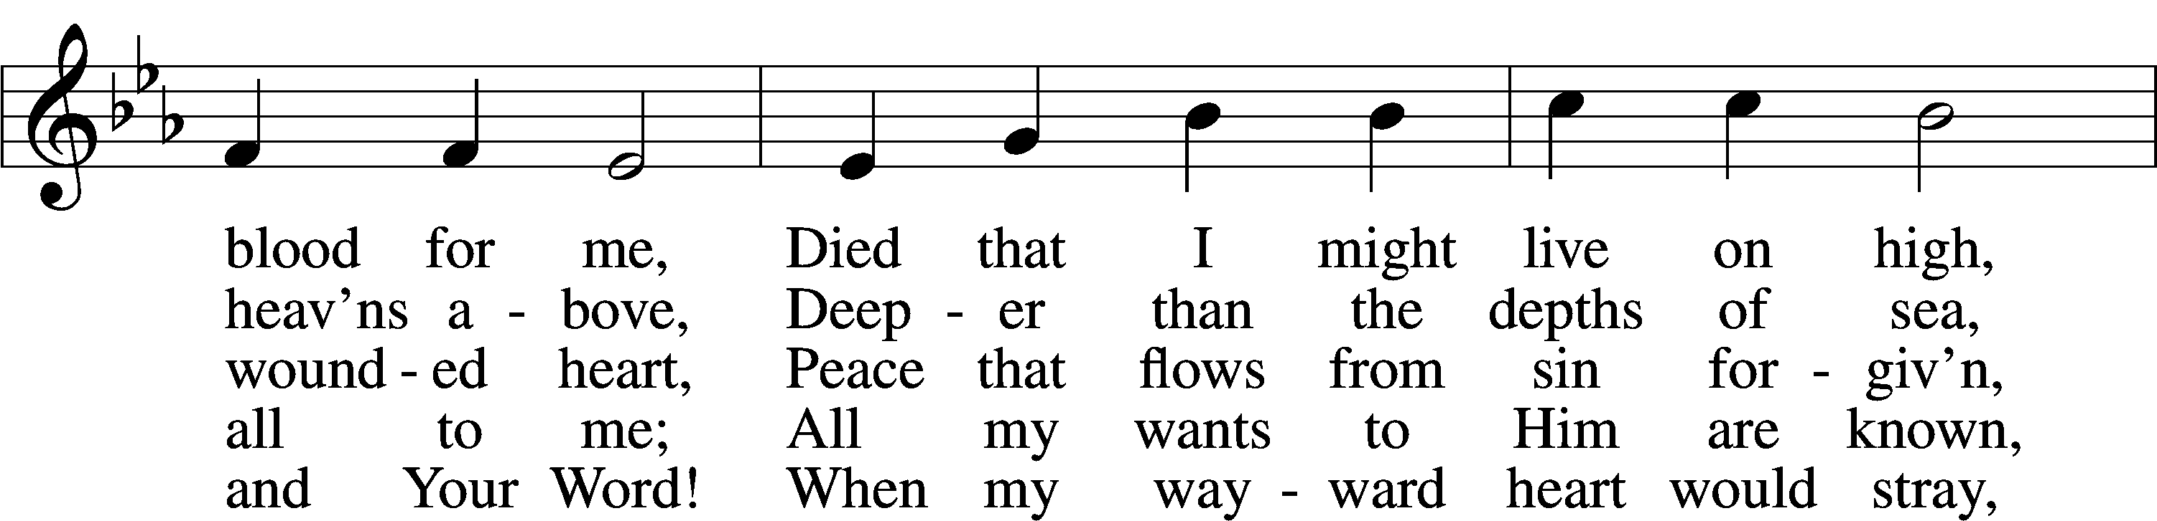
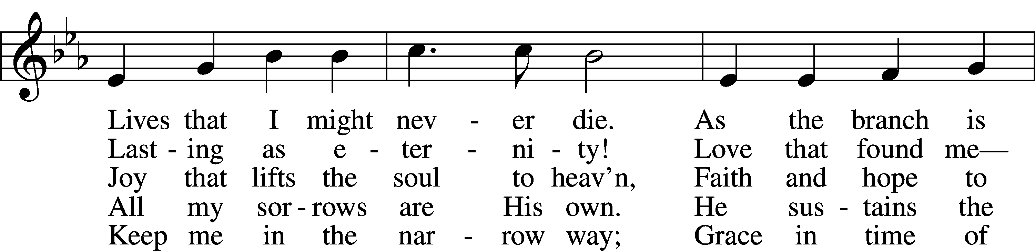
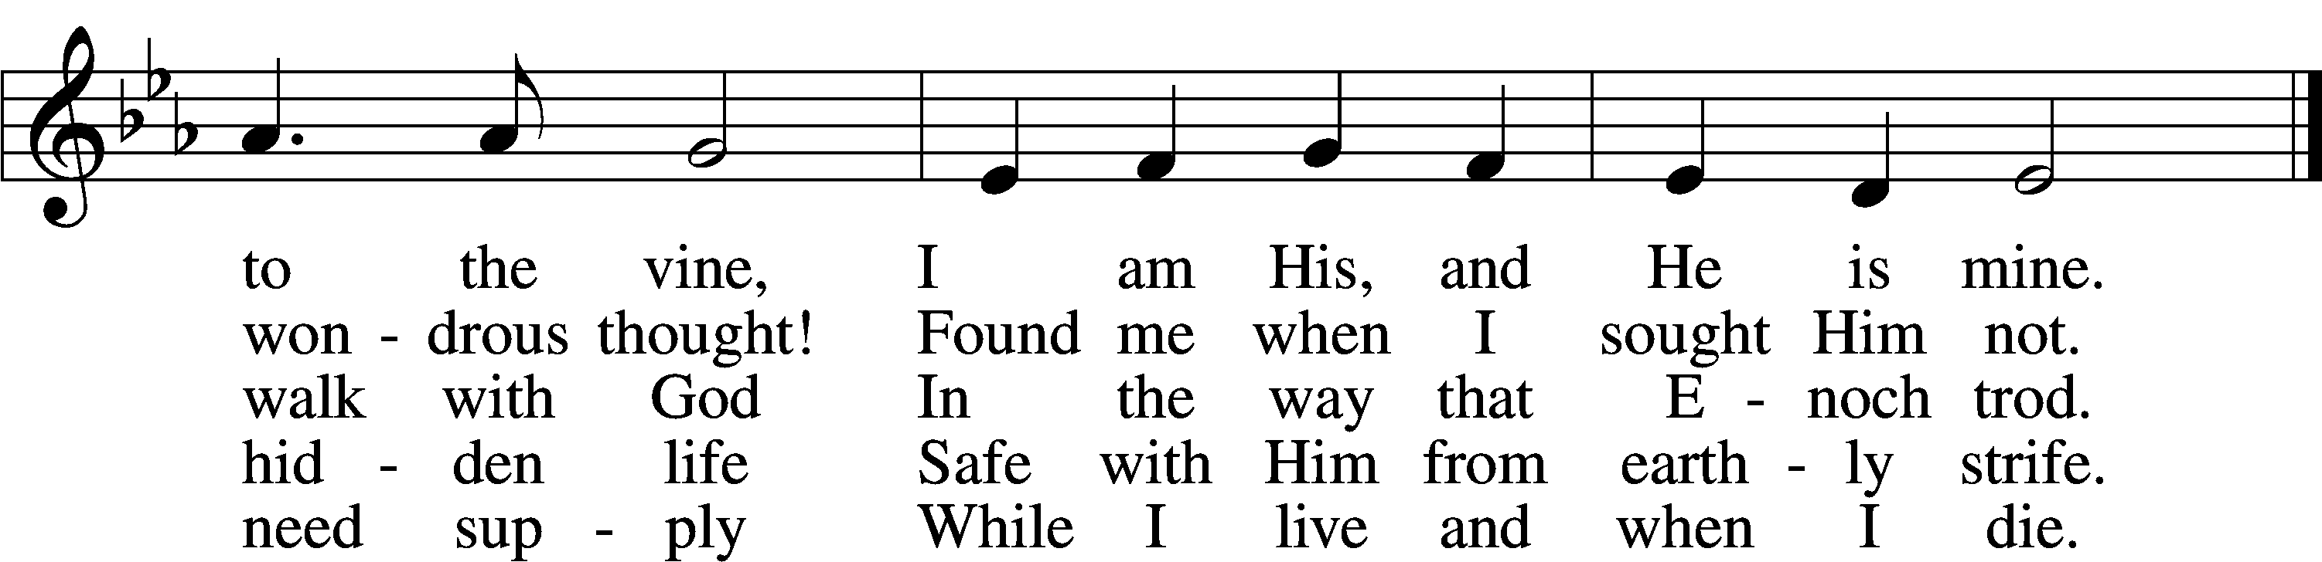
Tune and text: Public domain

Nunc Dimittis LSB 199
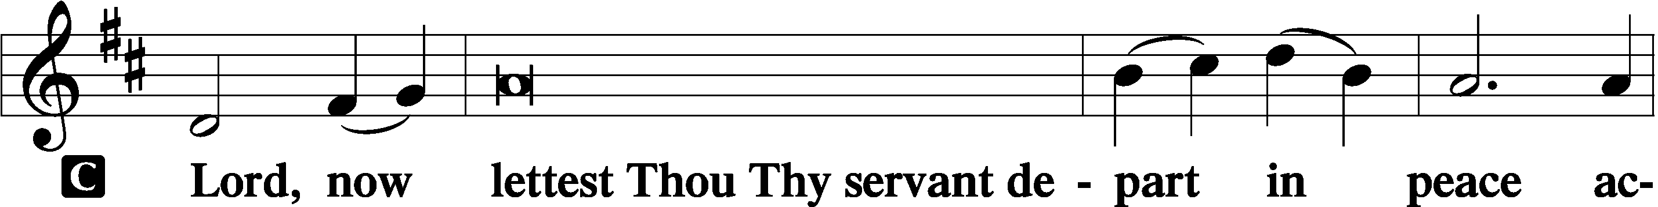

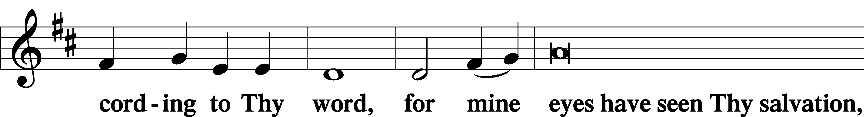

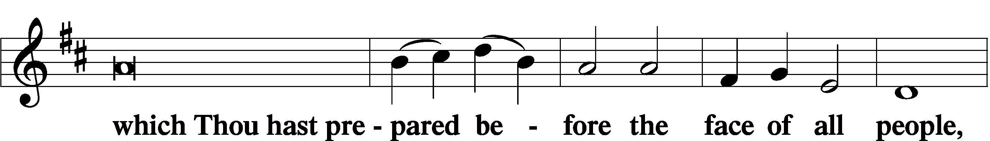

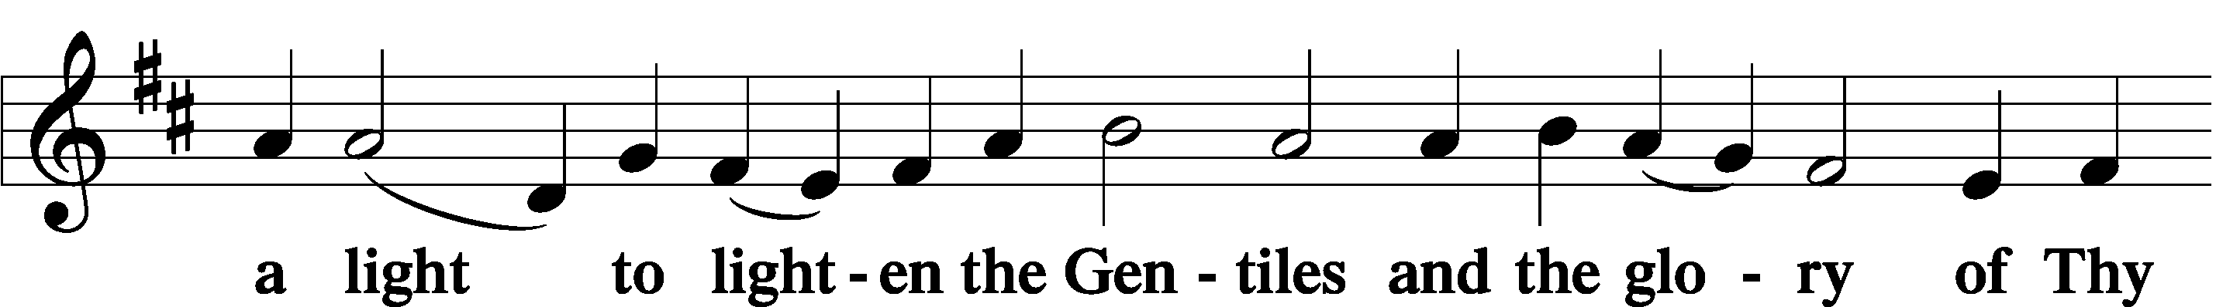

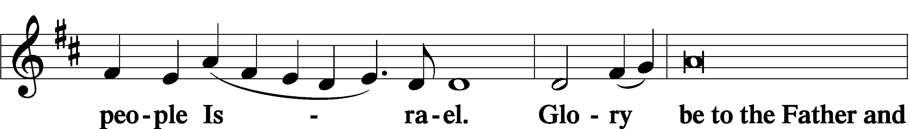

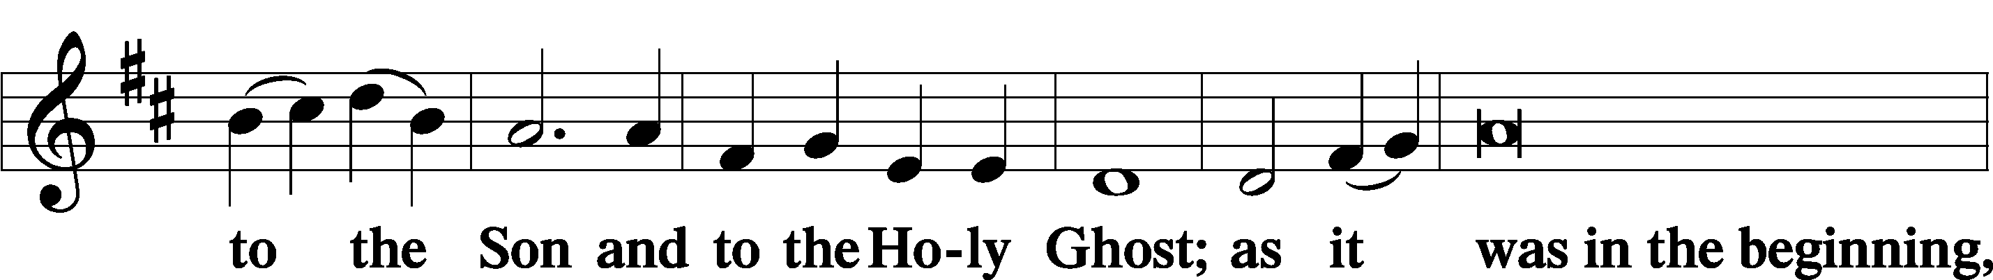

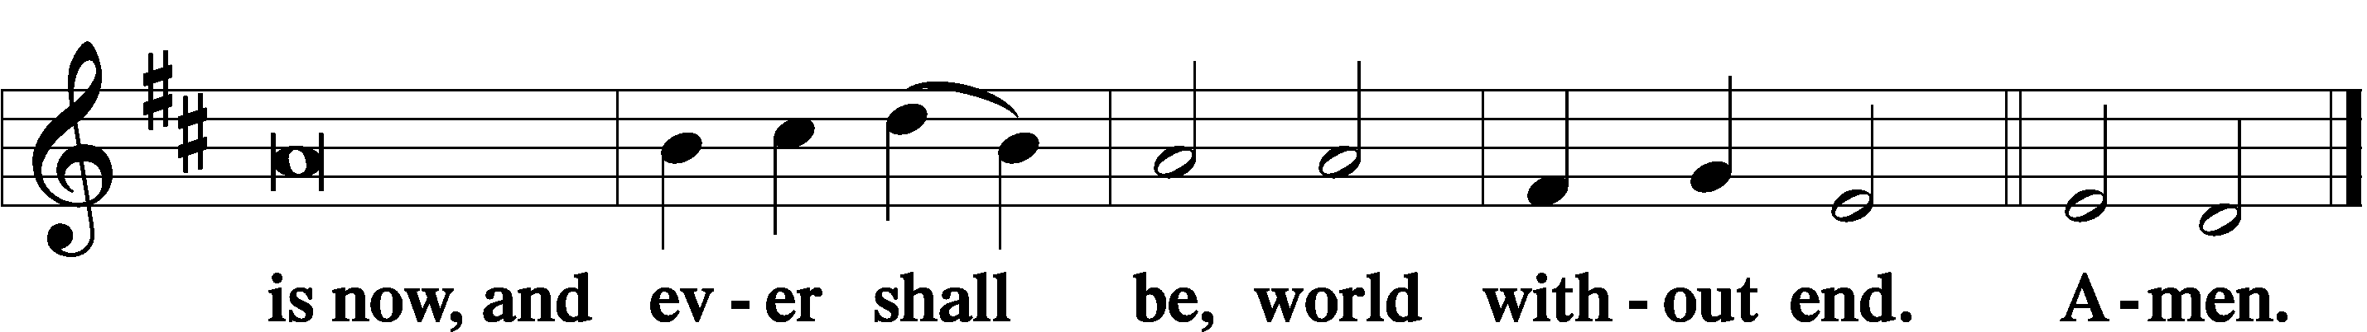

Thanksgiving LSB 200
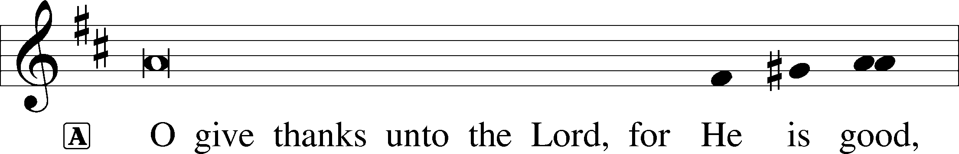

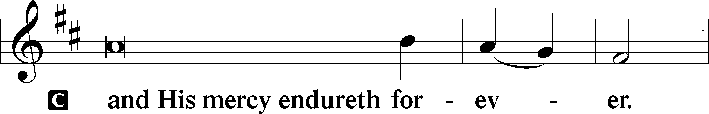

A Let us pray.
O God the Father, the fountain and source of all goodness, who in loving-kindness sent Your only-begotten Son into the flesh, we thank You that for His sake You have given us pardon and peace in this Sacrament, and we ask You not to forsake Your children but always to rule our hearts and minds by Your Holy Spirit that we may be enabled constantly to serve You; through Jesus Christ, Your Son, our Lord, who lives and reigns with You and the Holy Spirit, one God, now and forever.
C Amen.

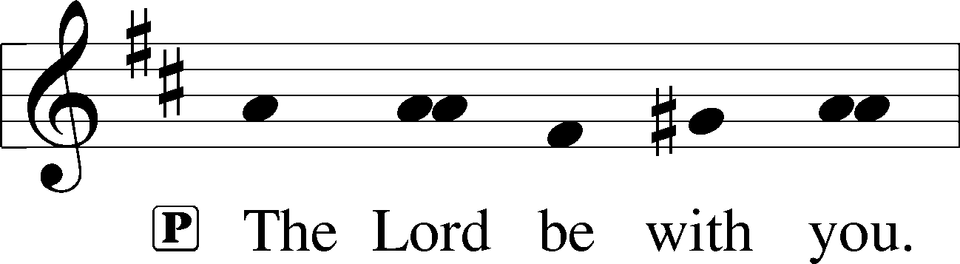

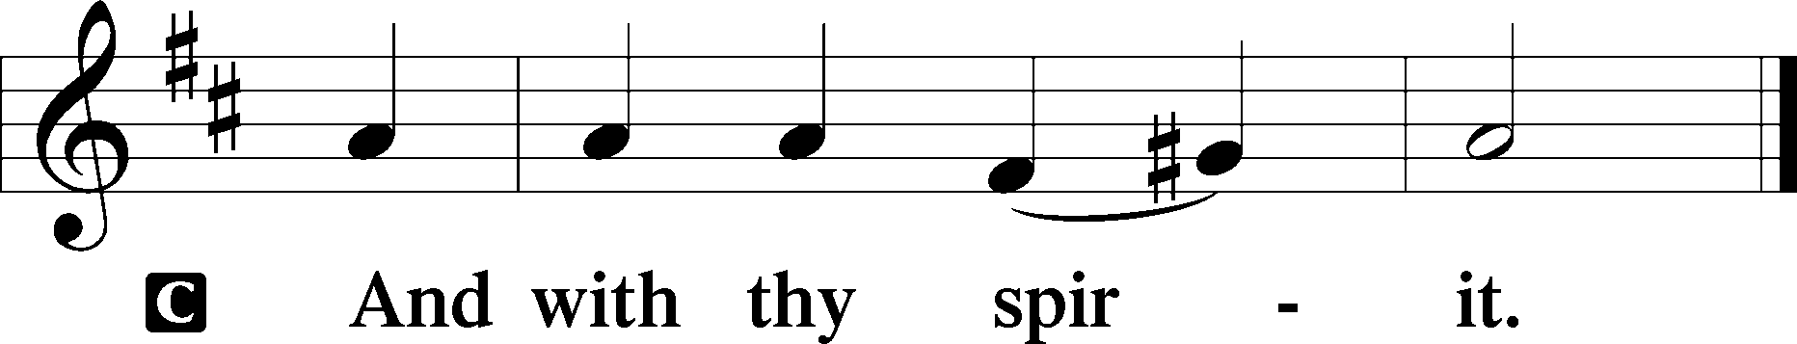

Benedicamus LSB 202
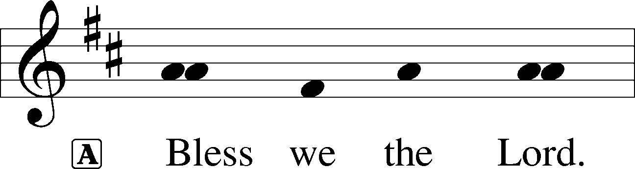

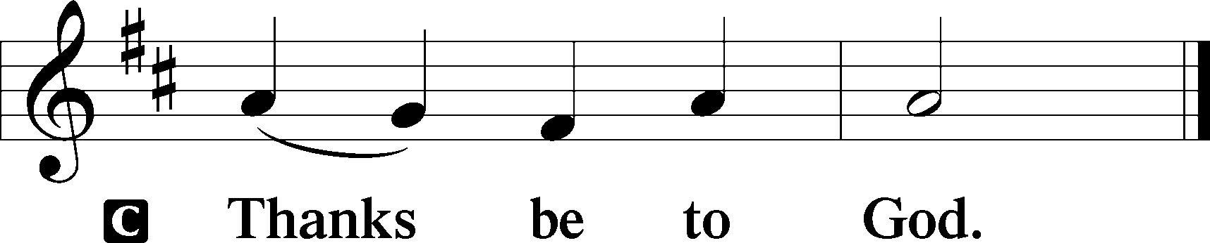
Benediction LSB 202
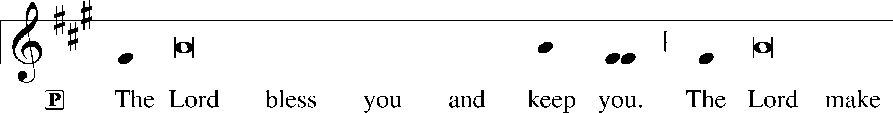
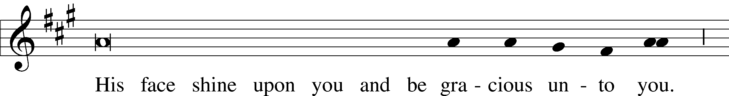
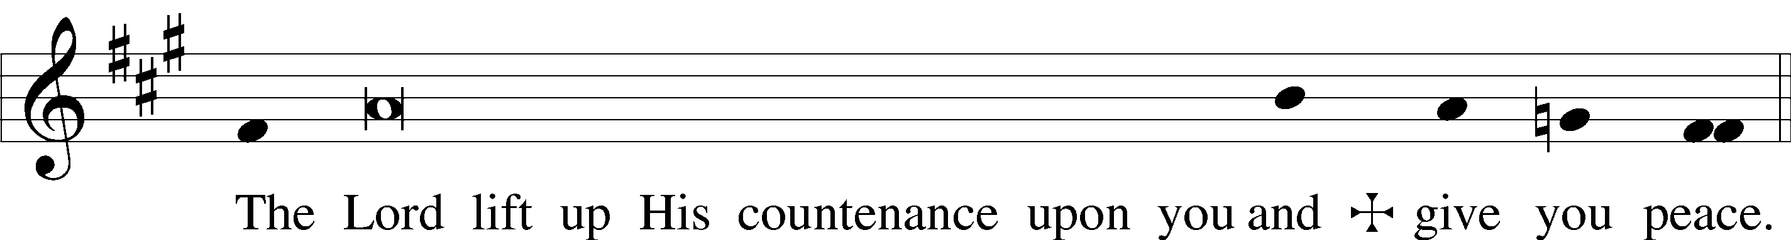
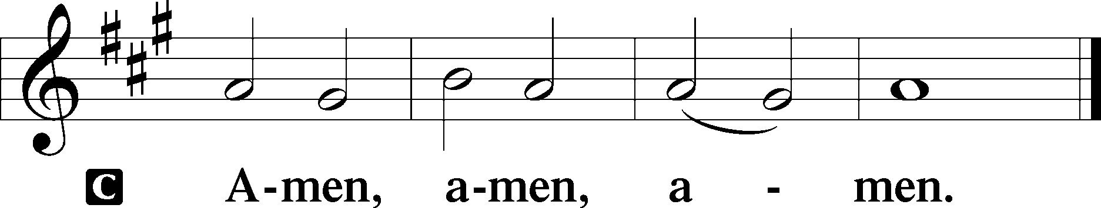

895 Now Thank We All Our God
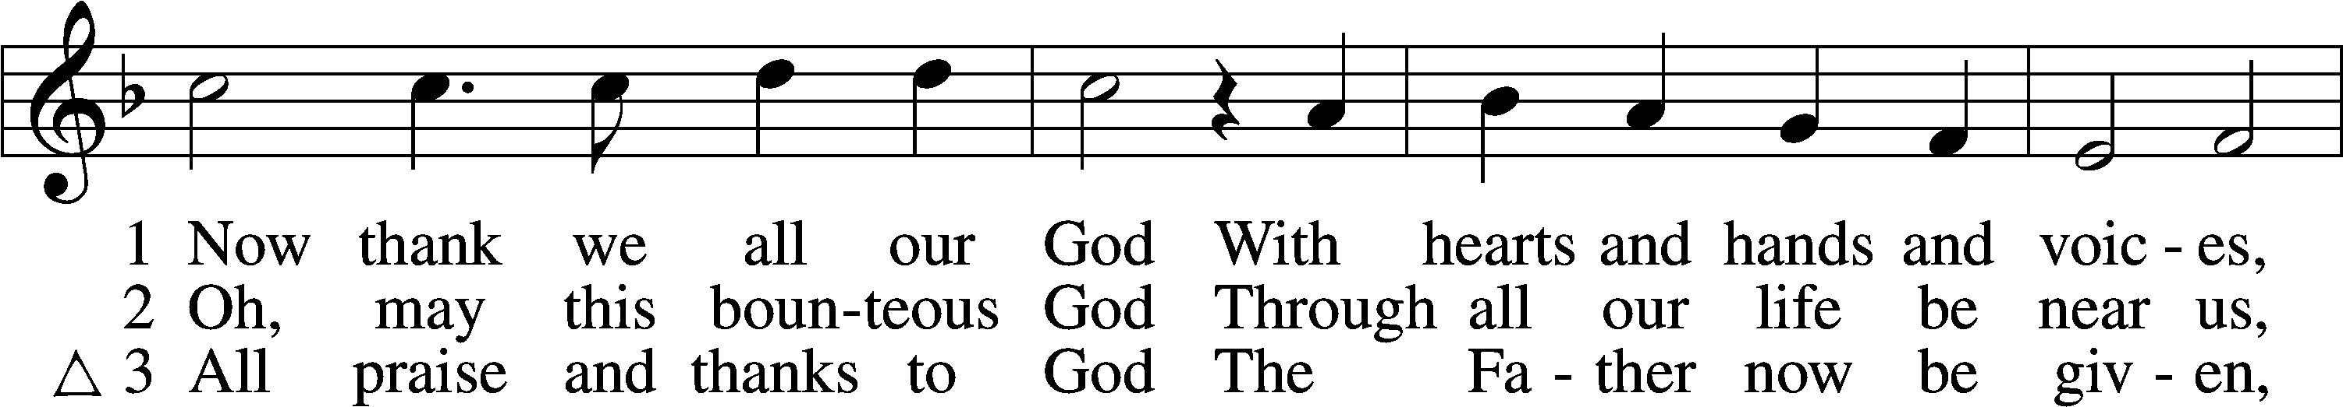
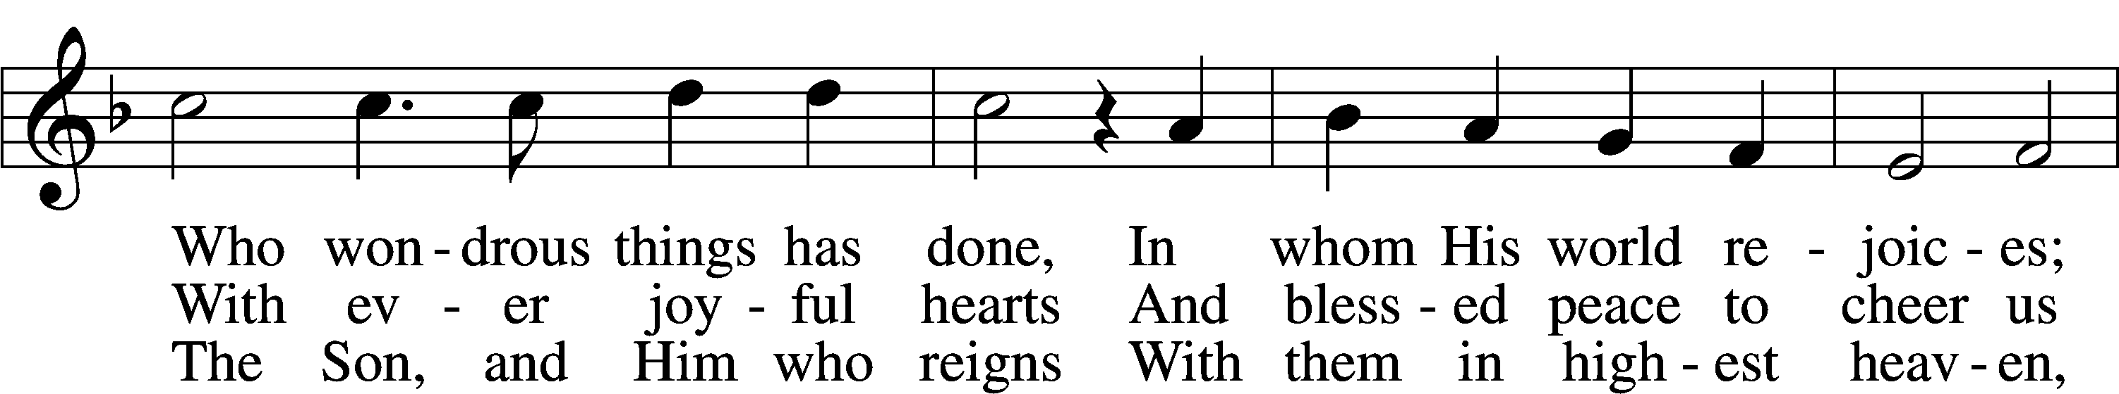
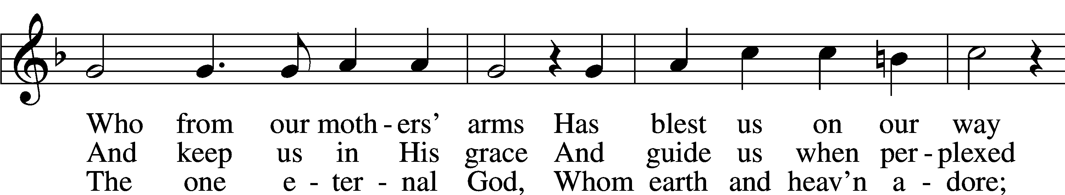
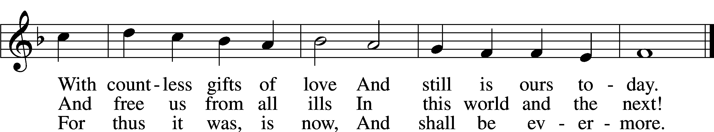
Text and tune: Public domain

Acknowledgments
Divine Service, Setting Three from Lutheran Service Book
Unless otherwise indicated, Scripture quotations are from the ESV® Bible (The Holy Bible, English Standard Version®), copyright © 2001 by Crossway, a publishing ministry of Good News Publishers. Used by permission. All rights reserved.
Created by Lutheran Service Builder © 2018 Concordia Publishing House.
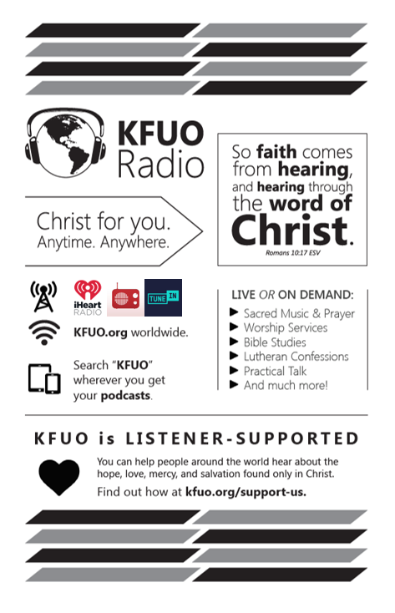Gifts of Time and Treasure

“Do not store up for yourselves treasures on earth..,”, “but store up for yourselves treasures in heaven…”
Matthew 6:19-20

LAST WEEK’S OFFERINGS LAST WEEK’S ATTENDANCE
General Fund $ 3,620.48 Service
Needed Weekly $ 3,963.38 Communed
Adult Bible Study $ 5.00
Hoff Memorial $ 100.00
Diamond Memorial $ 50.00

The Lord’s Week

Today 9:00 am – Adult Bible Study
(Sept. 13th) 10:00 am – Divine Service

Tuesday 9:00 am – MDO

Thursday 9:00 am – MDO

Next Sunday 9:00 am – Adult Bible Study
(Sept. 20th) 10:00 am – Divine Service

In His Service

Elder: Tom Griffith
Ushers: Noe Lopez & John Larson
Acolytes: Coco & Collin Utley
Organist:

