**Last Sunday of the Church Year –**

**Proper 29**

**"Christ Before and Above All"**

Matthew 25:31-46

**November 22, 2020**

**Messiah Lutheran Church**

**Lutheran Church-Missouri Synod**

4102 Trinity River Dr., Corpus Christi, Texas 78410

**Pastor:**  **Rev. Scott E. Herbert**

Church Phone: 361-387-7748 Email: mlc@stx.rr.com

Church Fax: 361-767-1768 Website: [www.messiahlcms-cc.org](http://www.messiahlcms-cc.org)

Pastor Phone: 469-693-9683 Pastor Email: chirev59@gmail.com

**WELCOME TO MESSIAH!**

We are glad you are here to receive what God is doing for you during Divine Service. Please sign our Guest Book located near the front door. Feel free to converse quietly until the organ prelude begins. If you are looking for a church home, please talk to the Pastor at the door. We would love to have you join us.

**Preparing for Service**

***The Gospel Prepares Us for Our Heavenly Bridegroom’s Coming***

The Day of the Lord is *“darkness, and not light”* (Amos 5:18, 20) for all who trust in their own righteousness and piety. The Lord will not accept their *“burnt offerings and grain offerings,”* nor will He look upon their *“peace offerings”* (Amos 5:22). Instead, He desires a heart of faith that trusts in Him, which lets *“justice roll down like waters, and righteousness like an ever-flowing stream”* (Amos 5:24) in love for the neighbor. In order for the “lamps” of our lives to burn brightly with such love, we must be filled with the “oil” of forgiveness through faith in our Bridegroom, Jesus Christ (Matt. 25:1–4). Therefore, as we await His coming, wisdom directs us *“to the dealers”* (Matt. 25:9), that is, to the ministers of His Gospel. Thus, we wait upon the Lord, and we *“encourage one another with these words”* (1 Thess. 4:18). Waking or sleeping, we are prepared to meet Him when He comes *“with a cry of command, with the voice of an archangel, and with the sound of the trumpet of God,”* and *“we will always be with the Lord”* (1 Thess. 4:16, 17).

# Confession and Absolution

905 Come, Thou Almighty King

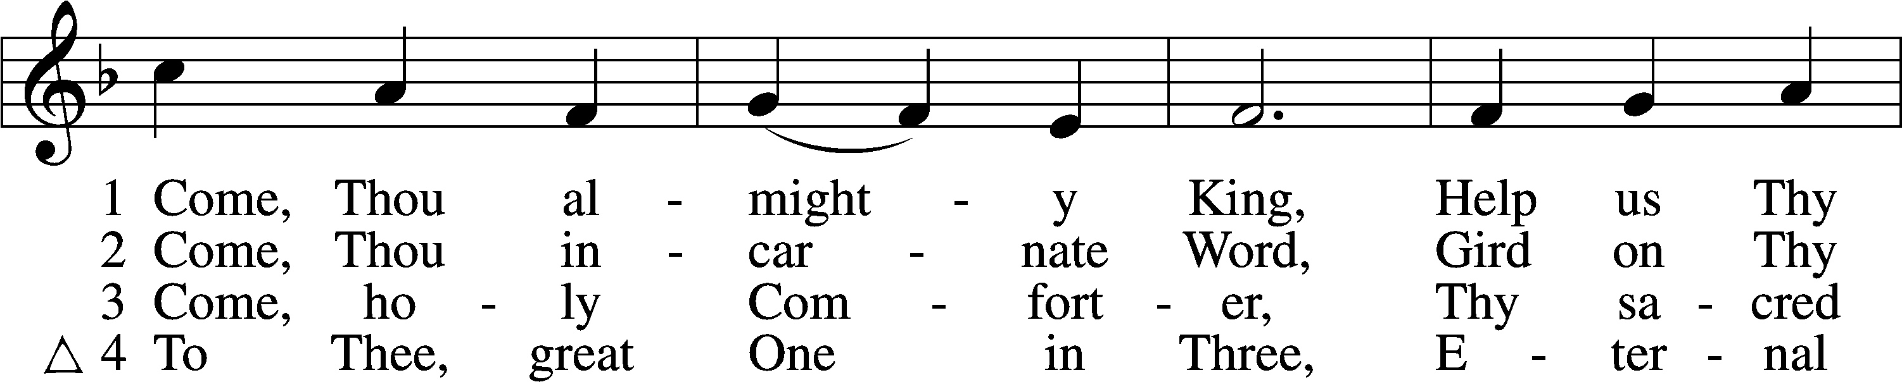

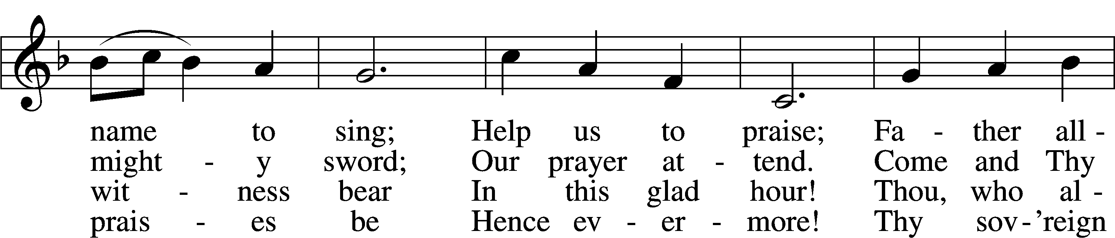

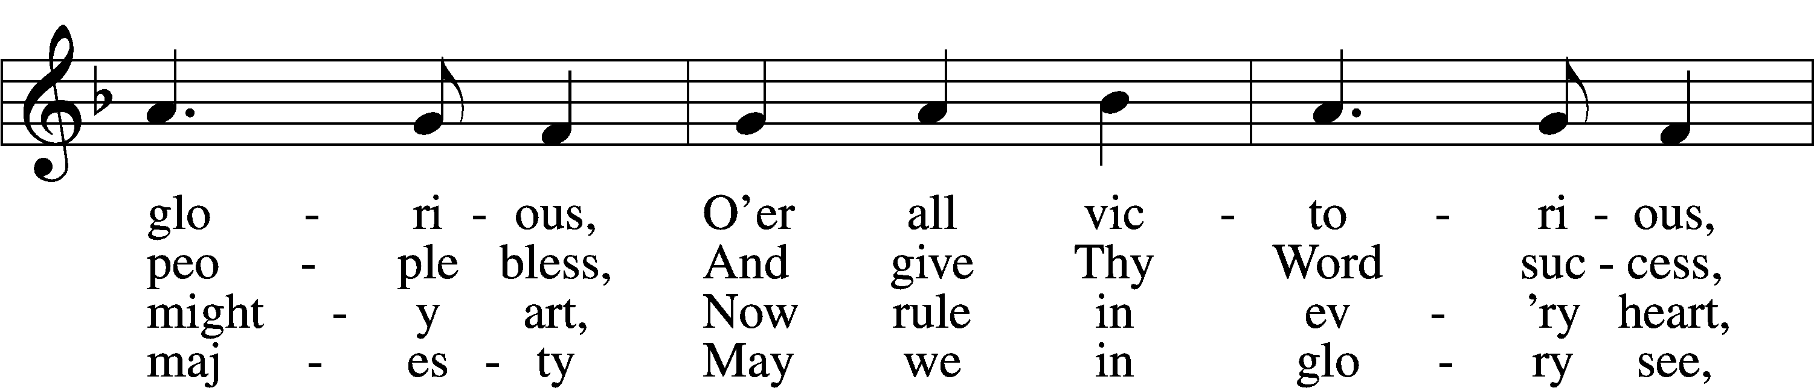

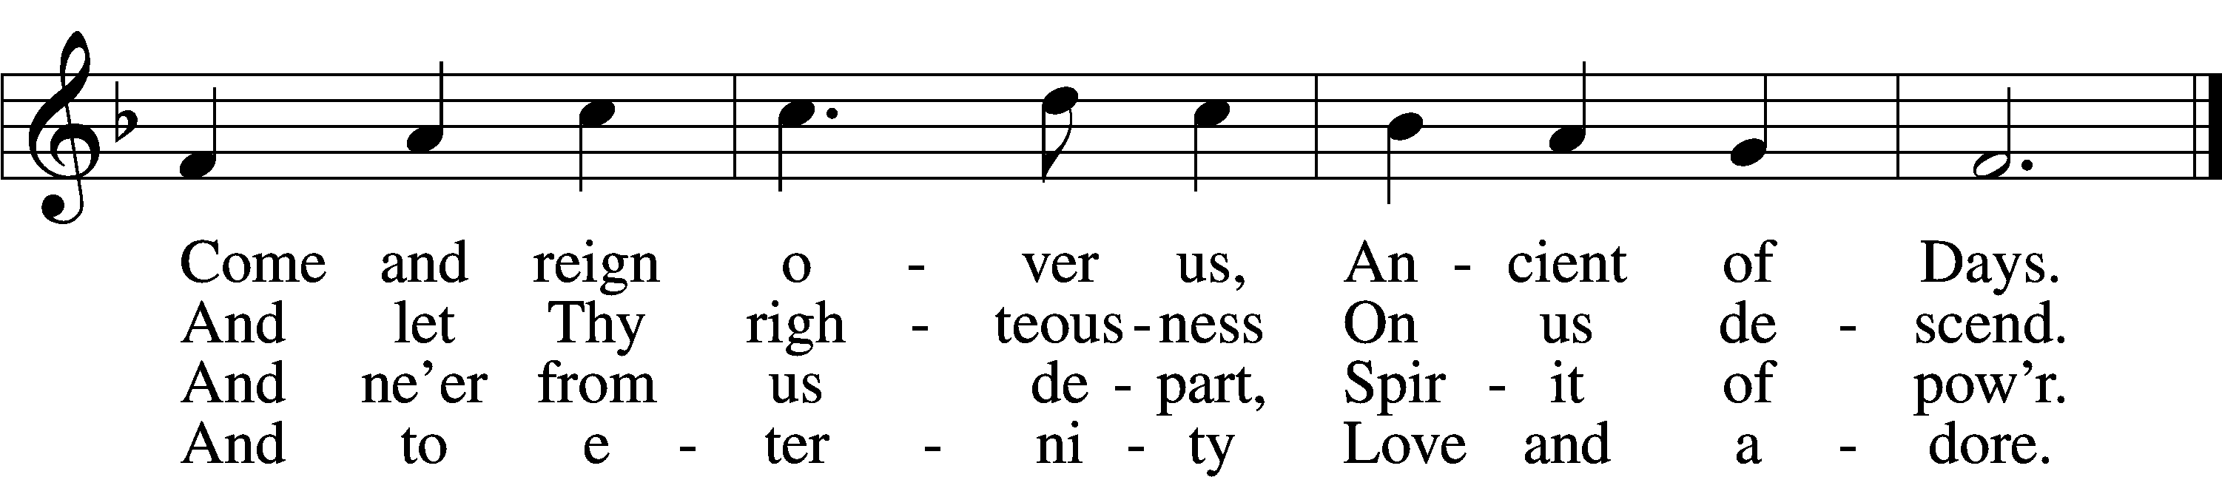

Text and tune: Public domain

P In the name of the Father and of the T Son and of the Holy Spirit.

C **Amen.**

P Beloved in the Lord! Let us draw near with a true heart and confess our sins unto God our Father, beseeching Him in the name of our Lord Jesus Christ to grant us forgiveness.

P Our help is in the name of the Lord,

C **who made heaven and earth.**

P I said, I will confess my transgressions unto the Lord,

C **and You forgave the iniquity of my sin.**

P O almighty God, merciful Father,

C **I, a poor, miserable sinner, confess unto You all my sins and iniquities with which I have ever offended You and justly deserved Your temporal and eternal punishment. But I am heartily sorry for them and sincerely repent of them, and I pray You of Your boundless mercy and for the sake of the holy, innocent, bitter sufferings and death of Your beloved Son, Jesus Christ, to be gracious and merciful to me, a poor, sinful being.**

P Upon this your confession, I, by virtue of my office, as a called and ordained servant of the Word, announce the grace of God unto all of you, and in the stead and by the command of my Lord Jesus Christ I forgive you all your sins in the name of the Father and of the T Son and of the Holy Spirit.

C **Amen.**

# Service of the Word

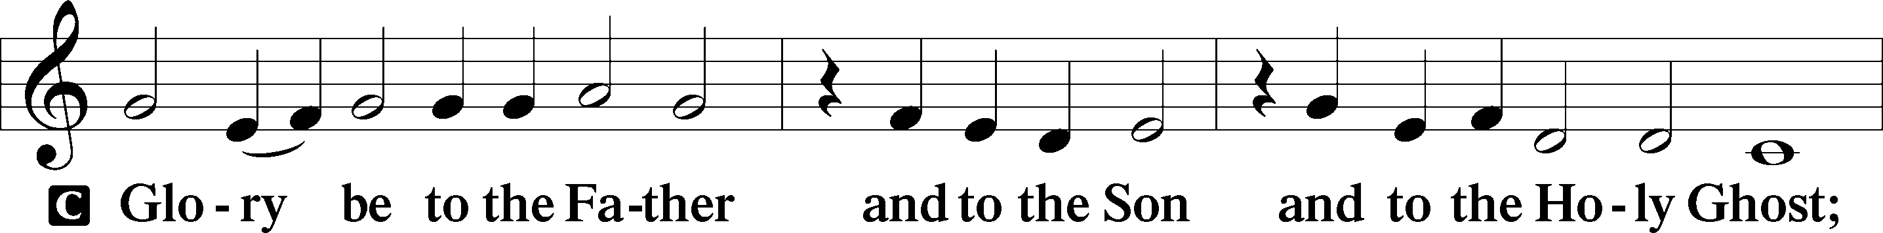

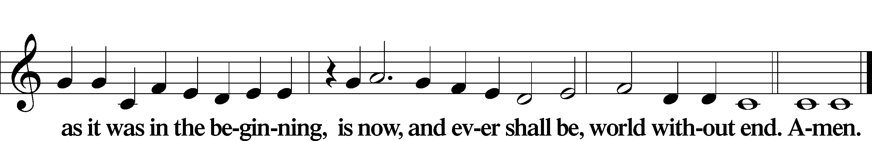

Kyrie LSB 186

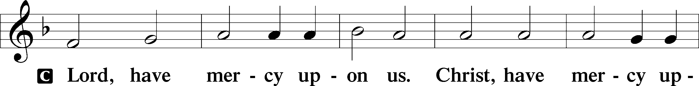

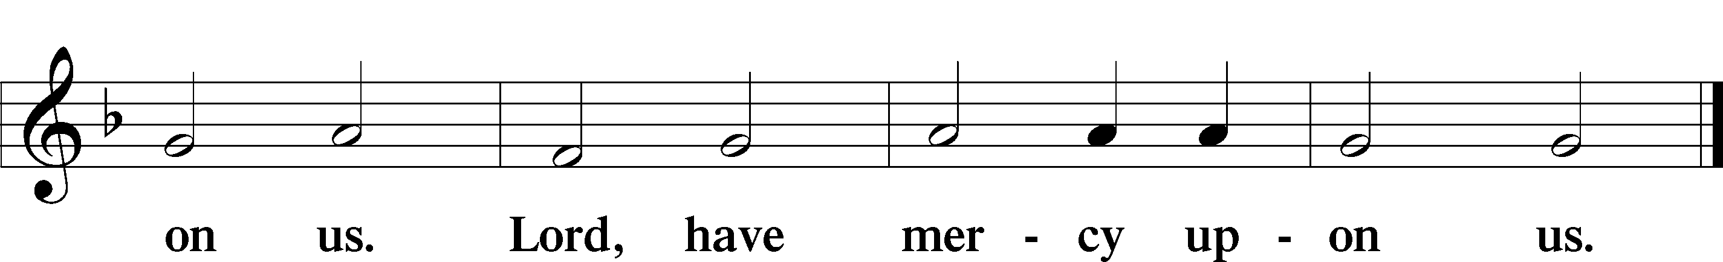

Gloria in Excelsis LSB 187

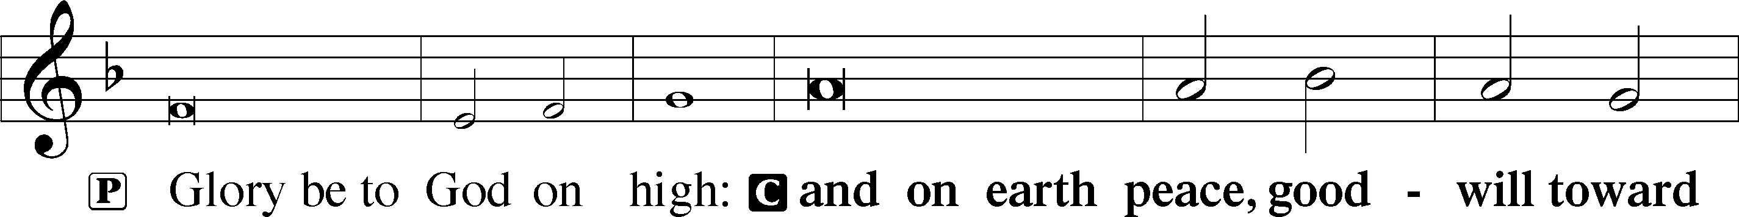

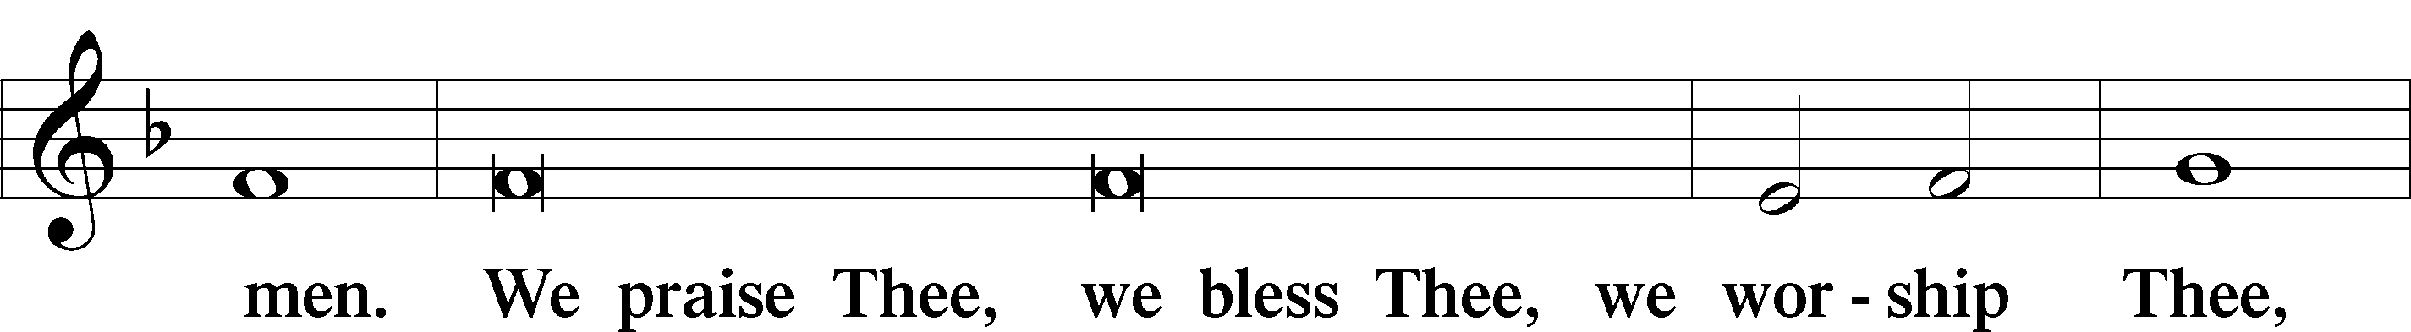

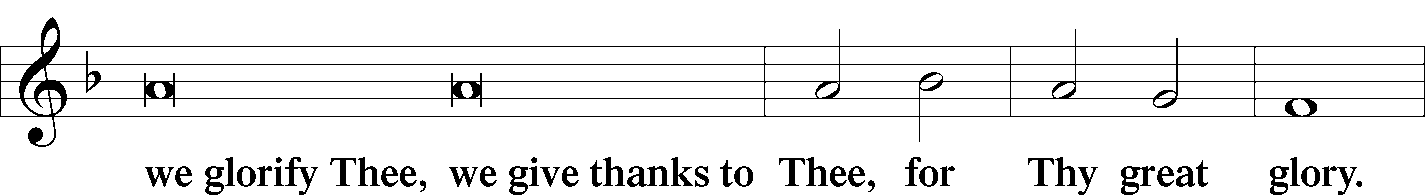

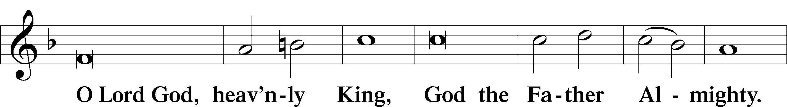

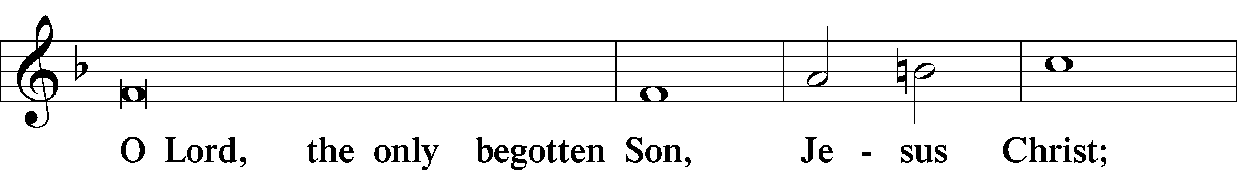

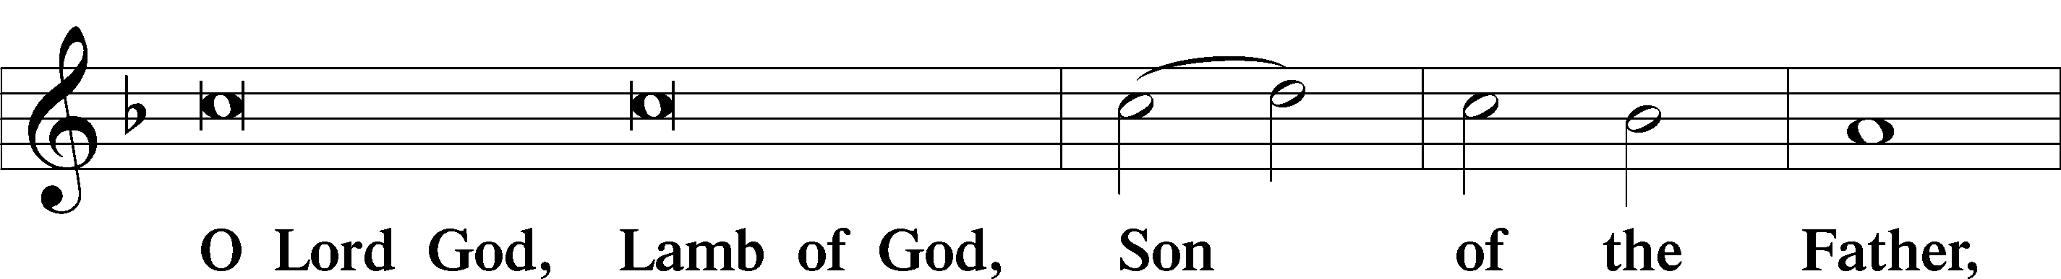

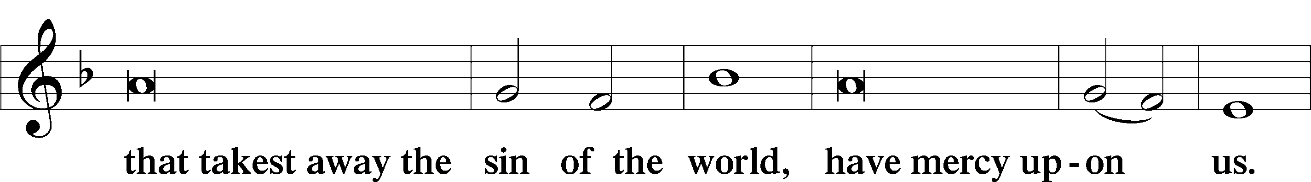

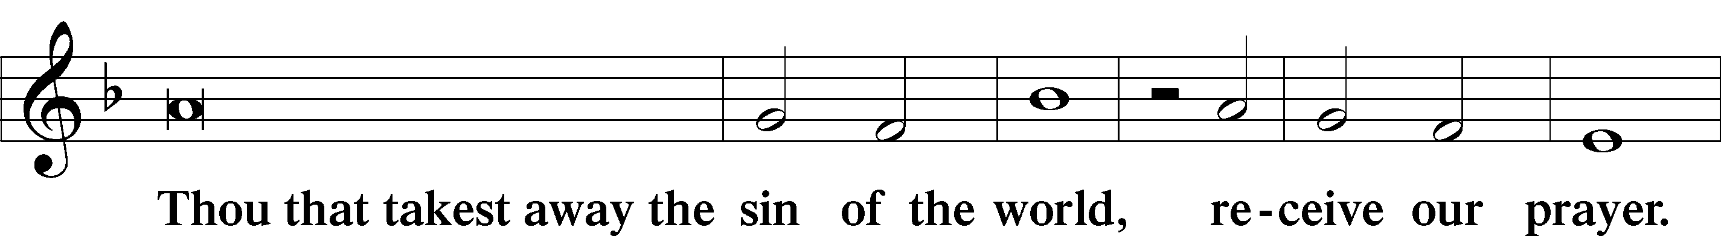

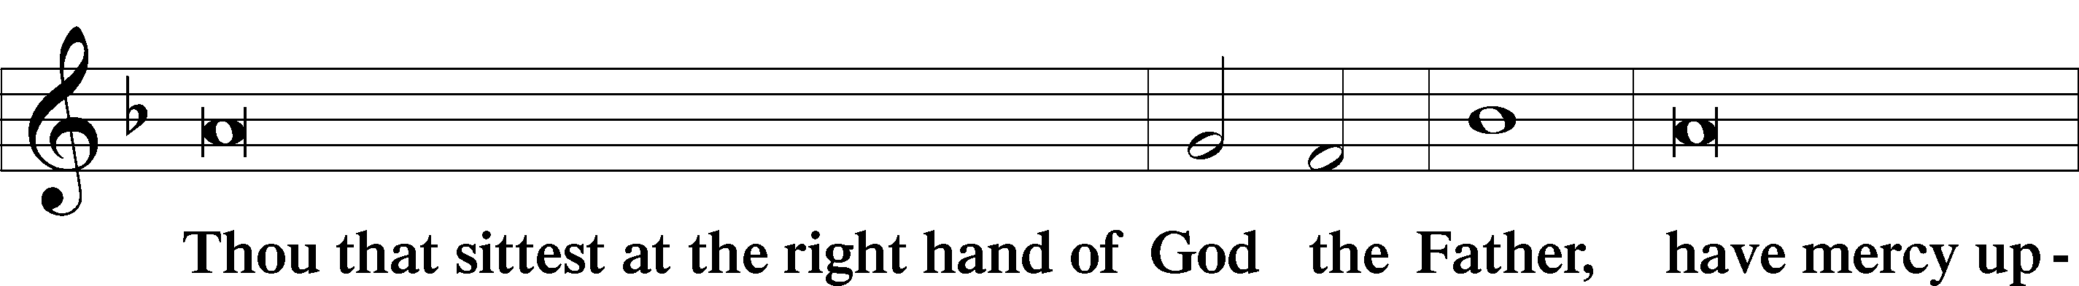

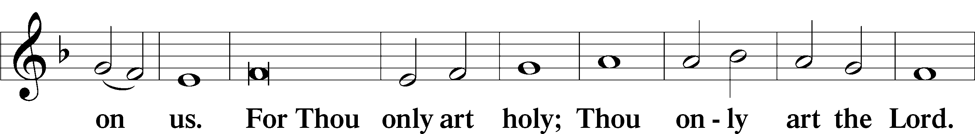

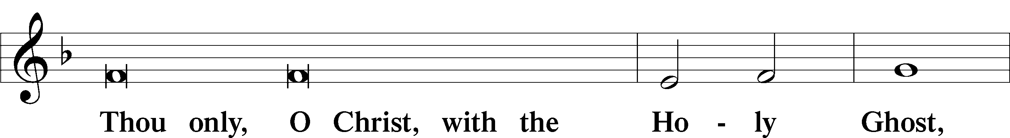

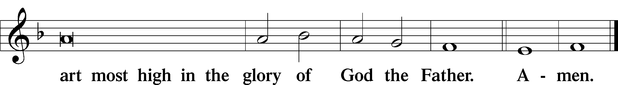

Salutation and Collect of the Day

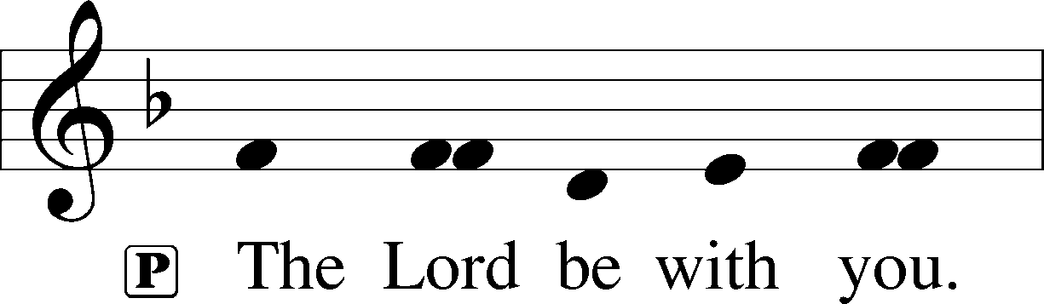

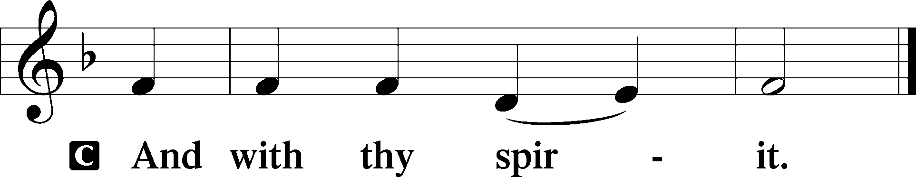

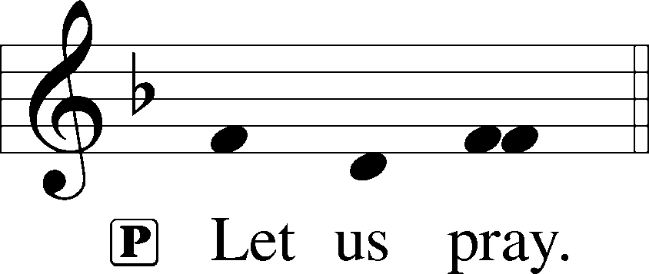

P Eternal God, merciful Father, You have appointed Your Son as judge of the living and the dead. Enable us to wait for the day of His return with our eyes fixed on the kingdom prepared for Your own from the foundation of the world; through Jesus Christ, our Lord, who lives and reigns with You and the Holy Spirit, one God, now and forever.

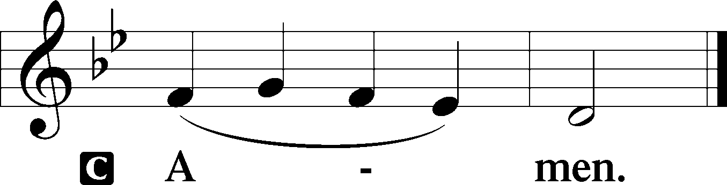

Old Testament Reading Ezekiel 34:11–16, 20–24

11“For thus says the Lord God: Behold, I, I myself will search for my sheep and will seek them out. 12As a shepherd seeks out his flock when he is among his sheep that have been scattered, so will I seek out my sheep, and I will rescue them from all places where they have been scattered on a day of clouds and thick darkness. 13And I will bring them out from the peoples and gather them from the countries, and will bring them into their own land. And I will feed them on the mountains of Israel, by the ravines, and in all the inhabited places of the country. 14I will feed them with good pasture, and on the mountain heights of Israel shall be their grazing land. There they shall lie down in good grazing land, and on rich pasture they shall feed on the mountains of Israel. 15I myself will be the shepherd of my sheep, and I myself will make them lie down, declares the Lord God. 16I will seek the lost, and I will bring back the strayed, and I will bind up the injured, and I will strengthen the weak, and the fat and the strong I will destroy. I will feed them in justice. . . .

20“Therefore, thus says the Lord God to them: Behold, I, I myself will judge between the fat sheep and the lean sheep. 21Because you push with side and shoulder, and thrust at all the weak with your horns, till you have scattered them abroad, 22I will rescue my flock; they shall no longer be a prey. And I will judge between sheep and sheep. 23And I will set up over them one shepherd, my servant David, and he shall feed them: he shall feed them and be their shepherd. 24And I, the Lord, will be their God, and my servant David shall be prince among them. I am the Lord; I have spoken.”

A This is the Word of the Lord.

C **Thanks be to God.**

Psalm Psalm 95:1–7a; antiphon: v. 7a

1Oh come, let us sing to the Lord;  
 **let us make a joyful noise to the rock of our salvation!**2Let us come into his presence with thanksgiving;  
 **let us make a joyful noise to him with songs of praise!**3For the Lord is a great God,  
 **and a great King above all gods.**4In his hand are the depths of the earth;  
 **the heights of the mountains are his also.**5The sea is his, for he made it,  
 **and his hands formed the dry land.**

6Oh come, let us worship and bow down;  
 **let us kneel before the Lord, our Maker!**7For he is our God,  
 **and we are the people of his pasture,**

**and the sheep of his hand.**

Epistle 1 Corinthians 15:20–28

20But in fact Christ has been raised from the dead, the firstfruits of those who have fallen asleep. 21For as by a man came death, by a man has come also the resurrection of the dead. 22For as in Adam all die, so also in Christ shall all be made alive. 23But each in his own order: Christ the firstfruits, then at his coming those who belong to Christ. 24Then comes the end, when he delivers the kingdom to God the Father after destroying every rule and every authority and power. 25For he must reign until he has put all his enemies under his feet. 26The last enemy to be destroyed is death. 27For “God has put all things in subjection under his feet.” But when it says, “all things are put in subjection,” it is plain that he is excepted who put all things in subjection under him. 28When all things are subjected to him, then the Son himself will also be subjected to him who put all things in subjection under him, that God may be all in all.

A This is the Word of the Lord.

C **Thanks be to God.**

Alleluia LSB 190

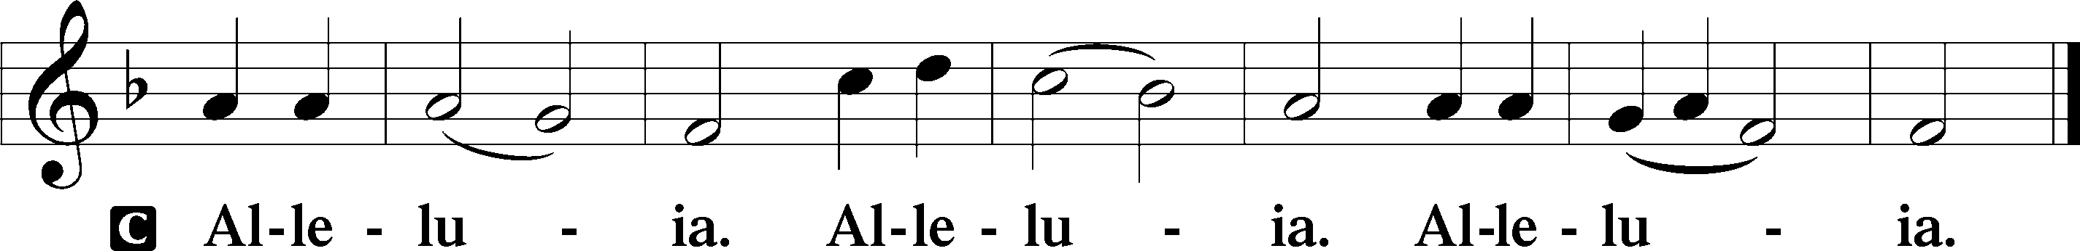

Holy Gospel Matthew 25:31–46

P The Holy Gospel according to St. Matthew, the twenty-fifth chapter.

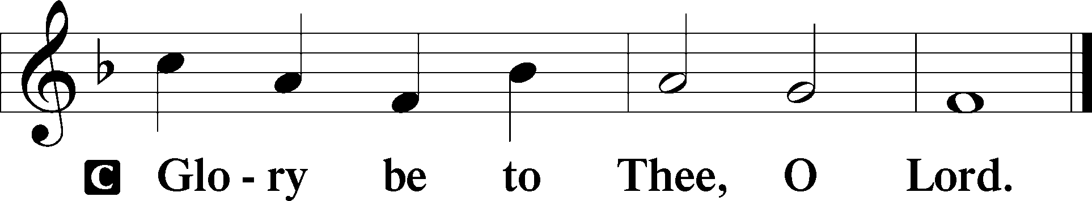

31[Jesus said:] “When the Son of Man comes in his glory, and all the angels with him, then he will sit on his glorious throne. 32Before him will be gathered all the nations, and he will separate people one from another as a shepherd separates the sheep from the goats. 33And he will place the sheep on his right, but the goats on the left. 34Then the King will say to those on his right, ‘Come, you who are blessed by my Father, inherit the kingdom prepared for you from the foundation of the world. 35For I was hungry and you gave me food, I was thirsty and you gave me drink, I was a stranger and you welcomed me, 36I was naked and you clothed me, I was sick and you visited me, I was in prison and you came to me.’ 37Then the righteous will answer him, saying, ‘Lord, when did we see you hungry and feed you, or thirsty and give you drink? 38And when did we see you a stranger and welcome you, or naked and clothe you? 39And when did we see you sick or in prison and visit you?’ 40And the King will answer them, ‘Truly, I say to you, as you did it to one of the least of these my brothers, you did it to me.’

41“Then he will say to those on his left, ‘Depart from me, you cursed, into the eternal fire prepared for the devil and his angels. 42For I was hungry and you gave me no food, I was thirsty and you gave me no drink, 43I was a stranger and you did not welcome me, naked and you did not clothe me, sick and in prison and you did not visit me.’ 44Then they also will answer, saying, ‘Lord, when did we see you hungry or thirsty or a stranger or naked or sick or in prison, and did not minister to you?’ 45Then he will answer them, saying, ‘Truly, I say to you, as you did not do it to one of the least of these, you did not do it to me.’ 46And these will go away into eternal punishment, but the righteous into eternal life.”

P This is the Gospel of the Lord.

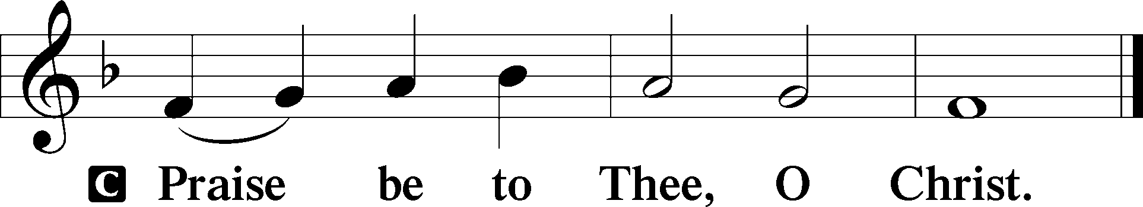

Nicene Creed

C **I believe in one God,**

**the Father Almighty,**

**maker of heaven and earth**

**and of all things visible and invisible.**

**And in one Lord Jesus Christ,**

**the only-begotten Son of God,**

**begotten of His Father before all worlds,**

**God of God, Light of Light,**

**very God of very God,**

**begotten, not made,**

**being of one substance with the Father,**

**by whom all things were made;**

**who for us men and for our salvation came down from heaven**

**and was incarnate by the Holy Spirit of the virgin Mary**

**and was made man;**

**and was crucified also for us under Pontius Pilate.**

**He suffered and was buried.**

**And the third day He rose again according to the Scriptures**

**and ascended into heaven**

**and sits at the right hand of the Father.**

**And He will come again with glory to judge both the living and the dead, whose kingdom will have no end.**

**And I believe in the Holy Spirit,**

**the Lord and giver of life,**

**who proceeds from the Father and the Son,**

**who with the Father and the Son together is worshiped and glorified,**

**who spoke by the prophets.**

**And I believe in one holy Christian and apostolic Church,**

**I acknowledge one Baptism for the remission of sins,**

**and I look for the resurrection of the dead**

**and the life** T **of the world to come. Amen.**

Children’s Message Thanks Living

532 The Head That Once Was Crowned with Thorns

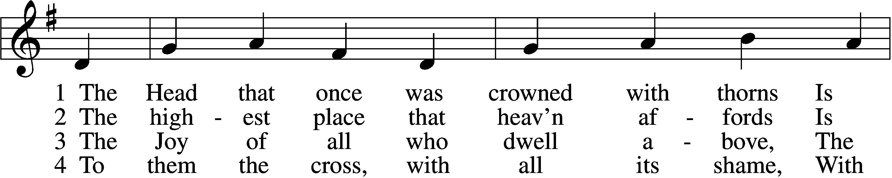

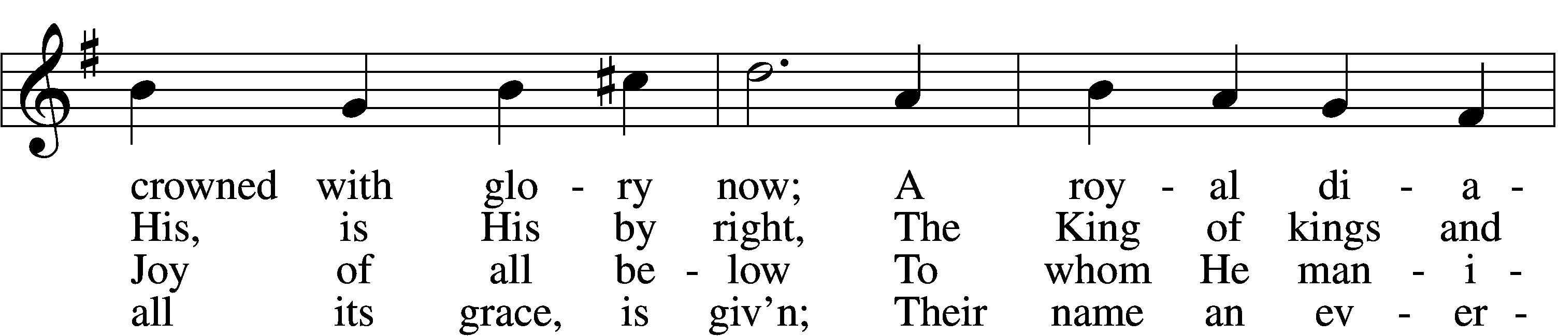

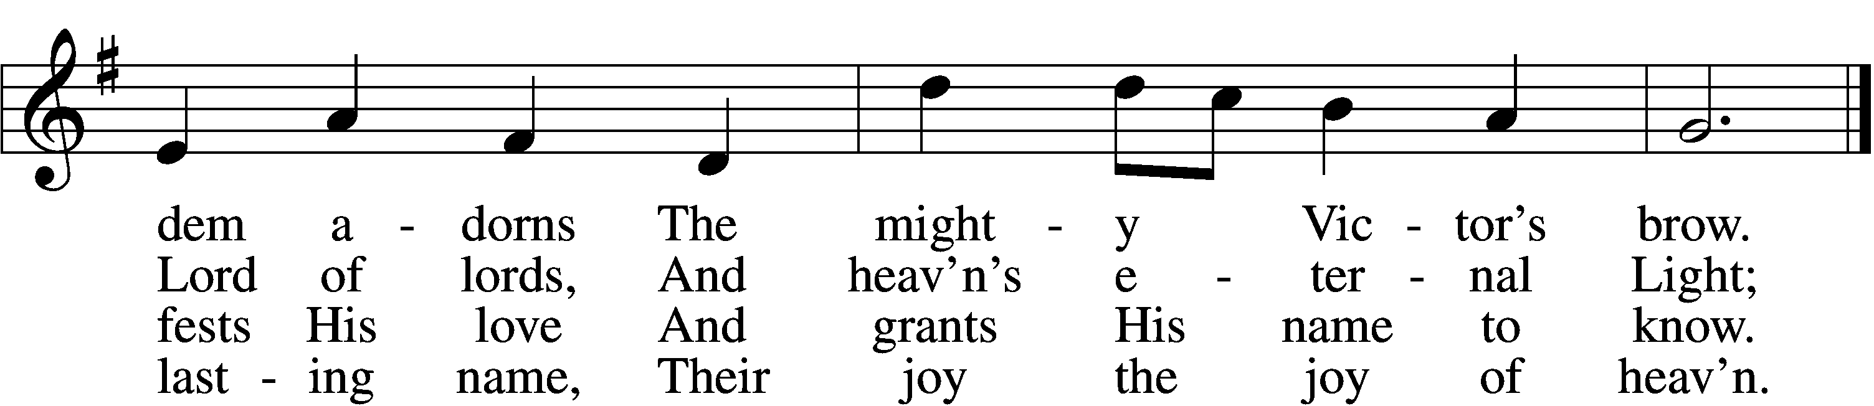

Text and tune: Public domain

Sermon “Christ Before and Above All”

Offertory LSB 192

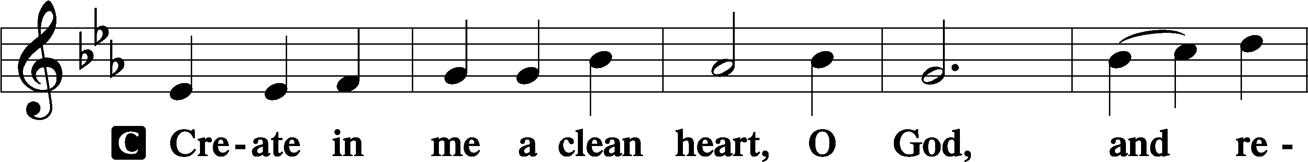

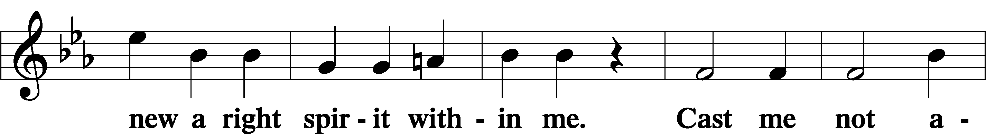

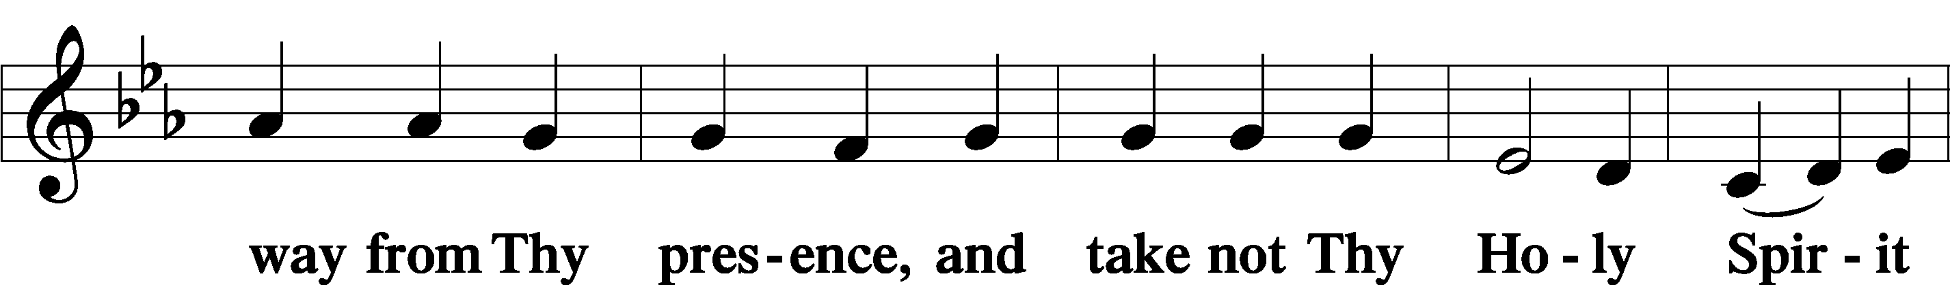

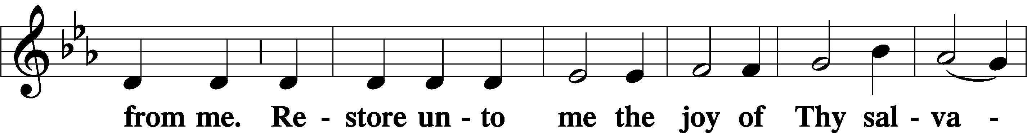

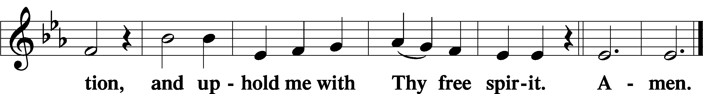

Prayer of the Church

# Service of the Sacrament

Preface LSB 194







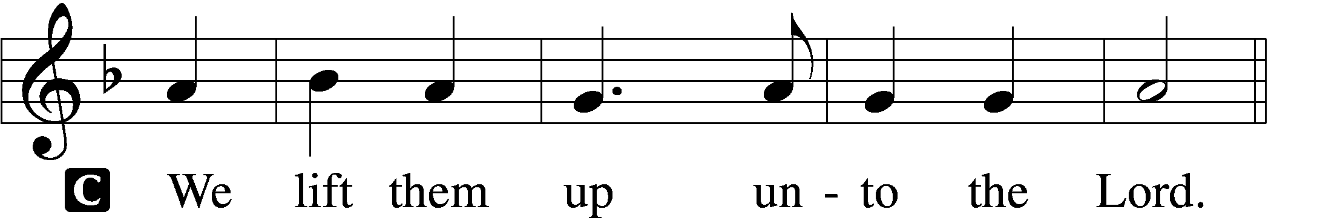

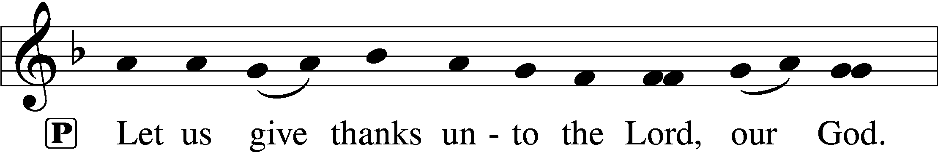

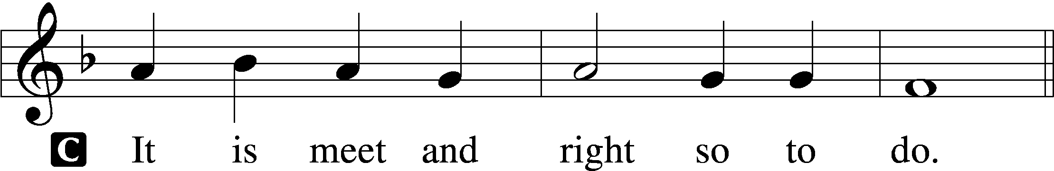

P It is truly meet, right, and salutary that we should at all times and in all places give thanks to You, holy Lord, almighty Father, everlasting God, through Jesus Christ, our Lord, who, having created all things, took on human flesh and was born of the virgin Mary. For our sake He died on the cross and rose from the dead to put an end to death, thus fulfilling Your will and gaining for You a holy people. Therefore with angels and archangels and with all the company of heaven we laud and magnify Your glorious name, evermore praising You and saying:

Sanctus LSB 195

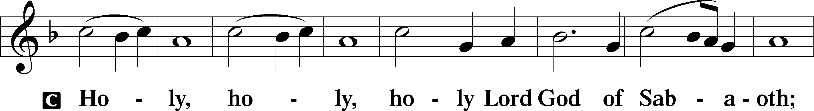

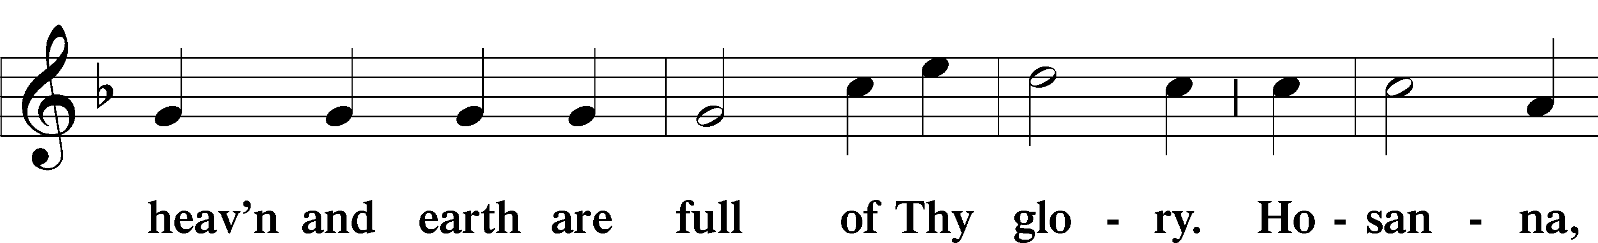

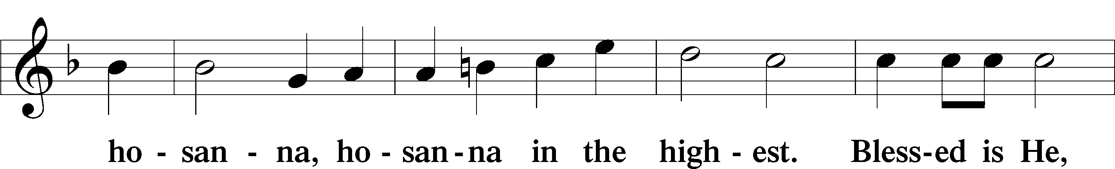

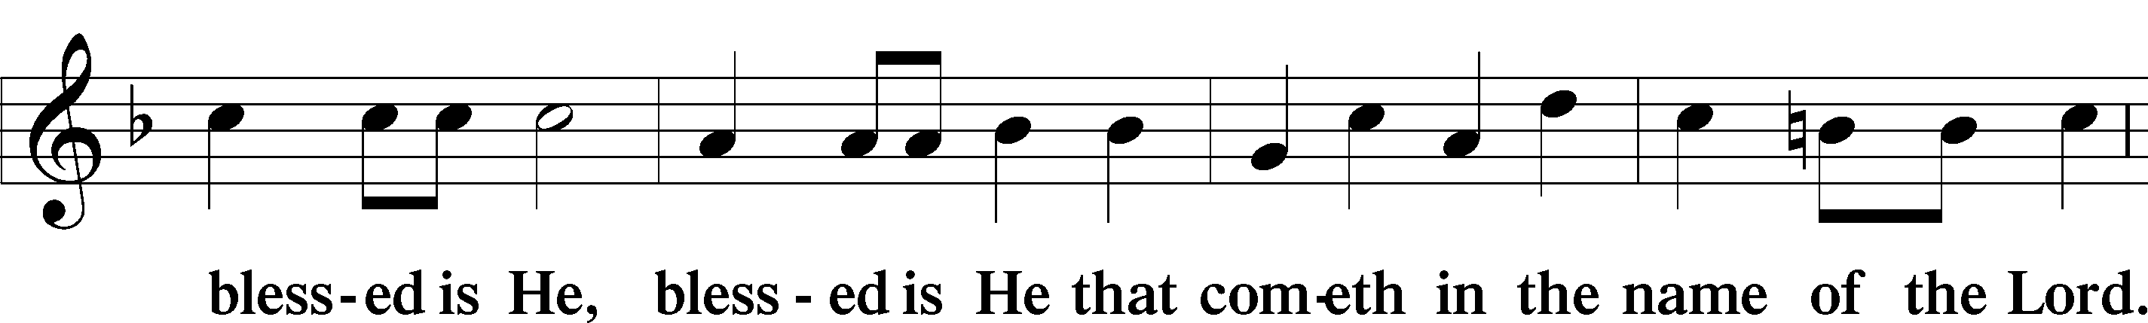

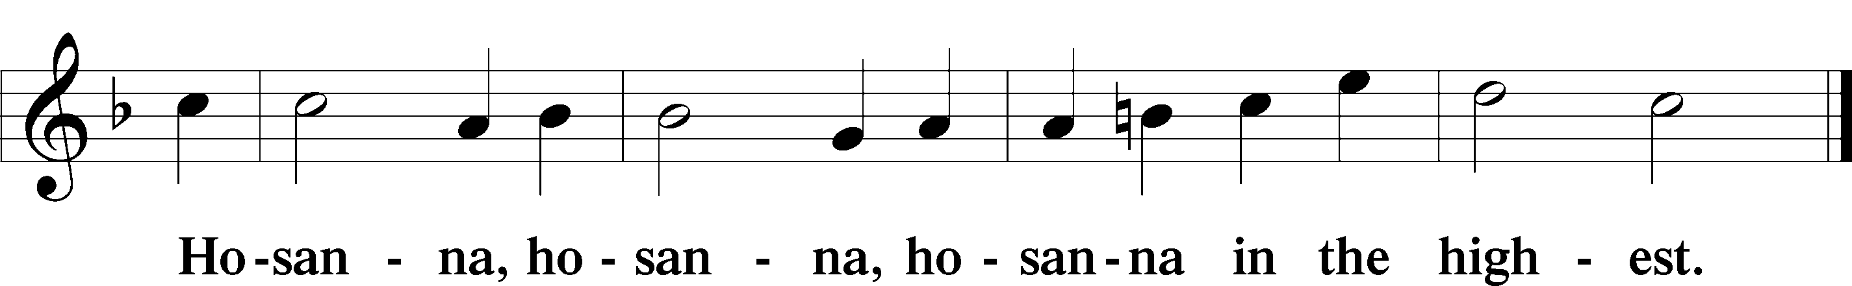

Lord’s Prayer LSB 196

P Our Father who art in heaven,

hallowed be Thy name,

Thy kingdom come,

Thy will be done on earth as it is in heaven;

give us this day our daily bread;

and forgive us our trespasses as we forgive those who trespass against us;

and lead us not into temptation,

but deliver us from evil.

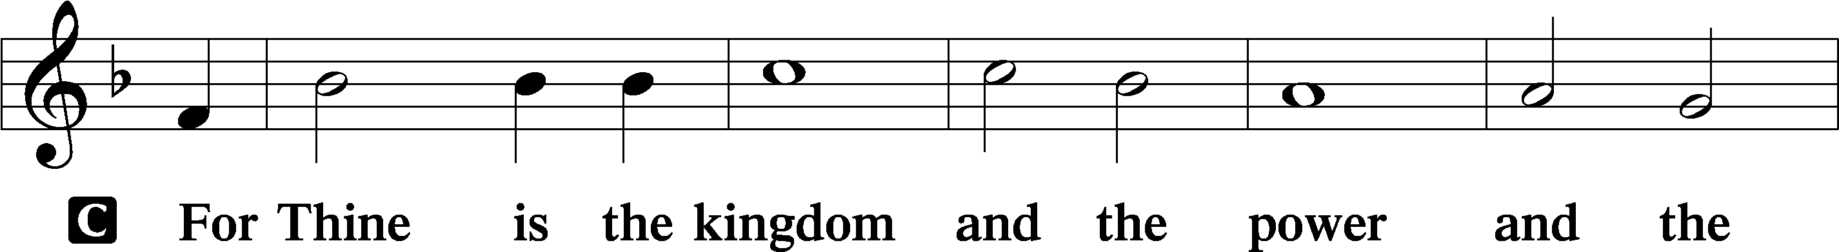

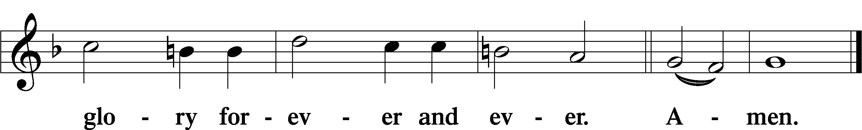

The Words of Our Lord LSB 197

P Our Lord Jesus Christ, on the night when He was betrayed, took bread, and when He had given thanks, He broke it and gave it to the disciples and said: “Take, eat; this is My T body, which is given for you. This do in remembrance of Me.”

In the same way also He took the cup after supper, and when He had given thanks, He gave it to them, saying: “Drink of it, all of you; this cup is the new testament in My T blood, which is shed for you for the forgiveness of sins. This do, as often as you drink it, in remembrance of Me.”

Pax Domini LSB 197

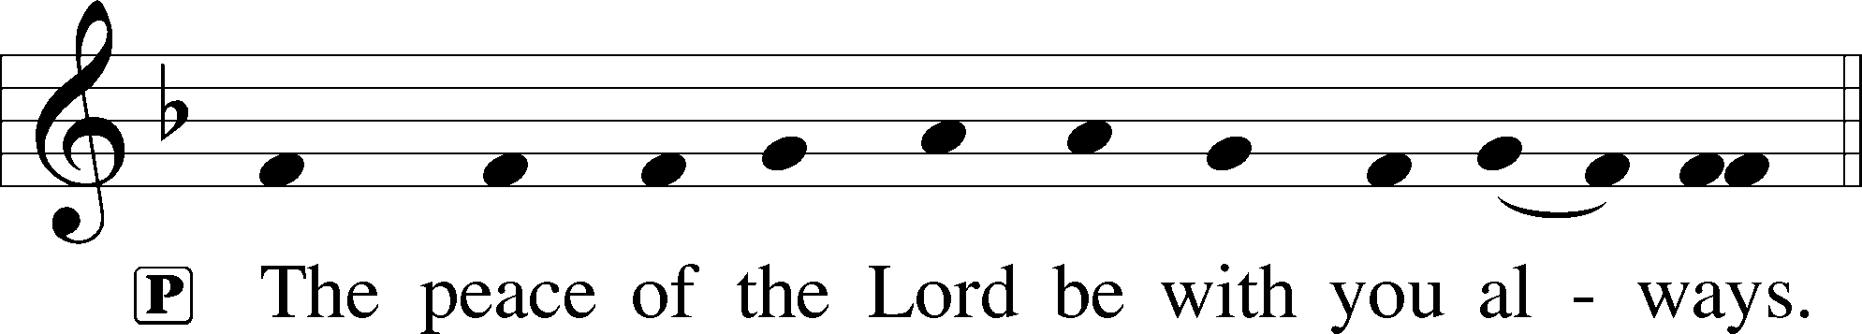

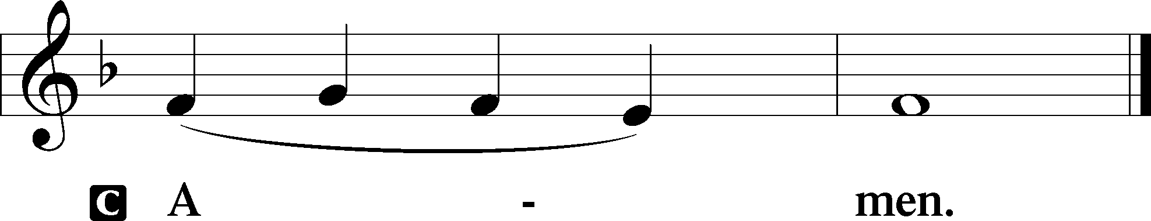

Agnus Dei LSB 198

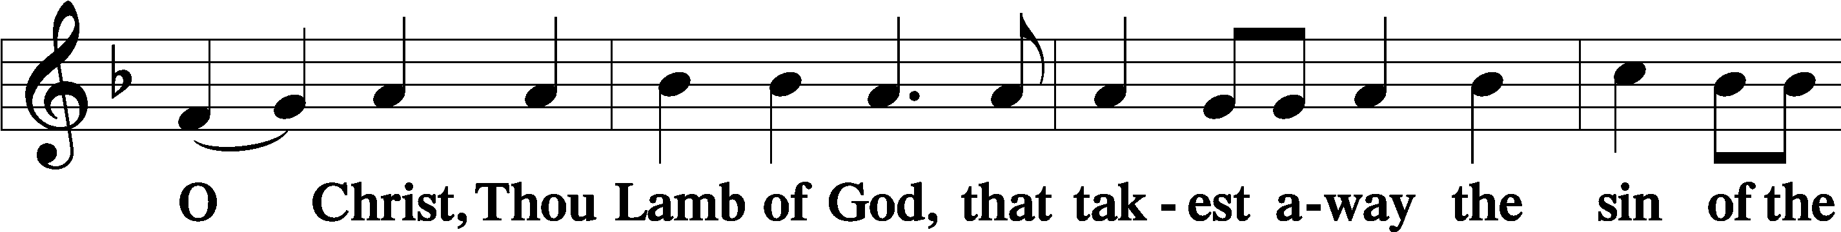

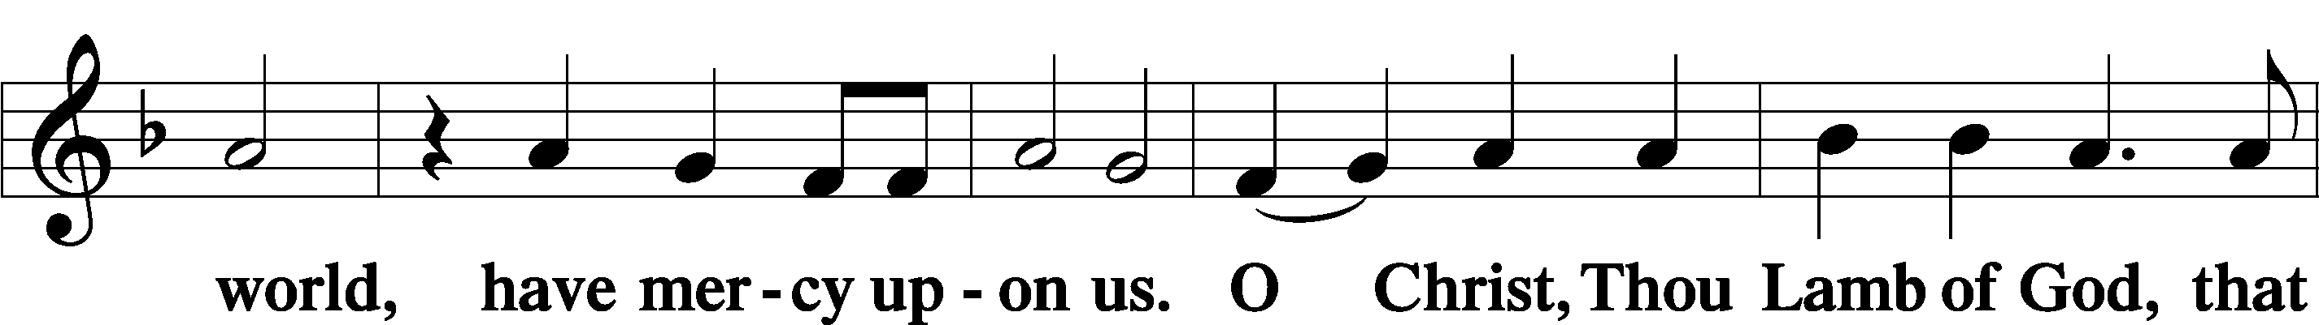

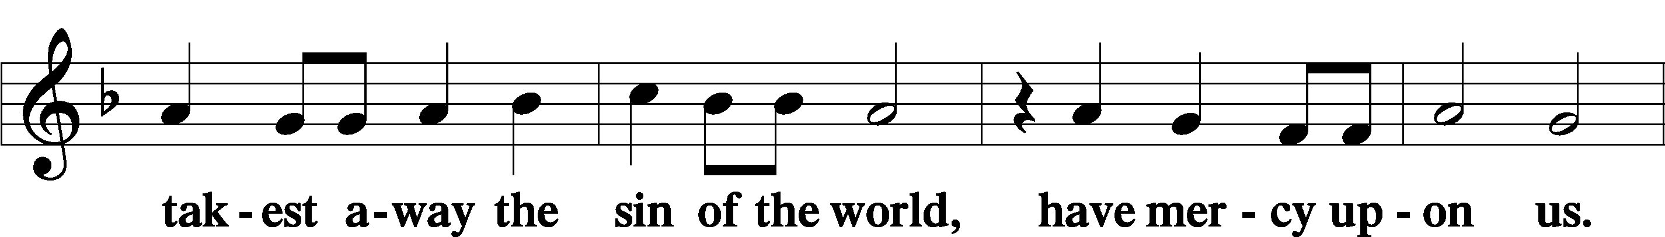

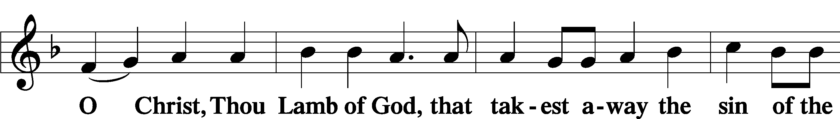

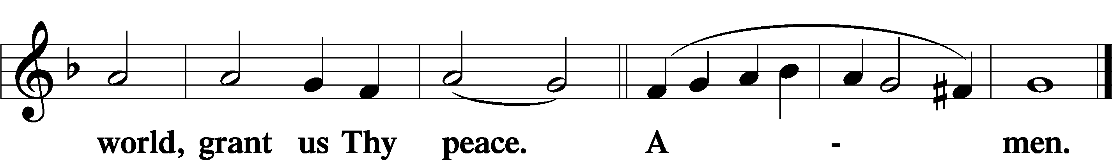

621 Let All Mortal Flesh Keep Silence

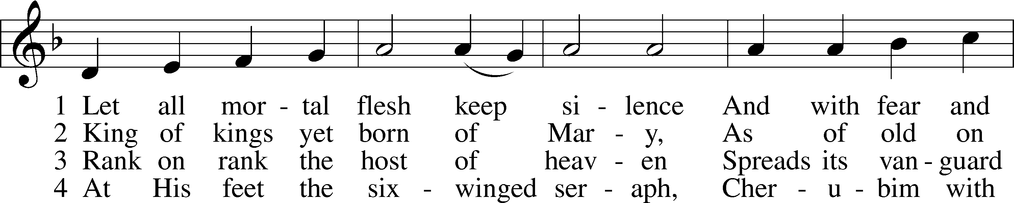

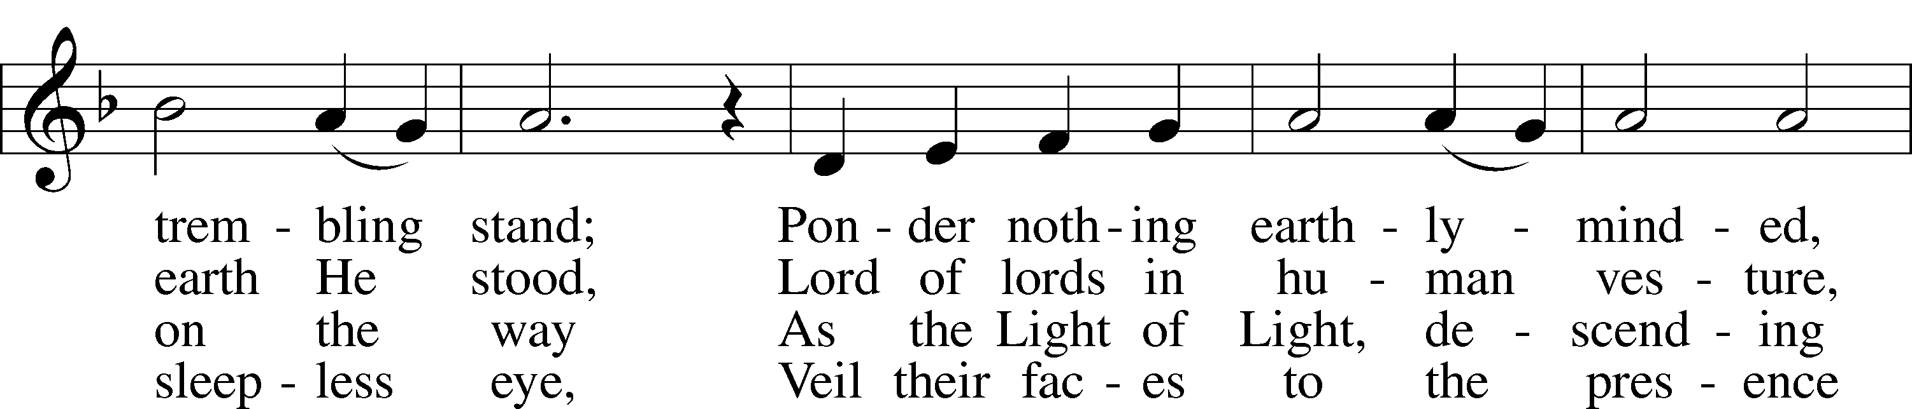

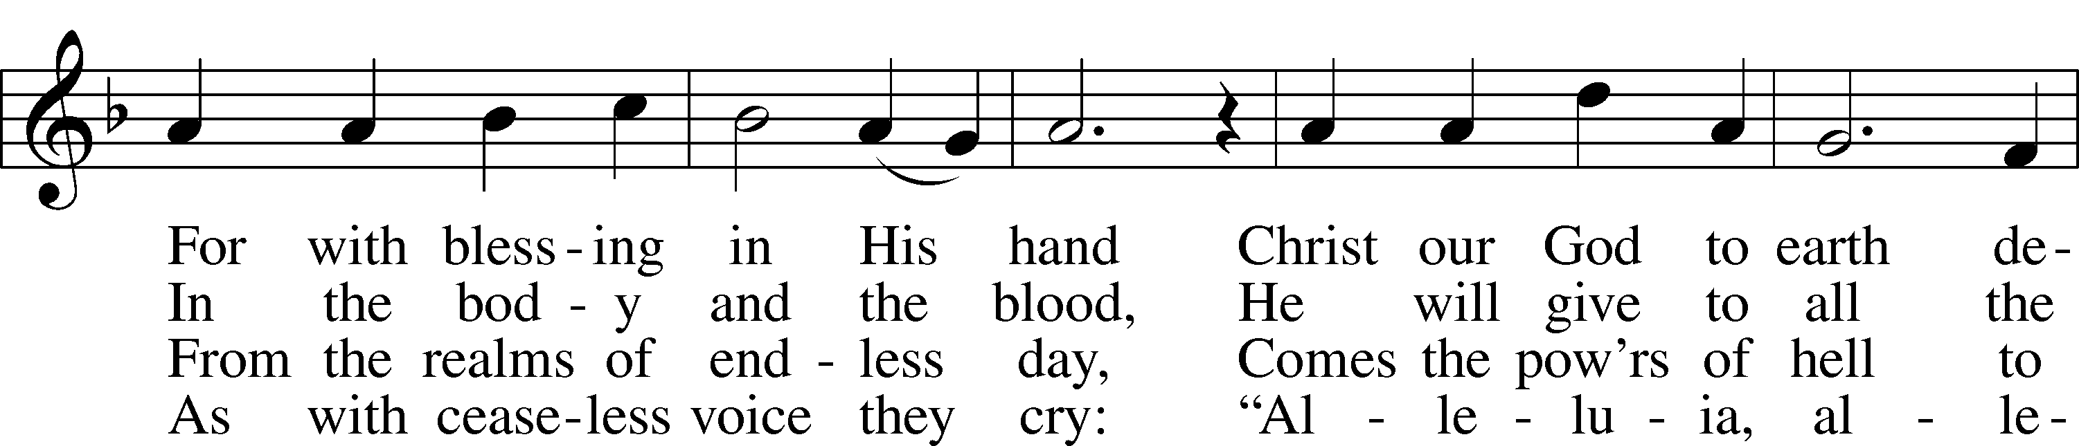

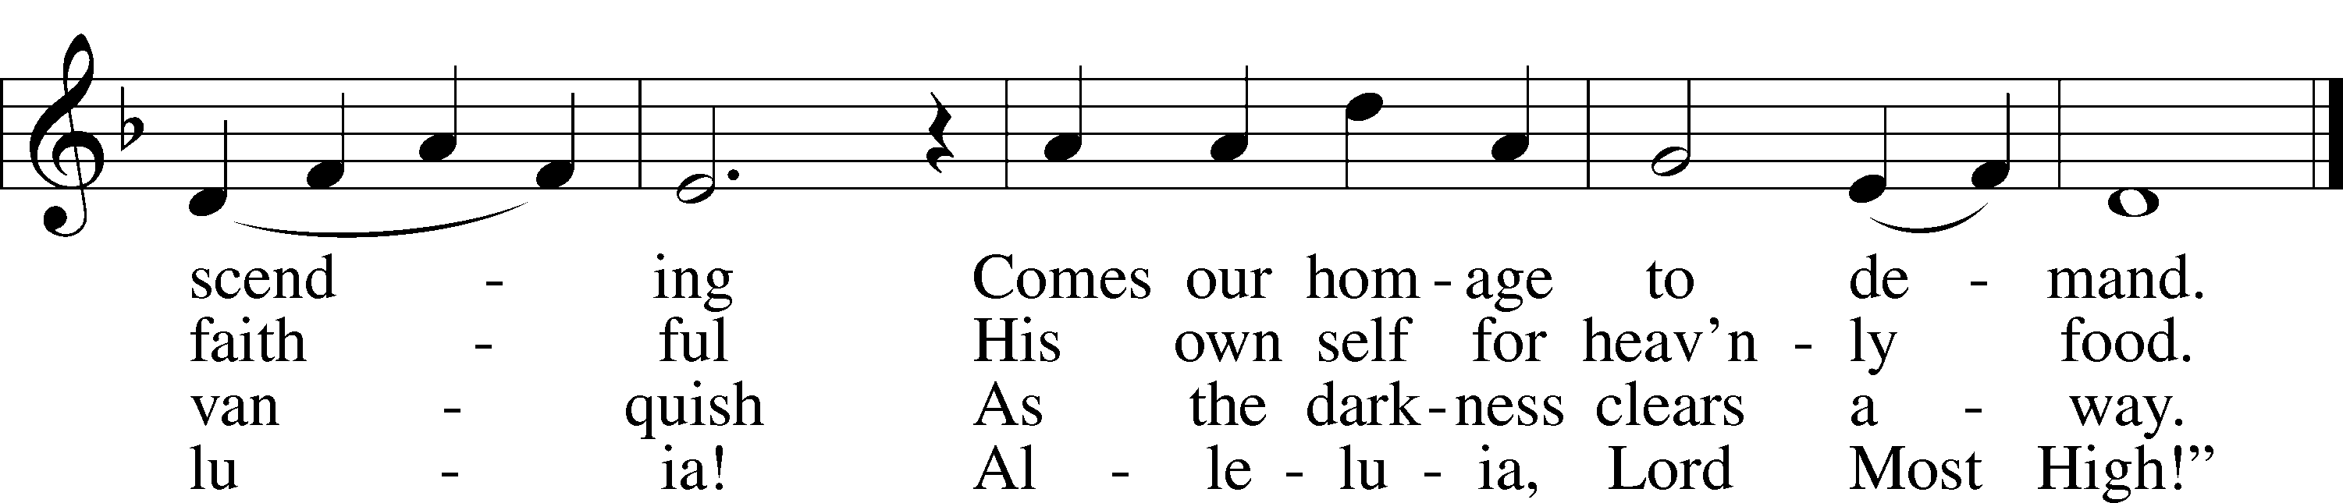

Text and tune: Public domain

Nunc Dimittis LSB 199

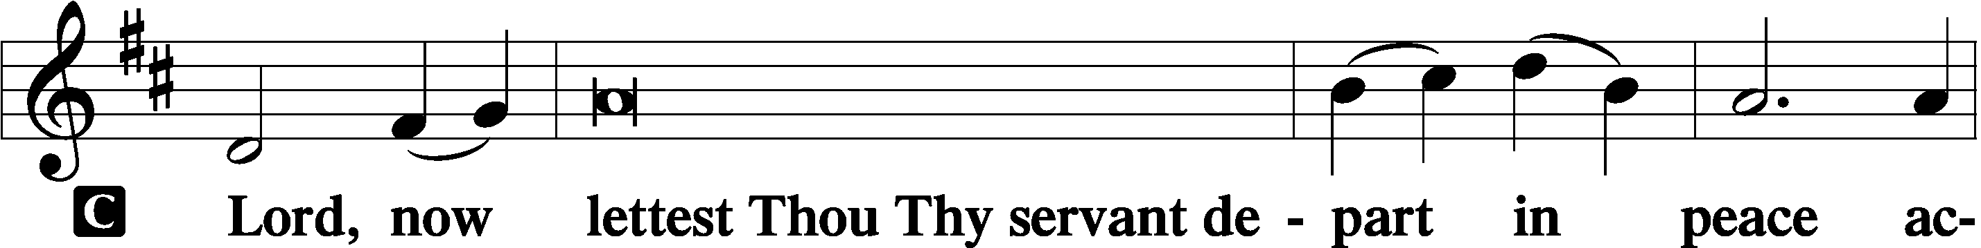

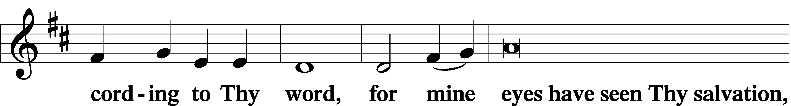

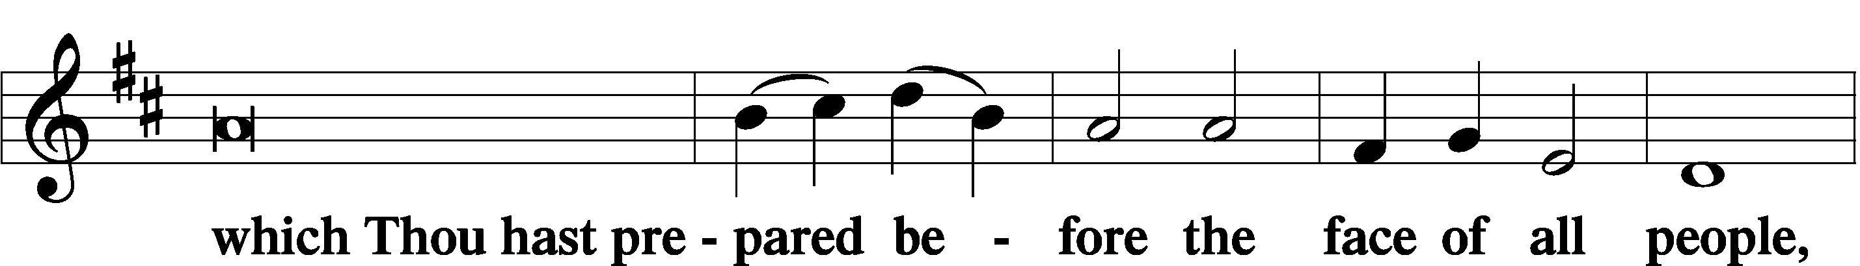

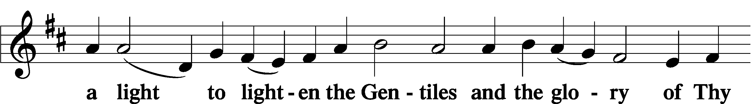

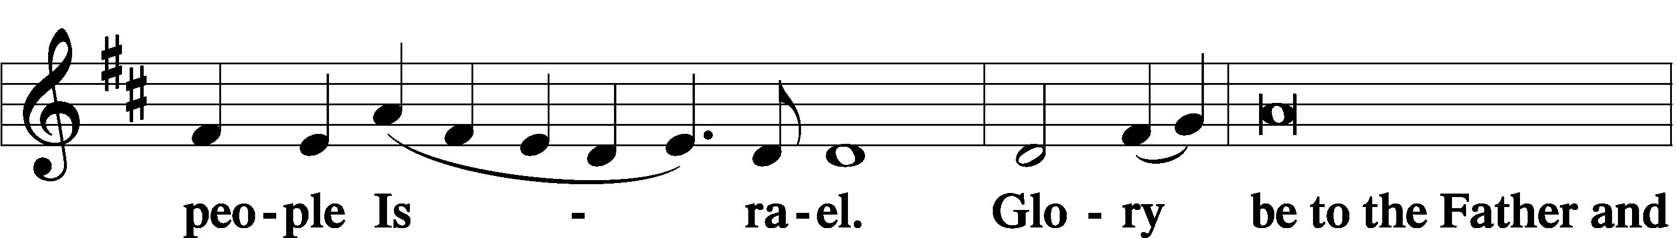

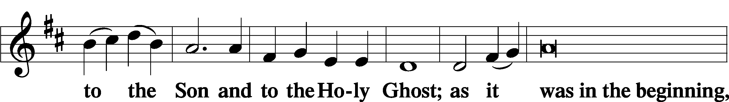

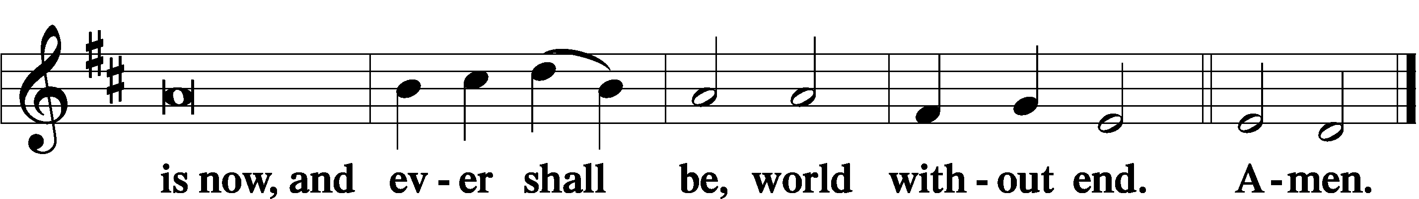

Thanksgiving LSB 200

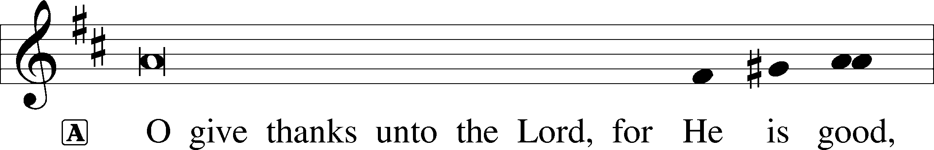

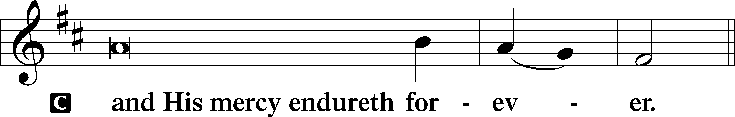

A Let us pray.

We give thanks to You, almighty God, that You have refreshed us through this salutary gift, and we implore You that of Your mercy You would strengthen us through the same in faith toward You and in fervent love toward one another; through Jesus Christ, Your Son, our Lord, who lives and reigns with You and the Holy Spirit, one God, now and forever.

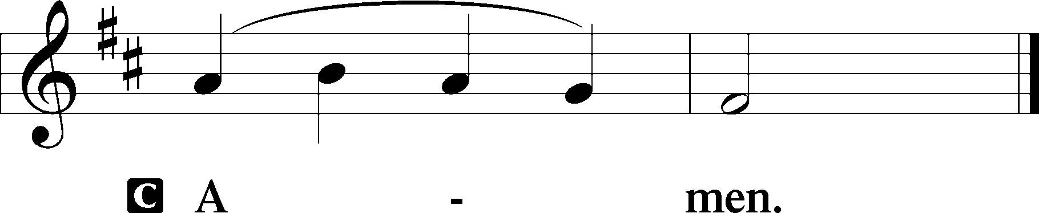

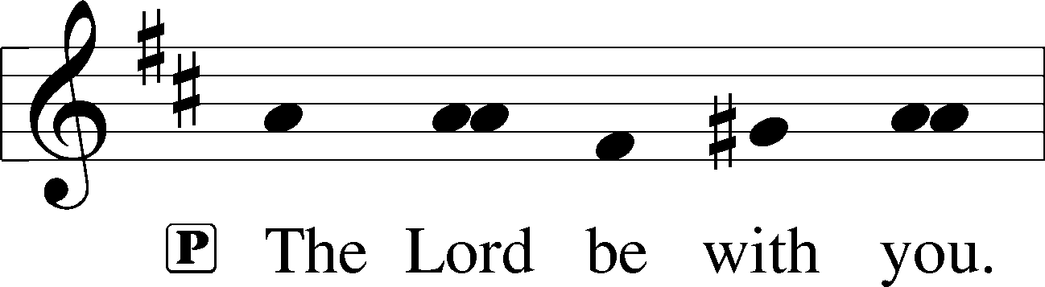

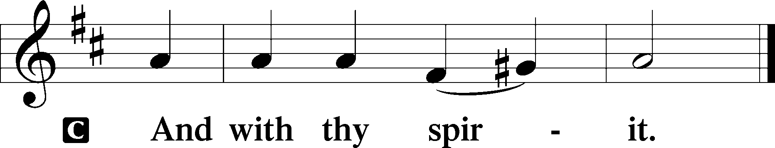

Benedicamus LSB 202

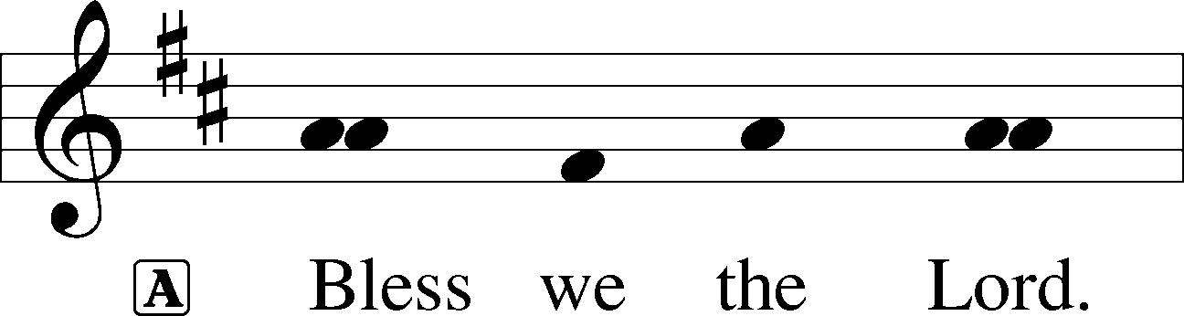

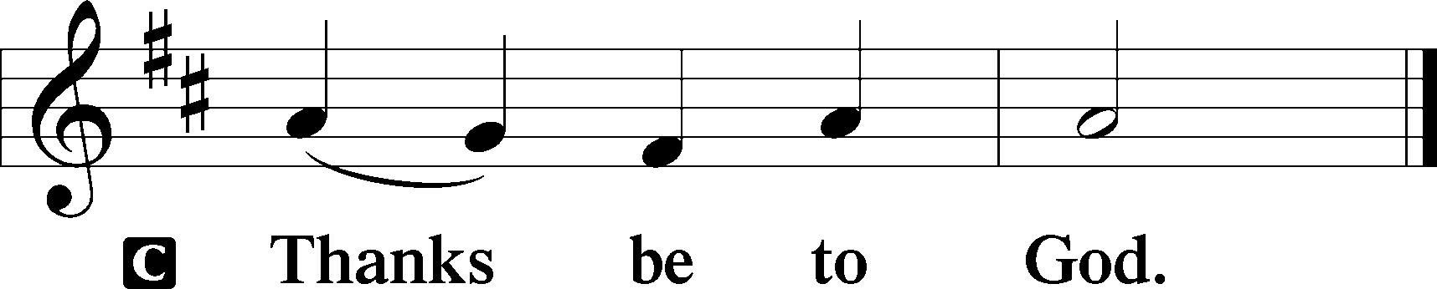

Benediction LSB 202

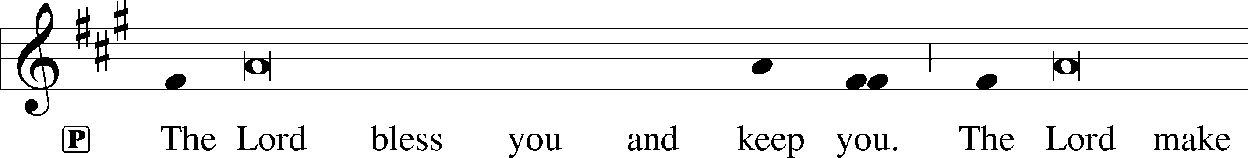

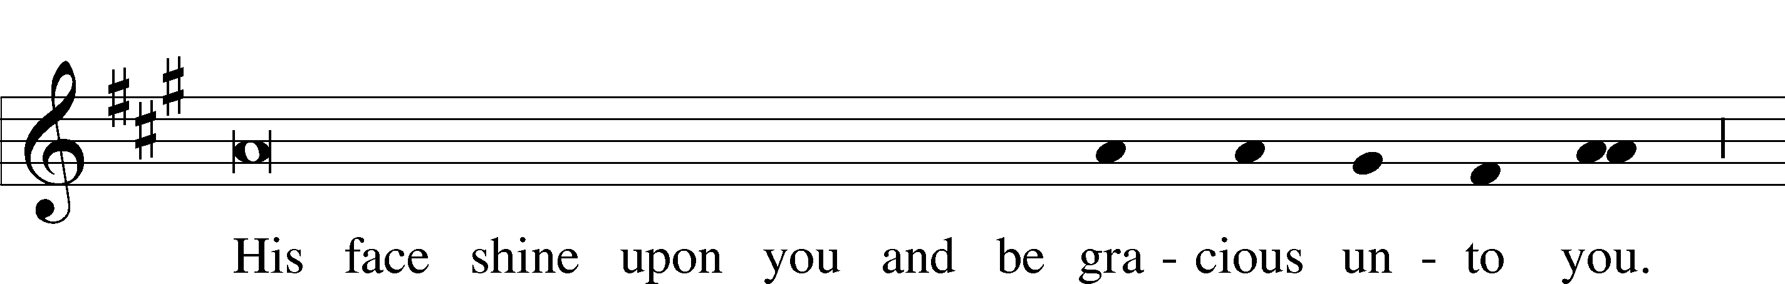

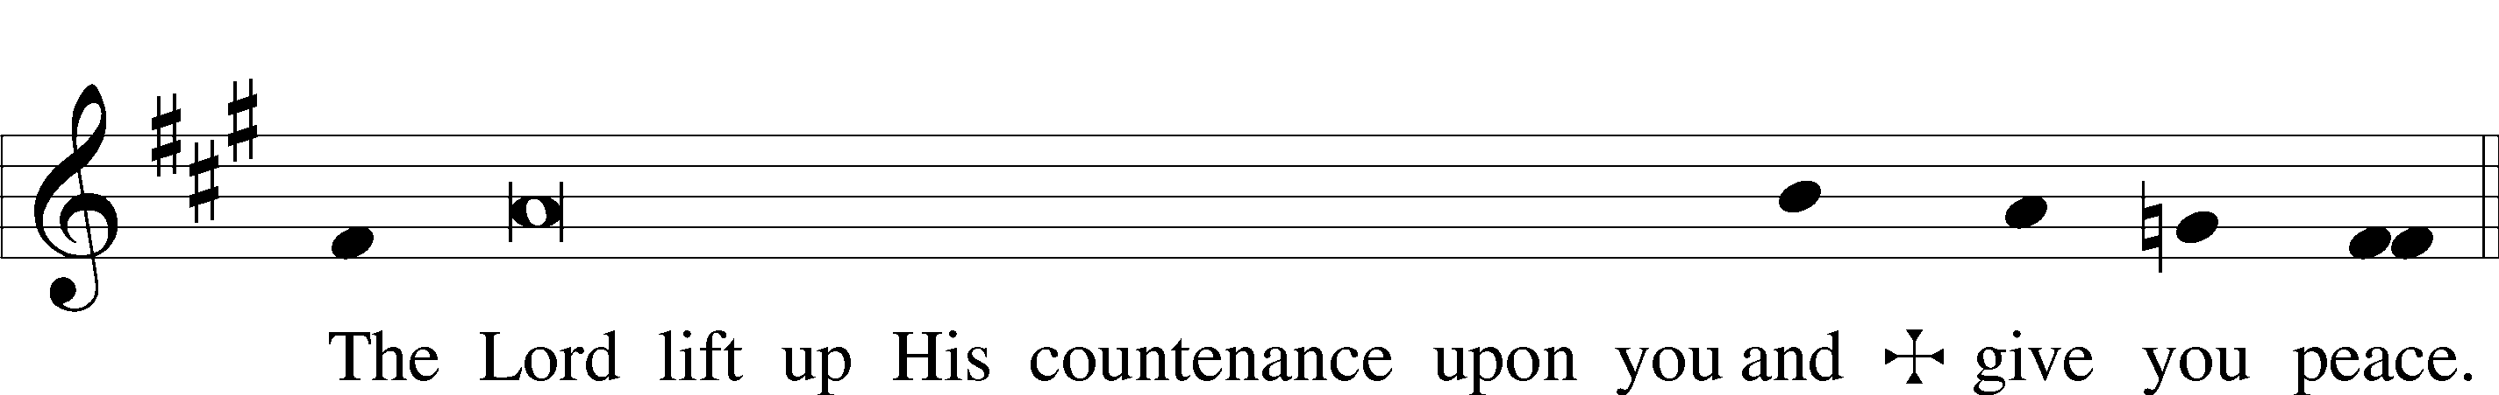

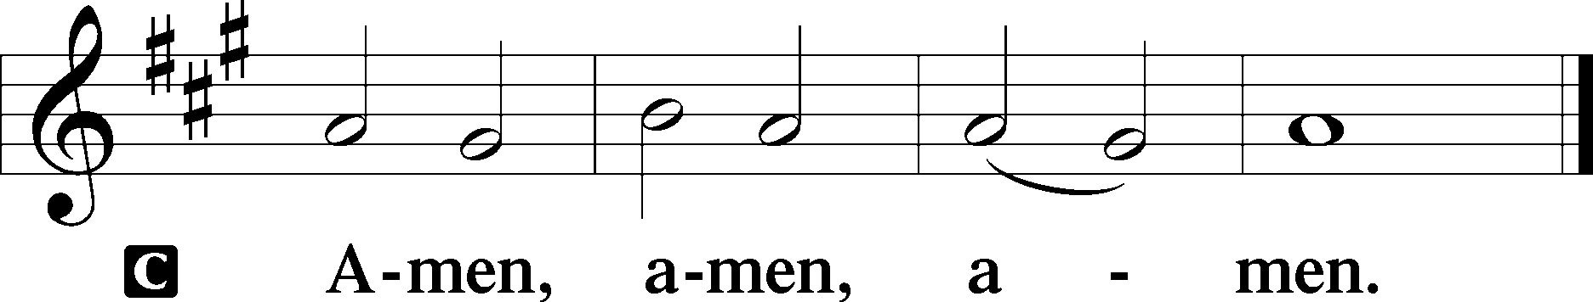

705 The Man Is Ever Blessed

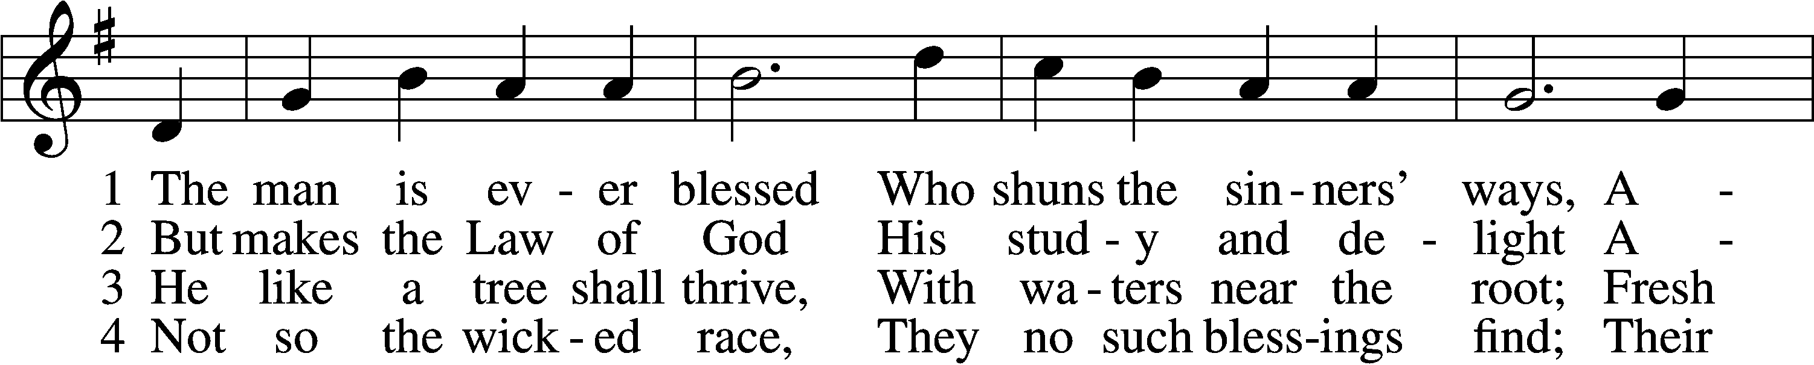

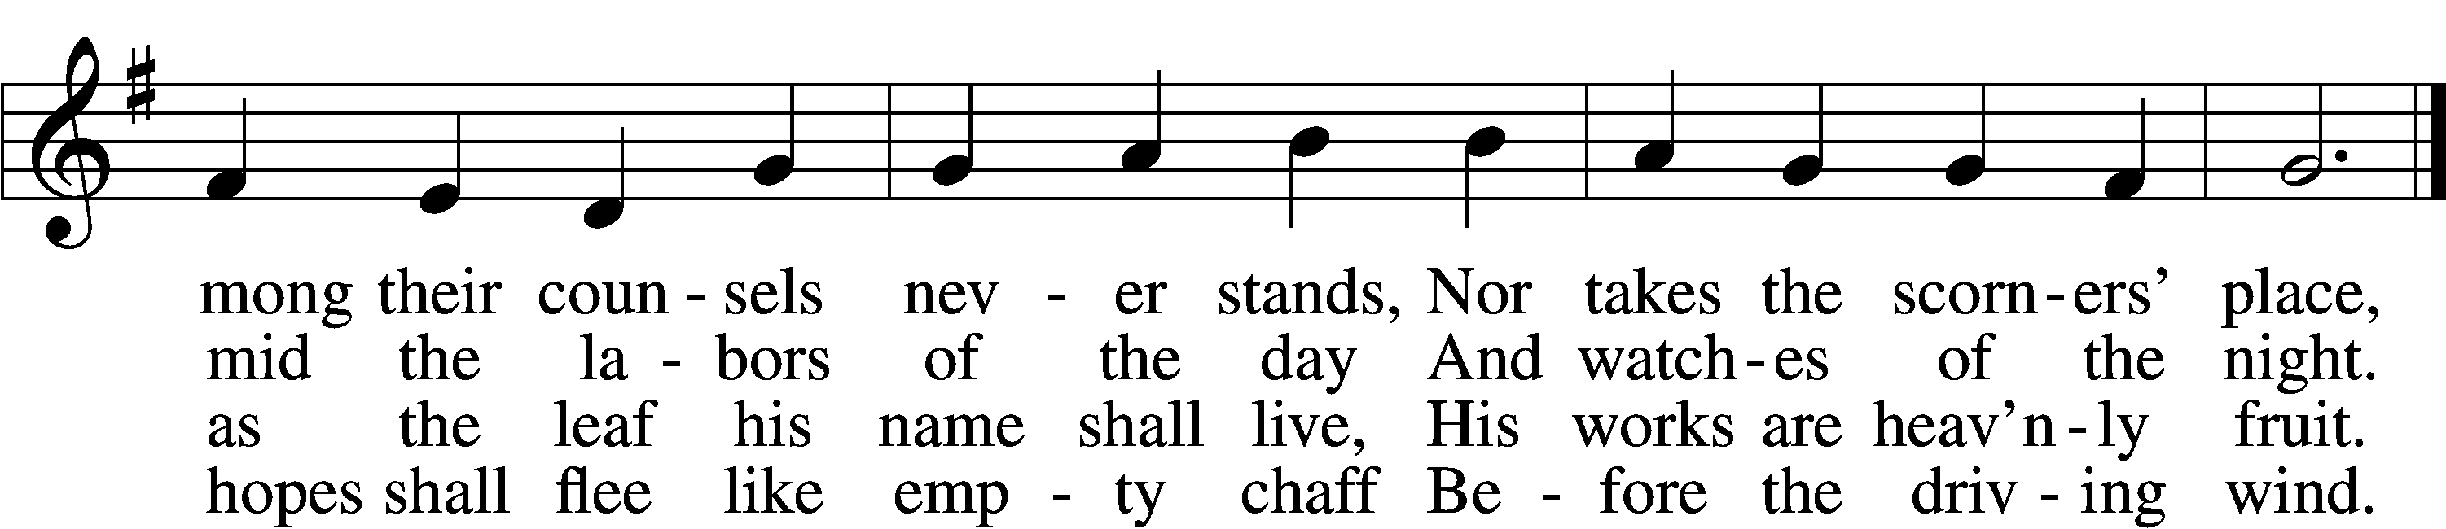

5 How will they bear to stand  
 Before the judgment seat  
Where all the saints at Christ’s right hand  
 In full assembly meet?

6 He knows and He approves  
 The way the righteous go;  
But sinners and their works shall meet  
 A dreadful overthrow.

Text and tune: Public domain

Acknowledgments

Divine Service, Setting Three from Lutheran Service Book

Unless otherwise indicated, Scripture quotations are from the ESV® Bible (The Holy Bible, English Standard Version®), copyright © 2001 by Crossway, a publishing ministry of Good News Publishers. Used by permission. All rights reserved.

Created by Lutheran Service Builder © 2018 Concordia Publishing House.

**November 22** “This Thanksgiving, let’s remember exactly what God has bought for us with the blood of His Son—not just anything, but everything that matters: Pardon from sin and release from guilt. Peace with God and a home in heaven. We come empty-handed to this banquet of blessings. No marshmallow-topped side dish of good works can earn us a place at this buffet. We have nothing to offer God in exchange, yet ‘[t]he LORD has done great things for us, and we are filled with joy” (Psalm 126:3).’” Sarah Habban, Time of Grace – A Life Quote from Lutherans For Life • [www.lutheransforlife.org](http://www.lutheransforlife.org)

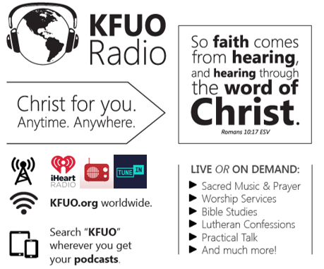

**This week on KFUO.org,** begin studying 2 Corinthians on Thy Strong Word (weekdays at 11:00 a.m. CT), finish Titus on Sharper Iron (weekdays at 8:00 a.m. CT), and consider how our Lutheran Confessions tie into our practice and vocation as Lutherans on Concord Matters (11/24 at 2:00 p.m. CT). Find these programs on demand at kfuo.org or wherever you get your podcasts.

**Gifts of Time and Treasure**

***“Whatever you do, work heartily for the Lord…”***

***Matthew 6:21***

**LAST WEEK’S OFFERINGS**  **LAST WEEK’S ATTENDANCE**

General Fund $ 3,124.38 Service 40

Needed Weekly $ 3,963.38 Communed 35

Adult Bible Study $ 6.00

Children’s SS/Mission $ 10.00

**The Lord’s Week**

Today 8:45 am – Bible Studies for all ages

**(Nov. 22nd)** 10:00 am – Divine Service

11:30 am – Confirmation

7:30 pm – Thanksgiving Service

Wednesday **No Women’s Bible Study**

Thursday **Happy Thanksgiving!!**

Next Sunday 8:45 am – Bible Studies for all ages

**(Nov. 29th)** 10:00 am – Divine Service

11:30 am – Confirmation

**In His Service**

Elder: John Polen

Organist: Sharon Schrader

Acolytes: Parker Bluntzer, Cody Wilson

Alter: Devereaux Brewer