**Second Sunday After Christmas**

**“Understanding, Wisdom, Discernment”**

1 Kings 3:4–15

**January 3, 2021**

**Messiah Lutheran Church**

**Lutheran Church-Missouri Synod**

4102 Trinity River Dr., Corpus Christi, Texas 78410

**Pastor:**  **Rev. Scott E. Herbert**

Church Phone: 361-387-7748 Email: mlc@stx.rr.com

Church Fax: 361-767-1768 Website: [www.messiahlcms-cc.org](http://www.messiahlcms-cc.org)

Pastor Phone: 469-693-9683 Pastor Email: chirev59@gmail.com

**WELCOME TO MESSIAH!**

We are glad you are here to receive what God is doing for you during Divine Service. Please sign our Guest Book located near the front door. Feel free to converse quietly until the organ prelude begins. If you are looking for a church home, please talk to the Pastor at the door. We would love to have you join us.

**Preparing for Service**

***The Lord Jesus Is Found in the Temple of His Church***

The Lord Jesus *“grew and became strong”* (Luke 2:40); He *“increased in wisdom and in stature and in favor with God and man”* (Luke 2:52). As His body grew and developed, His mind also increased in knowledge and understanding. For as our brother in the flesh, that we might *“have redemption through his blood”* (Eph. 1:7), He lived by faith in the Word of His Father. Thus, He was catechized by His parents, who took Him up *“to Jerusalem every year at the Feast of the Passover”* (Luke 2:41); and when He was of age, He gave attention to the Holy Scriptures in His Father’s house (Luke 2:46, 49). Christ Jesus is still found in His Church, in *“the word of truth, the gospel,”* by which we are adopted by His Father and sealed with His Spirit (Eph. 1:5, 13). Thus do we gain *“an understanding mind”* to go about our vocations, discerning *“between good and evil”* (1 Kings 3:9). And so do we also go up to Jerusalem, to stand *“before the ark of the covenant of the Lord”* (1 Kings 3:15), that is, in the Holy Communion of His body and blood.

# Confession and Absolution

981 To Your Temple, Lord, I Come

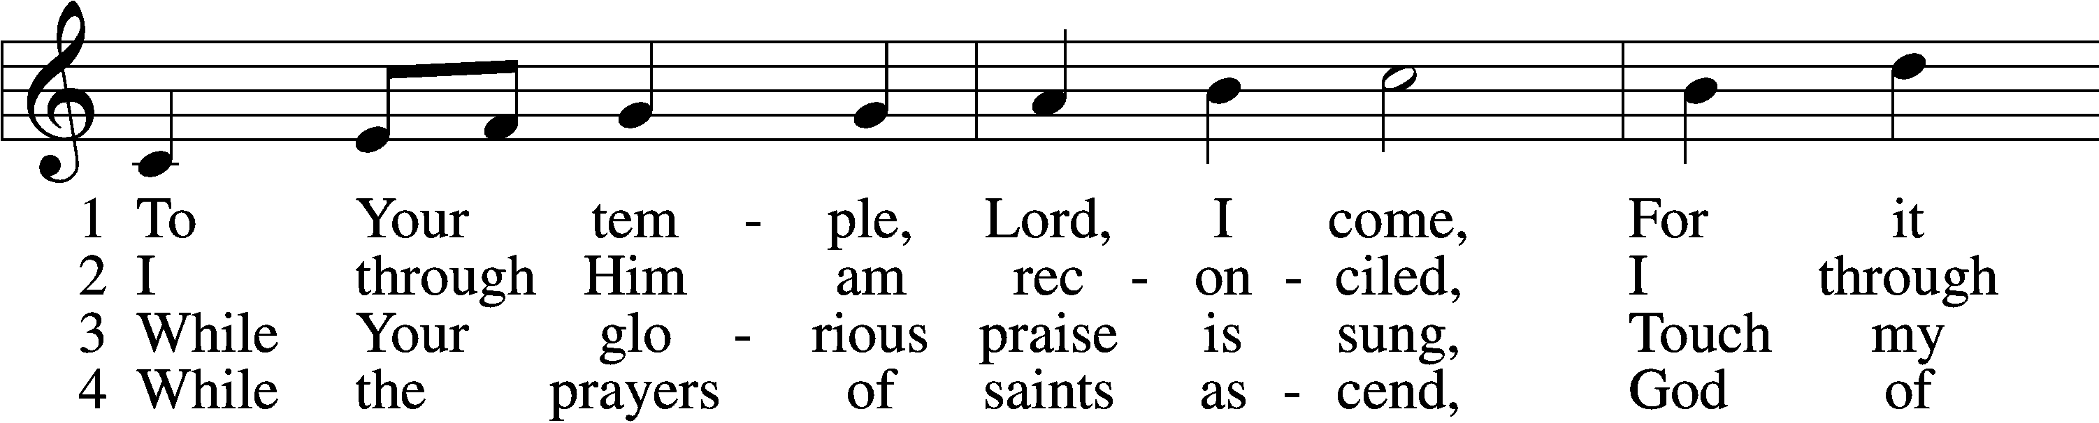

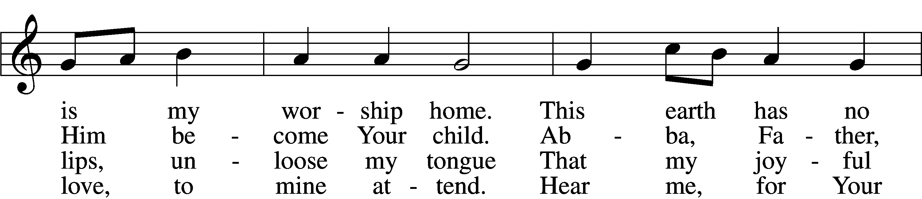

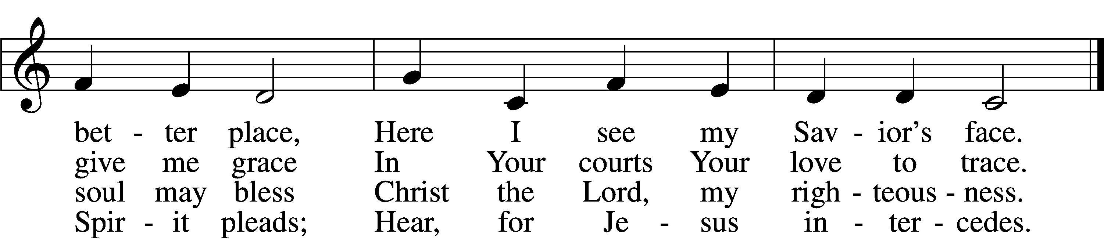

5 While I listen to Your Law,  
Fill my soul with humble awe  
Till Your Gospel bring to me  
Life and immortality.

6 While Your ministers proclaim  
Peace and pardon in Your name,  
Through their voice, by faith, may I  
Hear You speaking from the sky.

7 From Your house when I return,  
May my heart within me burn,  
And at evening let me say,  
“I have walked with God today.”

Text and tune: Public domain

P In the name of the Father and of the T Son and of the Holy Spirit.

C **Amen.**

P Our help is in the name of the Lord,

C **who made heaven and earth.**

P If You, O Lord, kept a record of sins, O Lord, who could stand?

C **But with You there is forgiveness; therefore You are feared.**

P Since we are gathered to hear God’s Word, call upon Him in prayer and praise, and receive the body and blood of our Lord Jesus Christ in the fellowship of this altar, let us first consider our unworthiness and confess before God and one another that we have sinned in thought, word, and deed, and that we cannot free ourselves from our sinful condition. Together as His people let us take refuge in the infinite mercy of God, our heavenly Father, seeking His grace for the sake of Christ, and saying: God, be merciful to me, a sinner.

C **Almighty God, have mercy upon us, forgive us our sins, and lead us to everlasting life. Amen.**

P Almighty God, merciful Father, in Holy Baptism You declared us to be Your children and gathered us into Your one, holy Church, in which You daily and richly forgive us our sins and grant us new life through Your Spirit. Be in our midst, enliven our faith, and graciously receive our prayer and praise; through Your Son, Jesus Christ, our Lord.

C **Amen.**

# Service of the Word

Introit Psalm 147:1, 5, 11–12; antiphon: John 1:14

The Word became flesh and dwelt among us, and we have seen his glory,  
 **glory as of the only Son from the Father, full of grace and truth.**Praise the Lord! For it is good to sing praises to our God;  
 **for it is pleasant, and a song of praise is fitting.**Great is our Lord, and abundant in power;  
 **his understanding is beyond measure.**But the Lord takes pleasure in those who fear him,  
 **in those who hope in his steadfast love.**  
Praise the Lord, O Jerusalem!  
 **Praise your God, O Zion!  
Glory be to the Father and to the Son and to the Holy Spirit;**  
**as it was in the beginning, is now, and will be forever. Amen.**  
The Word became flesh and dwelt among us, and we have seen his glory,  
 **glory as of the only Son from the Father, full of grace and truth.**

Kyrie LSB 204

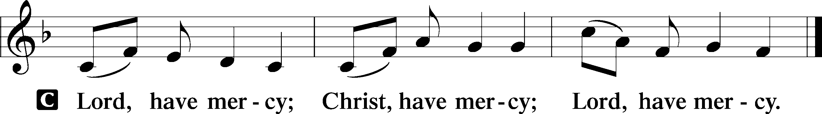

Gloria in Excelsis LSB 204

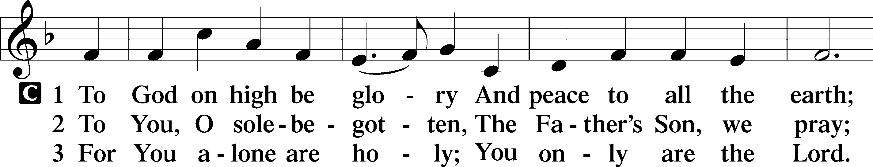

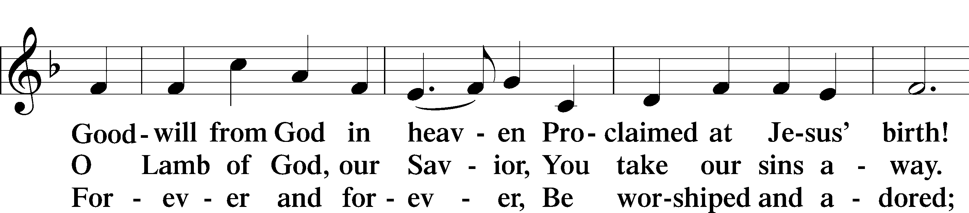

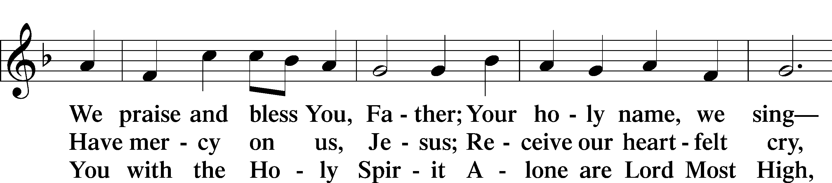

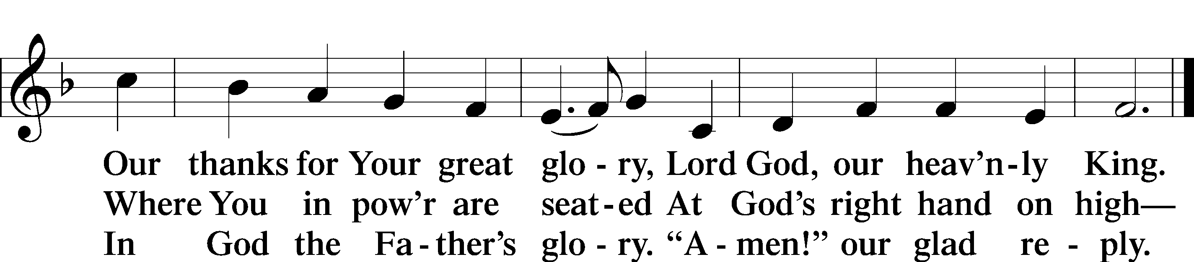

Salutation and Collect of the Day

P The Lord be with you.

C **And also with you.**

P Let us pray.

Almighty God, You have poured into our hearts the true Light of Your incarnate Word. Grant that this Light may shine forth in our lives; through the same Jesus Christ, Your Son, our Lord, who lives and reigns with You and the Holy Spirit, one God, now and forever.

C **Amen.**

Old Testament Reading 1 Kings 3:4–15

4 The king went to Gibeon to sacrifice there, for that was the great high place. Solomon used to offer a thousand burnt offerings on that altar. 5At Gibeon the Lord appeared to Solomon in a dream by night, and God said, “Ask what I shall give you.” 6And Solomon said, “You have shown great and steadfast love to your servant David my father, because he walked before you in faithfulness, in righteousness, and in uprightness of heart toward you. And you have kept for him this great and steadfast love and have given him a son to sit on his throne this day. 7And now, O Lord my God, you have made your servant king in place of David my father, although I am but a little child. I do not know how to go out or come in. 8And your servant is in the midst of your people whom you have chosen, a great people, too many to be numbered or counted for multitude. 9Give your servant therefore an understanding mind to govern your people, that I may discern between good and evil, for who is able to govern this your great people?”

10It pleased the Lord that Solomon had asked this. 11And God said to him, “Because you have asked this, and have not asked for yourself long life or riches or the life of your enemies, but have asked for yourself understanding to discern what is right, 12behold, I now do according to your word. Behold, I give you a wise and discerning mind, so that none like you has been before you and none like you shall arise after you. 13I give you also what you have not asked, both riches and honor, so that no other king shall compare with you, all your days. 14And if you will walk in my ways, keeping my statutes and my commandments, as your father David walked, then I will lengthen your days.”

15And Solomon awoke, and behold, it was a dream. Then he came to Jerusalem and stood before the ark of the covenant of the Lord, and offered up burnt offerings and peace offerings, and made a feast for all his servants.

A This is the Word of the Lord.

C **Thanks be to God.**

Epistle Ephesians 1:3–14

3Blessed be the God and Father of our Lord Jesus Christ, who has blessed us in Christ with every spiritual blessing in the heavenly places, 4even as he chose us in him before the foundation of the world, that we should be holy and blameless before him. In love 5he predestined us for adoption as sons through Jesus Christ, according to the purpose of his will, 6to the praise of his glorious grace, with which he has blessed us in the Beloved. 7In him we have redemption through his blood, the forgiveness of our trespasses, according to the riches of his grace, 8which he lavished upon us, in all wisdom and insight 9making known to us the mystery of his will, according to his purpose, which he set forth in Christ 10as a plan for the fullness of time, to unite all things in him, things in heaven and things on earth.

11In him we have obtained an inheritance, having been predestined according to the purpose of him who works all things according to the counsel of his will, 12so that we who were the first to hope in Christ might be to the praise of his glory. 13In him you also, when you heard the word of truth, the gospel of your salvation, and believed in him, were sealed with the promised Holy Spirit, 14who is the guarantee of our inheritance until we acquire possession of it, to the praise of his glory.

A This is the Word of the Lord.

C **Thanks be to God.**

Alleluia and Verse

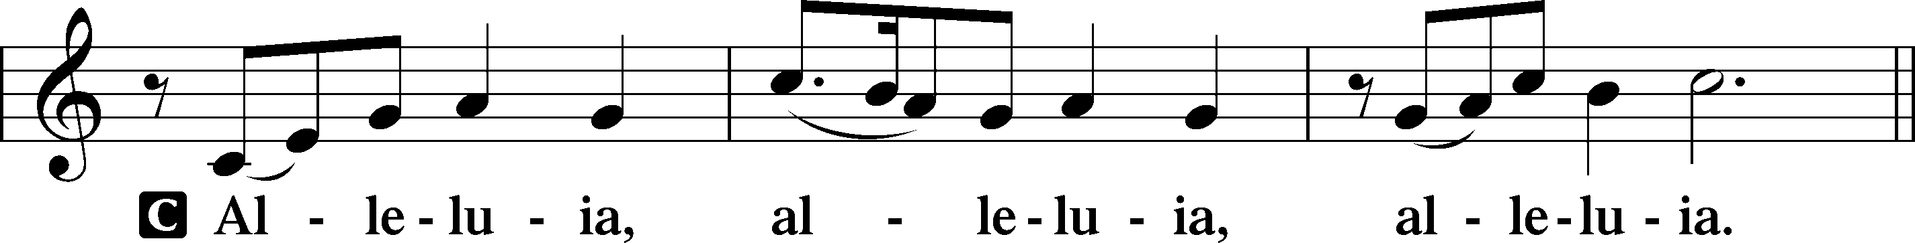

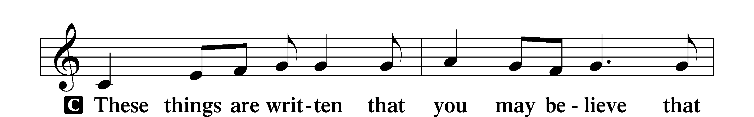

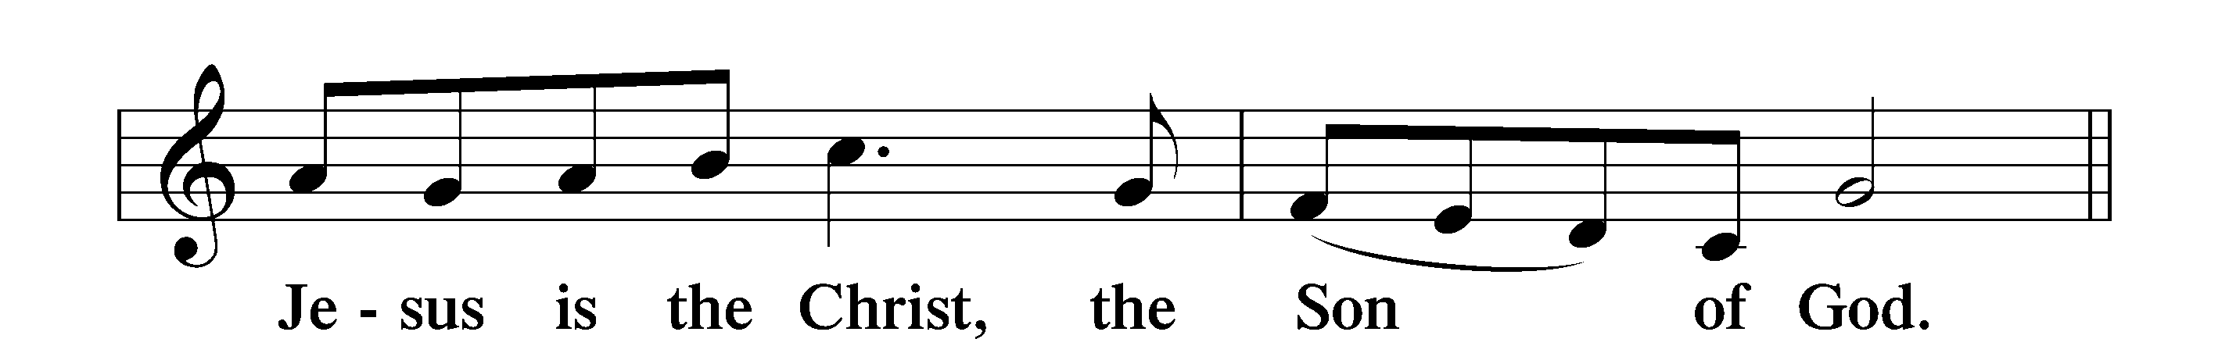

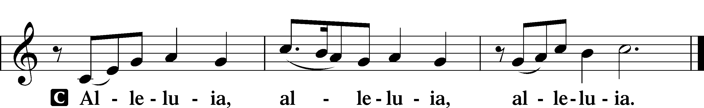

Holy Gospel Luke 2:40–52

P The Holy Gospel according to St. Luke, the second chapter.

C **Glory to You, O Lord.**

40The child [Jesus] grew and became strong, filled with wisdom. And the favor of God was upon him.

41Now his parents went to Jerusalem every year at the Feast of the Passover. 42And when he was twelve years old, they went up according to custom. 43And when the feast was ended, as they were returning, the boy Jesus stayed behind in Jerusalem. His parents did not know it, 44but supposing him to be in the group they went a day’s journey, but then they began to search for him among their relatives and acquaintances, 45and when they did not find him, they returned to Jerusalem, searching for him. 46After three days they found him in the temple, sitting among the teachers, listening to them and asking them questions. 47And all who heard him were amazed at his understanding and his answers. 48And when his parents saw him, they were astonished. And his mother said to him, “Son, why have you treated us so? Behold, your father and I have been searching for you in great distress.” 49And he said to them, “Why were you looking for me? Did you not know that I must be in my Father’s house?” 50And they did not understand the saying that he spoke to them. 51And he went down with them and came to Nazareth and was submissive to them. And his mother treasured up all these things in her heart.

52And Jesus increased in wisdom and in stature and in favor with God and man.

P This is the Gospel of the Lord.

C **Praise to You, O Christ.**

Apostles’ Creed

C **I believe in God, the Father Almighty,**

**maker of heaven and earth.**

**And in Jesus Christ, His only Son, our Lord,**

**who was conceived by the Holy Spirit,**

**born of the virgin Mary,**

**suffered under Pontius Pilate,**

**was crucified, died and was buried.**

**He descended into hell.**

**The third day He rose again from the dead.**

**He ascended into heaven**

**and sits at the right hand of God the Father Almighty.**

**From thence He will come to judge the living and the dead.**

**I believe in the Holy Spirit,**

**the holy Christian Church,**

**the communion of saints,**

**the forgiveness of sins,**

**the resurrection of the body,**

**and the life** T **everlasting. Amen.**

Children’s Message In Dad’s House

410 Within the Father’s House

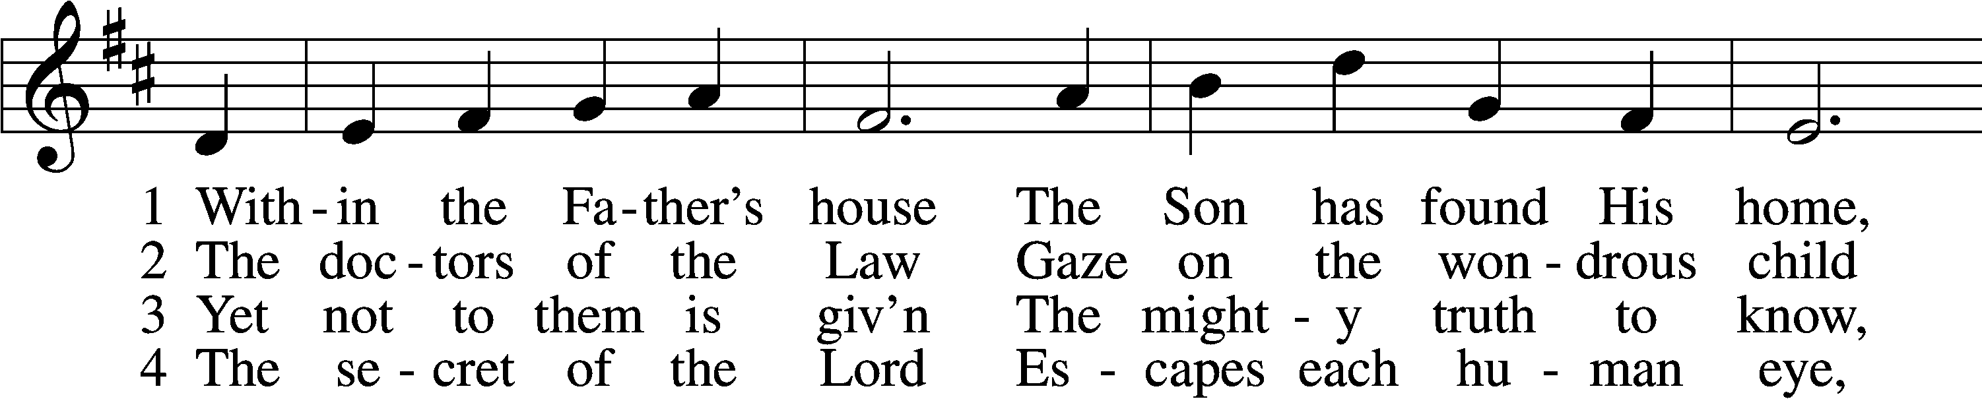

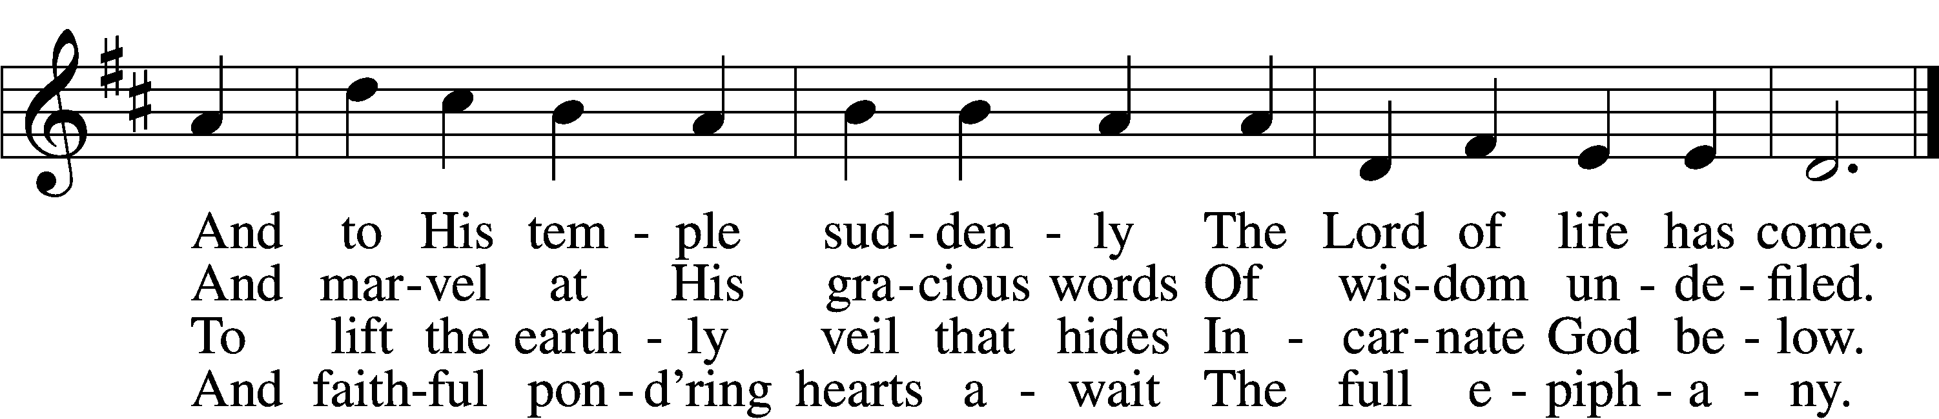

5 Lord, visit Thou our souls  
 And teach us by Thy grace  
Each dim revealing of Thyself  
 With loving awe to trace

D 6 Till we behold Thy face  
 And know as we are known  
Thee, Father, Son, and Holy Ghost,  
 Coequal Three in One.

Text and tune: Public domain

Sermon Understanding, Wisdom, Discernment

Prayer of the Church

P Let us pray for the whole people of God in Christ Jesus and for all people according to their needs.

P For the faithful proclamation of Christ’s saving name, that God’s people may be strengthened in the true faith and His kingdom extended, let us pray to the Lord:

C **Lord, have mercy.**

P For the holy Christian Church throughout the world and for all who confess the name of Christ, that God would guard and defend us from the temptations of the devil, the world, and our sinful nature, let us pray to the Lord:

C **Lord, have mercy.**

P For this congregation, its mission and its people; for the ability to meet the needs that arise as we do the work God has given us to do; and for the unity of the Spirit in the bond of peace, let us pray to the Lord:

C **Lord, have mercy.**

P For the educational institutions of our synod: for our preschools, our day schools and high schools, our colleges and universities, and for our seminaries, that those who teach and those who learn in them would be transformed by the wisdom of Christ, let us pray to the Lord:

C **Lord, have mercy.**

P For all who partake this day of Christ’s holy body and blood, that in their eating and drinking they may receive the benefits of forgiveness of sins and the renewal of life and have a foretaste of the feast to come, let us pray to the Lord:

C **Lord, have mercy.**

P For those who have wandered from the faith, that the Holy Spirit would use us to call them home to the Father, let us pray to the Lord:

C **Lord, have mercy.**

P For the government and all who have been set into positions of leadership, that they may use their authority honorably and for the good of the people, let us pray to the Lord:

C **Lord, have mercy.**

P For all the faithful, that the Spirit would lead them to cheerful, generous giving from the bounty the Lord provides, to support the Church and to help those in need, let us pray to the Lord:

C **Lord, have mercy.**

P For those who are sick, that God would grant healing to their bodies and strength to bear their infirmities with patience and grace, let us pray to the Lord:

C **Lord, have mercy.**

P For those who mourn, that in their time of sorrow they would not lose hope but rely on God’s promise that He will never leave them or forsake them, let us pray to the Lord:

C **Lord, have mercy.**

P For those who rejoice in the rich blessings of God, that they may always remember the Giver of every gift and give Him heartfelt thanks, let us pray to the Lord:

C **Lord, have mercy.**

P O Lord, heavenly Father, we gratefully remember the sufferings and death of Your dear Son, Jesus Christ, for our salvation. Rejoicing in His victorious resurrection from the dead, we draw strength from His ascension before You, where He ever stands for us as our own High Priest. Gather us together from the ends of the earth to celebrate with all the faithful the marriage feast of the Lamb in His kingdom, which has no end. Graciously receive our prayers, deliver and preserve us, for to You alone we give all glory, honor, and worship, Father, Son, and Holy Spirit, one God, now and forever.

C **Amen.**

Offering

# Service of the Sacrament

Preface LSB 208

P The Lord be with you.

C **And also with you.**

P Lift up your hearts.

C **We lift them to the Lord.**

P Let us give thanks to the Lord our God.

C **It is right to give Him thanks and praise.**

P It is truly good, right, and salutary that we should at all times and in all places give thanks to You, O Lord, holy Father, almighty and everlasting God, for the countless blessings You so freely bestow on us and all creation. Above all, we give thanks for Your boundless love shown to us when You sent Your only-begotten Son, Jesus Christ, into our flesh and laid on Him our sin, giving Him into death that we might not die eternally. Because He is now risen from the dead and lives and reigns to all eternity, all who believe in Him will overcome sin and death and will rise again to new life. Therefore with angels and archangels and with all the company of heaven we laud and magnify Your glorious name, evermore praising You and saying:

Sanctus LSB 208

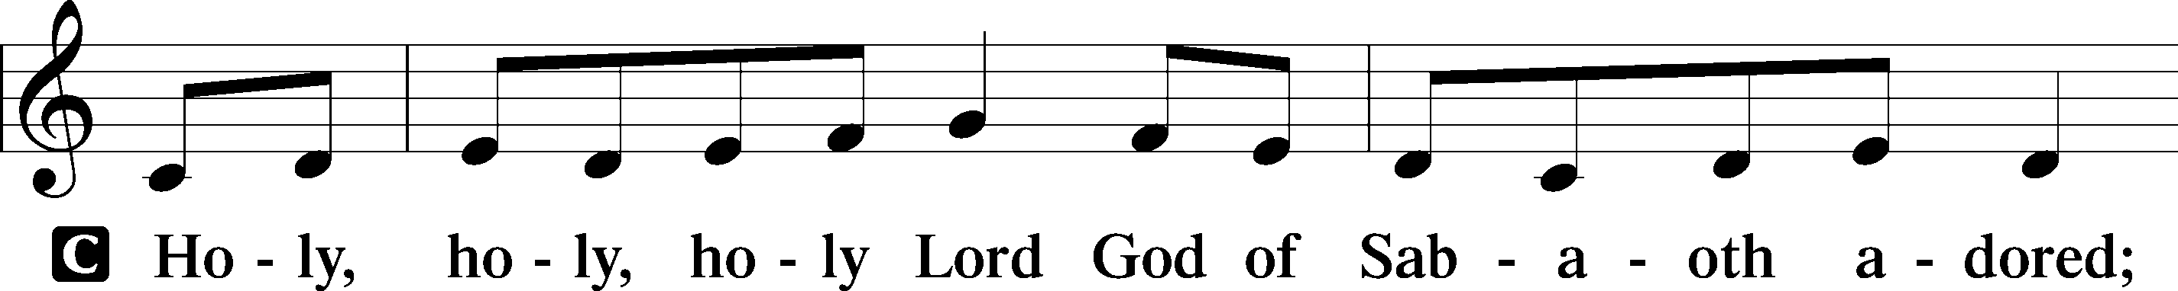

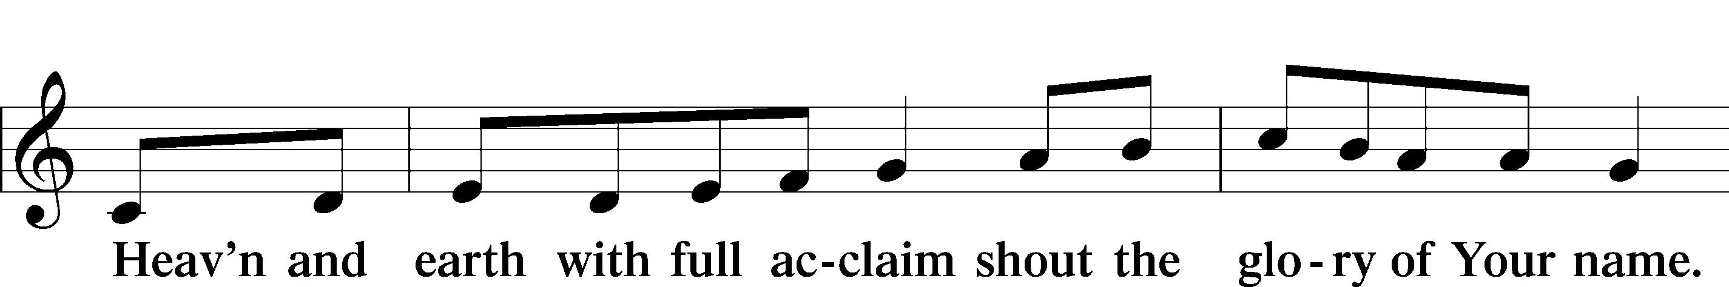

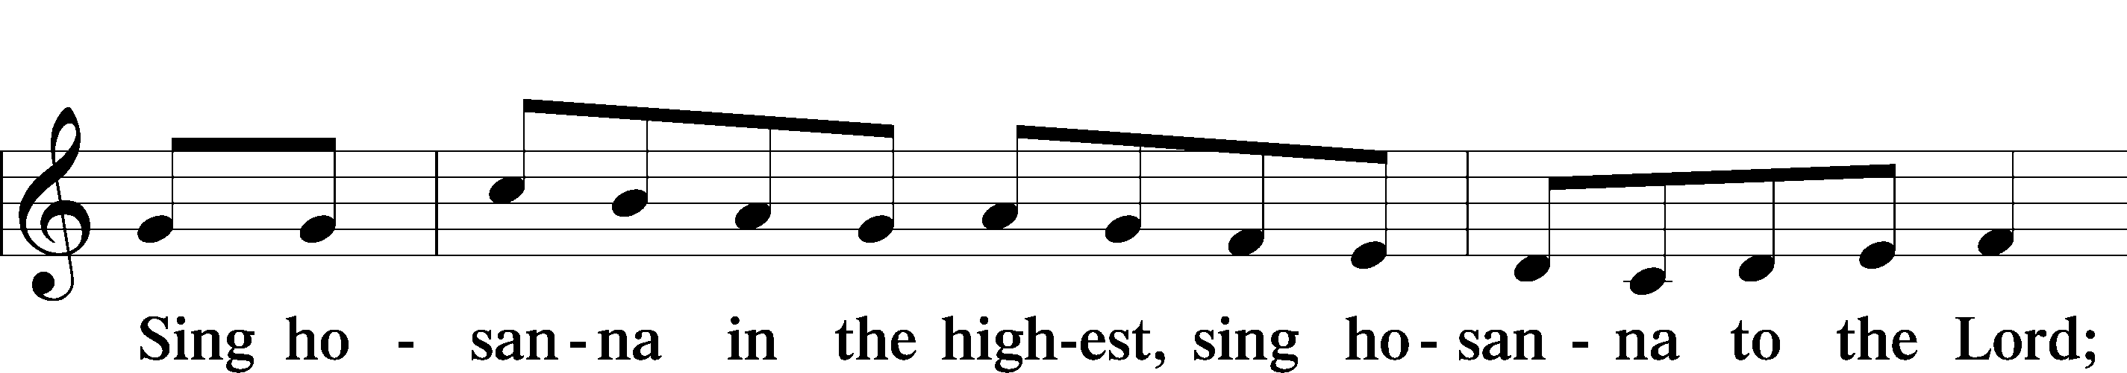

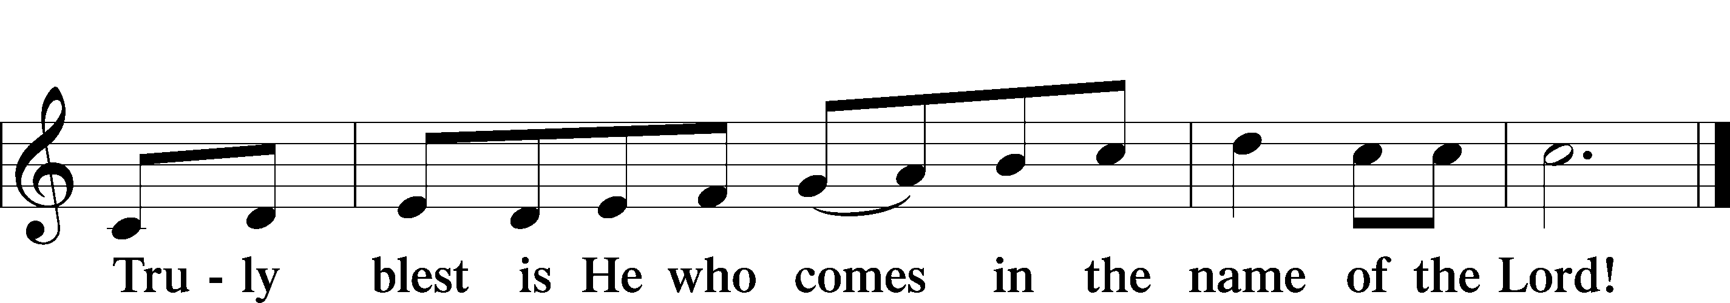

Prayer of Thanksgiving

P Blessed are You, O Lord our God, king of all creation, for You have had mercy on us and given Your only-begotten Son that whoever believes in Him should not perish but have eternal life.

In the beginning You created all things by Your Word; and in the fullness of time Your Word became flesh and dwelt among us, full of grace and truth.

Let Your Word made flesh dwell richly among us that, faithfully eating His body and drinking His blood, we may receive the fullness of Your grace and truth in Christ Jesus, our Lord.

Hear us as we pray in His name and as He has taught us:

Lord’s Prayer

C **Our Father who art in heaven,**

**hallowed be Thy name,**

**Thy kingdom come,**

**Thy will be done on earth**

**as it is in heaven;**

**give us this day our daily bread;**

**and forgive us our trespasses**

**as we forgive those**

**who trespass against us;**

**and lead us not into temptation,**

**but deliver us from evil.**

**For Thine is the kingdom**

**and the power and the glory**

**forever and ever. Amen.**

The Words of Our Lord

P Our Lord Jesus Christ, on the night when He was betrayed, took bread, and when He had given thanks, He broke it and gave it to the disciples and said: “Take, eat; this is My T body, which is given for you. This do in remembrance of Me.”

In the same way also He took the cup after supper, and when He had given thanks, He gave it to them, saying: “Drink of it, all of you; this cup is the new testament in My T blood, which is shed for you for the forgiveness of sins. This do, as often as you drink it, in remembrance of Me.”

Pax Domini

P The peace of the Lord be with you always.

C **Amen.**

Agnus Dei LSB 210

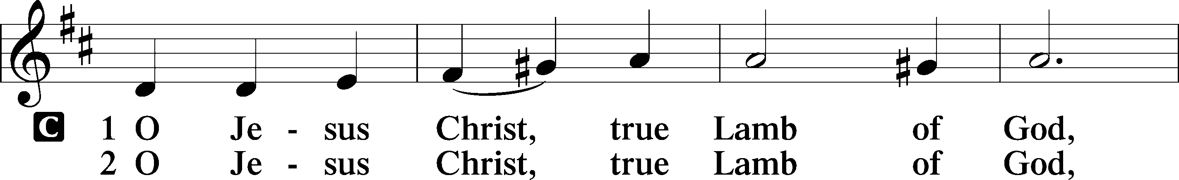

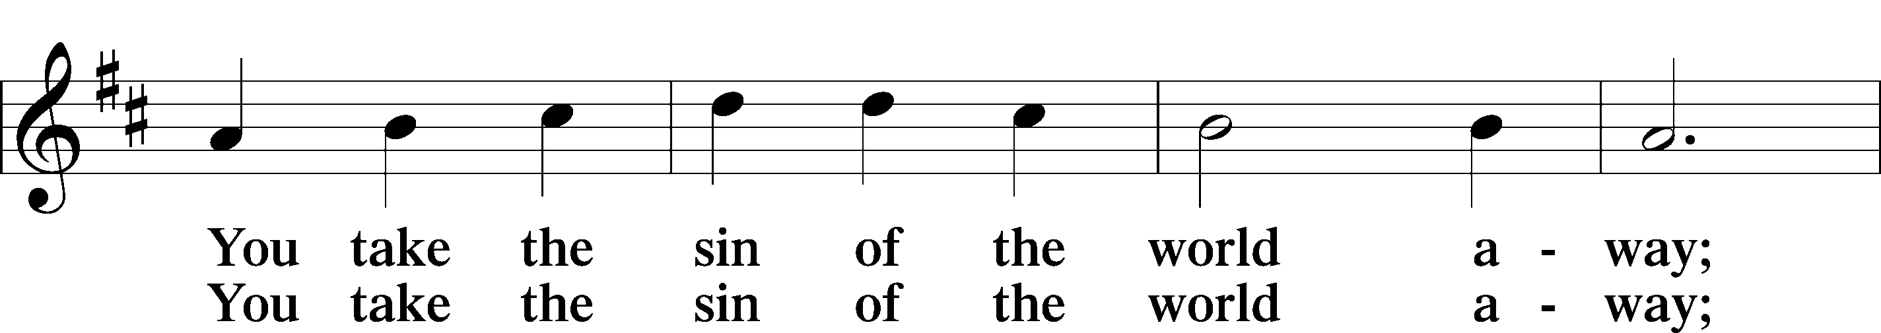

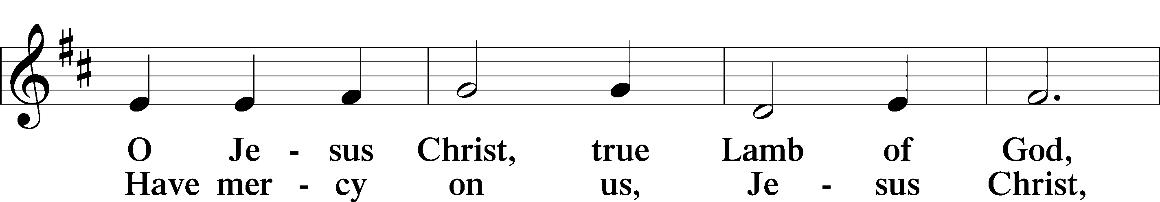

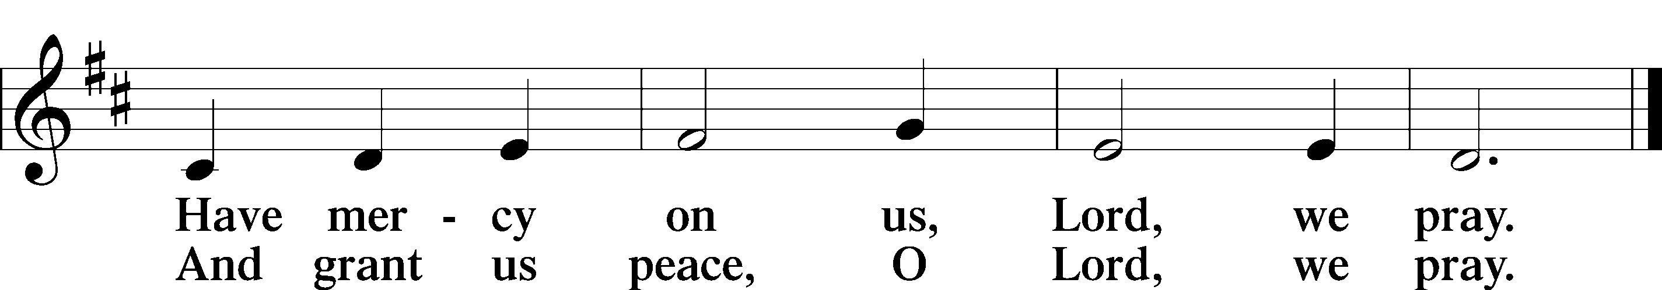

Distribution

602 The Gifts Christ Freely Gives

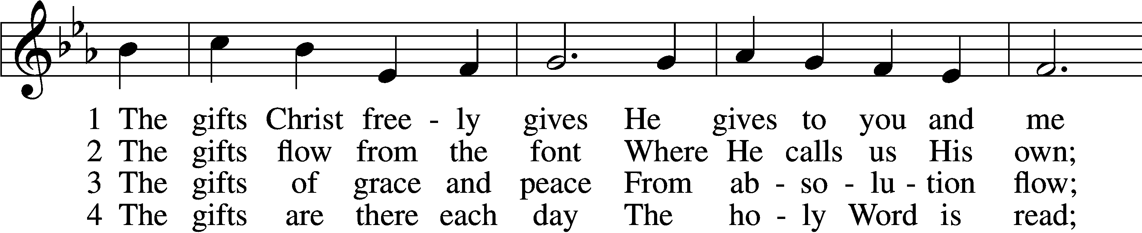

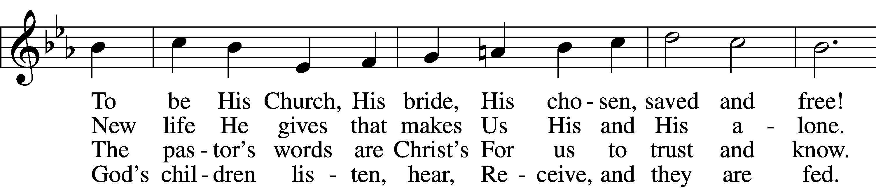

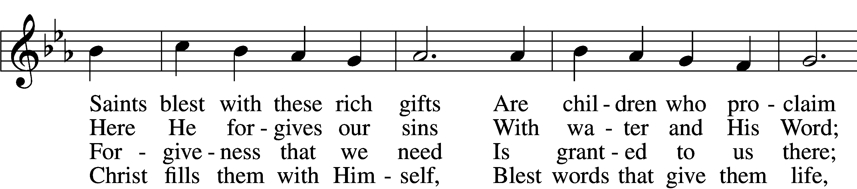

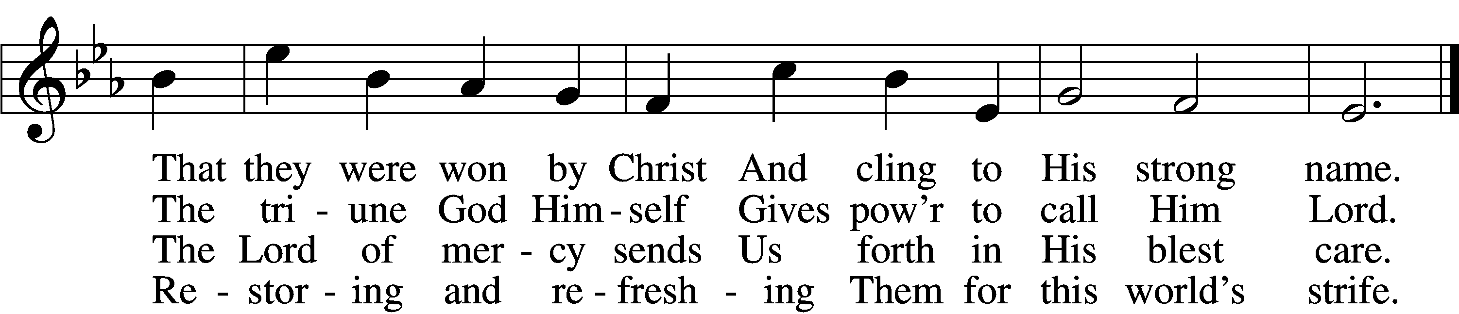

5 The gifts are in the feast,  
 Gifts far more than we see;  
Beneath the bread and wine  
 Is food from Calvary.  
The body and the blood  
 Remove our ev’ry sin;  
We leave His presence in  
 His peace, renewed again.

6 All glory to the One  
 Who lavishes such love;  
The triune God in love  
 Assures our life above.  
His means of grace for us  
 Are gifts He loves to give;  
All thanks and praise for His  
 Great love by which we live!

Tune: Public domain

Text: © 2001 Richard C. Resch. Used by permission: LSB Hymn License no. 110005047

Nunc Dimittis LSB 211

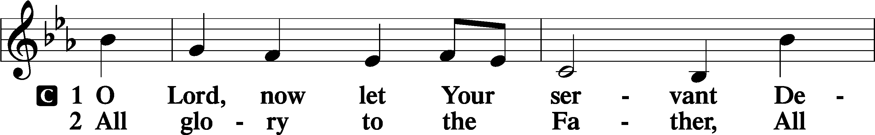

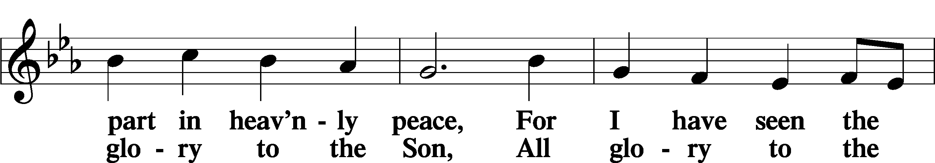

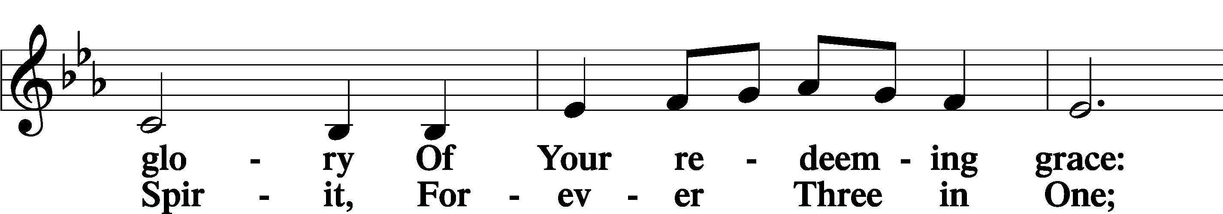

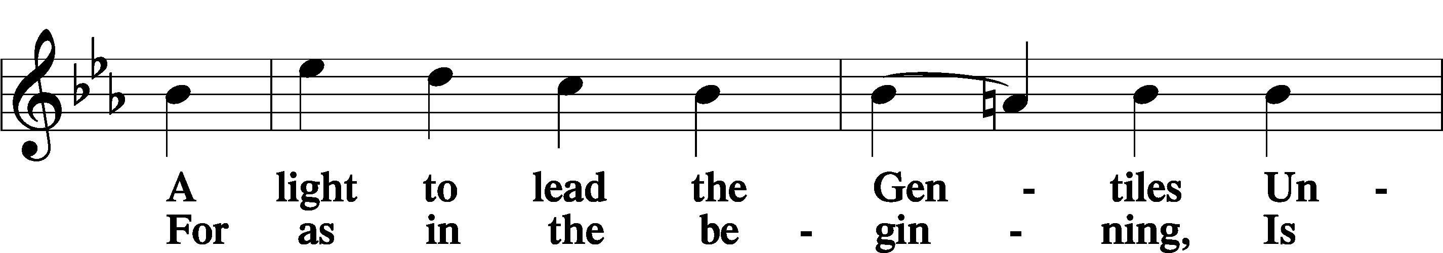

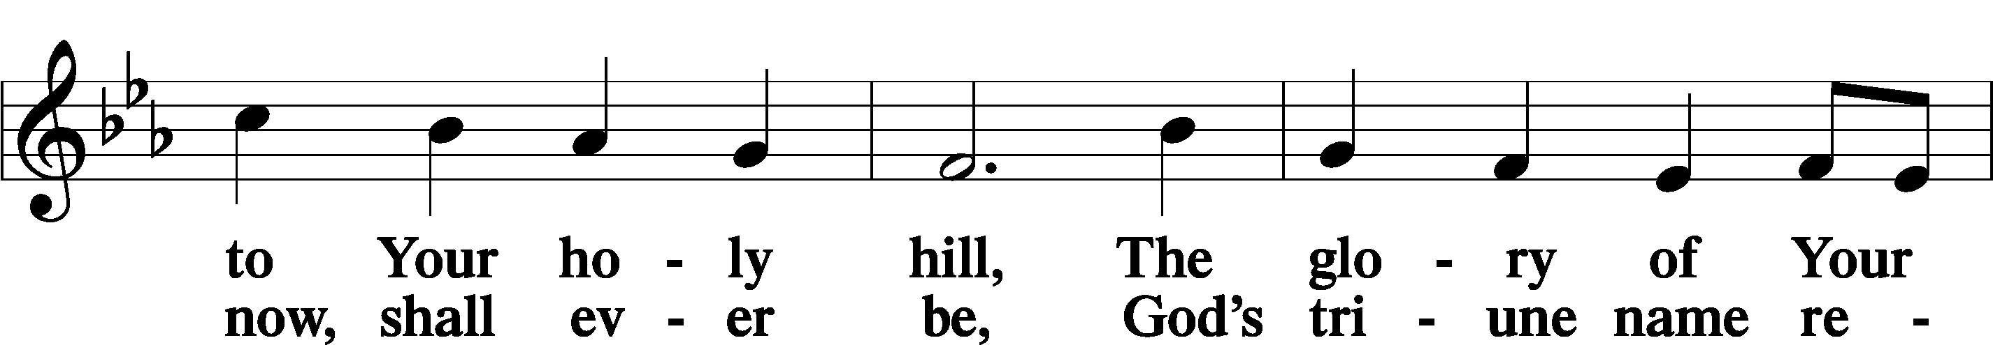

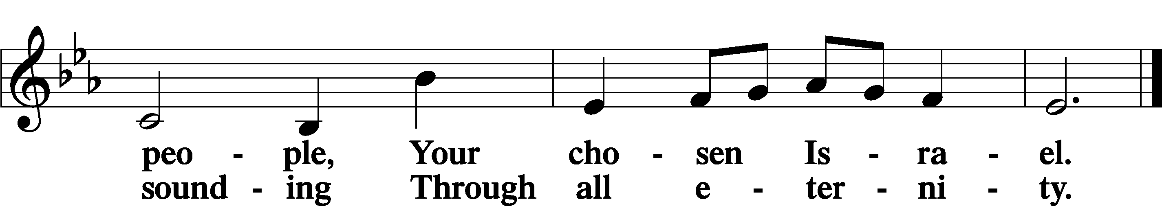

Post-Communion Collect

A Let us pray.

We give thanks to You, almighty God, that You have refreshed us through this salutary gift, and we implore You that of Your mercy You would strengthen us through the same in faith toward You and in fervent love toward one another; through Jesus Christ, Your Son, our Lord, who lives and reigns with You and the Holy Spirit, one God, now and forever.

C **Amen.**

Benedicamus LSB 212

A Let us bless the Lord.

C **Thanks be to God.**

Benediction

P The Lord bless you and keep you.

The Lord make His face shine on you and be gracious to you.

The Lord look upon you with favor and T give you peace.

C **Amen.**

385 From East to West

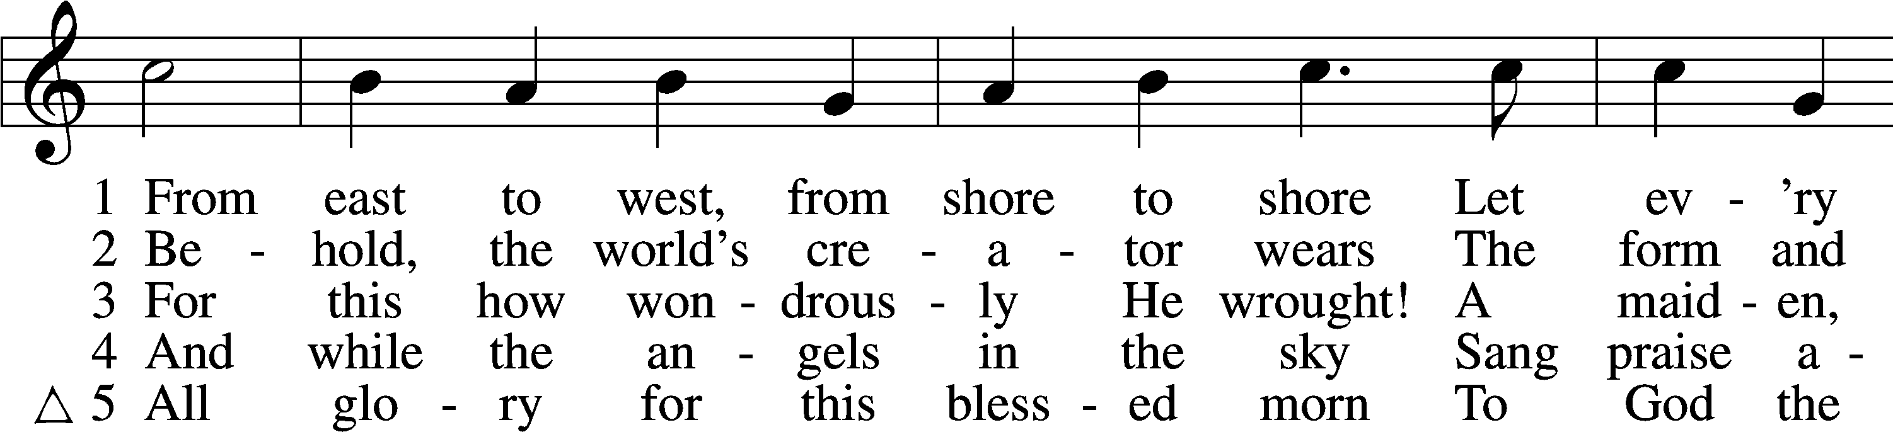

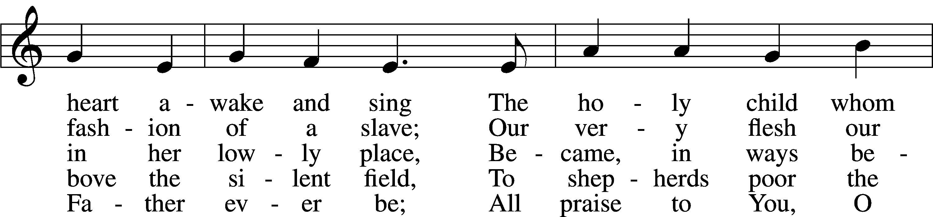

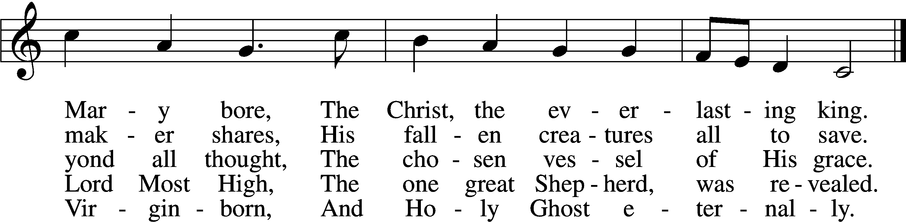

Tune and text: Public domain

Acknowledgments

Divine Service, Setting Four from Lutheran Service Book

Unless otherwise indicated, Scripture quotations are from the ESV® Bible (The Holy Bible, English Standard Version®), copyright © 2001 by Crossway, a publishing ministry of Good News Publishers. Used by permission. All rights reserved.

Created by Lutheran Service Builder © 2020 Concordia Publishing House.

**January 3**“God is not just our God or the God of just our people or just our nation or our congregation or our denomination or our demographic category or our tribe or our ethnicity or our language. There is no justice if it’s just about just us. No, God is the God of all time and all space and all people. In Christ, all things hang together. Step into your new year with this fresh recognition that the Holy Spirit wants to fill every nook and cranny of your life until you overflow with God’s everlasting love for everybody.” *Pastor John Nunes on The Lutheran Hour – A Life Quote from Lutherans For Life • lutheransforlife.org*

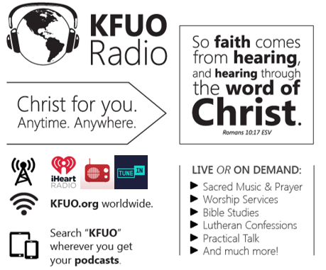

**This week on KFUO.org,** we celebrate our Savior’s birth during the 12 Days of Christmas with music, prayer, and scripture, with regular programming resuming January 7. We are excited to welcome Rev. Brady Finnern as the host for Thy Strong Word, airing weekdays at 11:00 a.m. CT.

**Gifts of Time and Treasure**

***“…freely you have received, freely give.”***

***Matthew 10:8***

**LAST TWO WEEK’S OFFERINGS**  **LAST TWO WEEK’S ATTENDANCE**

**12/20: 12/24: 12/27: 12/20: 12/24: 12/27:**

**General Fund** $ 1,677.44 630.00 1380.00 **Service** 44 43 18

**Needed Weekly** $ 3,963.38 “ “ **Communed** 44 43 18

**Adult Bible Study** $ 21.00 24.00

Memorial- Birnbaum $ 50.00

**The Lord’s Week**

Today 8:45 am – Bible Studies for all ages

**(Jan 3rd 2021)** 10:00 am – Divine Service

11:30 am – Confirmation

Wednesday 10:00 am –Women’s Bible Study

Thursday **7:00 pm – Council Meeting**

Next Sunday 8:45 am – Bible Studies for all ages

**(Jan. 10th)** 10:00 am – Divine Service

11:30 am – Confirmation

**In His Service**

Elder: Justin Perkins

Usher: Jason Schrader

Organist:

Acolytes: Noah Denton & Kaylee Larson

Alter: Laura Lopez

Flowers: