**Thirteenth Sunday**

**After Pentecost**

“Deny Yourself. Bear Your Cross.”

**August 30, 2020**

**Messiah Lutheran Church**

**Lutheran Church-Missouri Synod**

4102 Trinity River Dr., Corpus Christi, Texas 78410

**Pastor:**  **Rev. Scott E. Herbert**

Church Phone: 361-387-7748 Email: mlc@stx.rr.com

Church Fax: 361-767-1768 Website: [www.messiahlcms-cc.org](http://www.messiahlcms-cc.org)

Pastor Phone: 469-644-4772 Pastor Email: chirev59@gmail.com

**WELCOME TO MESSIAH!**

We are glad you are here to receive what God is doing for you during Divine Service. Please sign our Guest Book located near the front door. Feel free to converse quietly until the organ prelude begins. If you are looking for a church home, please talk to the Pastor at the door. We would love to have you join us.

**Preparing for Service**

# ***The Glory of God Is the Passion and Cross of Christ Jesus***

# After St. Peter confessed that Jesus is the Christ, the Son of the living God, our Lord *“began to show his disciples that he must go to Jerusalem and suffer many things from the elders and chief priests and scribes, and be killed, and on the third day be raised”* (Matt. 16:21). Upon hearing this “theology of the cross,” Simon Peter stumbled into a satanic “theology of glory.” But the glory of God is revealed in the Passion and cross of His incarnate Son. The faithful prophets, such as Jeremiah, suffered persecution and rejection in anticipation of Jesus’ cross. Yet the Lord did not abandon them; He remembered them, and He was with them to deliver them (Jer. 15:15–20). By His cross, Jesus has redeemed the world, and in His resurrection, He has vindicated all who trust in Him. Thus, the Christian life is a discipleship of self-sacrificing love. Since Christ Jesus has reconciled us to God, we *“live peaceably with all”* (Rom. 12:18). By the certainty of His cross and resurrection, we *“rejoice in hope,”* and we are *“patient in tribulation”* and *“constant in prayer”* (Rom. 12:12).

# Confession and Absolution

851 Lord of Glory, You Have Bought Us

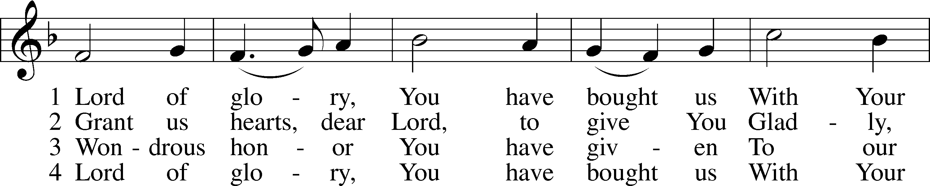

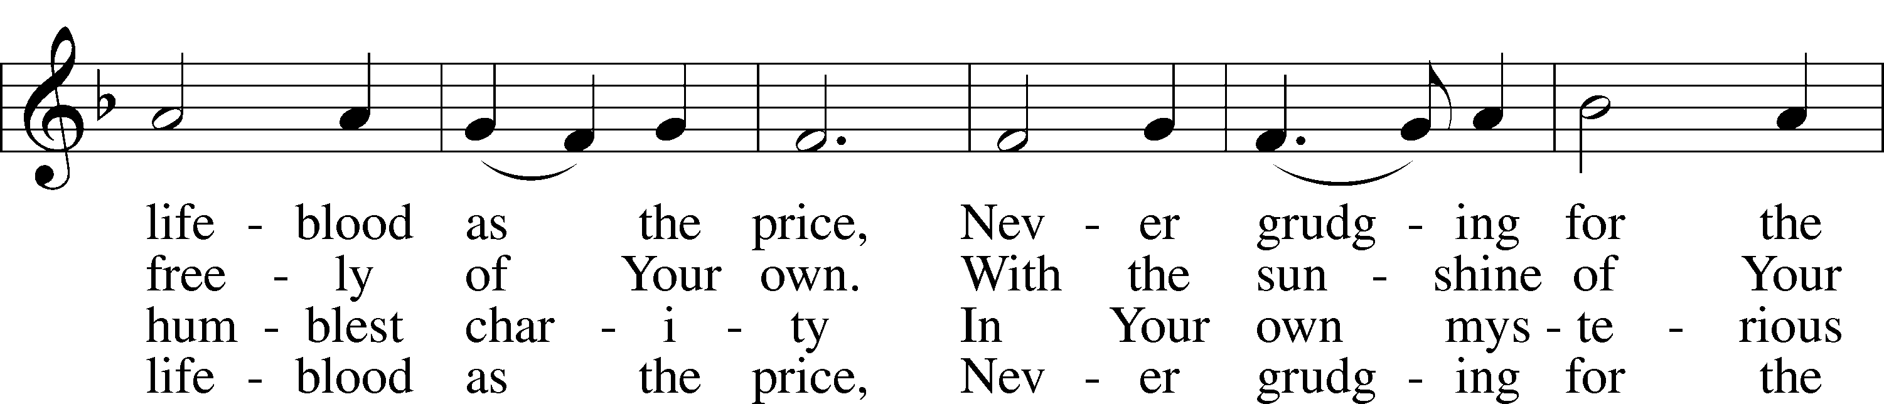

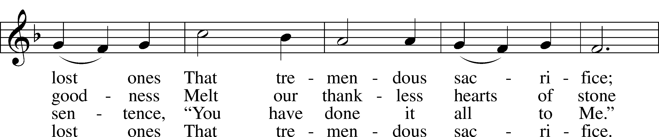

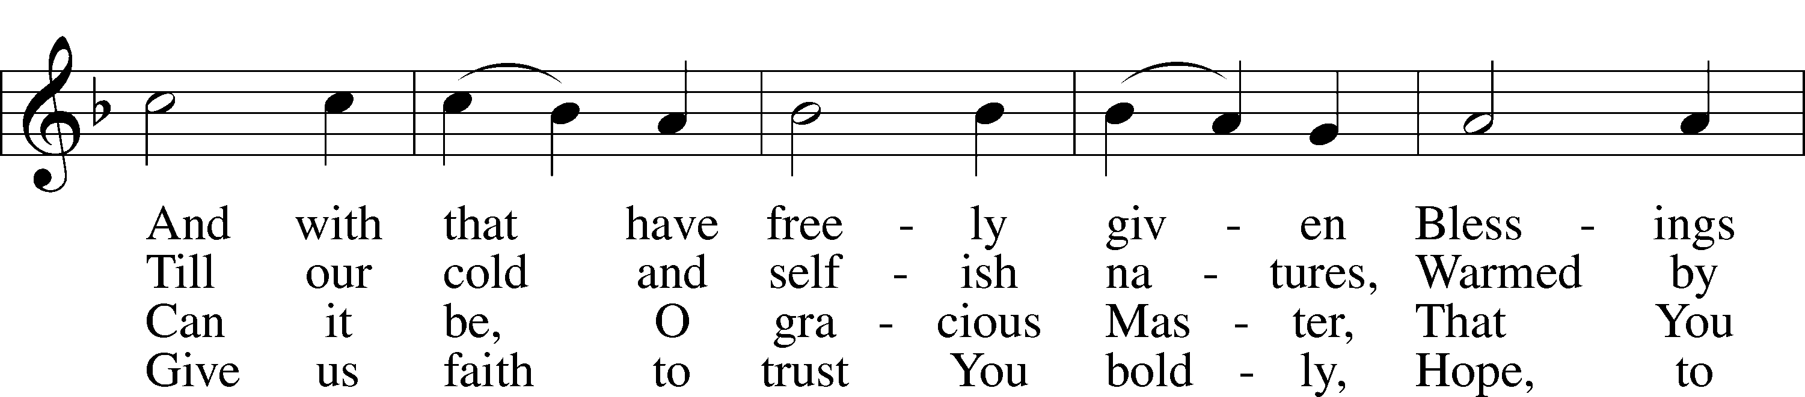

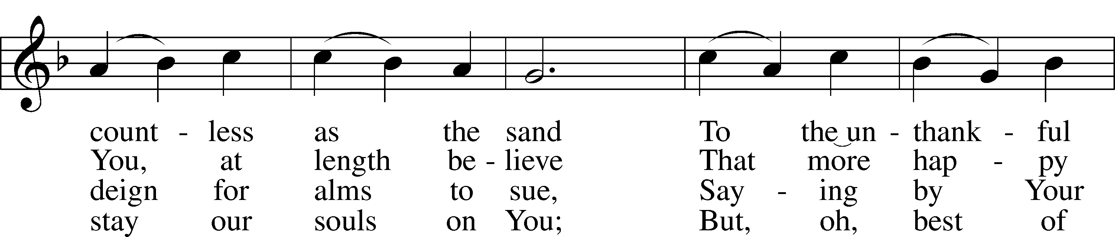

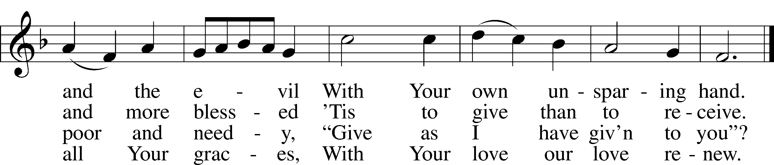

Text and tune: Public domain

P In the name of the Father and of the T Son and of the Holy Spirit.

C **Amen.**

P Beloved in the Lord! Let us draw near with a true heart and confess our sins unto God our Father, beseeching Him in the name of our Lord Jesus Christ to grant us forgiveness.

P Our help is in the name of the Lord,

C **who made heaven and earth.**

P I said, I will confess my transgressions unto the Lord,

C **and You forgave the iniquity of my sin.**

P Almighty God, our maker and redeemer, we poor sinners confess unto You that we are by nature sinful and unclean and that we have sinned against You by thought, word, and deed. Wherefore we flee for refuge to Your infinite mercy, seeking and imploring Your grace for the sake of our Lord Jesus Christ.

C **O most merciful God, who has given Your only-begotten Son to die for us, have mercy upon us and for His sake grant us remission of all our sins; and by Your Holy Spirit increase in us true knowledge of You and of Your will and true obedience to Your Word, to the end that by Your grace we may come to everlasting life; through Jesus Christ, our Lord. Amen.**

P Almighty God, our heavenly Father, has had mercy upon us and has given His only Son to die for us and for His sake forgives us all our sins. To those who believe on His name He gives power to become the children of God and has promised them His Holy Spirit.

He that believes and is baptized shall be saved.  
  
Grant this, Lord, unto us all.

C **Amen.**

# Service of the Word

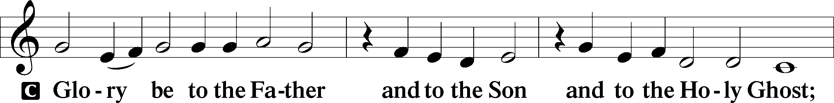

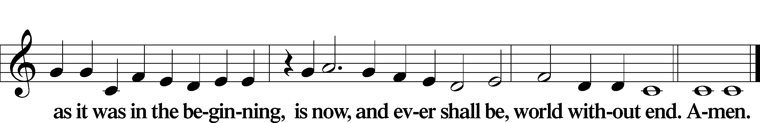

Kyrie LSB 186

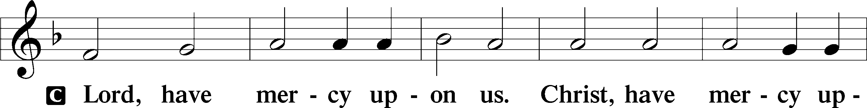

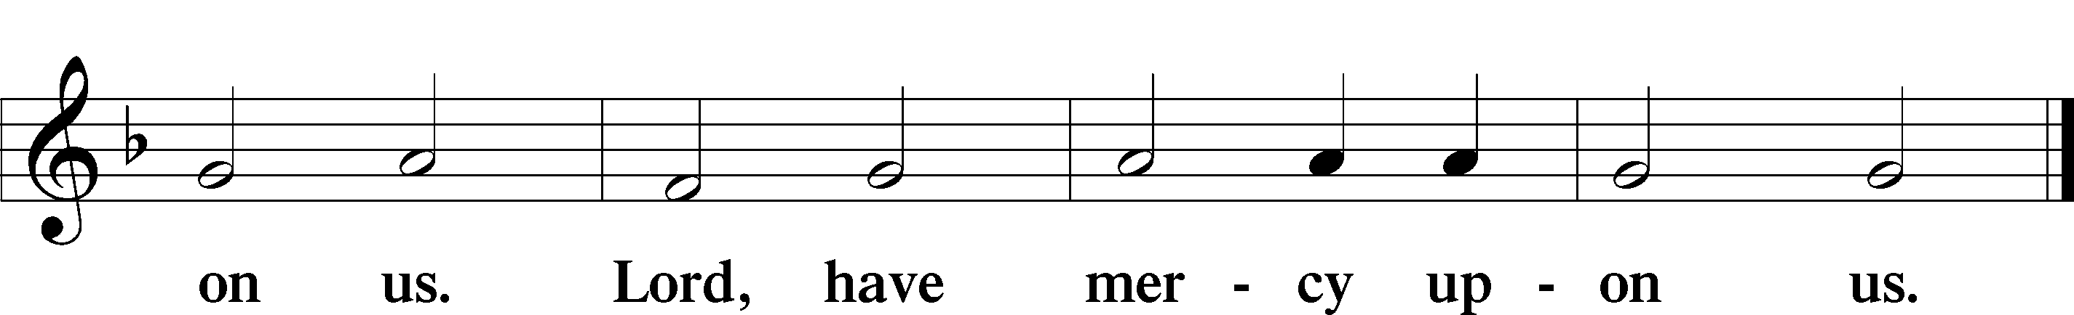

Gloria in Excelsis LSB 187

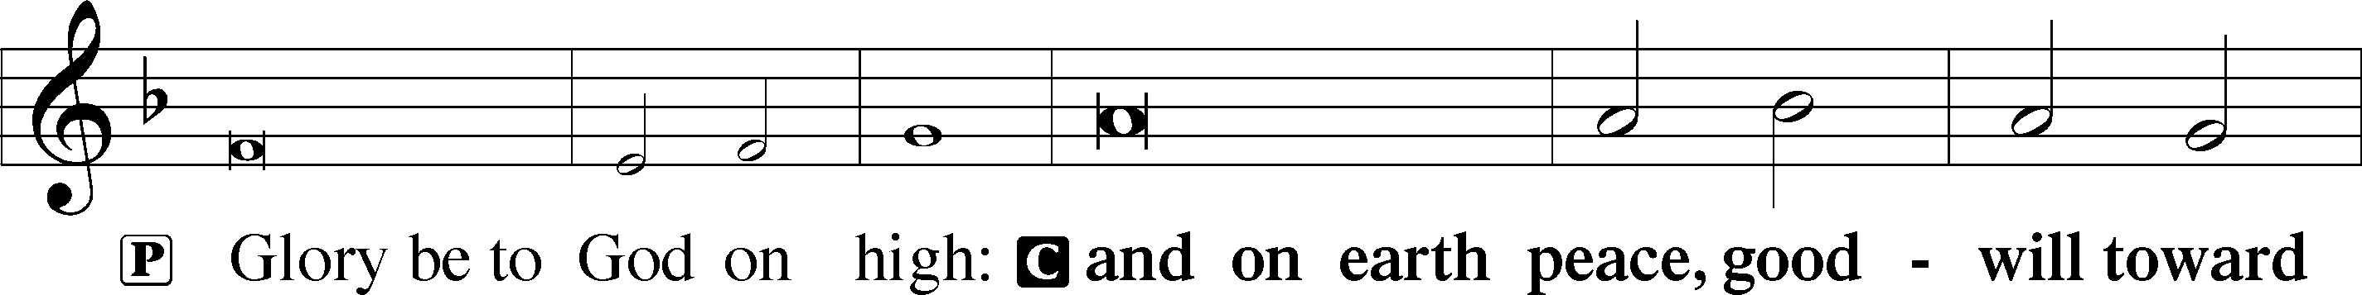

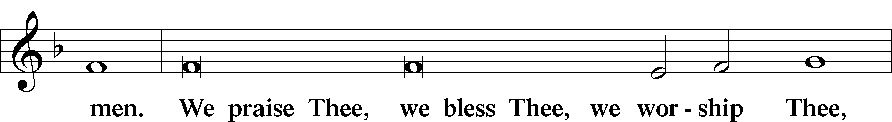

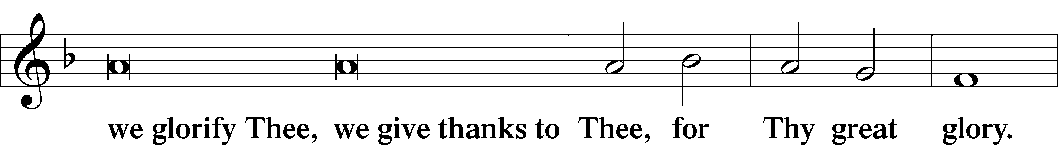

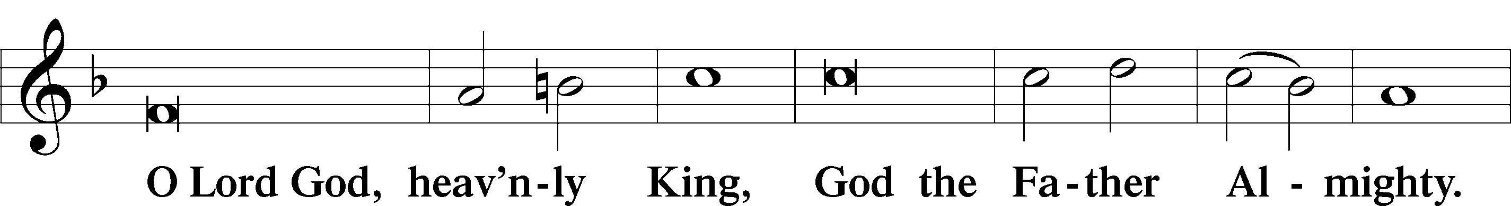

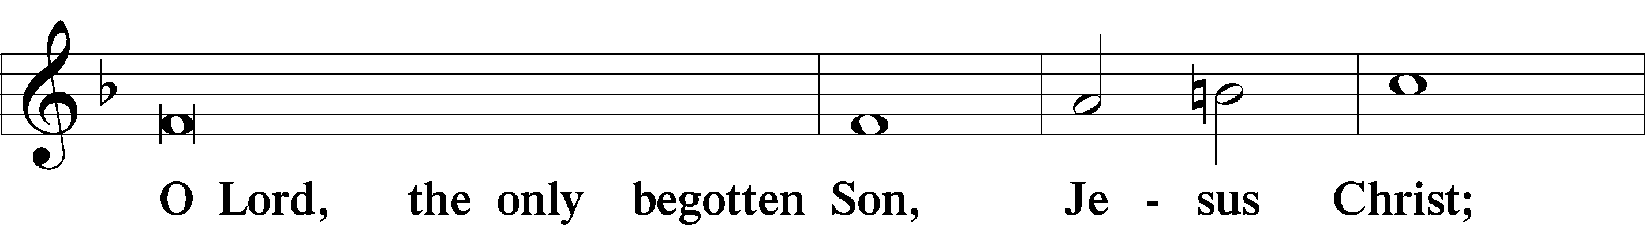

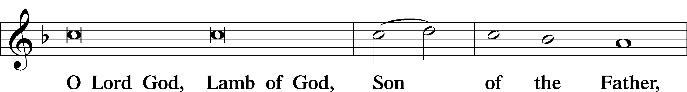

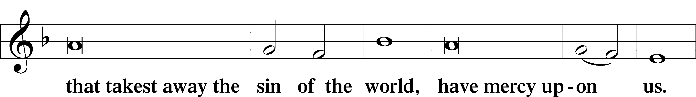

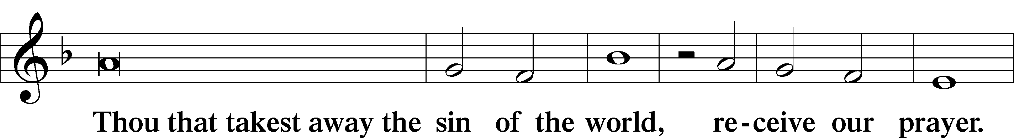

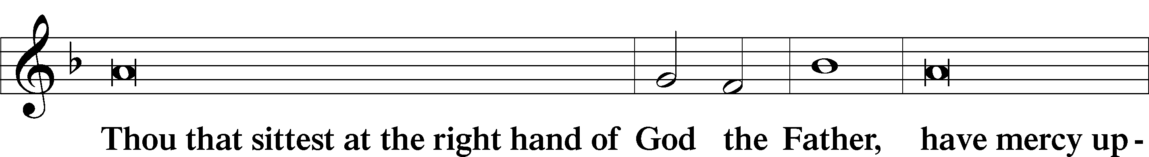

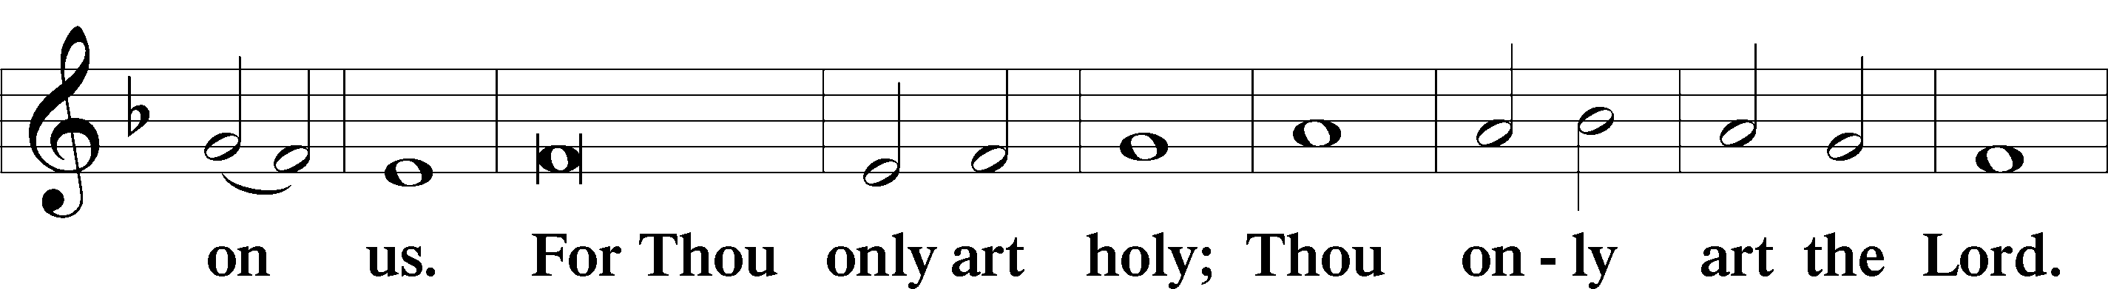

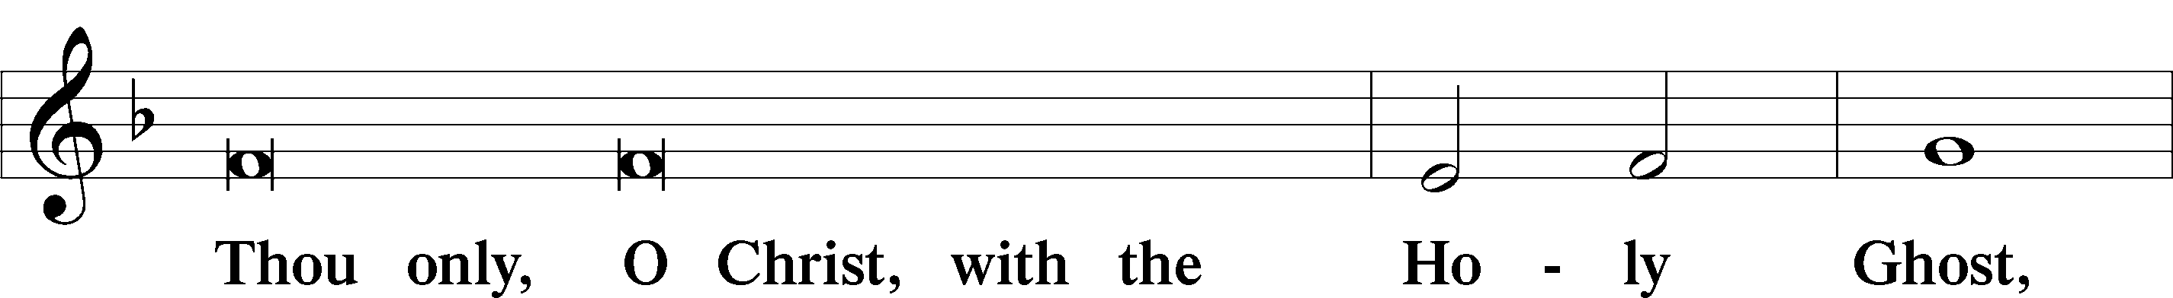

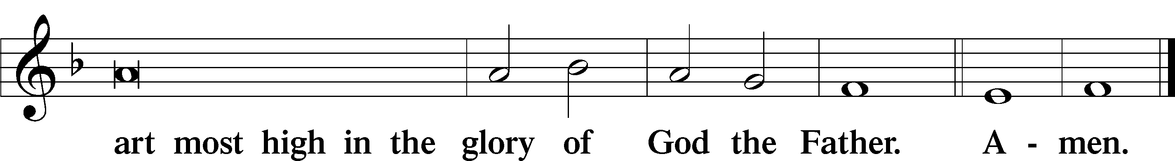

Salutation and Collect of the Day

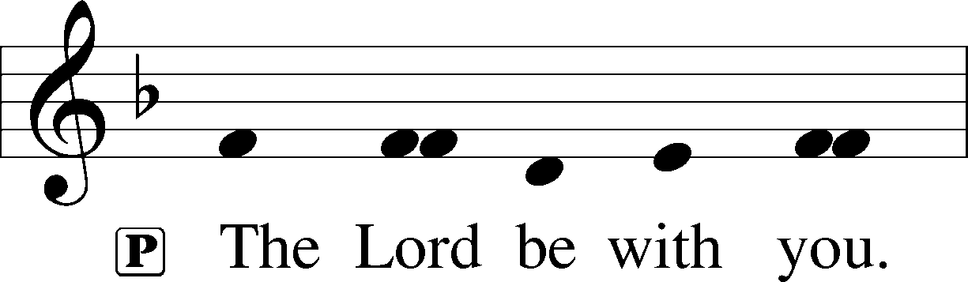

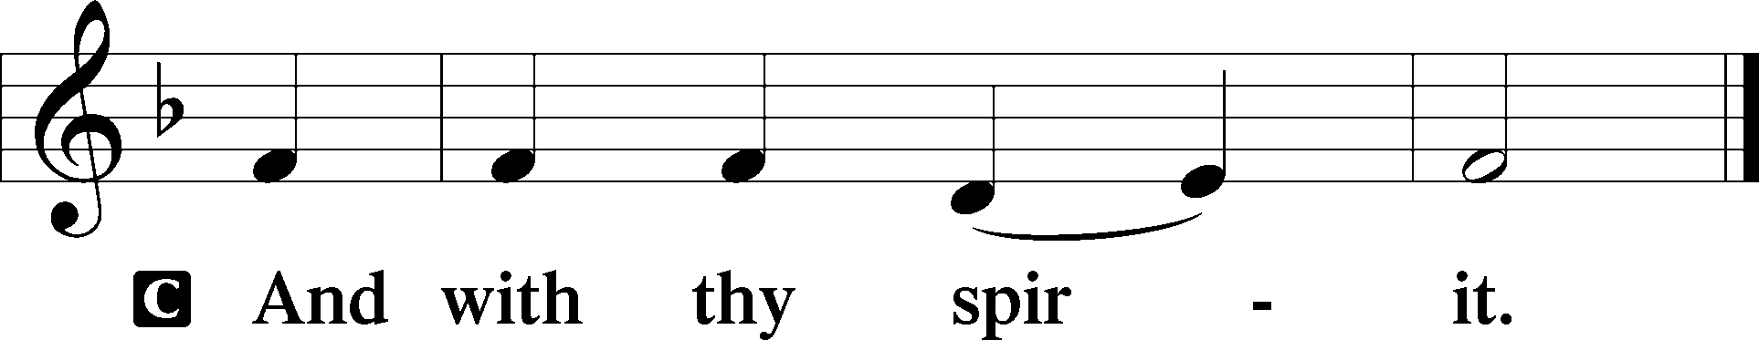

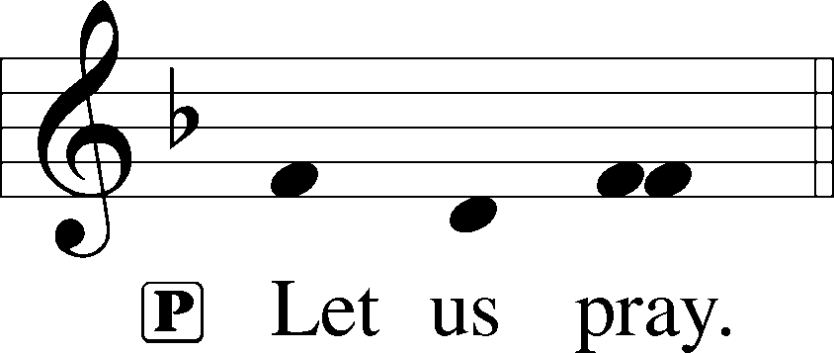

P Almighty God, Your Son willingly endured the agony and shame of the cross for our redemption. Grant us courage to take up our cross daily and follow Him wherever He leads; through the same Jesus Christ, our Lord, who lives and reigns with You and the Holy Spirit, one God, now and forever.

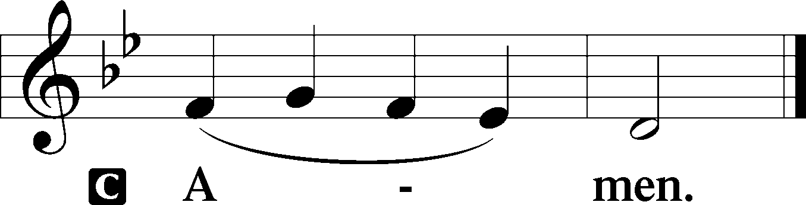

Old Testament Reading Jeremiah 15:15–21

15O Lord, you know; remember me and visit me,  
 and take vengeance for me on my persecutors.  
In your forbearance take me not away;  
 know that for your sake I bear reproach.  
16Your words were found, and I ate them, and your words became to me a joy and the delight of my heart, for I am called by your name, O Lord, God of hosts.  
17I did not sit in the company of revelers, nor did I rejoice;  
I sat alone, because your hand was upon me,  
 for you had filled me with indignation.  
18Why is my pain unceasing, my wound incurable,  
 refusing to be healed?  
Will you be to me like a deceitful brook, like waters that fail?  
19Therefore thus says the Lord: “If you return, I will restore you, and you shall stand before me. If you utter what is precious, and not what is worthless, you shall be as my mouth. They shall turn to you, but you shall not turn to them.  
20And I will make you to this people a fortified wall of bronze;  
they will fight against you, but they shall not prevail over you, for I am with you to save you and deliver you, declares the Lord.  
21I will deliver you out of the hand of the wicked,  
 and redeem you from the grasp of the ruthless.”

A This is the Word of the Lord.

C **Thanks be to God.**

Psalm Psalm 26

1Vindicate me, O Lord,  
 **for I have walked in my integrity,  
 and I have trusted in the Lord without wavering.**2Prove me, O Lord, and try me;  
 **test my heart and my mind.**3For your steadfast love is before my eyes,  
 **and I walk in your faithfulness.**

4I do not sit with men of falsehood,  
 **nor do I consort with hypocrites.**  
5I hate the assembly of evildoers,  
 **and I will not sit with the wicked.**

6I wash my hands in innocence  
 **and go around your altar, O Lord,**7proclaiming thanksgiving aloud,  
 **and telling all your wondrous deeds.**

8O Lord, I love the habitation of your house  
 **and the place where your glory dwells.**9Do not sweep my soul away with sinners,  
 **nor my life with bloodthirsty men,**10in whose hands are evil devices,  
 **and whose right hands are full of bribes.**

11But as for me, I shall walk in my integrity;  
 **redeem me, and be gracious to me.**12My foot stands on level ground;  
 **in the great assembly I will bless the Lord.**

Epistle Romans 12:9–21

9Let love be genuine. Abhor what is evil; hold fast to what is good. 10Love one another with brotherly affection. Outdo one another in showing honor. 11Do not be slothful in zeal, be fervent in spirit, serve the Lord. 12Rejoice in hope, be patient in tribulation, be constant in prayer. 13Contribute to the needs of the saints and seek to show hospitality.

14Bless those who persecute you; bless and do not curse them. 15Rejoice with those who rejoice, weep with those who weep. 16Live in harmony with one another.

Do not be haughty, but associate with the lowly. Never be conceited. 17Repay no one evil for evil, but give thought to do what is honorable in the sight of all. 18If possible, so far as it depends on you, live peaceably with all. 19Beloved, never avenge yourselves, but leave it to the wrath of God, for it is written, “Vengeance is mine, I will repay, says the Lord.” 20To the contrary, “if your enemy is hungry, feed him; if he is thirsty, give him something to drink; for by so doing you will heap burning coals on his head.” 21Do not be overcome by evil, but overcome evil with good.

A This is the Word of the Lord.

C **Thanks be to God.**

Alleluia LSB 190

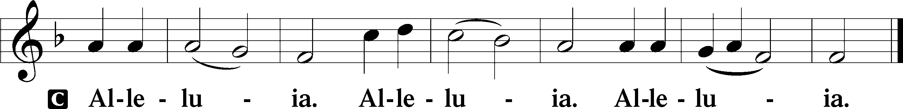

Holy Gospel Matthew 16:21–28

P The Holy Gospel according to St. Matthew, the sixteenth chapter.

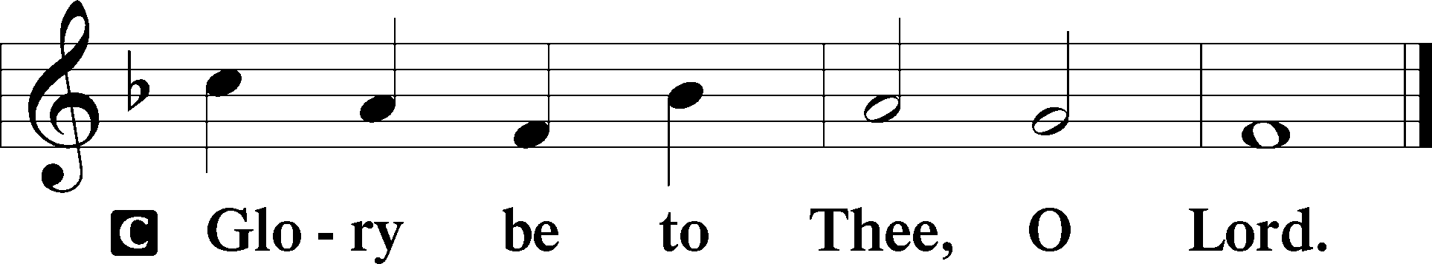

21From that time Jesus began to show his disciples that he must go to Jerusalem and suffer many things from the elders and chief priests and scribes, and be killed, and on the third day be raised. 22And Peter took him aside and began to rebuke him, saying, “Far be it from you, Lord! This shall never happen to you.” 23But he turned and said to Peter, “Get behind me, Satan! You are a hindrance to me. For you are not setting your mind on the things of God, but on the things of man.”

24Then Jesus told his disciples, “If anyone would come after me, let him deny himself and take up his cross and follow me.

25For whoever would save his life will lose it, but whoever loses his life for my sake will find it. 26For what will it profit a man if he gains the whole world and forfeits his life? Or what shall a man give in return for his life? 27For the Son of Man is going to come with his angels in the glory of his Father, and then he will repay each person according to what he has done. 28Truly, I say to you, there are some standing here who will not taste death until they see the Son of Man coming in his kingdom.”

P This is the Gospel of the Lord.

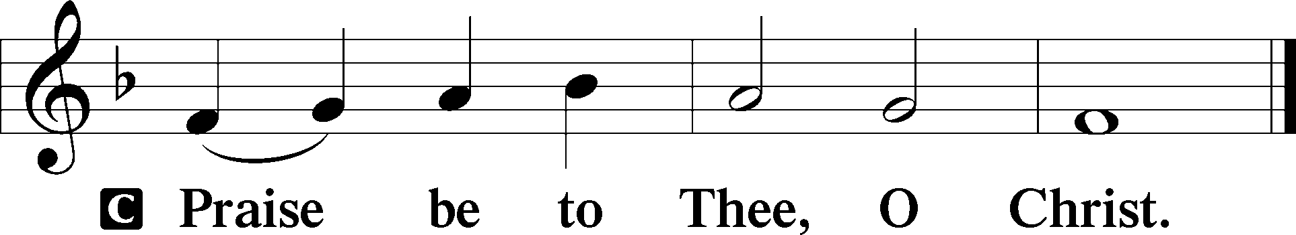

Apostles’ Creed

C **I believe in God, the Father Almighty,**

**maker of heaven and earth.**

**And in Jesus Christ, His only Son, our Lord,**

**who was conceived by the Holy Spirit,**

**born of the virgin Mary,**

**suffered under Pontius Pilate,**

**was crucified, died and was buried.**

**He descended into hell.**

**The third day He rose again from the dead.**

**He ascended into heaven**

**and sits at the right hand of God the Father Almighty.**

**From thence He will come to judge the living and the dead.**

**I believe in the Holy Spirit,**

**the holy Christian Church,**

**the communion of saints,**

**the forgiveness of sins,**

**the resurrection of the body,**

**and the life** T **everlasting. Amen.**

Children’s Message

531 Hail, Thou Once Despised Jesus

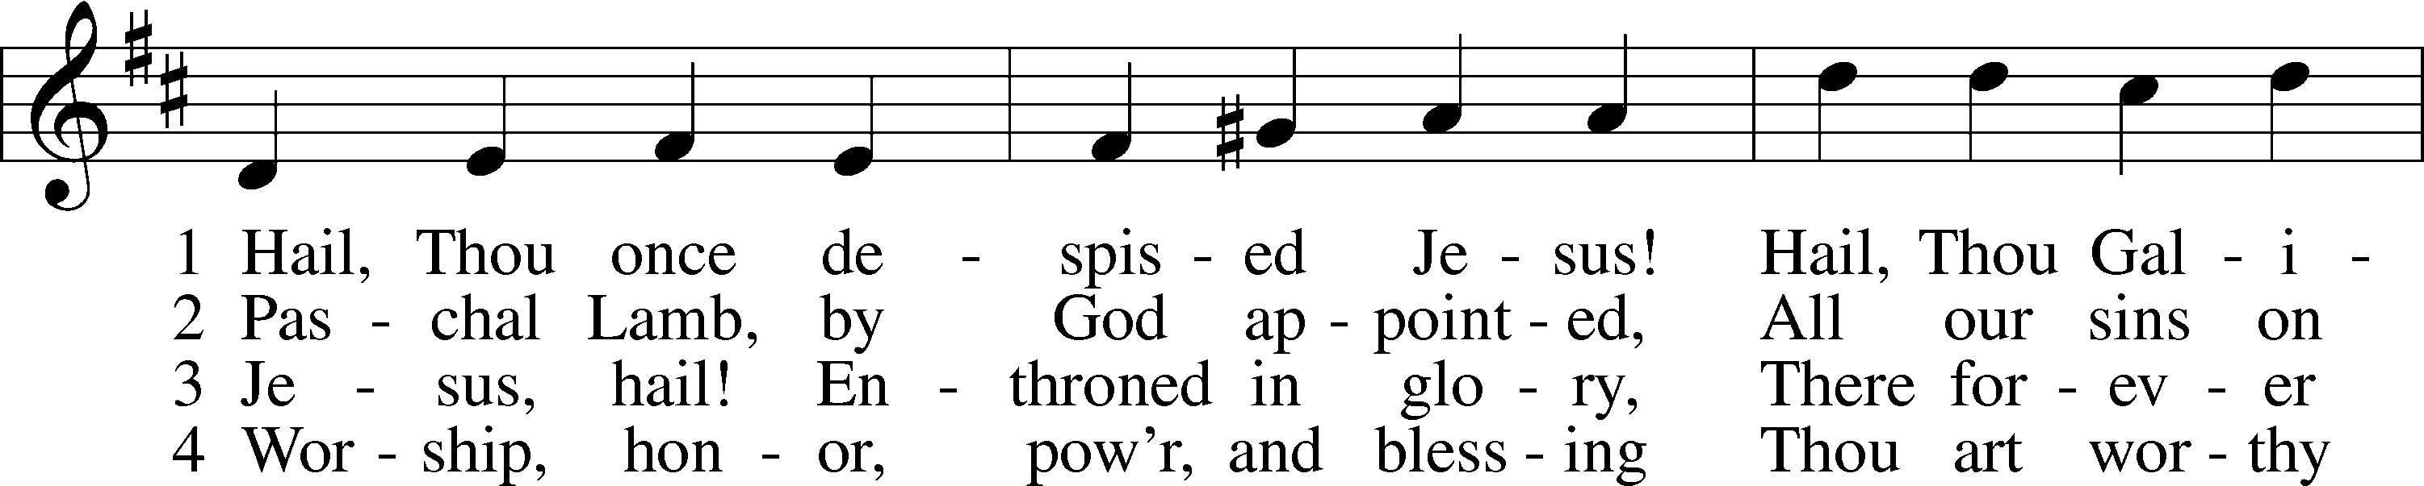

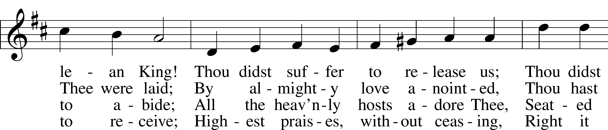

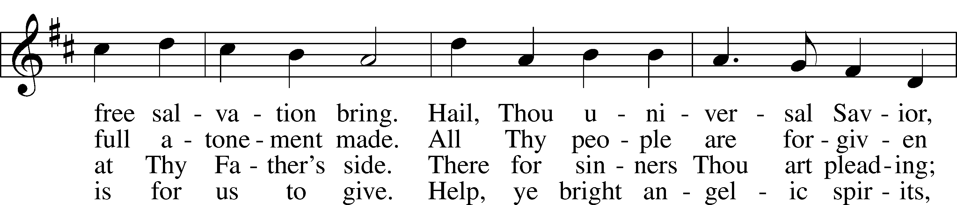

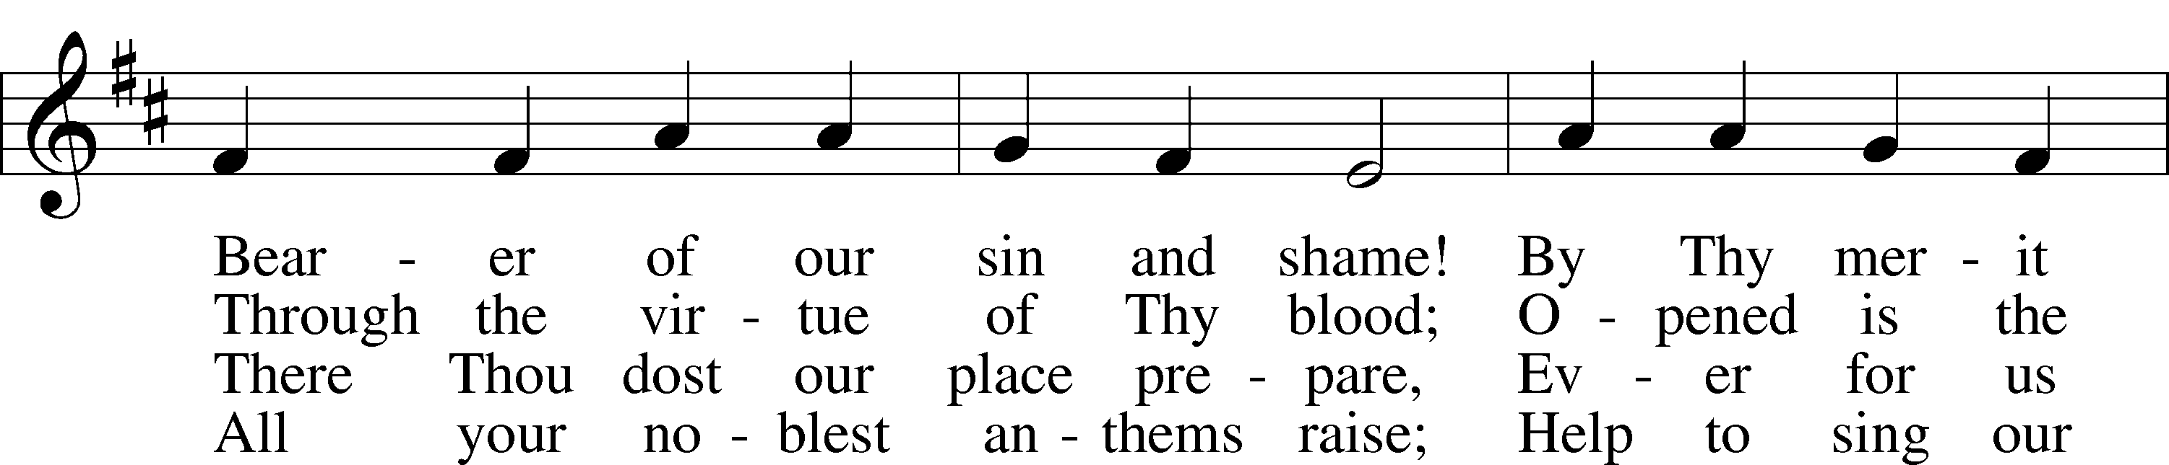

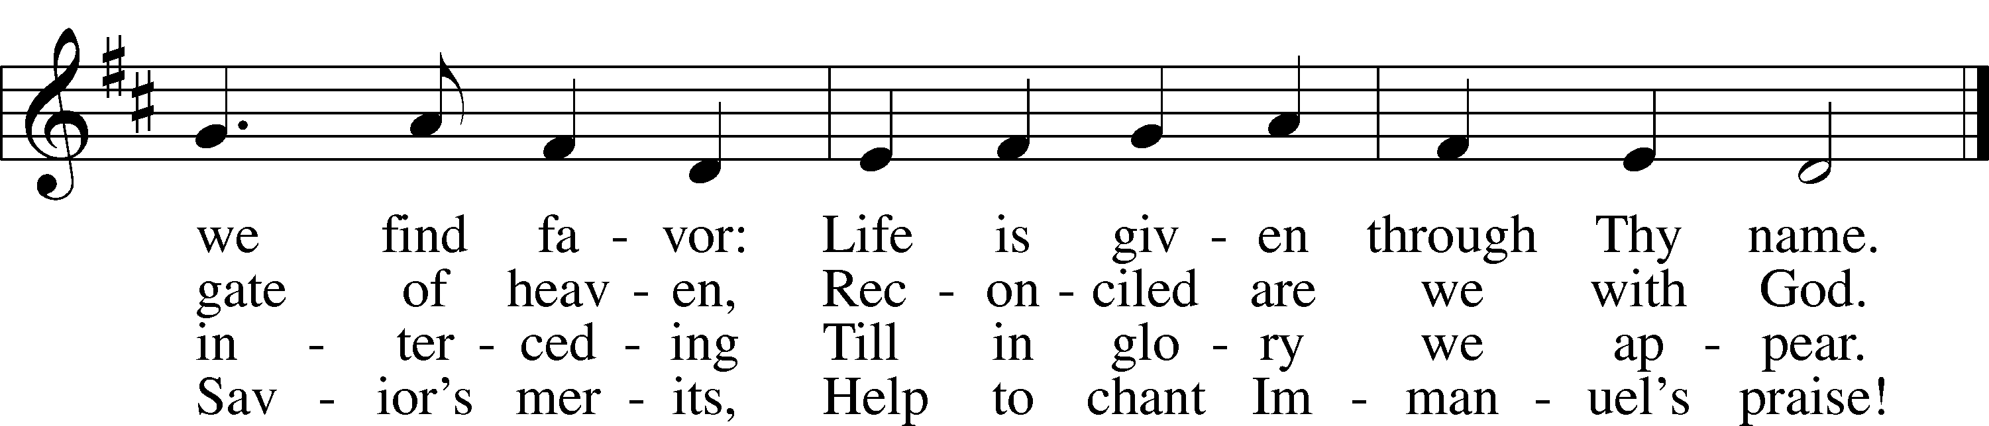

Tune and text: Public domain

Sermon “Deny Yourself. Bear Your Cross.”

Offertory LSB 192

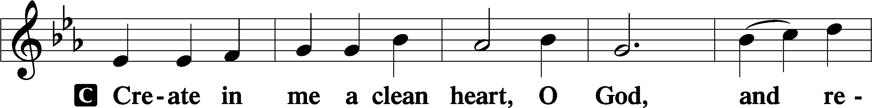

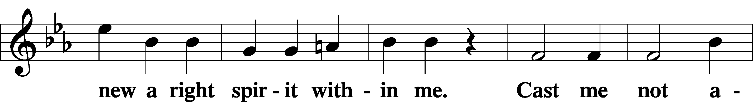

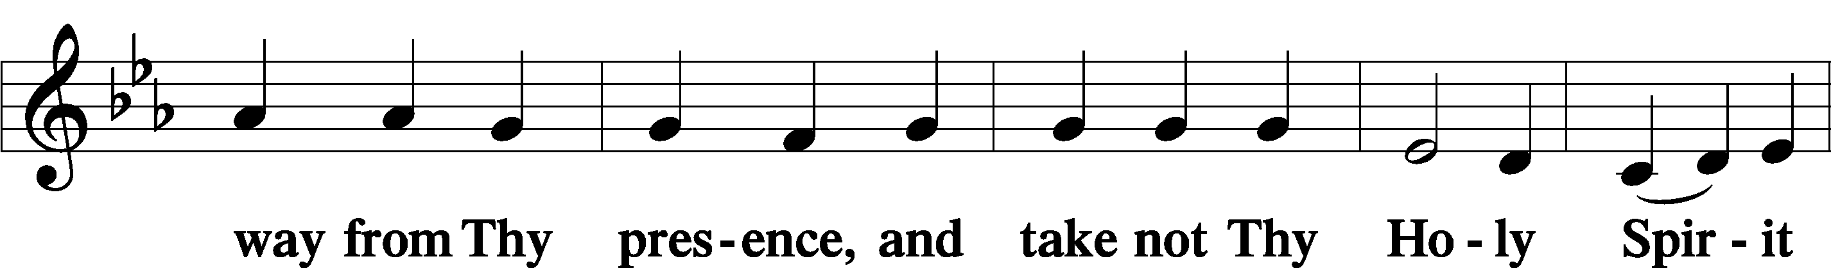

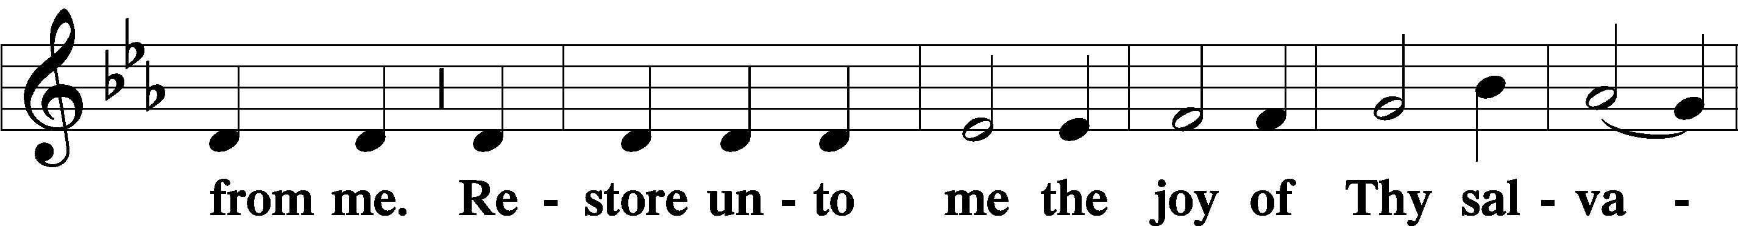

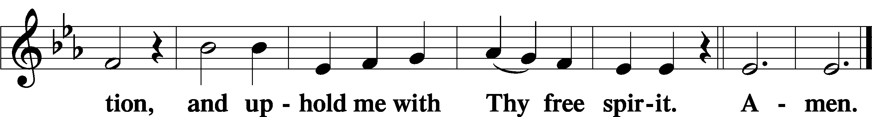

Prayer of the Church

# Service of the Sacrament

Preface LSB 194



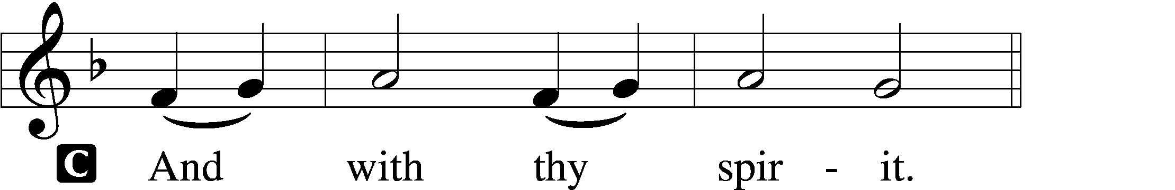



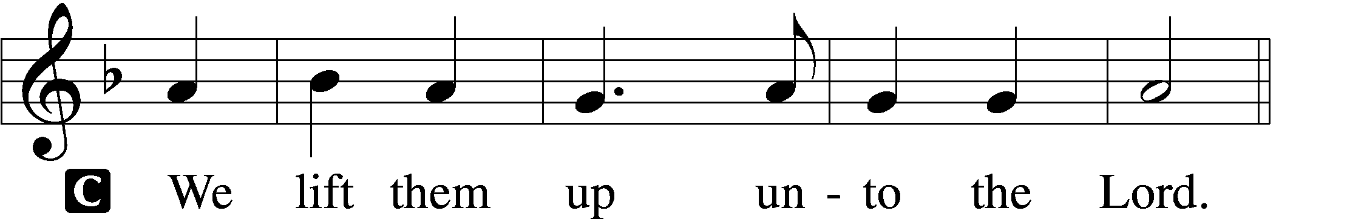

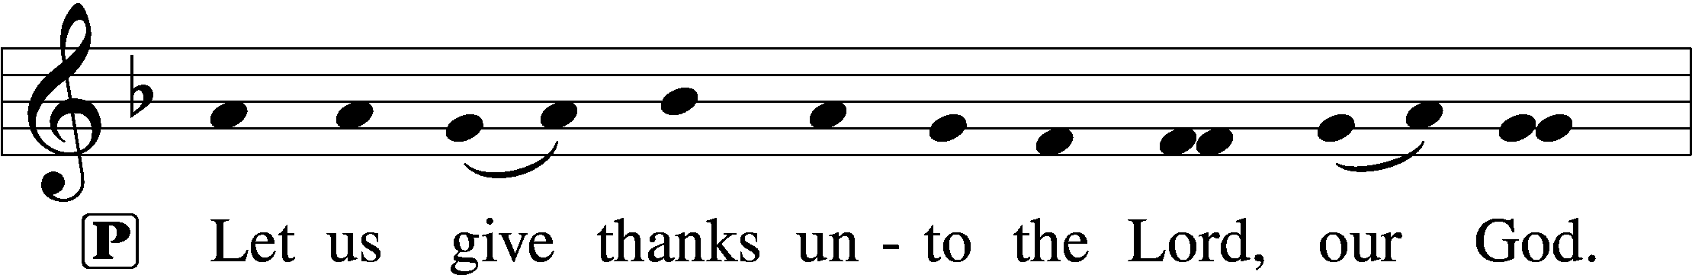

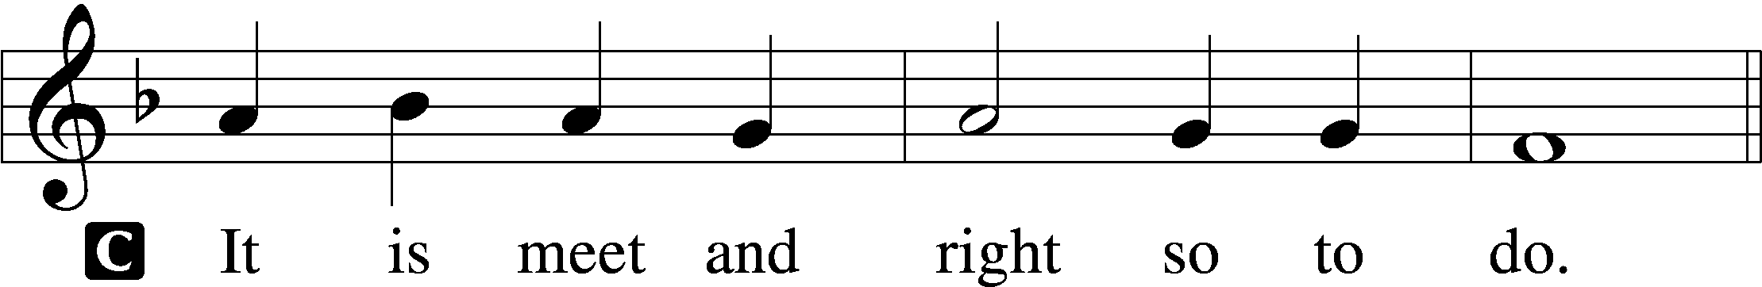

P It is truly meet, right, and salutary that we should at all times and in all places give thanks to You, holy Lord, almighty Father, everlasting God, through Jesus Christ, our Lord, who, out of love for His fallen creation, humbled Himself by taking on the form of a servant, becoming obedient unto death, even death upon a cross. Risen from the dead, He has freed us from eternal death and given us life everlasting. Therefore with angels and archangels and with all the company of heaven we laud and magnify Your glorious name, evermore praising You and saying:

Sanctus LSB 195

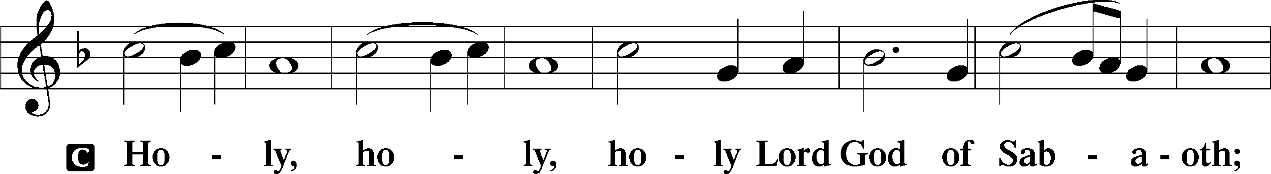

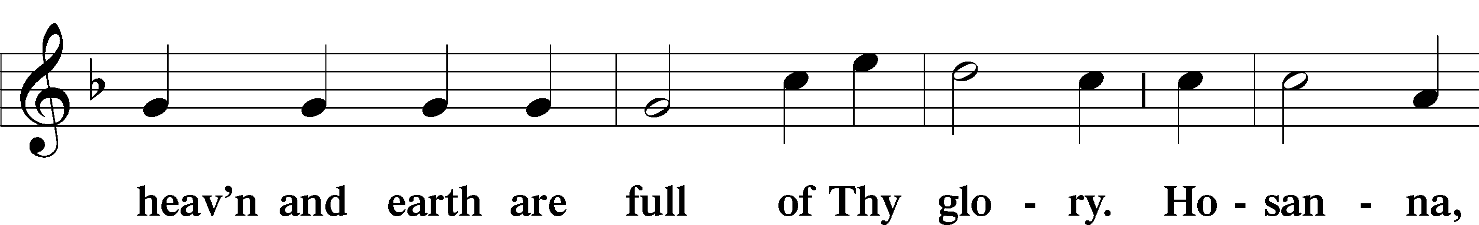

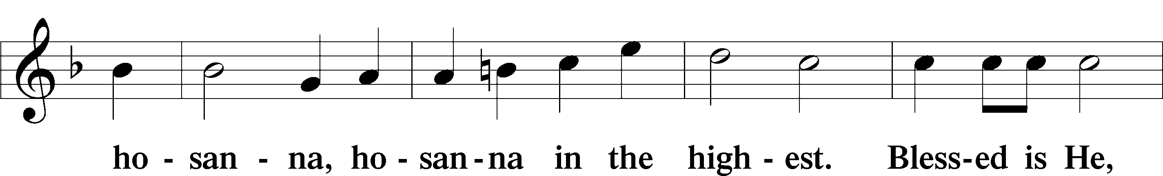

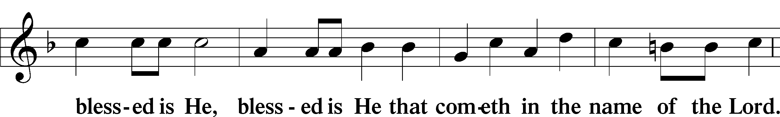

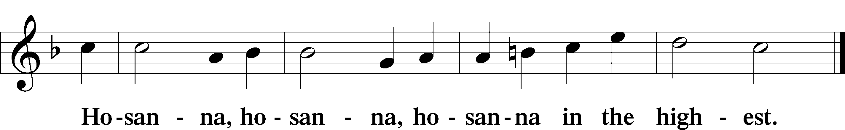

Lord’s Prayer LSB 196

P Our Father who art in heaven,

hallowed be Thy name,

Thy kingdom come,

Thy will be done on earth as it is in heaven;

give us this day our daily bread;

and forgive us our trespasses as we forgive those who trespass against us;

and lead us not into temptation,

but deliver us from evil.

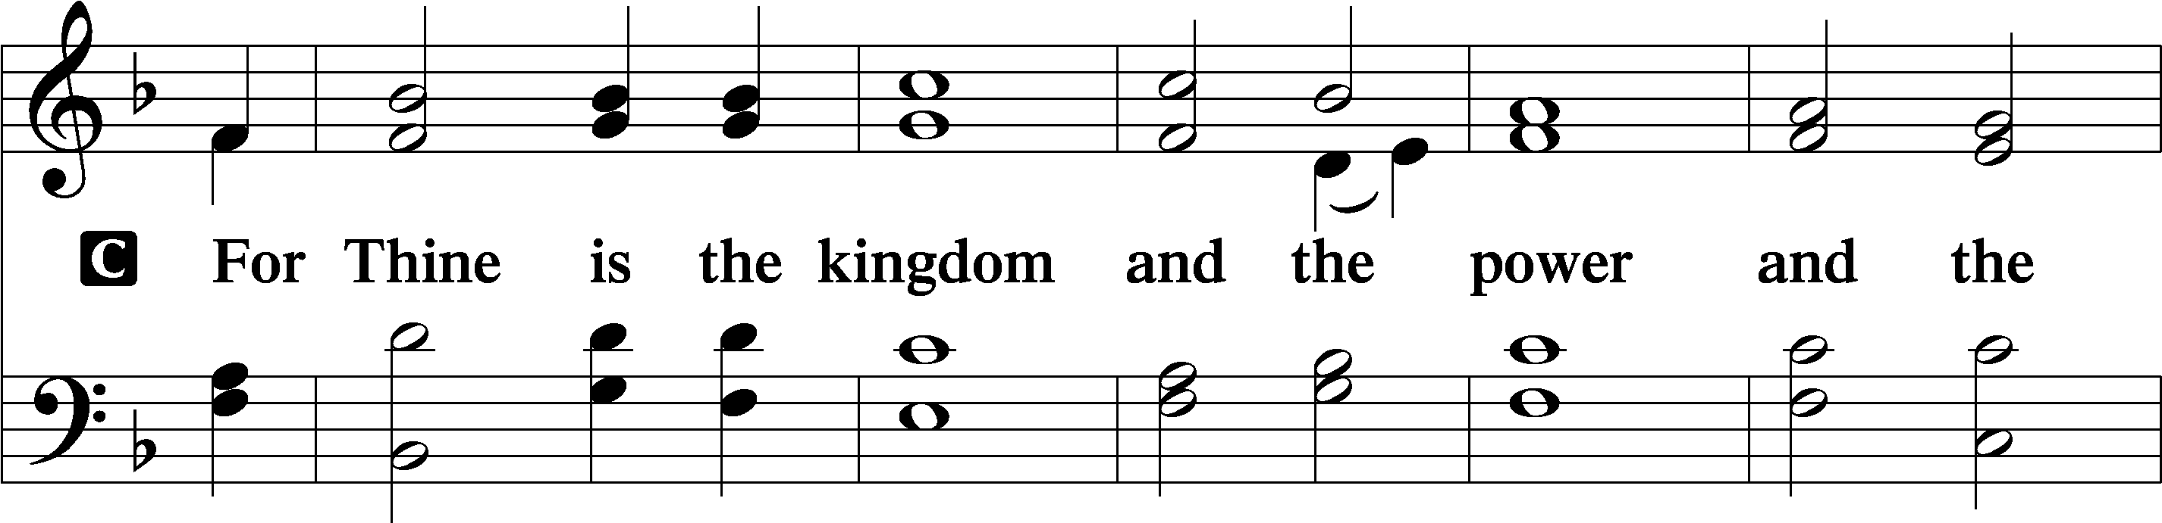

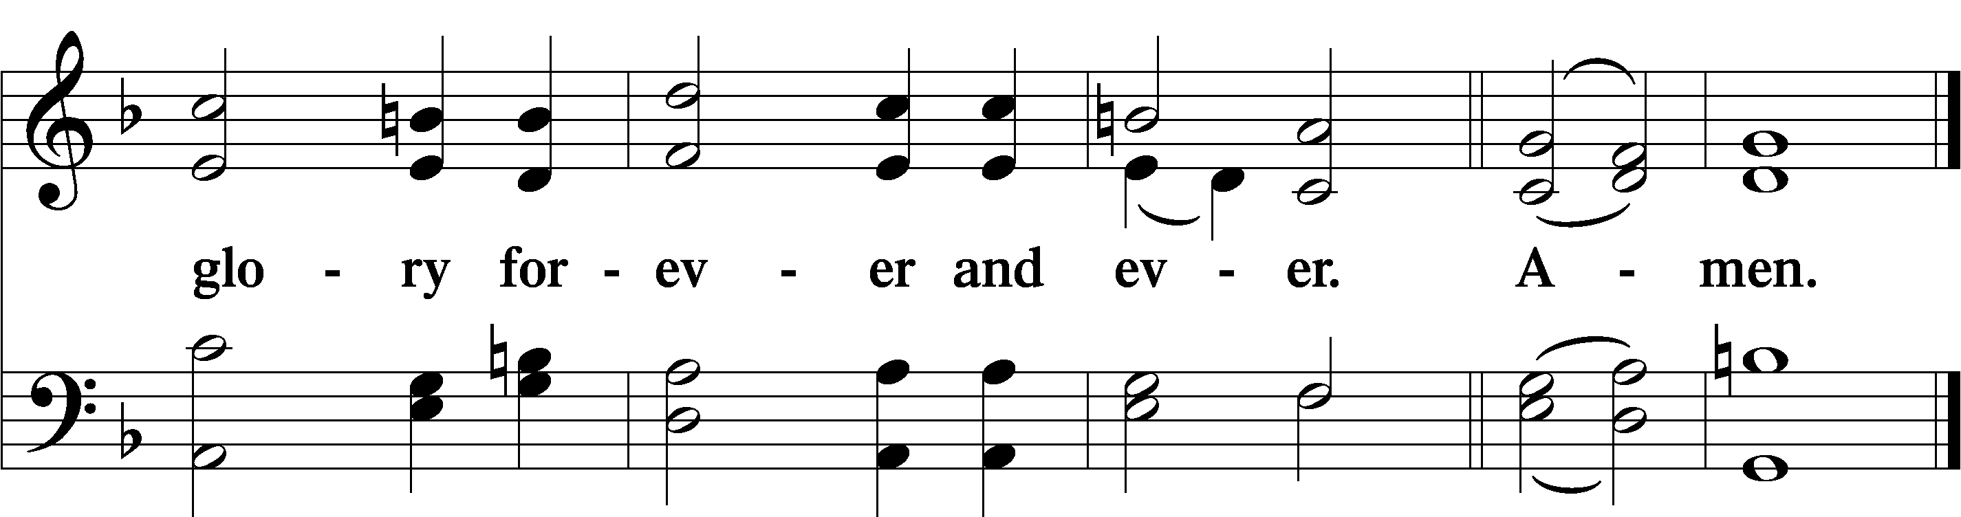

The Words of Our Lord LSB 197

P Our Lord Jesus Christ, on the night when He was betrayed, took bread, and when He had given thanks, He broke it and gave it to the disciples and said: “Take, eat; this is My T body, which is given for you. This do in remembrance of Me.”

In the same way also He took the cup after supper, and when He had given thanks, He gave it to them, saying: “Drink of it, all of you; this cup is the new testament in My T blood, which is shed for you for the forgiveness of sins. This do, as often as you drink it, in remembrance of Me.”

Pax Domini LSB 197

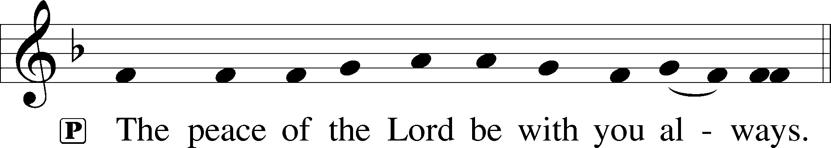

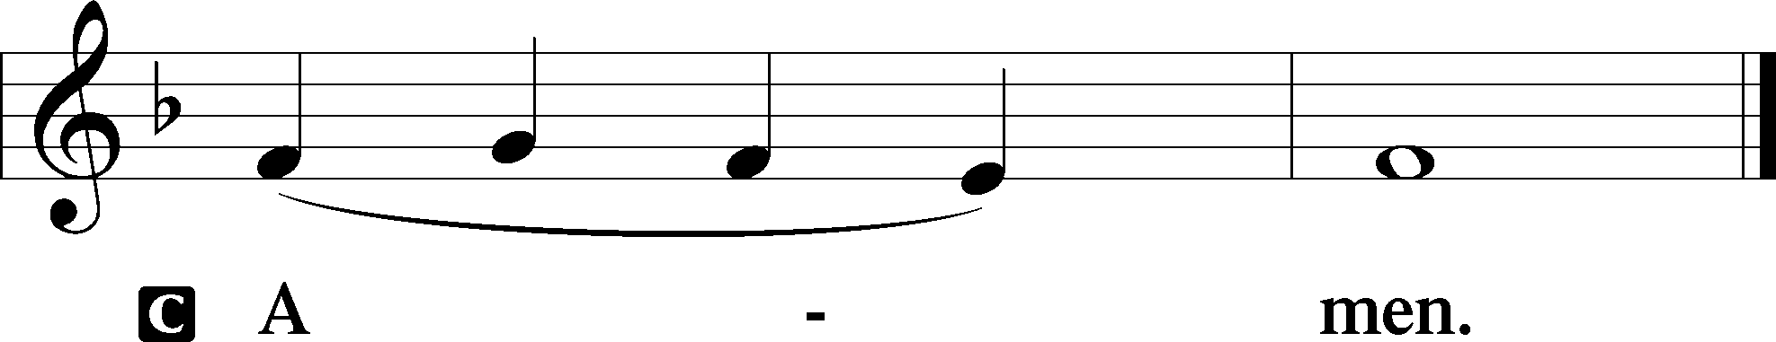

Agnus Dei LSB 198

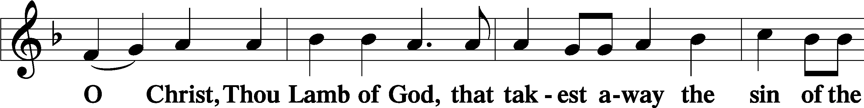

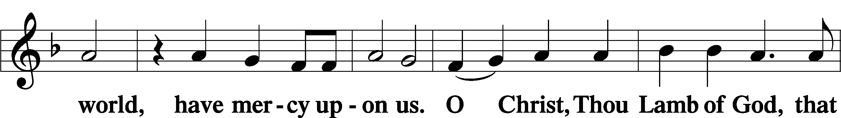

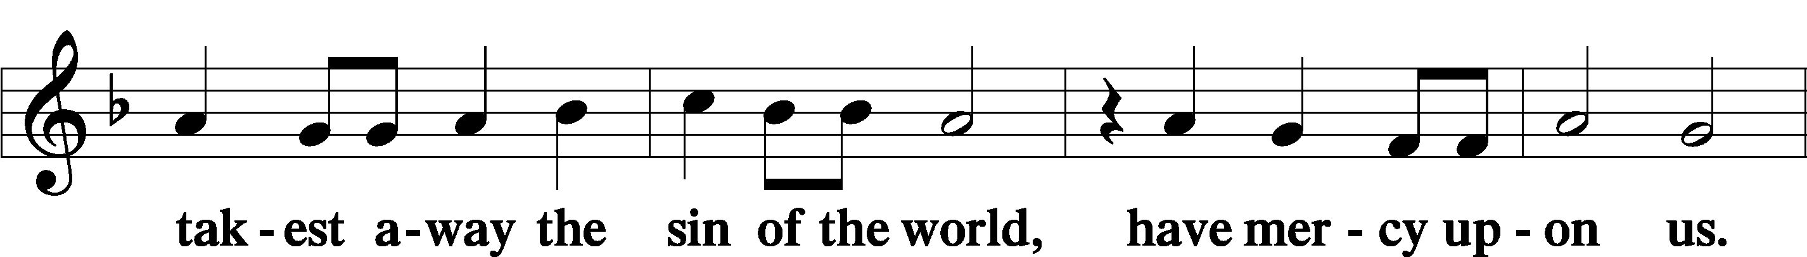

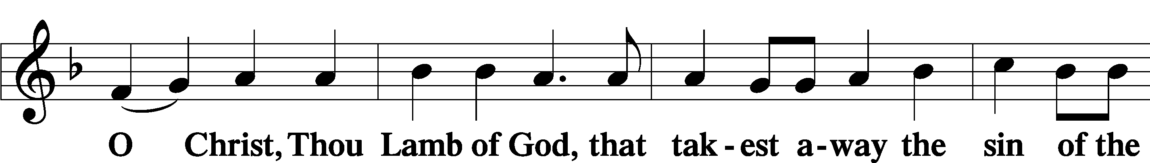

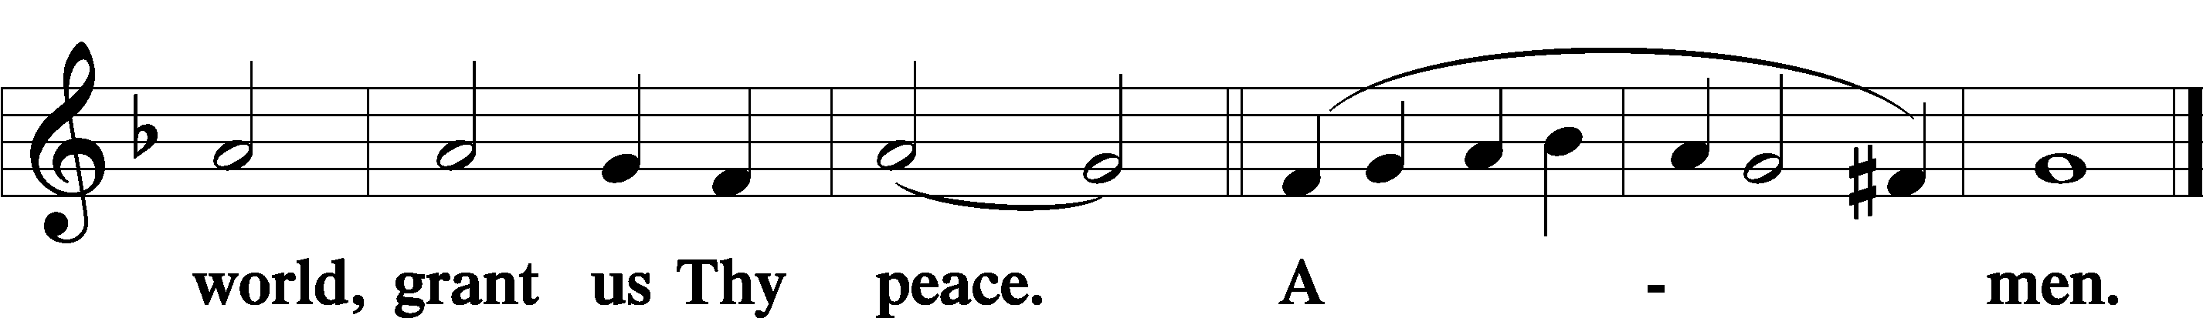

Distribution

621 Let All Mortal Flesh Keep Silence

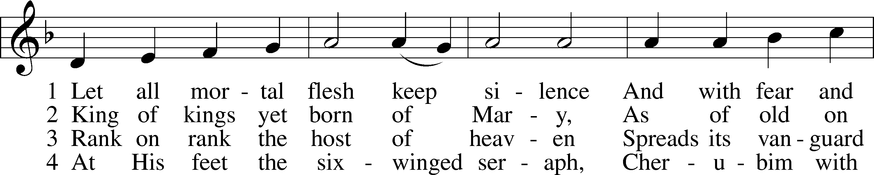

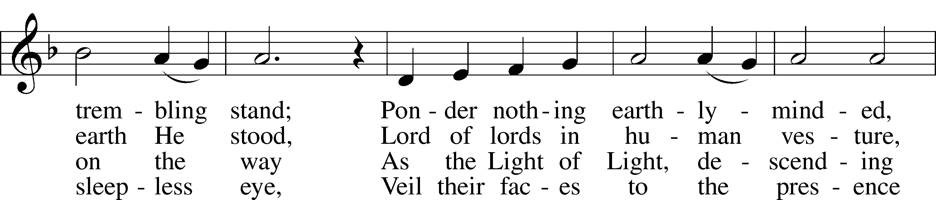

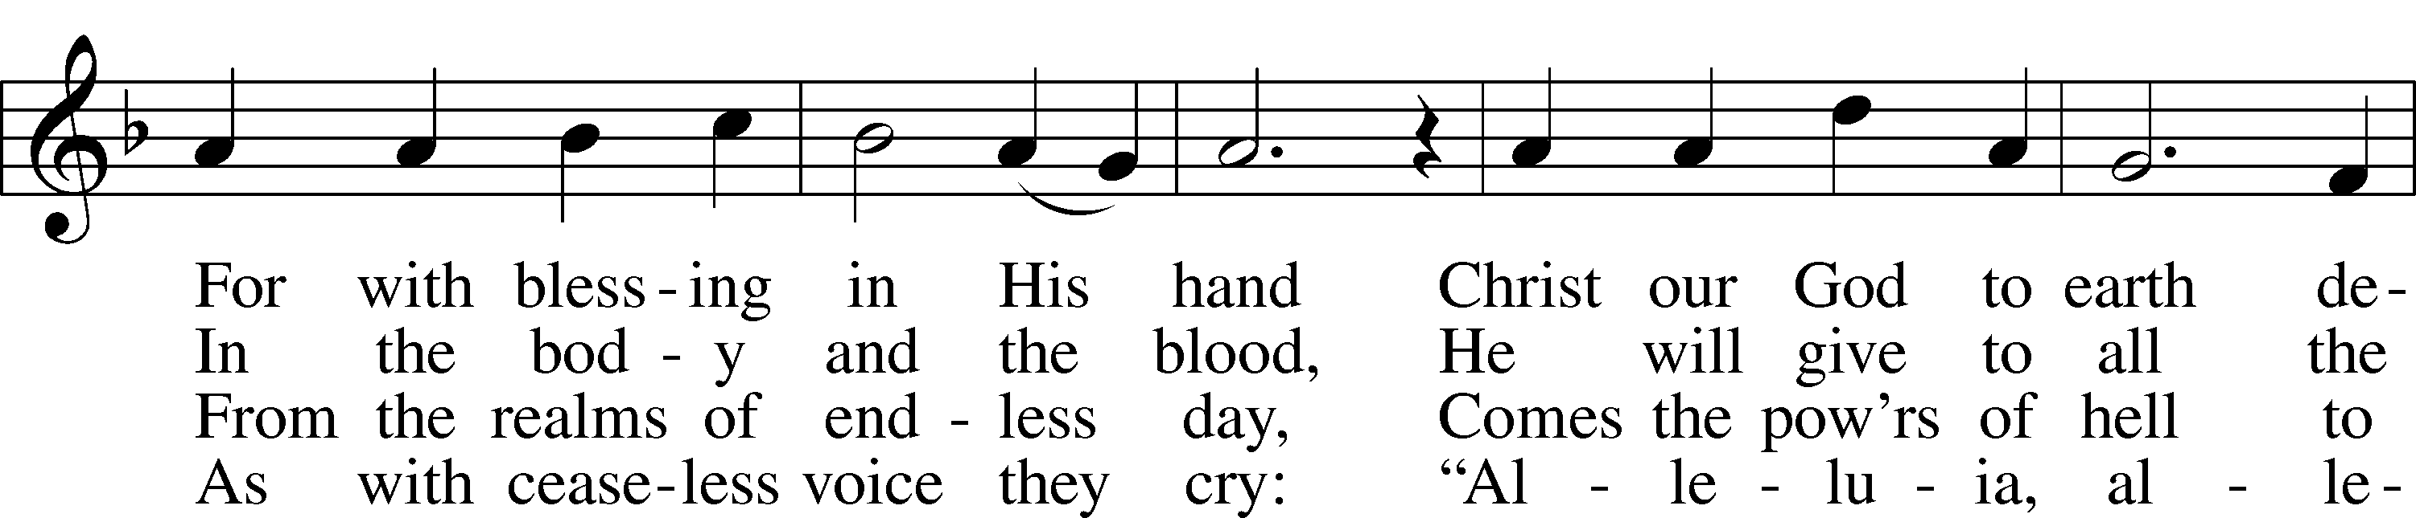

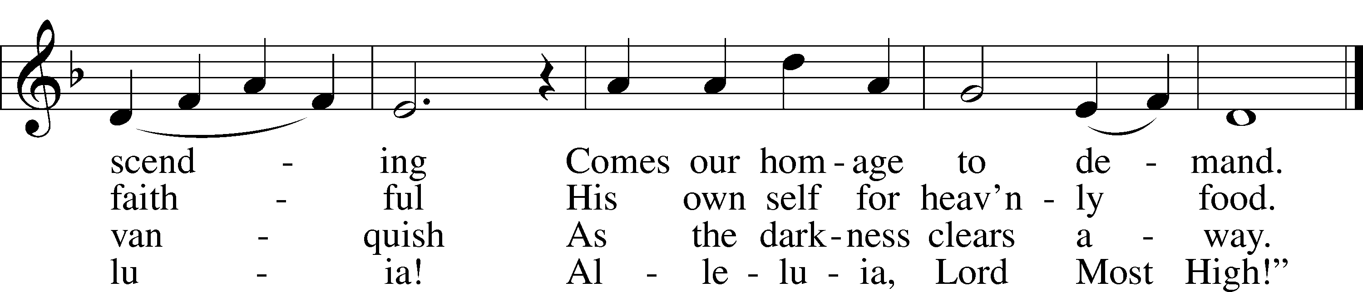

Text and tune: Public domain

Nunc Dimittis LSB 199

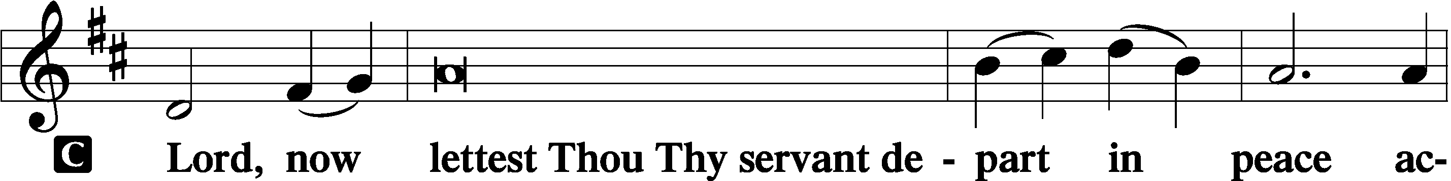

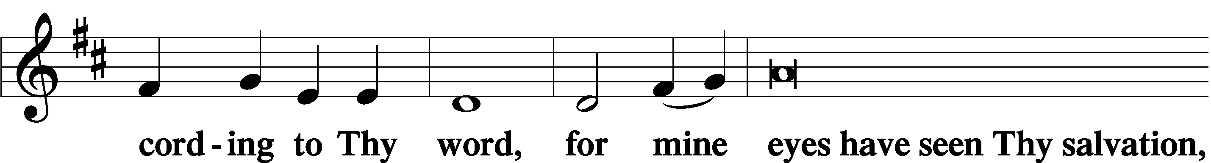

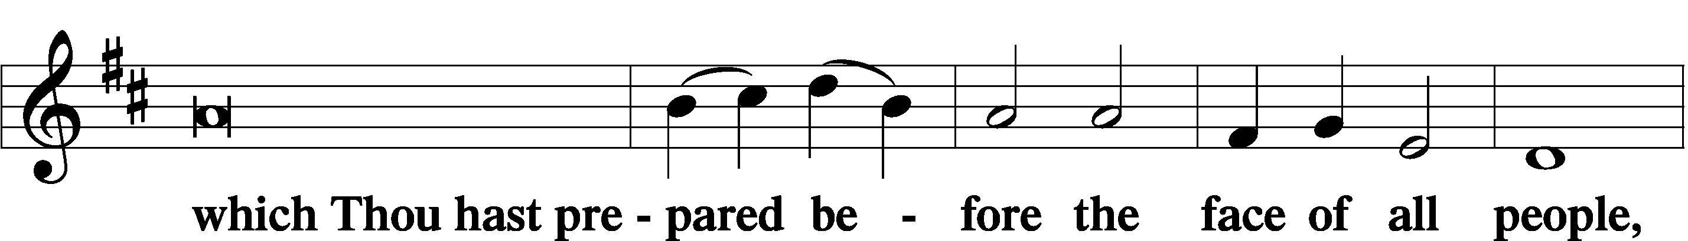

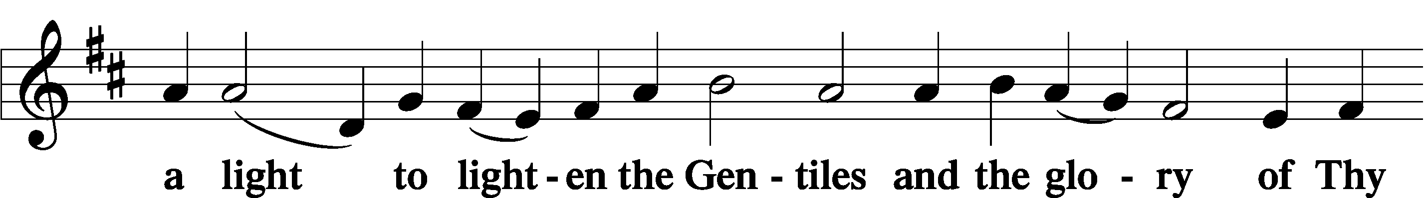

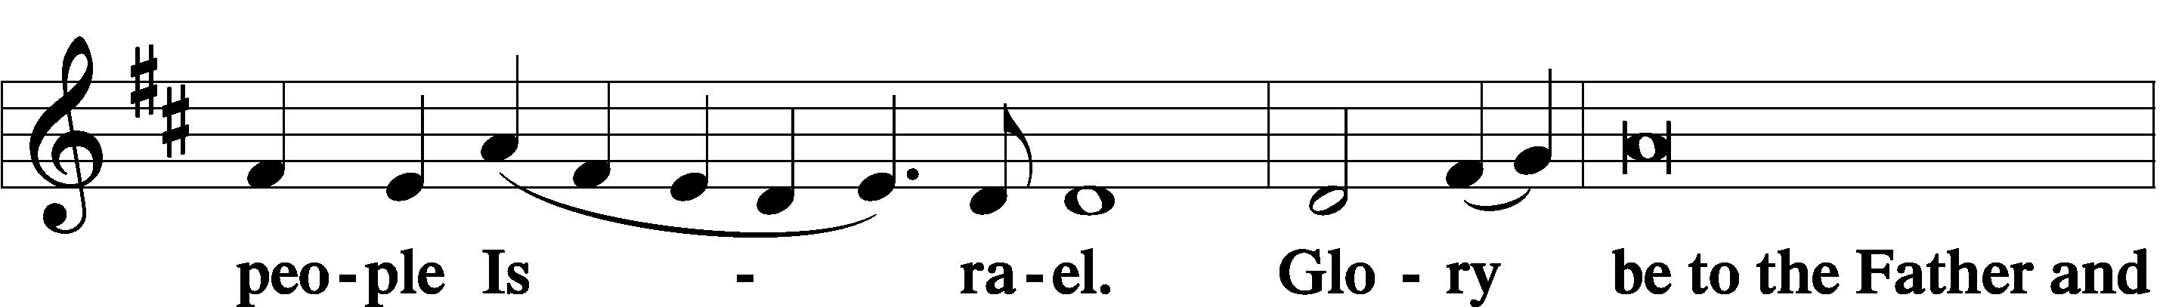

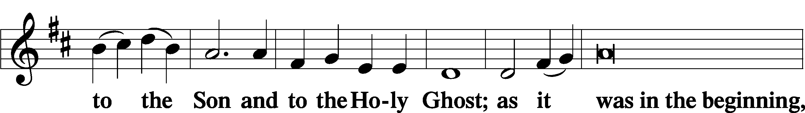

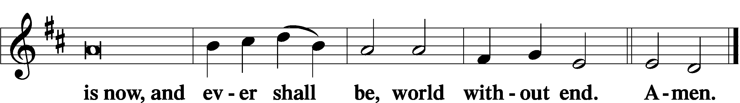

Thanksgiving LSB 200

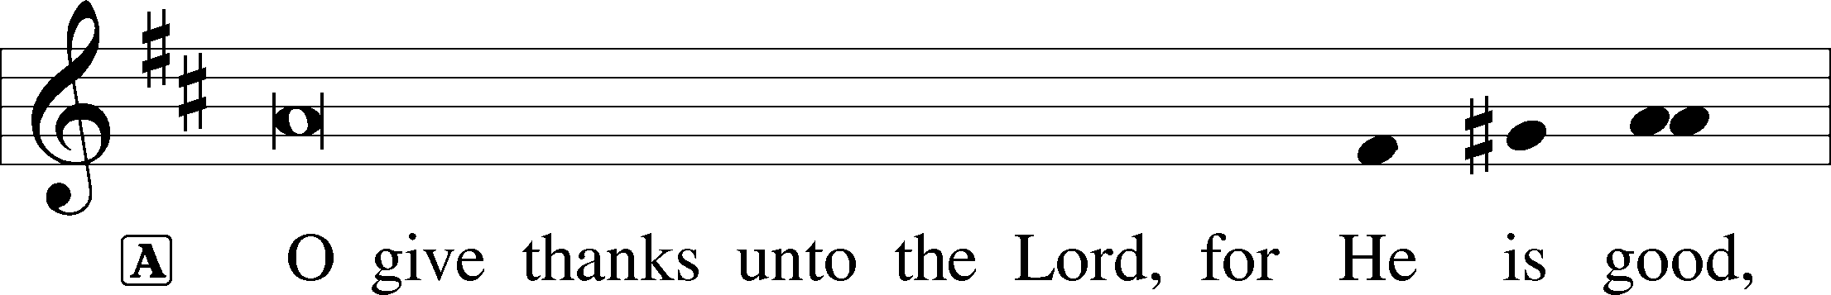

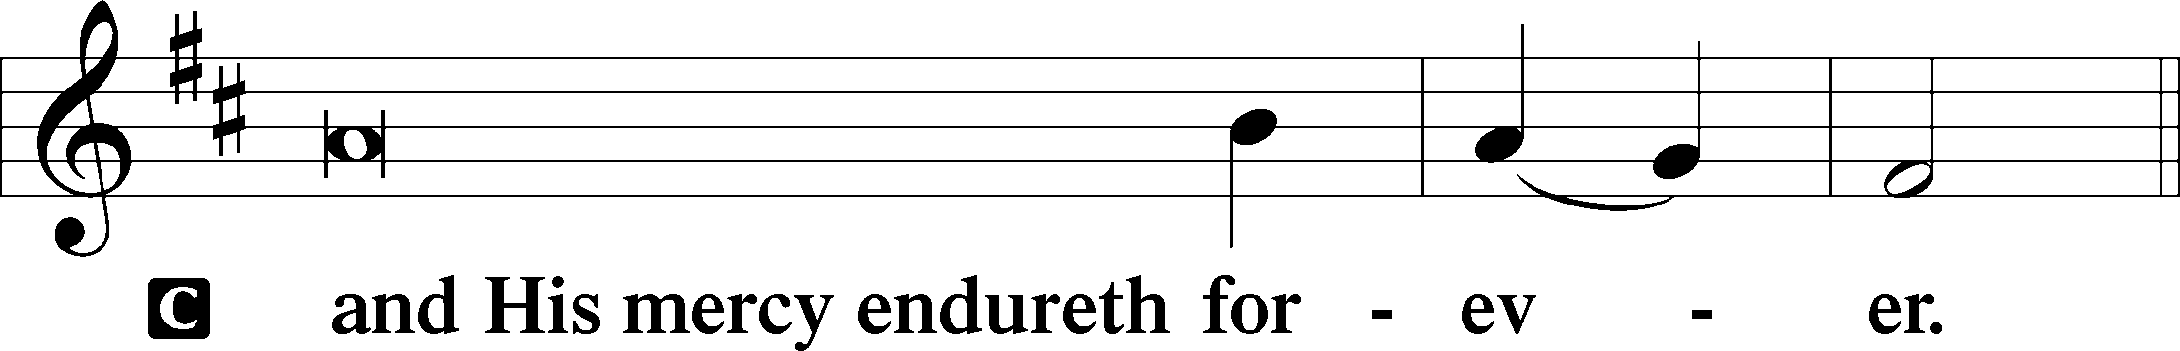

A Let us pray.

We give thanks to You, almighty God, that You have refreshed us through this salutary gift, and we implore You that of Your mercy You would strengthen us through the same in faith toward You and in fervent love toward one another; through Jesus Christ, Your Son, our Lord, who lives and reigns with You and the Holy Spirit, one God, now and forever.

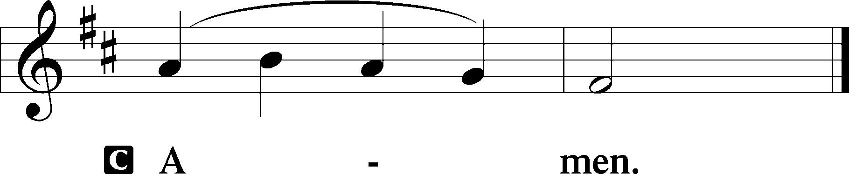

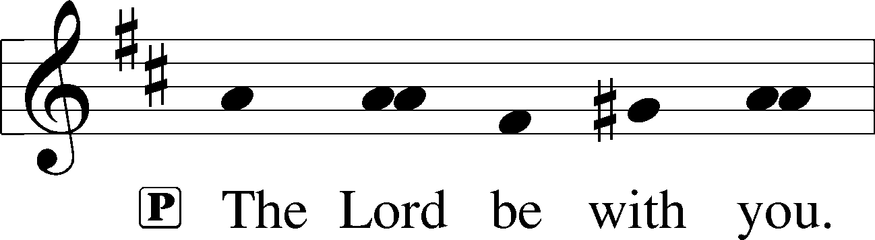

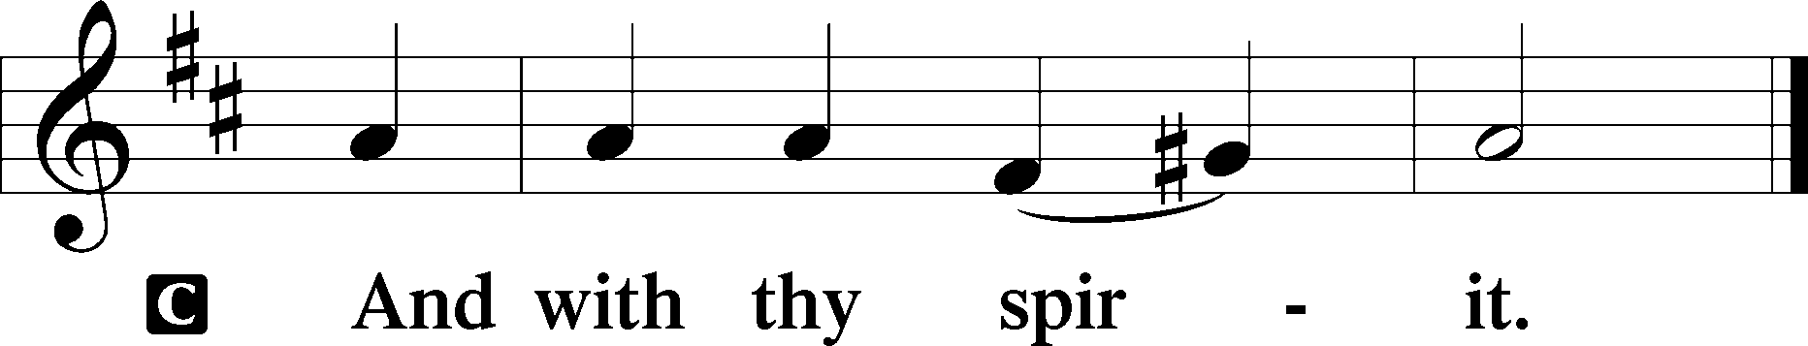

Benedicamus LSB 202

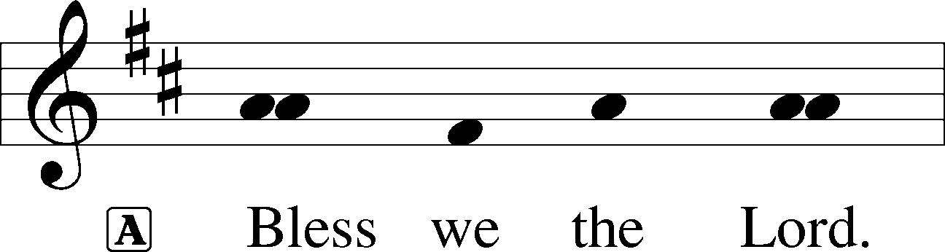

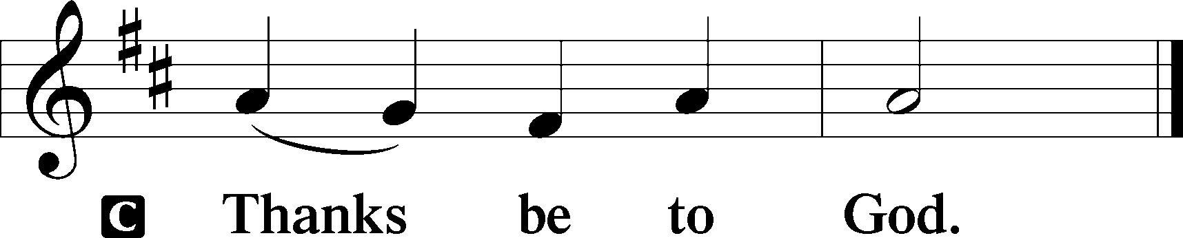

Benediction LSB 202

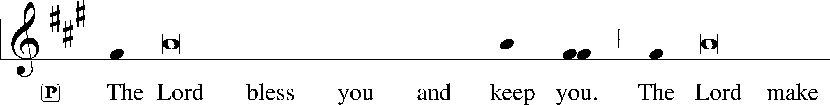

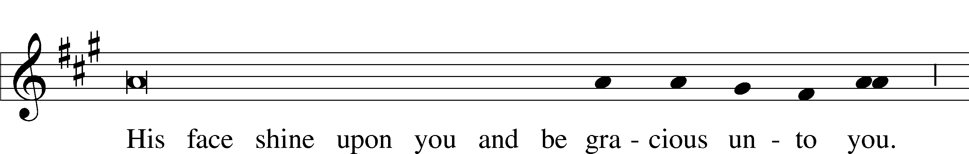

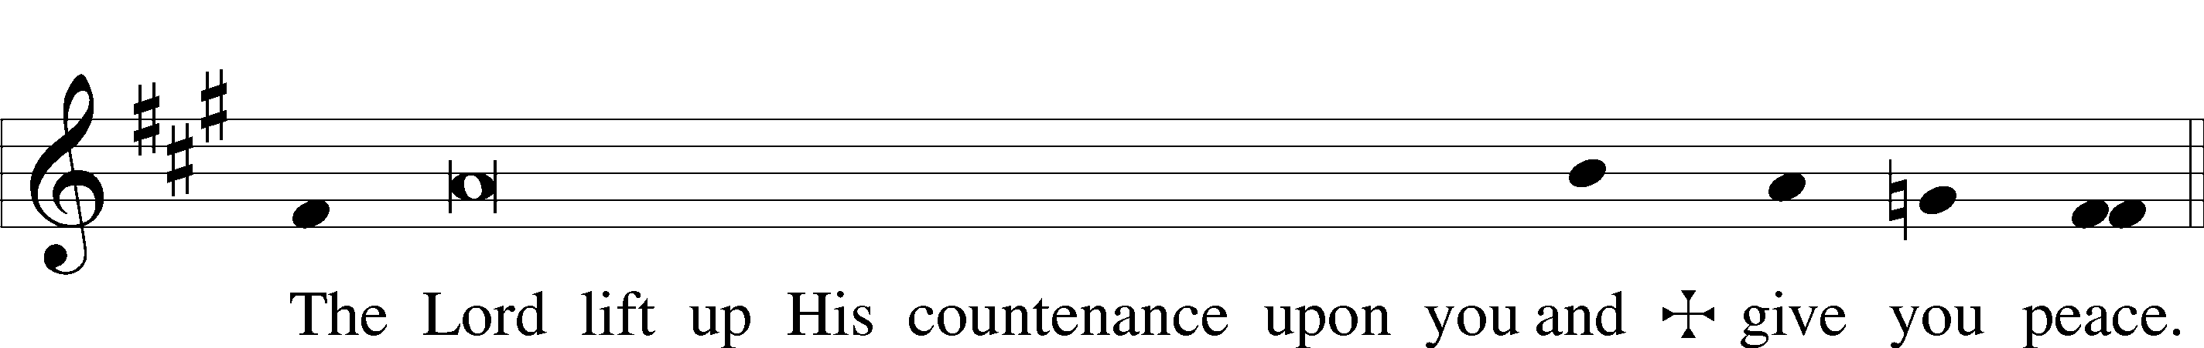

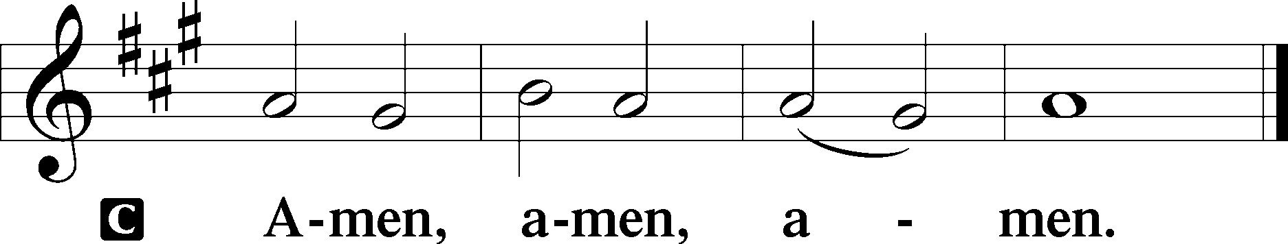

845 Where Charity and Love Prevail

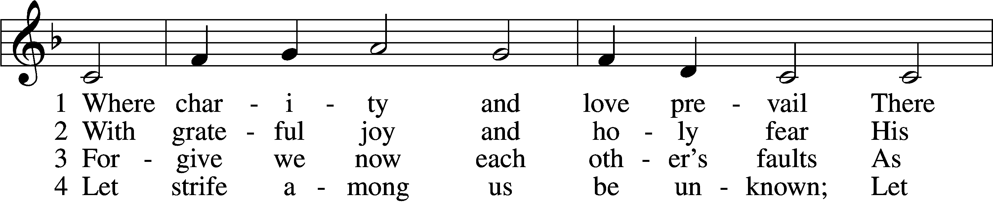

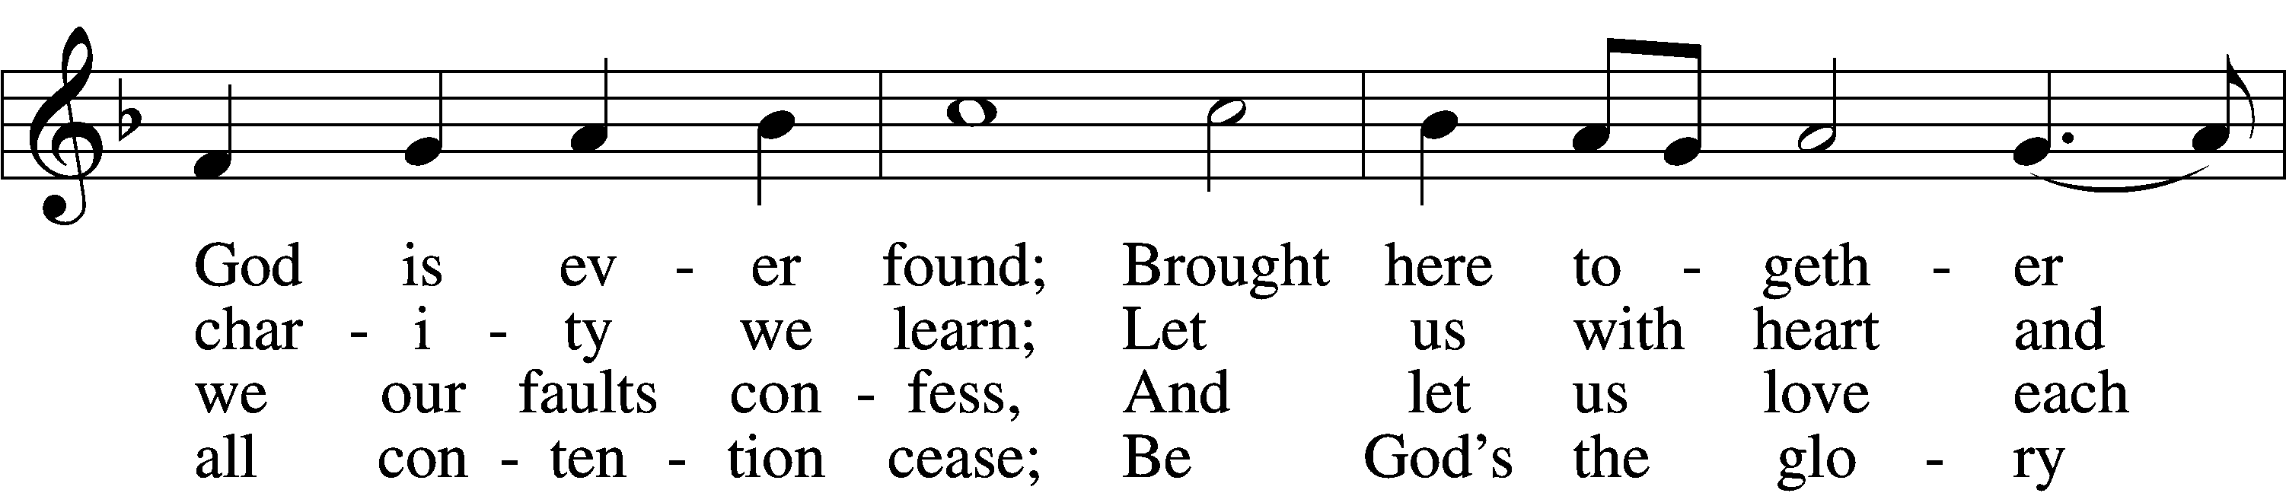

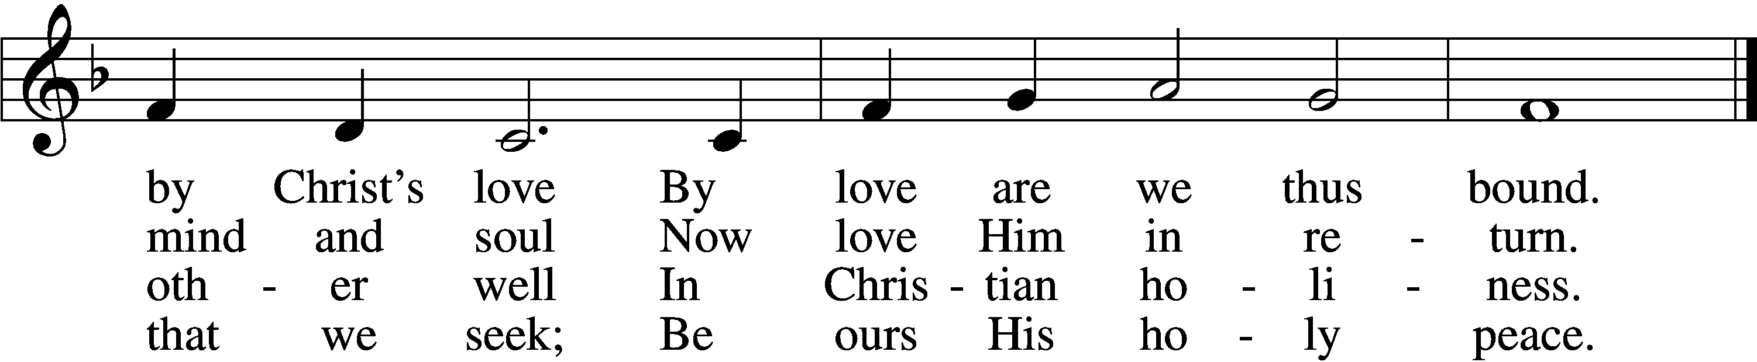

Tune: Public domain

Text: © 1960 World Library Publications. Used by permission: LSB Hymn License no. 110005047

Acknowledgments

Divine Service, Setting Three from Lutheran Service Book

Unless otherwise indicated, Scripture quotations are from the ESV® Bible (The Holy Bible, English Standard Version®), copyright © 2001 by Crossway, a publishing ministry of Good News Publishers. Used by permission. All rights reserved.

Created by Lutheran Service Builder © 2018 Concordia Publishing House.

**Gifts of Time and Treasure**

**“But remember the Lord your God, for it is he who gives you the ability to produce wealth…”**

**Deuteronomy 8:18a (NIV)**

**LAST WEEK’S OFFERINGS**  **LAST WEEK’S ATTENDANCE**

General Fund $ 6,228.96 Service 22

Needed Weekly $ 3,963.38 Communed 21

Allen Diamond Mem. $ 50.00

John Sims Mem. $ 50.00

**The Lord’s Week**

Today 9:00 am – Adult Bible Study

**(August 30th)** 10:00 am – Divine Service

Next Sunday 9:00 am – Adult Bible Study

**(Sept. 6th)** 10:00 am – Divine Service

**In His Service**

Elder: Jim Bounds

Ushers: Paul & Taylor Crozier

Acolytes: Parker Bluntzer & Cody Wilson

Altar: Judy Kunkel & Laura Lopez

Organist: Sharon Shrader

Flowers: Dev & Irma Brewer