**Fourteenth Sunday**

**After Pentecost**

“Repent and Believe”

Ezekiel 33:7-9

**September 6, 2020**

**Messiah Lutheran Church**

**Lutheran Church-Missouri Synod**

4102 Trinity River Dr., Corpus Christi, Texas 78410

**Pastor:**  **Rev. Scott E. Herbert**

Church Phone: 361-387-7748 Email: mlc@stx.rr.com

Church Fax: 361-767-1768 Website: [www.messiahlcms-cc.org](http://www.messiahlcms-cc.org)

Pastor Phone: 469-644-4772 Pastor Email: chirev59@gmail.com

**WELCOME TO MESSIAH!**

We are glad you are here to receive what God is doing for you during Divine Service. Please sign our Guest Book located near the front door. Feel free to converse quietly until the organ prelude begins. If you are looking for a church home, please talk to the Pastor at the door. We would love to have you join us.

**Preparing for Service**

# ***Living as Humble Little Children of the Father***

# True greatness is not self-sufficient strength, but humility like that of a little child. The greatness of childlike faith receives all good things as gracious gifts from our Father in heaven. Apart from such faith, *“you will never enter the kingdom of heaven*,” but whoever is humbled like a little child will be “*the greatest in the kingdom of heaven”* (Matt. 18:3–4). Though in our sin we deserve to be *“drowned in the depth of the sea”* (Matt. 18:6), we have instead been drowned (“buried”) with Christ in Baptism and then raised to the new, humble life of a child of God. The Lord sends His watchman to warn us with a word from His mouth, in order that we may not die in our iniquity but be turned from our pride and selfishness to live (Ezek. 33:7–9). Thus, we live in humility and faith before God as well as in love for our neighbor, which *“is the fulfilling of the law”* (Rom. 13:10). In the reverent fear of God, we do no harm to our neighbor, but we *“pay to all what is owed to them”* (Rom. 13:7) and we *“owe no one anything, except to love each other”* (Rom. 13:8).

# Confession and Absolution

902 Lord Jesus Christ, Be Present Now

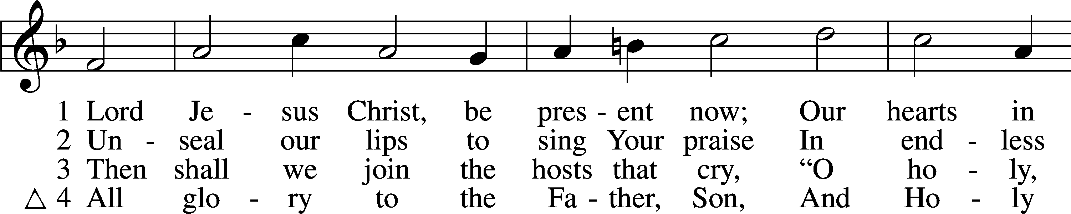

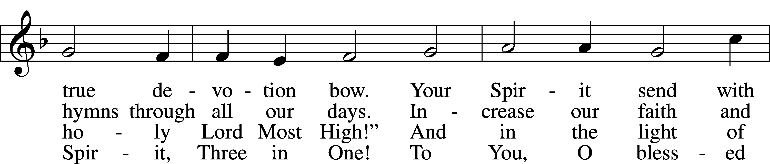

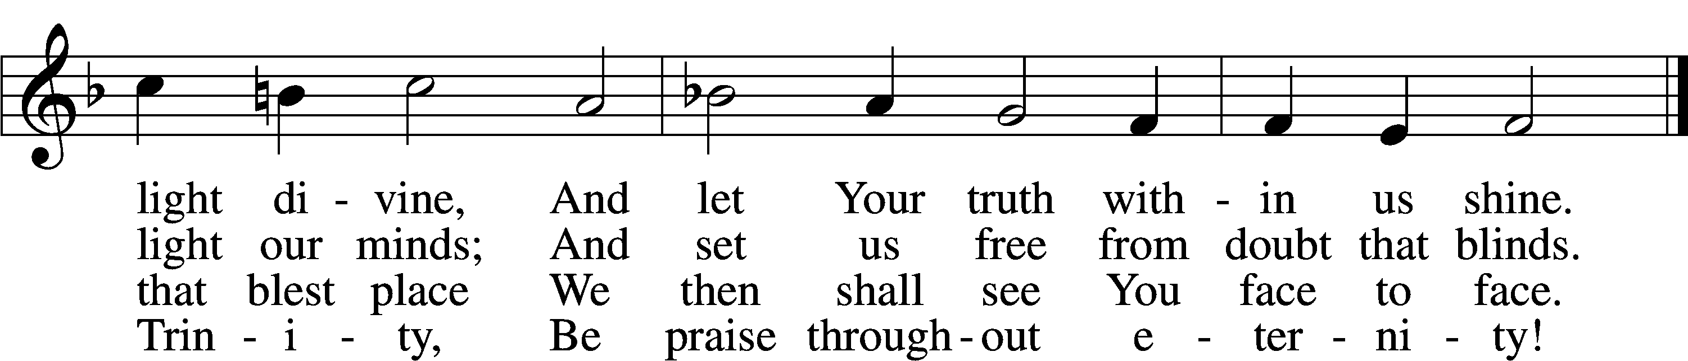

Tune and text: Public domain

P In the name of the Father and of the T Son and of the Holy Spirit.

C **Amen.**

P If we say we have no sin, we deceive ourselves, and the truth is not in us.

C **But if we confess our sins, God, who is faithful and just, will forgive our sins and cleanse us from all unrighteousness.**

P Let us then confess our sins to God our Father.

C **Most merciful God, we confess that we are by nature sinful and unclean. We have sinned against You in thought, word, and deed, by what we have done and by what we have left undone. We have not loved You with our whole heart; we have not loved our neighbors as ourselves. We justly deserve Your present and eternal punishment. For the sake of Your Son, Jesus Christ, have mercy on us. Forgive us, renew us, and lead us, so that we may delight in Your will and walk in Your ways to the glory of Your holy name. Amen.**

P Almighty God in His mercy has given His Son to die for you and for His sake forgives you all your sins. As a called and ordained servant of Christ, and by His authority, I therefore forgive you all your sins in the name of the Father and of the T Son and of the Holy Spirit.

C **Amen.**

# Service of the Word

Kyrie LSB 152



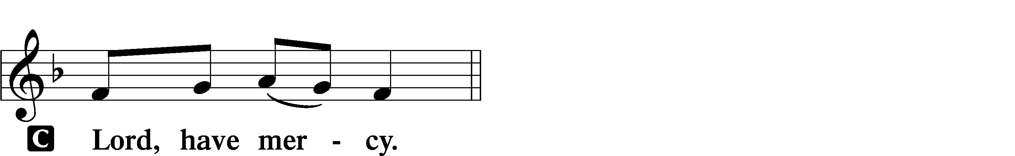

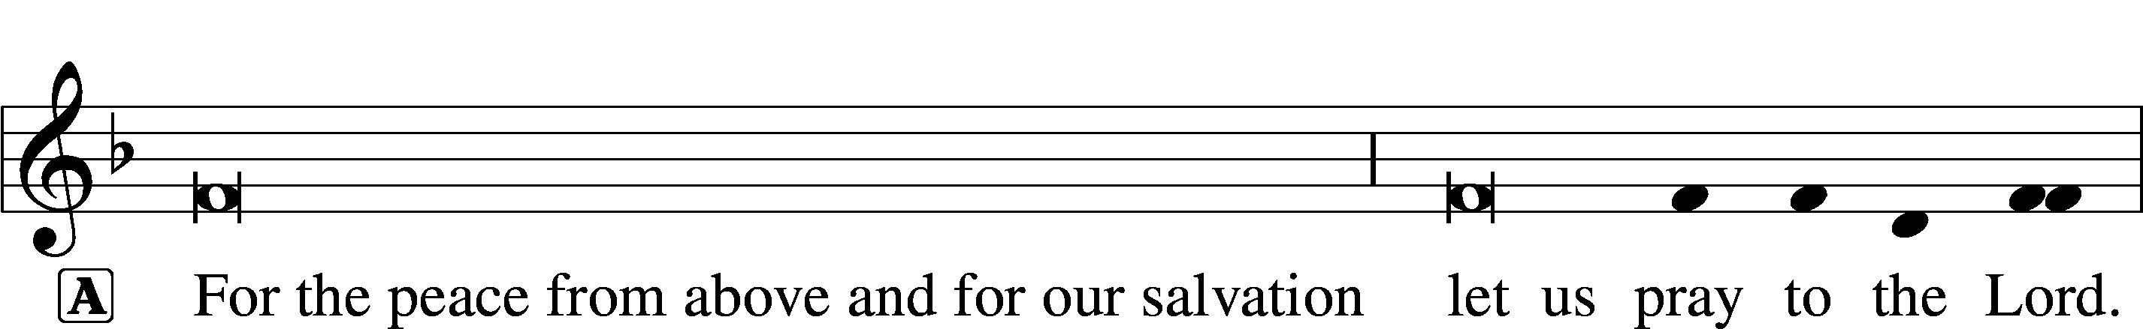

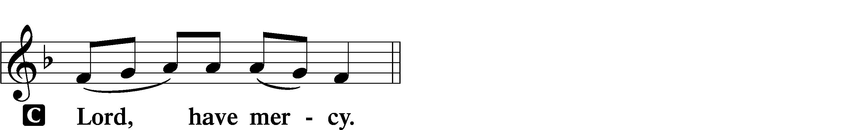

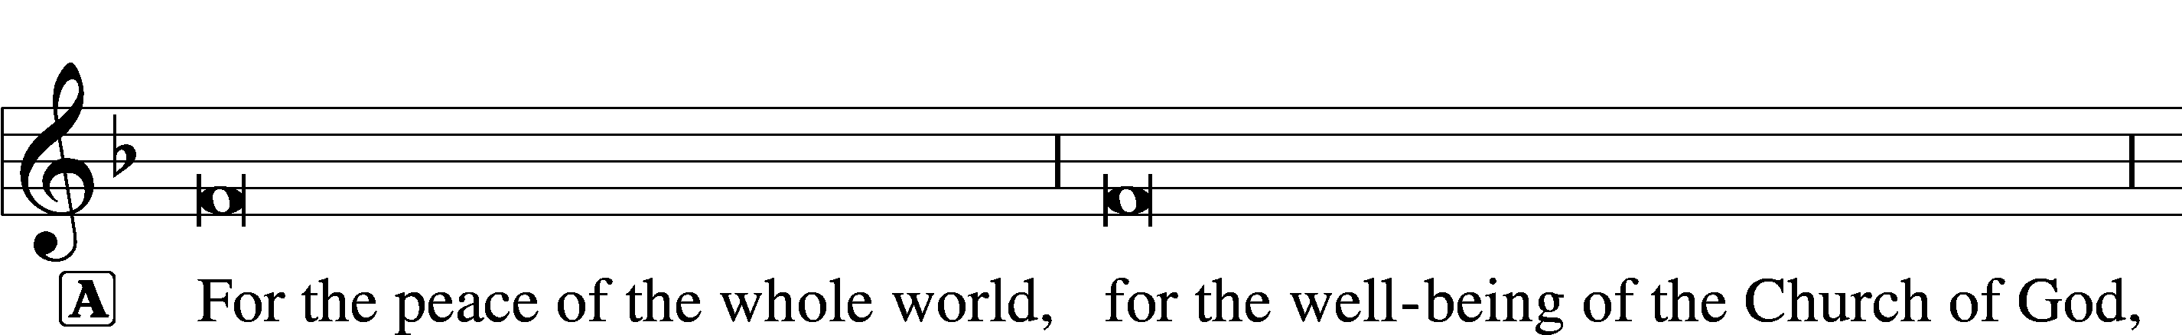

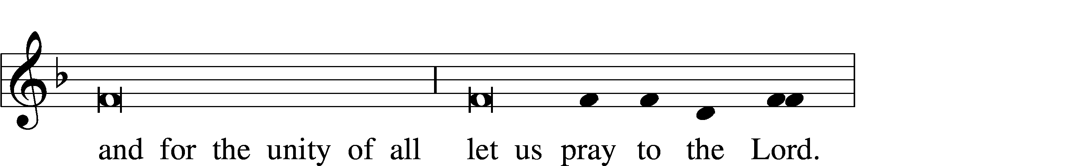

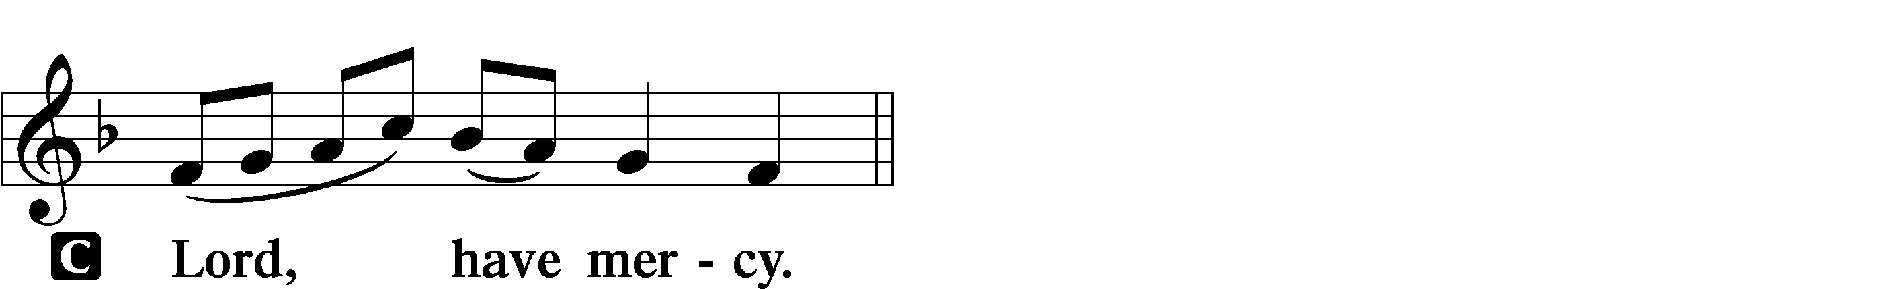

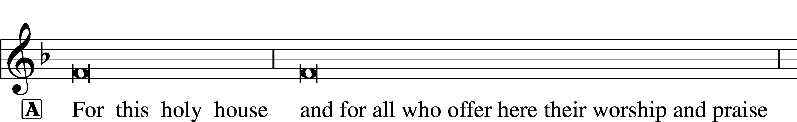



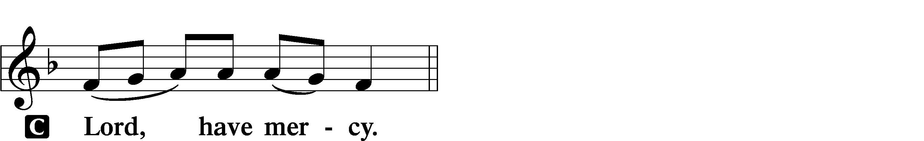

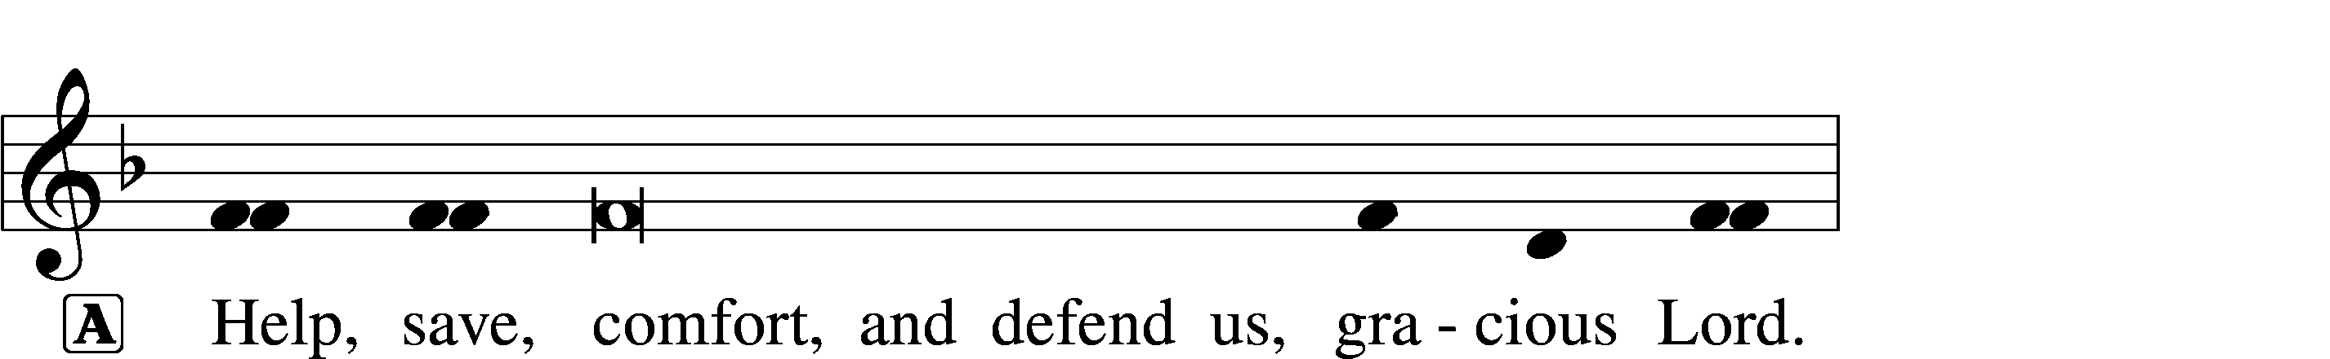



This Is the Feast LSB 155

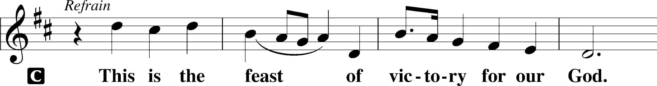

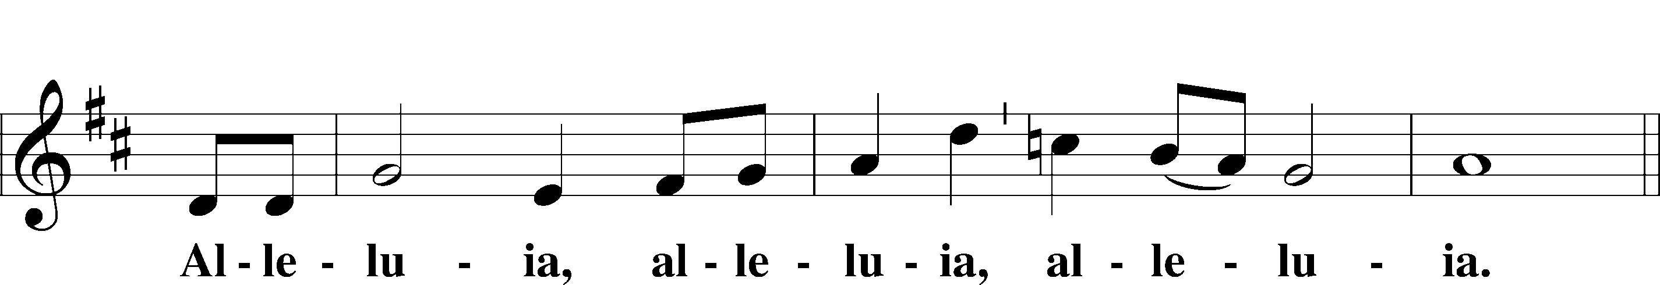

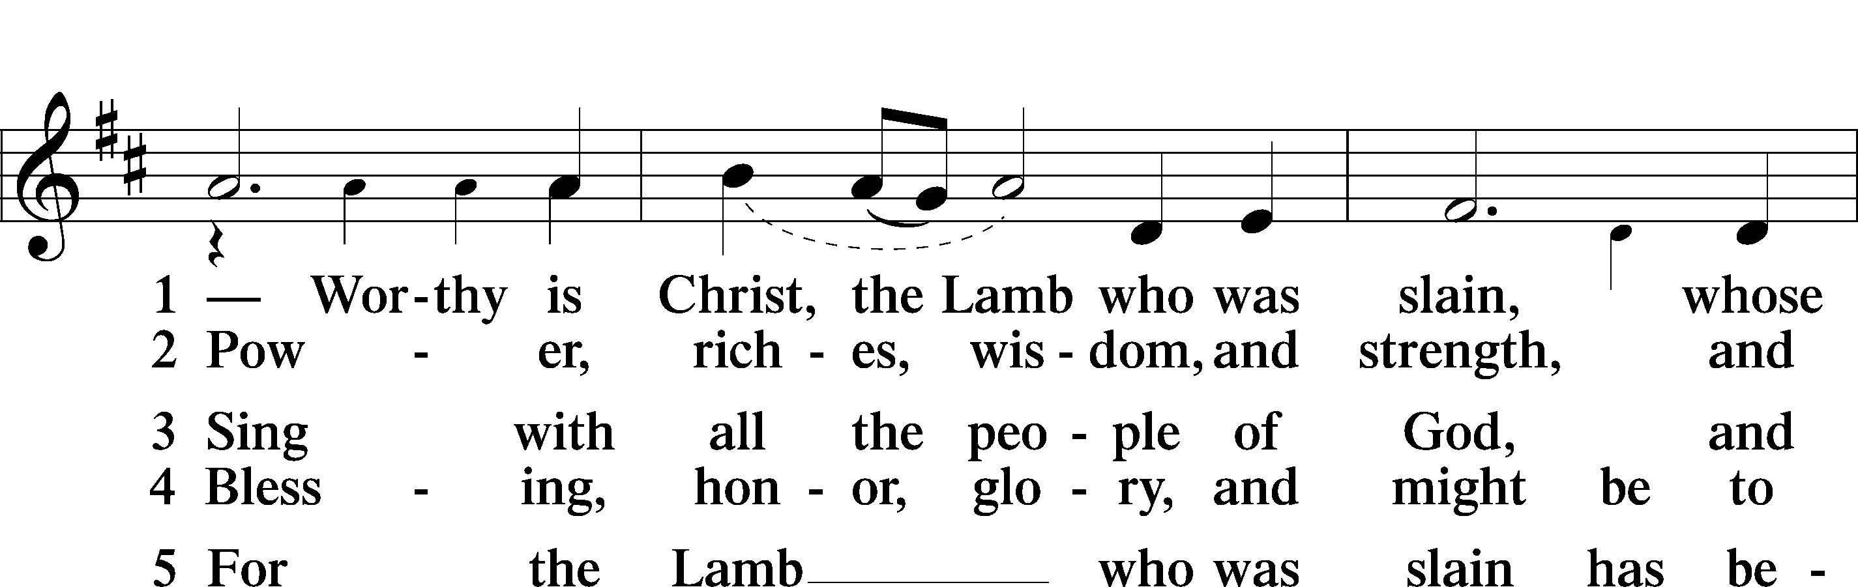

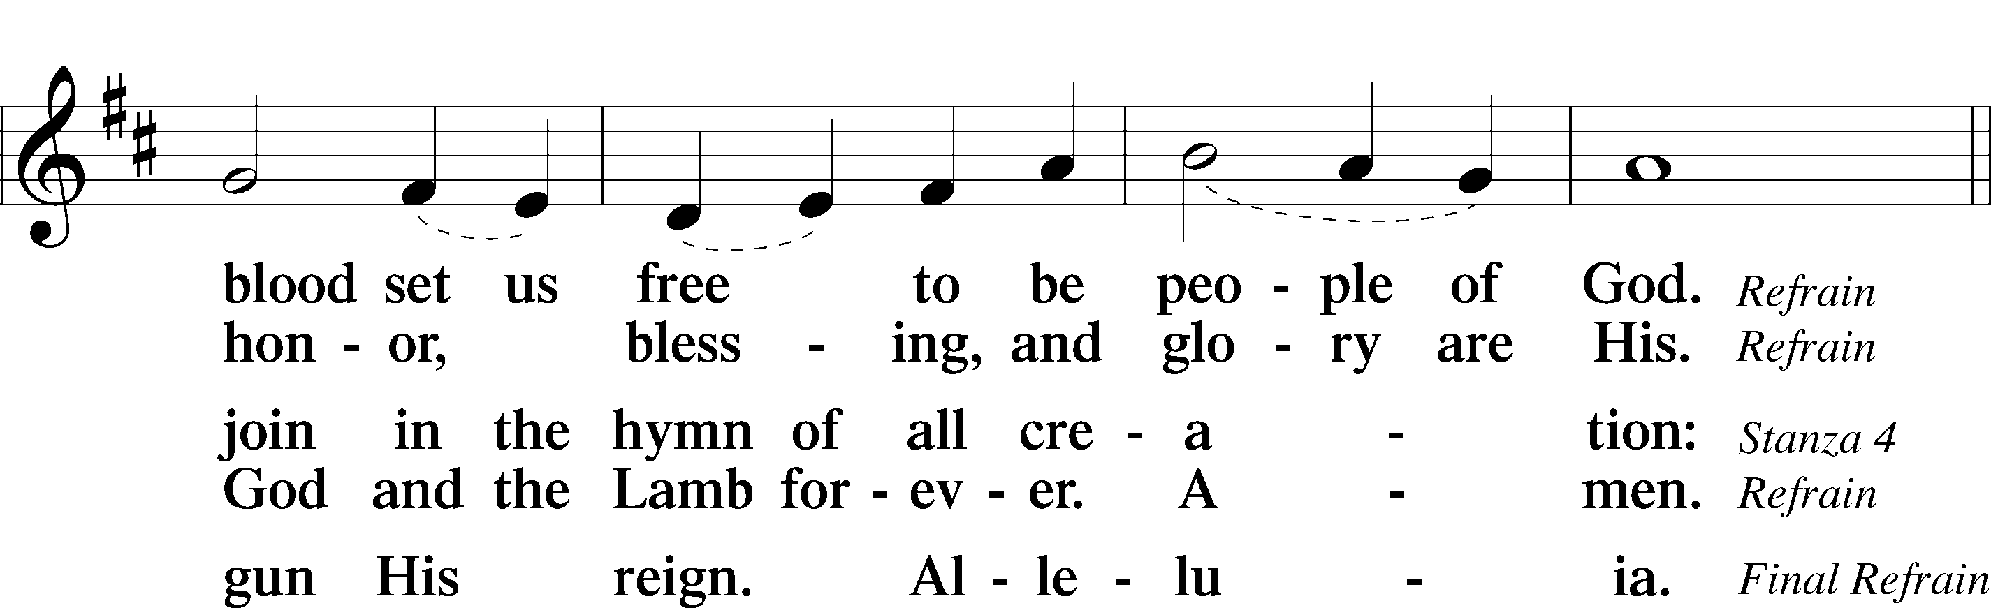

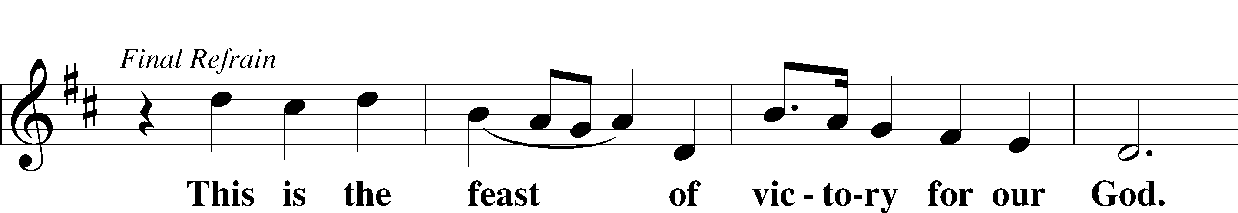

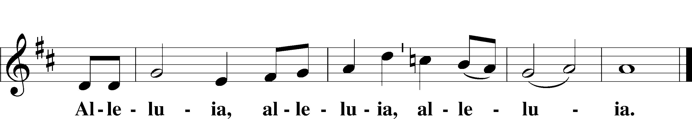

Salutation and Collect of the Day

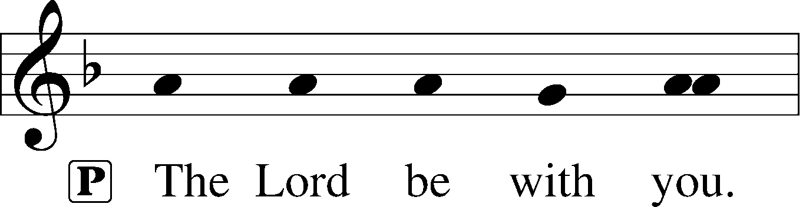

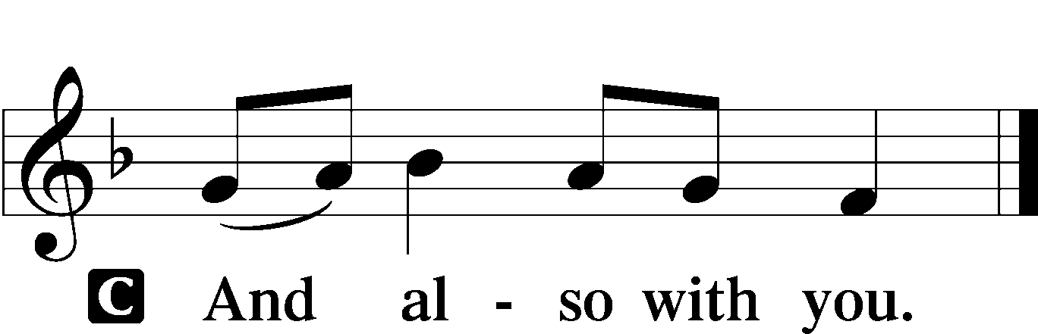

P Let us pray.

O God, from whom all good proceeds, grant to us, Your humble servants, Your holy inspiration, that we may set our minds on the things that are right and, by Your merciful guiding, accomplish them; through Jesus Christ, Your Son, our Lord, who lives and reigns with You and the Holy Spirit, one God, now and forever.

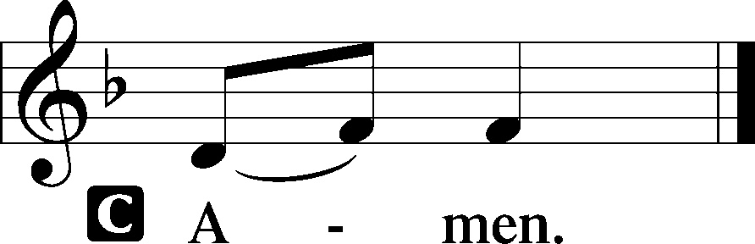

Old Testament Reading Ezekiel 33:7–9

7“So you, son of man, I have made a watchman for the house of Israel. Whenever you hear a word from my mouth, you shall give them warning from me. 8If I say to the wicked, O wicked one, you shall surely die, and you do not speak to warn the wicked to turn from his way, that wicked person shall die in his iniquity, but his blood I will require at your hand. 9But if you warn the wicked to turn from his way, and he does not turn from his way, that person shall die in his iniquity, but you will have delivered your soul.”

A This is the Word of the Lord.

C **Thanks be to God.**

Psalm Psalm 32:1–7

1Blessèd is the one whose transgression is forgiven,  
 **whose sin is covered.**2Blessèd is the man against whom the Lord counts no iniquity,  
 **and in whose spirit there is no deceit.**

3For when I kept silent, my bones wasted away  
 **through my groaning all day long.**4For day and night your hand was heavy upon me;  
 **my strength was dried up as by the heat of summer.**

5I acknowledged my sin to you,  
 **and I did not cover my iniquity;**I said, “I will confess my transgressions to the Lord,”  
 **and you forgave the iniquity of my sin.**

6Therefore let everyone who is godly  
 **offer prayer to you at a time when you may be found;**surely in the rush of great waters,  
 **they shall not reach him.**7You are a hiding place for me;  
 **you preserve me from trouble;  
 you surround me with shouts of deliverance.**

Epistle Romans 13:1–10

1Let every person be subject to the governing authorities. For there is no authority except from God, and those that exist have been instituted by God. 2Therefore whoever resists the authorities resists what God has appointed, and those who resist will incur judgment. 3For rulers are not a terror to good conduct, but to bad. Would you have no fear of the one who is in authority? Then do what is good, and you will receive his approval, 4for he is God’s servant for your good. But if you do wrong, be afraid, for he does not bear the sword in vain. For he is the servant of God, an avenger who carries out God’s wrath on the wrongdoer. 5Therefore one must be in subjection, not only to avoid God’s wrath but also for the sake of conscience. 6For the same reason you also pay taxes, for the authorities are ministers of God, attending to this very thing. 7Pay to all what is owed to them: taxes to whom taxes are owed, revenue to whom revenue is owed, respect to whom respect is owed, honor to whom honor is owed.

8Owe no one anything, except to love each other, for the one who loves another has fulfilled the law. 9The commandments, “You shall not commit adultery, You shall not murder, You shall not steal, You shall not covet,” and any other commandment, are summed up in this word: “You shall love your neighbor as yourself.” 10Love does no wrong to a neighbor; therefore love is the fulfilling of the law.

A This is the Word of the Lord.

C **Thanks be to God.**

Alleluia and Verse LSB 156

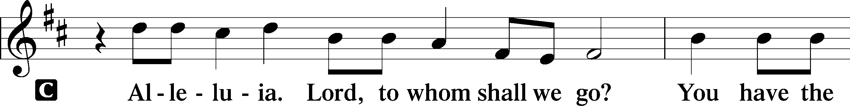

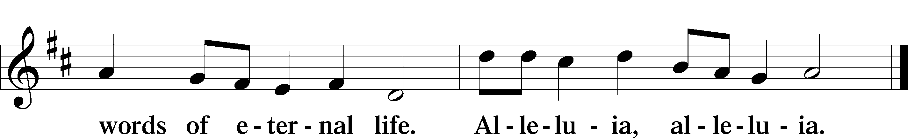

Holy Gospel Matthew 18:1–20

P The Holy Gospel according to St. Matthew, the 18th chapter.

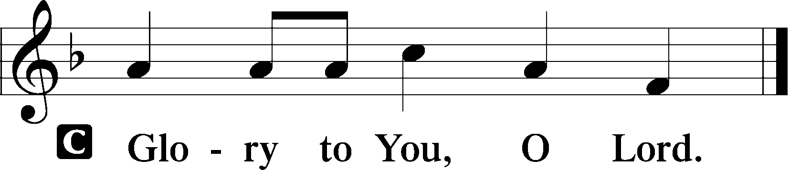

1At that time the disciples came to Jesus, saying, “Who is the greatest in the kingdom of heaven?” 2And calling to him a child, he put him in the midst of them 3and said, “Truly, I say to you, unless you turn and become like children, you will never enter the kingdom of heaven. 4Whoever humbles himself like this child is the greatest in the kingdom of heaven.

5“Whoever receives one such child in my name receives me, 6but whoever causes one of these little ones who believe in me to sin, it would be better for him to have a great millstone fastened around his neck and to be drowned in the depth of the sea.

7“Woe to the world for temptations to sin! For it is necessary that temptations come, but woe to the one by whom the temptation comes! 8And if your hand or your foot causes you to sin, cut it off and throw it away. It is better for you to enter life crippled or lame than with two hands or two feet to be thrown into the eternal fire. 9And if your eye causes you to sin, tear it out and throw it away. It is better for you to enter life with one eye than with two eyes to be thrown into the hell of fire.

10“See that you do not despise one of these little ones. For I tell you that in heaven their angels always see the face of my Father who is in heaven. 11For the Son of Man came to save the lost. 12What do you think? If a man has a hundred sheep and one of them has gone astray, does he not leave the ninety-nine on the mountains and go in search of the one that went astray? 13And if he finds it, truly, I say to you, he rejoices over it more than over the ninety-nine that never went astray. 14So it is not the will of my Father who is in heaven that one of these little ones should perish.

15“If your brother sins against you, go and tell him his fault, between you and him alone. If he listens to you, you have gained your brother. 16But if he does not listen, take one or two others along with you, that every charge may be established by the evidence of two or three witnesses. 17If he refuses to listen to them, tell it to the church. And if he refuses to listen even to the church, let him be to you as a Gentile and a tax collector. 18Truly, I say to you, whatever you bind on earth shall be bound in heaven, and whatever you loose on earth shall be loosed in heaven. 19Again I say to you, if two of you agree on earth about anything they ask, it will be done for them by my Father in heaven. 20For where two or three are gathered in my name, there am I among them.”

P This is the Gospel of the Lord.

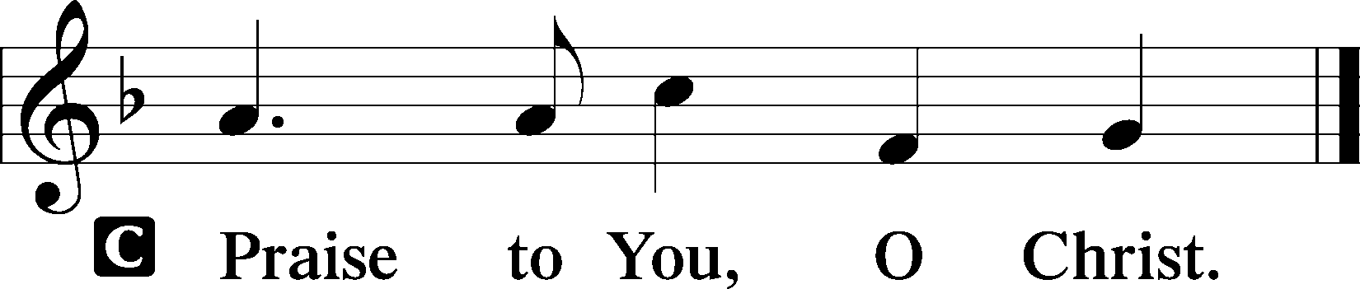

Children’s Message

614 “As Surely as I Live,” God Said

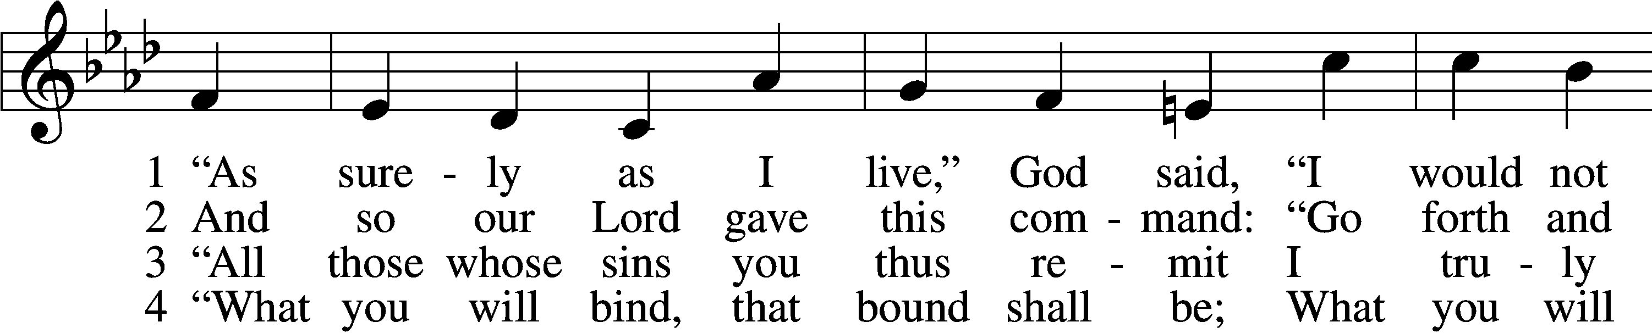

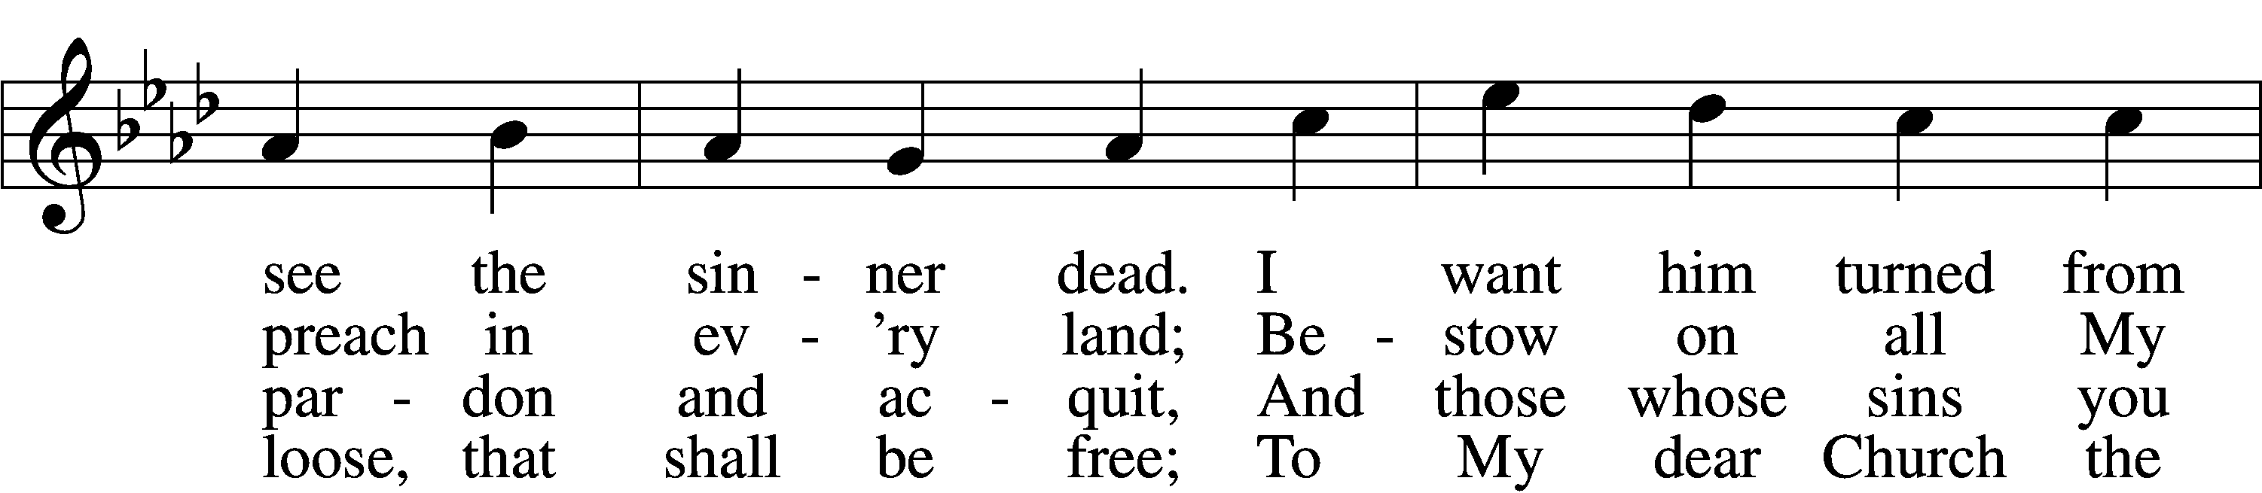

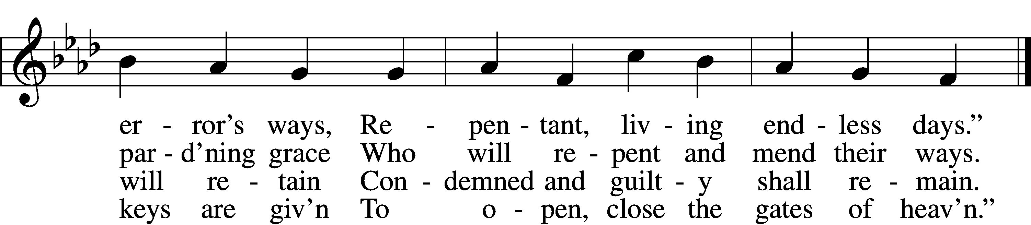

D 8 Praise God the Father and the Son  
And Holy Spirit, Three in One,  
As was, is now, and so shall be  
World without end, eternally!

Text and tune: Public domain

Sermon “Repent and Believe”

Nicene Creed

C **I believe in one God,**

**the Father Almighty,**

**maker of heaven and earth**

**and of all things visible and invisible.**

**And in one Lord Jesus Christ,**

**the only-begotten Son of God,**

**begotten of His Father before all worlds,**

**God of God, Light of Light,**

**very God of very God,**

**begotten, not made,**

**being of one substance with the Father,**

**by whom all things were made;**

**who for us men and for our salvation came down from heaven**

**and was incarnate by the Holy Spirit of the virgin Mary**

**and was made man;**

**and was crucified also for us under Pontius Pilate.**

**He suffered and was buried.**

**And the third day He rose again according to the Scriptures**

**and ascended into heaven**

**and sits at the right hand of the Father.**

**And He will come again with glory to judge both the living and the dead,**

**whose kingdom will have no end.**

**And I believe in the Holy Spirit,**

**the Lord and giver of life,**

**who proceeds from the Father and the Son,**

**who with the Father and the Son together is worshiped and glorified,**

**who spoke by the prophets.**

**And I believe in one holy Christian and apostolic Church,**

**I acknowledge one Baptism for the remission of sins,**

**and I look for the resurrection of the dead**

**and the life** T **of the world to come. Amen.**

Offertory LSB 159

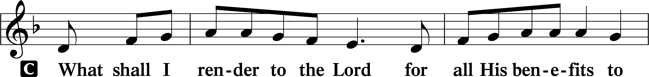

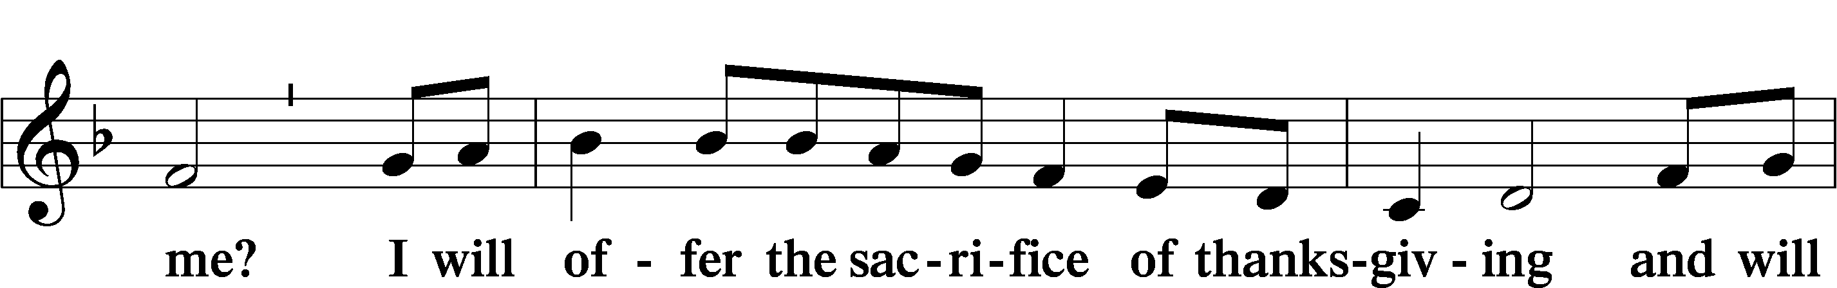

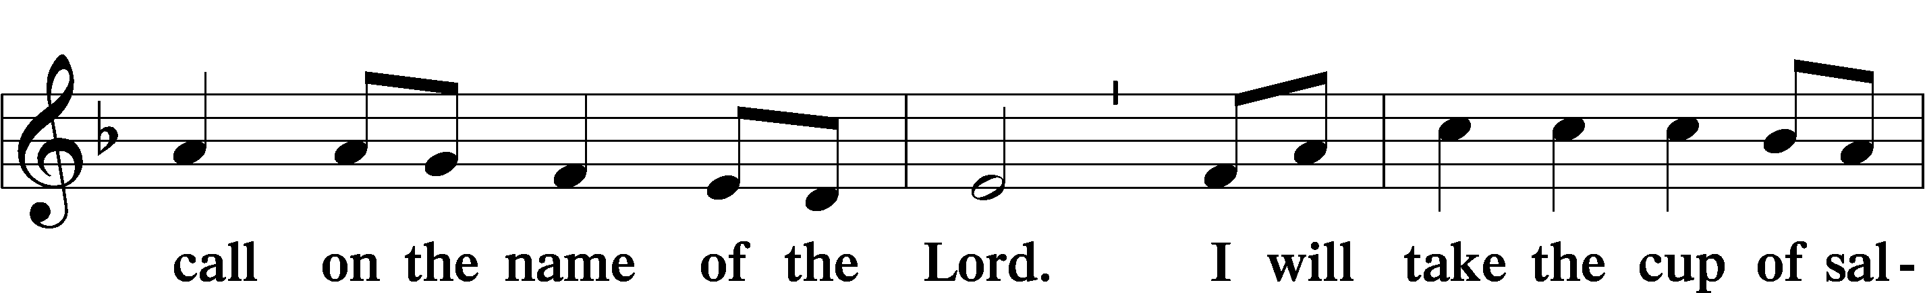

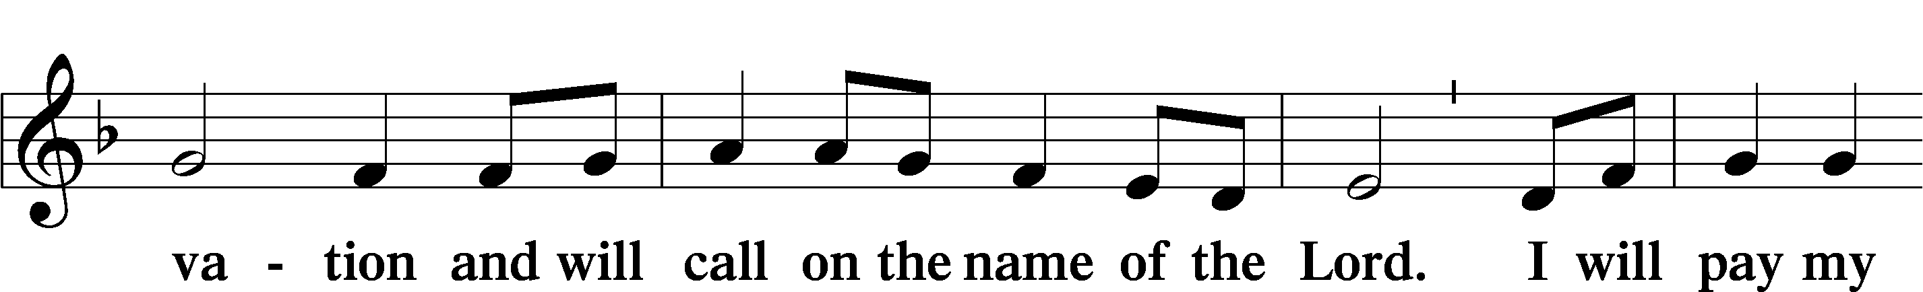

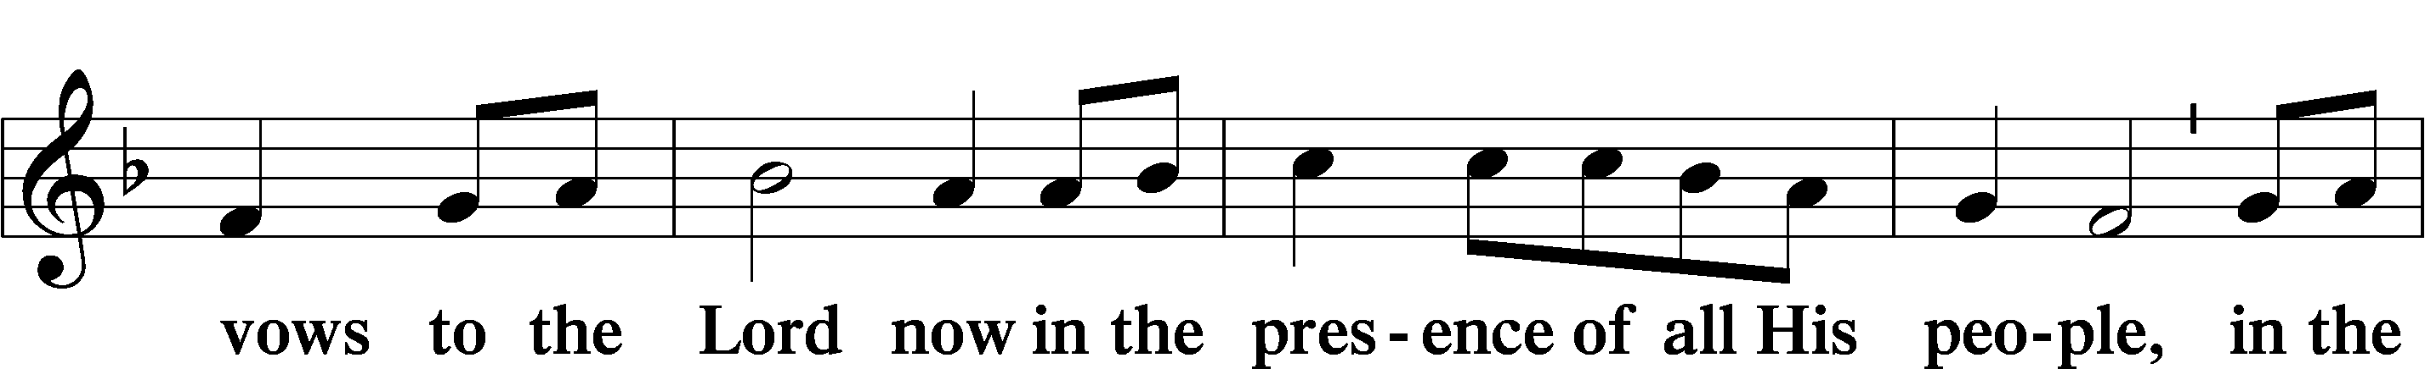

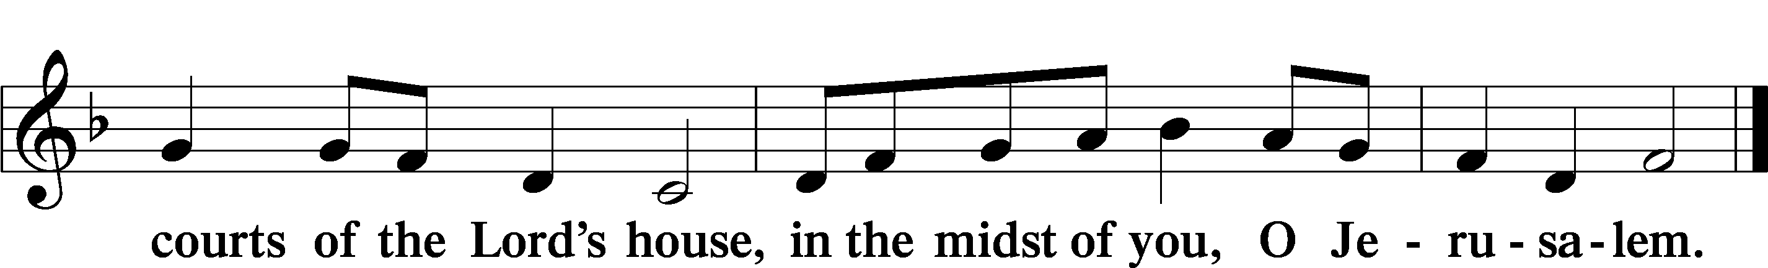

# Service of the Sacrament

Preface LSB 160

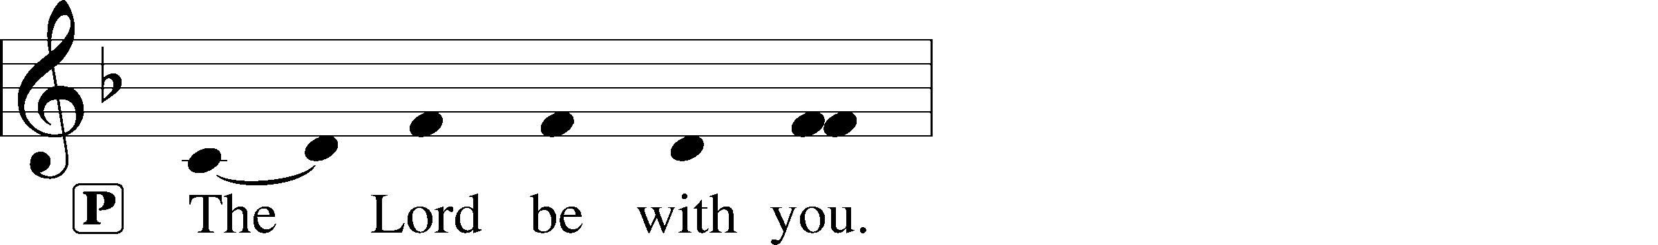

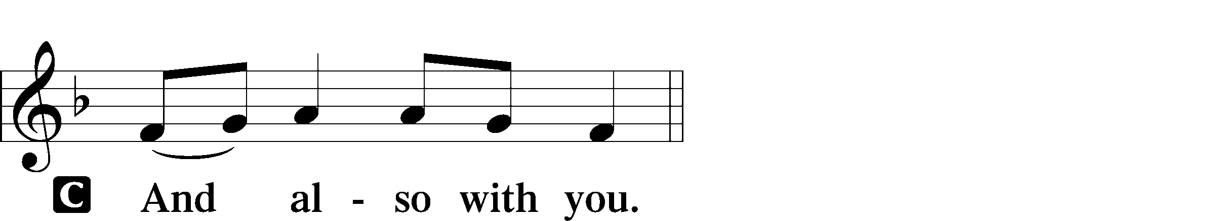

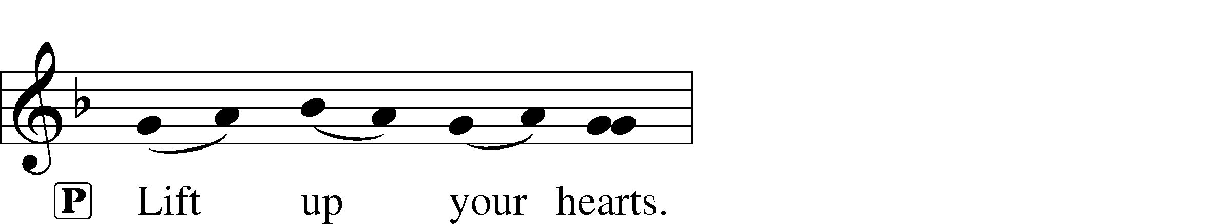



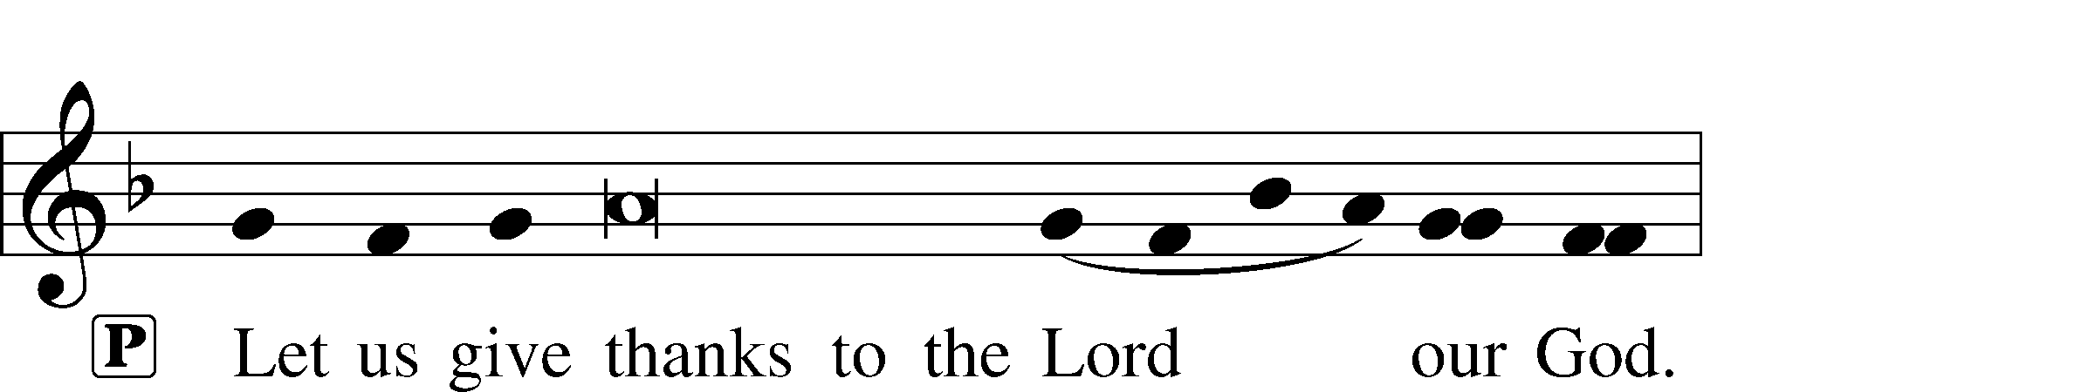

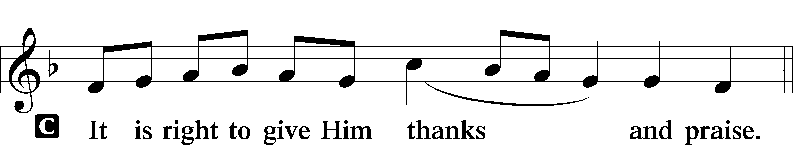

P It is truly good, right, and salutary that we should at all times and in all places give thanks to You, holy Lord, almighty Father, everlasting God, through Jesus Christ, our Lord. Therefore with angels and archangels and with all the company of heaven we laud and magnify Your glorious name, evermore praising You and saying:

Sanctus LSB 161

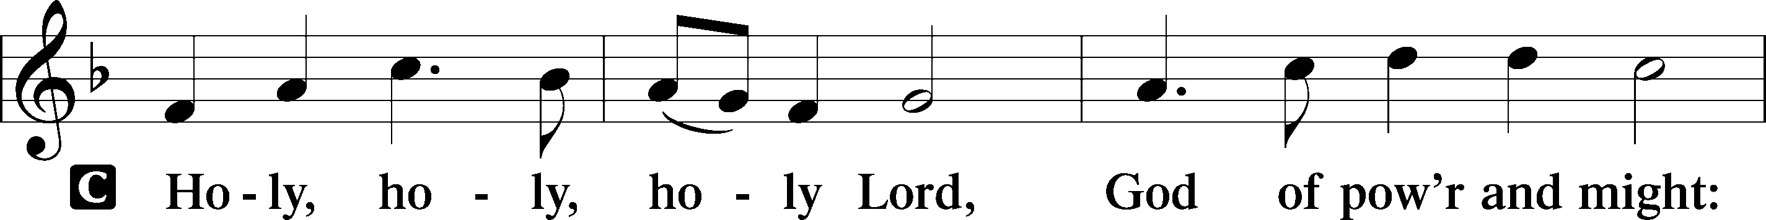

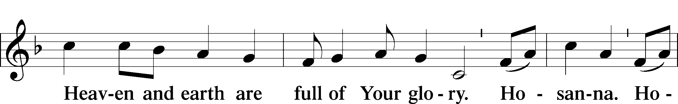

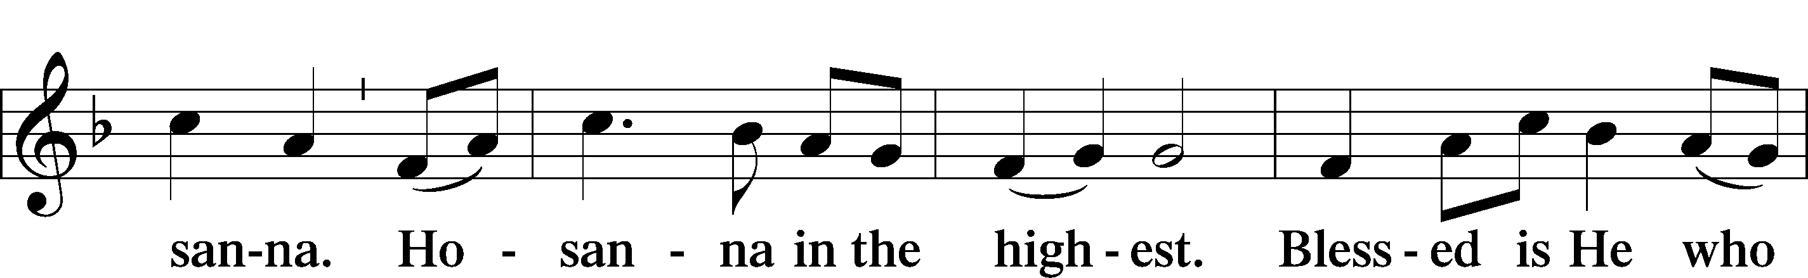

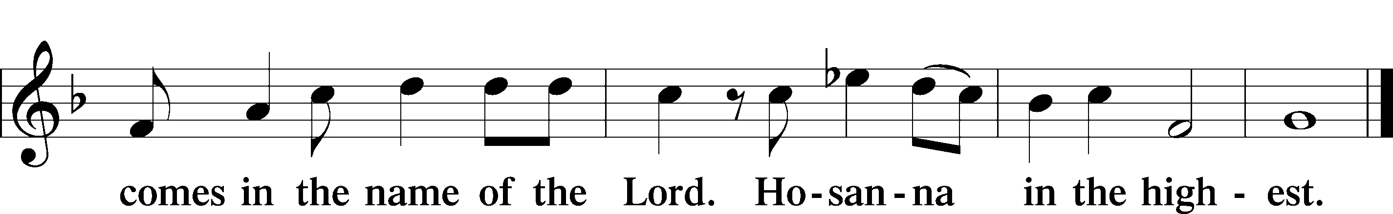

The Words of Our Lord

P Our Lord Jesus Christ, on the night when He was betrayed, took bread, and when He had given thanks, He broke it and gave it to the disciples and said: “Take, eat; this is My T body, which is given for you. This do in remembrance of Me.”

In the same way also He took the cup after supper, and when He had given thanks, He gave it to them, saying: “Drink of it, all of you; this cup is the new testament in My T blood, which is shed for you for the forgiveness of sins. This do, as often as you drink it, in remembrance of Me.”

P As often as we eat this bread and drink this cup, we proclaim the Lord’s death until He comes.

C **Amen. Come, Lord Jesus.**

P O Lord Jesus Christ, only Son of the Father, in giving us Your body and blood to eat and to drink, You lead us to remember and confess Your holy cross and passion, Your blessed death, Your rest in the tomb, Your resurrection from the dead, Your ascension into heaven, and Your coming for the final judgment. So remember us in Your kingdom and teach us to pray:

Lord’s Prayer

C **Our Father who art in heaven,**

**hallowed be Thy name,**

**Thy kingdom come,**

**Thy will be done on earth**

**as it is in heaven;**

**give us this day our daily bread;**

**and forgive us our trespasses**

**as we forgive those**

**who trespass against us;**

**and lead us not into temptation,**

**but deliver us from evil.**

**For Thine is the kingdom**

**and the power and the glory**

**forever and ever. Amen.**

Pax Domini LSB 163

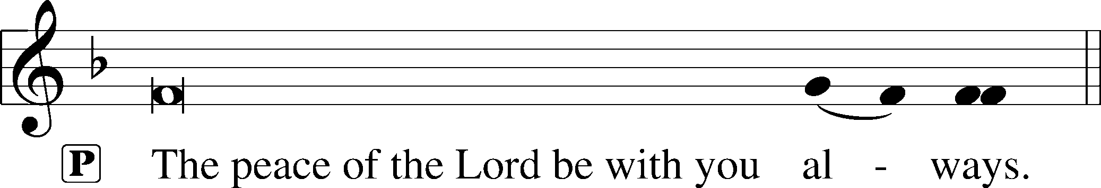



Agnus Dei LSB 163

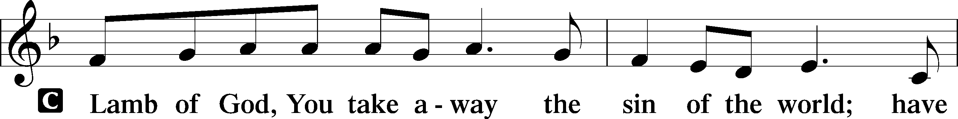

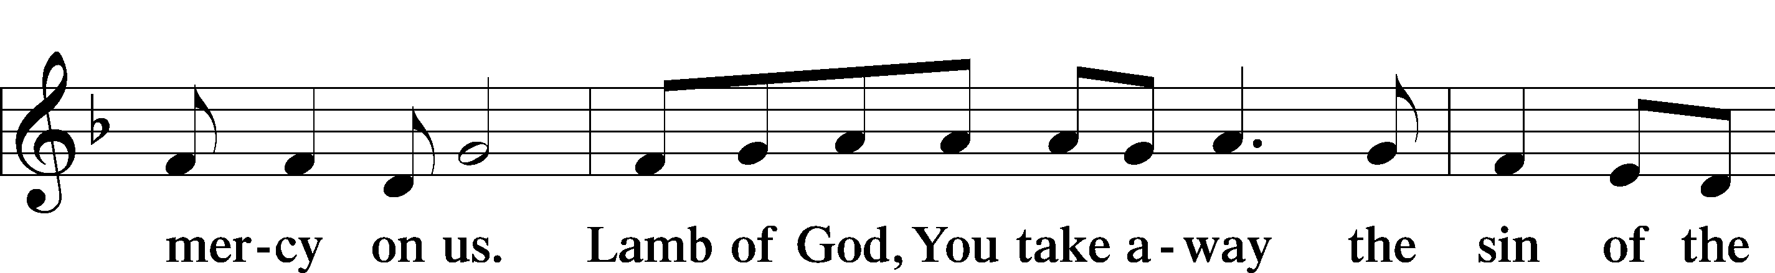

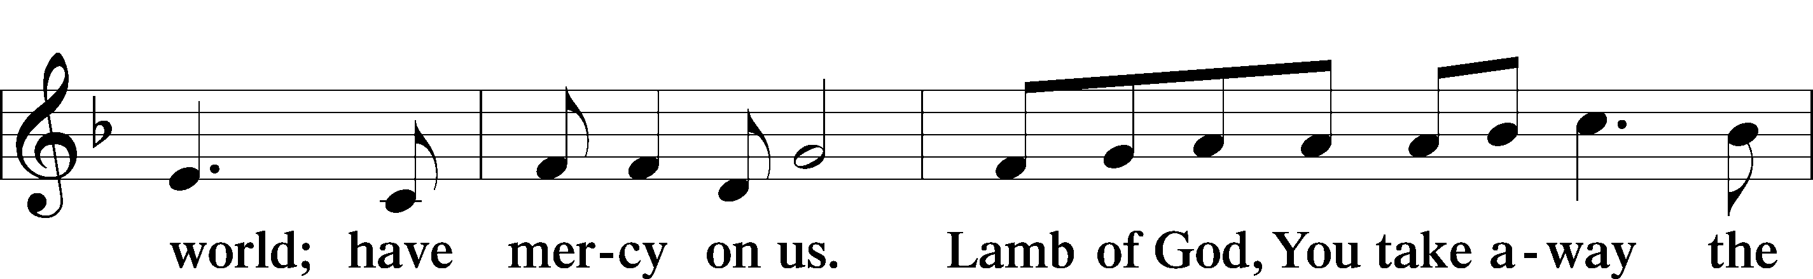

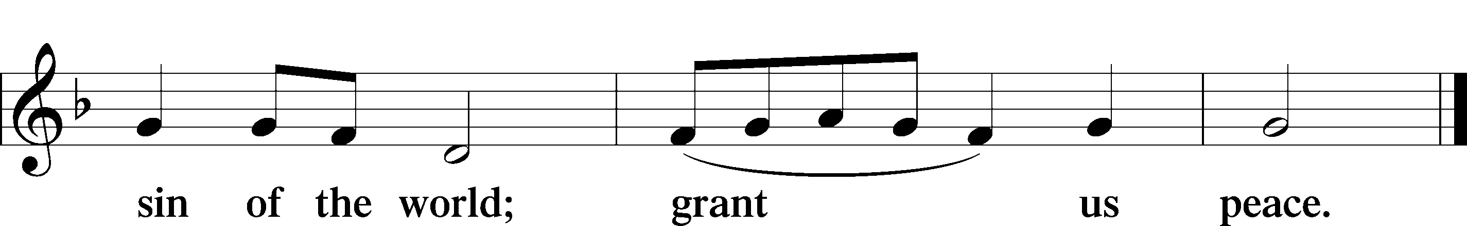

Distribution

622 Lord Jesus Christ, You Have Prepared

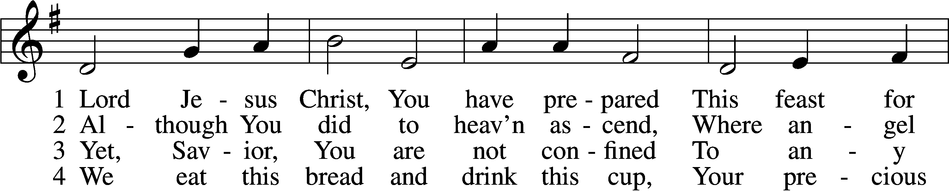

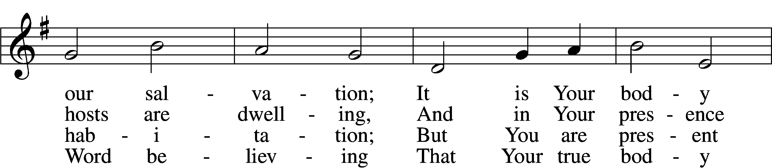

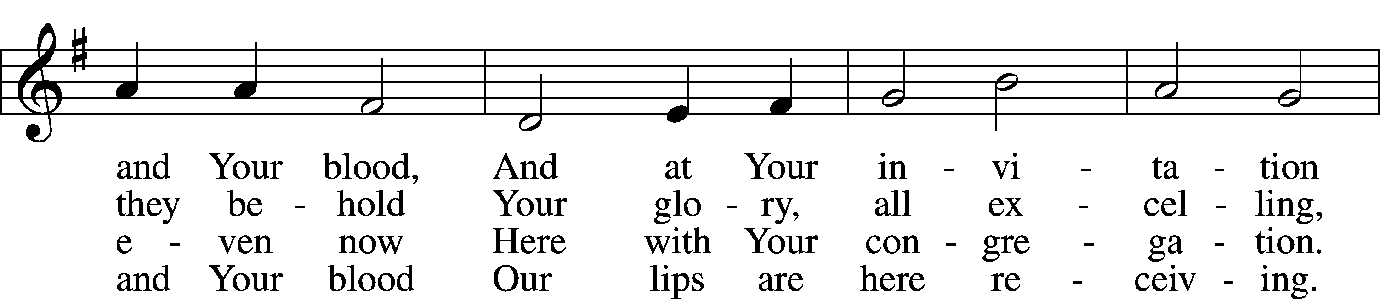

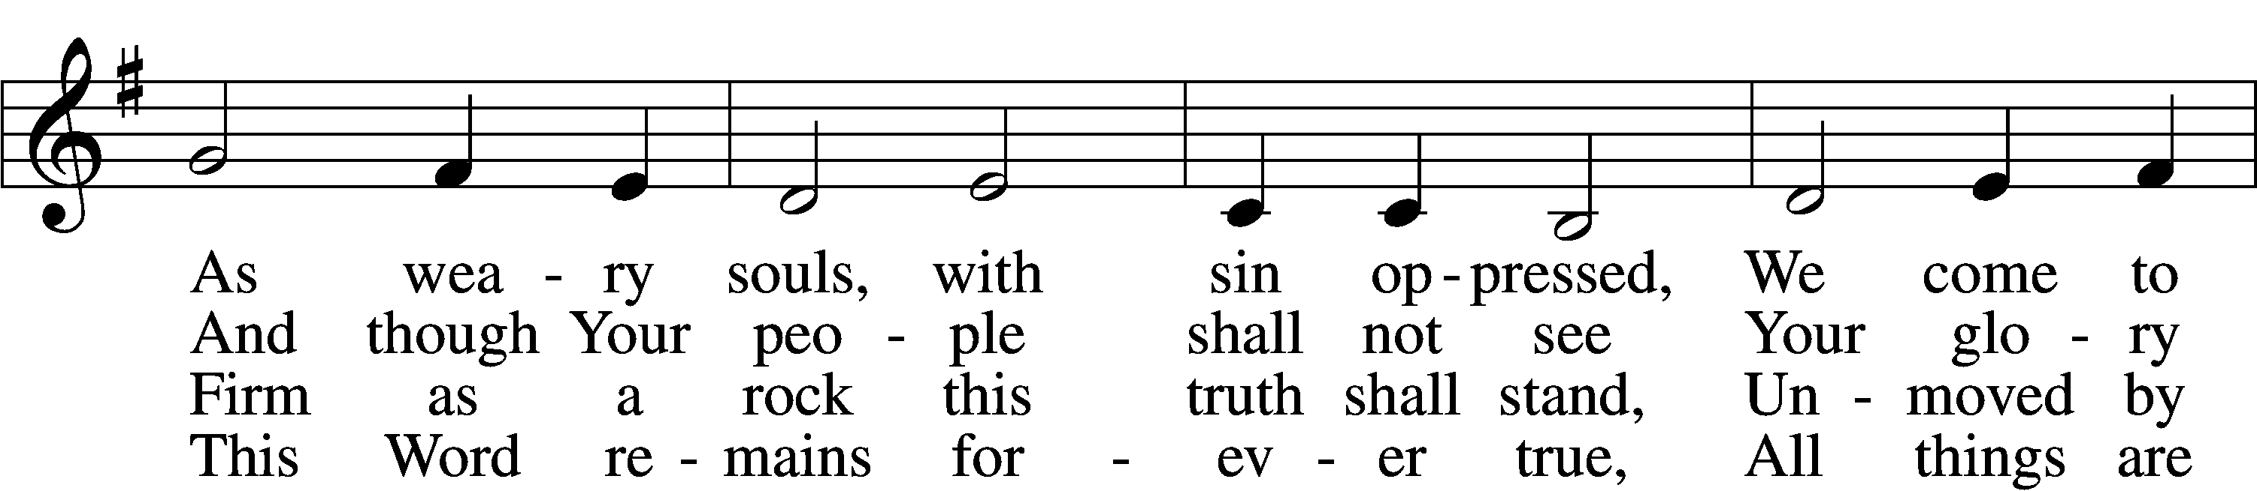

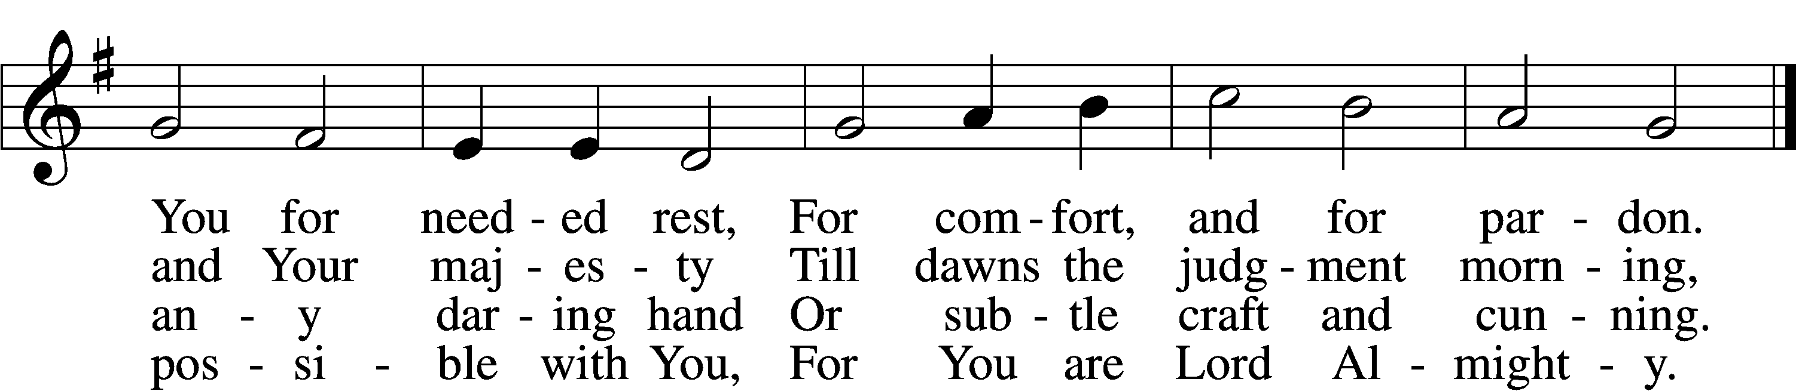

7 Grant that we worthily receive  
 Your supper, Lord, our Savior,  
And, truly grieving for our sins,  
 May prove by our behavior  
That we are thankful for Your grace  
And day by day may run our race,  
 In holiness increasing.

8 For Your consoling supper, Lord,  
 Be praised throughout all ages!  
Preserve it, for in ev’ry place  
 The world against it rages.  
Grant that this sacrament may be  
A blessèd comfort unto me  
 When living and when dying.

Tune and text: Public domain

Thank the Lord LSB 164

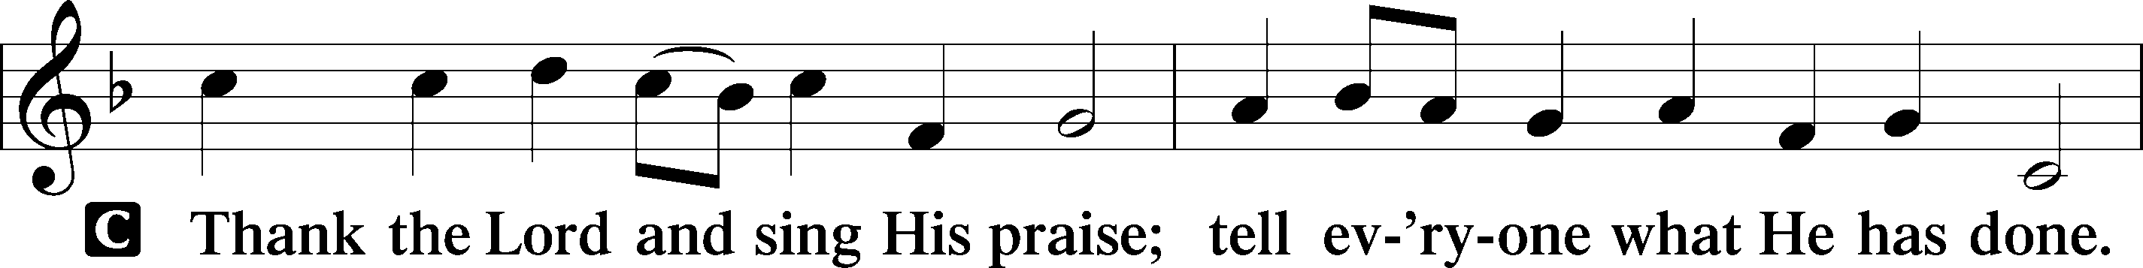

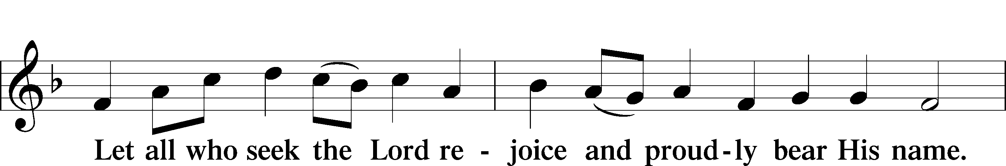

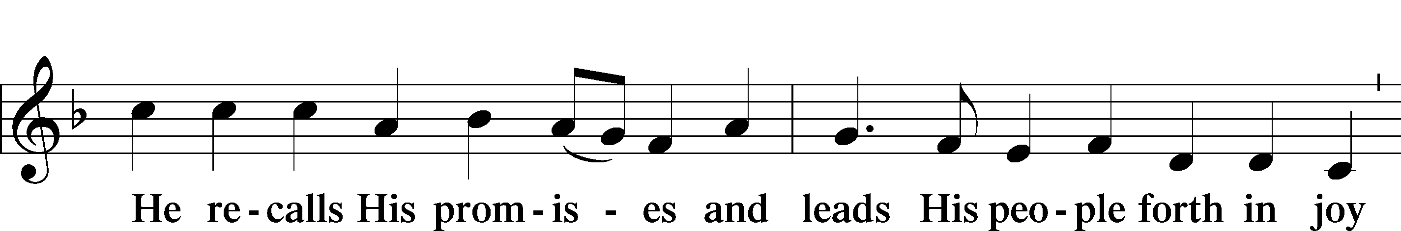

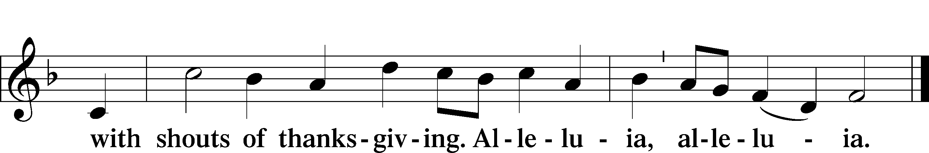

Post-Communion Collect

A Let us pray.

Gracious God, our heavenly Father, You have given us a foretaste of the feast to come in the Holy Supper of Your Son’s body and blood. Keep us firm in the true faith throughout our days of pilgrimage that, on the day of His coming, we may, together with all Your saints, celebrate the marriage feast of the Lamb in His kingdom which has no end; through Jesus Christ, Your Son, our Lord, who lives and reigns with You and the Holy Spirit, one God, now and forever.

C **Amen.**

Benediction LSB 166

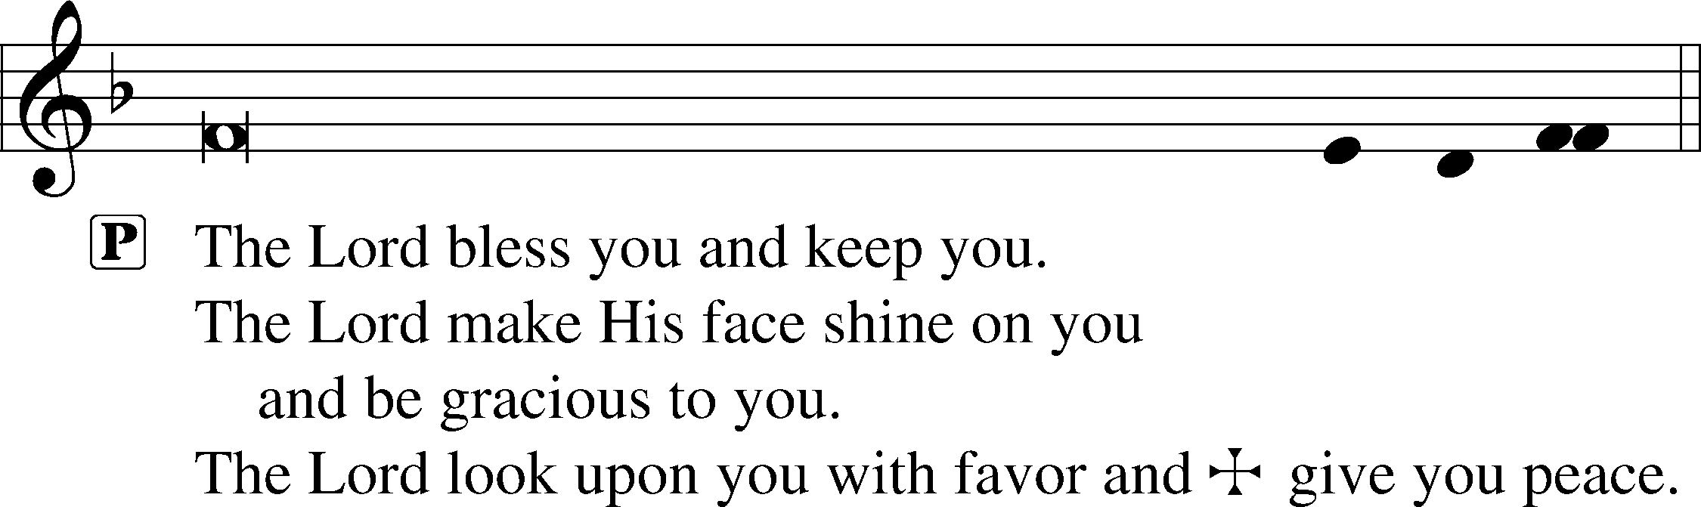



920 Forth in the Peace of Christ We Go

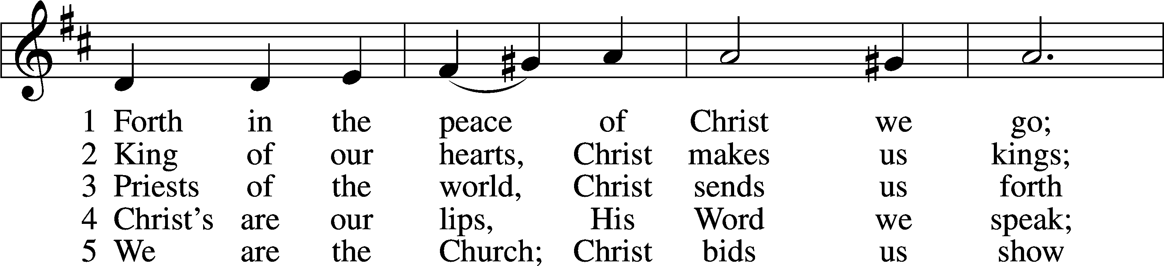

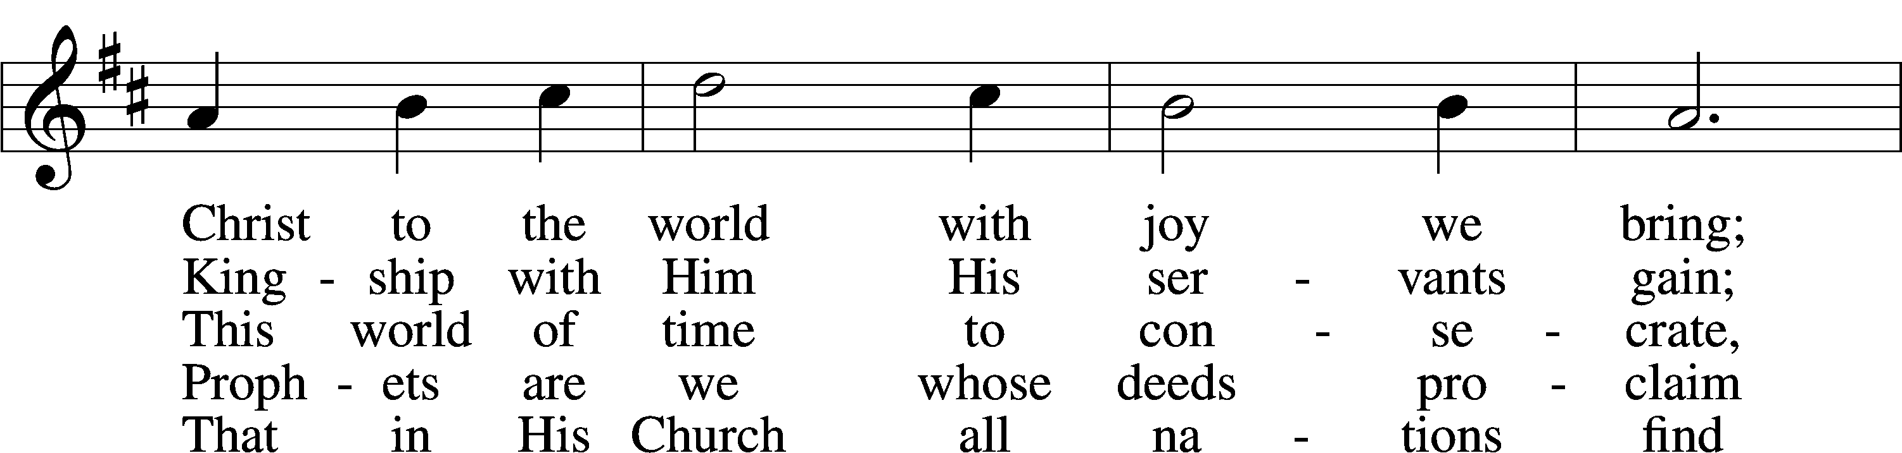

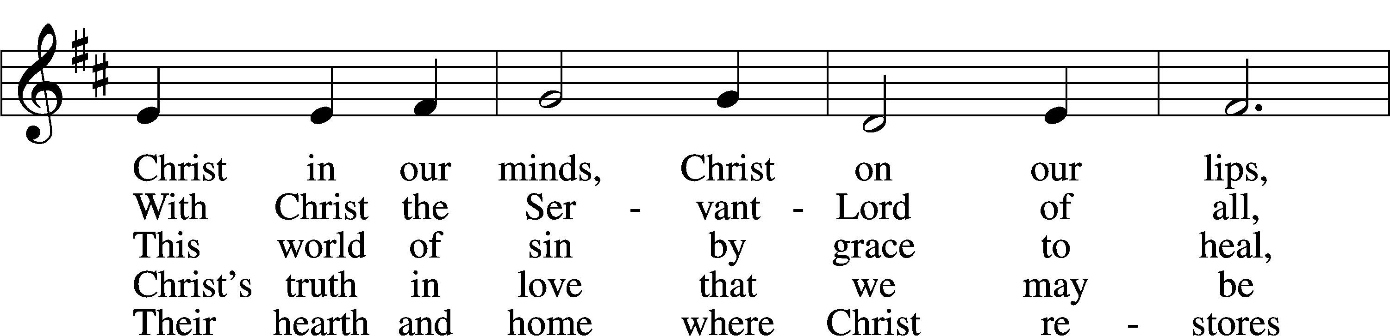

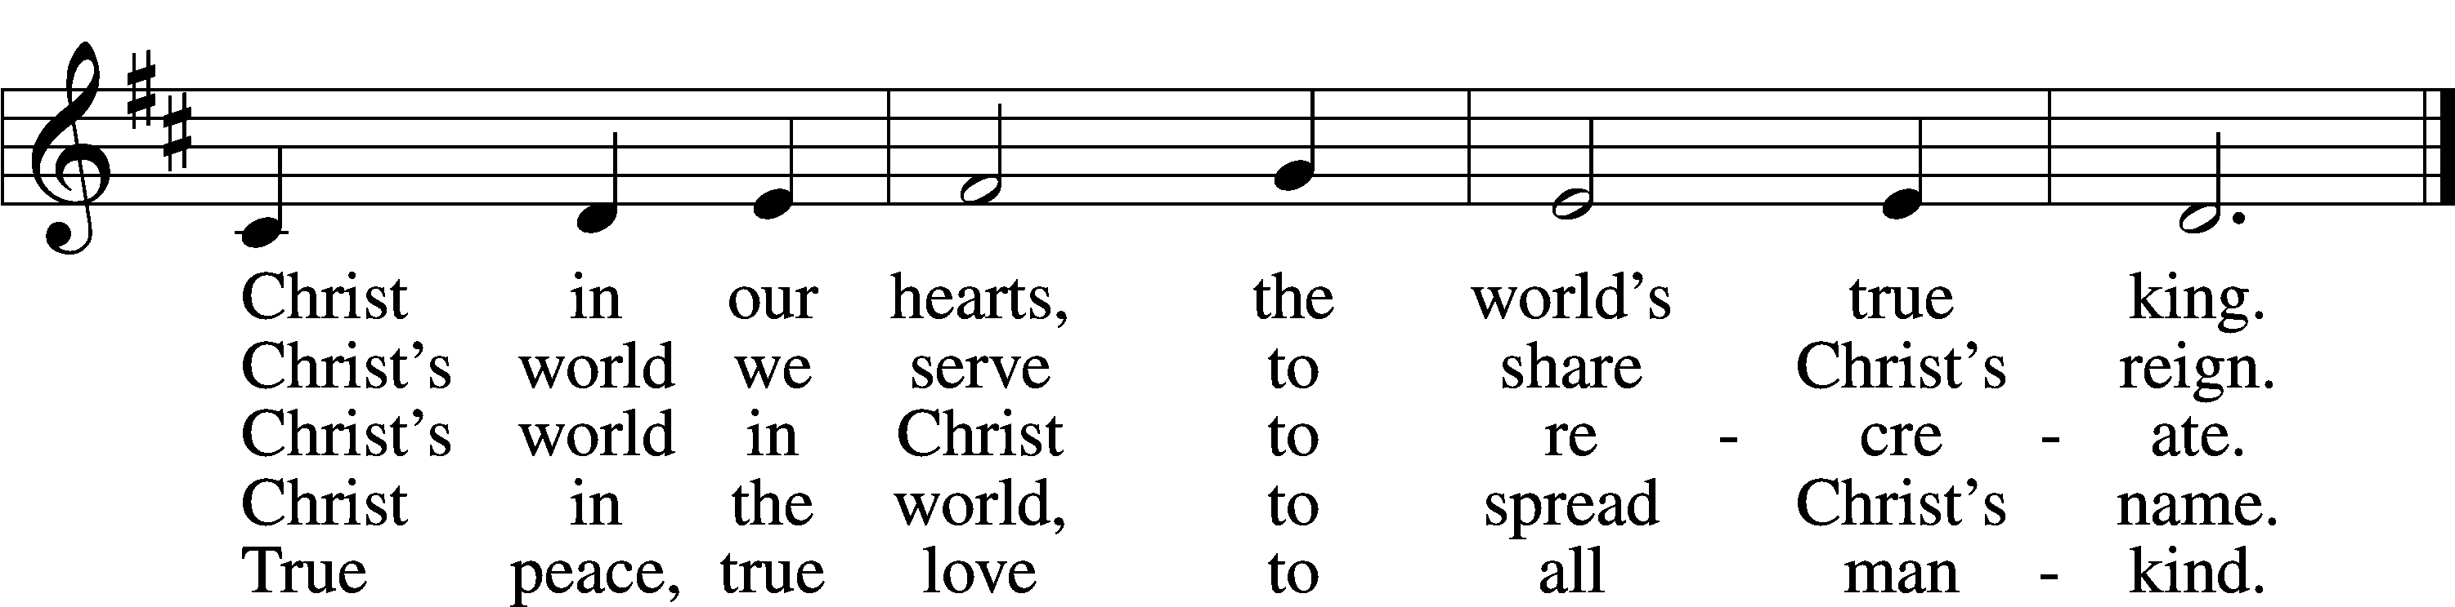

Text: © 1969, 1987 OCP Publications. Used by permission: LSB Hymn License no. 110005047

Tune: Public domain

Acknowledgments

Divine Service, Setting One from Lutheran Service Book

Unless otherwise indicated, Scripture quotations are from the ESV® Bible (The Holy Bible, English Standard Version®), copyright © 2001 by Crossway, a publishing ministry of Good News Publishers. Used by permission. All rights reserved.

Created by Lutheran Service Builder © 2018 Concordia Publishing House.

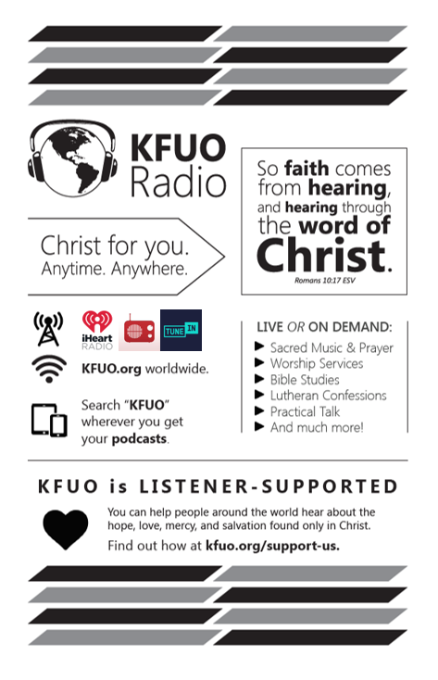**Gifts of Time and Treasure**

**“Do not store up for yourselves treasures on earth..,”, “but store up for yourselves treasures in heaven…”**

**Matthew 6:19-20**

**LAST WEEK’S OFFERINGS**  **LAST WEEK’S ATTENDANCE**

General Fund $ 1,593.16 Service 28

Needed Weekly $ 3,963.38 Communed 26

Adult Bible Study $ 4.00

**The Lord’s Week**

Today 9:00 am – Adult Bible Study

**(Sept. 6th)** 10:00 am – Divine Service

Tuesday 9:00 am – MDO starts

Next Sunday 9:00 am – Adult Bible Study

**(Sept. 13th)** 10:00 am – Divine Service

**In His Service**

Elder: Tom Griffith

Ushers: Noe Lopez & John Larson

Acolytes: Coco & Collin Utley

Organist: Stephen Brynestad