Fifth Sunday after the Epiphany
Divine Service, Setting Four
“Run the Gospel Race”
1 Corinthians 9:16-27

February 7, 2021

Messiah Lutheran Church
Lutheran Church-Missouri Synod
4102 Trinity River Dr., Corpus Christi, Texas 78410

Pastor: Rev. Scott E. Herbert

Church Phone: 361-387-7748 Email: mlc@stx.rr.com
Church Fax: 361-767-1768 Website: www.messiahlcms-cc.org
Pastor Phone: 469-693-9683 Pastor Email: chirev59@gmail.com

WELCOME TO MESSIAH!
We are glad you are here to receive what God is doing for you during Divine Service. Please sign our Guest Book located near the front door. Feel free to converse quietly until the organ prelude begins. If you are looking for a church home, please talk to the Pastor at the door. We would love to have you join us.

Preparing for Service
The Son of God, Christ Jesus, Makes Us a New Creation

The Lord alone “is the everlasting God, the Creator of the ends of the earth” (Is. 40:28). He “sits above the circle of the earth” and “stretches out the heavens like a curtain” (Is. 40:22). Yet, His almighty power is demonstrated chiefly by His mercy and compassion. “He gives power to the faint, and to him who has no might he increases strength” (Is. 40:29). The only begotten Son of the Father, the very Word by whom all things were made, becomes flesh and takes all the poverty and weakness of our sin and death upon Himself, bearing it in His body to the cross. As He dies for us there, He also raises us up, a new creation, in His resurrection from the dead. Thus, by the preaching of this Word, He heals “many who were sick with various diseases,” and He casts out “many demons” (Mark 1:34, 39). And His preaching continues through those whom He has sent, who are “entrusted with a stewardship” to “preach the gospel” (1 Cor. 9:16–17). Thus, we are set free by the Word of Christ, and we exercise our freedom in loving service to others.
Confession and Absolution
795 Voices Raised to You We Offer
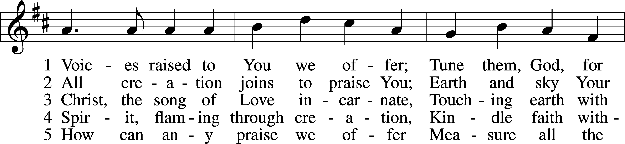
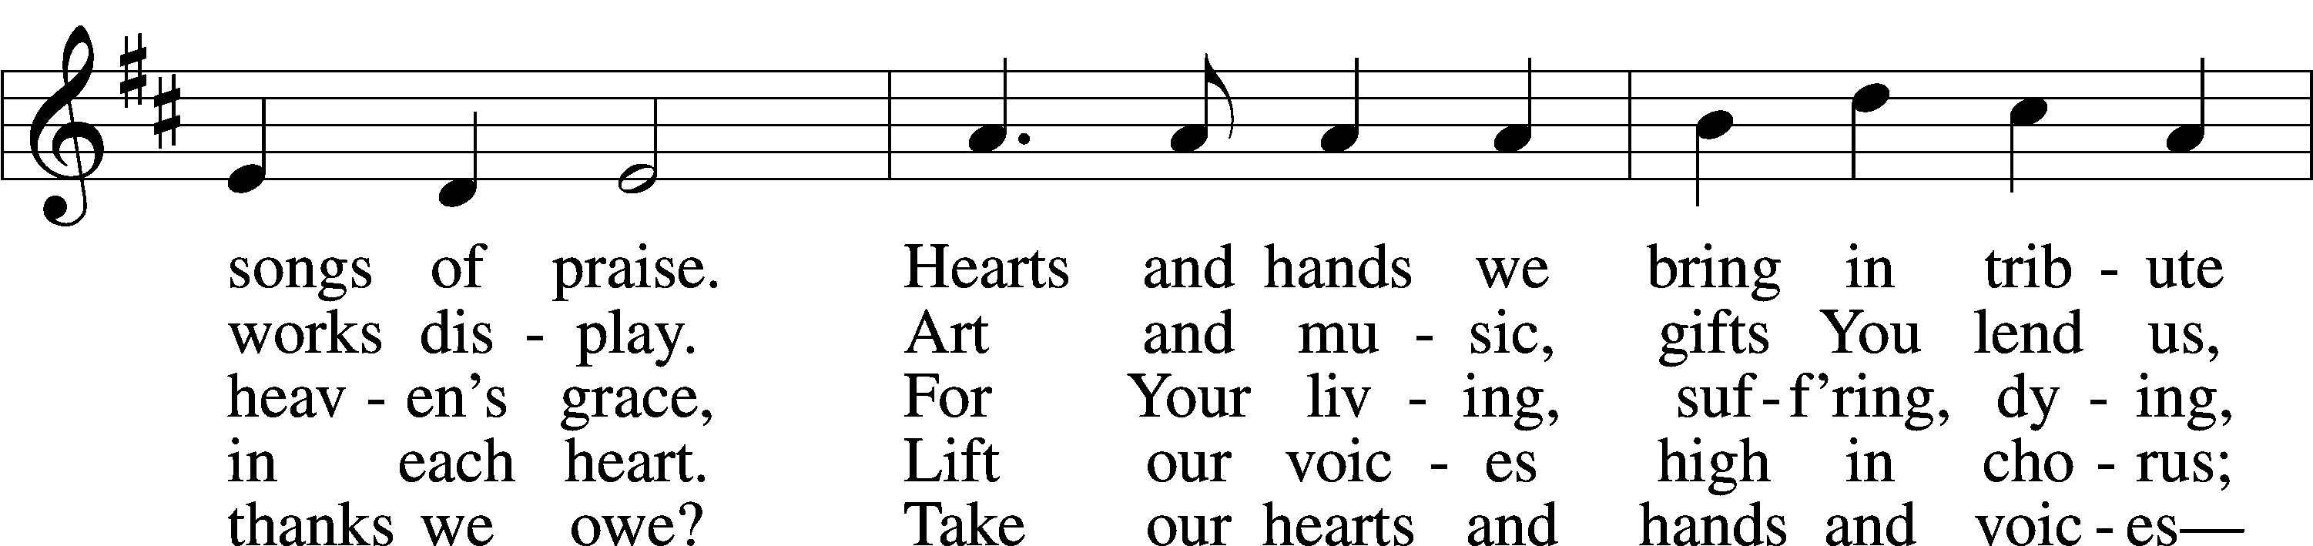
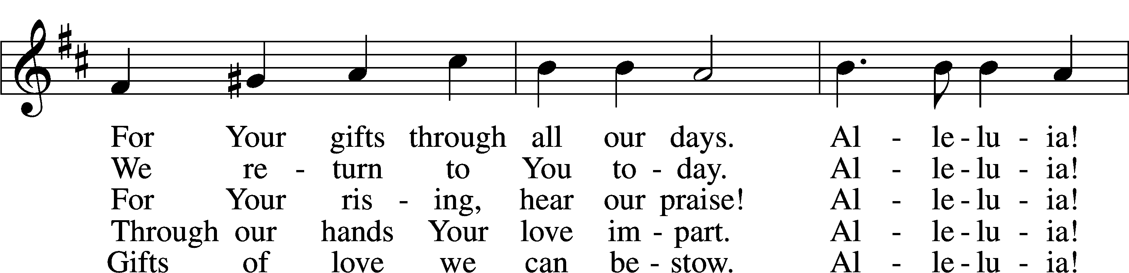
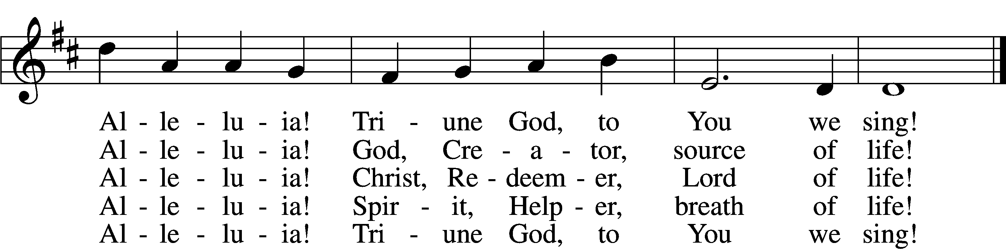
Tune: © 1996 Carolyn Jennings. Used by permission: LSB Hymn License no. 110005047
Text: © 1997 GIA Publications, Inc. Used by permission: LSB Hymn License no. 110005047

P In the name of the Father and of the T Son and of the Holy Spirit.
C Amen.

P Our help is in the name of the Lord,
C who made heaven and earth.

P If You, O Lord, kept a record of sins, O Lord, who could stand?
C But with You there is forgiveness; therefore You are feared.

P Since we are gathered to hear God’s Word, call upon Him in prayer and praise, and receive the body and blood of our Lord Jesus Christ in the fellowship of this altar, let us first consider our unworthiness and confess before God and one another that we have sinned in thought, word, and deed, and that we cannot free ourselves from our sinful condition. Together as His people let us take refuge in the infinite mercy of God, our heavenly Father, seeking His grace for the sake of Christ, and saying: God, be merciful to me, a sinner.
C Almighty God, have mercy upon us, forgive us our sins, and lead us to everlasting life. Amen.

P Almighty God, merciful Father, in Holy Baptism You declared us to be Your children and gathered us into Your one, holy Church, in which You daily and richly forgive us our sins and grant us new life through Your Spirit. Be in our midst, enliven our faith, and graciously receive our prayer and praise; through Your Son, Jesus Christ, our Lord.
C Amen.

Service of the Word

Introit Psalm 13:3–5; antiphon: v. 6
I will sing to the Lord,
because he has dealt bountifully with me.
Consider and answer me, O Lord my God;
light up my eyes, lest I sleep the sleep of death,
lest my enemy say, “I have prevailed over him,”
lest my foes rejoice because I am shaken.
But I have trusted in your steadfast love;
my heart shall rejoice in your salvation.
Glory be to the Father and to the Son and to the Holy Spirit;
as it was in the beginning, is now, and will be forever. Amen.
I will sing to the Lord,
because he has dealt bountifully with me.
Kyrie LSB 204
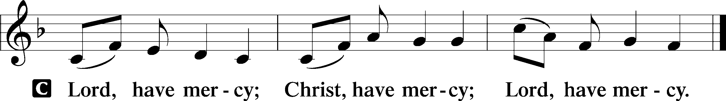

Gloria in Excelsis LSB 204
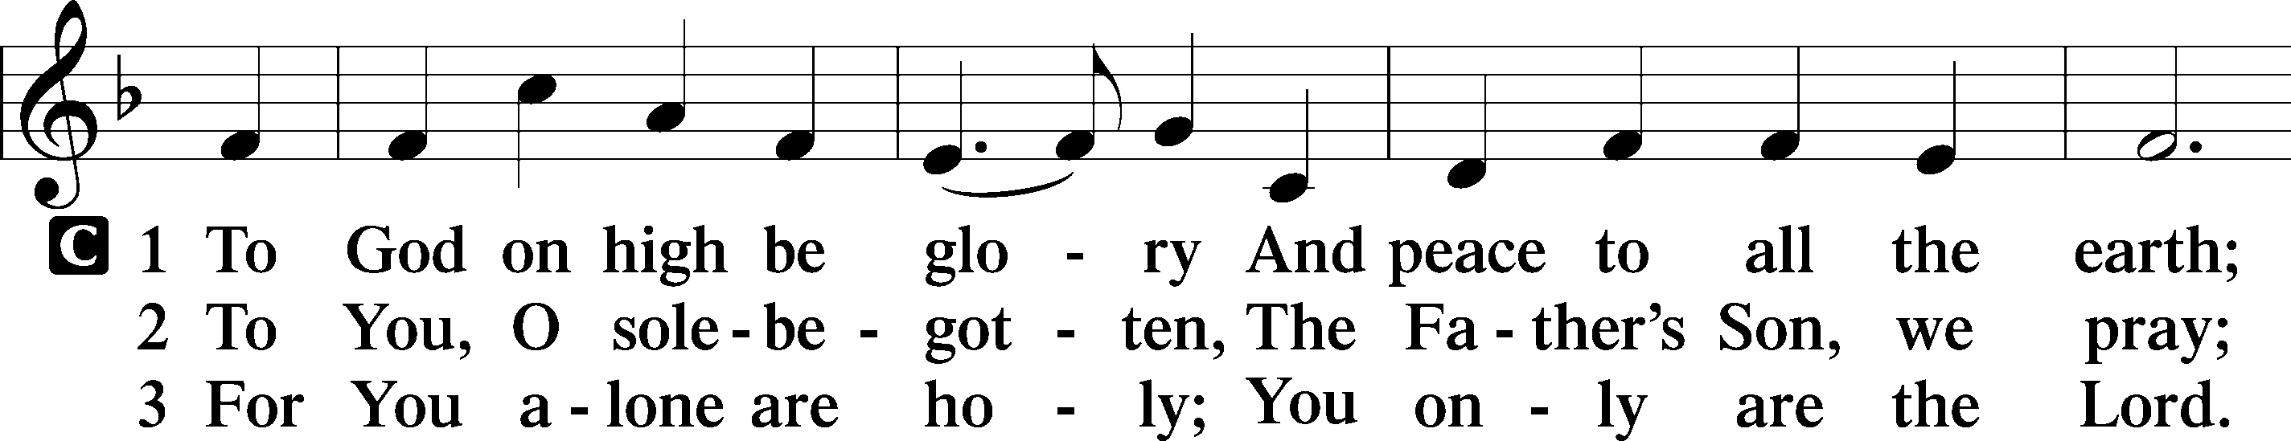
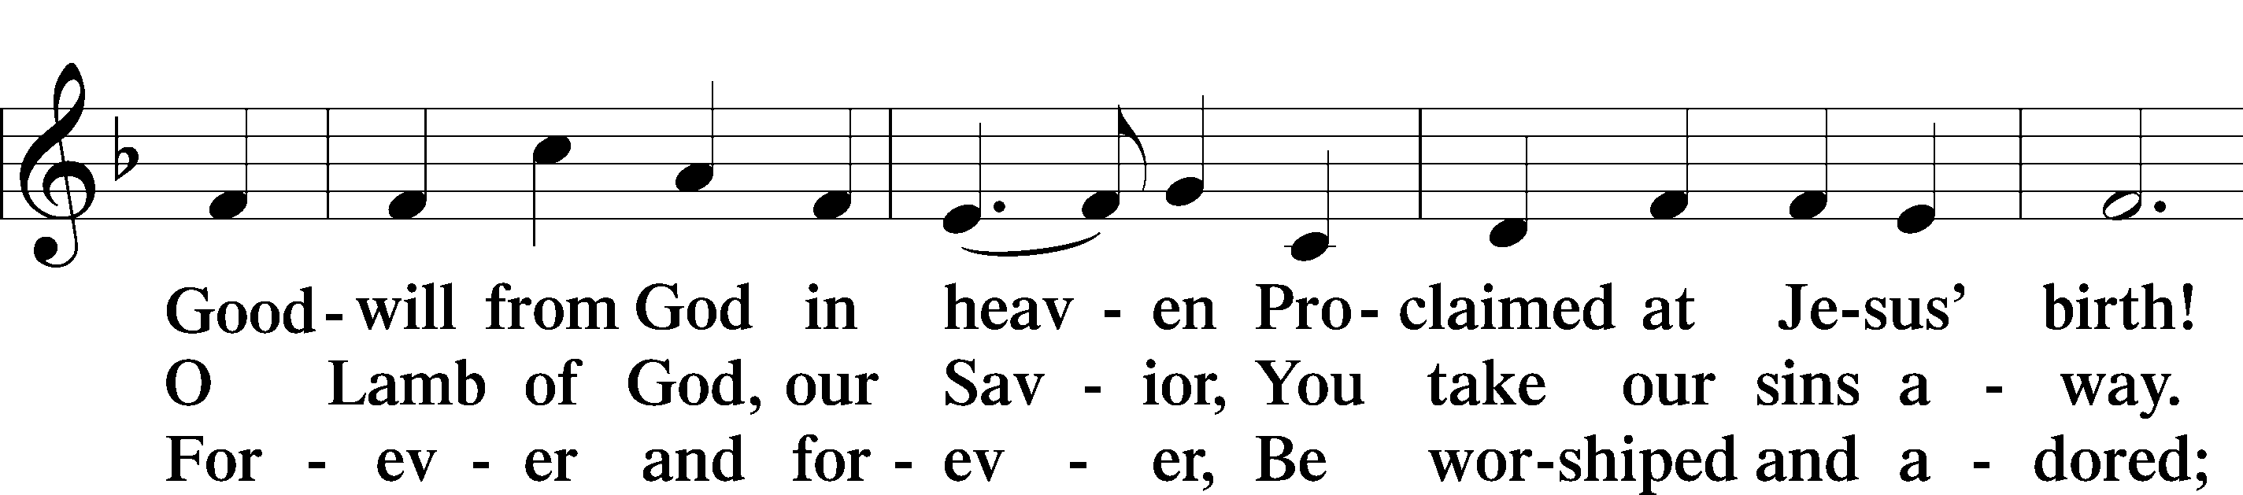
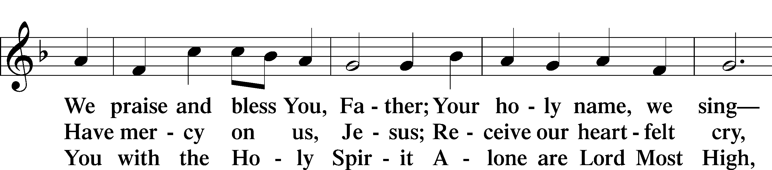
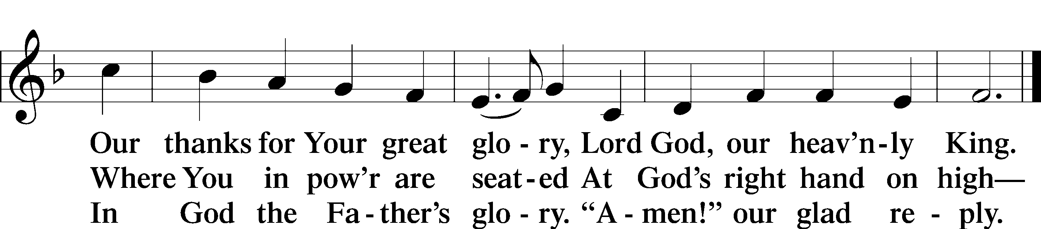

Salutation and Collect of the Day
P The Lord be with you.
C And also with you.

P Let us pray.
O Lord, keep Your family the Church continually in the true faith that, relying on the hope of Your heavenly grace, we may ever be defended by Your mighty power; through Jesus Christ, Your Son, our Lord, who lives and reigns with You and the Holy Spirit, one God, now and forever.
C Amen.
Old Testament Reading Isaiah 40:21–31
21Do you not know? Do you not hear?
Has it not been told you from the beginning?
Have you not understood from the foundations of the earth?
22It is he who sits above the circle of the earth,
and its inhabitants are like grasshoppers;
who stretches out the heavens like a curtain,
and spreads them like a tent to dwell in;
23who brings princes to nothing,
and makes the rulers of the earth as emptiness.
24Scarcely are they planted, scarcely sown,
scarcely has their stem taken root in the earth,
when he blows on them, and they wither,
and the tempest carries them off like stubble.
25To whom then will you compare me,
that I should be like him? says the Holy One.
26Lift up your eyes on high and see:
who created these?
He who brings out their host by number,
calling them all by name,
by the greatness of his might,
and because he is strong in power
not one is missing.
27Why do you say, O Jacob,
and speak, O Israel,
“My way is hidden from the Lord,
and my right is disregarded by my God”?
28Have you not known? Have you not heard?
The Lord is the everlasting God,
the Creator of the ends of the earth.
He does not faint or grow weary;
his understanding is unsearchable.
29He gives power to the faint,
and to him who has no might he increases strength.
30Even youths shall faint and be weary,
and young men shall fall exhausted;
31but they who wait for the Lord shall renew their strength;
they shall mount up with wings like eagles;
they shall run and not be weary;
they shall walk and not faint.

A This is the Word of the Lord.
C Thanks be to God.

Epistle 1 Corinthians 9:16–27
16If I preach the gospel, that gives me no ground for boasting. For necessity is laid upon me. Woe to me if I do not preach the gospel! 17For if I do this of my own will, I have a reward, but not of my own will, I am still entrusted with a stewardship. 18What then is my reward? That in my preaching I may present the gospel free of charge, so as not to make full use of my right in the gospel.
19For though I am free from all, I have made myself a servant to all, that I might win more of them. 20To the Jews I became as a Jew, in order to win Jews. To those under the law I became as one under the law (though not being myself under the law) that I might win those under the law. 21To those outside the law I became as one outside the law (not being outside the law of God but under the law of Christ) that I might win those outside the law. 22To the weak I became weak, that I might win the weak. I have become all things to all people, that by all means I might save some. 23I do it all for the sake of the gospel, that I may share with them in its blessings.
24Do you not know that in a race all the runners compete, but only one receives the prize? So run that you may obtain it. 25Every athlete exercises self-control in all things. They do it to receive a perishable wreath, but we an imperishable. 26So I do not run aimlessly; I do not box as one beating the air. 27But I discipline my body and keep it under control, lest after preaching to others I myself should be disqualified.

A This is the Word of the Lord.
C Thanks be to God.
Alleluia and Verse

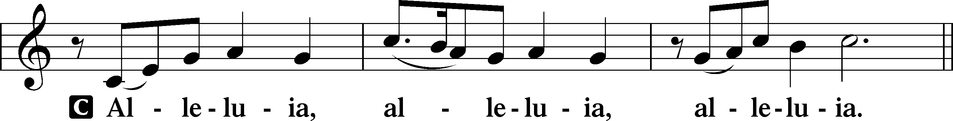

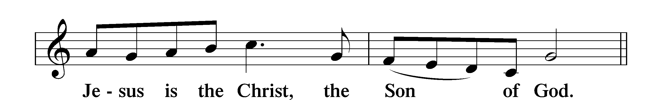

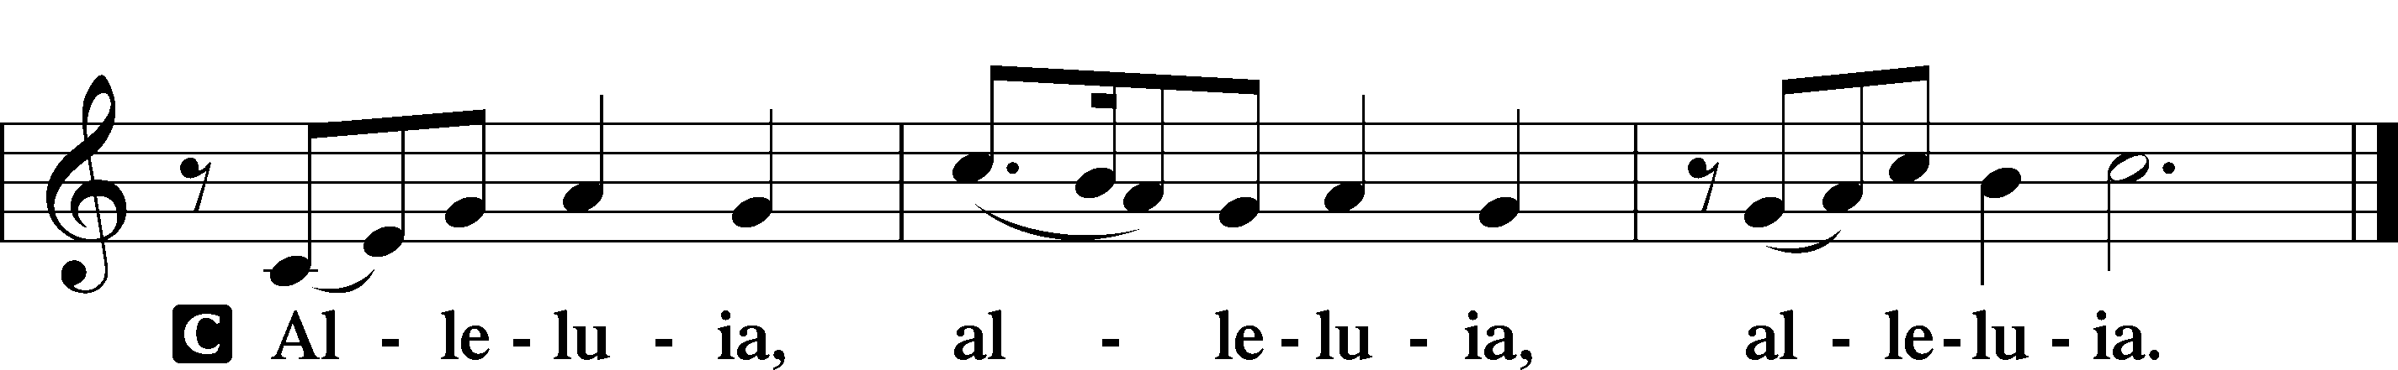

Holy Gospel Mark 1:29–39
P The Holy Gospel according to St. Mark, the first chapter.
C Glory to You, O Lord.

29Immediately [Jesus] left the synagogue and entered the house of Simon and Andrew, with James and John. 30Now Simon’s mother-in-law lay ill with a fever, and immediately they told him about her. 31And he came and took her by the hand and lifted her up, and the fever left her, and she began to serve them.
32That evening at sundown they brought to him all who were sick or oppressed by demons. 33And the whole city was gathered together at the door. 34And he healed many who were sick with various diseases, and cast out many demons. And he would not permit the demons to speak, because they knew him.
35And rising very early in the morning, while it was still dark, he departed and went out to a desolate place, and there he prayed. 36And Simon and those who were with him searched for him, 37and they found him and said to him, “Everyone is looking for you.” 38And he said to them, “Let us go on to the next towns, that I may preach there also, for that is why I came out.” 39And he went throughout all Galilee, preaching in their synagogues and casting out demons.

P This is the Gospel of the Lord.
C Praise to You, O Christ.

Nicene Creed
C I believe in one God,
the Father Almighty,
maker of heaven and earth
and of all things visible and invisible.

And in one Lord Jesus Christ,
the only-begotten Son of God,
begotten of His Father before all worlds,
God of God, Light of Light,
very God of very God,
begotten, not made,
being of one substance with the Father,
by whom all things were made;
who for us men and for our salvation came down from heaven
and was incarnate by the Holy Spirit of the virgin Mary
and was made man;
and was crucified also for us under Pontius Pilate.
He suffered and was buried.
And the third day He rose again according to the Scriptures
and ascended into heaven
and sits at the right hand of the Father.
And He will come again with glory to judge both the living and the dead, whose kingdom will have no end.

And I believe in the Holy Spirit,
the Lord and giver of life,
who proceeds from the Father and the Son,
who with the Father and the Son together is worshiped and glorified,
who spoke by the prophets.
And I believe in one holy Christian and apostolic Church,
I acknowledge one Baptism for the remission of sins,
and I look for the resurrection of the dead
and the life T of the world to come. Amen.

Children’s Message Recharging our Batteries

693 O Holy Spirit, Grant Us Grace
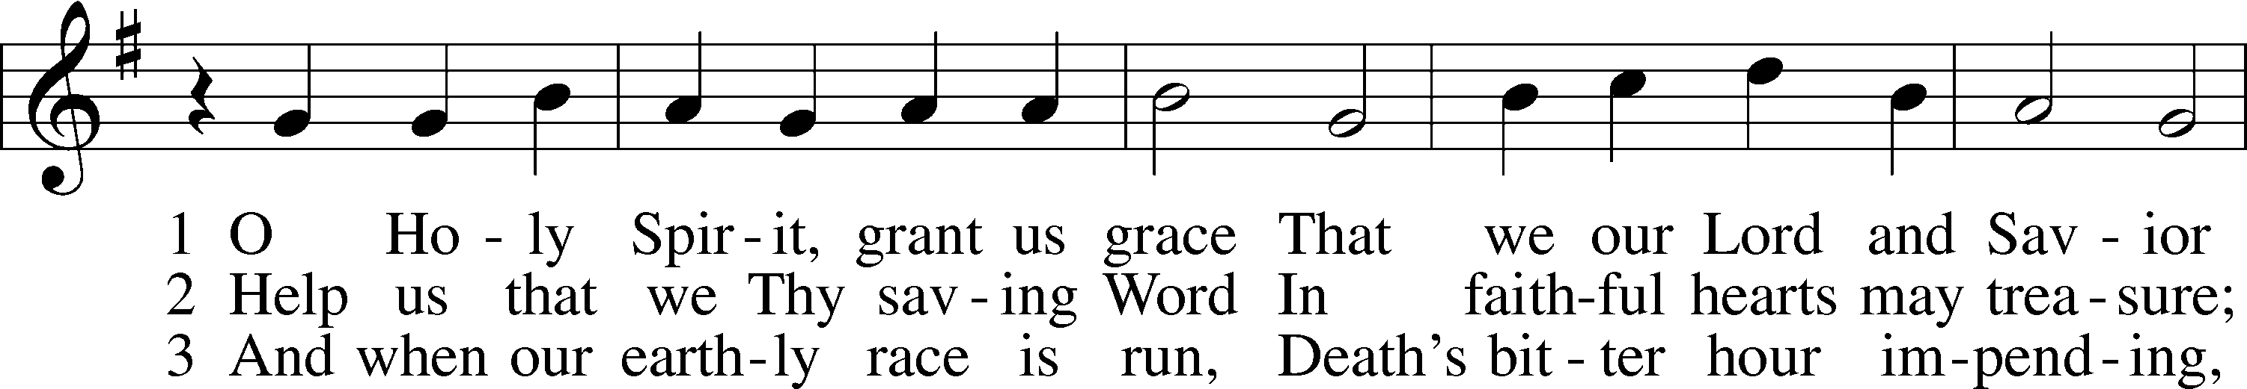
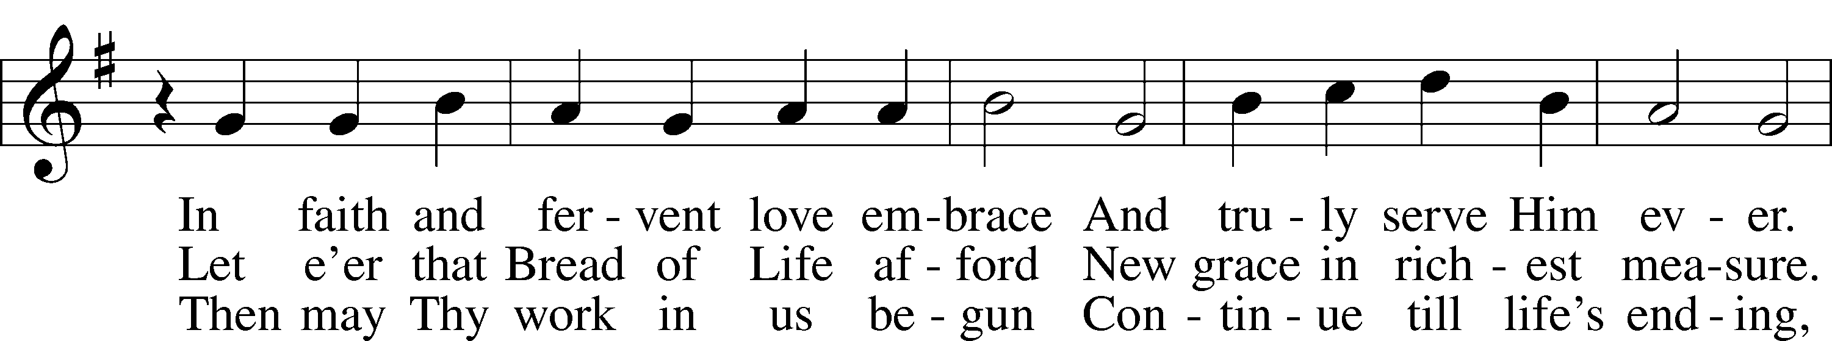
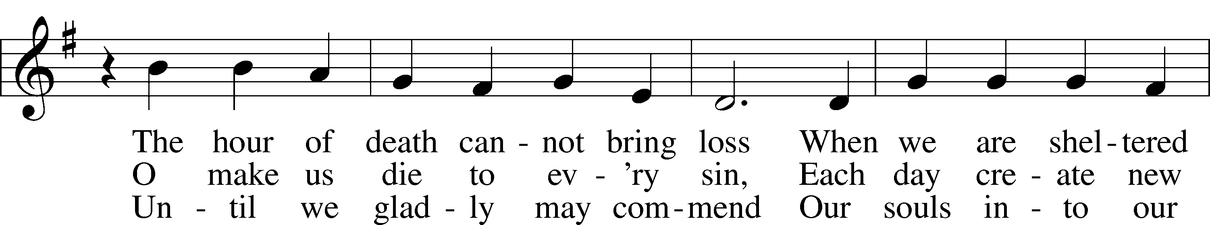
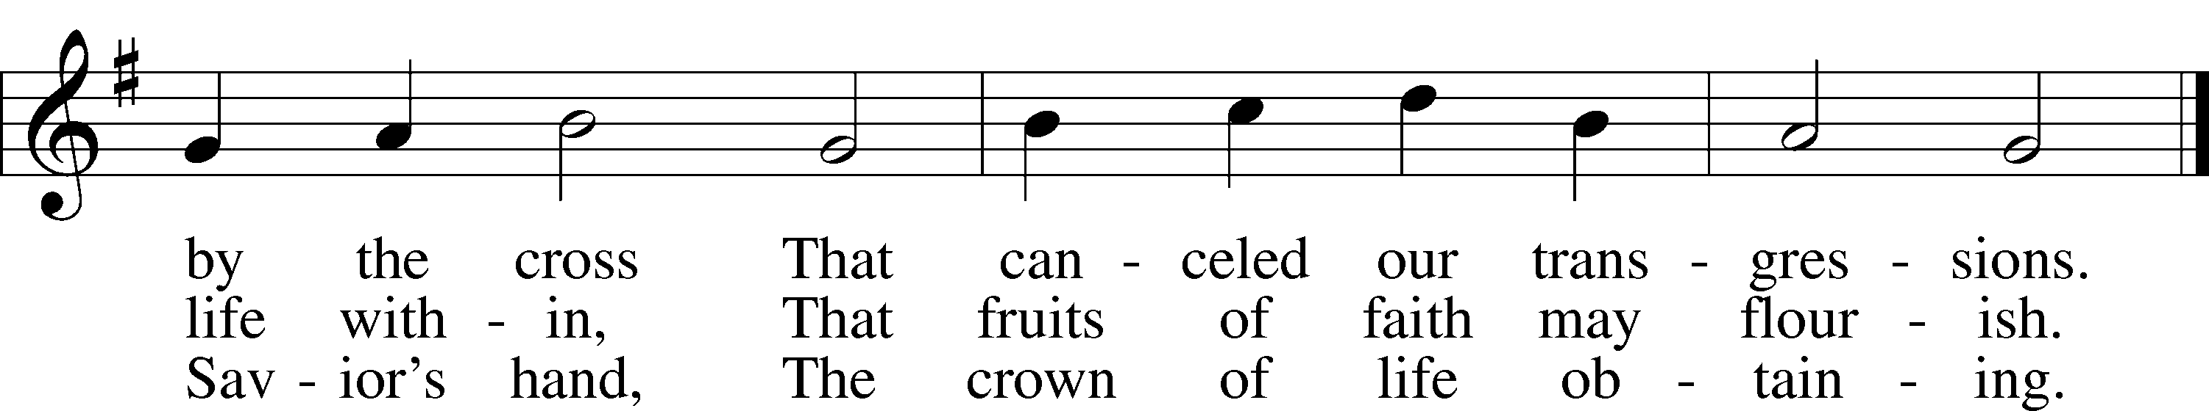
Text and tune: Public domain

Sermon Run the Gospel Race (1 Corinthians 9:16-27)

Prayer of the Church
P Dear heavenly Father, You sent Your Son to be the light of the world. Send out messengers and missionaries to share the light of Christ in every corner of the earth, that people from every tribe, nation, and language would follow Jesus. Lord, in Your mercy,
C hear our prayer.

P Lord, walk with all those who are grieving in the shadow of death. Comfort them with the hope of the resurrection to eternal light and life. Lord, in Your mercy,
C hear our prayer.

P Lord, shine Your light upon all those in public office. Enlighten them with Your wisdom and keep them from the darkness of the evil one. Lord, in Your mercy,
C hear our prayer.

P Lord, strengthen all those who are poor, homeless, hungry, oppressed, or in need in any way. Help us to see these people as Your creations in need of Your mercy and light, just as we are. Lord, in Your mercy,
C hear our prayer.

P Lord, look with favor upon all who are sick, injured, and recovering. Have mercy upon them and heal them according to Your good and gracious will. Lord, in Your mercy,
C hear our prayer.

P Lord, we commend all of these things to Your infinite mercies, which are new every morning. Lord, in Your mercy,
C hear our prayer. Amen.

Service of the Sacrament

Preface LSB 208
P The Lord be with you.
C And also with you.

P Lift up your hearts.
C We lift them to the Lord.

P Let us give thanks to the Lord our God.
C It is right to give Him thanks and praise.

P It is truly good, right, and salutary that we should at all times and in all places give thanks to You, O Lord, holy Father, almighty and everlasting God, for the countless blessings You so freely bestow on us and all creation. Above all, we give thanks for Your boundless love shown to us when You sent Your only-begotten Son, Jesus Christ, into our flesh and laid on Him our sin, giving Him into death that we might not die eternally. Because He is now risen from the dead and lives and reigns to all eternity, all who believe in Him will overcome sin and death and will rise again to new life. Therefore with angels and archangels and with all the company of heaven we laud and magnify Your glorious name, evermore praising You and saying:

Sanctus LSB 208
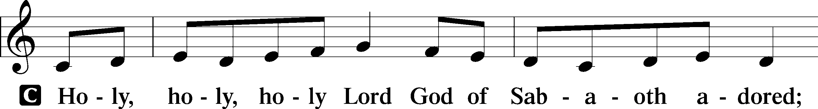
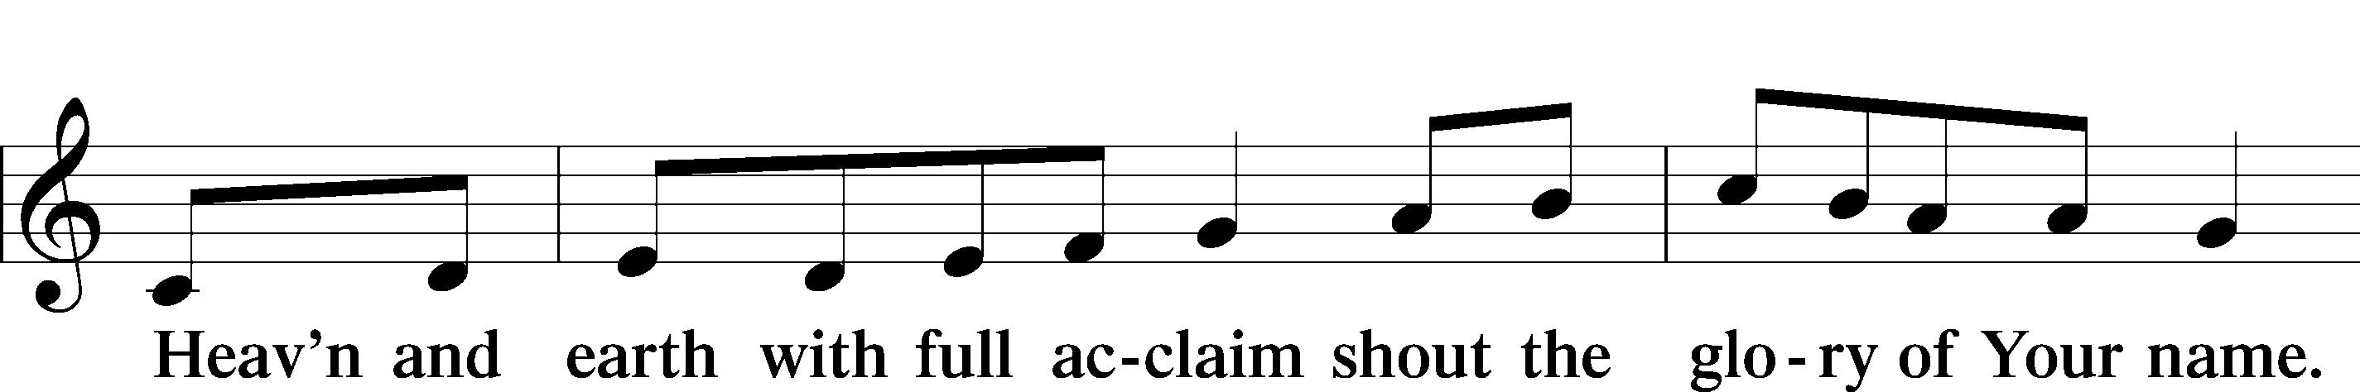
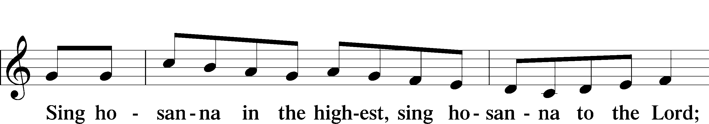
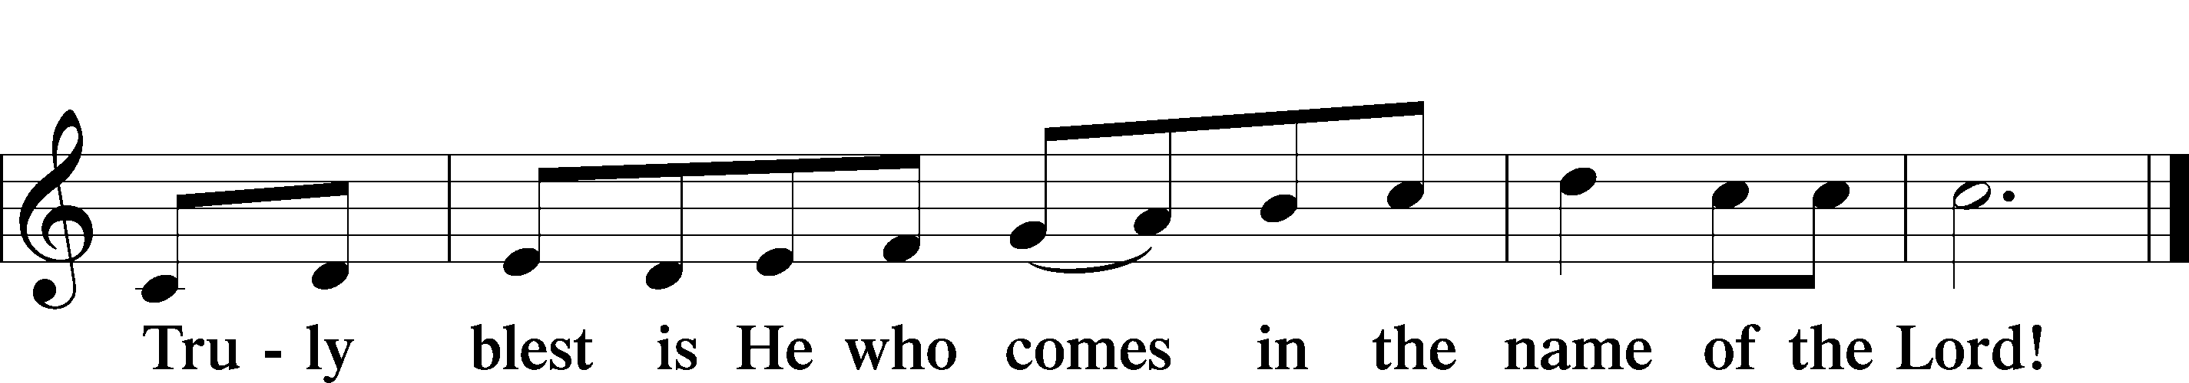

Prayer of Thanksgiving
P Blessed are You, O Lord our God, king of all creation, for You have had mercy on us and given Your only-begotten Son that whoever believes in Him should not perish but have eternal life.

As the glory of Your presence once filled Your ancient temple, so in the incarnation of Your Son, Jesus Christ, You manifested the fullness of Your glory in human flesh.

We give You thanks that in His most Holy Supper You reveal Your glory to us. Grant us faithfully to eat His body and drink His blood so that we may one day behold Your glory face to face.

Hear us as we pray in His name and as He has taught us:

Lord’s Prayer
C Our Father who art in heaven,
hallowed be Thy name,
Thy kingdom come,
Thy will be done on earth
as it is in heaven;
give us this day our daily bread;
and forgive us our trespasses
as we forgive those
who trespass against us;
and lead us not into temptation,
but deliver us from evil.
For Thine is the kingdom
and the power and the glory
forever and ever. Amen.

The Words of Our Lord
P Our Lord Jesus Christ, on the night when He was betrayed, took bread, and when He had given thanks, He broke it and gave it to the disciples and said: “Take, eat; this is My T body, which is given for you. This do in remembrance of Me.”

In the same way also He took the cup after supper, and when He had given thanks, He gave it to them, saying: “Drink of it, all of you; this cup is the new testament in My T blood, which is shed for you for the forgiveness of sins. This do, as often as you drink it, in remembrance of Me.”
Pax Domini
P The peace of the Lord be with you always.
C Amen.

Agnus Dei LSB 210
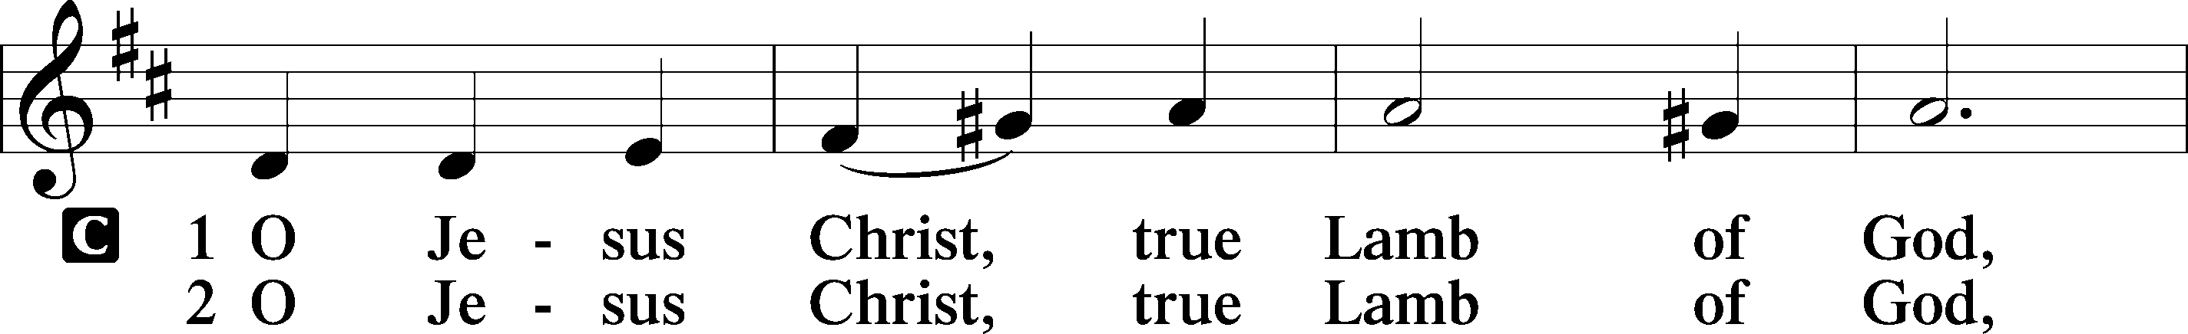
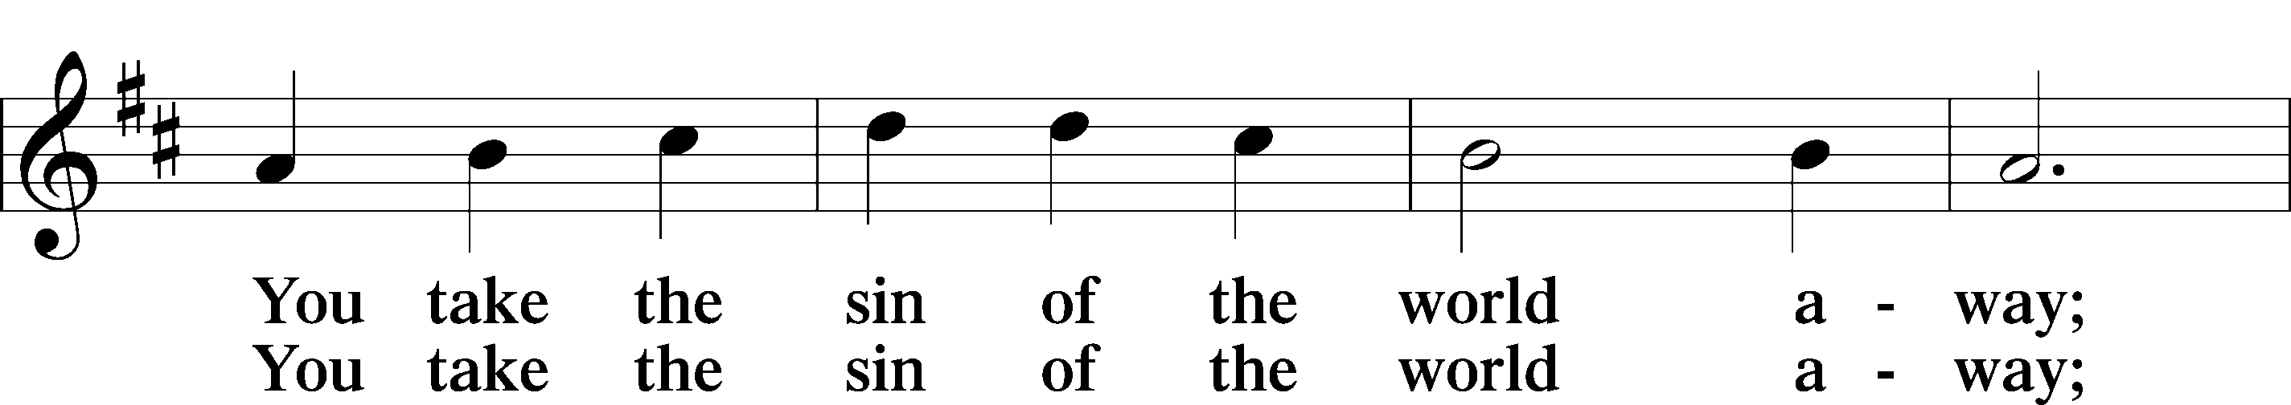
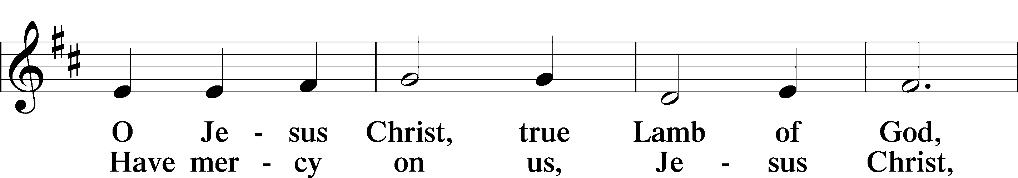
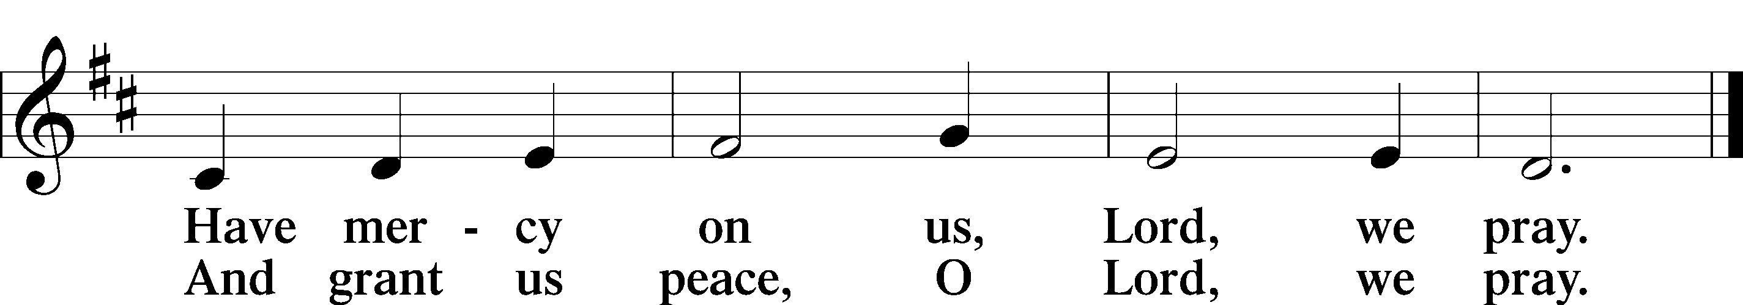

Distribution

Take, eat; this is the true body of our Lord and Savior Jesus Christ, given into death for your sins.
Amen.

Take, drink; this is the true blood of our Lord and Savior Jesus Christ, shed for the forgiveness of your sins.
Amen.

P The body and blood of our Lord Jesus Christ strengthen and preserve you in body and soul to life everlasting. Depart T in peace.
C Amen.

620 Jesus Comes Today with Healing
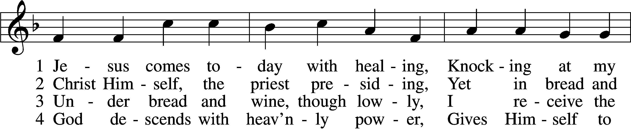
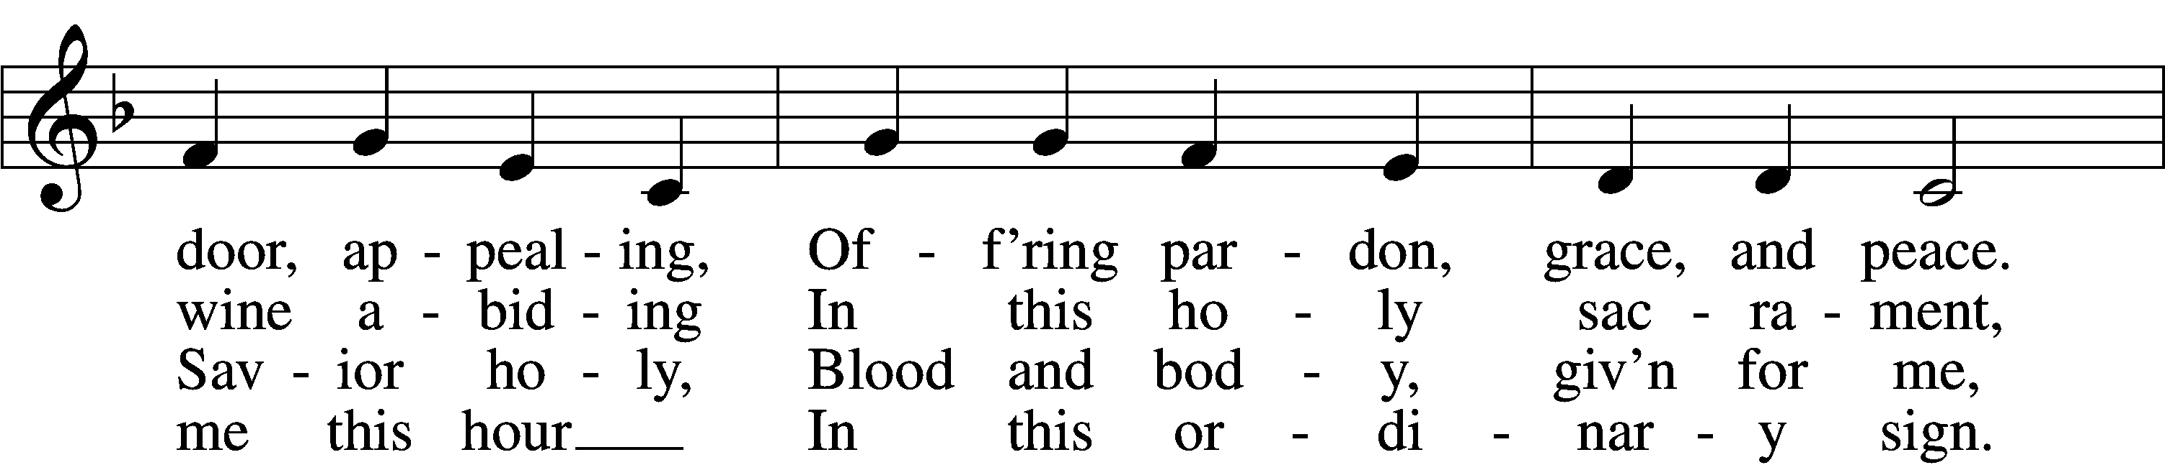
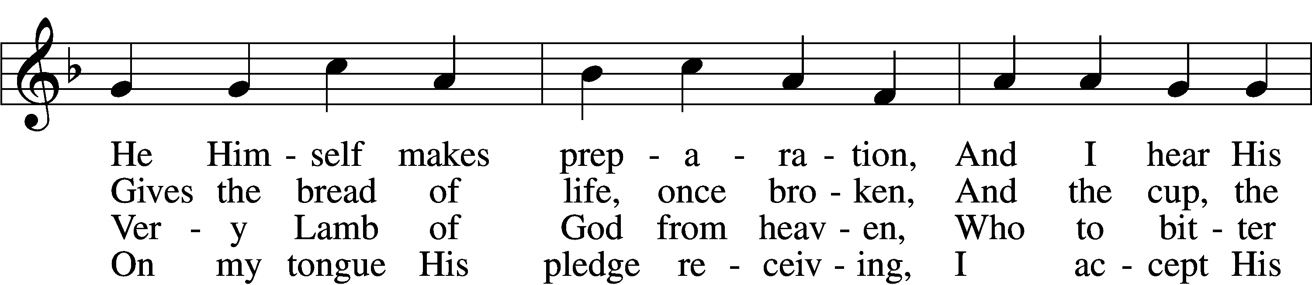
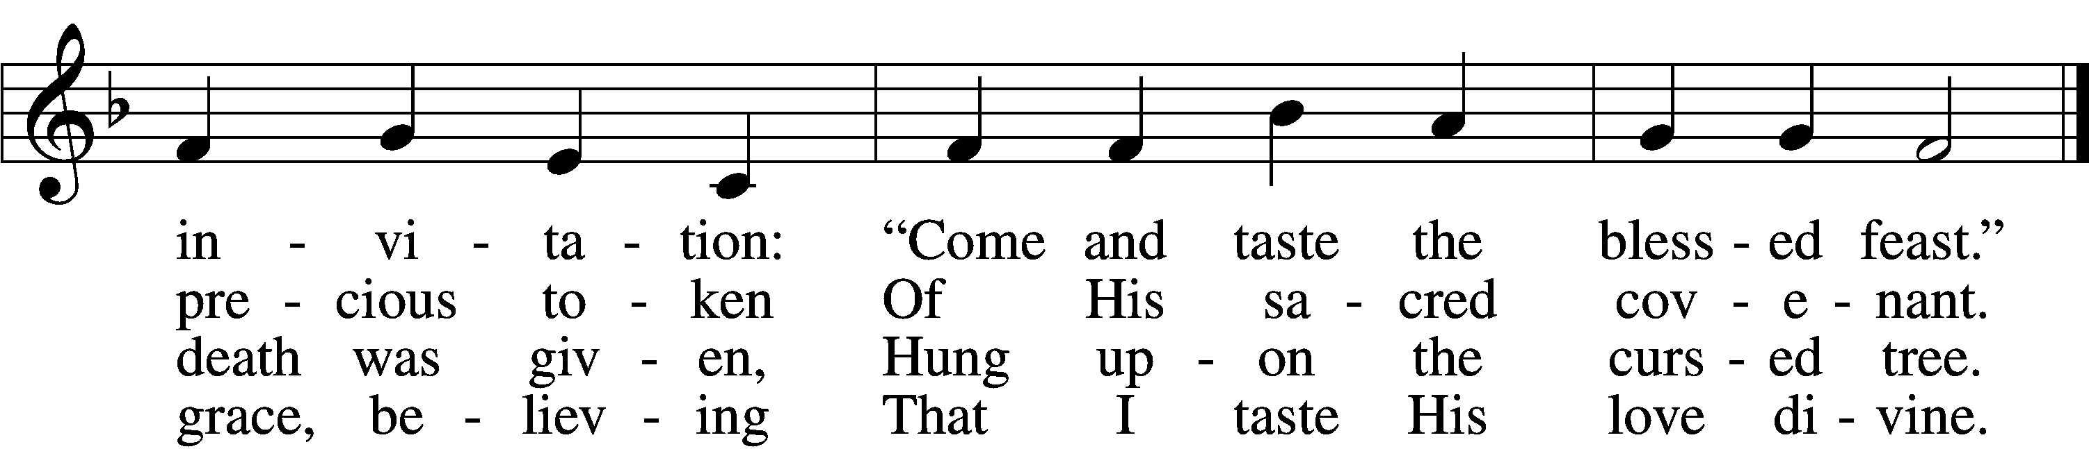

5 Let me praise God’s boundless favor,
Whose own feast of love I savor,
Bidden by His gracious call.
Wedding garments He provides me,
With a robe of white He hides me,
Fits me for the royal hall.

6 Now have I found consolation,
Comfort in my tribulation,
Balm to heal the troubled soul.
God, my shield from ev’ry terror,
Cleanses me from sin and error,
Makes my wounded spirit whole.
Text: © David W. Rogner. Used by permission: LSB Hymn License no. 110005047
Tune: Public domain

Nunc Dimittis LSB 211
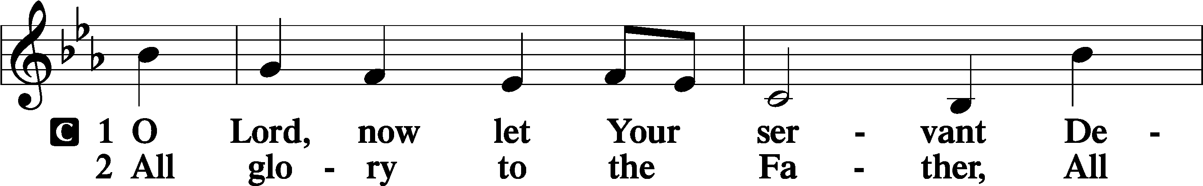
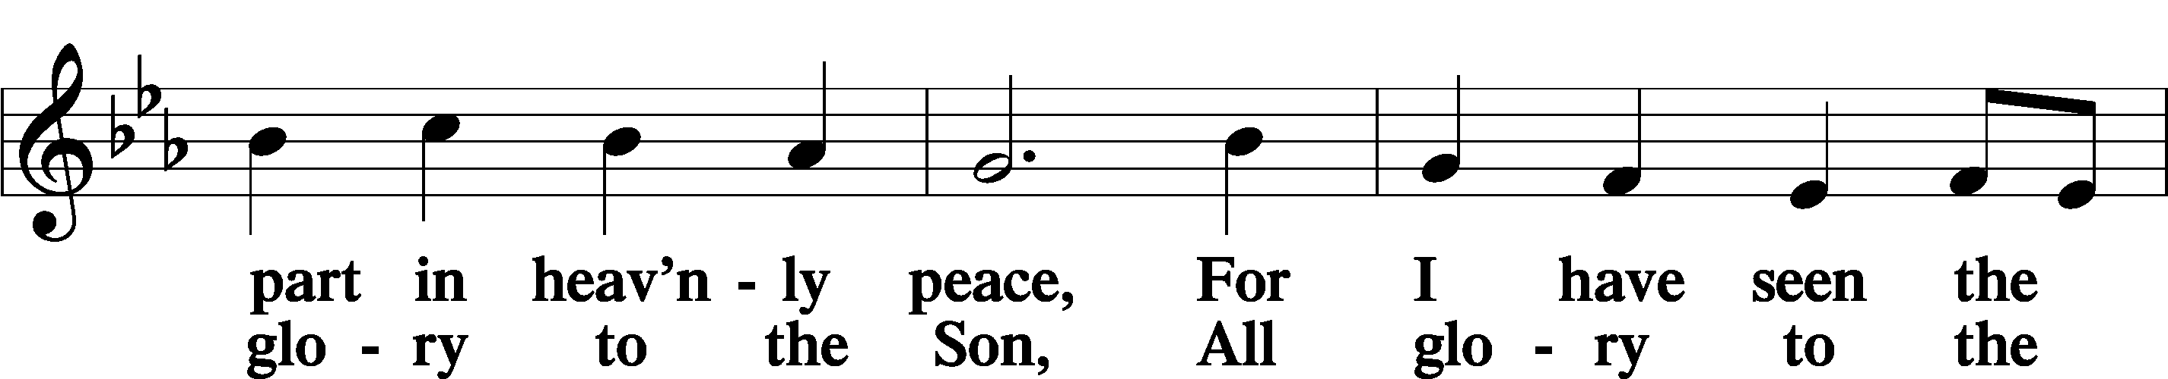
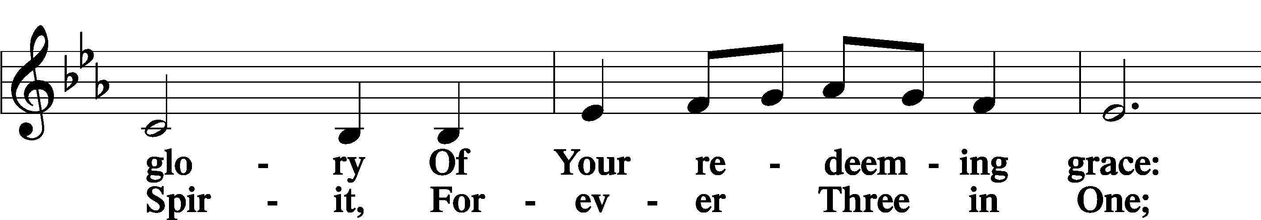
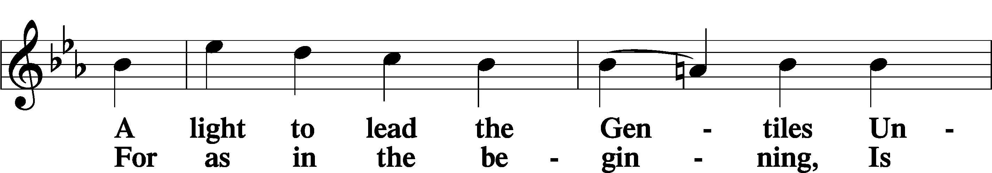
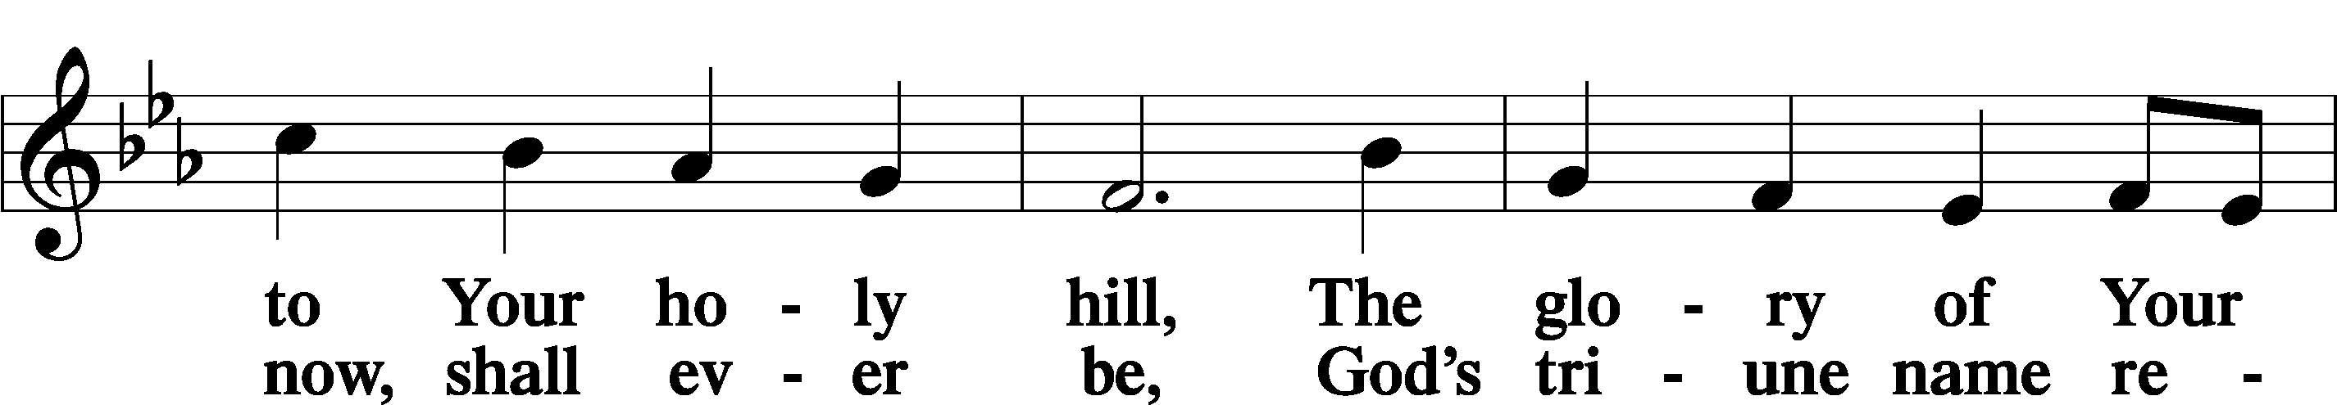
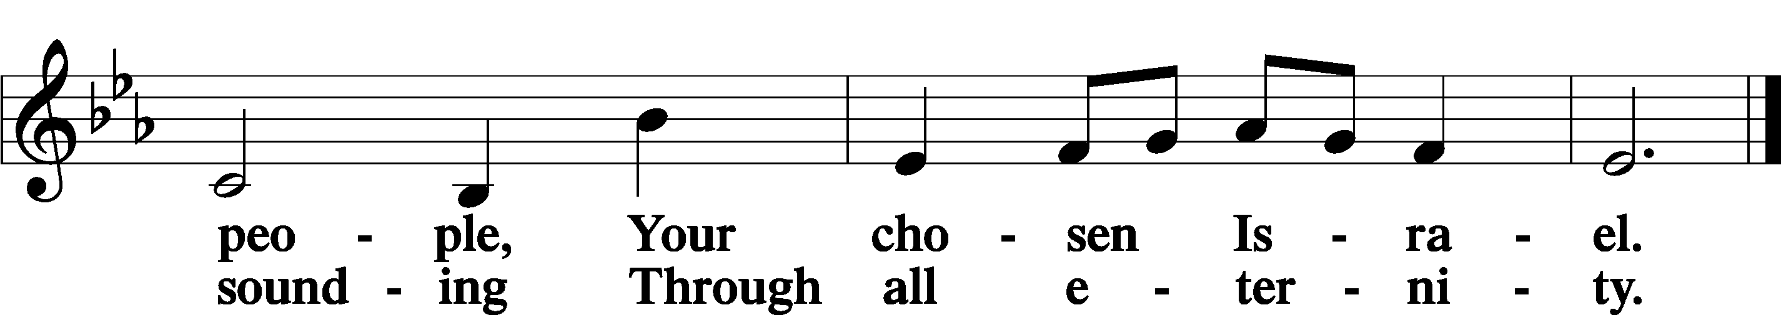

Post-Communion Collect
A Let us pray.
We give thanks to You, almighty God, that You have refreshed us through this salutary gift, and we implore You that of Your mercy You would strengthen us through the same in faith toward You and in fervent love toward one another; through Jesus Christ, Your Son, our Lord, who lives and reigns with You and the Holy Spirit, one God, now and forever.
C Amen.
Benedicamus and Benediction LSB 212
A Let us bless the Lord.
C Thanks be to God.

P The Lord bless you and keep you.
The Lord make His face shine on you and be gracious to you.
The Lord look upon you with favor and T give you peace.
C Amen.

868 Awake, My Soul, and with the Sun
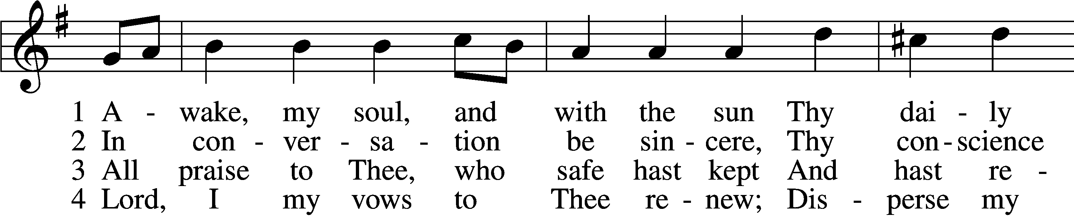
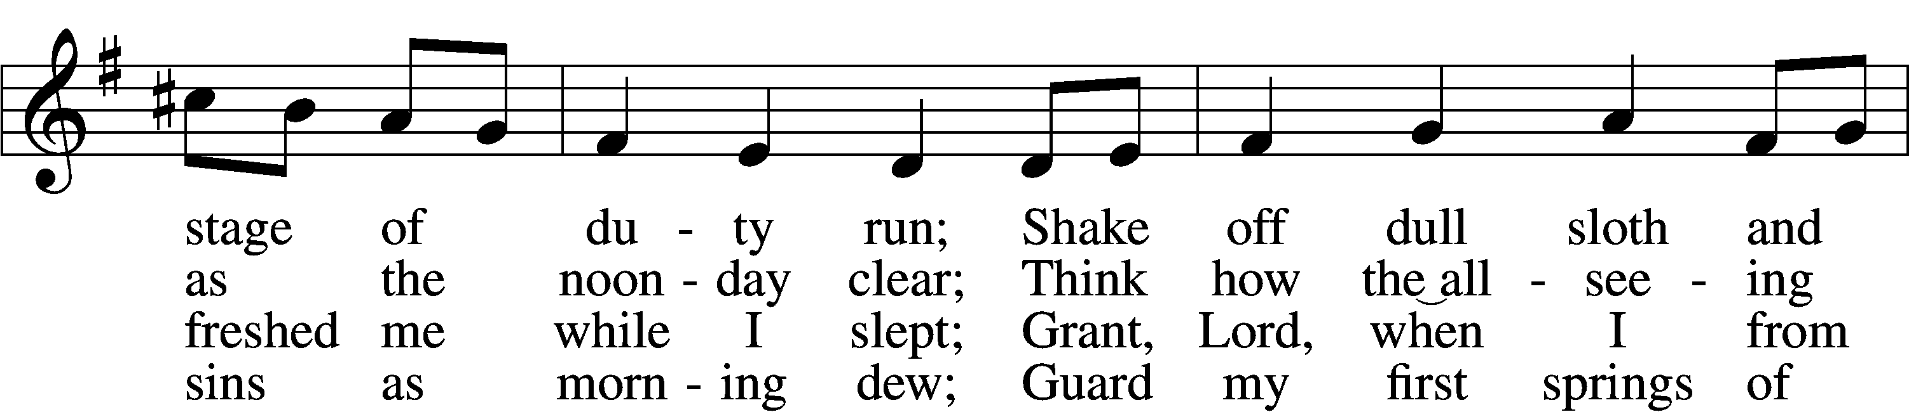
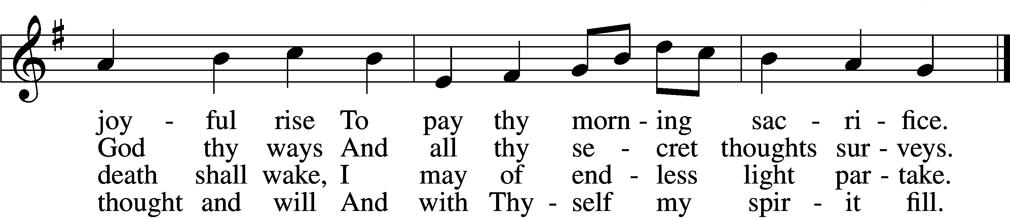

5 Direct, control, suggest this day
All I design or do or say
That all my pow’rs with all their might
In Thy sole glory may unite.

D 6 Praise God, from whom all blessings flow;
Praise Him, all creatures here below;
Praise Him above, ye heav’nly host:
Praise Father, Son, and Holy Ghost.
Tune and text: Public domain

Acknowledgments
Divine Service, Setting Four from Lutheran Service Book
Unless otherwise indicated, Scripture quotations are from the ESV® Bible (The Holy Bible, English Standard Version®), copyright © 2001 by Crossway, a publishing ministry of Good News Publishers. Used by permission. All rights reserved.
Created by Lutheran Service Builder © 2020 Concordia Publishing House.

February 7 “If your boyfriend or girlfriend won’t go to church with you while you are dating, he or she probably won’t when you’re married either. How long can you keep your faith life going if your spouse thinks praying, Bible reading, and churchgoing are stupid wastes of time? Abraham went to great lengths to find a believing wife for Isaac.” Pastor Mark Jeske, Time of Grace – A Life Quote from Lutherans For Life • lutheransforlife.org

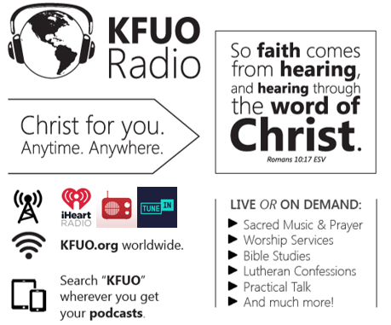

This week on KFUO.org, study Galatians on Thy Strong Word with host Rev. Brady Finnern (weekdays at 11:00 a.m. CT), continue in Mark 6-7 on Sharper Iron with host Rev. Timothy Appel (weekdays at 8:00 a.m. CT), and worship with us in Daily Chapel weekdays at 10:00 a.m. CT. Find your favorite programs on demand at kfuo.org or on your podcast app.

Gifts of Time and Treasure
“And my God will meet all your needs according to His glorious
riches in Christ Jesus.” Philippians 4:19

LAST WEEK’S OFFERINGS LAST WEEK’S ATTENDANCE
General Fund $ 1,500.00 Service 39
Needed Weekly $ 4,669.00 Communed 33
Adult Bible Study $ 6.00
Children’s SS/ Mission $ 20.00

The Lord’s Week

Today 8:45 am – Bible Studies for all ages
(Feb. 7th) 10:00 am – Divine Service
11:30 am – Confirmation

Wednesday 10:00 am – Women’s Bible Study

Next Sunday 8:45 am – Bible Studies for all ages
(Feb. 14th) 10:00 am – Divine Service
11:45 am – Confirmation

In His Service

Elder: Justin Perkins
Usher:
Acolytes: Whitney Larson
Organist:
Alter: Laura Lopez
Flowers: Happy Birthday, Sharon Schrader!

