Fourth Sunday in Advent
" I Am the Servant of the Lord "

December 20, 2020

Messiah Lutheran Church
Lutheran Church-Missouri Synod
4102 Trinity River Dr., Corpus Christi, Texas 78410

Pastor: Rev. Scott E. Herbert

Church Phone: 361-387-7748 Email: mlc@stx.rr.com
Church Fax: 361-767-1768 Website: www.messiahlcms-cc.org
Pastor Phone: 469-693-9683 Pastor Email: chirev59@gmail.com

WELCOME TO MESSIAH!
We are glad you are here to receive what God is doing for you during Divine Service. Please sign our Guest Book located near the front door. Feel free to converse quietly until the organ prelude begins. If you are looking for a church home, please talk to the Pastor at the door. We would love to have you join us.

Preparing for Service
The Coming of the Christ Brings True Rejoicing in His Forgiveness
When he preaches repentance, John the Baptist points us to Christ Jesus. John was sent by God “as a witness, to bear witness about the light, that all might believe through him” (John 1:7). He baptizes with water in order to “make straight the way of the Lord,” who shall redeem His people from their sins (John 1:23). That Lord Jesus “who comes after” John now stands among us and makes Himself known to us (John 1:26–27). He has been anointed by the Holy Spirit “to bring good news to the poor” and “to bind up the brokenhearted” (Is. 61:1). By the washing of the water with His Word and Spirit, He clothes His Church with “the garments of salvation” and adorns her with His own righteousness “as a bride adorns herself with her jewels” (Is. 61:10). Therefore, we “rejoice always” in the Lord, “pray without ceasing” and “give thanks in all circumstances” (1 Thess. 5:16–18). For “the God of peace,” who has called you by the Gospel, will surely “sanctify you completely,” so that “your whole spirit and soul and body” will “be kept blameless at the coming of our Lord Jesus Christ” (1 Thess. 5:23–24).
Confession and Absolution

383 A Great and Mighty Wonder
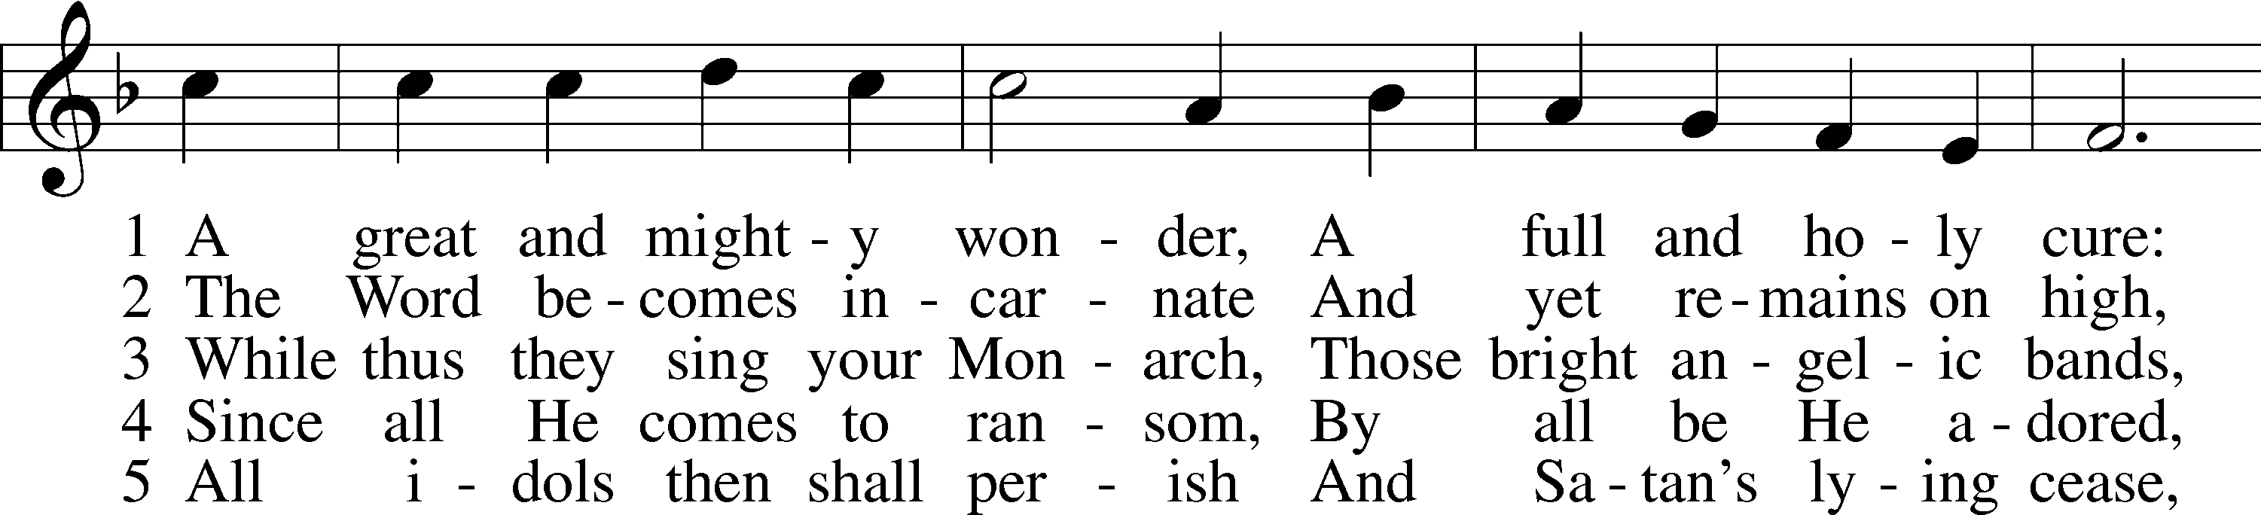
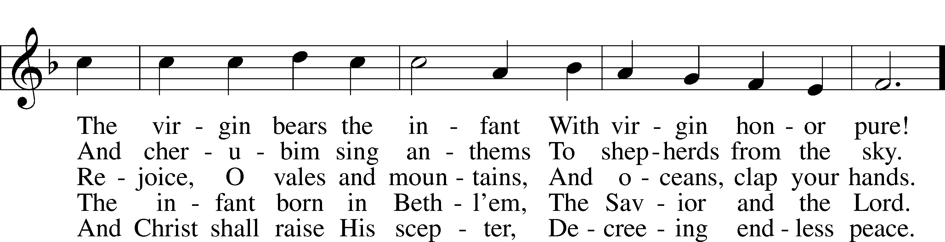
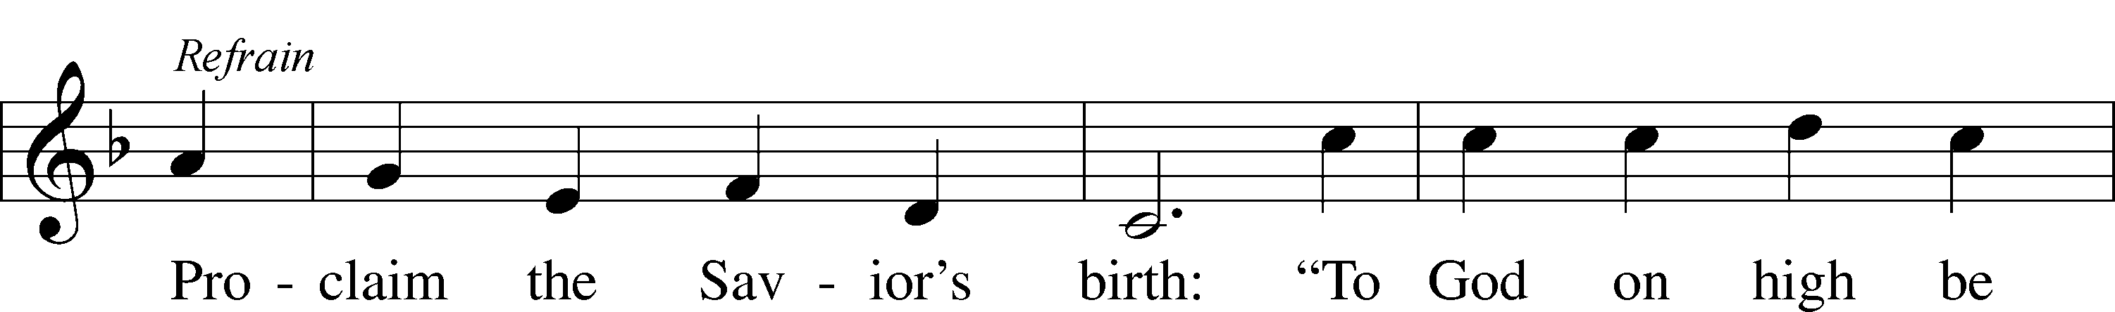
Text and tune: Public domain

P In the name of the Father and of the T Son and of the Holy Spirit.
C Amen.

P Beloved in the Lord! Let us draw near with a true heart and confess our sins unto God our Father, beseeching Him in the name of our Lord Jesus Christ to grant us forgiveness.

P Our help is in the name of the Lord,
C who made heaven and earth.
P I said, I will confess my transgressions unto the Lord,
C and You forgave the iniquity of my sin.

P O almighty God, merciful Father,
C I, a poor, miserable sinner, confess unto You all my sins and iniquities with which I have ever offended You and justly deserved Your temporal and eternal punishment. But I am heartily sorry for them and sincerely repent of them, and I pray You of Your boundless mercy and for the sake of the holy, innocent, bitter sufferings and death of Your beloved Son, Jesus Christ, to be gracious and merciful to me, a poor, sinful being.

P Upon this your confession, I, by virtue of my office, as a called and ordained servant of the Word, announce the grace of God unto all of you, and in the stead and by the command of my Lord Jesus Christ I forgive you all your sins in the name of the Father and of the T Son and of the Holy Spirit.
C Amen.

Service of the Word

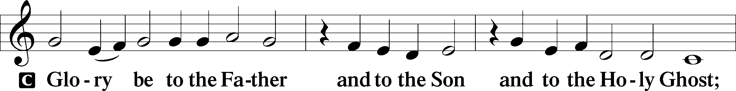
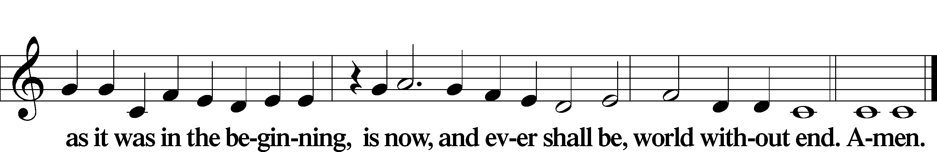

Kyrie LSB 186
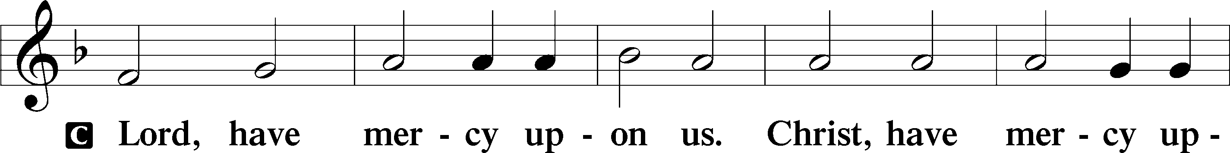
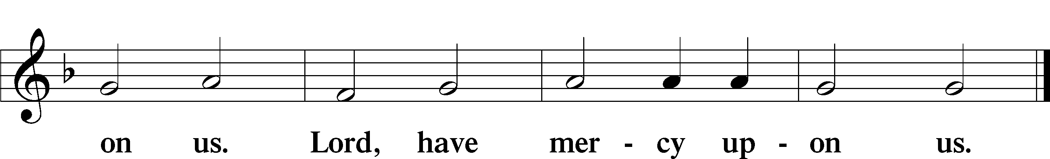
Salutation and Collect of the Day
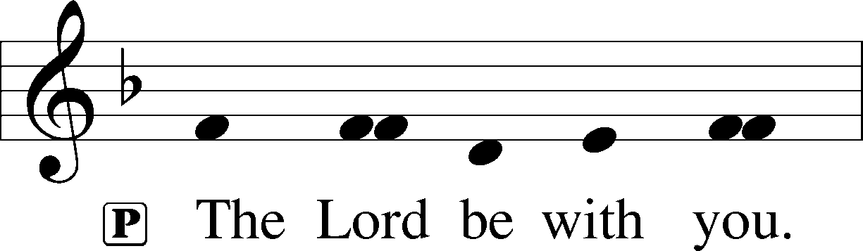
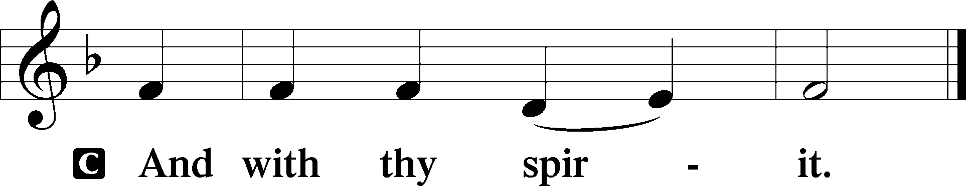

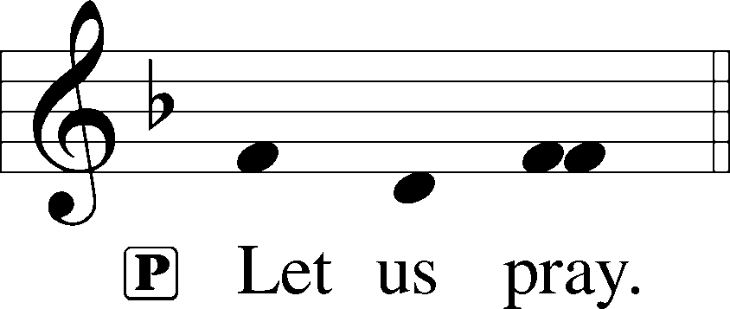

P Stir up Your power, O Lord, and come and help us by Your might, that the sins which weigh us down may be quickly lifted by Your grace and mercy; for You live and reign with the Father and the Holy Spirit, one God, now and forever.

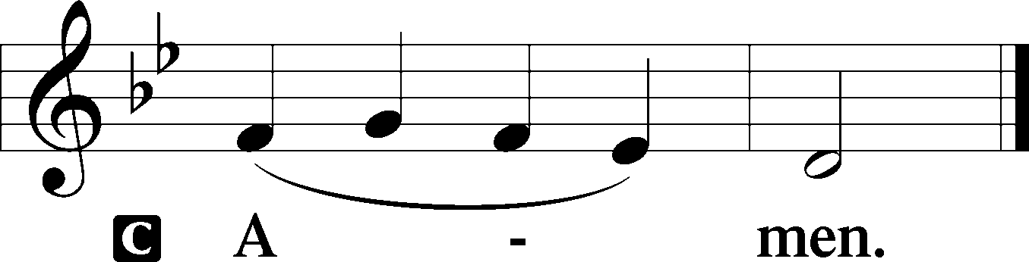

Old Testament Reading 2 Samuel 7:1–11, 16
1Now when the king lived in his house and the Lord had given him rest from all his surrounding enemies, 2the king said to Nathan the prophet, “See now, I dwell in a house of cedar, but the ark of God dwells in a tent.” 3And Nathan said to the king, “Go, do all that is in your heart, for the Lord is with you.”
4But that same night the word of the Lord came to Nathan, 5“Go and tell my servant David, ‘Thus says the Lord: Would you build me a house to dwell in? 6I have not lived in a house since the day I brought up the people of Israel from Egypt to this day, but I have been moving about in a tent for my dwelling. 7In all places where I have moved with all the people of Israel, did I speak a word with any of the judges of Israel, whom I commanded to shepherd my people Israel, saying, “Why have you not built me a house of cedar?”’ 8Now, therefore, thus you shall say to my servant David, ‘Thus says the Lord of hosts, I took you from the pasture, from following the sheep, that you should be prince over my people Israel. 9And I have been with you wherever you went and have cut off all your enemies from before you. And I will make for you a great name, like the name of the great ones of the earth. 10And I will appoint a place for my people Israel and will plant them, so that they may dwell in their own place and be disturbed no more. And violent men shall afflict them no more, as formerly, 11from the time that I appointed judges over my people Israel. And I will give you rest from all your enemies. Moreover, the Lord declares to you that the Lord will make you a house. . . .
16And your house and your kingdom shall be made sure forever before me. Your throne shall be established forever.’”

A This is the Word of the Lord.
C Thanks be to God.

Psalm Psalm 89:1–5; antiphon: v. 8
1I will sing of the steadfast love of the Lord, forever;
with my mouth I will make known your faithfulness to all generations.
2For I said, “Steadfast love will be built up forever;
in the heavens you will establish your faithfulness.”
3You have said, “I have made a covenant with my chosen one;
I have sworn to David my servant:
4‘I will establish your offspring forever,
and build your throne for all generations.’”
5Let the heavens praise your wonders, O Lord,
your faithfulness in the assembly of the holy ones!

Epistle Romans 16:25–27
25Now to him who is able to strengthen you according to my gospel and the preaching of Jesus Christ, according to the revelation of the mystery that was kept secret for long ages 26but has now been disclosed and through the prophetic writings has been made known to all nations, according to the command of the eternal God, to bring about the obedience of faith— 27to the only wise God be glory forevermore through Jesus Christ! Amen.

A This is the Word of the Lord.
C Thanks be to God.

Alleluia LSB 190
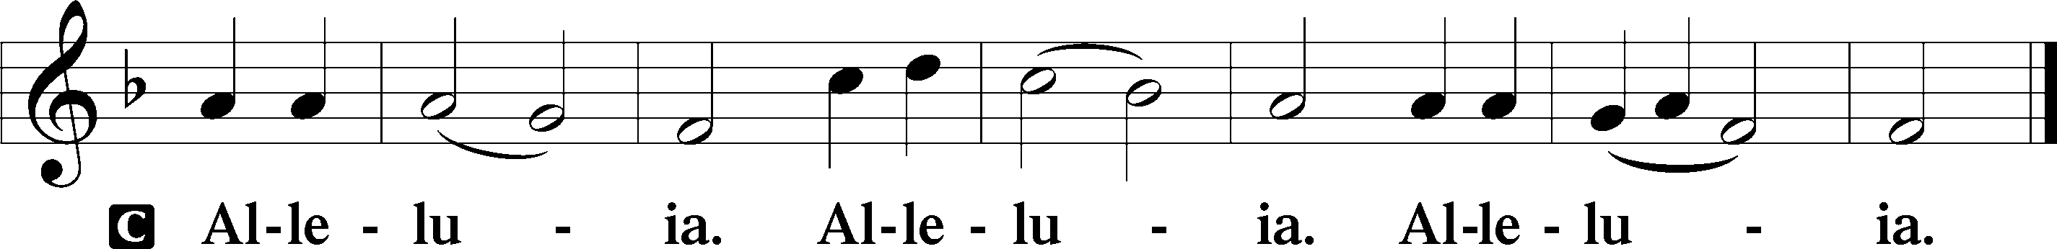

Holy Gospel Luke 1:26–38
P The Holy Gospel according to St. Luke, the first chapter.

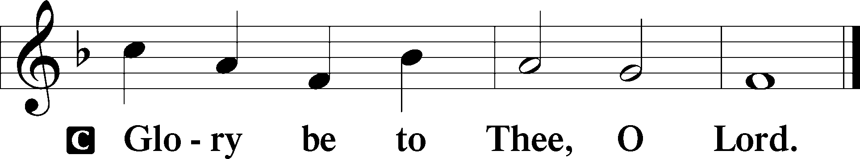

26In the sixth month the angel Gabriel was sent from God to a city of Galilee named Nazareth, 27to a virgin betrothed to a man whose name was Joseph, of the house of David. And the virgin’s name was Mary. 28And he came to her and said, “Greetings, O favored one, the Lord is with you!” 29But she was greatly troubled at the saying, and tried to discern what sort of greeting this might be. 30And the angel said to her, “Do not be afraid, Mary, for you have found favor with God. 31And behold, you will conceive in your womb and bear a son, and you shall call his name Jesus. 32He will be great and will be called the Son of the Most High. And the Lord God will give to him the throne of his father David, 33and he will reign over the house of Jacob forever, and of his kingdom there will be no end.”
34And Mary said to the angel, “How will this be, since I am a virgin?”
35And the angel answered her, “The Holy Spirit will come upon you, and the power of the Most High will overshadow you; therefore the child to be born will be called holy—the Son of God. 36And behold, your relative Elizabeth in her old age has also conceived a son, and this is the sixth month with her who was called barren. 37For nothing will be impossible with God.” 38And Mary said, “Behold, I am the servant of the Lord; let it be to me according to your word.” And the angel departed from her.

P This is the Gospel of the Lord.

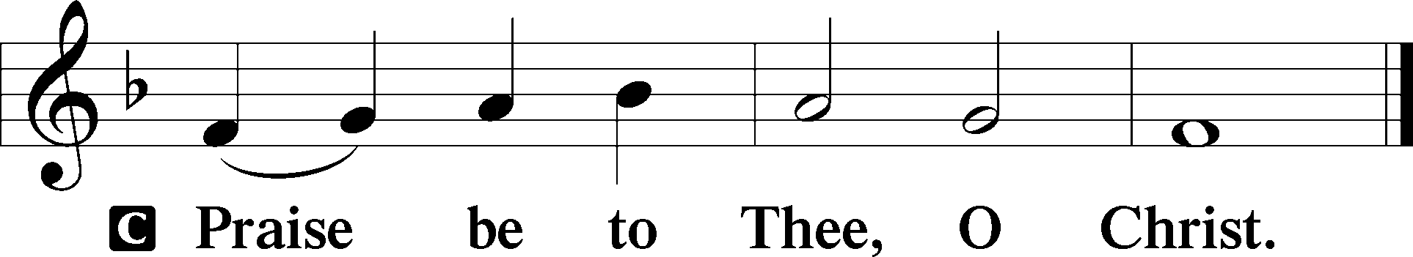

Apostles’ Creed
C I believe in God, the Father Almighty,
maker of heaven and earth.

And in Jesus Christ, His only Son, our Lord,
who was conceived by the Holy Spirit,
born of the virgin Mary,
suffered under Pontius Pilate,
was crucified, died and was buried.
He descended into hell.
The third day He rose again from the dead.
He ascended into heaven
and sits at the right hand of God the Father Almighty.
From thence He will come to judge the living and the dead.

I believe in the Holy Spirit,
the holy Christian Church,
the communion of saints,
the forgiveness of sins,
the resurrection of the body,
and the life T everlasting. Amen.

Children’s Message A Visit from an Angel

356 The Angel Gabriel from Heaven Came
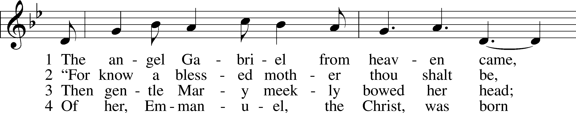
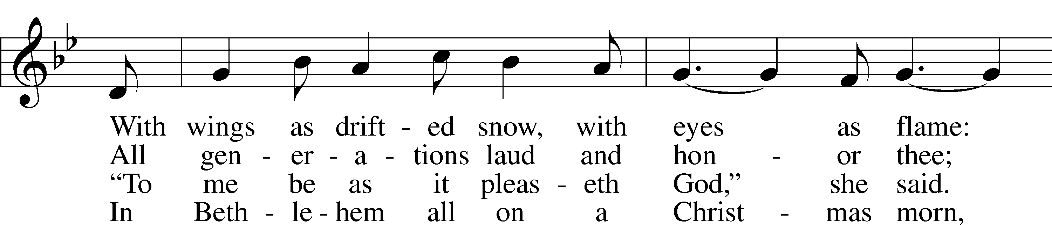
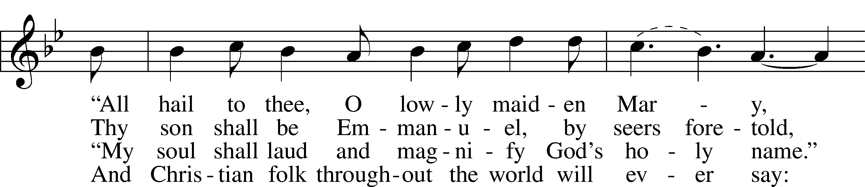
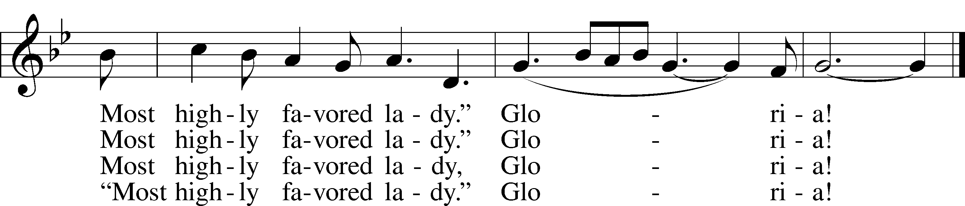
Tune and text: Public domain

Sermon I Am the Servant of the Lord

Offertory LSB 192
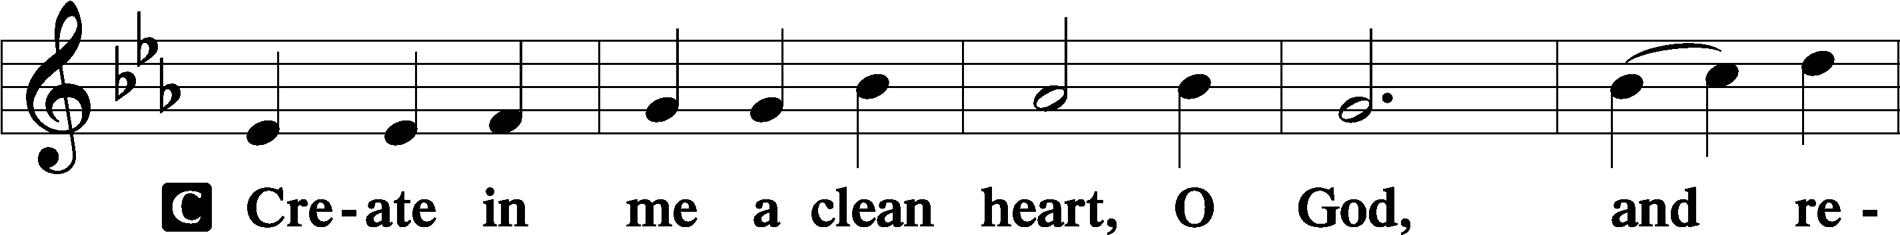
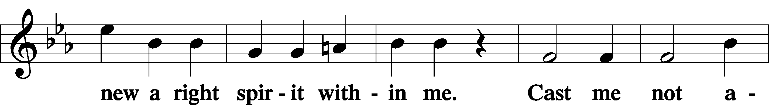
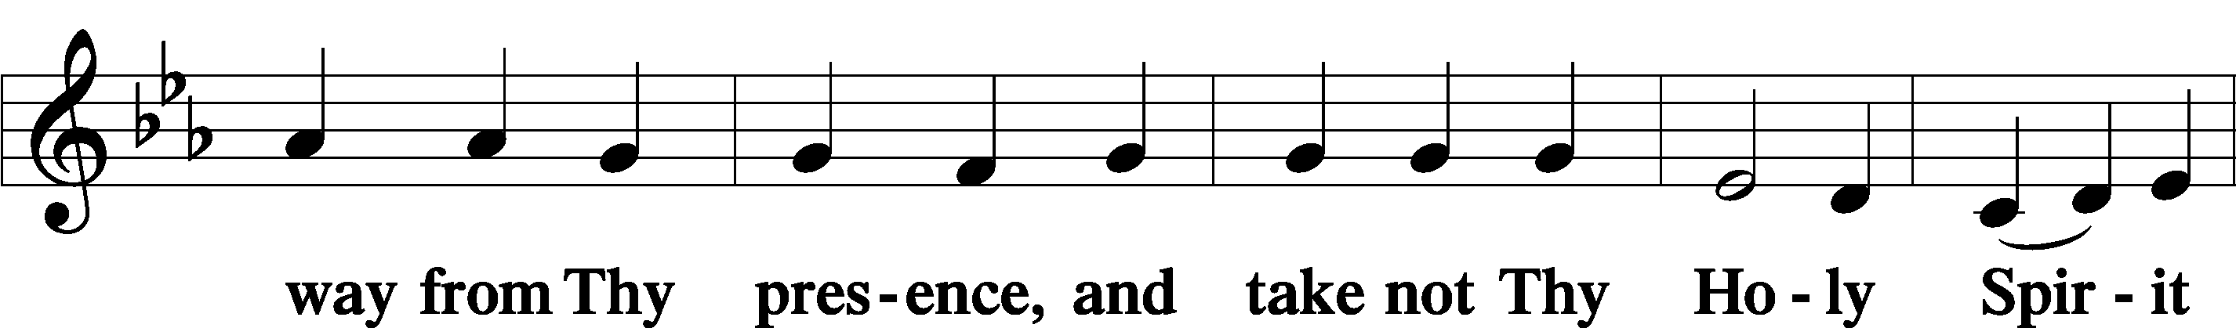
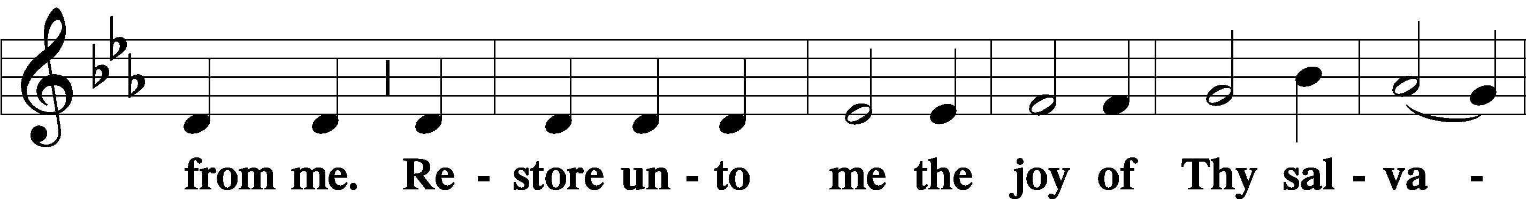
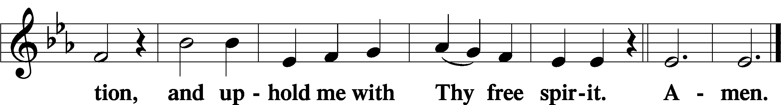

Offering

Prayer of the Church

Service of the Sacrament

Preface LSB 194

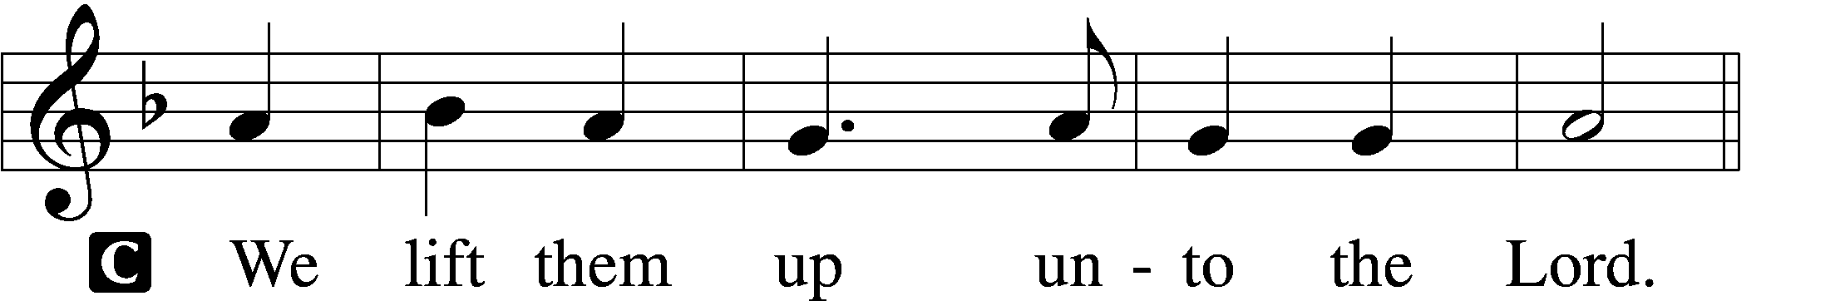

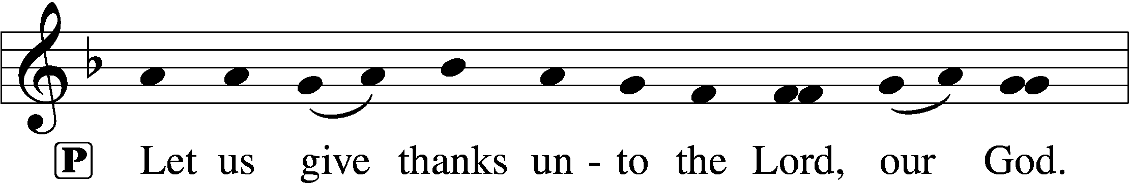
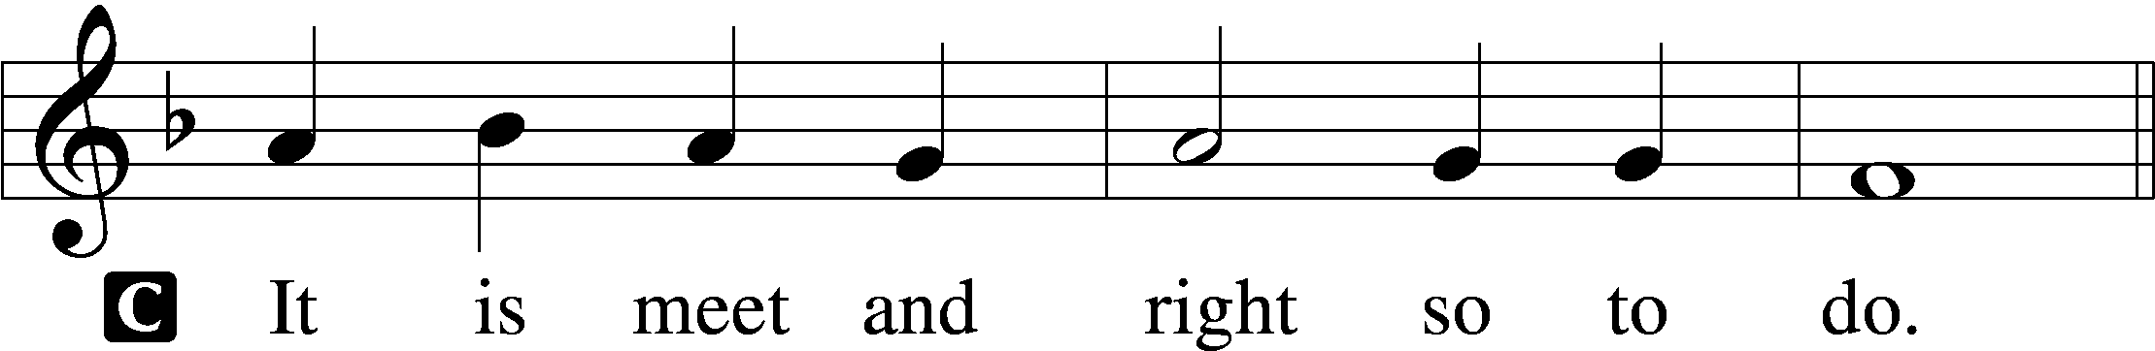

P It is truly meet, right, and salutary that we should at all times and in all places give thanks to You, holy Lord, almighty Father, everlasting God, through Jesus Christ, our Lord, whose way John the Baptist prepared, proclaiming Him the promised Messiah, the very Lamb of God who takes away the sin of the world, and calling sinners to repentance that they might escape from the wrath to be revealed when He comes again in glory. Therefore with angels and archangels and with all the company of heaven we laud and magnify Your glorious name, evermore praising You and saying:

Sanctus LSB 195
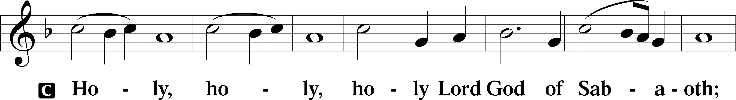
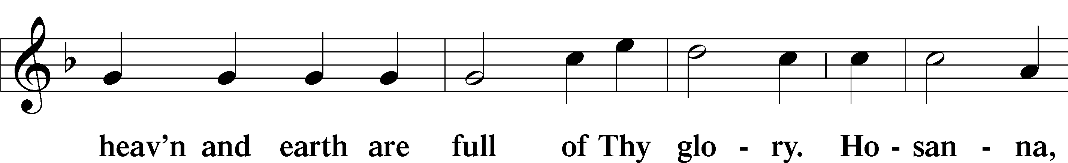
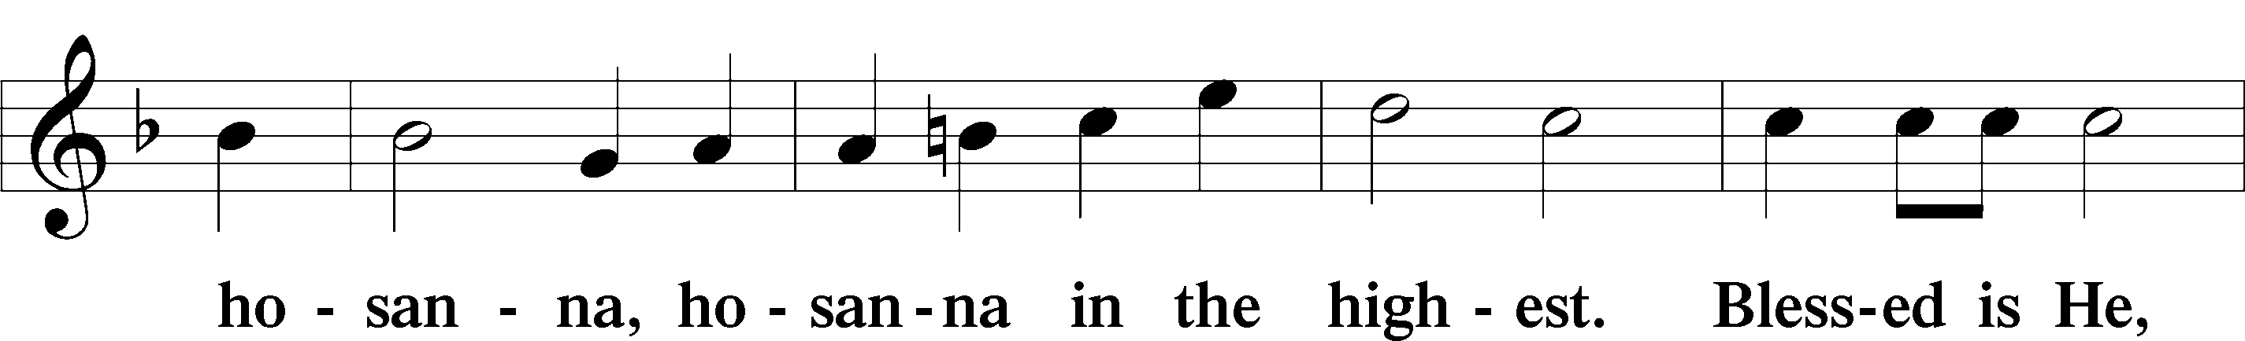
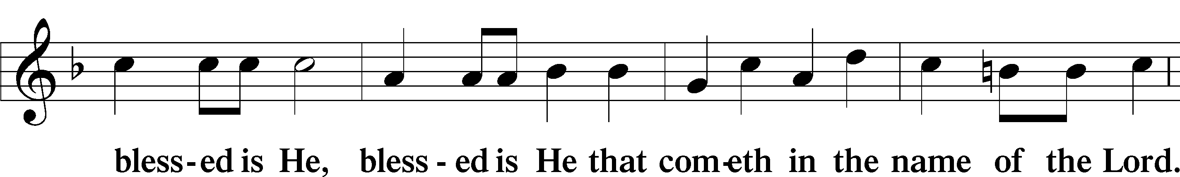
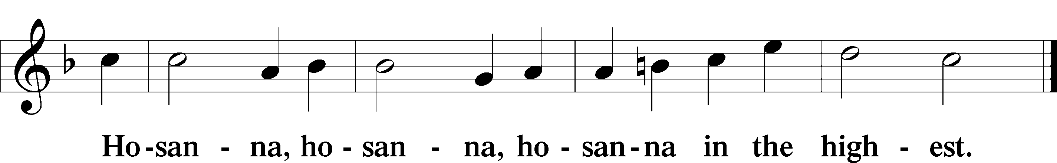

Lord’s Prayer LSB 196
C Our Father who art in heaven,
hallowed be Thy name,
Thy kingdom come,
Thy will be done on earth as it is in heaven;
give us this day our daily bread;
and forgive us our trespasses as we forgive those who trespass against us;
and lead us not into temptation,
but deliver us from evil.
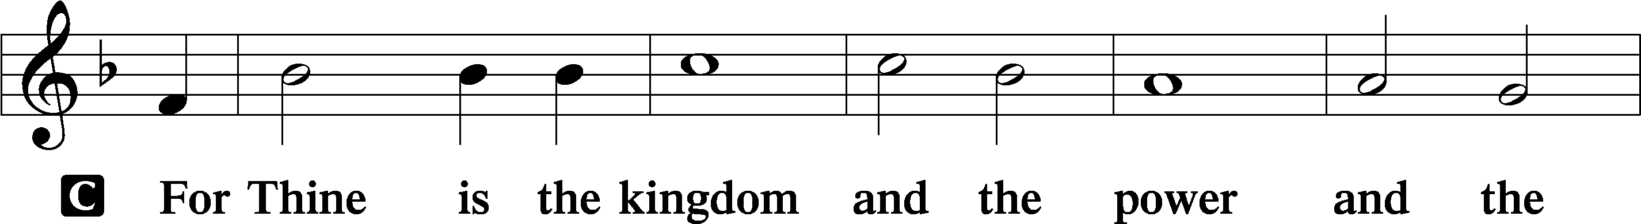
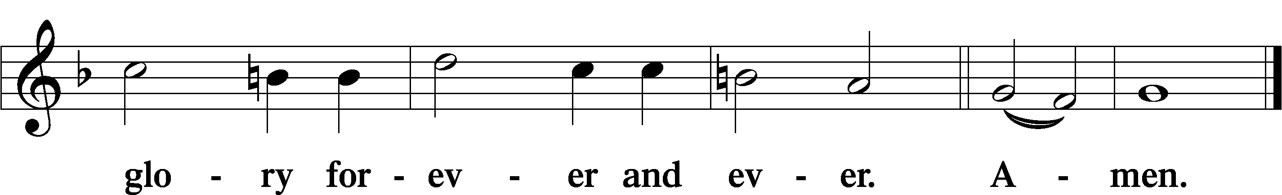

The Words of Our Lord LSB 197
P Our Lord Jesus Christ, on the night when He was betrayed, took bread, and when He had given thanks, He broke it and gave it to the disciples and said: “Take, eat; this is My T body, which is given for you. This do in remembrance of Me.”

In the same way also He took the cup after supper, and when He had given thanks, He gave it to them, saying: “Drink of it, all of you; this cup is the new testament in My T blood, which is shed for you for the forgiveness of sins. This do, as often as you drink it, in remembrance of Me.”

Pax Domini LSB 197
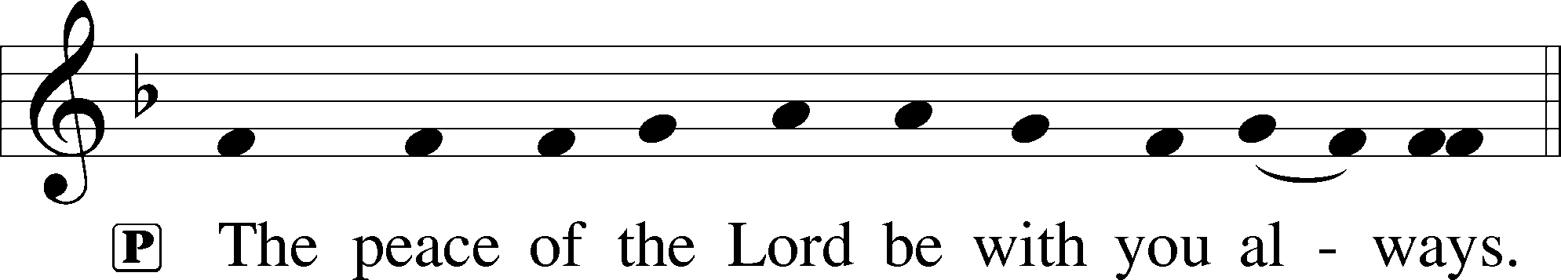

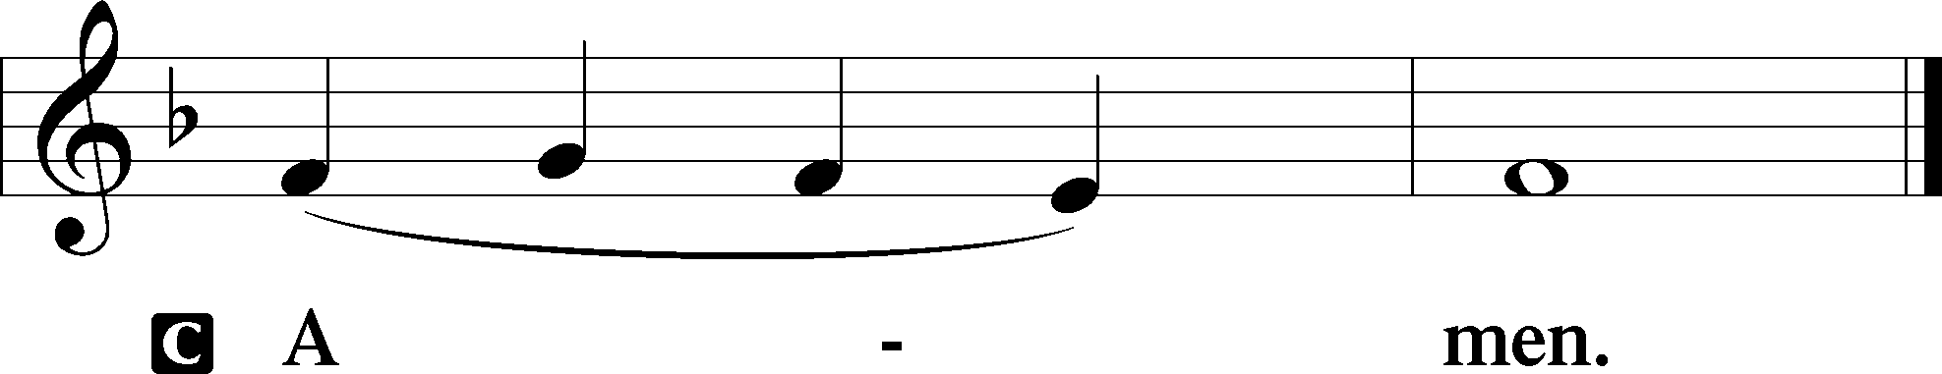

Agnus Dei LSB 198
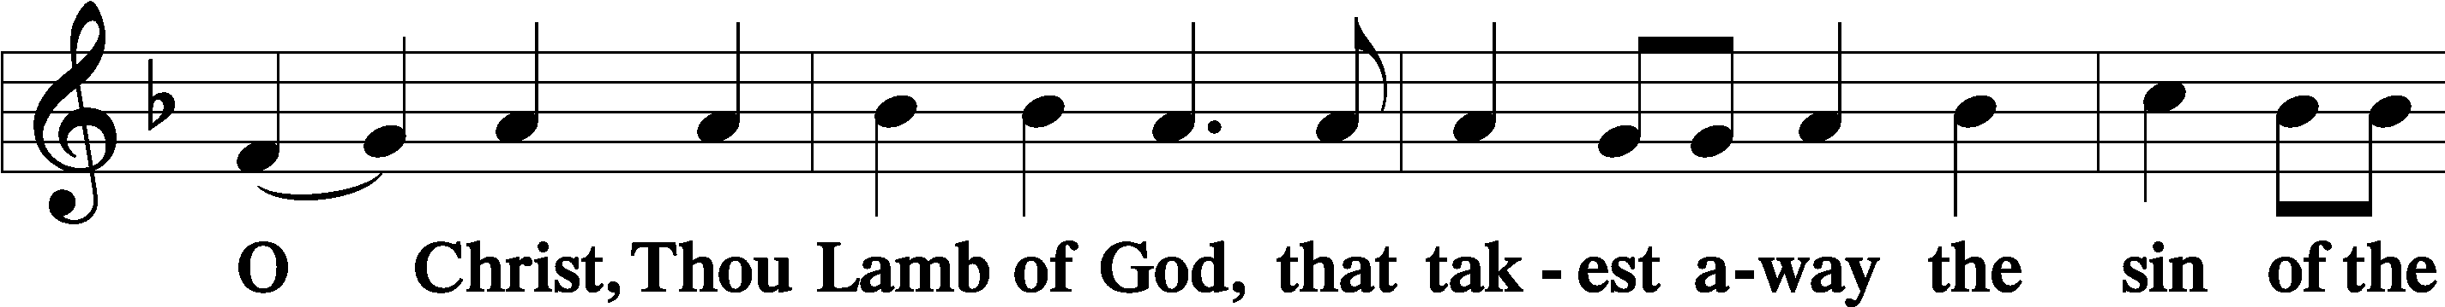
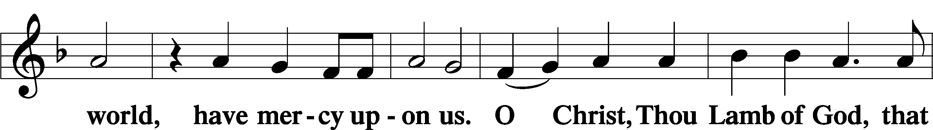
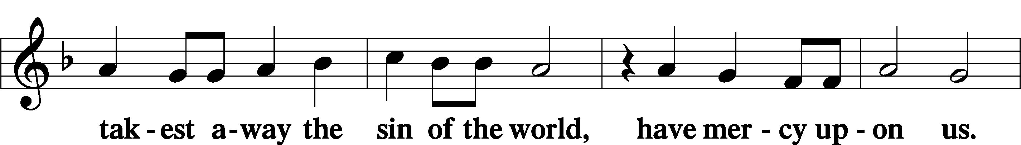
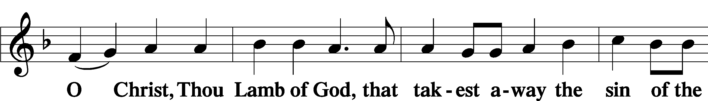
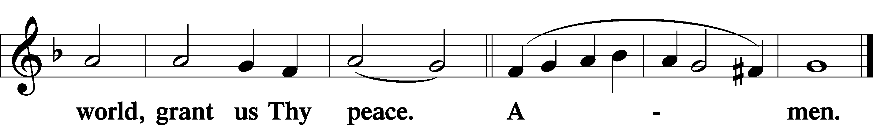

Distribution
337 The Night Will Soon Be Ending
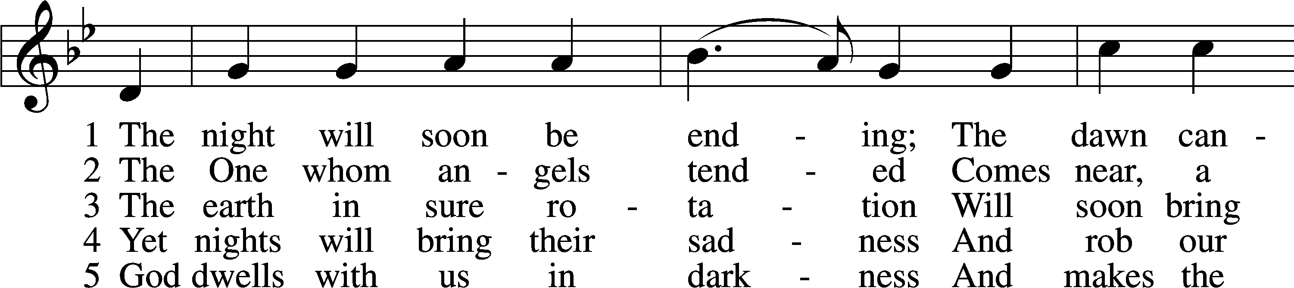
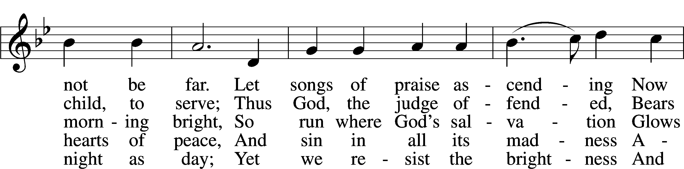
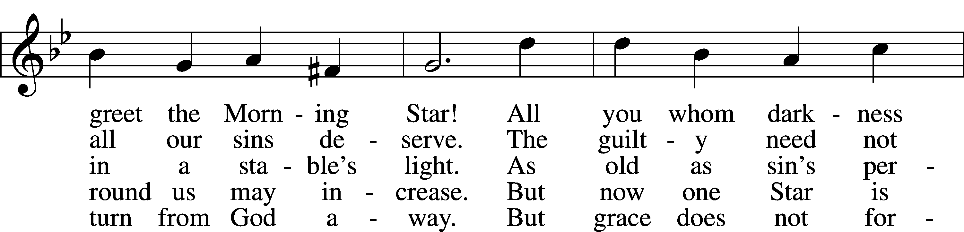
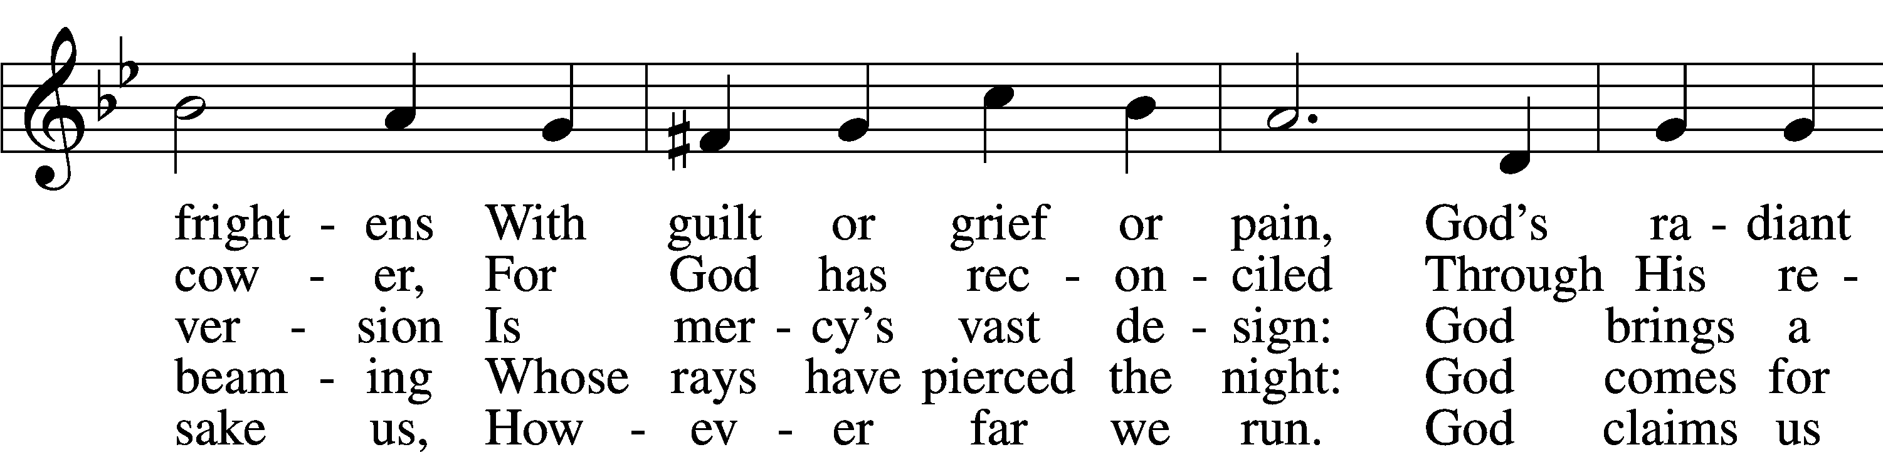
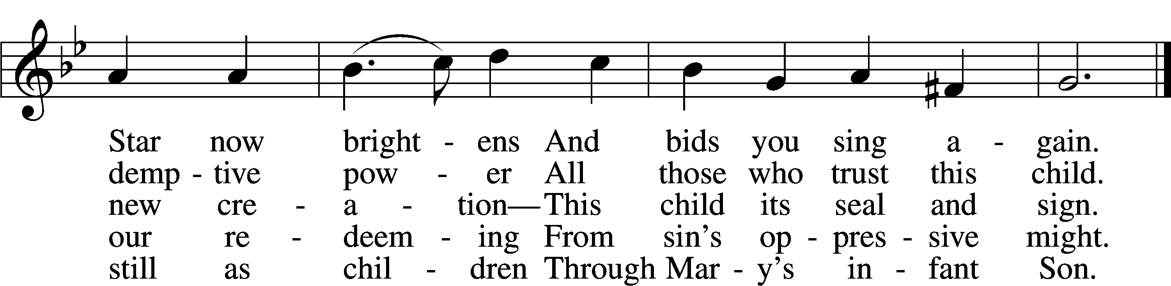
Text: © 1998 GIA Publications, Inc. Used by permission: LSB Hymn License no. 110005047
Tune: Public domain

Nunc Dimittis LSB 199
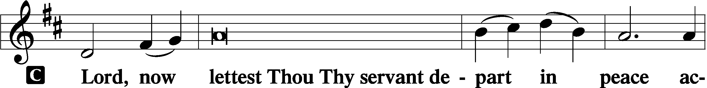

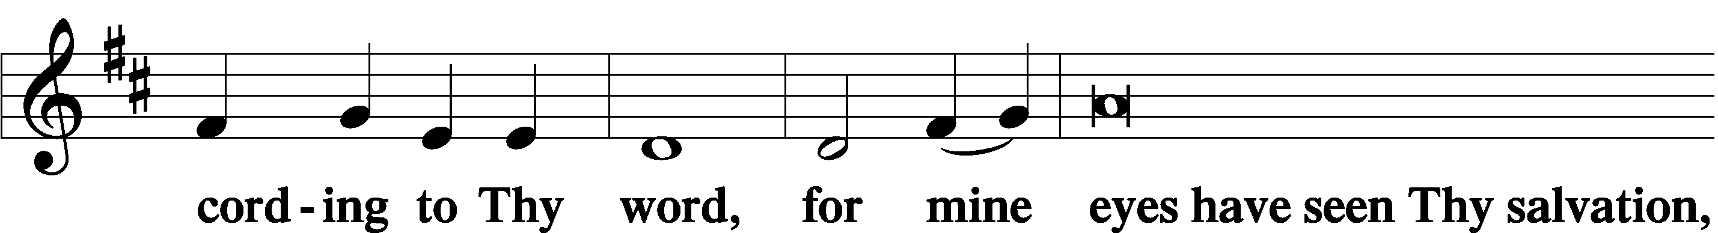

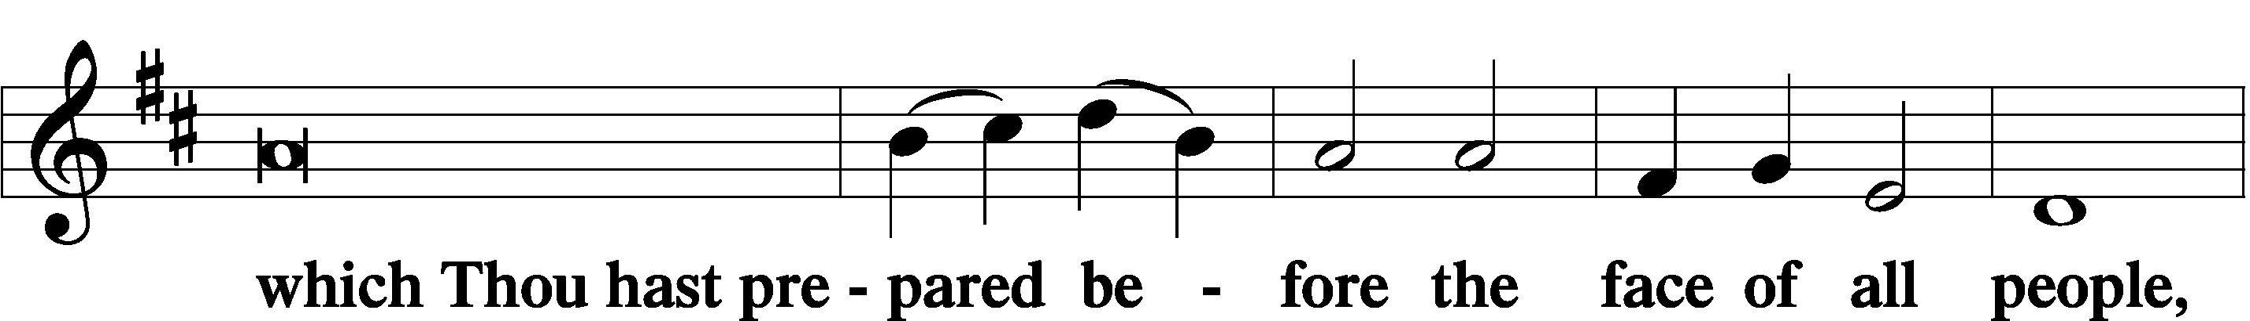

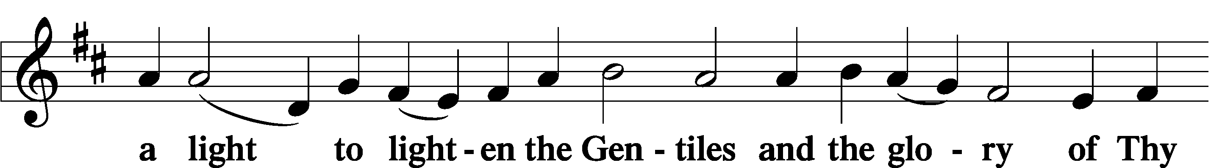

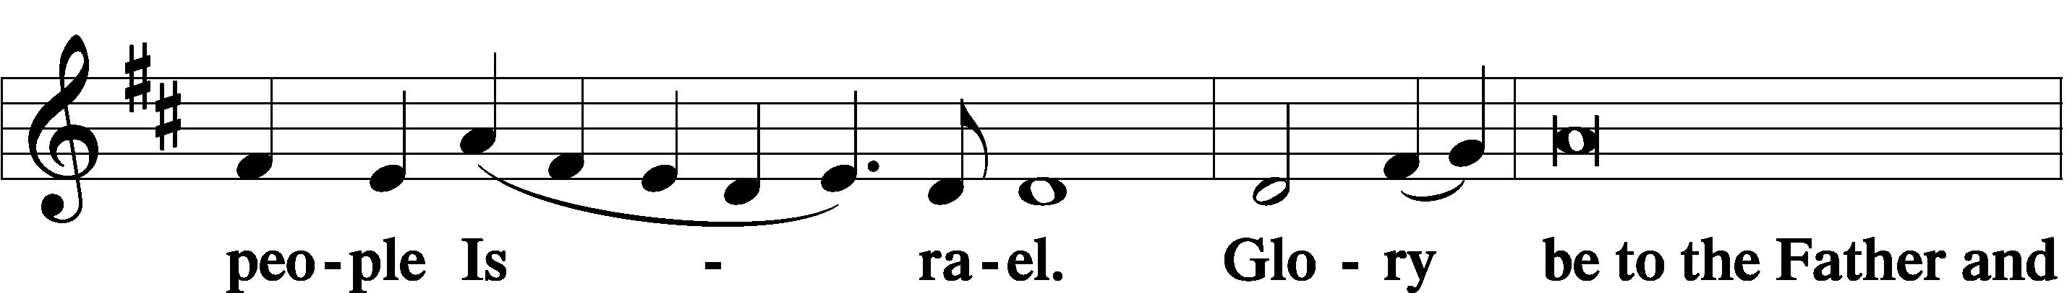

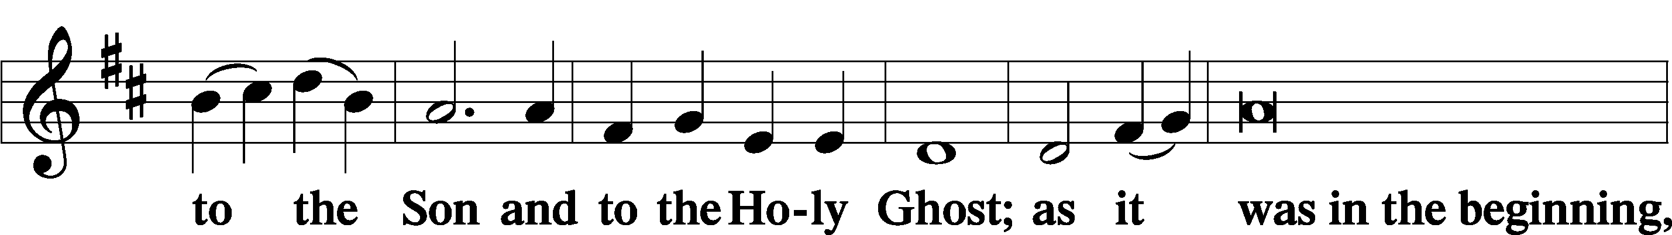

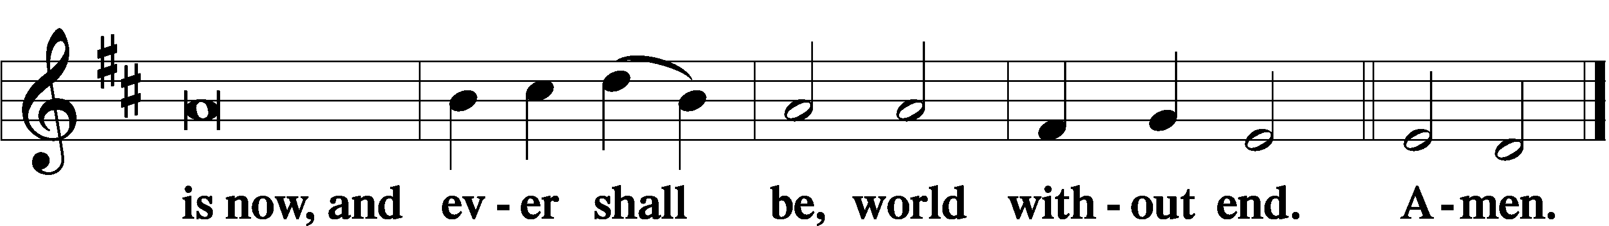

Thanksgiving LSB 200
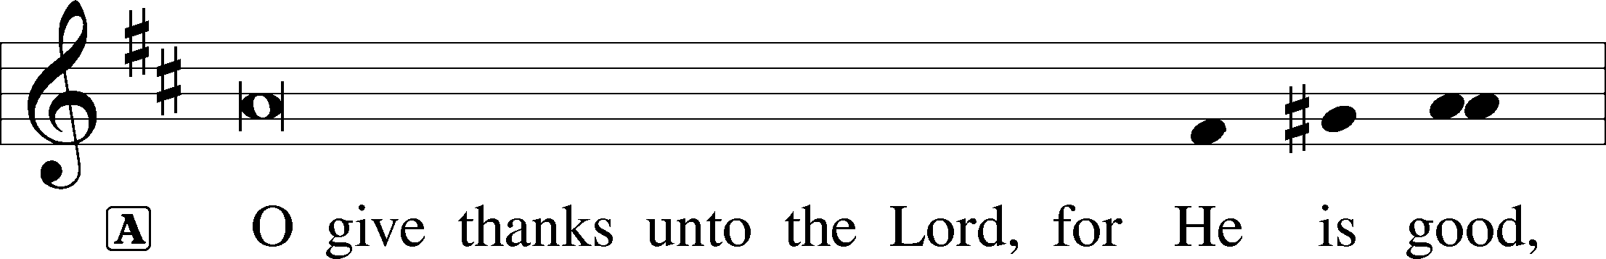

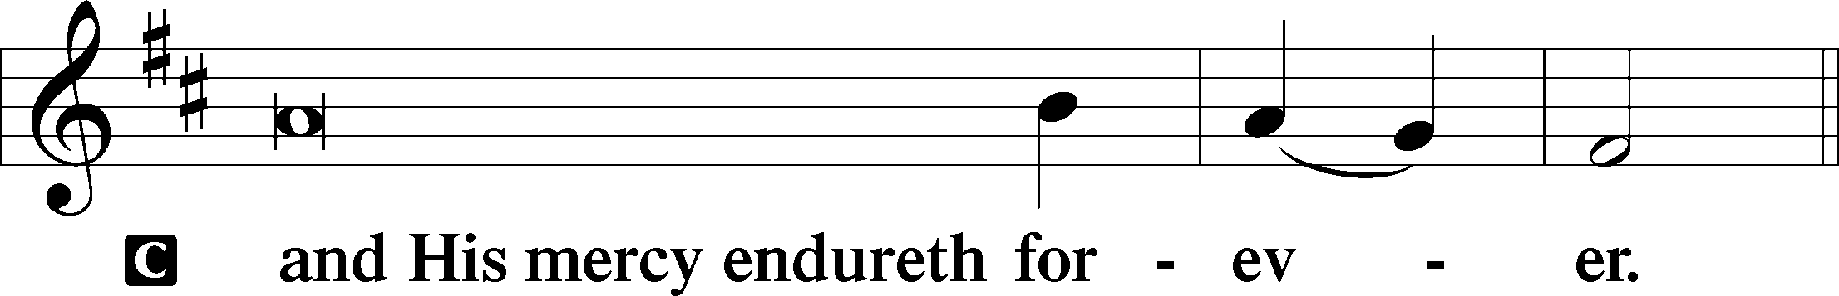

A Let us pray.
O God the Father, the fountain and source of all goodness, who in loving-kindness sent Your only-begotten Son into the flesh, we thank You that for His sake You have given us pardon and peace in this Sacrament, and we ask You not to forsake Your children but always to rule our hearts and minds by Your Holy Spirit that we may be enabled constantly to serve You; through Jesus Christ, Your Son, our Lord, who lives and reigns with You and the Holy Spirit, one God, now and forever.

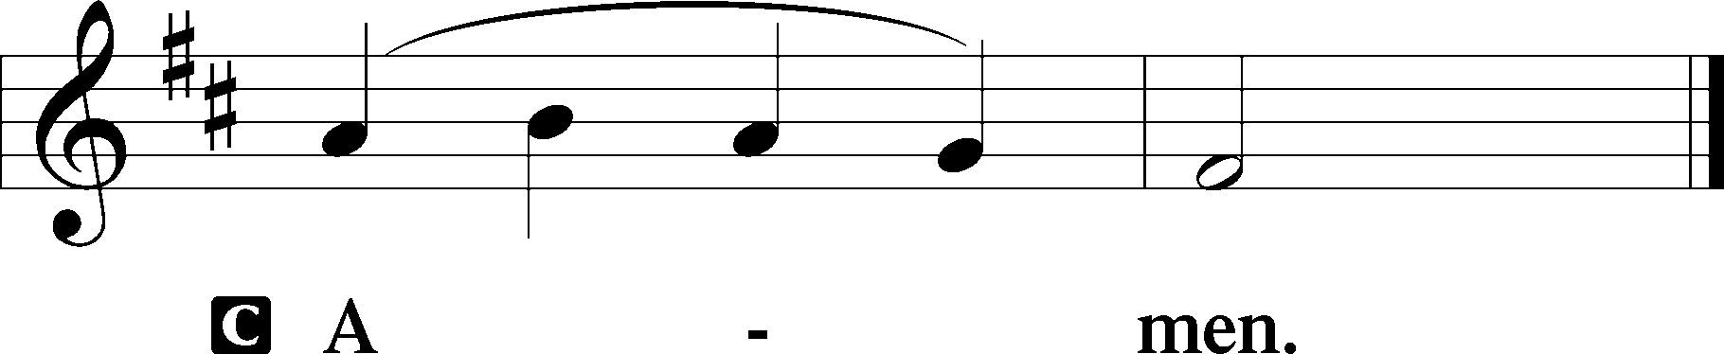

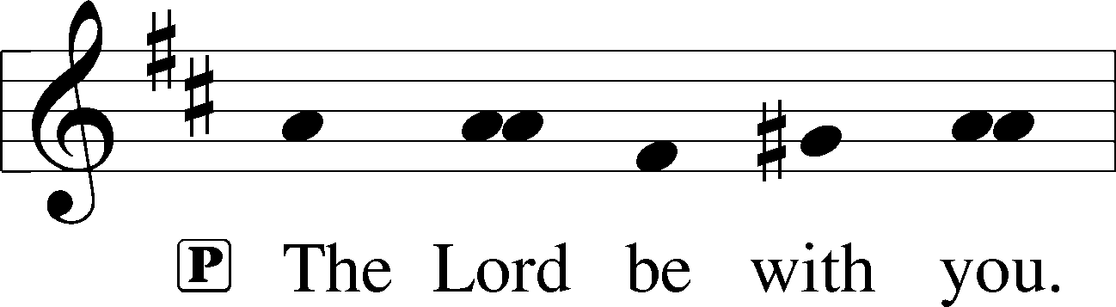

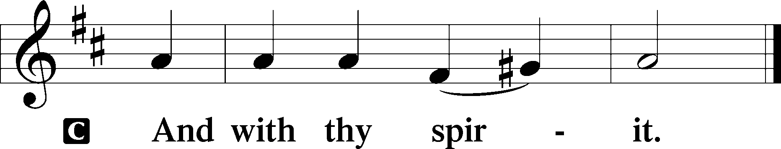
Benedicamus LSB 202
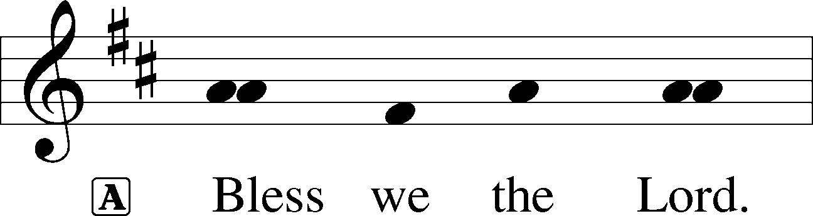

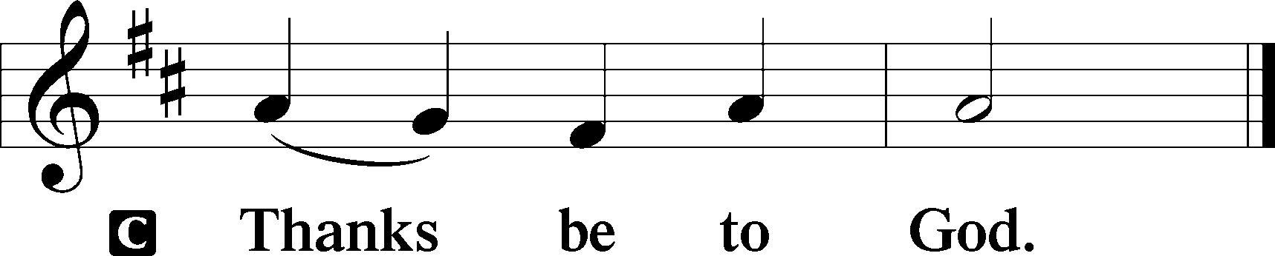

Benediction LSB 202
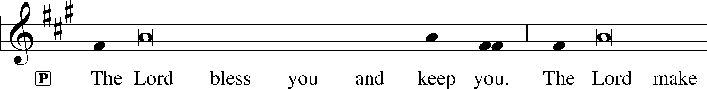
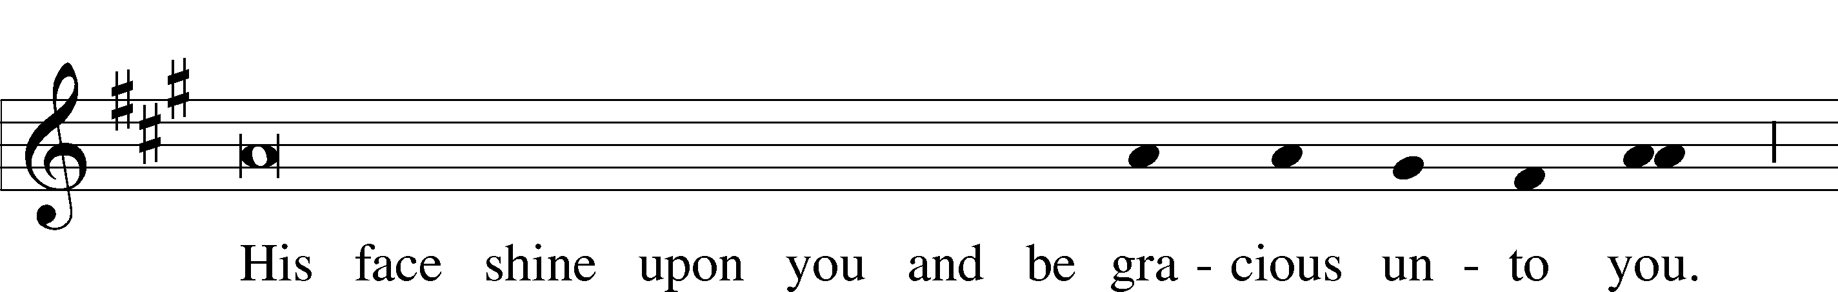
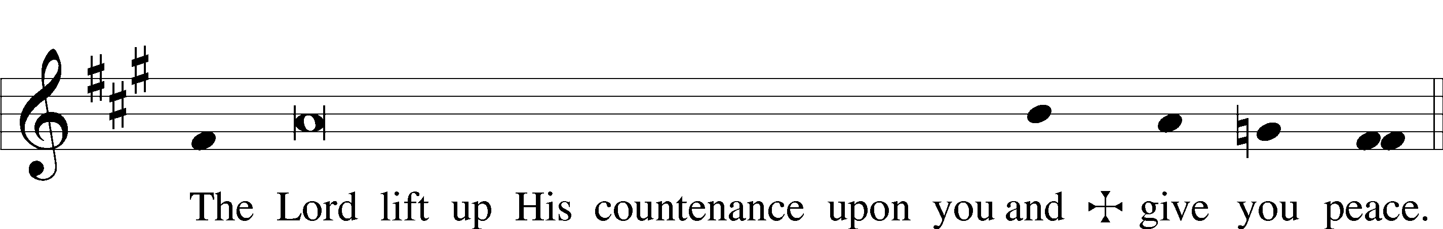

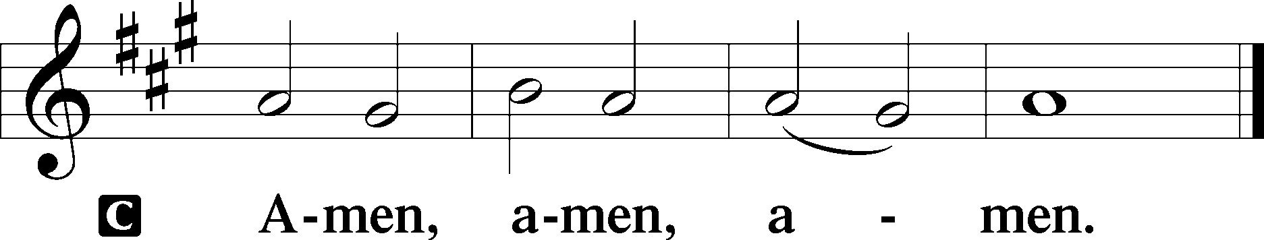

354 Arise, O Christian People
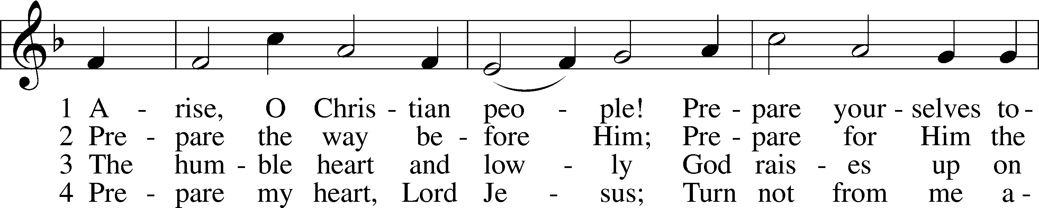
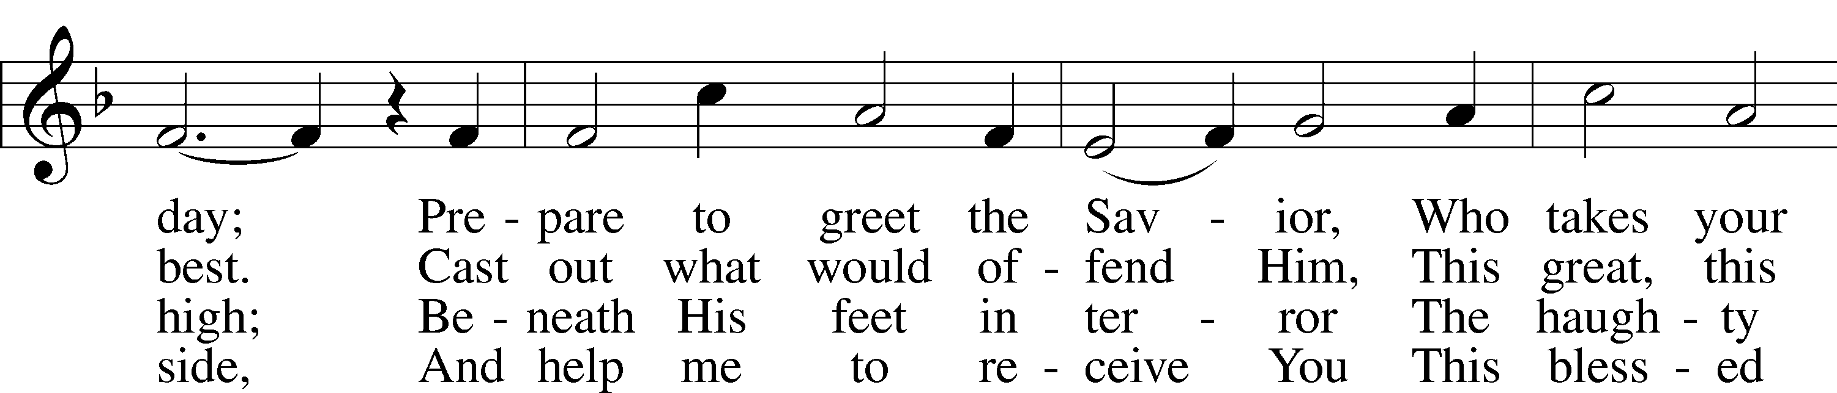
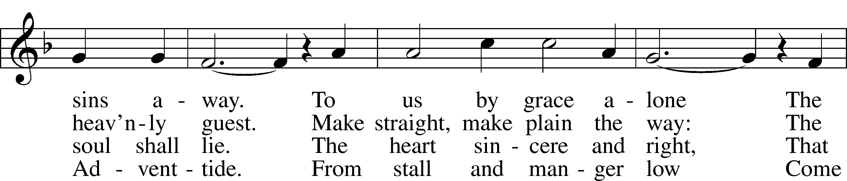
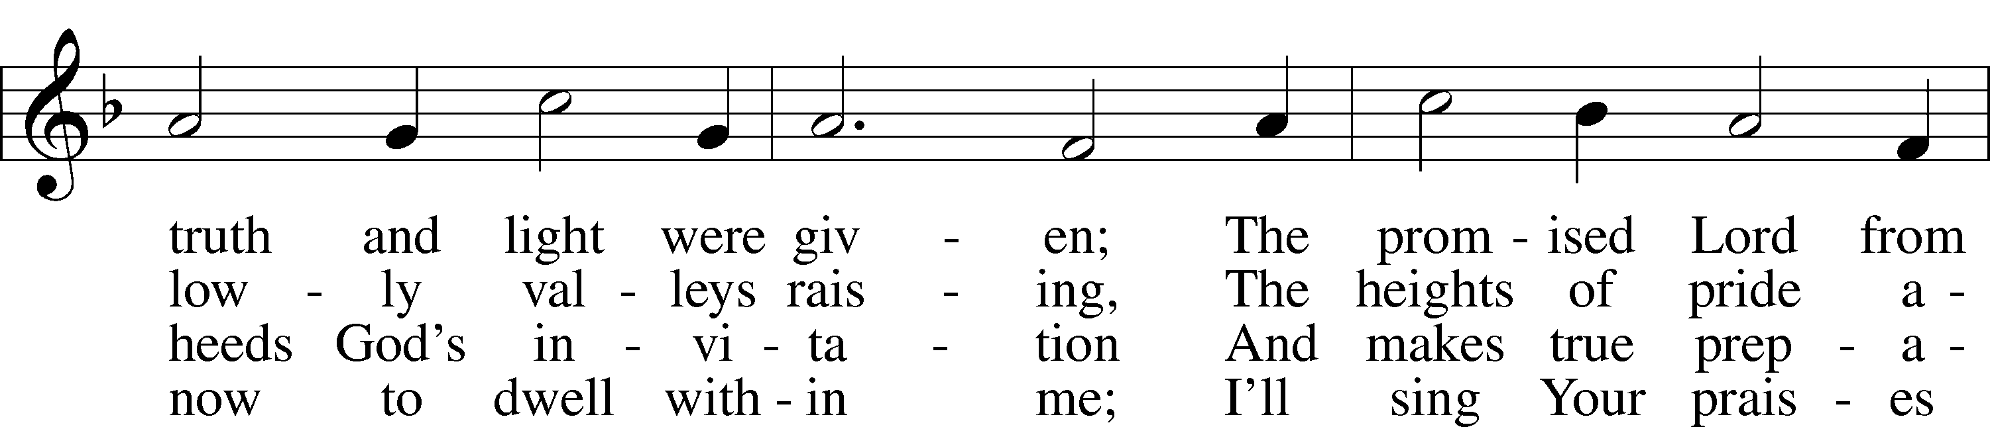
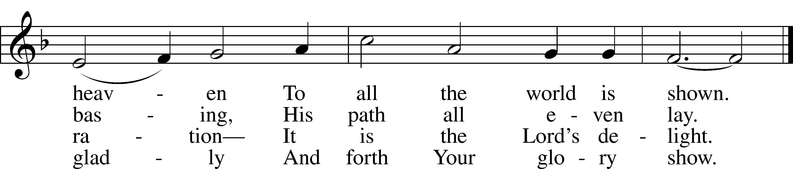
Text and tune: Public domain

Acknowledgments
Divine Service, Setting Three from Lutheran Service Book
Unless otherwise indicated, Scripture quotations are from the ESV® Bible (The Holy Bible, English Standard Version®), copyright © 2001 by Crossway, a publishing ministry of Good News Publishers. Used by permission. All rights reserved.
Created by Lutheran Service Builder © 2020 Concordia Publishing House.
December 20 “In carols of Christmas, you’ll sometimes hear more than gladness that the Child is born on Christmas. You’ll hear of deliverance: ‘Born that man no more may die. Born to raise the sons of earth …’ There is much to ponder before, during, and after Christmas. Let the meaning of Christmas fill our hearts with anticipation, wonder, and thanksgiving for many days! For death’s days are numbered because of a birth—the birth of the Key of David.” James M. Kushiner, Fellowship of St. James – A Life Quote from Lutherans For Life • lutheransforlife.org

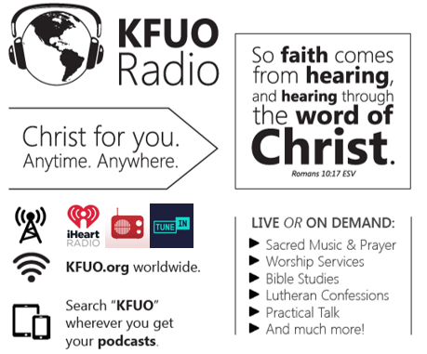

This week on KFUO.org, we begin our special Twelve Days of Christmas programming full of sacred music, scripture, prayers, and special talk segments. Listen to this special programming for the Christmas season from December 24 to January 6!

Gifts of Time and Treasure
“…freely you have received, freely give.”
Matthew 10:8

LAST WEEK’S OFFERINGS LAST WEEK’S ATTENDANCE
General Fund $ 2,904.25 Service 31
Needed Weekly $ 3,963.38 Communed 25
Adult Bible Study $ 6.00

The Lord’s Week

Today 8:45 am – Bible Studies for all ages
(Dec. 20th) 10:00 am – Children’s Program
11:30 am – Confirmation

Wednesday No Service

Thursday 7:00 pm – Christmas Eve Service, part 1
11:00 pm – Christmas Eve Service, part 2
Next Sunday 8:45 am – Bible Studies for all ages
(Dec. 27th) 10:00 am – Divine Service
11:30 am – Confirmation

In His Service

Elder: Devereaux Brewer
Usher: John Larson
Organist: Robert Kunkel
Acolytes: Coco & Collin Utley
Alter: Laura Lopez
Flowers: Happy 1st Birthday Abigail Perkins!

