The Baptism of Our Lord

“Died, Buried, and Resurrected”
Romans 6:1-11

January 10, 2021

Messiah Lutheran Church
Lutheran Church-Missouri Synod
4102 Trinity River Dr., Corpus Christi, Texas 78410

Pastor: Rev. Scott E. Herbert

Church Phone: 361-387-7748 Email: mlc@stx.rr.com
Church Fax: 361-767-1768 Website: www.messiahlcms-cc.org
Pastor Phone: 469-693-9683 Pastor Email: chirev59@gmail.com

WELCOME TO MESSIAH!
We are glad you are here to receive what God is doing for you during Divine Service. Please sign our Guest Book located near the front door. Feel free to converse quietly until the organ prelude begins. If you are looking for a church home, please talk to the Pastor at the door. We would love to have you join us.

Preparing for Service
In Holy Baptism, the Triune God Reveals Himself and Recreates Us in His Image
“In the beginning, God created the heavens and the earth” (Gen. 1:1). Then, as “the Spirit of God was hovering over the face of the waters” (Gen. 1:2), God spoke His Word: “‘Let there be light,’ and there was light” (Gen. 1:3). In the same way, “the beginning of the gospel of Jesus Christ” (Mark 1:1) brings about the new creation through the waters of Baptism by the same Word and Spirit of God. When John the Baptist came, “proclaiming a baptism of repentance for the forgiveness of sins,” Jesus also came “and was baptized by John in the Jordan” (Mark 1:4, 9). Although He had no sins of His own, He took His stand with sinners in His Baptism and took the sins and mortality of the world upon Himself. He was baptized into His own death, by which the heavens are opened and the Spirit is given to us. God the Father is well pleased with His beloved Son and raises Him from the dead. As we share His Baptism and are “united with him in a death like his” (Rom. 6:5), we also share His resurrection unto “newness of life” (Rom. 6:4).
Divine Service, Setting Four
Confession and Absolution

394 Songs of Thankfulness and Praise
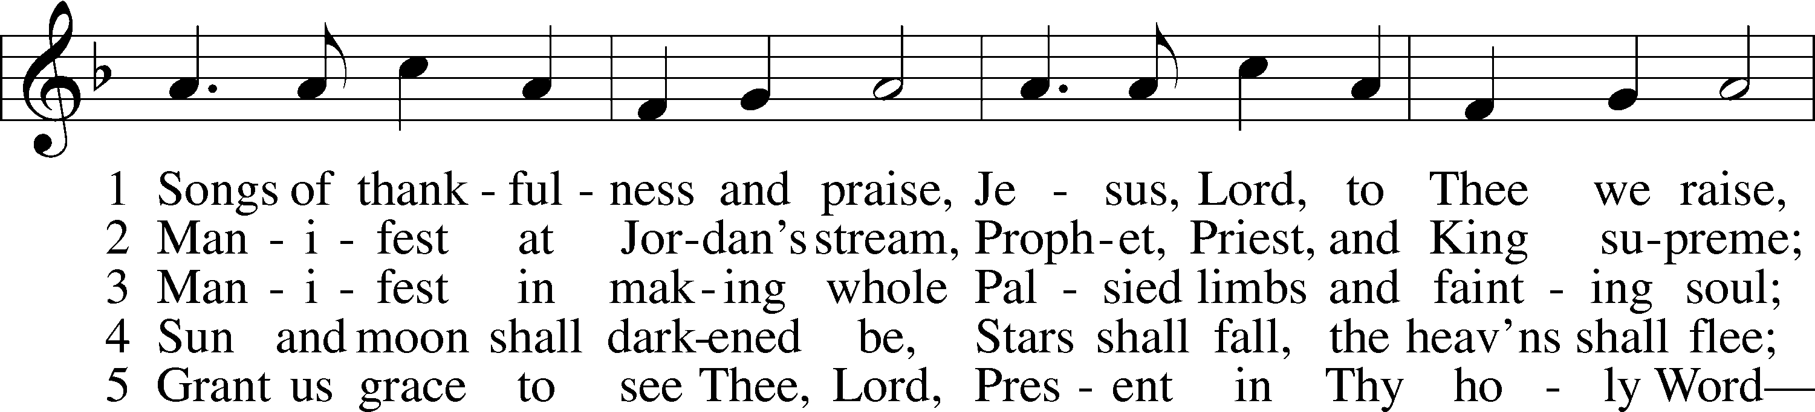
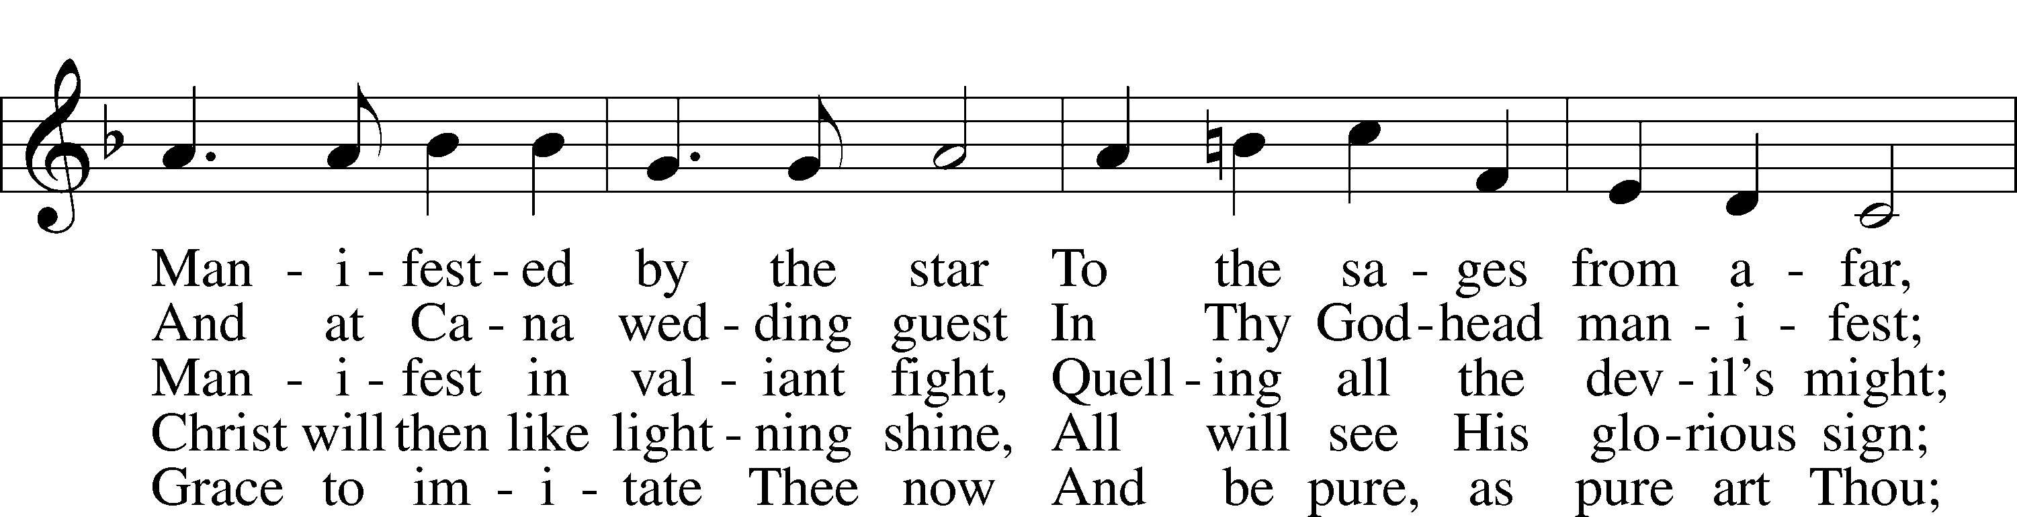
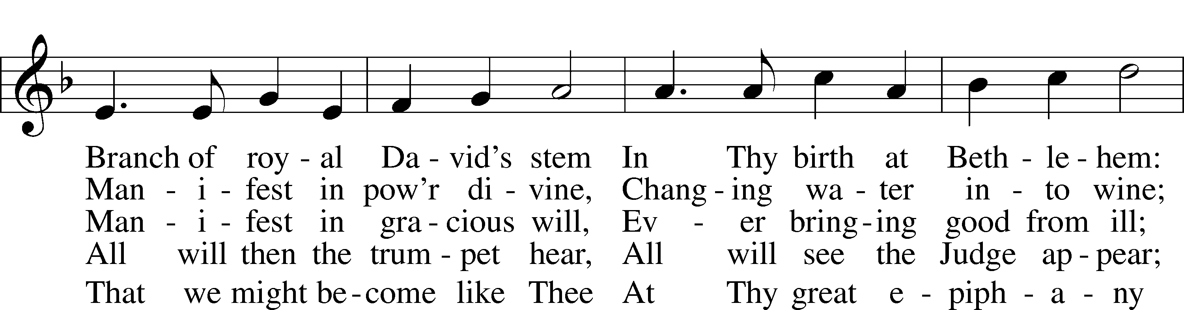
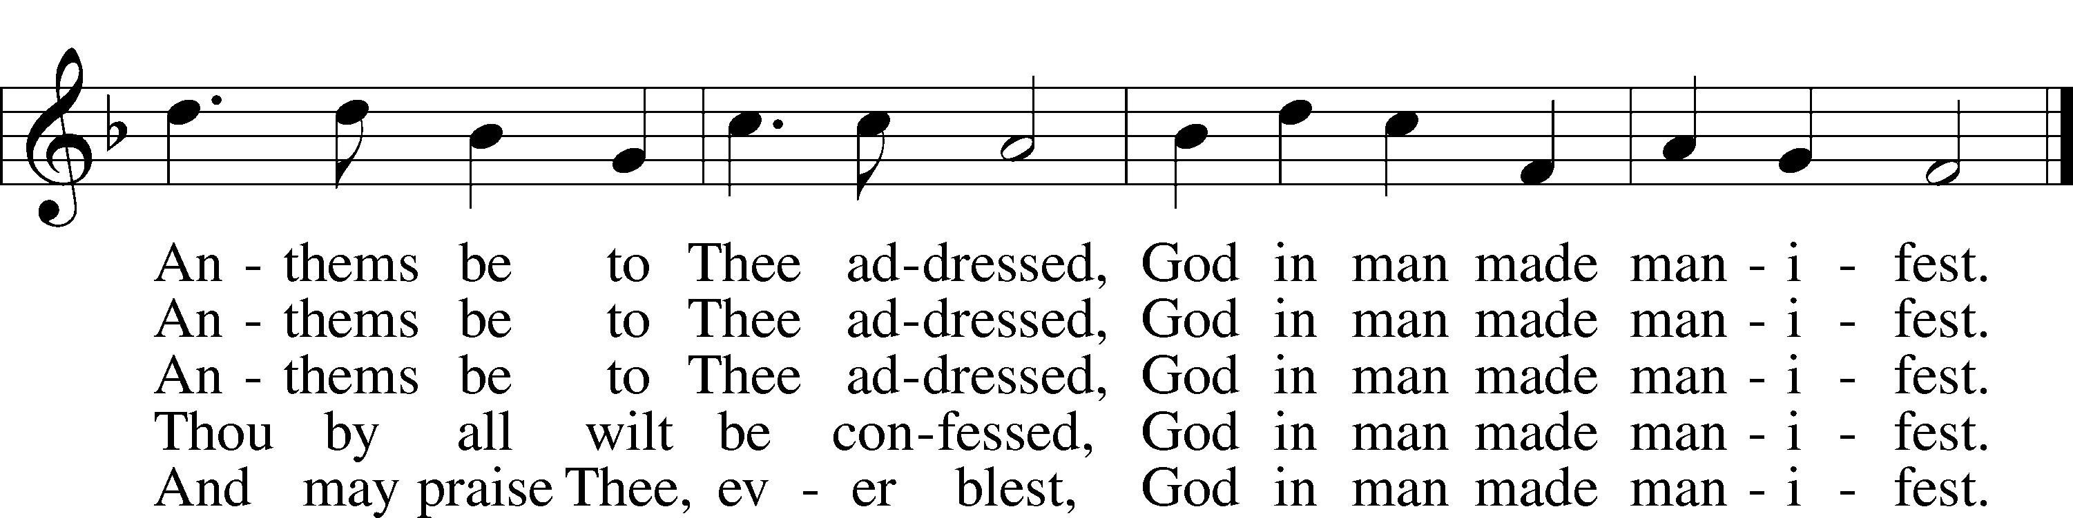
Text and tune: Public domain

P In the name of the Father and of the T Son and of the Holy Spirit.
C Amen.

P Our help is in the name of the Lord,
C who made heaven and earth.

P If You, O Lord, kept a record of sins, O Lord, who could stand?
C But with You there is forgiveness; therefore You are feared.

P Since we are gathered to hear God’s Word, call upon Him in prayer and praise, and receive the body and blood of our Lord Jesus Christ in the fellowship of this altar, let us first consider our unworthiness and confess before God and one another that we have sinned in thought, word, and deed, and that we cannot free ourselves from our sinful condition. Together as His people let us take refuge in the infinite mercy of God, our heavenly Father, seeking His grace for the sake of Christ, and saying: God, be merciful to me, a sinner.

C Almighty God, have mercy upon us, forgive us our sins, and lead us to everlasting life. Amen.

P Almighty God, merciful Father, in Holy Baptism You declared us to be Your children and gathered us into Your one, holy Church, in which You daily and richly forgive us our sins and grant us new life through Your Spirit. Be in our midst, enliven our faith, and graciously receive our prayer and praise; through Your Son, Jesus Christ, our Lord.
C Amen.

Service of the Word

Kyrie LSB 204
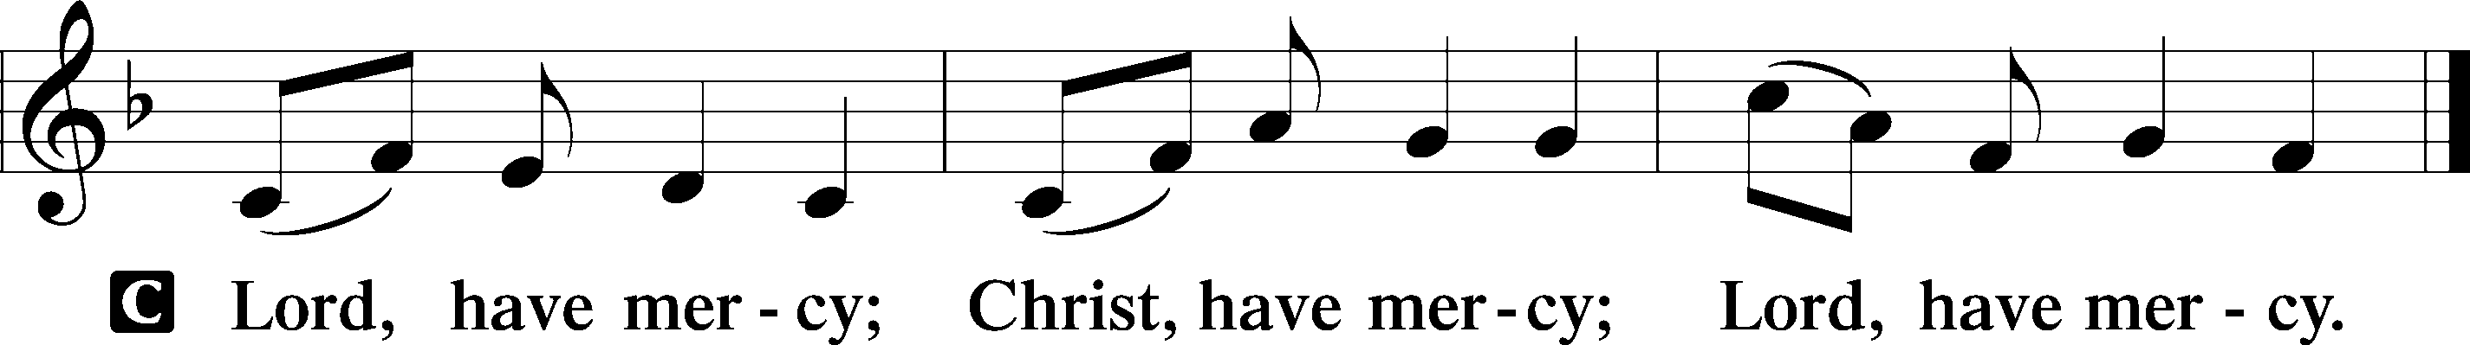

Gloria in Excelsis LSB 204
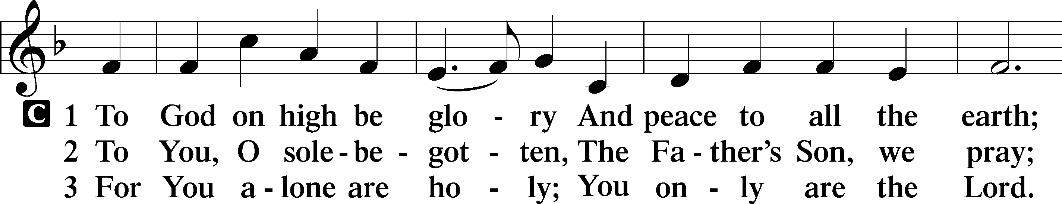
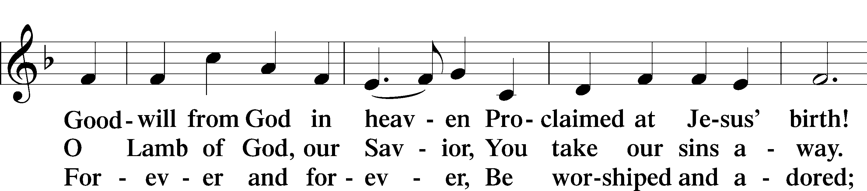
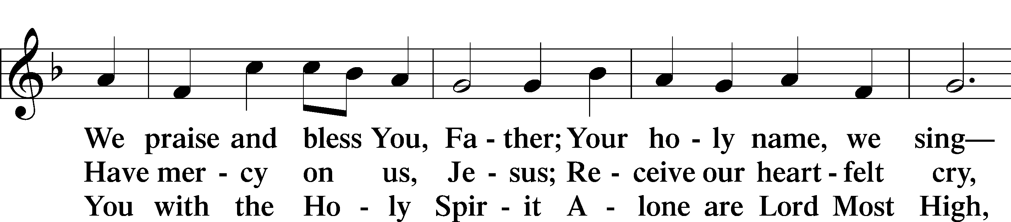
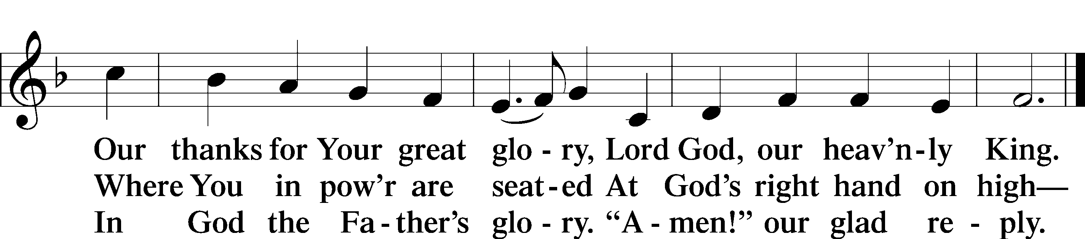

Salutation and Collect of the Day
P The Lord be with you.
C And also with you.

P Let us pray.
Father in heaven, at the Baptism of Jesus in the Jordan River You proclaimed Him Your beloved Son and anointed Him with the Holy Spirit. Make all who are baptized in His name faithful in their calling as Your children and inheritors with Him of everlasting life; through the same Jesus Christ, our Lord, who lives and reigns with You and the Holy Spirit, one God, now and forever.

C Amen.

Old Testament Reading Genesis 1:1–5
1In the beginning, God created the heavens and the earth. 2The earth was without form and void, and darkness was over the face of the deep. And the Spirit of God was hovering over the face of the waters.
3And God said, “Let there be light,” and there was light. 4And God saw that the light was good. And God separated the light from the darkness. 5God called the light Day, and the darkness he called Night. And there was evening and there was morning, the first day.

A This is the Word of the Lord.
C Thanks be to God.

Psalm Psalm 29; antiphon: v. 3
1Ascribe to the Lord, O heavenly beings,
ascribe to the Lord glory and strength.
2Ascribe to the Lord the glory due his name;
worship the Lord in the splendor of holiness.
3The voice of the Lord is over the waters;
the God of glory thunders, the Lord, over many waters.
4The voice of the Lord is powerful;
the voice of the Lord is full of majesty.
5The voice of the Lord breaks the cedars;
the Lord breaks the cedars of Lebanon.
6He makes Lebanon to skip like a calf,
and Sirion like a young wild ox.
7The voice of the Lord
flashes forth flames of fire.
8The voice of the Lord shakes the wilderness;
the Lord shakes the wilderness of Kadesh.
9The voice of the Lord makes the deer give birth
and strips the forests bare, and in his temple all cry, “Glory!”
10The Lord sits enthroned over the flood;
the Lord sits enthroned as king forever.
11May the Lord give strength to his people!
May the Lord bless his people with peace!
Epistle Romans 6:1–11
1What shall we say then? Are we to continue in sin that grace may abound? 2By no means! How can we who died to sin still live in it? 3Do you not know that all of us who have been baptized into Christ Jesus were baptized into his death? 4We were buried therefore with him by baptism into death, in order that, just as Christ was raised from the dead by the glory of the Father, we too might walk in newness of life.
5For if we have been united with him in a death like his, we shall certainly be united with him in a resurrection like his. 6We know that our old self was crucified with him in order that the body of sin might be brought to nothing, so that we would no longer be enslaved to sin. 7For one who has died has been set free from sin. 8Now if we have died with Christ, we believe that we will also live with him. 9We know that Christ being raised from the dead will never die again; death no longer has dominion over him. 10For the death he died he died to sin, once for all, but the life he lives he lives to God. 11So you also must consider yourselves dead to sin and alive to God in Christ Jesus.

A This is the Word of the Lord.
C Thanks be to God.

Alleluia and Verse

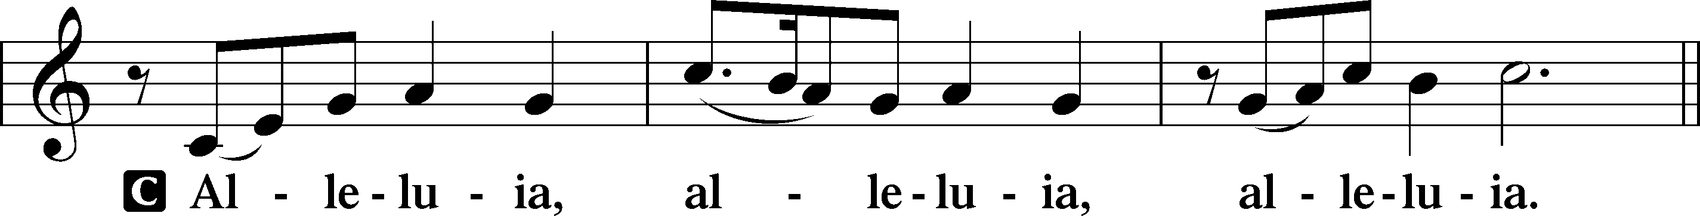
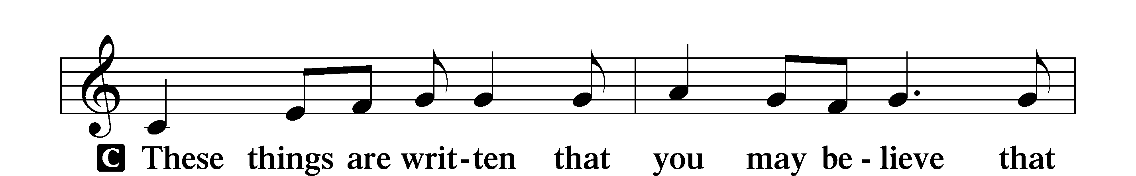
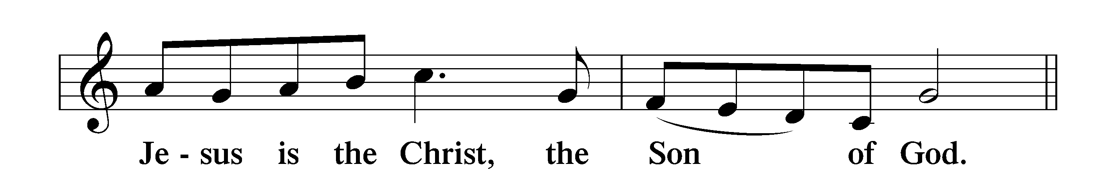
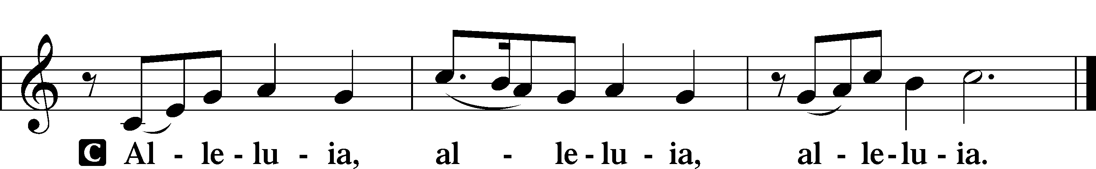
Holy Gospel Mark 1:4–11
P The Holy Gospel according to St. Mark, the first chapter.
C Glory to You, O Lord.

4John appeared, baptizing in the wilderness and proclaiming a baptism of repentance for the forgiveness of sins. 5And all the country of Judea and all Jerusalem were going out to him and were being baptized by him in the river Jordan, confessing their sins. 6Now John was clothed with camel’s hair and wore a leather belt around his waist and ate locusts and wild honey. 7And he preached, saying, “After me comes he who is mightier than I, the strap of whose sandals I am not worthy to stoop down and untie. 8I have baptized you with water, but he will baptize you with the Holy Spirit.”
9In those days Jesus came from Nazareth of Galilee and was baptized by John in the Jordan. 10And when he came up out of the water, immediately he saw the heavens opening and the Spirit descending on him like a dove. 11And a voice came from heaven, “You are my beloved Son; with you I am well pleased.”

P This is the Gospel of the Lord.
C Praise to You, O Christ.

Nicene Creed
C I believe in one God,
the Father Almighty,
maker of heaven and earth
and of all things visible and invisible.

And in one Lord Jesus Christ,
the only-begotten Son of God,
begotten of His Father before all worlds,
God of God, Light of Light,
very God of very God,
begotten, not made,
being of one substance with the Father,
by whom all things were made;
who for us men and for our salvation came down from heaven
and was incarnate by the Holy Spirit of the virgin Mary
and was made man;
and was crucified also for us under Pontius Pilate.
He suffered and was buried.
And the third day He rose again according to the Scriptures
and ascended into heaven
and sits at the right hand of the Father.
And He will come again with glory to judge both the living and the dead,
whose kingdom will have no end.

And I believe in the Holy Spirit,
the Lord and giver of life,
who proceeds from the Father and the Son,
who with the Father and the Son together is worshiped and glorified,
who spoke by the prophets.
And I believe in one holy Christian and apostolic Church,
I acknowledge one Baptism for the remission of sins,
and I look for the resurrection of the dead
and the life T of the world to come. Amen.

Children’s Message A Fresh Start

601 All Who Believe and Are Baptized
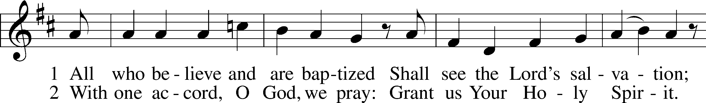
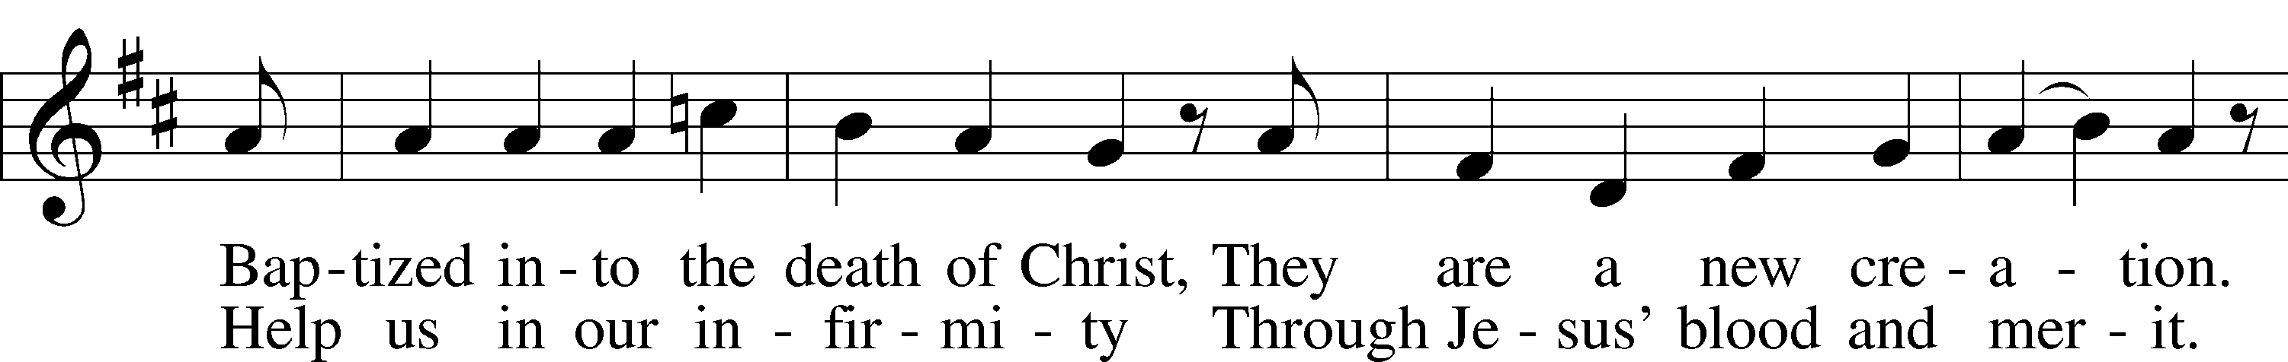
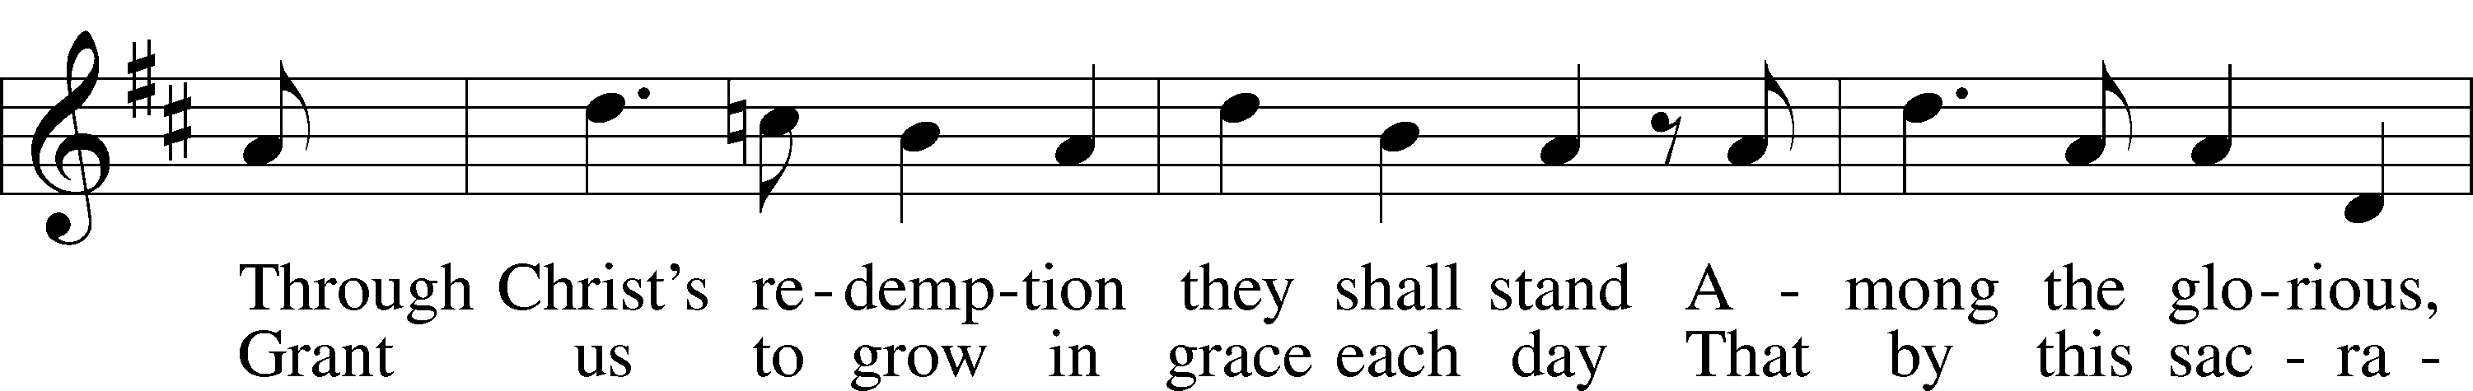
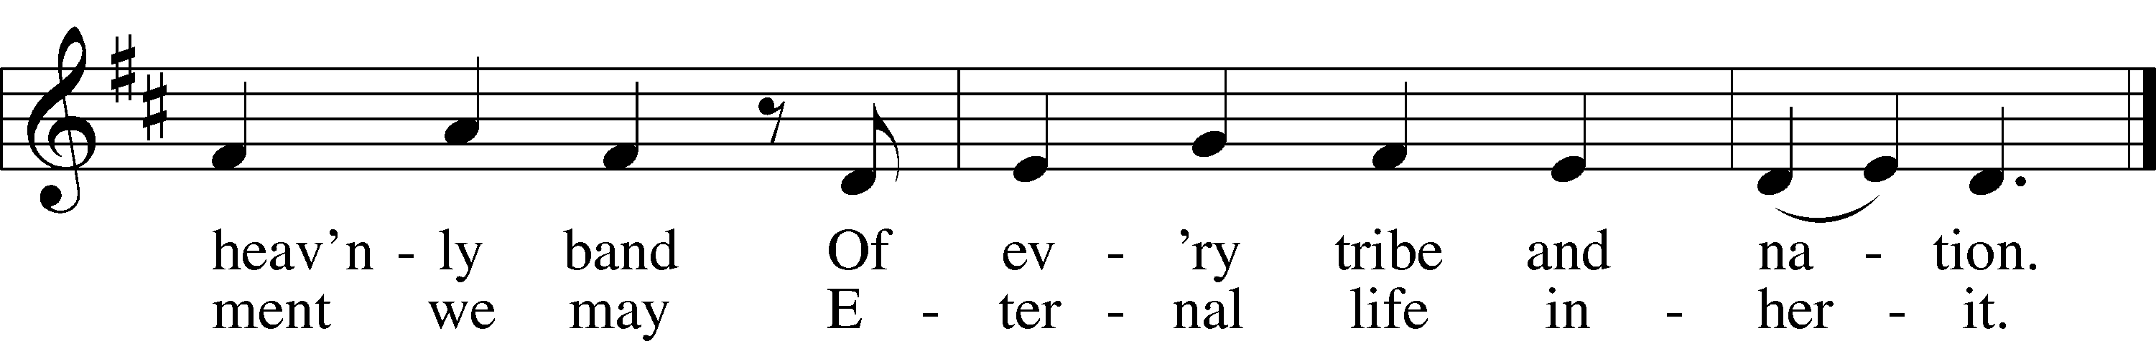
Text and tune: Public domain
Sermon Dead, Buried & Resurrected with Christ - (Romans 6:1-11)

Installation of LWML (Women of Messiah) Officers

Prayer of the Church
P Let us pray for the whole people of God in Christ Jesus and for all people according to their needs.

Dear heavenly Father, in the Jordan River, You revealed Jesus to be Your beloved Son. Lord, by mighty work and wonder,
C reveal Your grace to us.

P Lord, strengthen all those who have been baptized, especially those who have been baptized recently, with Your heavenly protection. Lead them to find their true identity in You as Your beloved sons and daughters. Lord, by mighty work and wonder,
C reveal Your grace to us.

P Lord, comfort all those who are suffering in grief. Console them with the sure and certain hope that just as we have been united with Christ in a death like His, we shall certainly be united with Him in a resurrection like His. Lord, by mighty work and wonder,
C reveal Your grace to us.

P Lord, give courage to all those who live in conflict with their family members, especially regarding differences of faith. Lord, by mighty work and wonder,
C reveal Your grace to us.

P Lord, bless all pastors, church planters, missionaries, and servants in Your Church who proclaim Your Word and administer Your Sacraments. Embolden them to seek and to save the lost and bring those who have strayed back into Your family. Lord, by mighty work and wonder,
C reveal Your grace to us.

P Lord, place Your healing hand upon all who are sick, injured, and recovering. Have mercy upon them, and lead them on the path to health according to Your will. Lord, by mighty work and wonder,
C reveal Your grace to us.

P Lord, we commend all these things to You in the name of Your beloved Son, Jesus. Lord, by mighty work and wonder,
C reveal Your grace to us.

Service of the Sacrament
Preface LSB 208
P The Lord be with you.
C And also with you.

P Lift up your hearts.
C We lift them to the Lord.

P Let us give thanks to the Lord our God.
C It is right to give Him thanks and praise.

P It is truly good, right, and salutary that we should at all times and in all places give thanks to You, O Lord, holy Father, almighty and everlasting God, for the countless blessings You so freely bestow on us and all creation. Above all, we give thanks for Your boundless love shown to us when You sent Your only-begotten Son, Jesus Christ, into our flesh and laid on Him our sin, giving Him into death that we might not die eternally. Because He is now risen from the dead and lives and reigns to all eternity, all who believe in Him will overcome sin and death and will rise again to new life. Therefore with angels and archangels and with all the company of heaven we laud and magnify Your glorious name, evermore praising You and saying:
Sanctus LSB 208
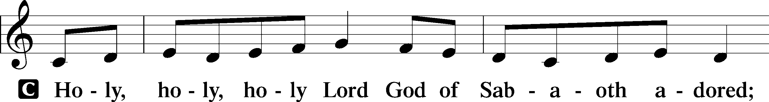
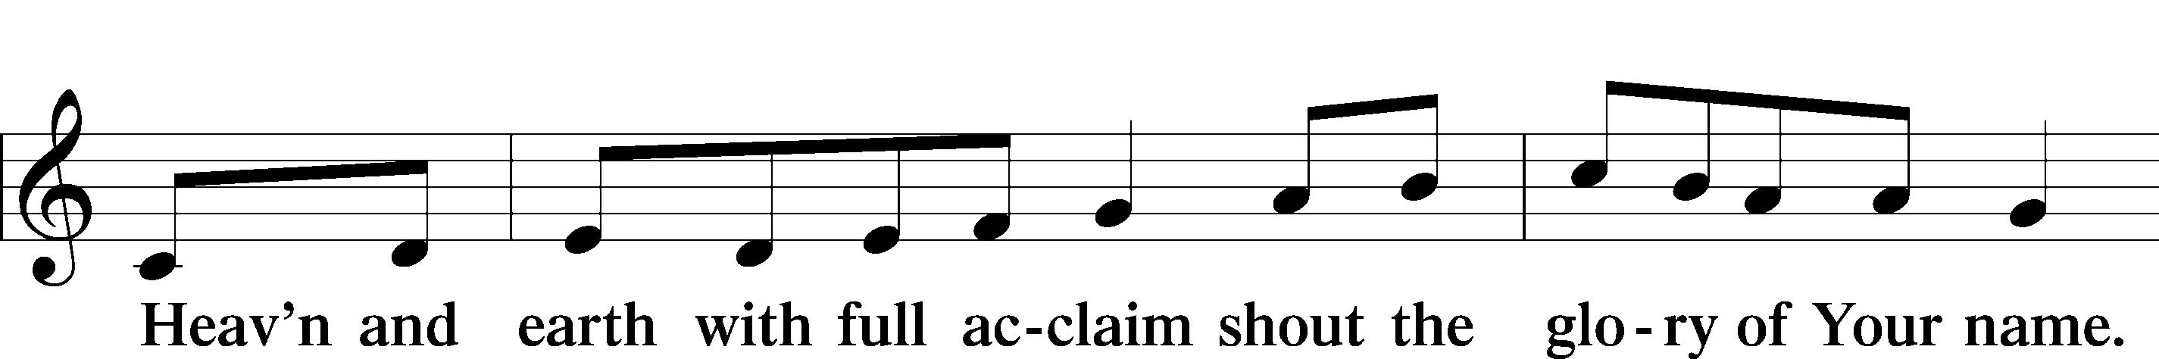
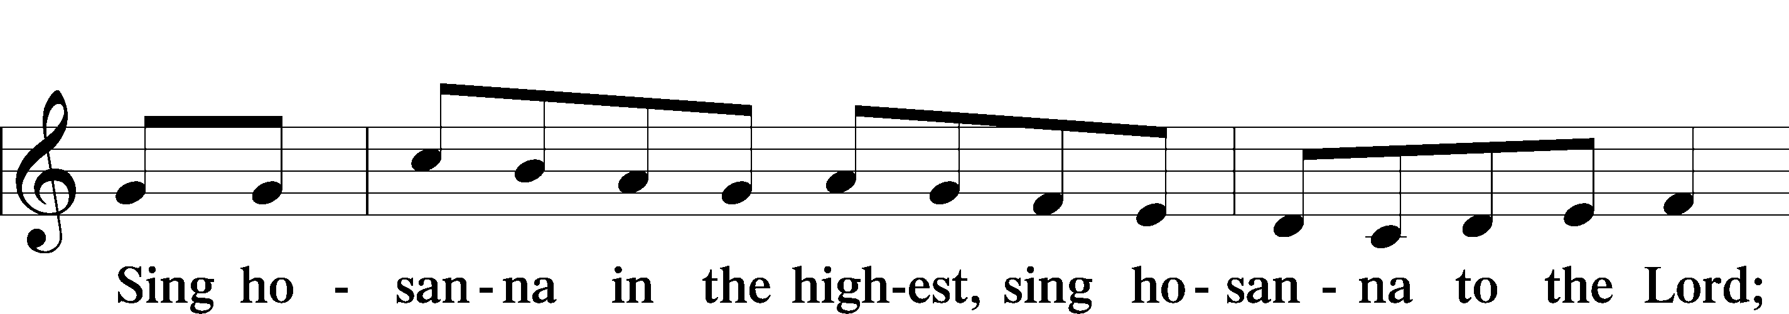
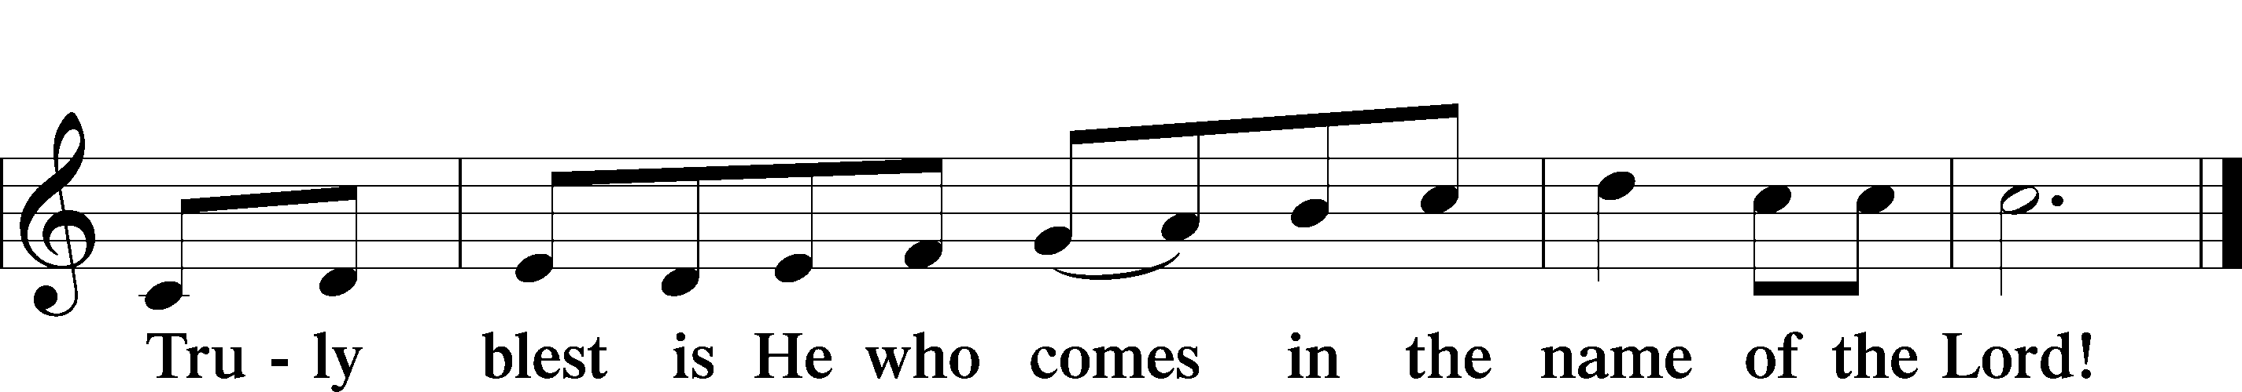

Prayer of Thanksgiving
P Blessed are You, O Lord our God, king of all creation, for You have had mercy on us and given Your only-begotten Son that whoever believes in Him should not perish but have eternal life.

As the glory of Your presence once filled Your ancient temple, so in the incarnation of Your Son, Jesus Christ, You manifested the fullness of Your glory in human flesh.

We give You thanks that in His most Holy Supper You reveal Your glory to us. Grant us faithfully to eat His body and drink His blood so that we may one day behold Your glory face to face.

Hear us as we pray in His name and as He has taught us:

Lord’s Prayer
C Our Father who art in heaven, hallowed be Thy name,
Thy kingdom come,
Thy will be done on earth as it is in heaven;
give us this day our daily bread;
and forgive us our trespasses
as we forgive those who trespass against us;
and lead us not into temptation,
but deliver us from evil.
For Thine is the kingdom and the power and the glory
forever and ever. Amen.

The Words of Our Lord
P Our Lord Jesus Christ, on the night when He was betrayed, took bread, and when He had given thanks, He broke it and gave it to the disciples and said: “Take, eat; this is My T body, which is given for you. This do in remembrance of Me.”

In the same way also He took the cup after supper, and when He had given thanks, He gave it to them, saying: “Drink of it, all of you; this cup is the new testament in My T blood, which is shed for you for the forgiveness of sins. This do, as often as you drink it, in remembrance of Me.”

Pax Domini
P The peace of the Lord be with you always.
C Amen.

Agnus Dei LSB 210
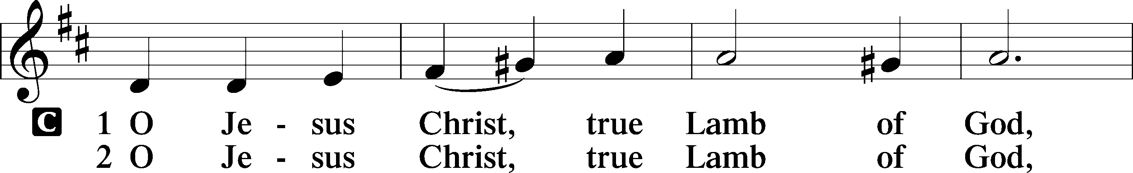
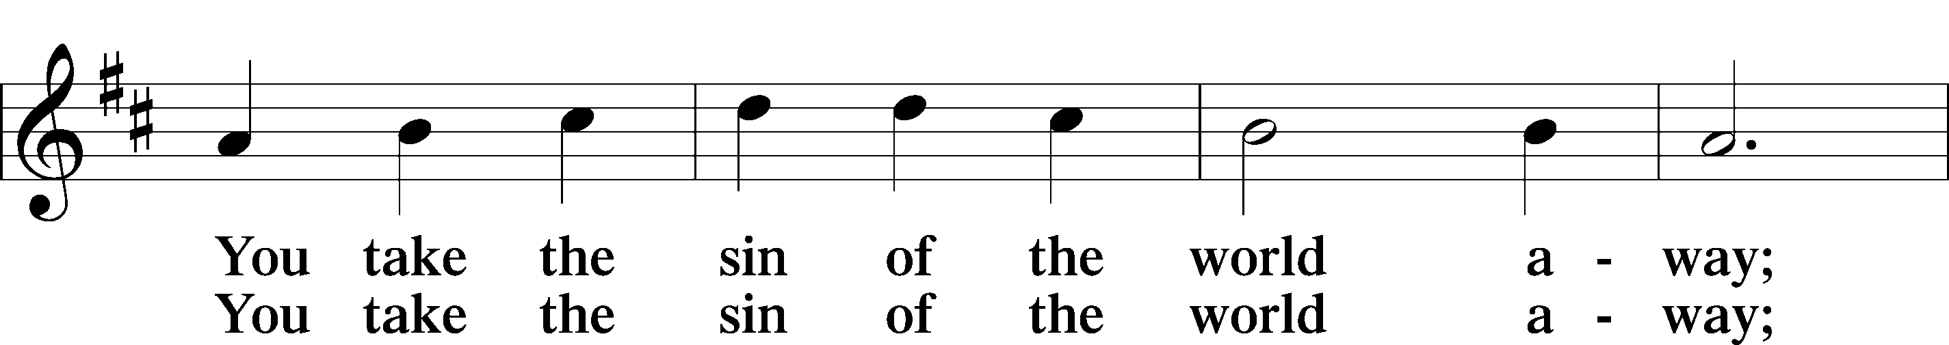
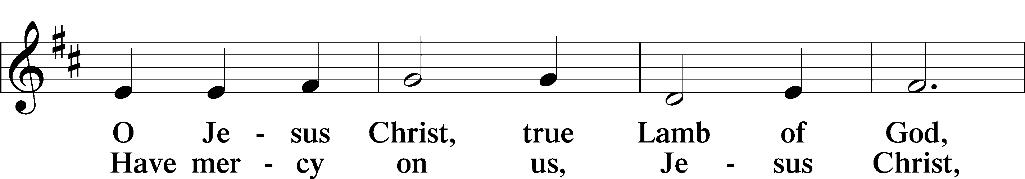
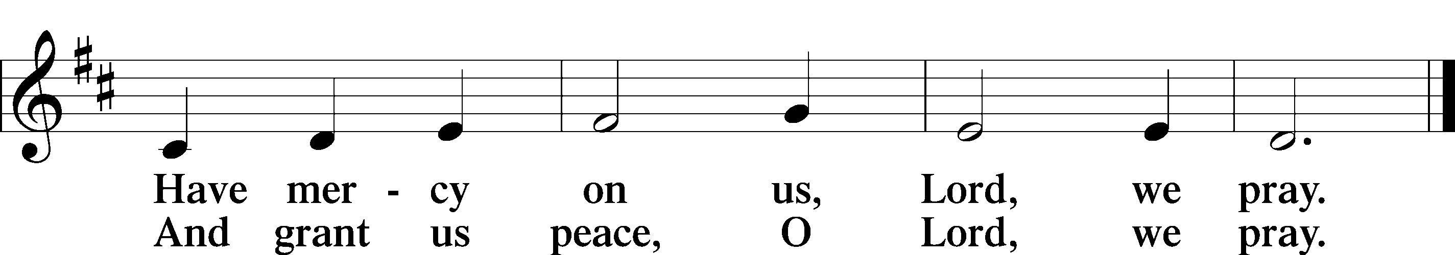
Distribution

624 The Infant Priest Was Holy Born
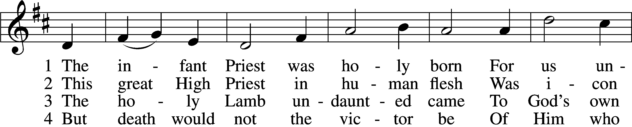
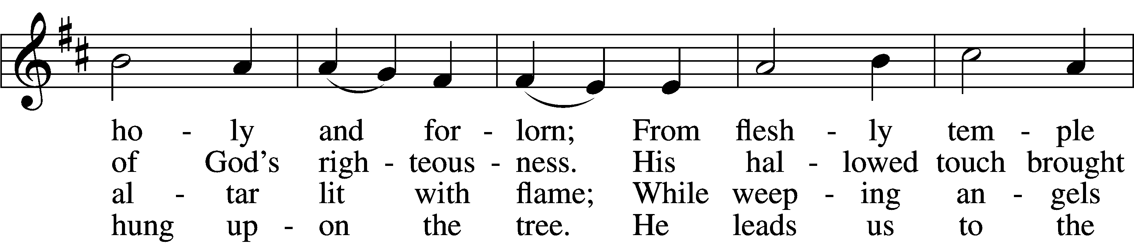
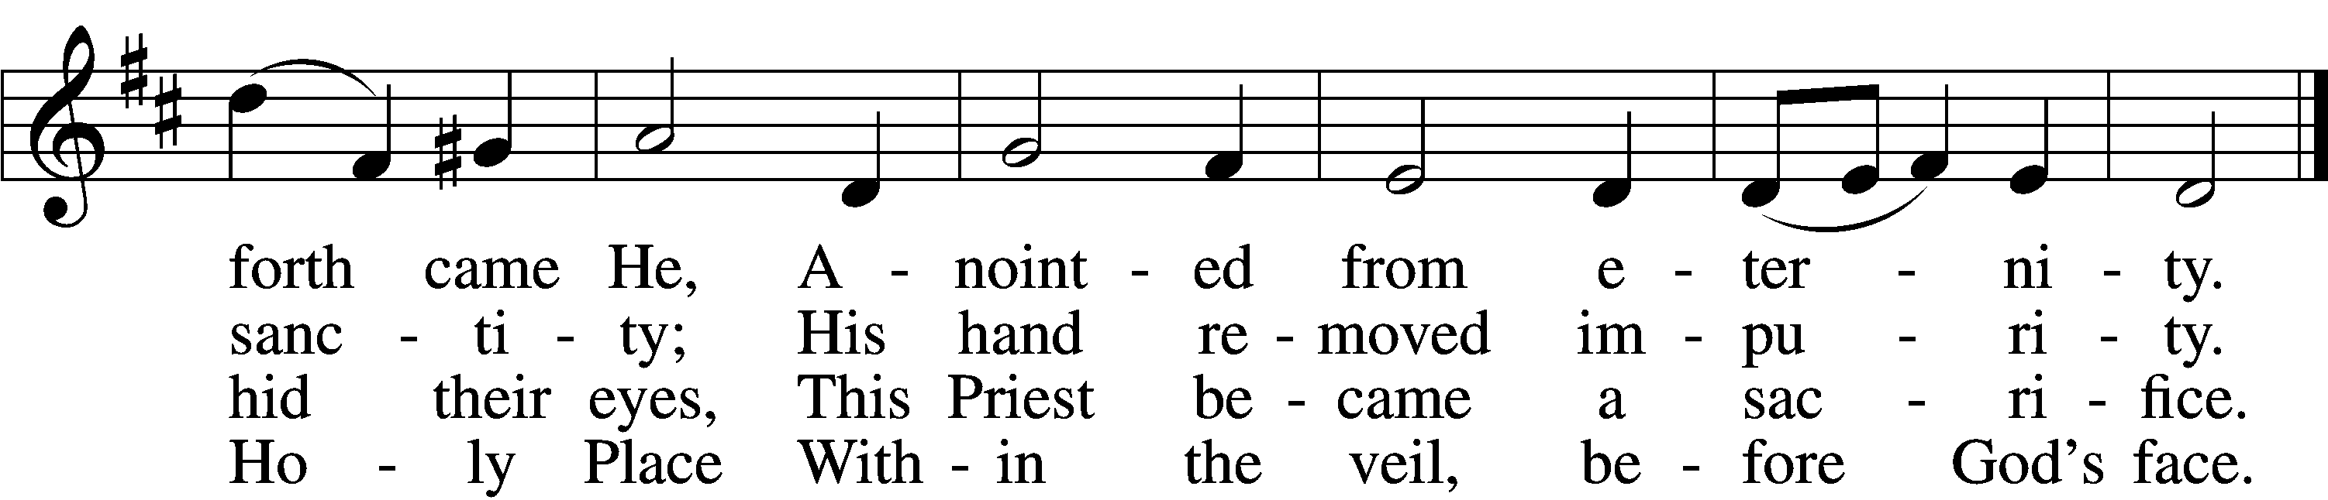

5 The veil is torn, our Priest we see,
As at the rail on bended knee
Our hungry mouths from Him receive
The bread of immortality.

6 The body of God’s Lamb we eat,
A priestly food and priestly meat;
On sin-parched lips the chalice pours
His quenching blood that life restores.

7 With cherubim and seraphim
Our voices join the endless hymn,
And “Holy, holy, holy” sing
To Christ, God’s Lamb, our Priest and King.
Text: © 1997, 2003 Chad L. Bird. Used by permission: LSB Hymn License no. 110005047.
Tune: Public domain

Nunc Dimittis LSB 211
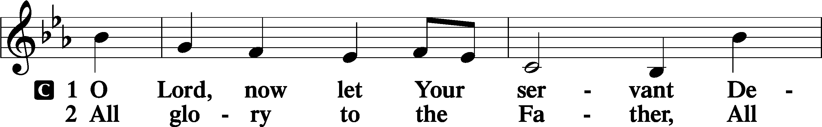
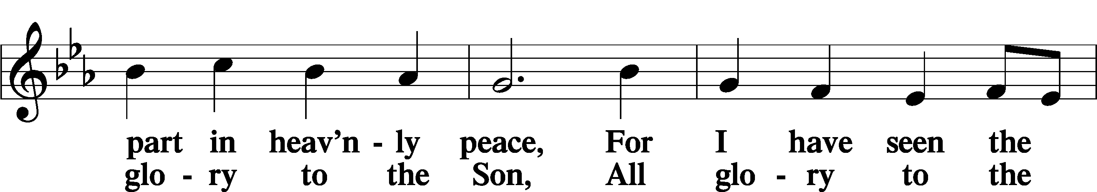
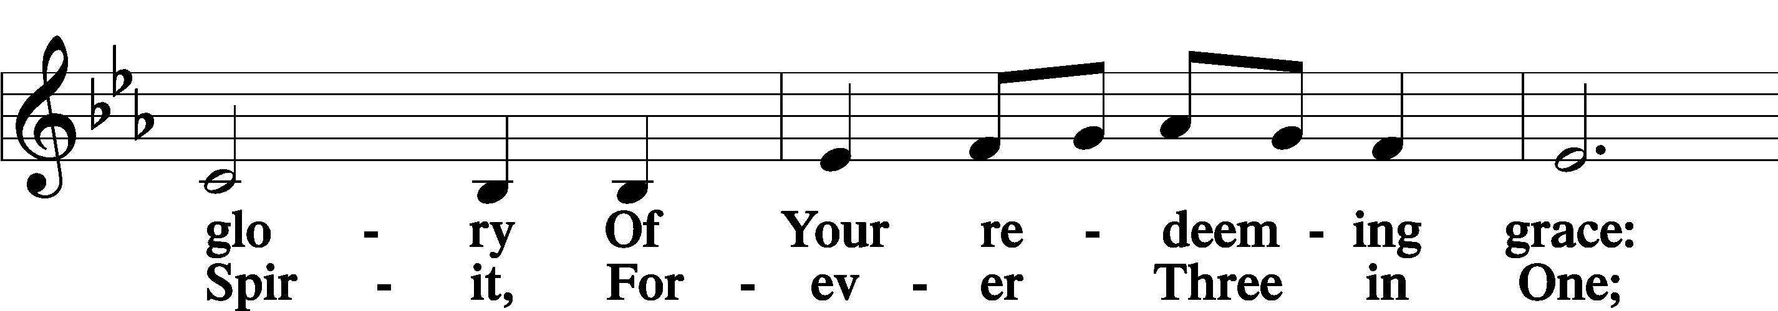
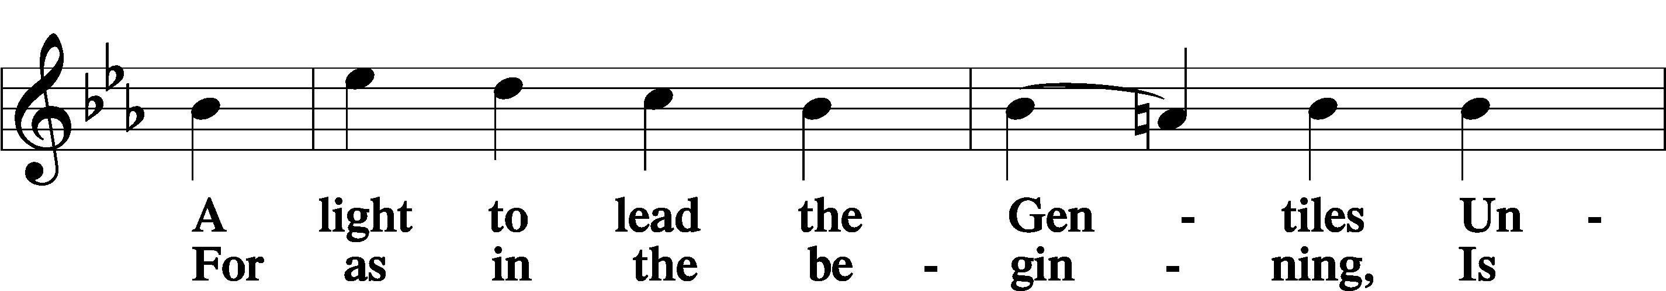
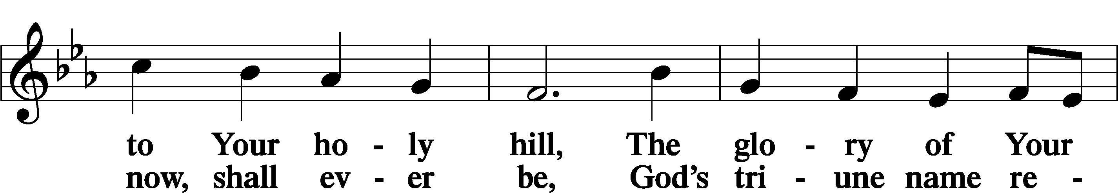
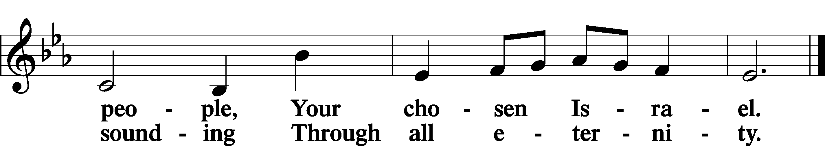

Post-Communion Collect
A Let us pray.
We give thanks to You, almighty God, that You have refreshed us through this salutary gift, and we implore You that of Your mercy You would strengthen us through the same in faith toward You and in fervent love toward one another; through Jesus Christ, Your Son, our Lord, who lives and reigns with You and the Holy Spirit, one God, now and forever.
C Amen.

Benedicamus LSB 212
A Let us bless the Lord.
C Thanks be to God.

Benediction
P The Lord bless you and keep you.
The Lord make His face shine on you and be gracious to you.
The Lord look upon you with favor and T give you peace.
C Amen.

839 O Christ, Our True and Only Light
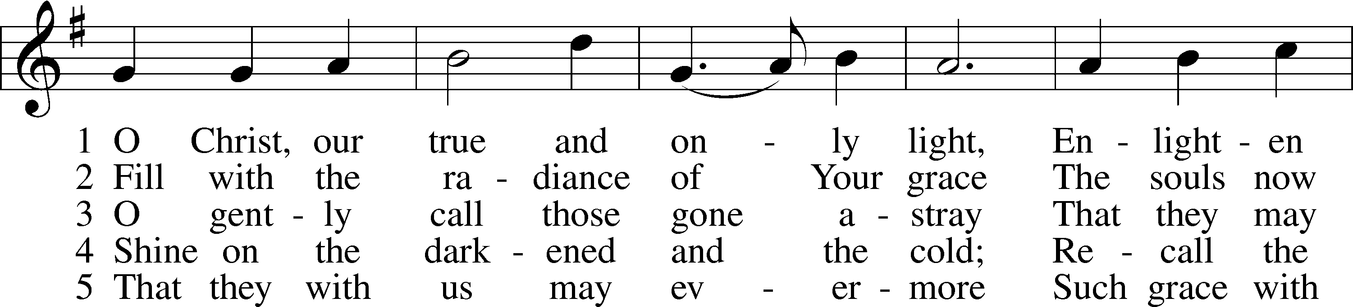
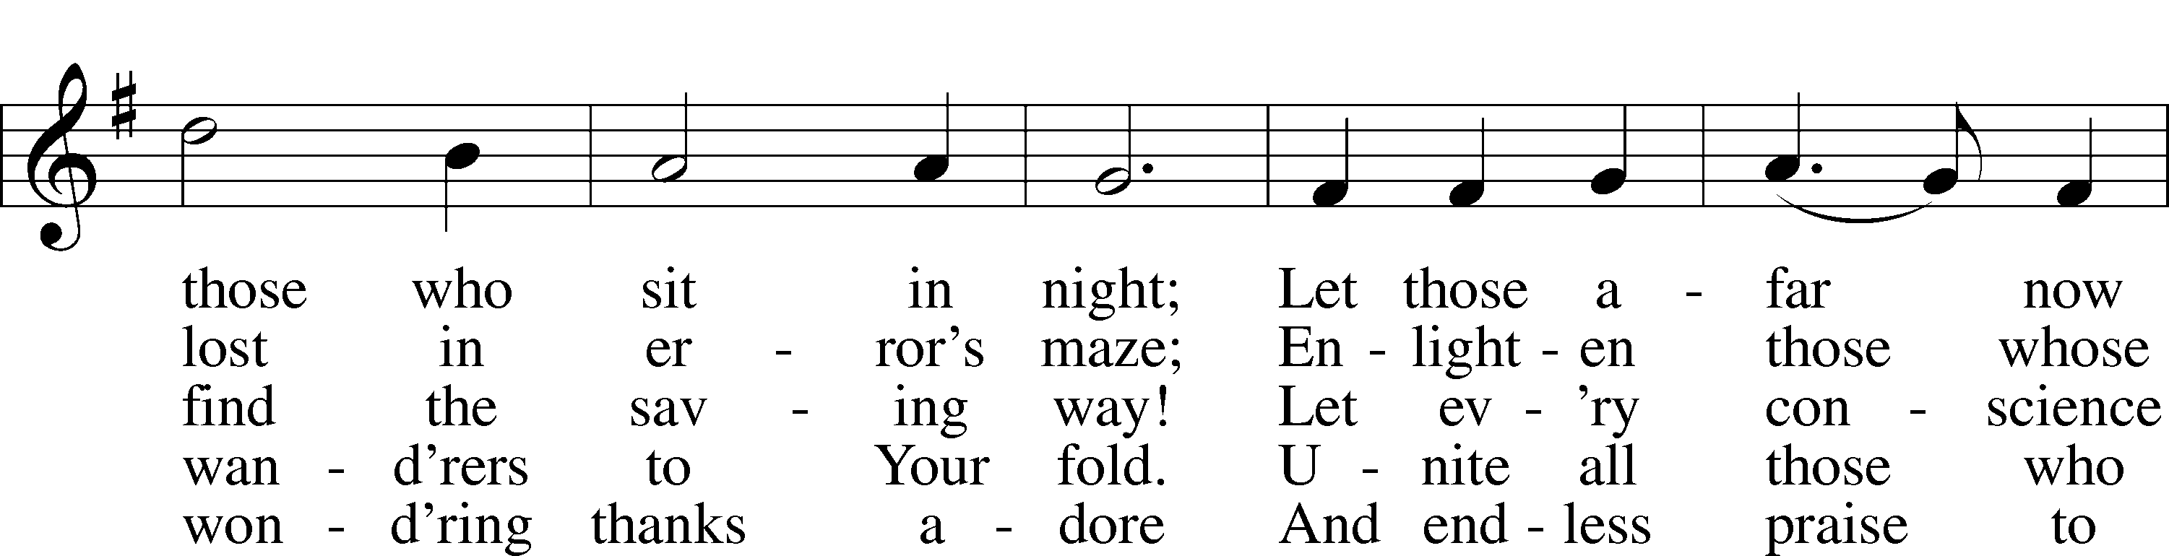
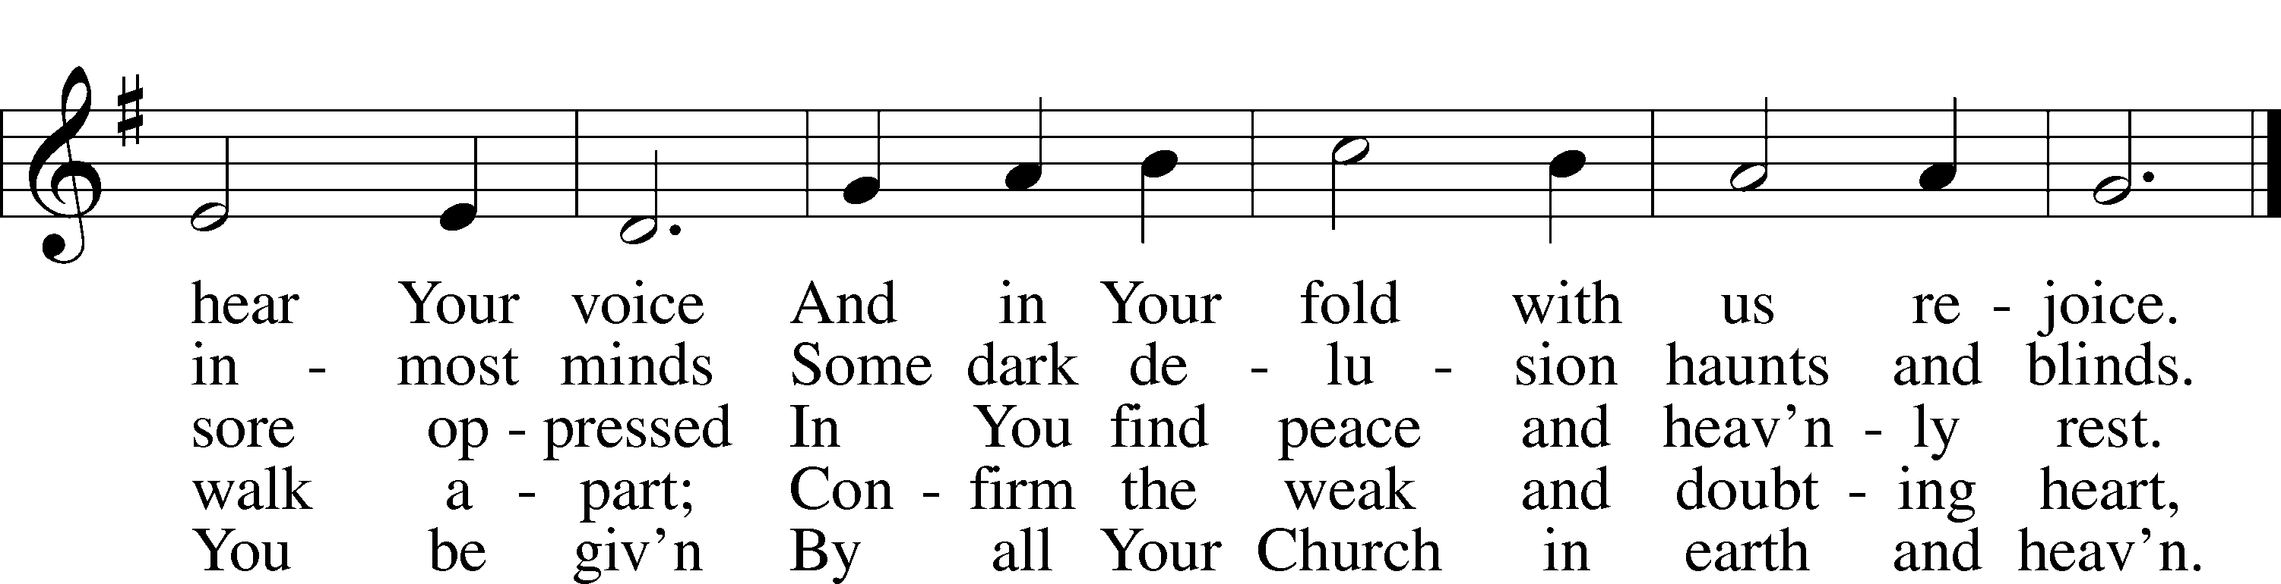
Tune and text: Public domain

Acknowledgments
Divine Service, Setting Four from Lutheran Service Book
Unless otherwise indicated, Scripture quotations are from the ESV® Bible (The Holy Bible, English Standard Version®), copyright © 2001 by Crossway, a publishing ministry of Good News Publishers. Used by permission. All rights reserved.
Created by Lutheran Service Builder © 2020 Concordia Publishing House.

January 10 “The world needs your voice to declare Jesus’ words of eternal life. The world needs your voice to declare God’s value of life in all of its stages. The world needs your voice to declare God’s convictions born of His Word. The world needs your voice to declare that God’s word of forgiveness purchased with the blood of Jesus extends to all of us sinners, including those who have chosen abortion. The world needs your voice!” Rev. David Eibel, Living Word Lutheran Church, Grapevine, Texas – A Life Quote from Lutherans For Life • lutheransforlife.org

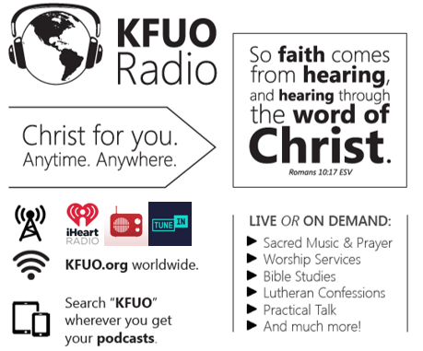

This week on KFUO.org, study the Gospel of Mark on Sharper Iron (weekdays at 8:00 a.m. CT), continue in 2 Corinthians on Thy Strong Word (weekdays at 11:00 a.m. CT), and take a moment in creation, scripture, faith, and family on Midday Moments (weekdays at 12:00 p.m. CT). Find these programs on demand at kfuo.org or your favorite podcasting app.

Gifts of Time and Treasure
“…from everyone who has been given much, much will be demanded…
Luke 12:48

LAST WEEK’S OFFERINGS LAST WEEK’S ATTENDANCE
General Fund $ 9,253.59 Service 33
Needed Weekly $ 3,963.38 Communed 30
Adult Bible Study $ 11.00

The Lord’s Week

Today 8:45 am – Bible Studies for all ages
(Jan. 10th) 10:00 am – Divine Service
11:30 am – Confirmation

Wednesday 10:00 am – Women’s Bible Study

Next Sunday 8:45 am – Bible Studies for all ages
(Jan. 17th) 10:00 am – Divine Service w/Installation of LWML Officers
11:30 am – Confirmation

In His Service

Elder: Justin Perkins
Usher: John Larson, Jason Schrader
Acolytes: Noah Denton, Kaylee Larson
Organist: Sharon Schrader
Alter: Laura Lopez
Flowers:

