The Confession of St. Peter
Divine Service, Setting Four
“You Are the Christ”
Mark 8:27-35

January 17, 2021

Messiah Lutheran Church
Lutheran Church-Missouri Synod
4102 Trinity River Dr., Corpus Christi, Texas 78410

Pastor: Rev. Scott E. Herbert

Church Phone: 361-387-7748 Email: mlc@stx.rr.com
Church Fax: 361-767-1768 Website: www.messiahlcms-cc.org
Pastor Phone: 469-693-9683 Pastor Email: chirev59@gmail.com

WELCOME TO MESSIAH!
We are glad you are here to receive what God is doing for you during Divine Service. Please sign our Guest Book located near the front door. Feel free to converse quietly until the organ prelude begins. If you are looking for a church home, please talk to the Pastor at the door. We would love to have you join us.

Preparing for Service
The Lord God Is with You and Reveals Himself to You by the Preaching of His Word

The Lord Jesus calls Philip and Nathanael to “come and see” that He is “the Son of God” and “the King of Israel” (John 1:43–49). And they shall see even “greater things than these” (John 1:50). For His body is the temple of God on earth, and by His priestly sacrifice the heavens will be opened to all who believe and are baptized into Him. Therefore, He calls Philip and Nathanael, first to hear His Word and then to speak as apostles, even as He once called Samuel and established him “as a prophet of the Lord” (1 Sam. 3:20). As the Lord was with Samuel “and let none of his words fall to the ground” (1 Sam. 3:19), He also accompanies and upholds the preachers of His Word in our day. Thus, by the Gospel that is preached to you, “your body is a temple of the Holy Spirit within you” (1 Cor. 6:19). Since your body thus belongs to the Body of Christ, is meant “for the Lord” and shall be raised up like Him, now “glorify God in your body” (1 Cor. 6:13–20).

Confession and Absolution
912 Christ Is Our Cornerstone
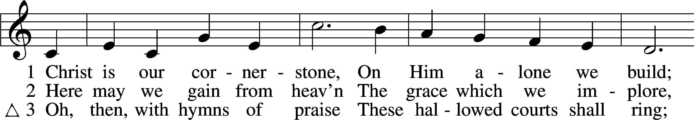
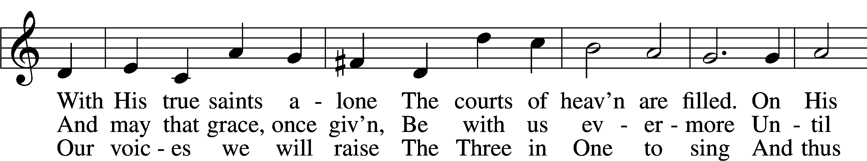
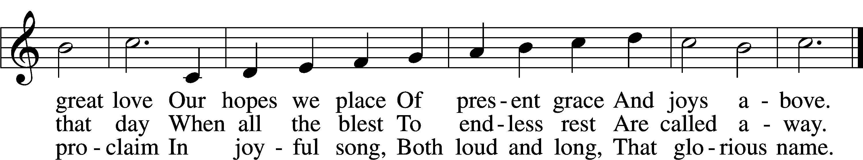
Text and tune: Public domain

P In the name of the Father and of the T Son and of the Holy Spirit.
C Amen.

P Our help is in the name of the Lord,
C who made heaven and earth.

P If You, O Lord, kept a record of sins, O Lord, who could stand?
C But with You there is forgiveness; therefore You are feared.

P Since we are gathered to hear God’s Word, call upon Him in prayer and praise, and receive the body and blood of our Lord Jesus Christ in the fellowship of this altar, let us first consider our unworthiness and confess before God and one another that we have sinned in thought, word, and deed, and that we cannot free ourselves from our sinful condition. Together as His people let us take refuge in the infinite mercy of God, our heavenly Father, seeking His grace for the sake of Christ, and saying: God, be merciful to me, a sinner.
C Almighty God, have mercy upon us, forgive us our sins, and lead us to everlasting life. Amen.
P Almighty God, merciful Father, in Holy Baptism You declared us to be Your children and gathered us into Your one, holy Church, in which You daily and richly forgive us our sins and grant us new life through Your Spirit. Be in our midst, enliven our faith, and graciously receive our prayer and praise; through Your Son, Jesus Christ, our Lord.
C Amen.

Service of the Word

Introit Psalm 89:1, 5, 15–16; antiphon: Psalm 119:46
I will speak of your testimonies before kings, [O Lord,]
and shall not be put to shame.
I will sing of the steadfast love of the Lord, forever;
with my mouth I will make known your faithfulness to all generations.
Let the heavens praise your wonders, O Lord,
your faithfulness in the assembly of the holy ones!
Blessèd are the people who know the festal shout,
who walk, O Lord, in the light of your face,
who exult in your name all the day
and in your righteousness are exalted.
Glory be to the Father and to the Son
and to the Holy Spirit;
as it was in the beginning,
is now, and will be forever. Amen.
I will speak of your testimonies before kings, [O Lord,]
and shall not be put to shame.

Kyrie LSB 204
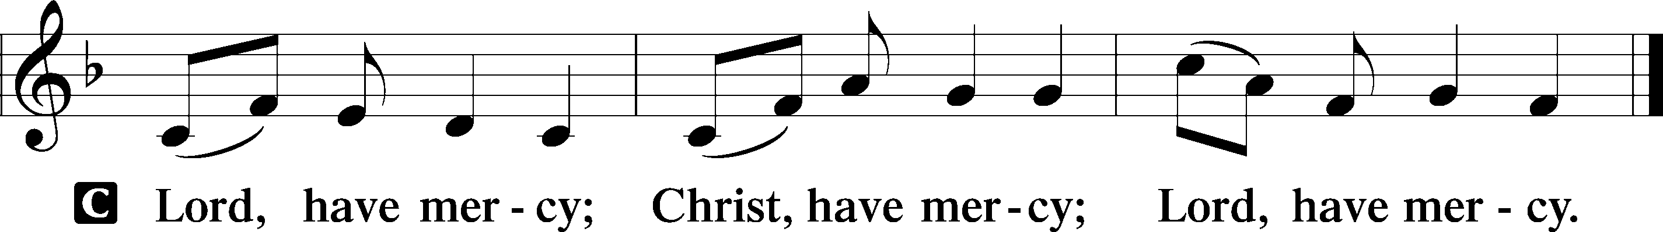

Gloria in Excelsis LSB 204
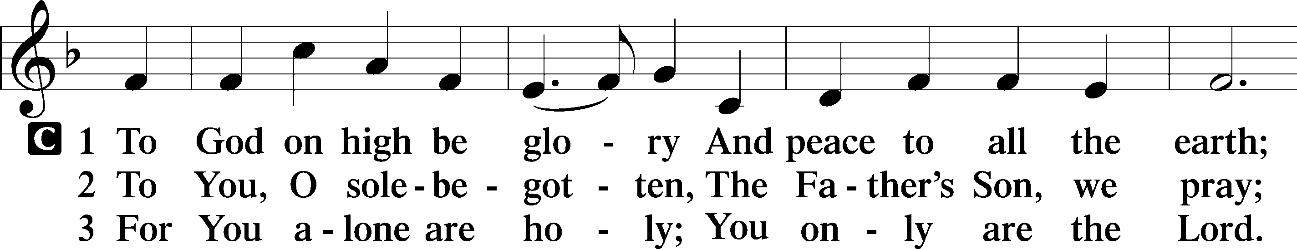
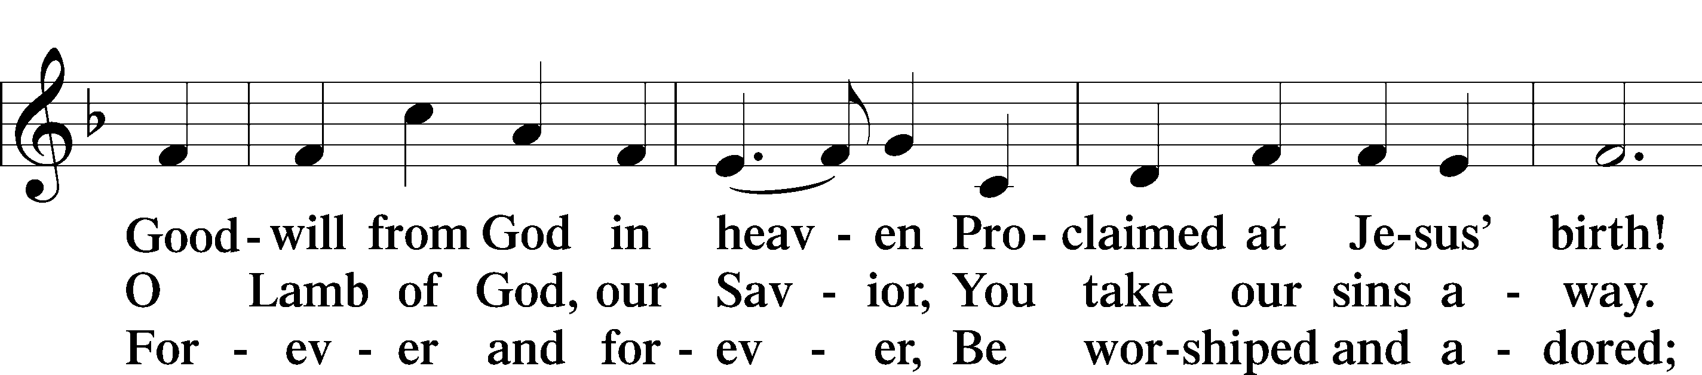
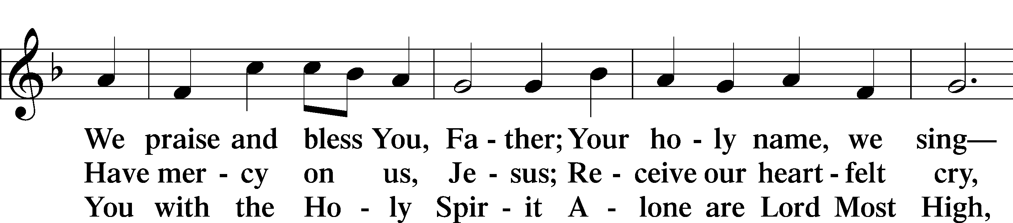
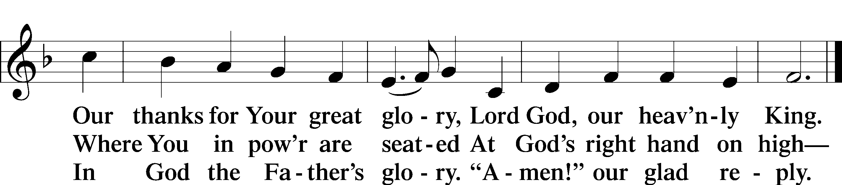

Salutation and Collect of the Day
P The Lord be with you.
C And also with you.

P Let us pray.
Heavenly Father, You revealed to the apostle Peter the blessed truth that Your Son Jesus is the Christ. Strengthen us by the proclamation of this truth that we too may joyfully confess that there is salvation in no one else; through the same Jesus Christ, our Lord, who lives and reigns with You and the Holy Spirit, one God, now and forever.
C Amen.

First Reading Acts 4:8–13
8Then Peter, filled with the Holy Spirit, said to them, “Rulers of the people and elders, 9if we are being examined today concerning a good deed done to a crippled man, by what means this man has been healed, 10let it be known to all of you and to all the people of Israel that by the name of Jesus Christ of Nazareth, whom you crucified, whom God raised from the dead—by him this man is standing before you well. 11This Jesus is the stone that was rejected by you, the builders, which has become the cornerstone. 12And there is salvation in no one else, for there is no other name under heaven given among men by which we must be saved.”
13Now when they saw the boldness of Peter and John, and perceived that they were uneducated, common men, they were astonished. And they recognized that they had been with Jesus.

A This is the Word of the Lord.
C Thanks be to God.

Epistle 2 Peter 1:1–15
1Simeon Peter, a servant and apostle of Jesus Christ,
To those who have obtained a faith of equal standing with ours by the righteousness of our God and Savior Jesus Christ:
2May grace and peace be multiplied to you in the knowledge of God and of Jesus our Lord.
3His divine power has granted to us all things that pertain to life and godliness, through the knowledge of him who called us to his own glory and excellence, 4by which he has granted to us his precious and very great promises, so that through them you may become partakers of the divine nature, having escaped from the corruption that is in the world because of sinful desire. 5For this very reason, make every effort to supplement your faith with virtue, and virtue with knowledge, 6and knowledge with self-control, and self-control with steadfastness, and steadfastness with godliness, 7and godliness with brotherly affection, and brotherly affection with love. 8For if these qualities are yours and are increasing, they keep you from being ineffective or unfruitful in the knowledge of our Lord Jesus Christ. 9For whoever lacks these qualities is so nearsighted that he is blind, having forgotten that he was cleansed from his former sins. 10Therefore, brothers, be all the more diligent to make your calling and election sure, for if you practice these qualities you will never fall. 11For in this way there will be richly provided for you an entrance into the eternal kingdom of our Lord and Savior Jesus Christ.
12Therefore I intend always to remind you of these qualities, though you know them and are established in the truth that you have. 13I think it right, as long as I am in this body, to stir you up by way of reminder, 14since I know that the putting off of my body will be soon, as our Lord Jesus Christ made clear to me. 15And I will make every effort so that after my departure you may be able at any time to recall these things.

A This is the Word of the Lord.
C Thanks be to God.

Alleluia and Verse

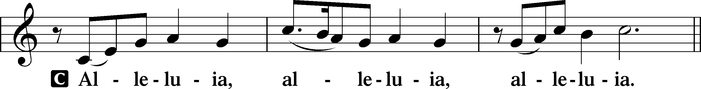

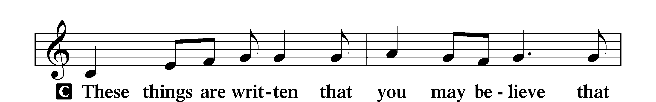
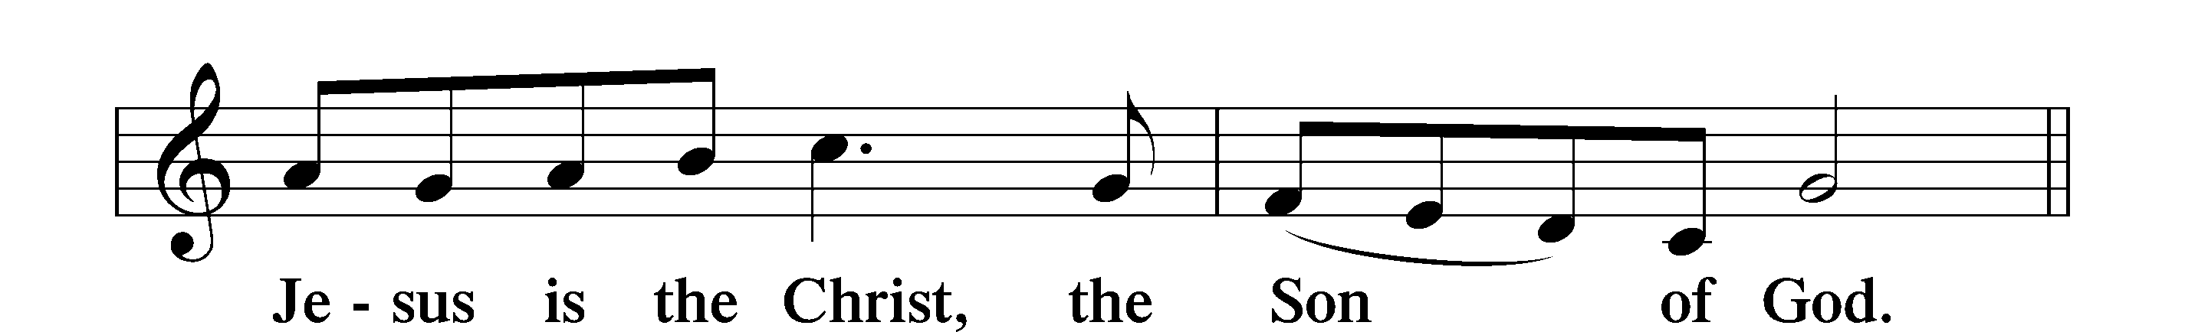

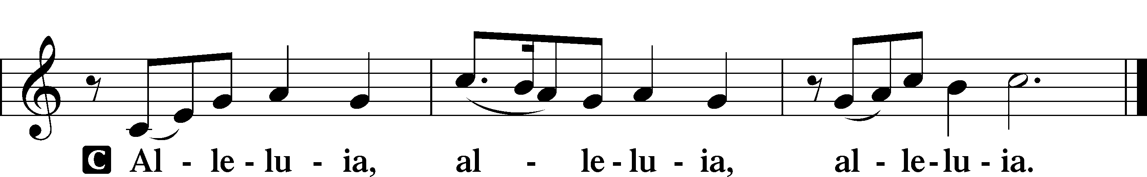

Holy Gospel Mark 8:27–35
P The Holy Gospel according to St. Mark, the eighth chapter.
C Glory to You, O Lord.

27And Jesus went on with his disciples to the villages of Caesarea Philippi. And on the way he asked his disciples, “Who do people say that I am?” 28And they told him, “John the Baptist; and others say, Elijah; and others, one of the prophets.” 29And he asked them, “But who do you say that I am?” Peter answered him, “You are the Christ.” 30And he strictly charged them to tell no one about him.
31And he began to teach them that the Son of Man must suffer many things and be rejected by the elders and the chief priests and the scribes and be killed, and after three days rise again. 32And he said this plainly. And Peter took him aside and began to rebuke him. 33But turning and seeing his disciples, he rebuked Peter and said, “Get behind me, Satan! For you are not setting your mind on the things of God, but on the things of man.”
34And he called to him the crowd with his disciples and said to them, “If anyone would come after me, let him deny himself and take up his cross and follow me. 35For whoever would save his life will lose it, but whoever loses his life for my sake and the gospel’s will save it.”

P This is the Gospel of the Lord.
C Praise to You, O Christ.

Apostles’ Creed
C I believe in God, the Father Almighty,
maker of heaven and earth.

And in Jesus Christ, His only Son, our Lord,
who was conceived by the Holy Spirit,
born of the virgin Mary,
suffered under Pontius Pilate,
was crucified, died and was buried.
He descended into hell.
The third day He rose again from the dead.
He ascended into heaven
and sits at the right hand of God the Father Almighty.
From thence He will come to judge the living and the dead.

I believe in the Holy Spirit,
the holy Christian Church,
the communion of saints,
the forgiveness of sins,
the resurrection of the body,
and the life T everlasting. Amen.

Children’s Message St. Peter’s Confession of Christ

753 All for Christ I Have Forsaken
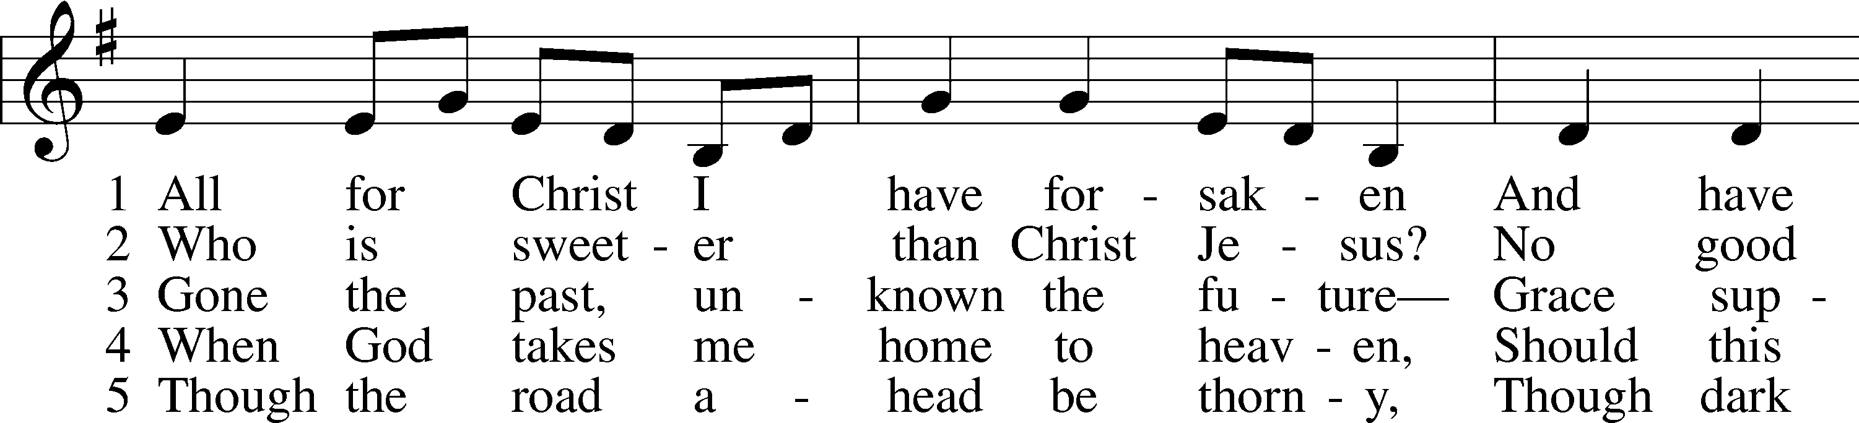
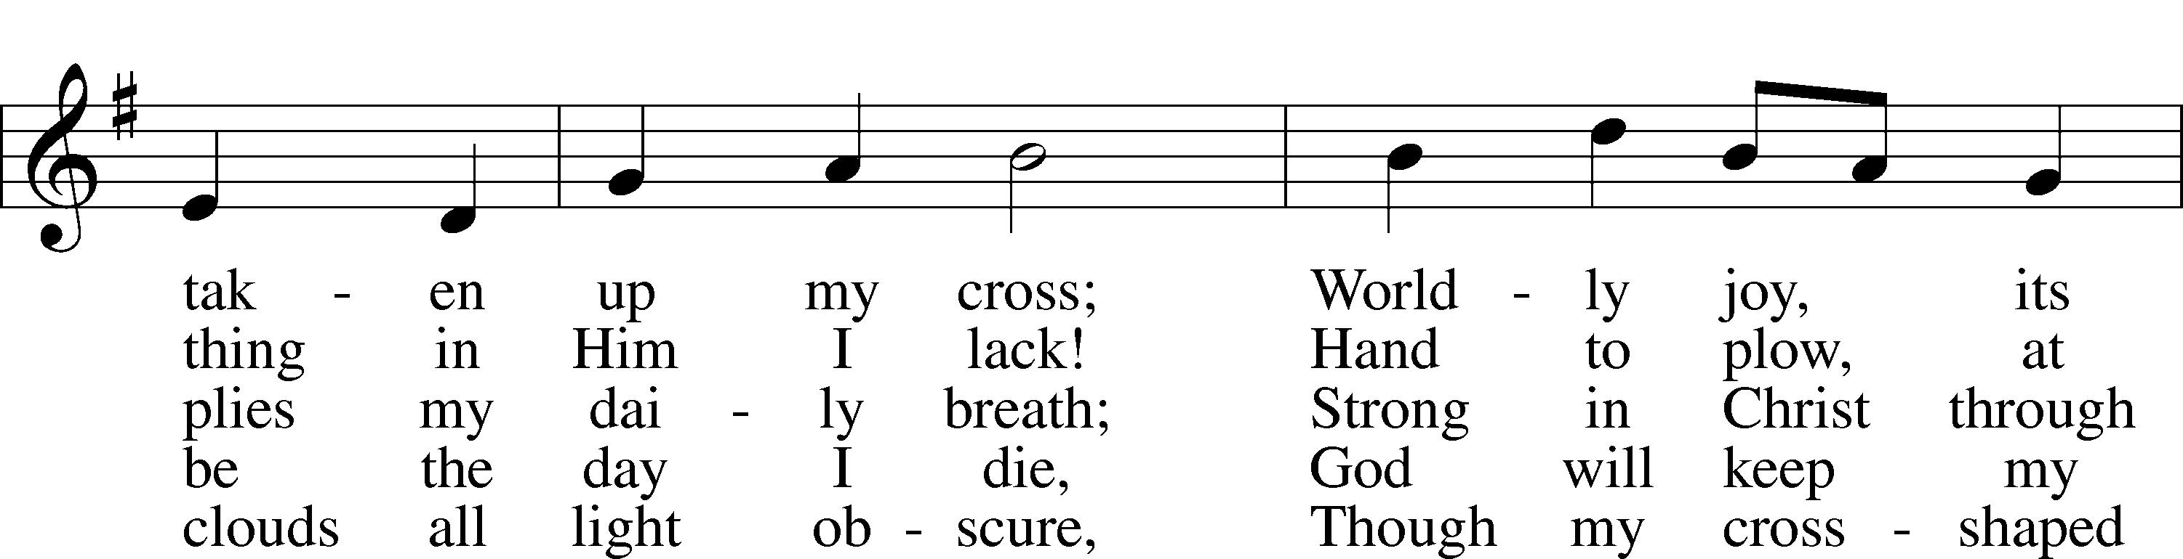
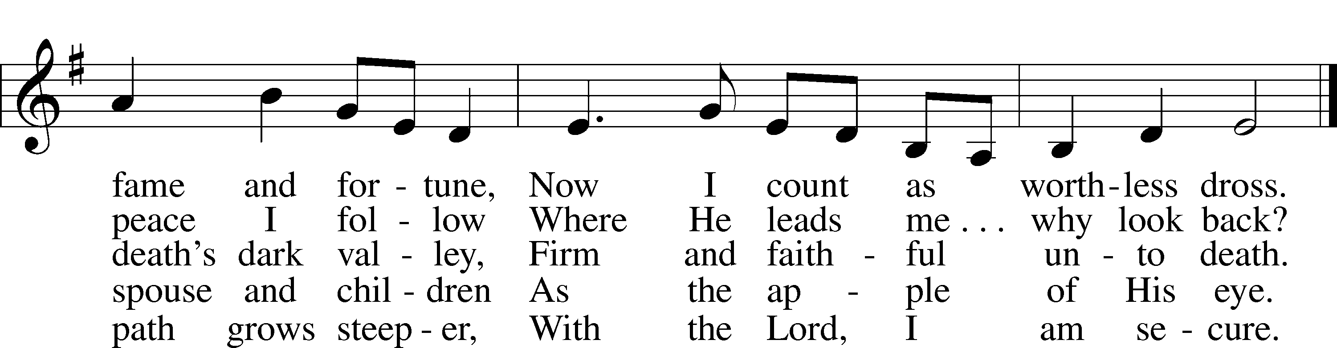
Tune: Public domain
Text: © 1999 Stephen P. Starke, admin. Concordia Publishing House. Used by permission: LSB Hymn License no. 110005047

Sermon “You Are the Christ” (Mark 8:27-35)

Prayer of the Church
P Friends in Christ, I urge you all to lift up your hearts to God and pray with me as Christ our Lord has taught us and freely promised to hear us.

God, our Father in heaven, look with mercy on us, Your needy children on earth, and grant us grace that Your holy name be hallowed by us and all the world through the pure and true teaching of Your Word and the fervent love shown forth in our lives. Graciously turn from us all false doctrine and evil living whereby Your precious name is blasphemed. Lord, in Your mercy,
C hear our prayer.

P May Your kingdom come to us and expand. Bring all transgressors and those who are blinded and bound in the devil’s kingdom to know Jesus Christ, Your Son, by faith that the number of Christians may be increased. Lord, in Your mercy,
C hear our prayer.

P Strengthen us by Your Spirit according to Your will, both in life and in death, in the midst of both good and evil things, that our own wills may be crucified daily and sacrificed to Your good and gracious will. Into Your merciful hands we commend [names] and all who are in need, praying for them at all times: Thy will be done. Lord, in Your mercy,
C hear our prayer.

P Grant us our daily bread, preserve us from greed and selfish cares, and help us trust in You to provide for all our needs. Lord, in Your mercy,
C hear our prayer.

P Forgive us our sins as we also forgive those who sin against us so that our hearts may be at peace and may rejoice in a good conscience before You, and that no sin may ever frighten or alarm us. Lord, in Your mercy,
C hear our prayer.

P Lead us not into temptation, O Lord, but help us by Your Spirit to subdue our flesh, to turn from the world and its ways, and to overcome the devil with all his wiles. Lord, in Your mercy,
C hear our prayer.

P And lastly, O heavenly Father, deliver us from all evil of both body and soul, now and forever. Lord, in Your mercy,
C hear our prayer.

P We trust, O Lord, in Your great mercy to hear and answer us; through Jesus Christ, our Lord.
C Amen.

Service of the Sacrament

Preface LSB 208
P The Lord be with you.
C And also with you.

P Lift up your hearts.
C We lift them to the Lord.

P Let us give thanks to the Lord our God.
C It is right to give Him thanks and praise.

P It is truly good, right, and salutary that we should at all times and in all places give thanks to You, O Lord, holy Father, almighty and everlasting God, for the countless blessings You so freely bestow on us and all creation. Above all, we give thanks for Your boundless love shown to us when You sent Your only-begotten Son, Jesus Christ, into our flesh and laid on Him our sin, giving Him into death that we might not die eternally. Because He is now risen from the dead and lives and reigns to all eternity, all who believe in Him will overcome sin and death and will rise again to new life. Therefore with angels and archangels and with all the company of heaven we laud and magnify Your glorious name, evermore praising You and saying:
Sanctus LSB 208
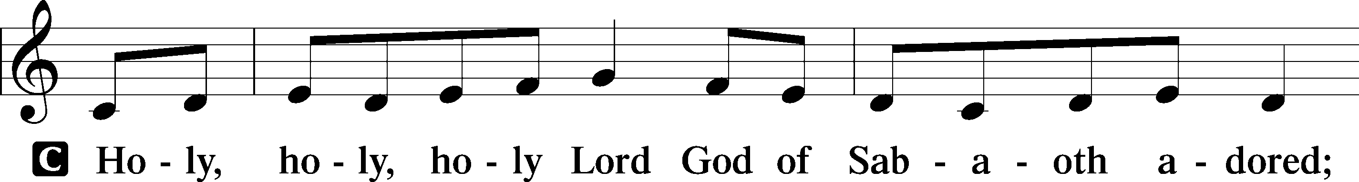
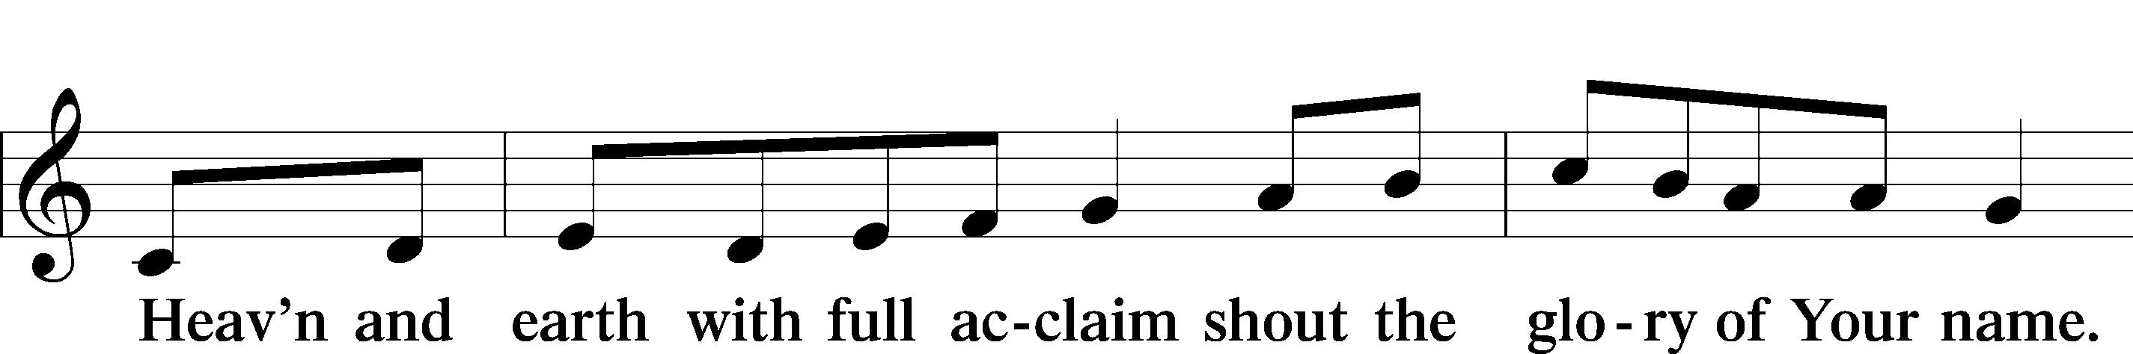
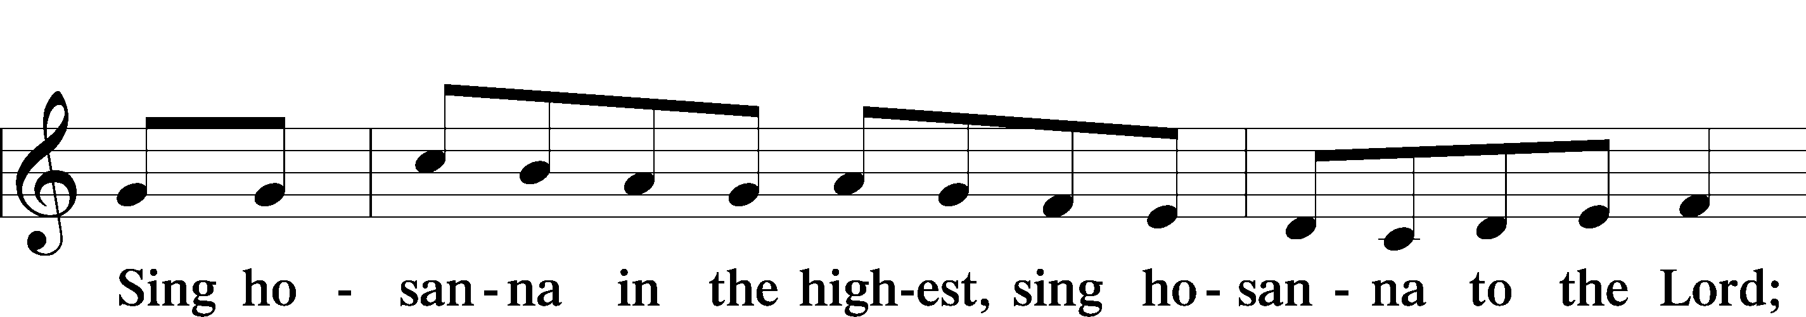
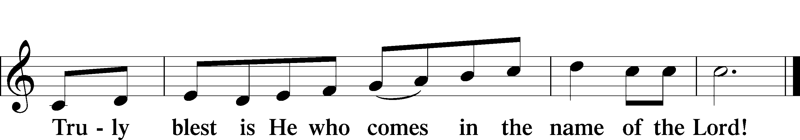

Prayer of Thanksgiving
P Blessed are You, O Lord our God, king of all creation, for You have had mercy on us and given Your only-begotten Son that whoever believes in Him should not perish but have eternal life.

You once proclaimed Your saving promise through the prophets of Israel, and by the apostles and evangelists You published the good news of Your saving promise fulfilled in the death and resurrection of Jesus Christ.

Grant that we, being instructed in the doctrine of the blessed apostles and evangelists, may faithfully eat His body and drink His blood and declare His salvation to all the world.

Hear us as we pray in His name and as He has taught us:

Lord’s Prayer
C Our Father who art in heaven,
hallowed be Thy name,
Thy kingdom come,
Thy will be done on earth as it is in heaven;
give us this day our daily bread;
and forgive us our trespasses
as we forgive those who trespass against us;
and lead us not into temptation,
but deliver us from evil.
For Thine is the kingdom and the power and the glory
forever and ever. Amen.

The Words of Our Lord
P Our Lord Jesus Christ, on the night when He was betrayed, took bread, and when He had given thanks, He broke it and gave it to the disciples and said: “Take, eat; this is My T body, which is given for you. This do in remembrance of Me.”

In the same way also He took the cup after supper, and when He had given thanks, He gave it to them, saying: “Drink of it, all of you; this cup is the new testament in My T blood, which is shed for you for the forgiveness of sins. This do, as often as you drink it, in remembrance of Me.”

Pax Domini
P The peace of the Lord be with you always.
C Amen.

Agnus Dei LSB 210
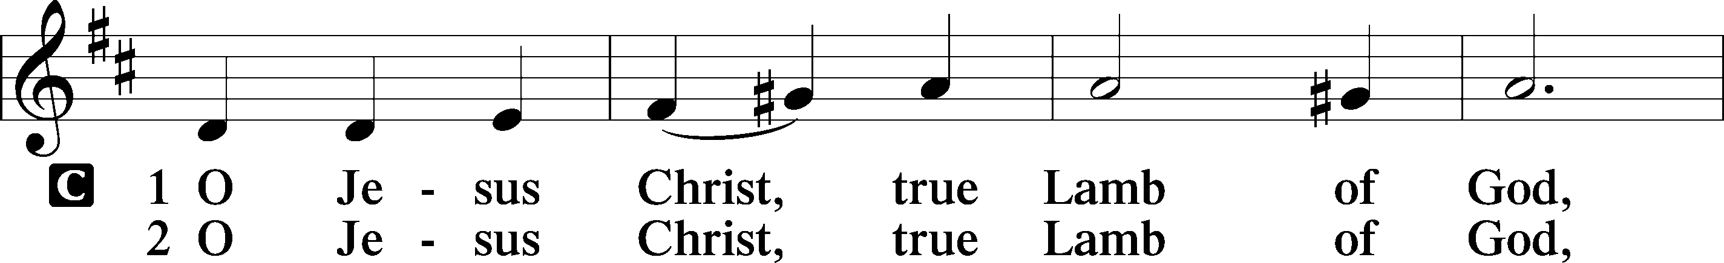
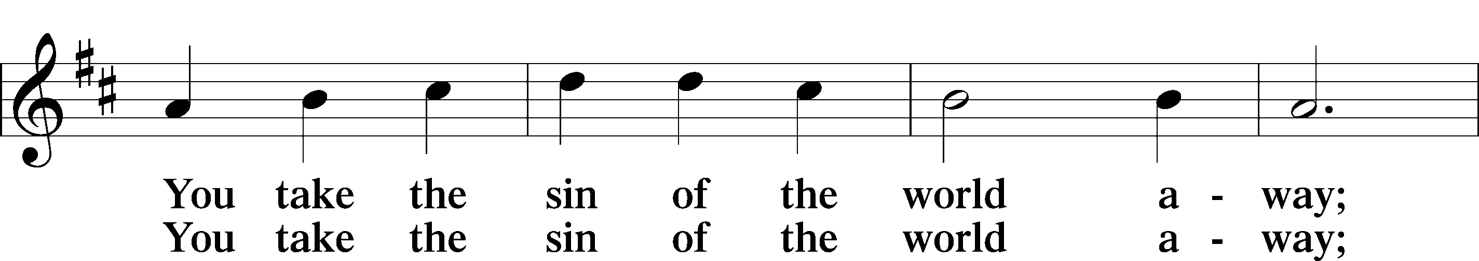
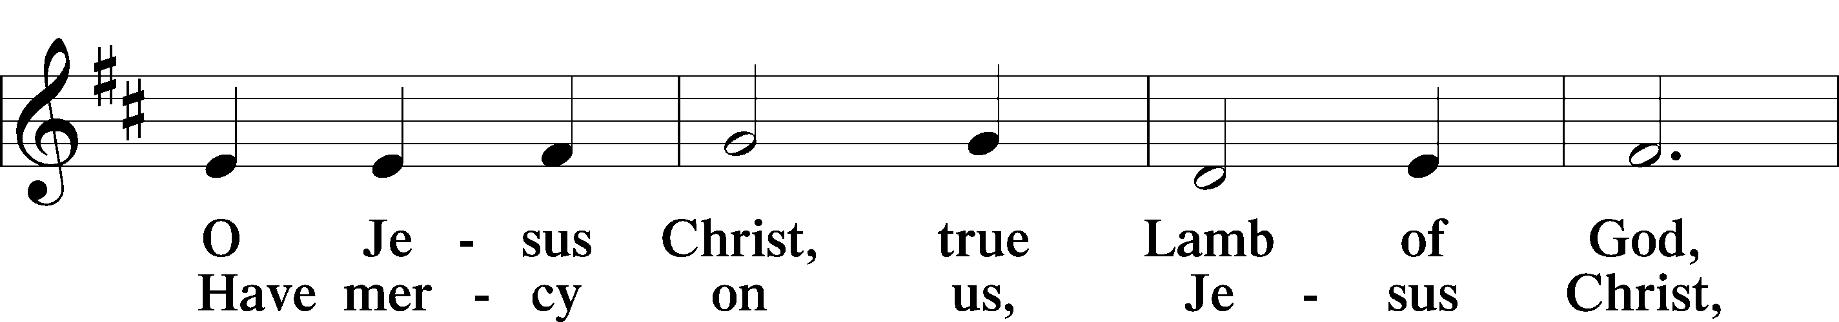
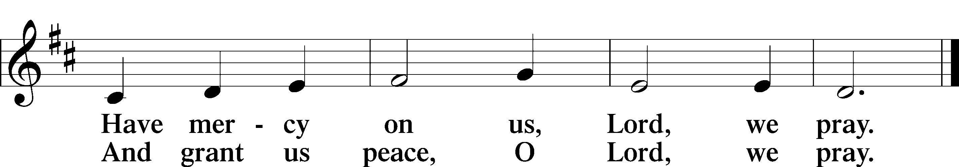
Distribution

Distribution Hymn
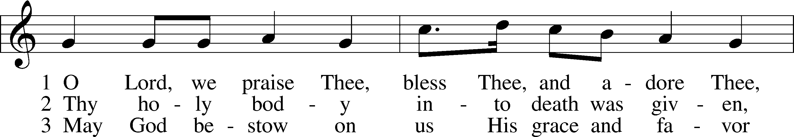
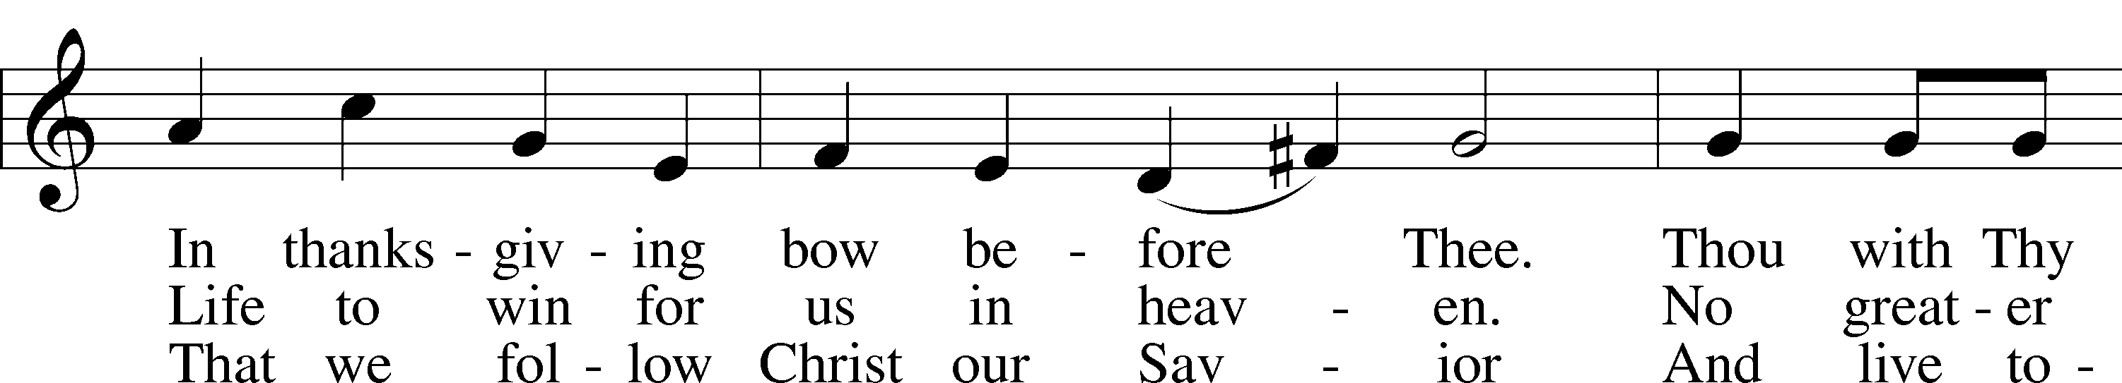
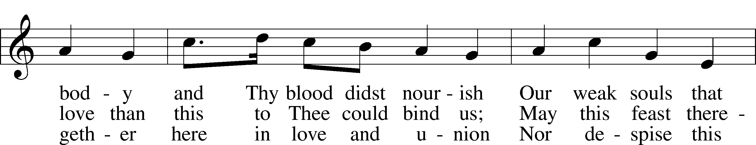
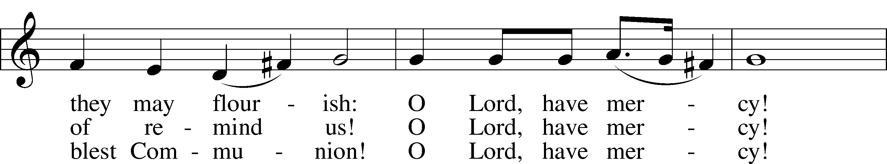
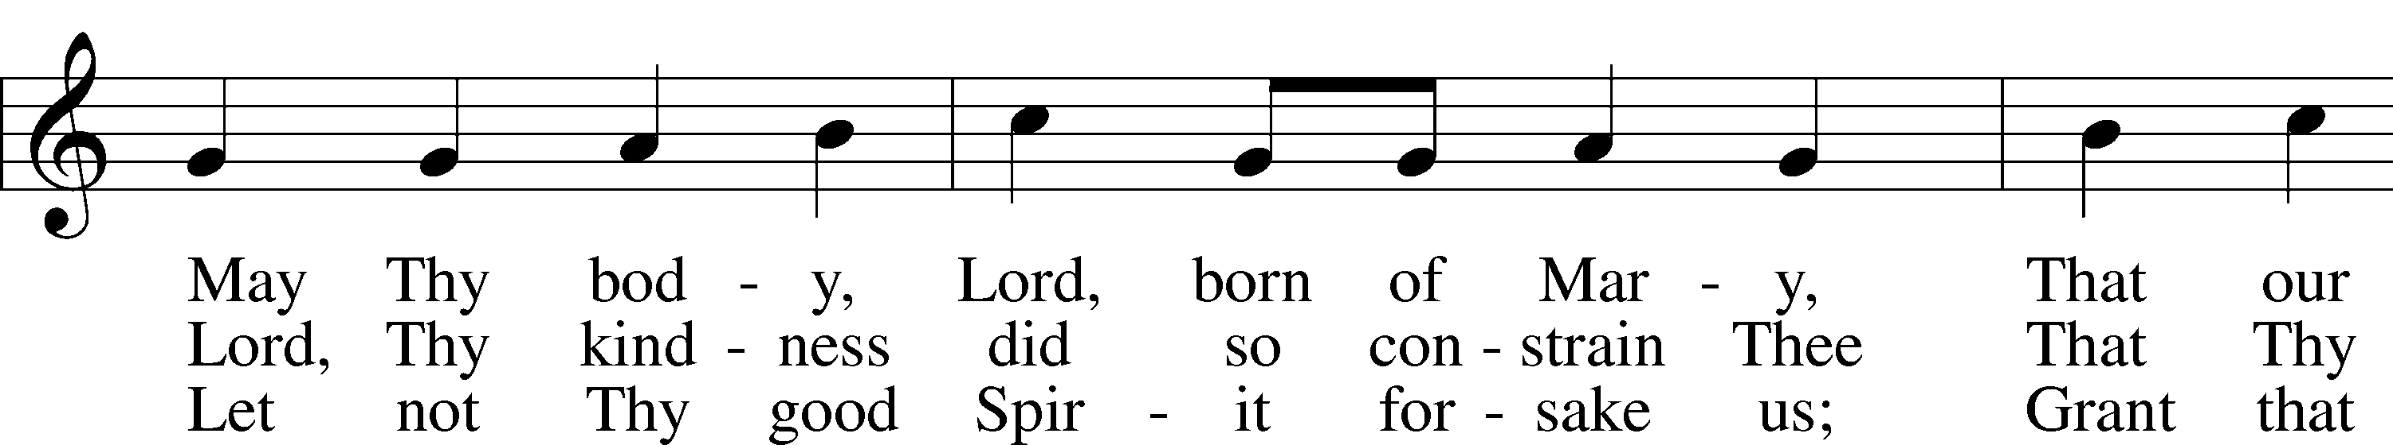
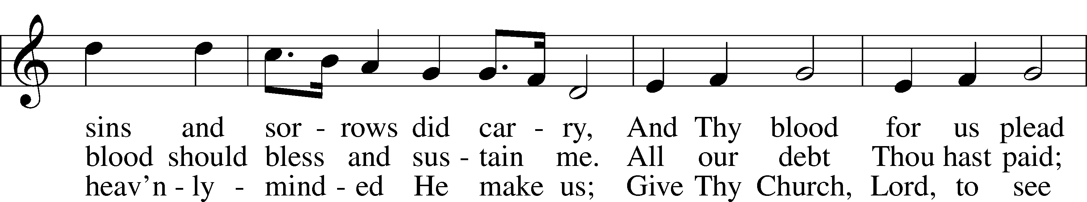
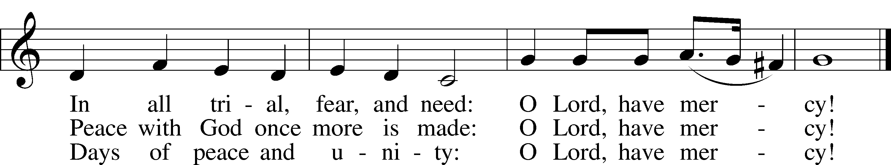
Tune: Public domain
Text: © 1941 Concordia Publishing House. Used by permission: LSB Hymn License no. 110005047

Nunc Dimittis LSB 211
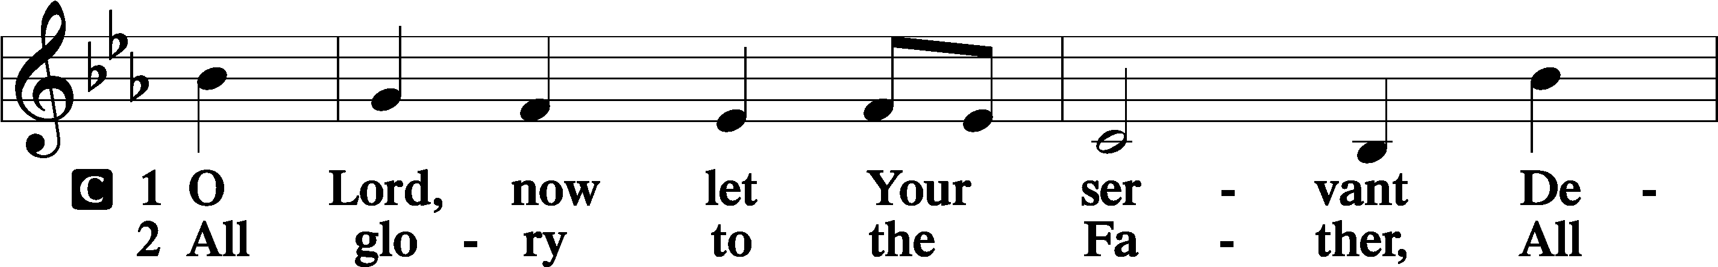
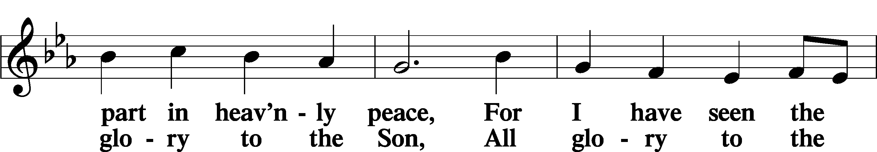
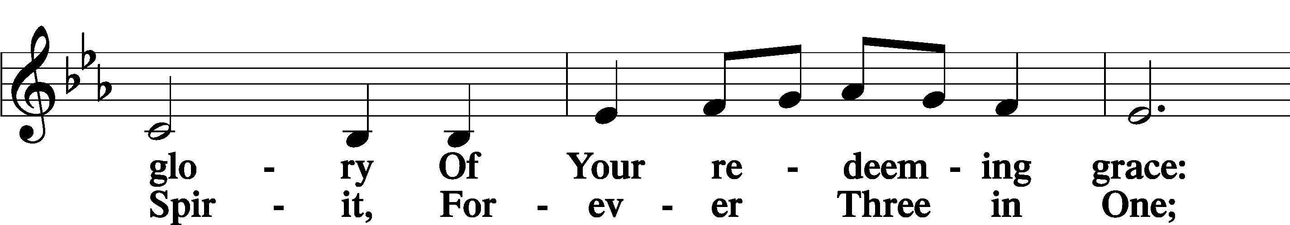
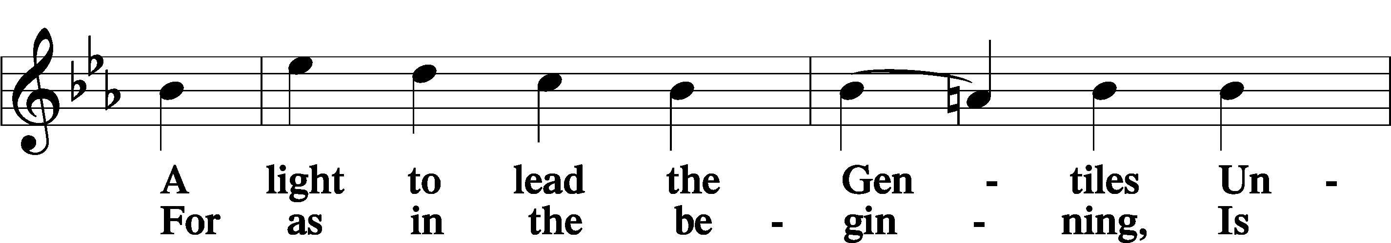
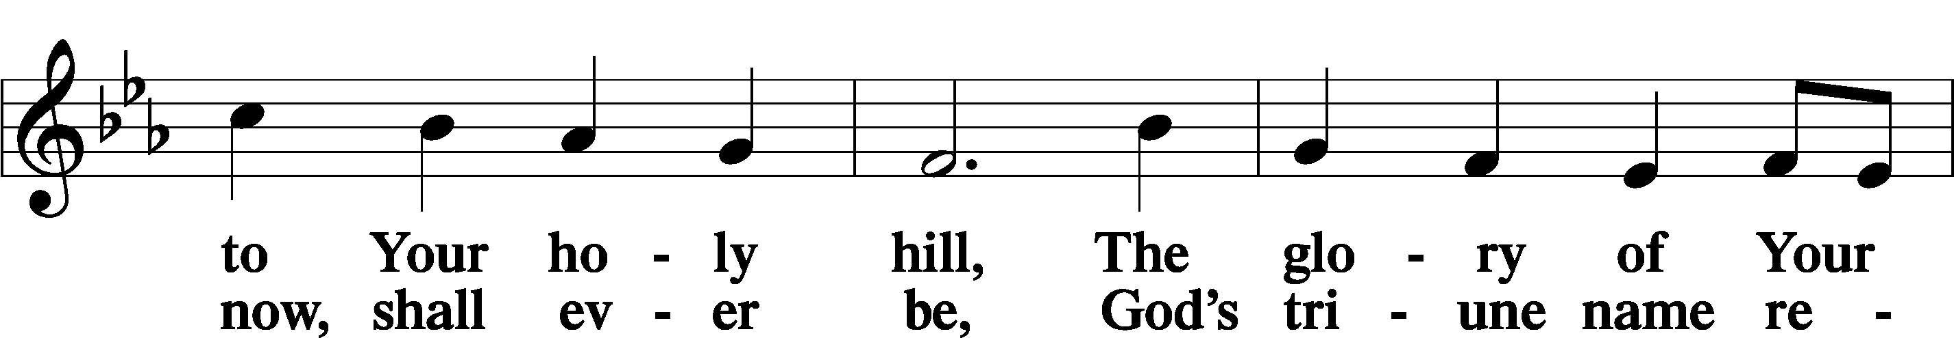
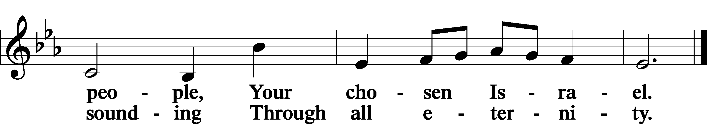

Post-Communion Collect
A Let us pray.
We give thanks to You, almighty God, that You have refreshed us through this salutary gift, and we implore You that of Your mercy You would strengthen us through the same in faith toward You and in fervent love toward one another; through Jesus Christ, Your Son, our Lord, who lives and reigns with You and the Holy Spirit, one God, now and forever.
C Amen.

Benedicamus and Benediction LSB 212
A Let us bless the Lord.
C Thanks be to God.

P The Lord bless you and keep you.
The Lord make His face shine on you and be gracious to you.
The Lord look upon you with favor and T give you peace.
C Amen.

557 Seek Where You May to Find a Way
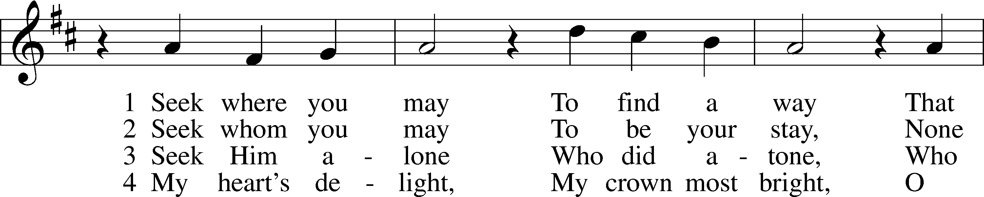
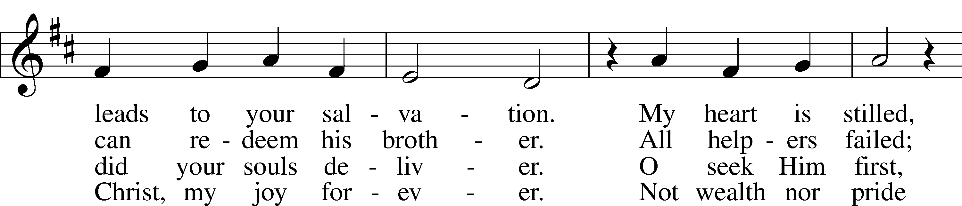
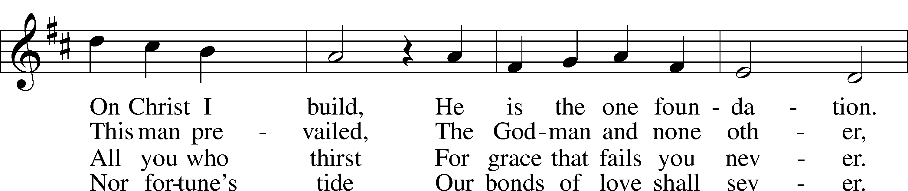
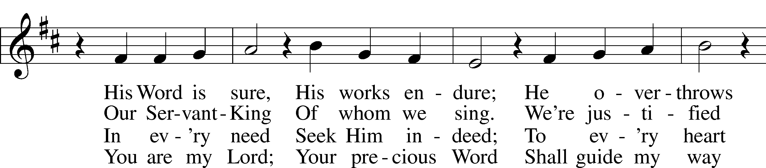
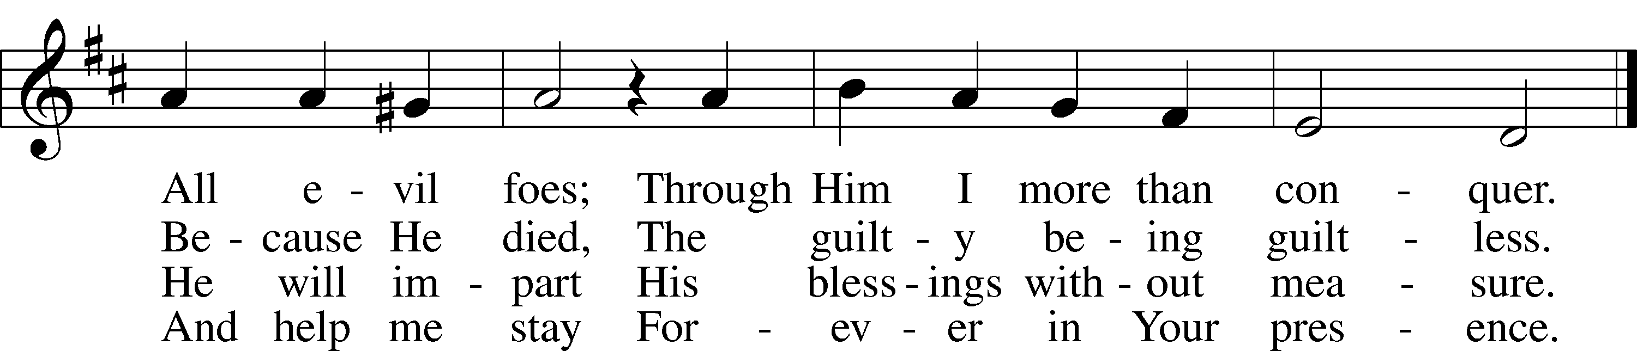
Text: © 1941 Concordia Publishing House. Used by permission: LSB Hymn License no. 110005047
Tune: Public domain

Acknowledgments
Divine Service, Setting Four from Lutheran Service Book
Unless otherwise indicated, Scripture quotations are from the ESV® Bible (The Holy Bible, English Standard Version®), copyright © 2001 by Crossway, a publishing ministry of Good News Publishers. Used by permission. All rights reserved.
Created by Lutheran Service Builder © 2020 Concordia Publishing House.

January 17 “Abortion isn’t something happening in another state or county or city. It is happening right in our backyards. And now we know many [who have had abortions] attend churches regularly and are sitting in our church pews looking for answers. May the Lord provide the answers needed to send a message of hope and forgiveness as well as proclaiming abortion to not be in God’s will.” Virginia J. Flo, Minnesota Regional Director & National Conference Director for Lutherans For Life – A Life Quote from Lutherans For Life • lutheransforlife.org

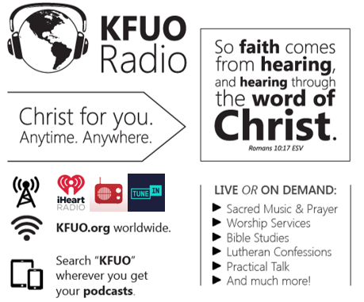

This week on KFUO.org, excite your imagination and comfort your soul on Cross Defense with Rev. Tyrel Bramwell (1/18 at 2:00 p.m. CT), hear practical application of our Lutheran Confessions on Concord Matters (1/19 at 2:00 p.m. CT), and worship with us in chapel services weekdays at 10:00 a.m. CT. Find these programs on demand at kfuo.org or your favorite podcasting app.

Gifts of Time and Treasure
“…from everyone who has been given much, much will be demanded…
Luke 12:48

LAST WEEK’S OFFERINGS LAST WEEK’S ATTENDANCE
General Fund $ 1,456.90 Service 33
Needed Weekly $ 3,963.38 Communed 30
Adult Bible Study $ 6.00
Benevolence $ 9.00

The Lord’s Week

Today 8:45 am – Bible Studies for all ages
(Jan. 17th) 10:00 am – Divine Service
11:30 am – Confirmation

Wednesday 10:00 am – Women’s Bible Study

Next Sunday 8:45 am – Bible Studies for all ages
(Jan. 24th) 10:00 am – Divine Service
11:30 am – Confirmation

In His Service

Elder: Justin Perkins
Usher: John Larson, Jason Schrader
Acolytes: Noah Denton, Kaylee Larson
Organist: Sharon Schrader
Alter: Laura Lopez
Flowers: Eddie & Laura Lopez

