**St. Timothy, Pastor and Confessor**

**Divine Service, Setting Four**

**“The Fight of Faith”**

1 Timothy 6:11-16

**January 24, 2021**

**Messiah Lutheran Church**

**Lutheran Church-Missouri Synod**

4102 Trinity River Dr., Corpus Christi, Texas 78410

**Pastor:**  **Rev. Scott E. Herbert**

Church Phone: 361-387-7748 Email: mlc@stx.rr.com

Church Fax: 361-767-1768 Website: [www.messiahlcms-cc.org](http://www.messiahlcms-cc.org)

Pastor Phone: 469-693-9683 Pastor Email: chirev59@gmail.com

**WELCOME TO MESSIAH!**

We are glad you are here to receive what God is doing for you during Divine Service. Please sign our Guest Book located near the front door. Feel free to converse quietly until the organ prelude begins. If you are looking for a church home, please talk to the Pastor at the door. We would love to have you join us.

**Preparing for Service**

***The Lord God Is with You and Reveals Himself to You by the Preaching of His Word***

The Lord Jesus calls Philip and Nathanael to *“come and see”* that He is *“the Son of God”* and *“the King of Israel”* (John 1:43–49). And they shall see even *“greater things than these”* (John 1:50). For His body is the temple of God on earth, and by His priestly sacrifice the heavens will be opened to all who believe and are baptized into Him. Therefore, He calls Philip and Nathanael, first to hear His Word and then to speak as apostles, even as He once called Samuel and established him *“as a prophet of the Lord”* (1 Sam. 3:20). As the Lord was with Samuel *“and let none of his words fall to the ground”* (1 Sam. 3:19), He also accompanies and upholds the preachers of His Word in our day. Thus, by the Gospel that is preached to you, *“your body is a temple of the Holy Spirit within you”* (1 Cor. 6:19). Since your body thus belongs to the Body of Christ, is meant *“for the Lord”* and shall be raised up like Him, now *“glorify God in your body”* (1 Cor. 6:13–20).

# Confession and Absolution

905 Come, Thou Almighty King Text and Tune: Public Domain

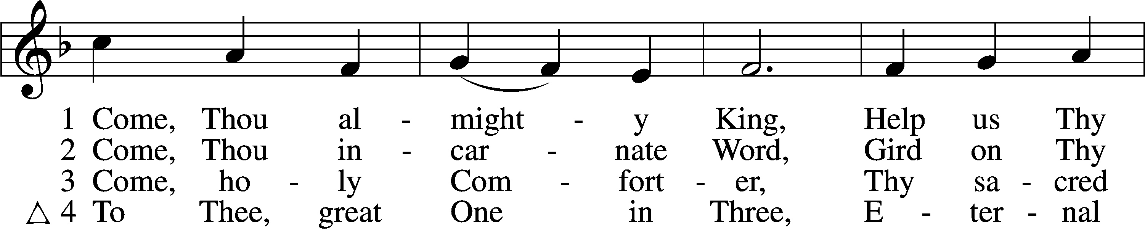

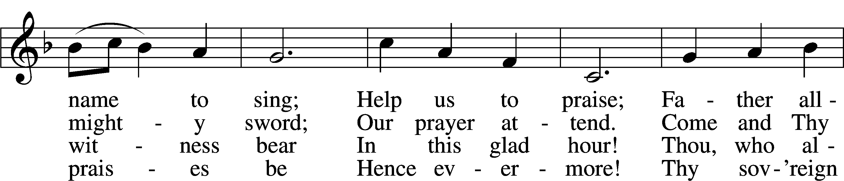

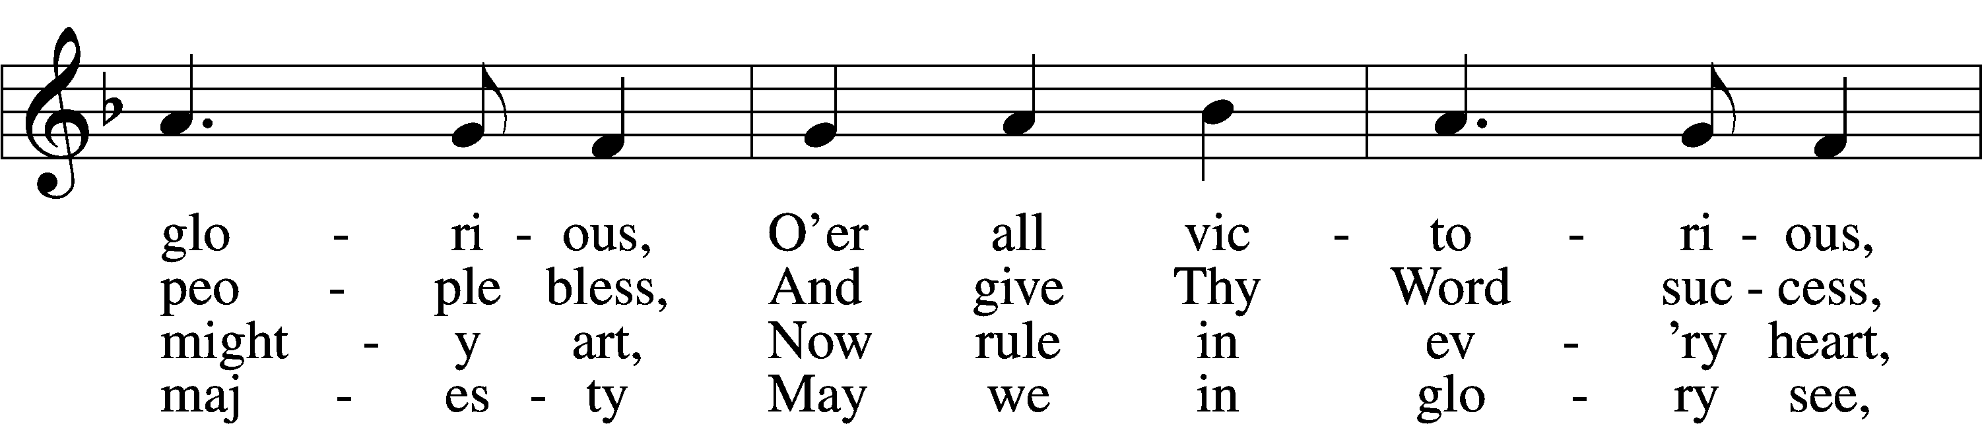

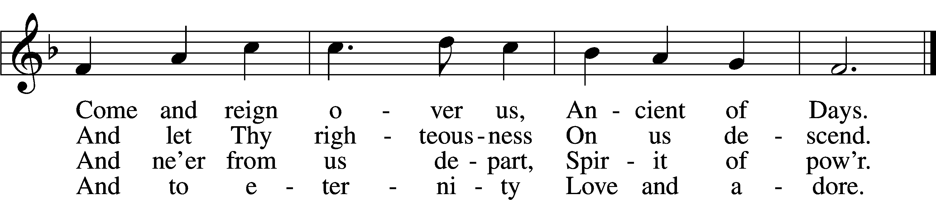

P In the name of the Father and of the T Son and of the Holy Spirit.

C **Amen.**

P Our help is in the name of the Lord,

C **who made heaven and earth.**

P If You, O Lord, kept a record of sins, O Lord, who could stand?

C **But with You there is forgiveness; therefore You are feared.**

P Since we are gathered to hear God’s Word, call upon Him in prayer and praise, and receive the body and blood of our Lord Jesus Christ in the fellowship of this altar, let us first consider our unworthiness and confess before God and one another that we have sinned in thought, word, and deed, and that we cannot free ourselves from our sinful condition. Together as His people let us take refuge in the infinite mercy of God, our heavenly Father, seeking His grace for the sake of Christ, and saying: God, be merciful to me, a sinner.

C **Almighty God, have mercy upon us, forgive us our sins, and lead us to everlasting life. Amen.**

P Almighty God, merciful Father, in Holy Baptism You declared us to be Your children and gathered us into Your one, holy Church, in which You daily and richly forgive us our sins and grant us new life through Your Spirit. Be in our midst, enliven our faith, and graciously receive our prayer and praise; through Your Son, Jesus Christ, our Lord.

C **Amen.**

# Service of the Word

Introit Psalm 89:1, 5, 15–16; antiphon: 1 Timothy 6:12a, b

Fight the good fight of the faith.  
 **Take hold of the eternal life to which you were called.**I will sing of the steadfast love of the Lord, forever;  
 **with my mouth I will make known your faithfulness to all generations.**Let the heavens praise your wonders, O Lord,  
 **your faithfulness in the assembly of the holy ones!**  
Blessèd are the people who know the festal shout,  
 **who walk, O Lord, in the light of your face,**who exult in your name all the day  
 **and in your righteousness are exalted.  
Glory be to the Father and to the Son and to the Holy Spirit;**  
**as it was in the beginning, is now, and will be forever. Amen.**  
Fight the good fight of the faith.  
 **Take hold of the eternal life to which you were called.**

Kyrie LSB 204

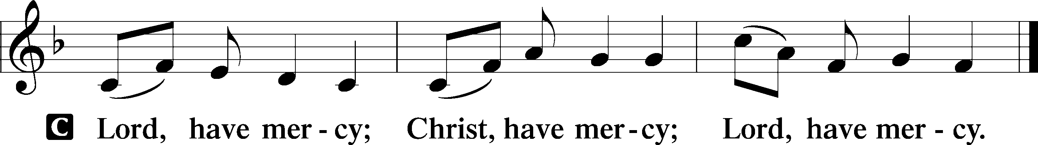

Gloria in Excelsis LSB 204

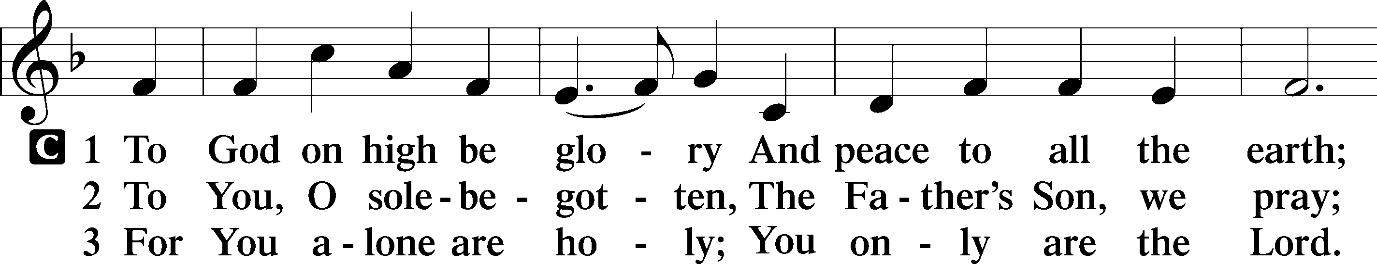

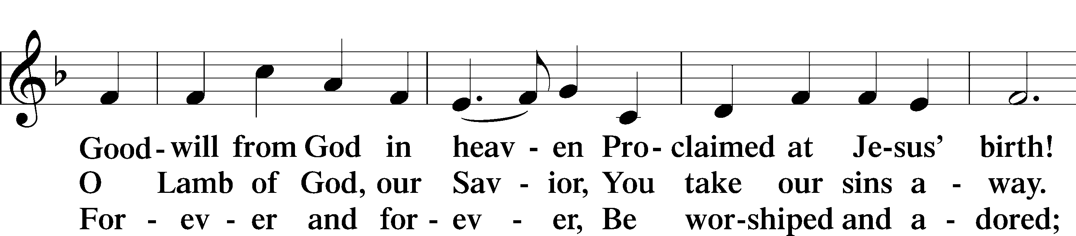

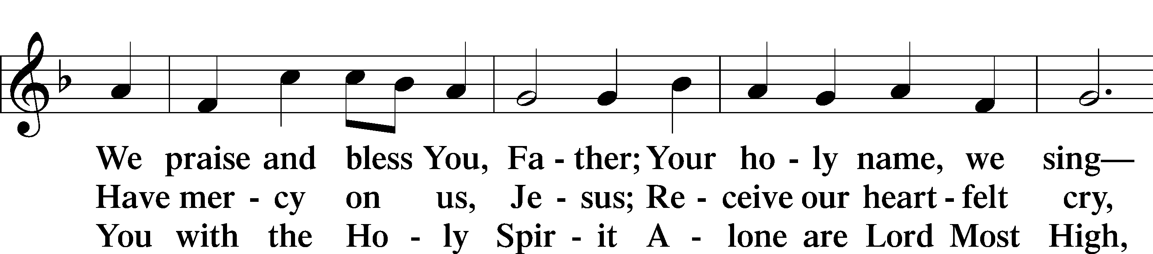

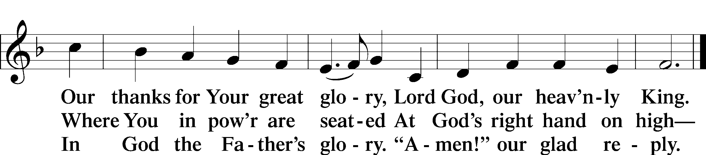

Salutation and Collect of the Day

P The Lord be with you.

C **And also with you.**

P Let us pray.

Lord Jesus Christ, You have always given to Your Church on earth faithful shepherds such as Timothy to guide and feed Your flock. Make all pastors diligent to preach Your holy Word and administer Your means of grace, and grant Your people wisdom to follow in the way that leads to life eternal; for You live and reign with the Father and the Holy Spirit, one God, now and forever.

C **Amen.**

First Reading Acts 16:1–5

1Paul came also to Derbe and to Lystra. A disciple was there, named Timothy, the son of a Jewish woman who was a believer, but his father was a Greek. 2He was well spoken of by the brothers at Lystra and Iconium. 3Paul wanted Timothy to accompany him, and he took him and circumcised him because of the Jews who were in those places, for they all knew that his father was a Greek. 4As they went on their way through the cities, they delivered to them for observance the decisions that had been reached by the apostles and elders who were in Jerusalem. 5So the churches were strengthened in the faith, and they increased in numbers daily.

A This is the Word of the Lord.

C **Thanks be to God.**

Epistle 1 Timothy 6:11–16

11But as for you, O man of God, flee these things. Pursue righteousness, godliness, faith, love, steadfastness, gentleness. 12Fight the good fight of the faith. Take hold of the eternal life to which you were called and about which you made the good confession in the presence of many witnesses. 13I charge you in the presence of God, who gives life to all things, and of Christ Jesus, who in his testimony before Pontius Pilate made the good confession, 14to keep the commandment unstained and free from reproach until the appearing of our Lord Jesus Christ, 15which he will display at the proper time—he who is the blessed and only Sovereign, the King of kings and Lord of lords, 16who alone has immortality, who dwells in unapproachable light, whom no one has ever seen or can see. To him be honor and eternal dominion. Amen.

A This is the Word of the Lord.

C **Thanks be to God.**

Alleluia and Verse

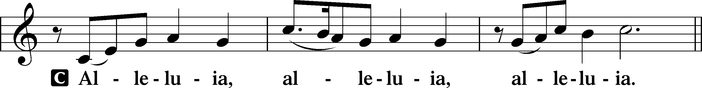

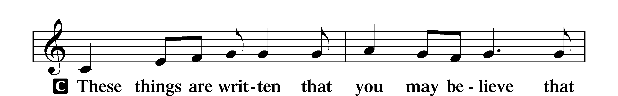

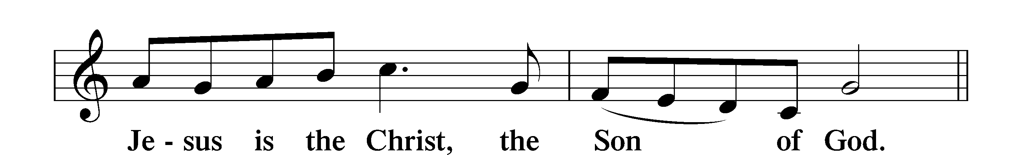

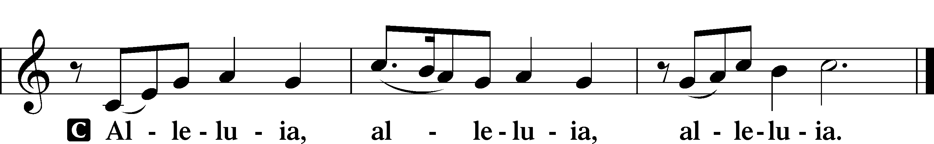

Holy Gospel Matthew 24:42–47

P The Holy Gospel according to St. Matthew, the twenty-fourth chapter.

C **Glory to You, O Lord.**

42[Jesus said:] “Therefore, stay awake, for you do not know on what day your Lord is coming. 43But know this, that if the master of the house had known in what part of the night the thief was coming, he would have stayed awake and would not have let his house be broken into. 44Therefore you also must be ready, for the Son of Man is coming at an hour you do not expect.

45“Who then is the faithful and wise servant, whom his master has set over his household, to give them their food at the proper time? 46Blessed is that servant whom his master will find so doing when he comes. 47Truly, I say to you, he will set him over all his possessions.”

P This is the Gospel of the Lord.

C **Praise to You, O Christ.**

Nicene Creed

C **I believe in one God,**

**the Father Almighty,**

**maker of heaven and earth**

**and of all things visible and invisible.**

**And in one Lord Jesus Christ,**

**the only-begotten Son of God,**

**begotten of His Father before all worlds,**

**God of God, Light of Light,**

**very God of very God,**

**begotten, not made,**

**being of one substance with the Father,**

**by whom all things were made;**

**who for us men and for our salvation came down from heaven**

**and was incarnate by the Holy Spirit of the virgin Mary**

**and was made man;**

**and was crucified also for us under Pontius Pilate.**

**He suffered and was buried.**

**And the third day He rose again according to the Scriptures**

**and ascended into heaven**

**and sits at the right hand of the Father.**

**And He will come again with glory to judge both the living and the dead,**

**whose kingdom will have no end.**

**And I believe in the Holy Spirit,**

**the Lord and giver of life,**

**who proceeds from the Father and the Son,**

**who with the Father and the Son together is worshiped and glorified,**

**who spoke by the prophets.**

**And I believe in one holy Christian and apostolic Church,**

**I acknowledge one Baptism for the remission of sins,**

**and I look for the resurrection of the dead**

**and the life** T **of the world to come. Amen.**

Children’s Message St. Timothy and Amazing Faith

664 Fight the Good Fight

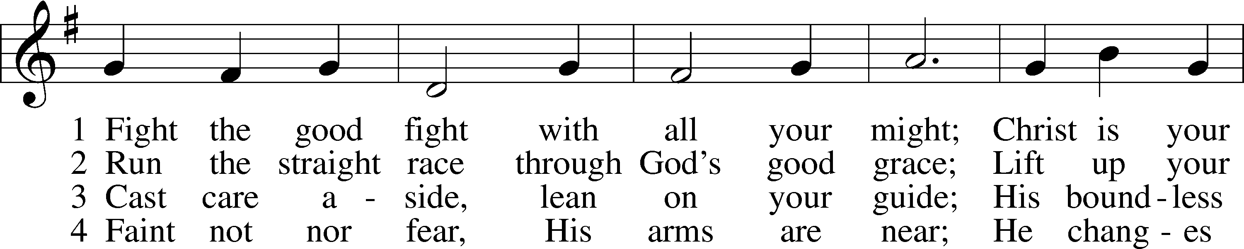

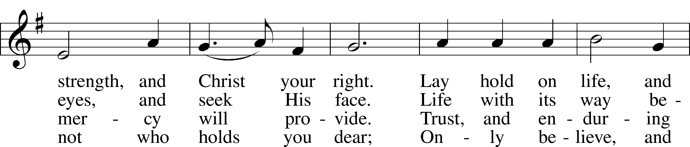

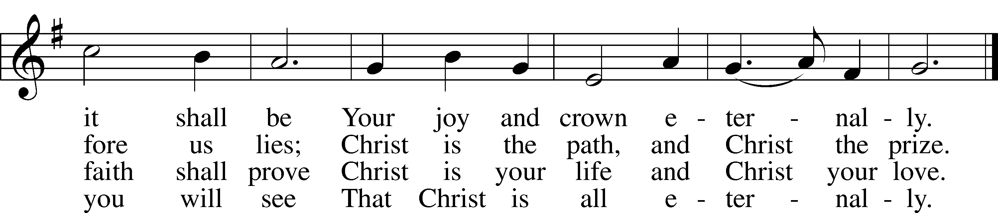

Text and tune: Public domain

Sermon The Fight of Faith (1 Timothy 6:11-16)

Prayer of the Church

P Let us pray for the whole people of God in Christ Jesus and for all people according to their needs.

We pray for the Church, that the light of the Gospel of salvation be proclaimed and the gifts of God be shared. Lord of the Church,

C **in mercy, hear our prayer.**

P We pray this day for our nation and for all nations of the world, that there be an end to hostilities and that times of peacefulness everywhere prevail. Lord of all times and all people,

C **in mercy, hear our prayer.**

P We pray for our families and our neighbors. Grant that we walk in the light of Christ and together praise our gracious God for all He has done for us. Lord of all generations,

C **in mercy, hear our prayer.**

P We pray for all sorts and conditions of people, especially for the hospitalized and those who are shut in during this season. We pray for those whose lives are in transition, the unemployed, those who are downcast or grieving, and all those for whom our petitions are desired, [*including* . . .]. Lord of care and grace,

C **in mercy, hear our prayer.**

P As a community of the faithful, we remember those who have shared the faith with us and now have departed this earthly life in hope and joy. Direct our ways on earth that we complete our journey of life in faith and rejoice together with them eternally with saints and angels and all the company of heaven in life everlasting. Lord of eternity,

C **in mercy, hear our prayer.**

P Into Your hands, O Lord, we commend all for whom we pray, trusting in Your mercy through Jesus Christ, our Lord and Savior.

C **Amen.**

# Service of the Sacrament

Preface LSB 208

P The Lord be with you.

C **And also with you.**

P Lift up your hearts.

C **We lift them to the Lord.**

P Let us give thanks to the Lord our God.

C **It is right to give Him thanks and praise.**

P It is truly good, right, and salutary that we should at all times and in all places give thanks to You, O Lord, holy Father, almighty and everlasting God, for the countless blessings You so freely bestow on us and all creation. Above all, we give thanks for Your boundless love shown to us when You sent Your only-begotten Son, Jesus Christ, into our flesh and laid on Him our sin, giving Him into death that we might not die eternally. Because He is now risen from the dead and lives and reigns to all eternity, all who believe in Him will overcome sin and death and will rise again to new life. Therefore with angels and archangels and with all the company of heaven we laud and magnify Your glorious name, evermore praising You and saying:

Sanctus LSB 208

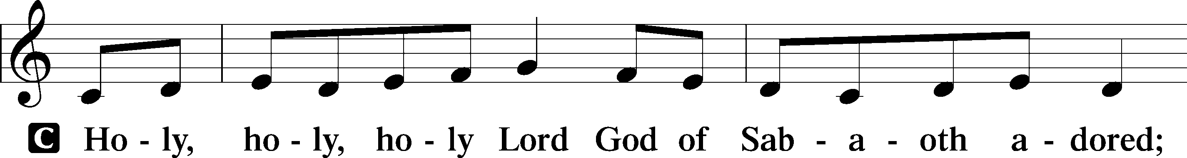

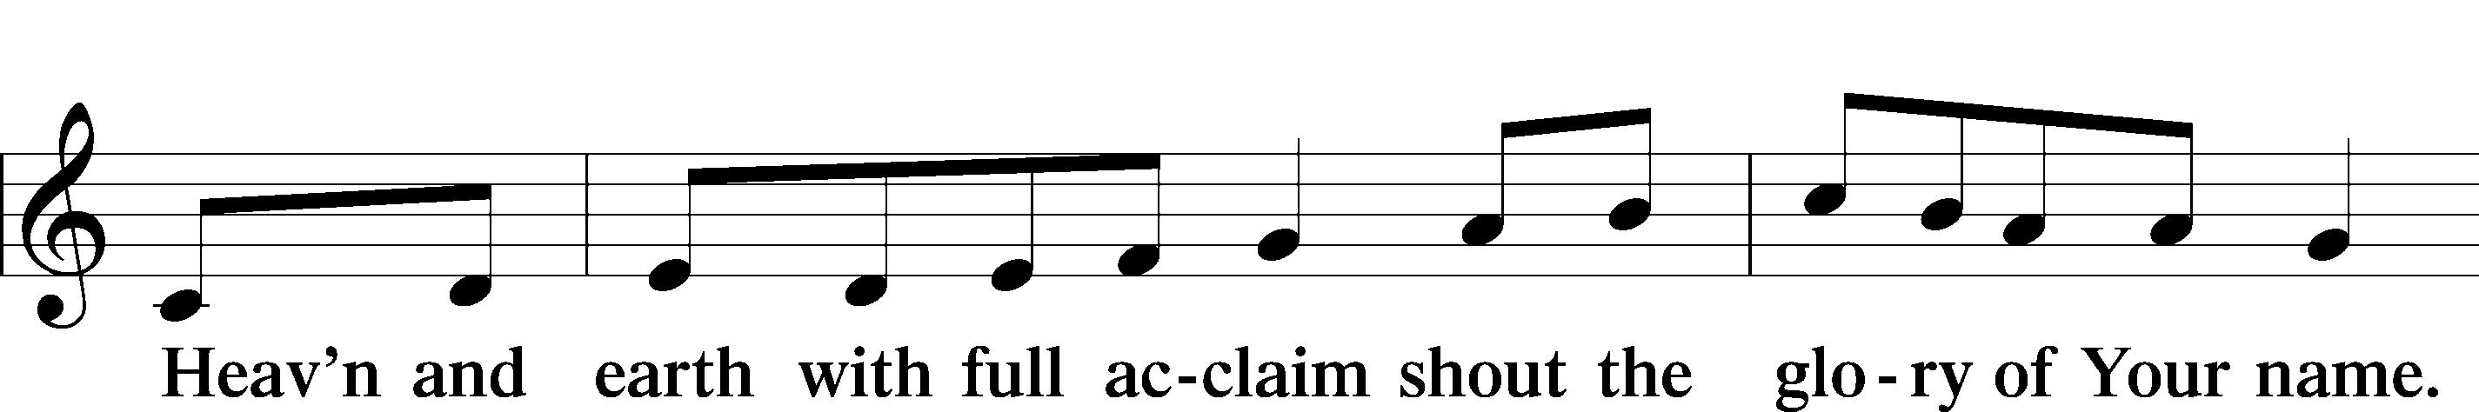

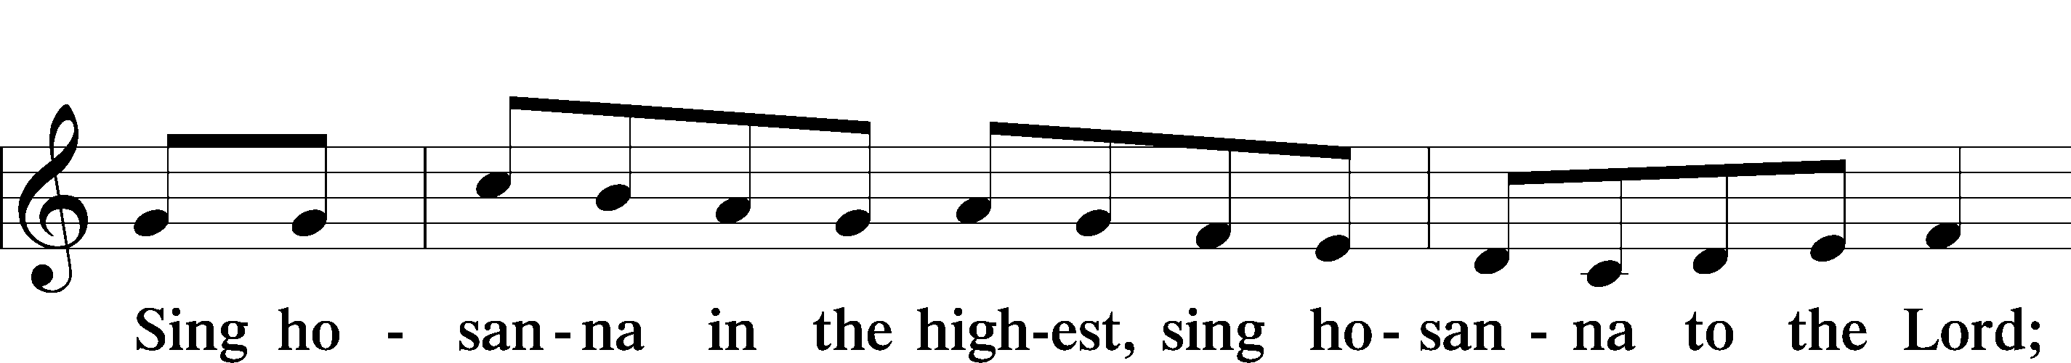

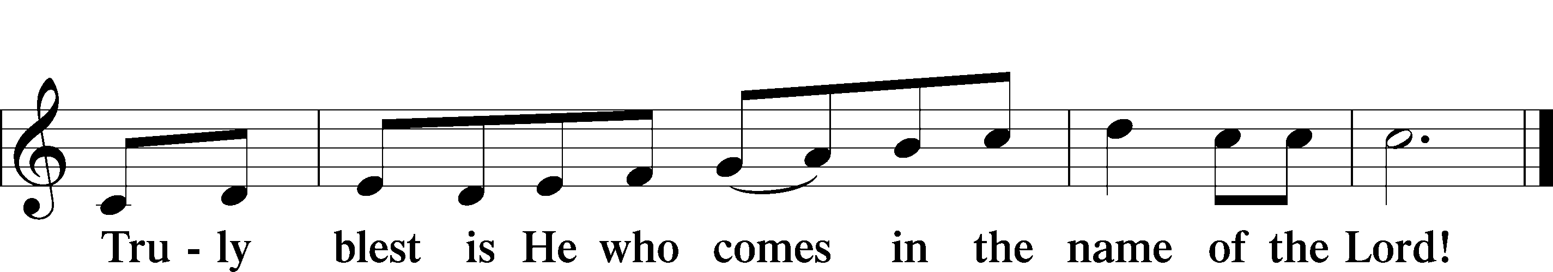

Prayer of Thanksgiving

P Blessed are You, O Lord our God, king of all creation, for You have had mercy on us and given Your only-begotten Son that whoever believes in Him should not perish but have eternal life.

You once proclaimed Your saving promise through the prophets of Israel, and by the apostles and evangelists You published the good news of Your saving promise fulfilled in the death and resurrection of Jesus Christ.

Grant that we, being instructed in the doctrine of the blessed apostles and evangelists, may faithfully eat His body and drink His blood and declare His salvation to all the world.

Hear us as we pray in His name and as He has taught us:

Lord’s Prayer

C **Our Father who art in heaven,**

**hallowed be Thy name,**

**Thy kingdom come,**

**Thy will be done on earth**

**as it is in heaven;**

**give us this day our daily bread;**

**and forgive us our trespasses**

**as we forgive those**

**who trespass against us;**

**and lead us not into temptation,**

**but deliver us from evil.**

**For Thine is the kingdom**

**and the power and the glory**

**forever and ever. Amen.**

The Words of Our Lord

P Our Lord Jesus Christ, on the night when He was betrayed, took bread, and when He had given thanks, He broke it and gave it to the disciples and said: “Take, eat; this is My T body, which is given for you. This do in remembrance of Me.”

In the same way also He took the cup after supper, and when He had given thanks, He gave it to them, saying: “Drink of it, all of you; this cup is the new testament in My T blood, which is shed for you for the forgiveness of sins. This do, as often as you drink it, in remembrance of Me.”

Pax Domini

P The peace of the Lord be with you always.

C **Amen.**

Agnus Dei LSB 210

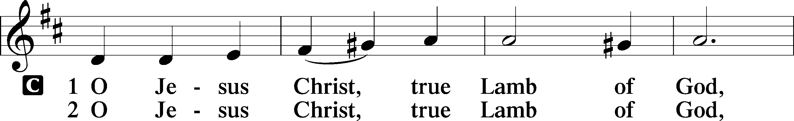

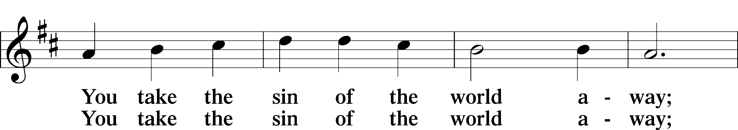

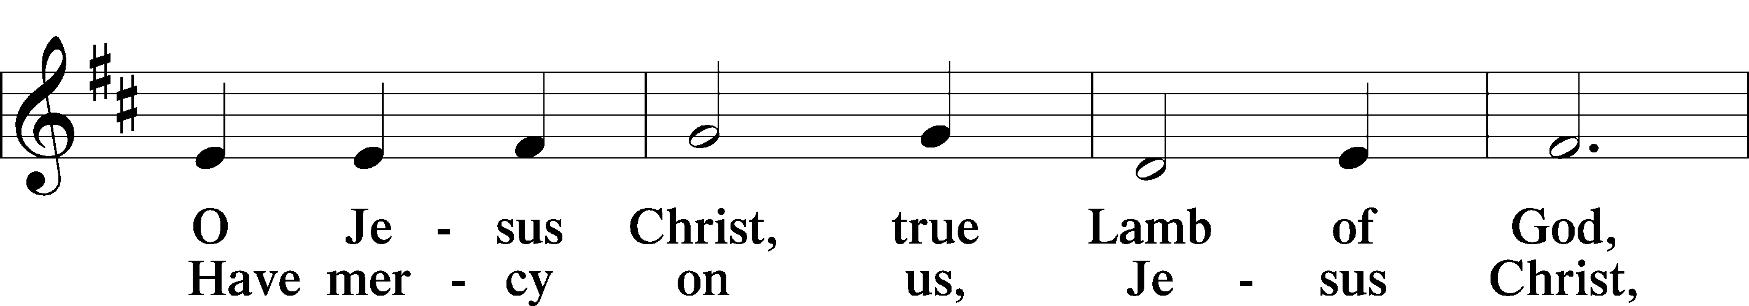

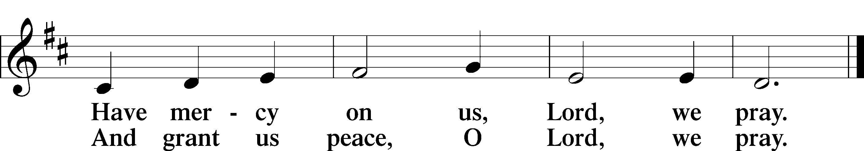

Distribution

618 I Come, O Savior, to Thy Table

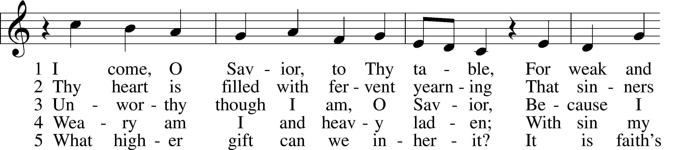

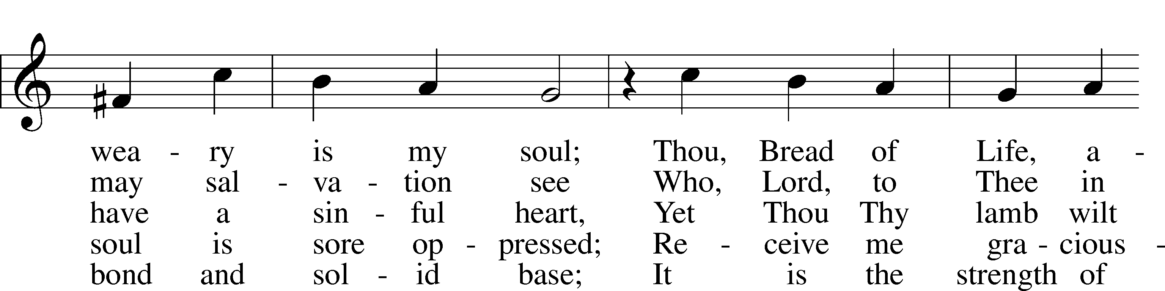

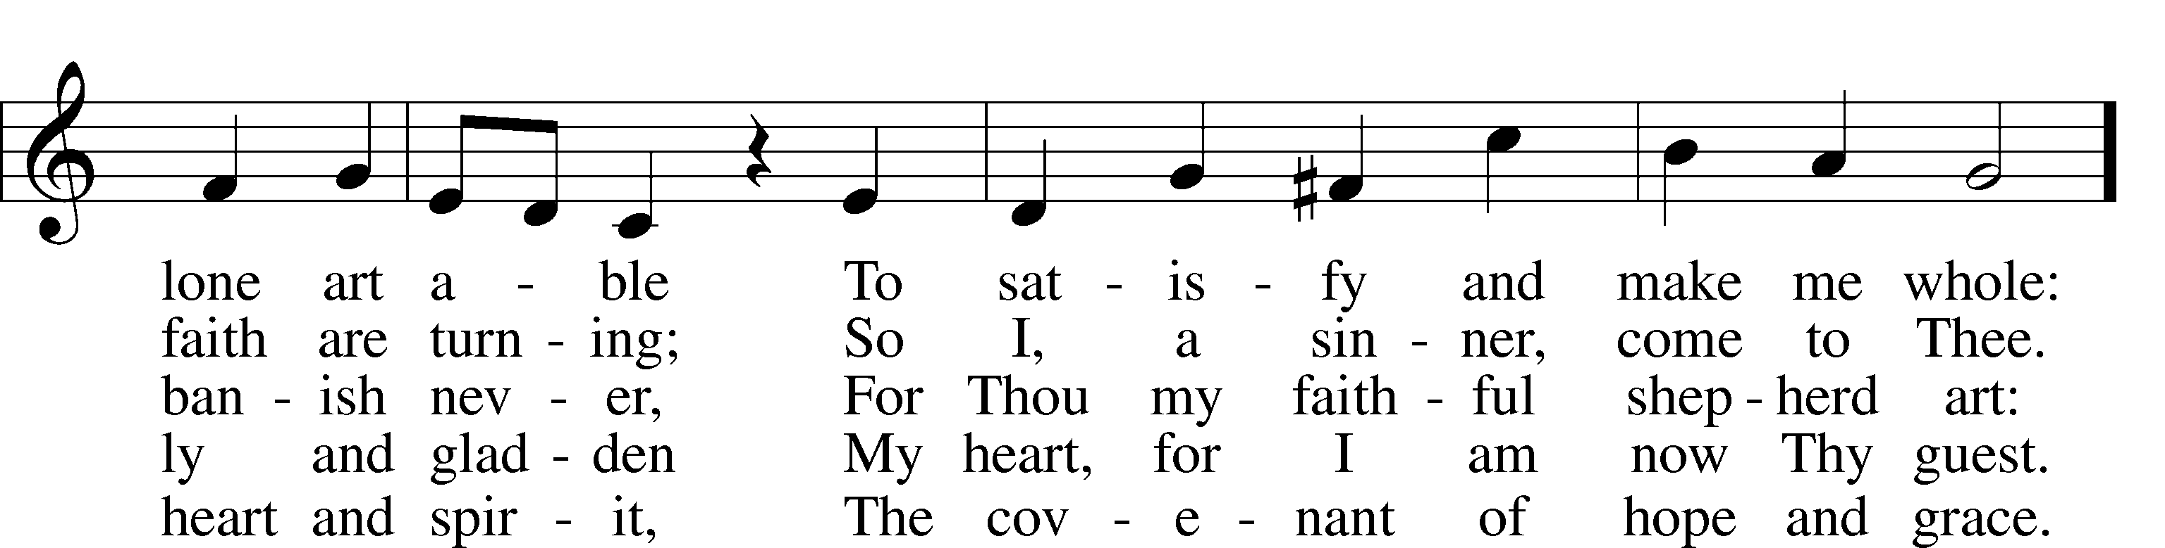

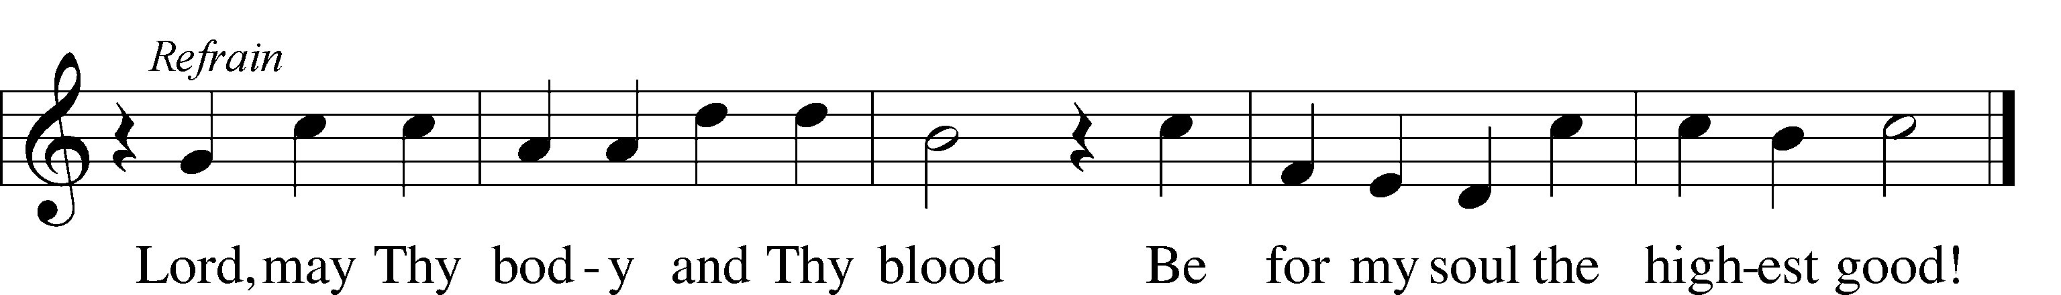

Tune: Public domain

Text: © 1941 Concordia Publishing House. Used by permission: LSB Hymn License no. 110005047

Nunc Dimittis LSB 211

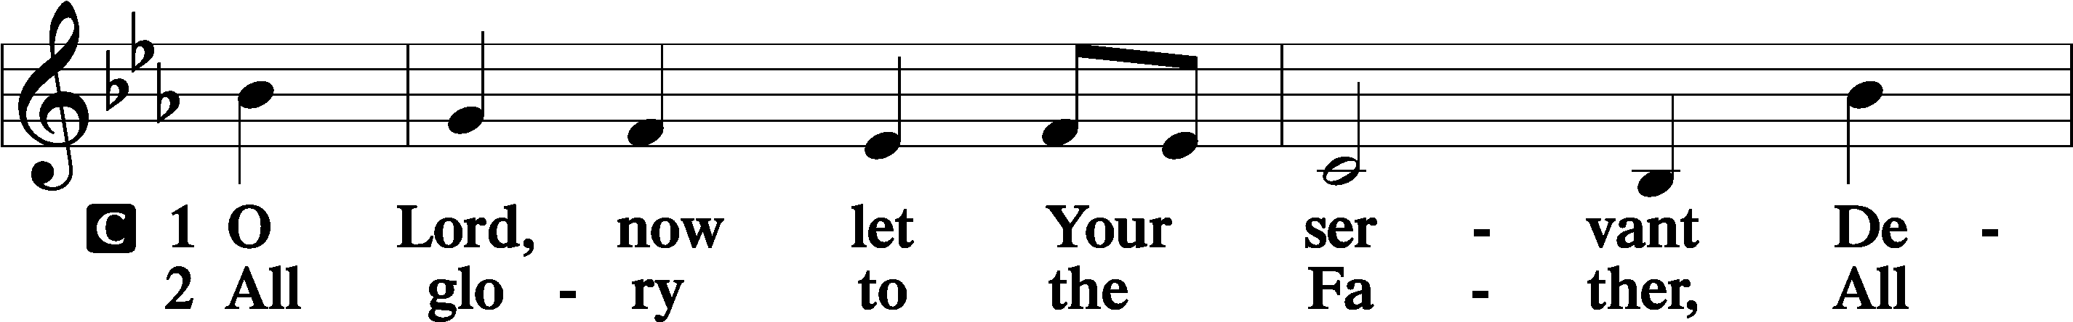

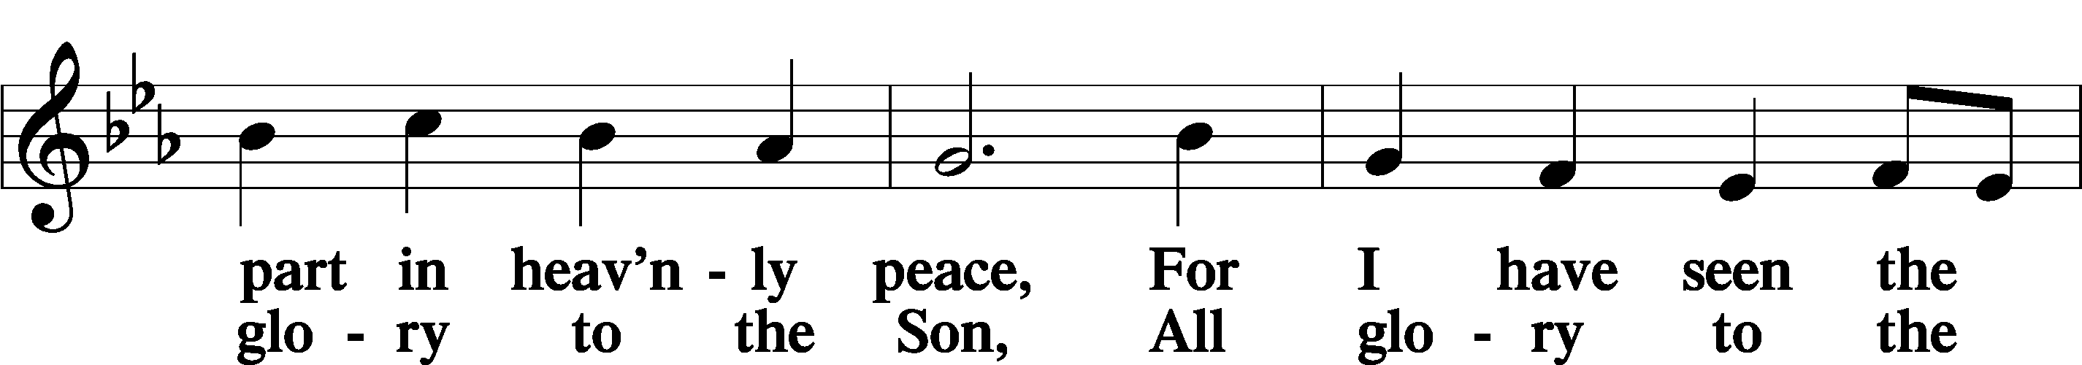

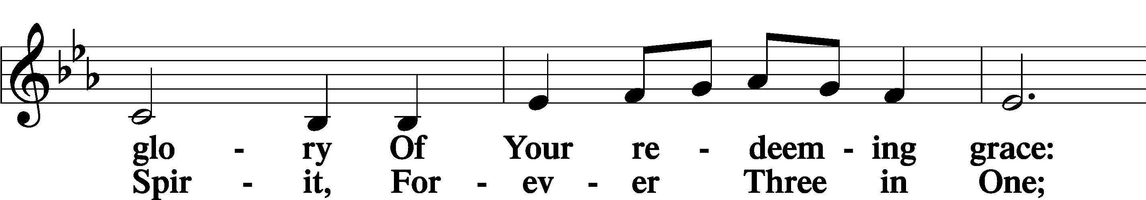

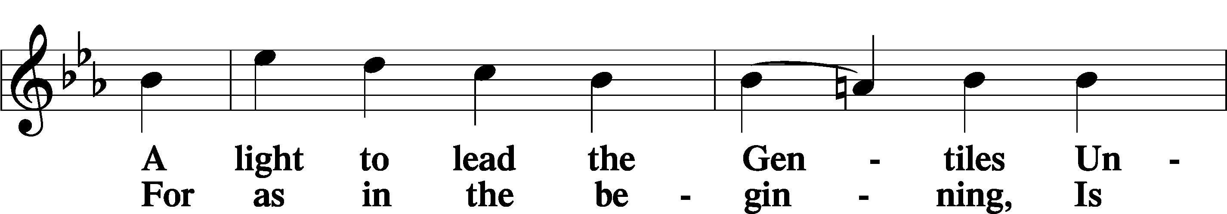

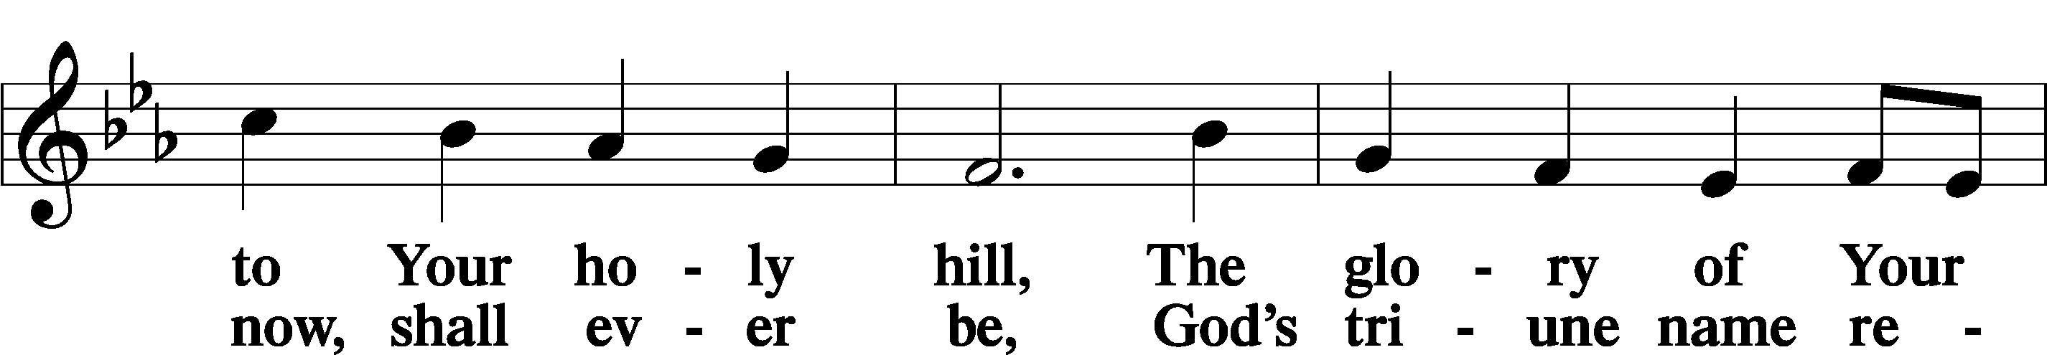

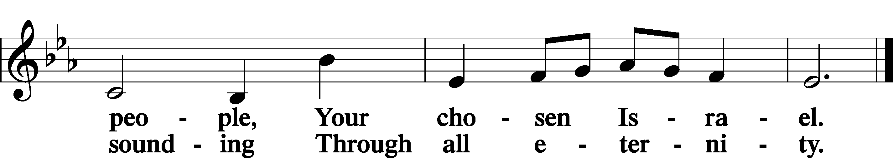

Post-Communion Collect

A Let us pray.

We give thanks to You, almighty God, that You have refreshed us through this salutary gift, and we implore You that of Your mercy You would strengthen us through the same in faith toward You and in fervent love toward one another; through Jesus Christ, Your Son, our Lord, who lives and reigns with You and the Holy Spirit, one God, now and forever.

C **Amen.**

Benedicamus and Benediction LSB 212

A Let us bless the Lord.

C **Thanks be to God.**

P The Lord bless you and keep you.

The Lord make His face shine on you and be gracious to you.

The Lord look upon you with favor and T give you peace.

C **Amen.**

854 Forth in Thy Name, O Lord, I Go

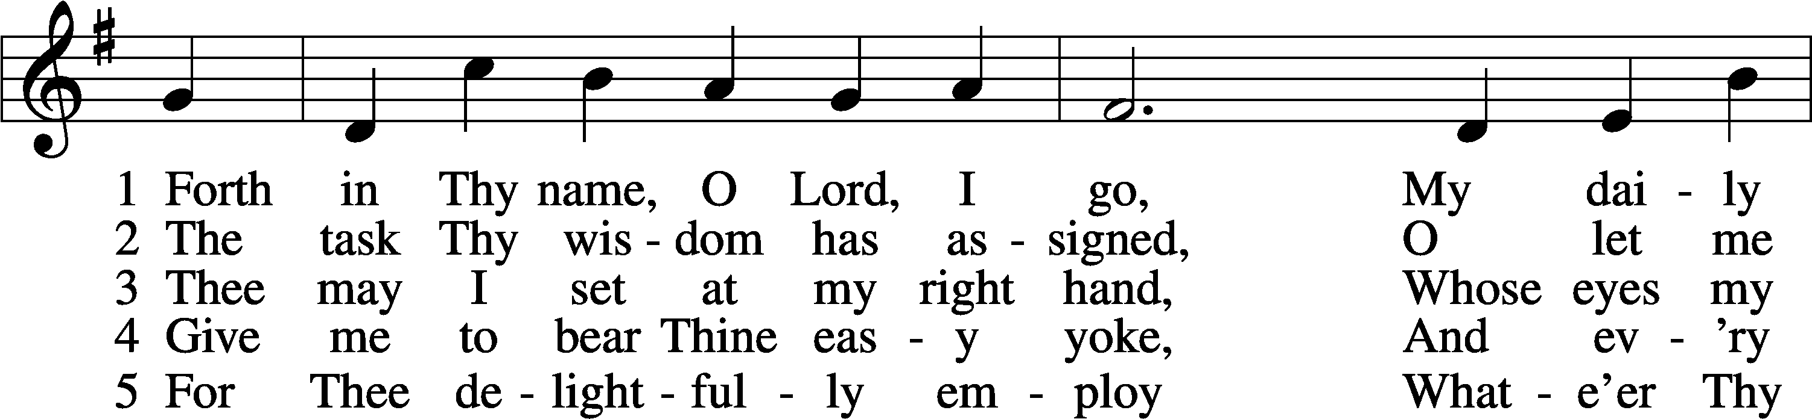

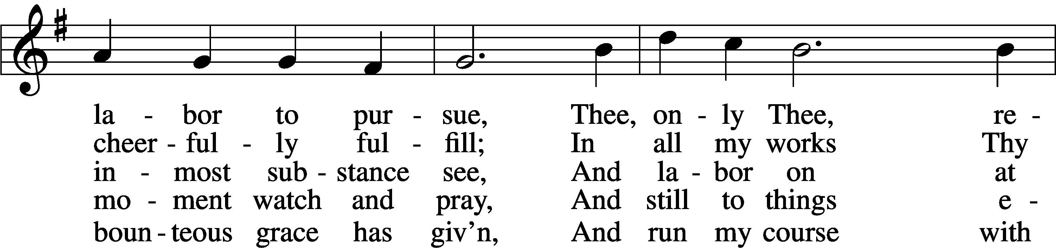

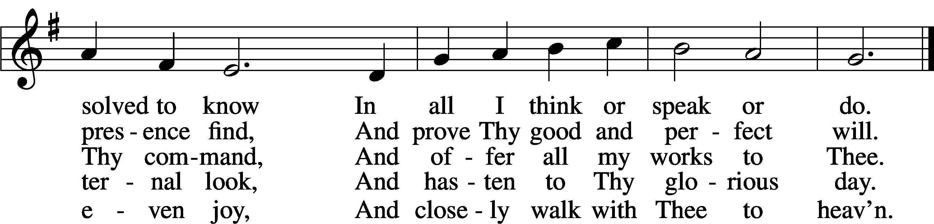

Acknowledgments

Divine Service, Setting Four from Lutheran Service Book

Unless otherwise indicated, Scripture quotations are from the ESV® Bible (The Holy Bible, English Standard Version®), copyright © 2001 by Crossway, a publishing ministry of Good News Publishers. Used by permission. All rights reserved.

Created by Lutheran Service Builder © 2020 Concordia Publishing House.

**Gifts of Time and Treasure**

***“…from everyone who has been given much, much will be demanded…***

***Luke 12:48***

**LAST WEEK’S OFFERINGS**  **LAST WEEK’S ATTENDANCE**

General Fund $ 1,572.93 Service 31

Needed Weekly $ 3,963.38 Communed 29

Adult Bible Study $ 7.32

**The Lord’s Week**

Today 8:45 am – Bible Studies for all ages

**(Jan. 24th)** 10:00 am – Divine Service

11:30 am – Confirmation

Wednesday 10:00 am – Women’s Bible Study

Next Sunday 8:45 am – Bible Studies for all ages

**(Jan. 31st)** 10:00 am – Divine Service

11:10 am – Voter’s Meeting

11:45 am – Confirmation

**In His Service**

Elder: Justin Perkins

Usher:

Acolytes: Whitney Larson

Organist:

Alter: Laura Lopez

Flowers: Eddie & Laura Lopez