**Fourth Sunday after the Epiphany**

**Divine Service, Setting Four**

**“The Holy One of God”**

Mark 1:21-28

**January 31, 2021**

**Messiah Lutheran Church**

**Lutheran Church-Missouri Synod**

4102 Trinity River Dr., Corpus Christi, Texas 78410

**Pastor:**  **Rev. Scott E. Herbert**

Church Phone: 361-387-7748 Email: mlc@stx.rr.com

Church Fax: 361-767-1768 Website: [www.messiahlcms-cc.org](http://www.messiahlcms-cc.org)

Pastor Phone: 469-693-9683 Pastor Email: chirev59@gmail.com

**WELCOME TO MESSIAH!**

We are glad you are here to receive what God is doing for you during Divine Service. Please sign our Guest Book located near the front door. Feel free to converse quietly until the organ prelude begins. If you are looking for a church home, please talk to the Pastor at the door. We would love to have you join us.

**Preparing for Service**

***Our Lord Jesus Christ, True God in the Flesh, Cleanses Our Consciences from Sin***

As He promised, the Lord our God has raised up *“a prophet”* like Moses, namely Jesus, our brother in the flesh. *“To him you shall listen,”* because the Word of the Lord is *“in his mouth”* (Deut. 18:15–18). Indeed, He is more than a prophet and more than a scribe of the Scriptures; He is the incarnate Word, and He speaks *“a new teaching with authority”* (Mark 1:22, 27). He enters *“the synagogue”* of His Church and provides true Sabbath rest, using His authority to silence and cast out *“even the unclean spirits”* (Mark 1:21–27). By His Word of the cross, He removes the accusations of the Law and of the devil, and He cleanses our consciences before God the Father, *“from whom are all things and for whom we exist.”* Hence, we are now set free from bondage and commended to God by the one Lord, Jesus Christ, *“through whom are all things and through whom we exist”* (1 Cor. 8:6). Therefore, use your freedom to care for your brothers and sisters, neither causing them to stumble nor wounding their consciences (1 Cor. 8:9–12), but cleansing and strengthening them with the Gospel.

# Confession and Absolution

904 Blessed Jesus, at Your Word

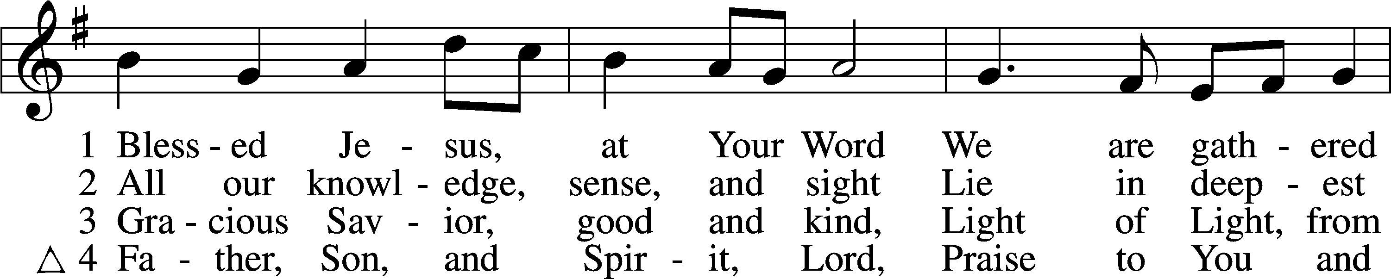

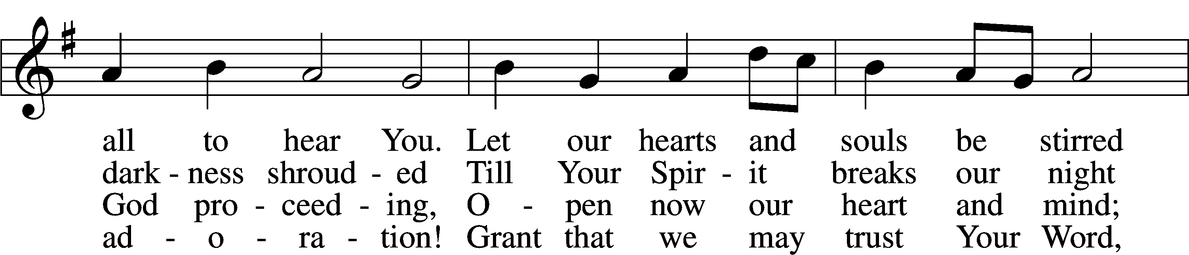

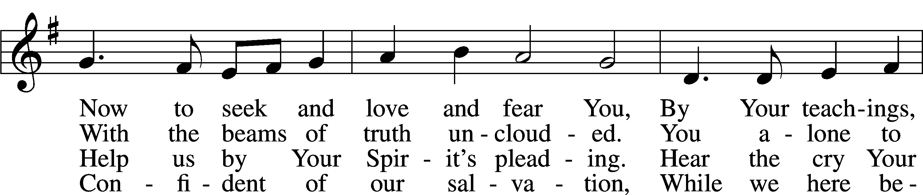

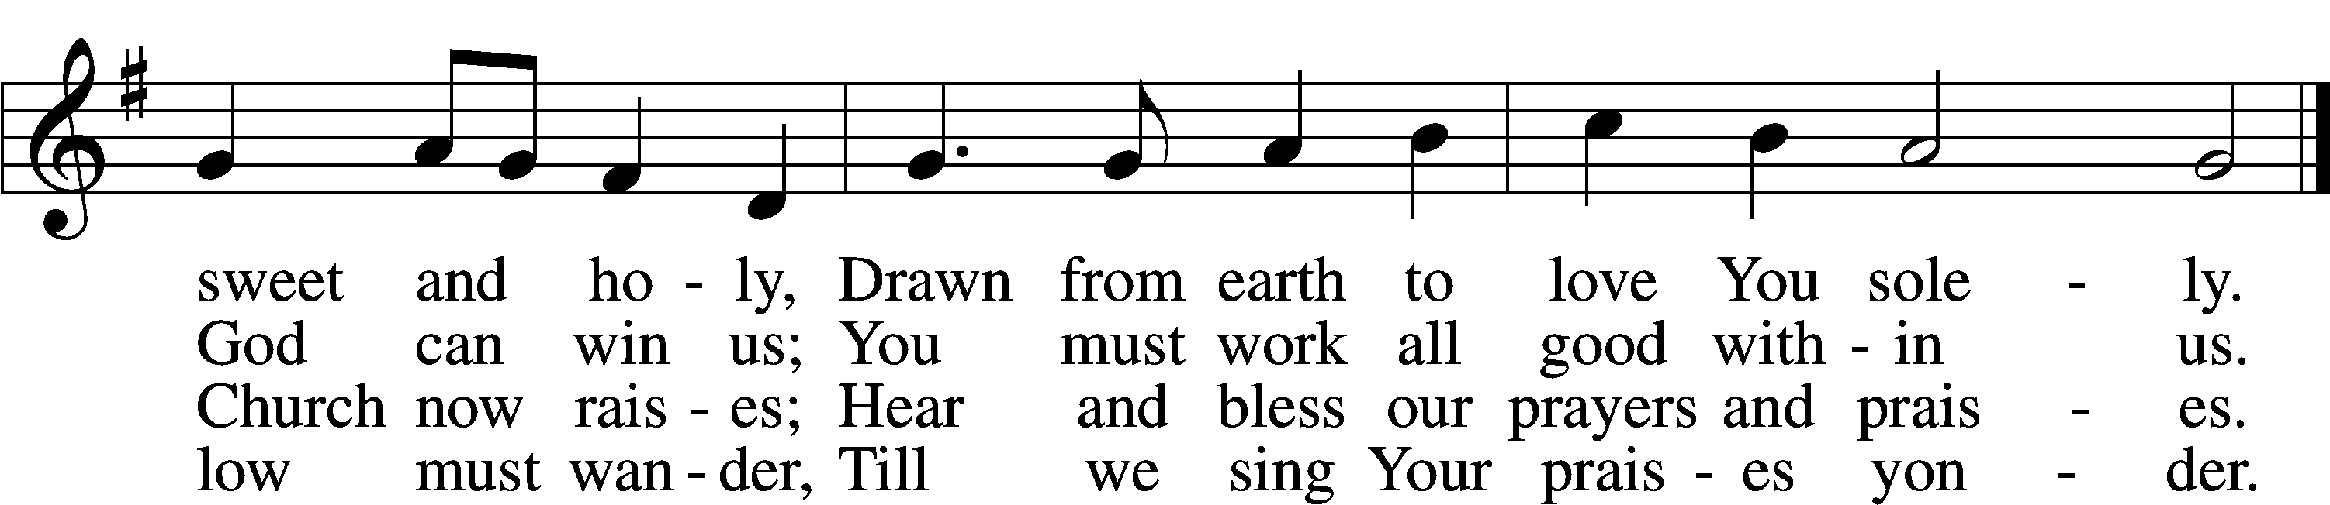

Tune and text: Public domain

P In the name of the Father and of the T Son and of the Holy Spirit.

C **Amen.**

P Our help is in the name of the Lord,

C **who made heaven and earth.**

P If You, O Lord, kept a record of sins, O Lord, who could stand?

C **But with You there is forgiveness; therefore You are feared.**

P Since we are gathered to hear God’s Word, call upon Him in prayer and praise, and receive the body and blood of our Lord Jesus Christ in the fellowship of this altar, let us first consider our unworthiness and confess before God and one another that we have sinned in thought, word, and deed, and that we cannot free ourselves from our sinful condition. Together as His people let us take refuge in the infinite mercy of God, our heavenly Father, seeking His grace for the sake of Christ, and saying: God, be merciful to me, a sinner.

C **Almighty God, have mercy upon us, forgive us our sins, and lead us to everlasting life. Amen.**

P Almighty God, merciful Father, in Holy Baptism You declared us to be Your children and gathered us into Your one, holy Church, in which You daily and richly forgive us our sins and grant us new life through Your Spirit. Be in our midst, enliven our faith, and graciously receive our prayer and praise; through Your Son, Jesus Christ, our Lord.

C **Amen.**

# Service of the Word

Introit Psalm 32:1–2, 5–7; antiphon: v. 10

Many are the sorrows of the wicked,  
 **but steadfast love surrounds the one who trusts in the Lord.**Blessèd is the one whose transgression is forgiven,  
 **whose sin is covered.**Blessèd is the man against whom the Lord counts no iniquity,  
 **and in whose spirit there is no deceit.**I acknowledged my sin to you, and I did not cover my iniquity;  
 **I said, “I will confess my transgressions to the Lord,” and you forgave the iniquity of my sin.**Therefore let everyone who is godly offer prayer to you at a time when you may be found;  
 **surely in the rush of great waters, they shall not reach him.**You are a hiding place for me; you preserve me from trouble;  
 **you surround me with shouts of deliverance.  
Glory be to the Father and to the ✠ Son and to the Holy Spirit;**  
**as it was in the beginning, is now, and will be forever. Amen.**  
Many are the sorrows of the wicked,  
 **but steadfast love surrounds the one who trusts in the Lord.**

Kyrie LSB 204

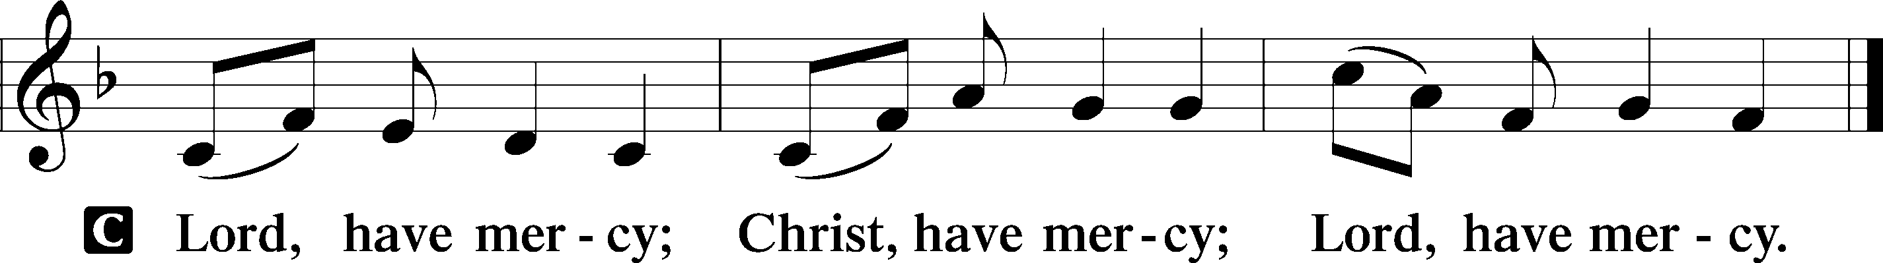

Gloria in Excelsis LSB 204

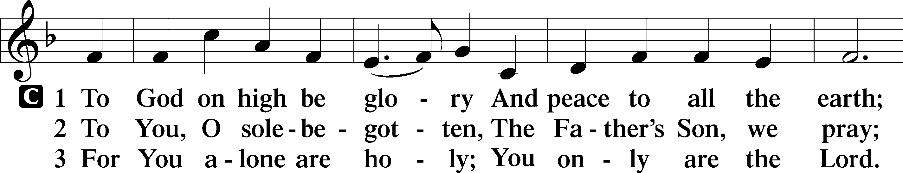

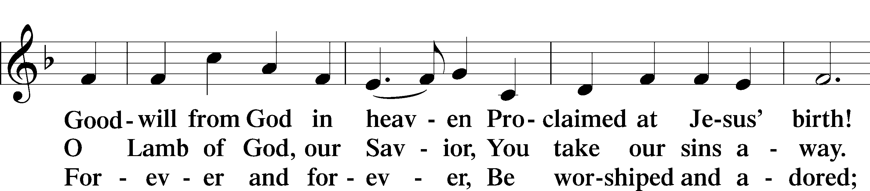

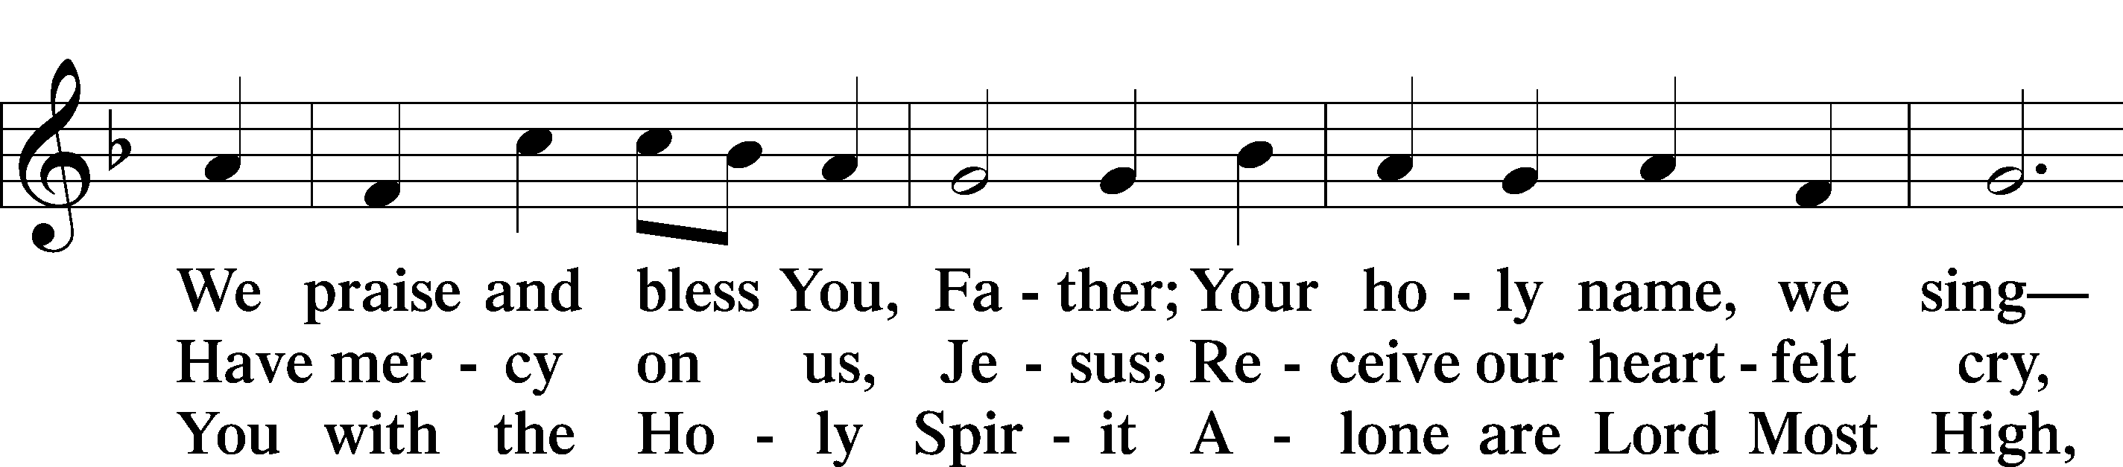

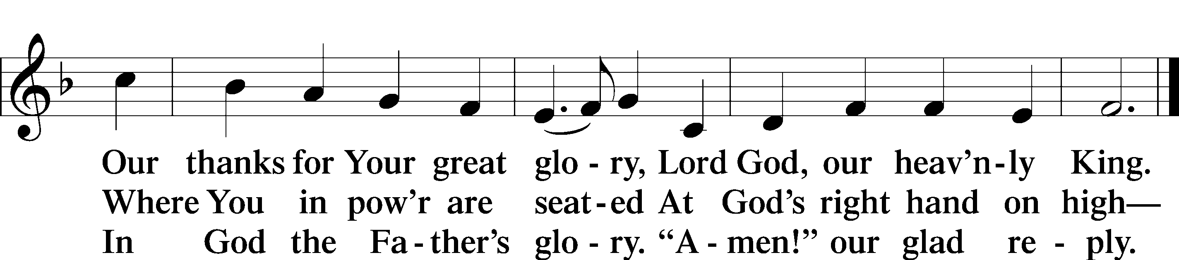

Salutation and Collect of the Day

P The Lord be with you.

C **And also with you.**

P Let us pray.

Almighty God, You know we live in the midst of so many dangers that in our frailty we cannot stand upright. Grant strength and protection to support us in all dangers and carry us through all temptations; through Jesus Christ, Your Son, our Lord, who lives and reigns with You and the Holy Spirit, one God, now and forever.

C **Amen.**

Old Testament Reading Deuteronomy 18:15–20

15“The Lord your God will raise up for you a prophet like me from among you, from your brothers—it is to him you shall listen— 16just as you desired of the Lord your God at Horeb on the day of the assembly, when you said, ‘Let me not hear again the voice of the Lord my God or see this great fire any more, lest I die.’ 17And the Lord said to me, ‘They are right in what they have spoken. 18I will raise up for them a prophet like you from among their brothers. And I will put my words in his mouth, and he shall speak to them all that I command him. 19And whoever will not listen to my words that he shall speak in my name, I myself will require it of him. 20But the prophet who presumes to speak a word in my name that I have not commanded him to speak, or who speaks in the name of other gods, that same prophet shall die.’”

A This is the Word of the Lord.

C **Thanks be to God.**

Epistle 1 Corinthians 8:1–13

1Concerning food offered to idols: we know that “all of us possess knowledge.” This “knowledge” puffs up, but love builds up. 2If anyone imagines that he knows something, he does not yet know as he ought to know. 3But if anyone loves God, he is known by God.

4Therefore, as to the eating of food offered to idols, we know that “an idol has no real existence,” and that “there is no God but one.” 5For although there may be so-called gods in heaven or on earth—as indeed there are many “gods” and many “lords”— 6yet for us there is one God, the Father, from whom are all things and for whom we exist, and one Lord, Jesus Christ, through whom are all things and through whom we exist.

7However, not all possess this knowledge. But some, through former association with idols, eat food as really offered to an idol, and their conscience, being weak, is defiled. 8Food will not commend us to God. We are no worse off if we do not eat, and no better off if we do. 9But take care that this right of yours does not somehow become a stumbling block to the weak. 10For if anyone sees you who have knowledge eating in an idol’s temple, will he not be encouraged, if his conscience is weak, to eat food offered to idols? 11And so by your knowledge this weak person is destroyed, the brother for whom Christ died. 12Thus, sinning against your brothers and wounding their conscience when it is weak, you sin against Christ. 13Therefore, if food makes my brother stumble, I will never eat meat, lest I make my brother stumble.

A This is the Word of the Lord.

C **Thanks be to God.**

Alleluia and Verse

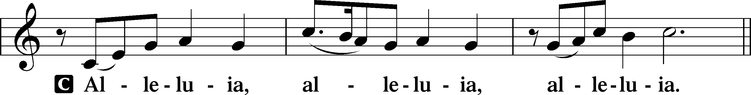

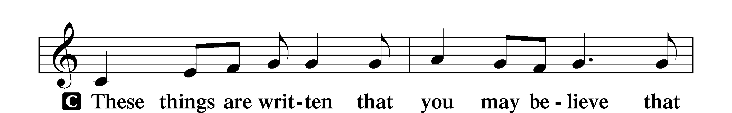

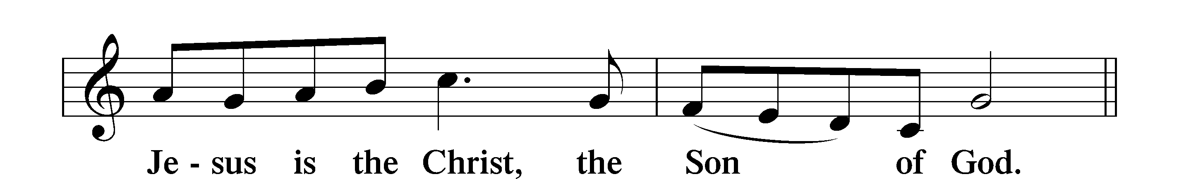

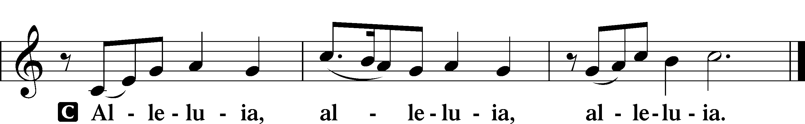

Holy Gospel Mark 1:21–28

P The Holy Gospel according to St. Mark, the first chapter.

C **Glory to You, O Lord.**

21They went into Capernaum, and immediately on the Sabbath [Jesus] entered the synagogue and was teaching. 22And they were astonished at his teaching, for he taught them as one who had authority, and not as the scribes. 23And immediately there was in their synagogue a man with an unclean spirit. And he cried out, 24“What have you to do with us, Jesus of Nazareth? Have you come to destroy us? I know who you are—the Holy One of God.” 25But Jesus rebuked him, saying, “Be silent, and come out of him!” 26And the unclean spirit, convulsing him and crying out with a loud voice, came out of him. 27And they were all amazed, so that they questioned among themselves, saying, “What is this? A new teaching with authority! He commands even the unclean spirits, and they obey him.” 28And at once his fame spread everywhere throughout all the surrounding region of Galilee.

P This is the Gospel of the Lord.

C **Praise to You, O Christ.**

Apostles’ Creed

C **I believe in God, the Father Almighty,**

**maker of heaven and earth.**

**And in Jesus Christ, His only Son, our Lord,**

**who was conceived by the Holy Spirit,**

**born of the virgin Mary,**

**suffered under Pontius Pilate,**

**was crucified, died and was buried.**

**He descended into hell.**

**The third day He rose again from the dead.**

**He ascended into heaven**

**and sits at the right hand of God the Father Almighty.**

**From thence He will come to judge the living and the dead.**

**I believe in the Holy Spirit,**

**the holy Christian Church, the communion of saints,**

**the forgiveness of sins,**

**the resurrection of the body,**

**and the life** T **everlasting. Amen.**

Children’s Message Who’s in Control?

541 “Away from Us!” the Demon Cried

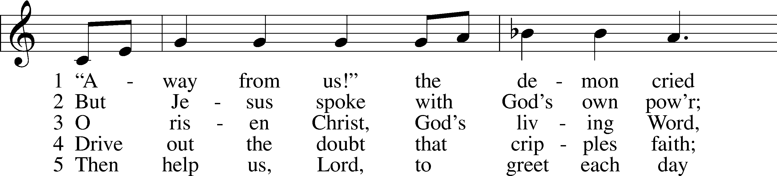

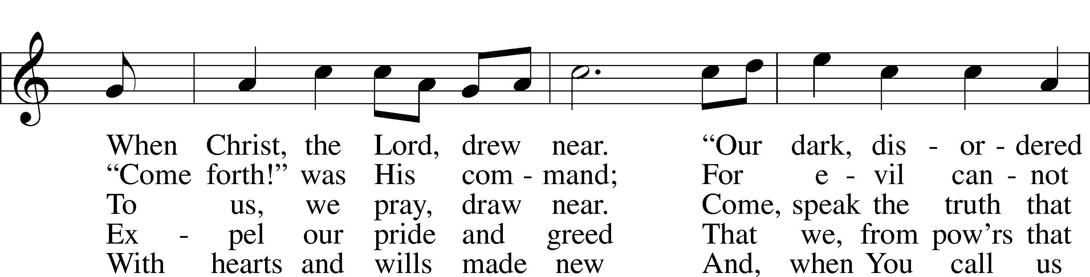

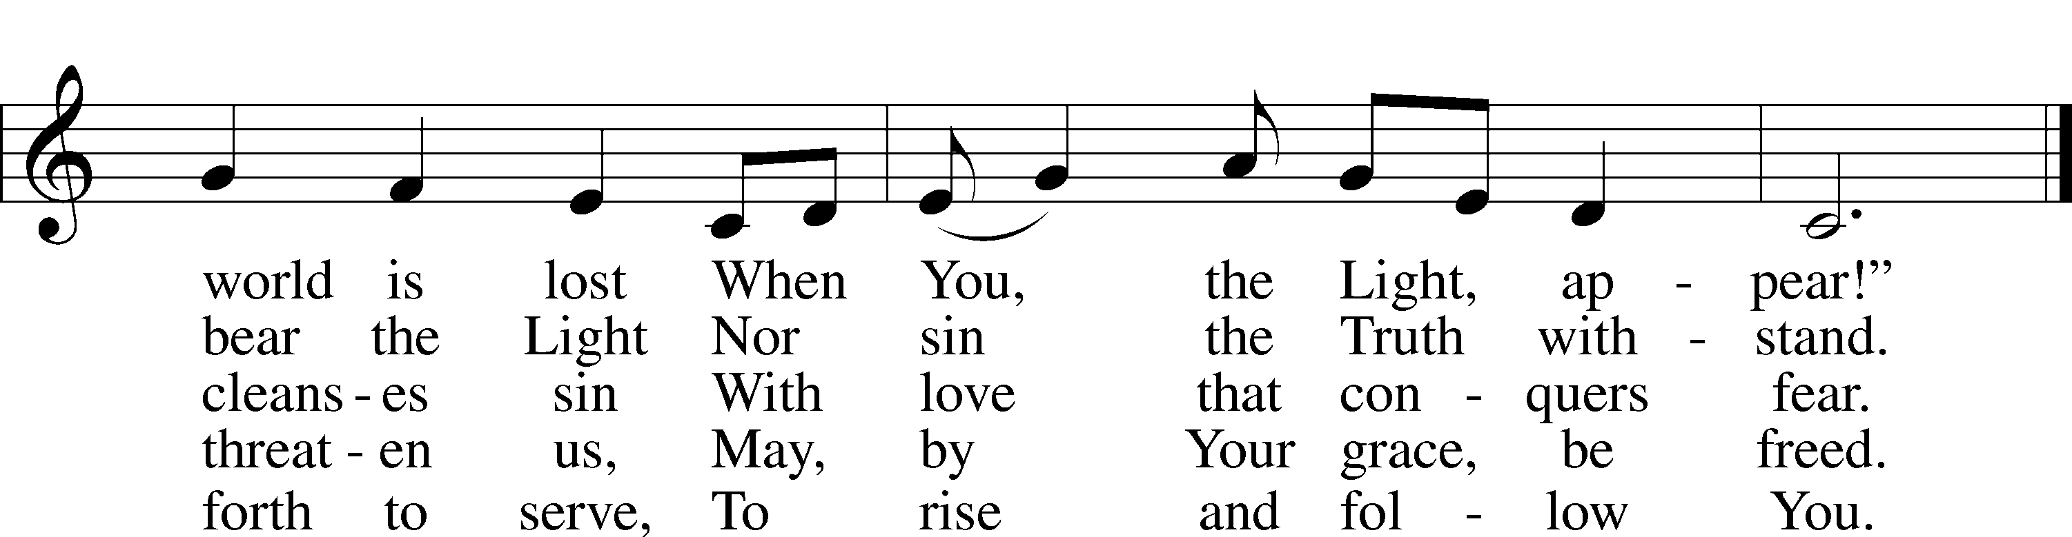

Tune: Public domain

Text: © 2000 GIA Publications, Inc. Used by permission: LSB Hymn License no. 110005047

Sermon The Holy One of God (Mark 1:21-28)

Prayer of the Church

P Friends in Christ, I urge you all to lift up your hearts to God and pray with me as Christ our Lord has taught us and freely promised to hear us.

God, our Father in heaven, look with mercy on us, Your needy children on earth, and grant us grace that Your holy name be hallowed by us and all the world through the pure and true teaching of Your Word and the fervent love shown forth in our lives. Graciously turn from us all false doctrine and evil living whereby Your precious name is blasphemed and profaned. Lord, in Your mercy,

C **hear our prayer.**

P May Your kingdom come to us and expand. Bring all transgressors and those who are blinded and bound in the devil’s kingdom to know Jesus Christ, Your Son, by faith that the number of Christians may be increased. Lord, in Your mercy,

C **hear our prayer.**

P Strengthen us by Your Spirit according to Your will, both in life and in death, in the midst of both good and evil things, that our own wills may be crucified daily and sacrificed to Your good and gracious will. Into Your merciful hands we commend [name(s)] and all who are in need, praying for them at all times: Thy will be done. Lord, in Your mercy,

C **hear our prayer.**

P Grant us our daily bread, preserve us from greed and selfish cares, and help us trust in You to provide for all our needs. Lord, in Your mercy,

C **hear our prayer.**

P Forgive us our sins as we also forgive those who sin against us so that our hearts may be at peace and may rejoice in a good conscience before You, and that no sin may ever frighten or alarm us. Lord, in Your mercy,

C **hear our prayer.**

P Lead us not into temptation, O Lord, but help us by Your Spirit to subdue our flesh, to turn from the world and its ways, and to overcome the devil with all his wiles. Lord, in Your mercy,

C **hear our prayer.**

P And lastly, O heavenly Father, deliver us from all evil of both body and soul, now and forever. Lord, in Your mercy,

C **hear our prayer.**

P We trust, O Lord, in Your great mercy to hear and answer us; through Jesus Christ, our Lord.

C **Amen.**

# Service of the Sacrament

Preface LSB 208

P The Lord be with you.

C **And also with you.**

P Lift up your hearts.

C **We lift them to the Lord.**

P Let us give thanks to the Lord our God.

C **It is right to give Him thanks and praise.**

P It is truly good, right, and salutary that we should at all times and in all places give thanks to You, O Lord, holy Father, almighty and everlasting God, for the countless blessings You so freely bestow on us and all creation. Above all, we give thanks for Your boundless love shown to us when You sent Your only-begotten Son, Jesus Christ, into our flesh and laid on Him our sin, giving Him into death that we might not die eternally. Because He is now risen from the dead and lives and reigns to all eternity, all who believe in Him will overcome sin and death and will rise again to new life. Therefore with angels and archangels and with all the company of heaven we laud and magnify Your glorious name, evermore praising You and saying:

Sanctus LSB 208

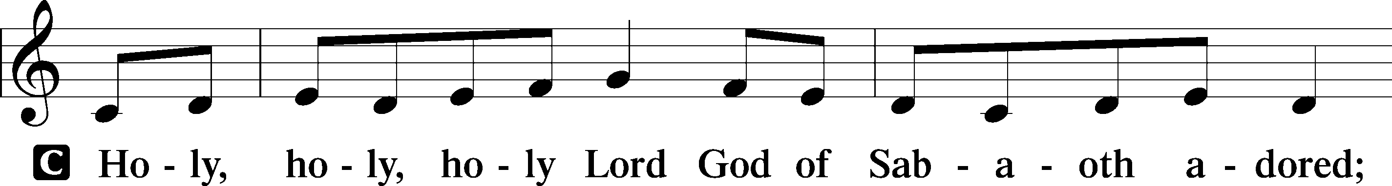

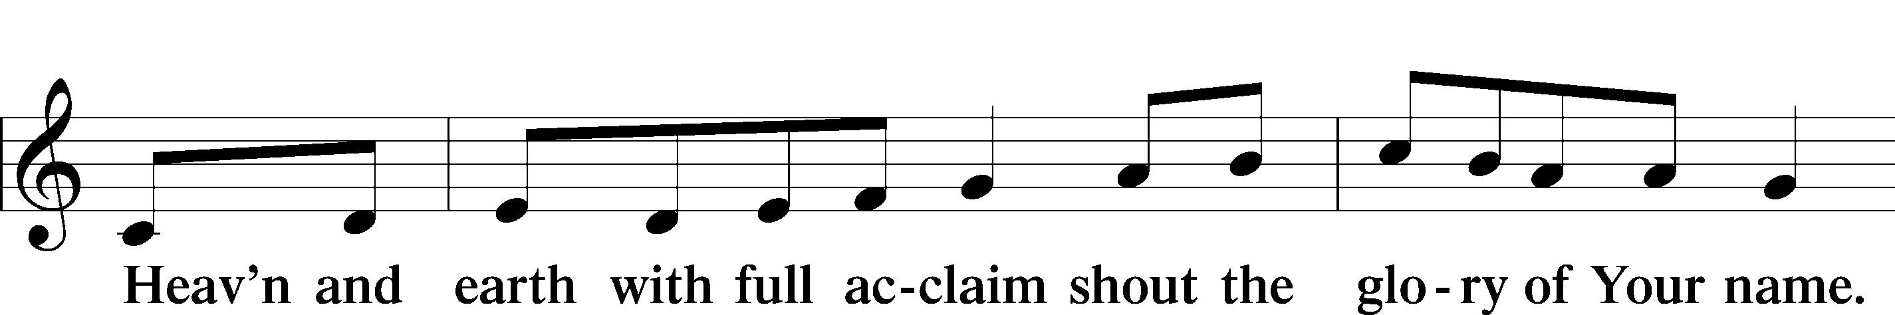

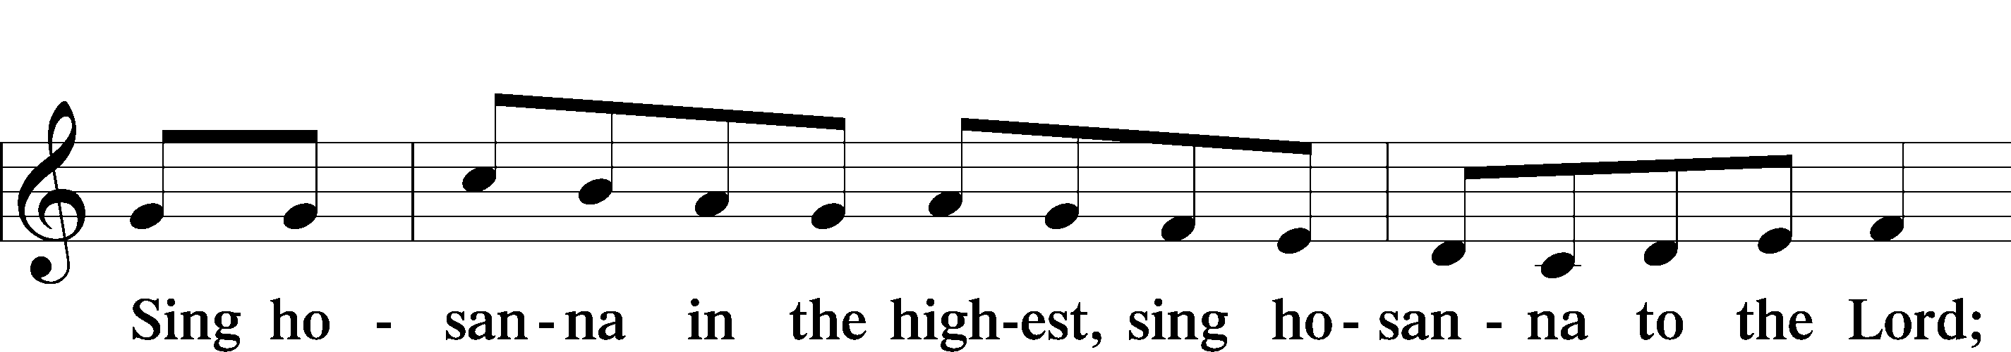

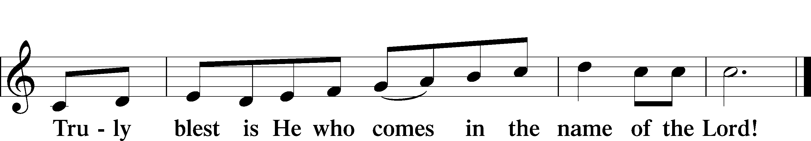

Prayer of Thanksgiving

P Blessed are You, O Lord our God, king of all creation, for You have had mercy on us and given Your only-begotten Son that whoever believes in Him should not perish but have eternal life.

As the glory of Your presence once filled Your ancient temple, so in the incarnation of Your Son, Jesus Christ, You manifested the fullness of Your glory in human flesh.

We give You thanks that in His most Holy Supper You reveal Your glory to us. Grant us faithfully to eat His body and drink His blood so that we may one day behold Your glory face to face.

Hear us as we pray in His name and as He has taught us:

Lord’s Prayer

C **Our Father who art in heaven,**

**hallowed be Thy name,**

**Thy kingdom come,**

**Thy will be done on earth**

**as it is in heaven;**

**give us this day our daily bread;**

**and forgive us our trespasses**

**as we forgive those**

**who trespass against us;**

**and lead us not into temptation,**

**but deliver us from evil.**

**For Thine is the kingdom**

**and the power and the glory**

**forever and ever. Amen.**

The Words of Our Lord

P Our Lord Jesus Christ, on the night when He was betrayed, took bread, and when He had given thanks, He broke it and gave it to the disciples and said: “Take, eat; this is My T body, which is given for you. This do in remembrance of Me.”

In the same way also He took the cup after supper, and when He had given thanks, He gave it to them, saying: “Drink of it, all of you; this cup is the new testament in My T blood, which is shed for you for the forgiveness of sins. This do, as often as you drink it, in remembrance of Me.”

Pax Domini

P The peace of the Lord be with you always.

C **Amen.**

Agnus Dei LSB 210

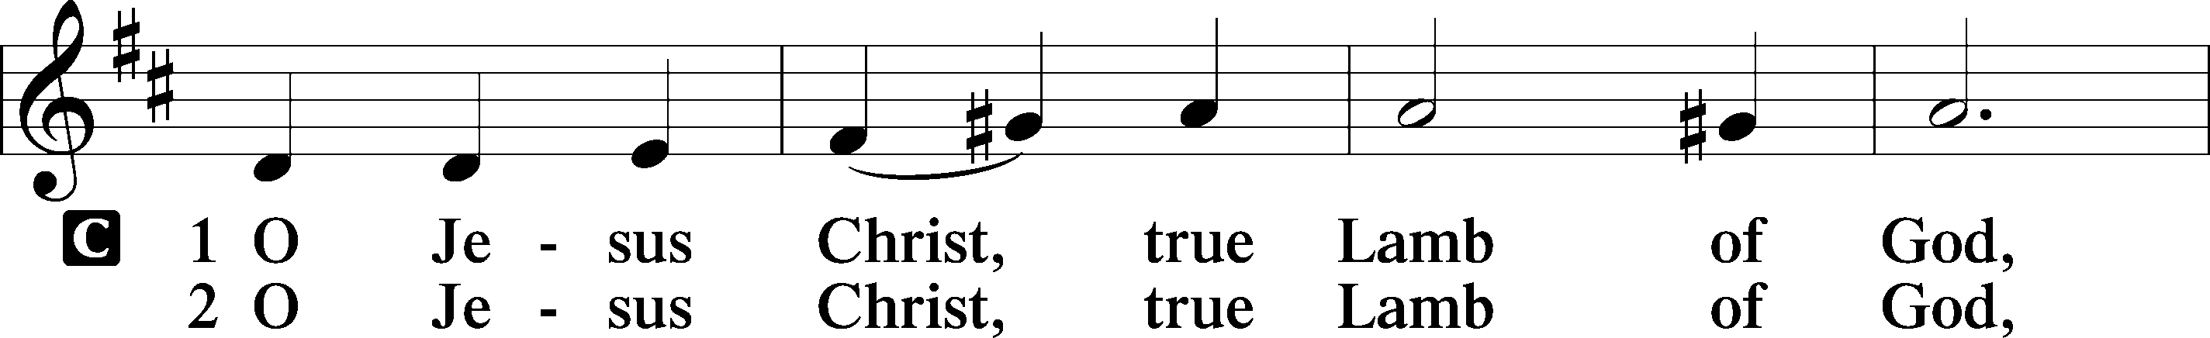

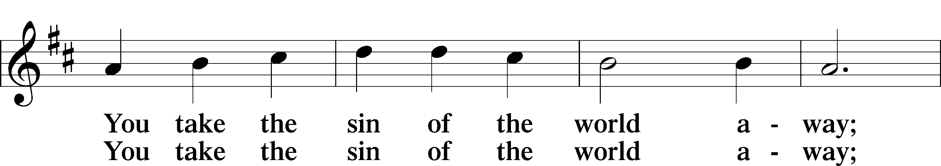

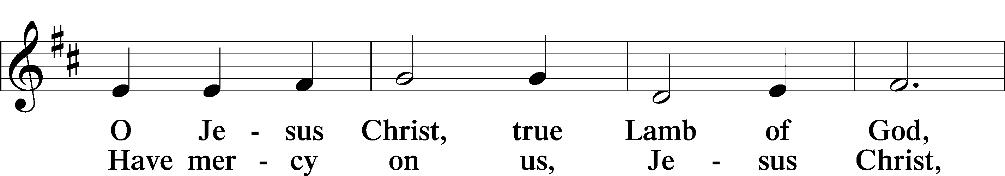

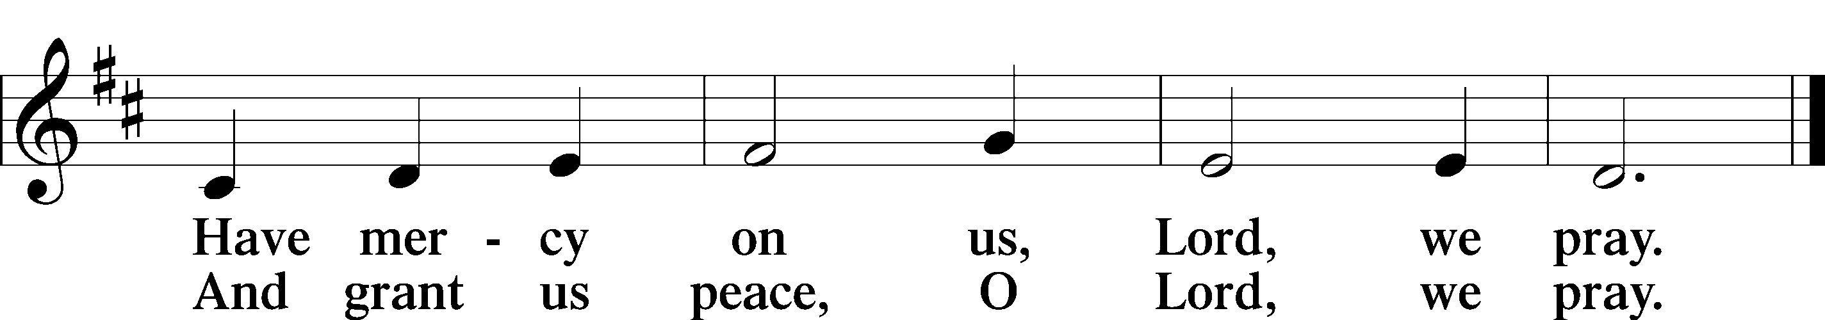

Distribution

Take, eat; this is the true body of our Lord and Savior Jesus Christ, given into death for your sins.

**Amen.**

Take, drink; this is the true blood of our Lord and Savior Jesus Christ, shed for the forgiveness of your sins.

**Amen.**

P The body and blood of our Lord Jesus Christ strengthen and preserve you in body and soul to life everlasting. Depart T in peace.

C **Amen.**

619 Thy Body, Given for Me, O Savior

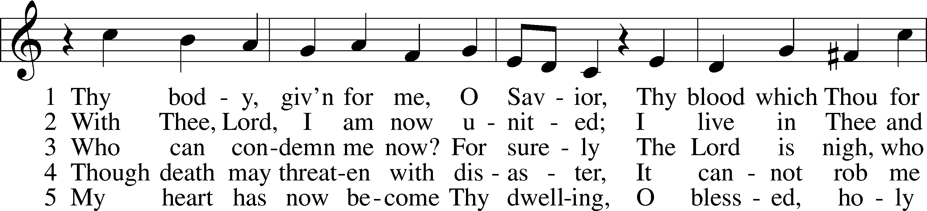

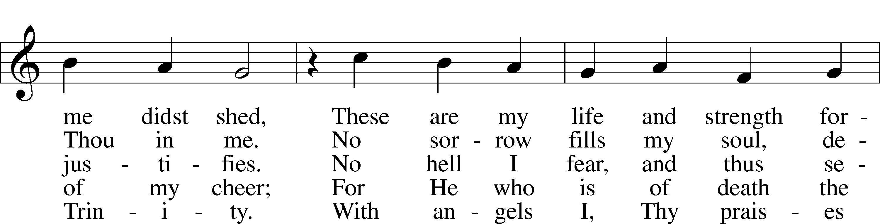

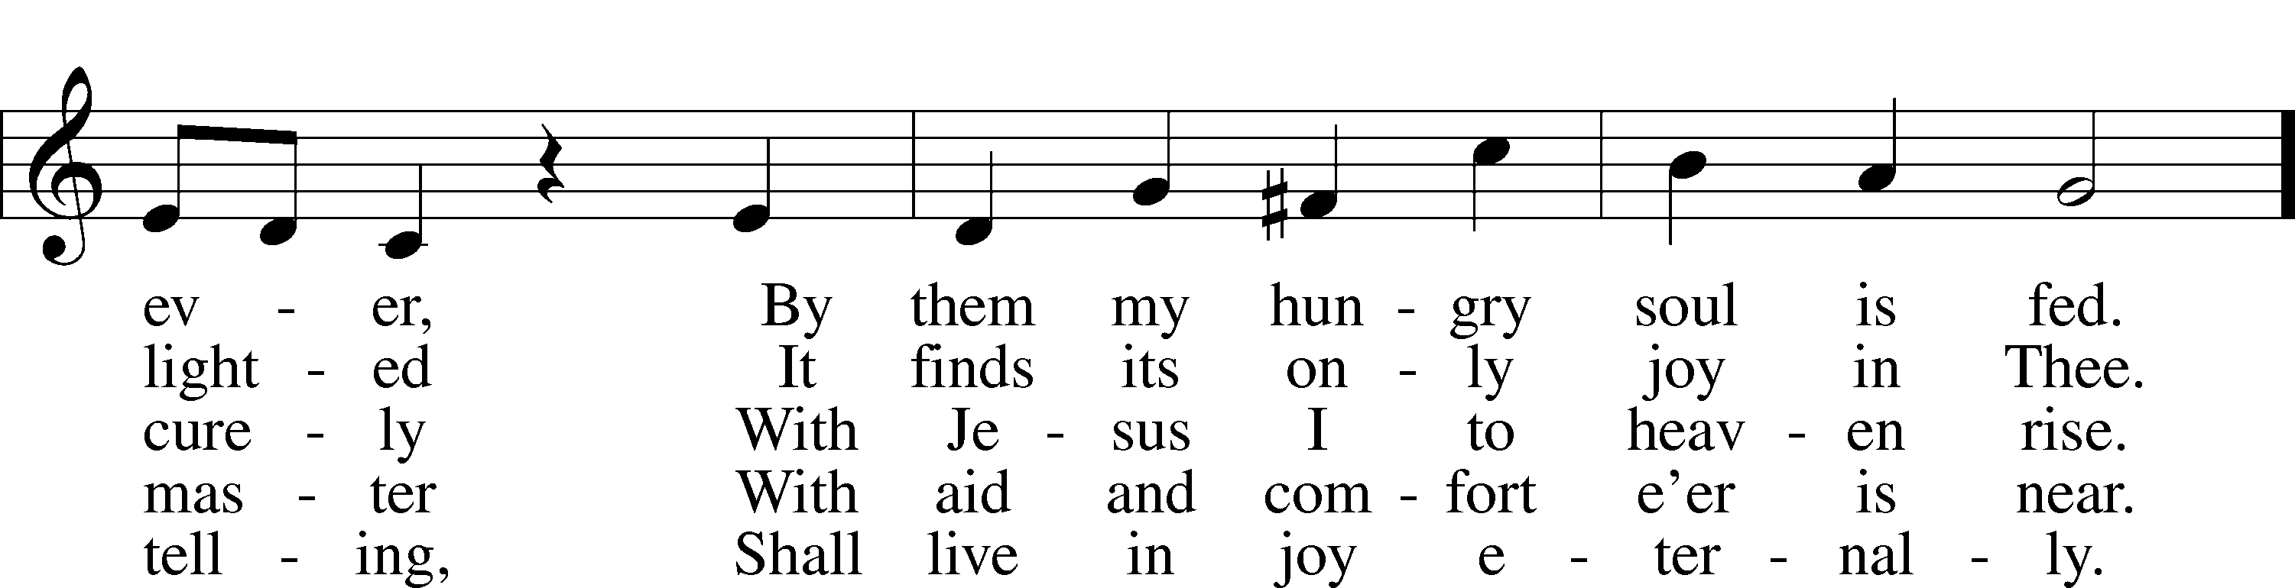

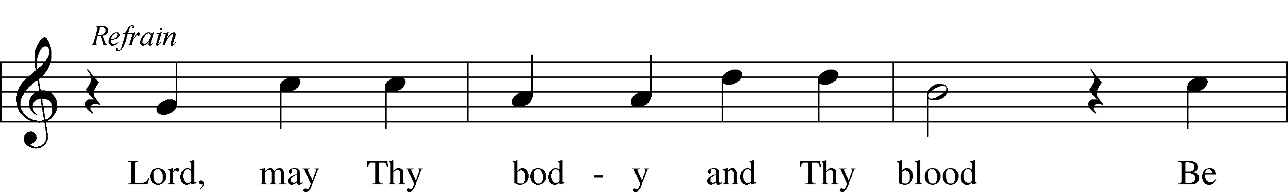

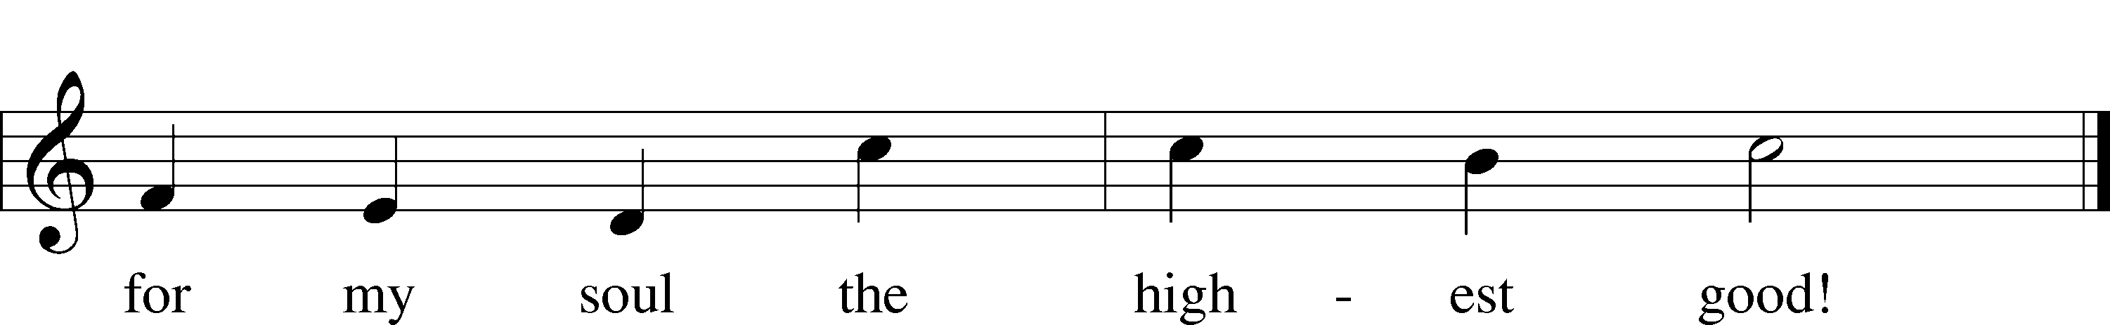

Tune: Public domain

Text: © 1941 Concordia Publishing House. Used by permission: LSB Hymn License no. 110005047

Nunc Dimittis LSB 211

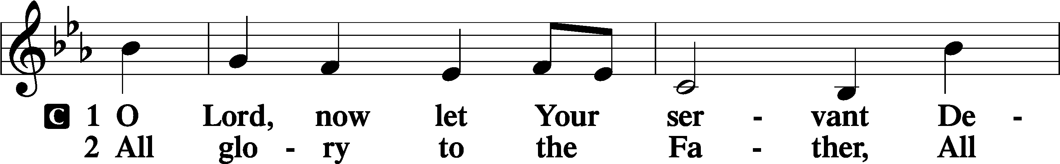

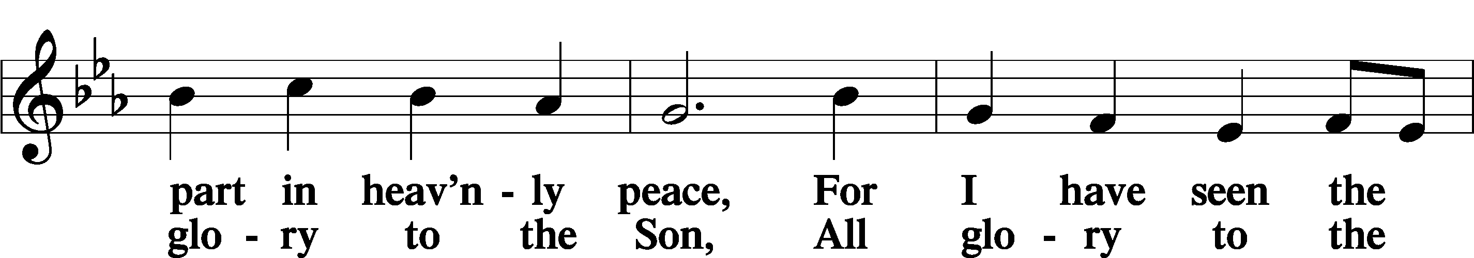

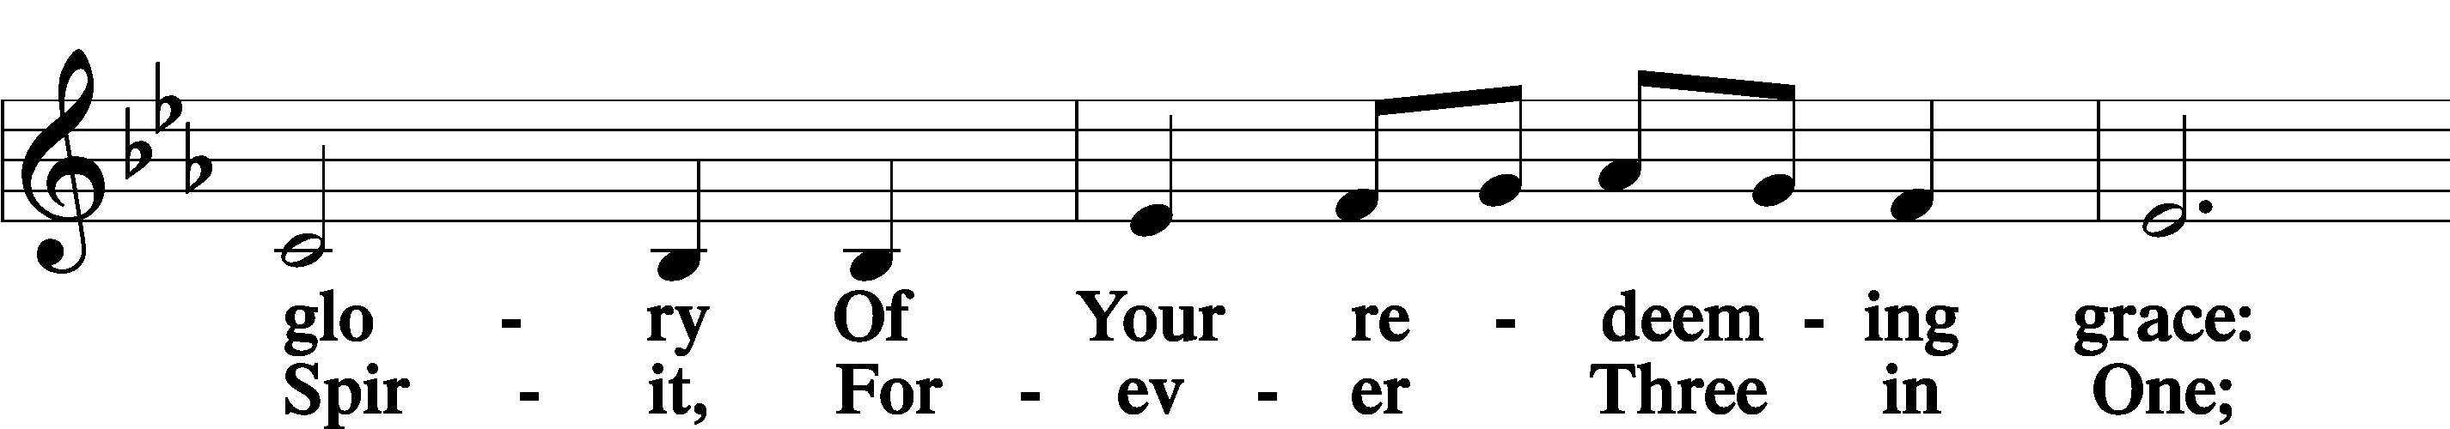

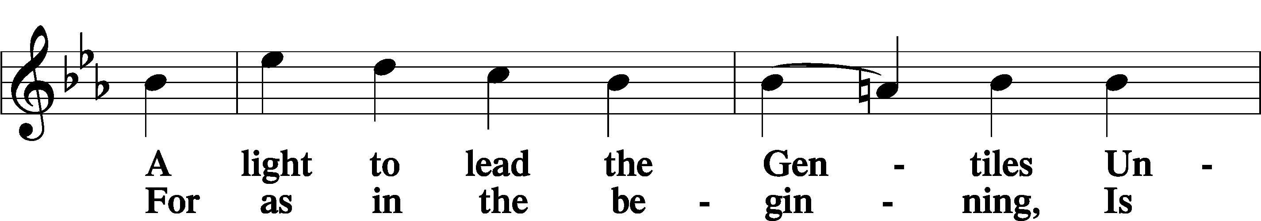

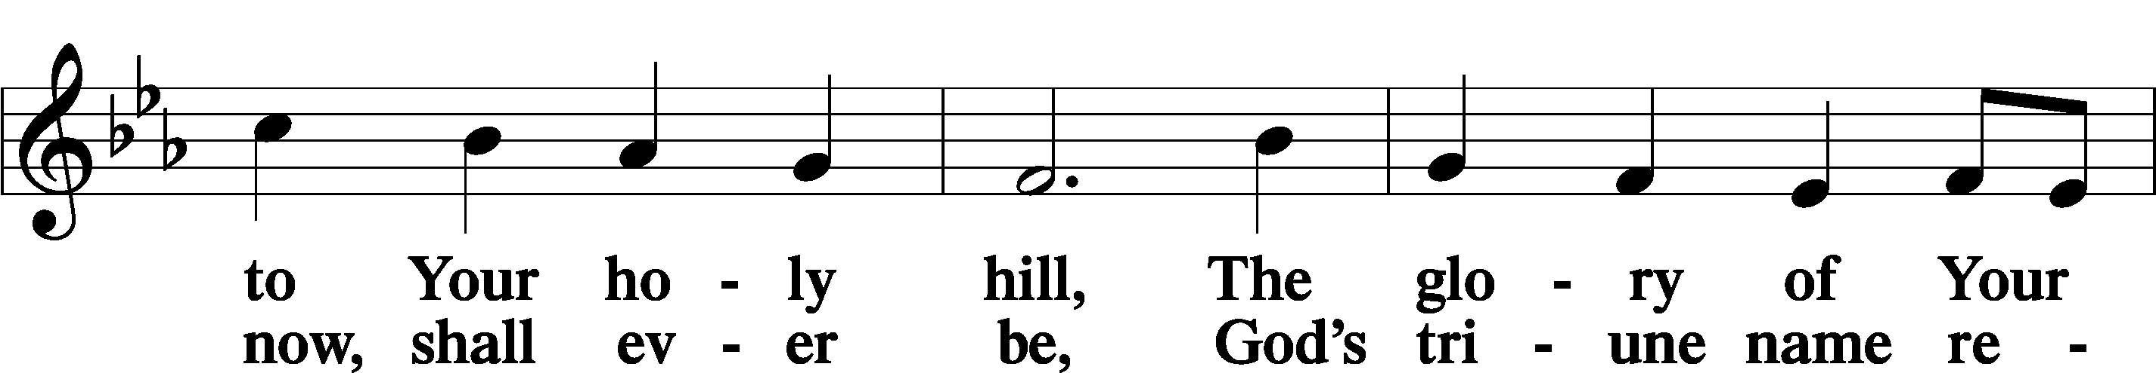

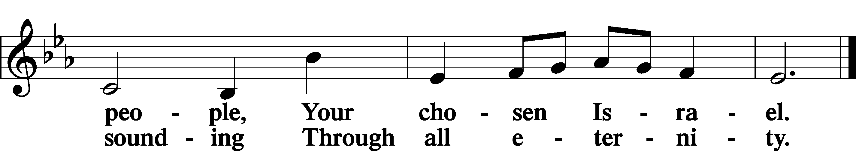

Post-Communion Collect

A Let us pray.

We give thanks to You, almighty God, that You have refreshed us through this salutary gift, and we implore You that of Your mercy You would strengthen us through the same in faith toward You and in fervent love toward one another; through Jesus Christ, Your Son, our Lord, who lives and reigns with You and the Holy Spirit, one God, now and forever.

C **Amen.**

Benedicamus and Benediction LSB 212

A Let us bless the Lord.

C **Thanks be to God.**

P The Lord bless you and keep you.

The Lord make His face shine on you and be gracious to you.

The Lord look upon you with favor and T give you peace.

C **Amen.**

690 Hope of the World

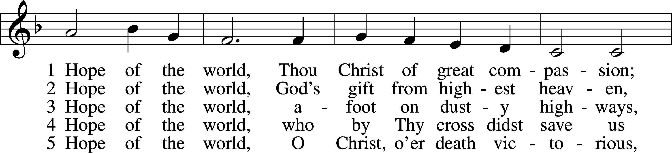

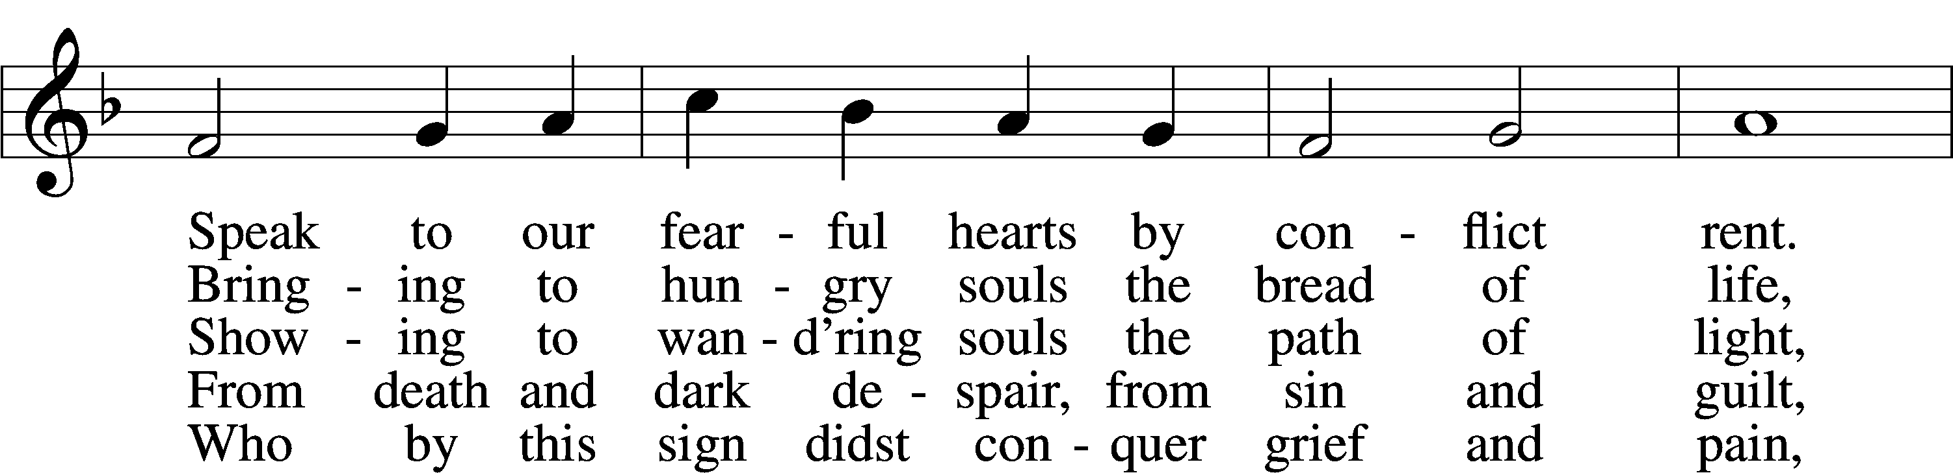

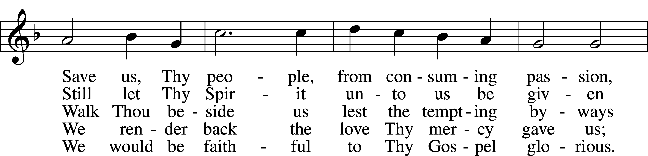

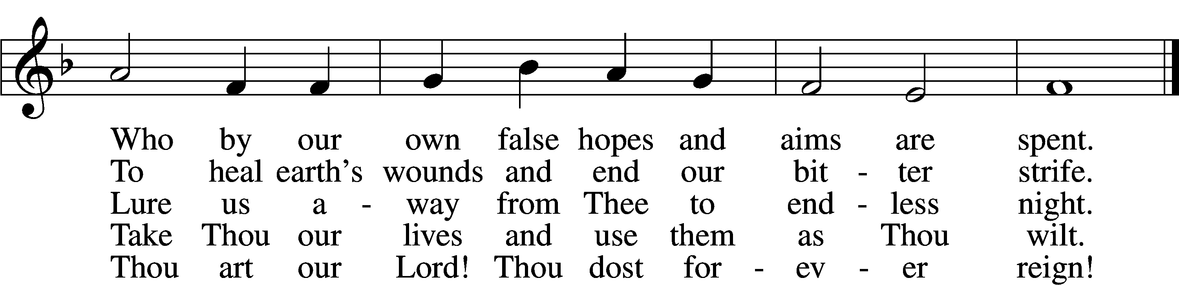

Text: © 1954, renewed 1982 The Hymn Society, admin. Hope Publishing Co. Used by permission: LSB Hymn License no. 110005047

Tune: Public domain

Acknowledgments

Divine Service, Setting Four from Lutheran Service Book

Unless otherwise indicated, Scripture quotations are from the ESV® Bible (The Holy Bible, English Standard Version®), copyright © 2001 by Crossway, a publishing ministry of Good News Publishers. Used by permission. All rights reserved.

Created by Lutheran Service Builder © 2020 Concordia Publishing House.