**Fourth Sunday in Lent**

**God’s Workmanship to Walk in Christ** Ephesians 2:1-10

**March 14, 2021**

**Messiah Lutheran Church**

**Lutheran Church-Missouri Synod**

4102 Trinity River Dr., Corpus Christi, Texas 78410

**Pastor:**  **Rev. Scott E. Herbert**

Church Phone: 361-387-7748 Email: mlc@stx.rr.com

Church Fax: 361-767-1768 Website: [www.messiahlcms-cc.org](http://www.messiahlcms-cc.org)

Pastor Phone: 469-693-9683 Pastor Email: chirev59@gmail.com

**WELCOME TO MESSIAH!**

We are glad you are here to receive what God is doing for you during Divine Service. Please sign our Guest Book located near the front door. Feel free to converse quietly until the organ prelude begins. If you are looking for a church home, please talk to the Pastor at the door. We would love to have you join us.

**Preparing for Service**

As we journey through this Lenten season and the days of Holy Week, we find Jesus teaching His disciples and the crowds. He warns them about the scribes and Pharisees, religious leaders of the time. Jesus says these leaders are hypocritical. They do not practice what they preach. They burden others with the heaviest forms of the law but refuse to do anything they command their hearers to do. Consider how different Jesus is from these leaders. When Jesus instructs us to love others, He shows us how, most especially in His willingness to go to the cross and die for us and our salvation.

# DIVINE SERVICE *Setting Three*

# Confession and Absolution

915 Today Your Mercy Calls Us

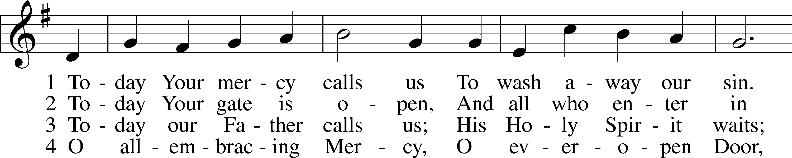

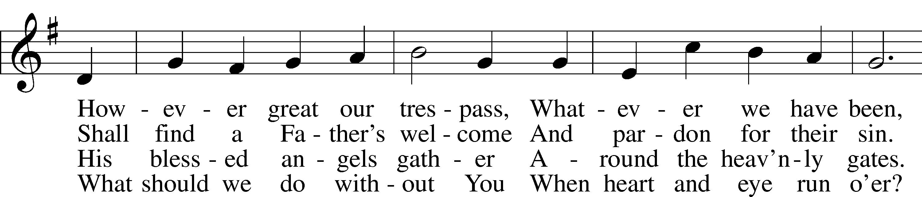

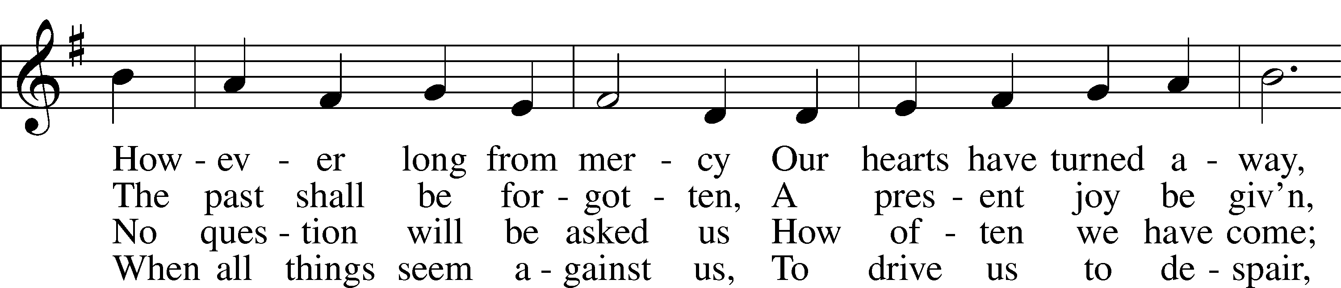

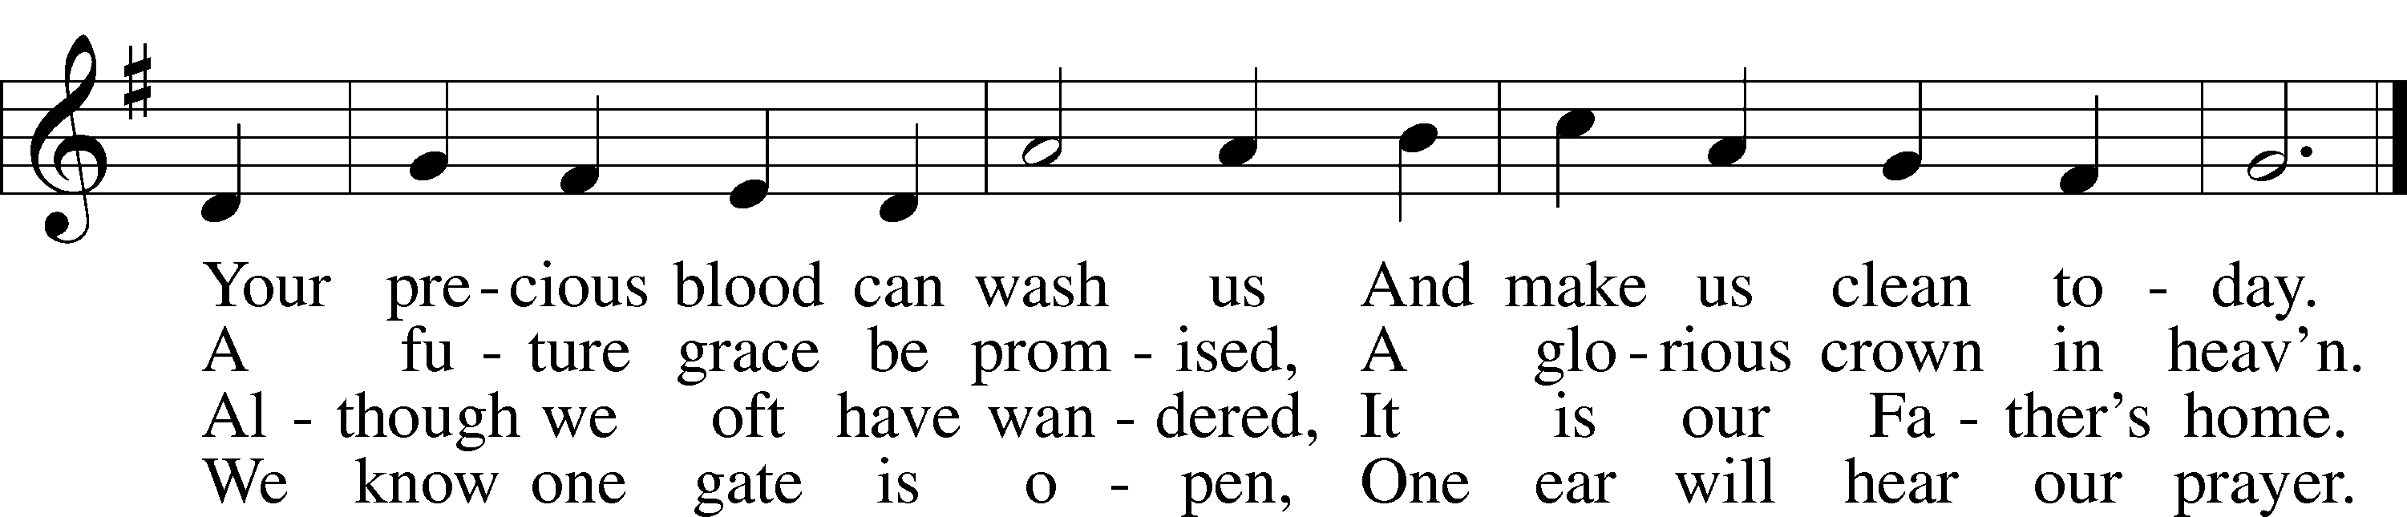

Text and tune: Public domain

P In the name of the Father and of the T Son and of the Holy Spirit.

C **Amen.**

P Beloved in the Lord! Let us draw near with a true heart and confess our sins unto God our Father, beseeching Him in the name of our Lord Jesus Christ to grant us forgiveness.

P Our help is in the name of the Lord,

C **who made heaven and earth.**

P I said, I will confess my transgressions unto the Lord,

C **and You forgave the iniquity of my sin.**

P O almighty God, merciful Father,

C **I, a poor, miserable sinner, confess unto You all my sins and iniquities with which I have ever offended You and justly deserved Your temporal and eternal punishment. But I am heartily sorry for them and sincerely repent of them, and I pray You of Your boundless mercy and for the sake of the holy, innocent, bitter sufferings and death of Your beloved Son, Jesus Christ, to be gracious and merciful to me, a poor, sinful being.**

P Upon this your confession, I, by virtue of my office, as a called and ordained servant of the Word, announce the grace of God unto all of you, and in the stead and by the command of my Lord Jesus Christ I forgive you all your sins in the name of the Father and of the T Son and of the Holy Spirit.

C **Amen.**

# Service of the Word

Introit Psalm 27:3–5; antiphon: v. 1

The Lord is my light and my salvation; whom shall I fear?  
 **The Lord is the stronghold of my life; of whom shall I be afraid?**Though an army encamp against me, my heart shall not fear;  
 **though war arise against me, yet I will be confident.**One thing have I asked of the Lord, that will I seek after:  
 **that I may dwell in the house of the Lord all the days of my life,** **to gaze upon the beauty of the Lord and to inquire in his temple**.   
For he will hide me in his shelter in the day of trouble;  
 **he will conceal me under the cover of his tent; he will lift me** **high upon a rock.**The Lord is my light and my salvation; whom shall I fear?  
 **The Lord is the stronghold of my life; of whom shall I be afraid?**

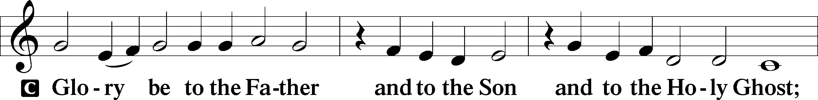

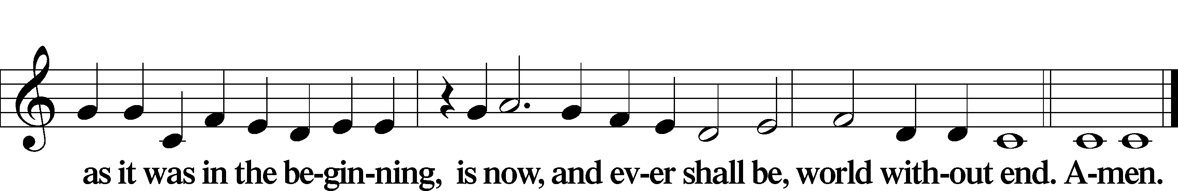

Kyrie LSB 186

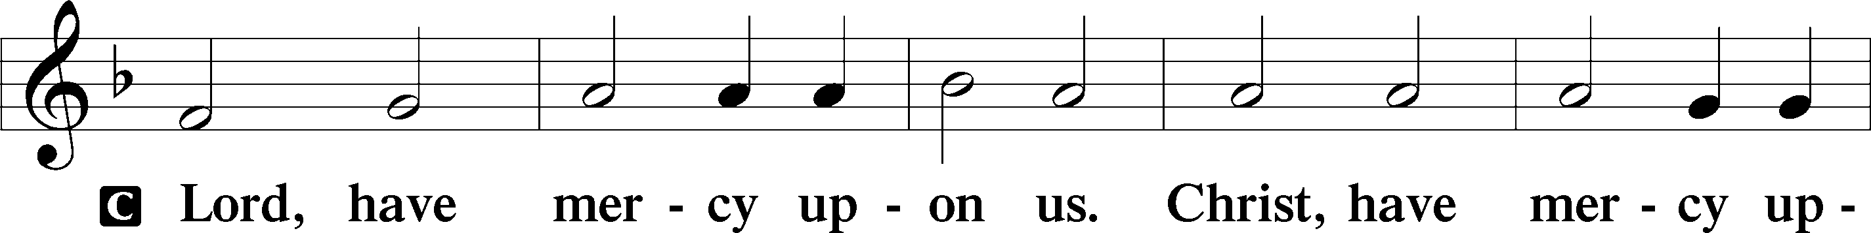

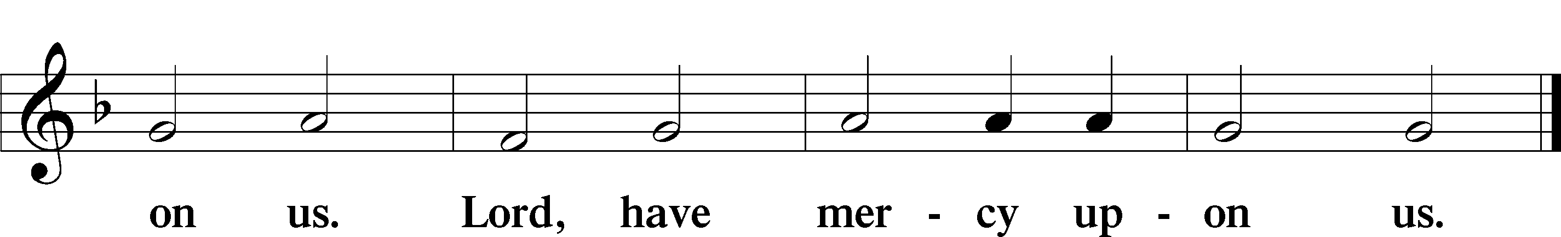

Salutation and Collect of the Day

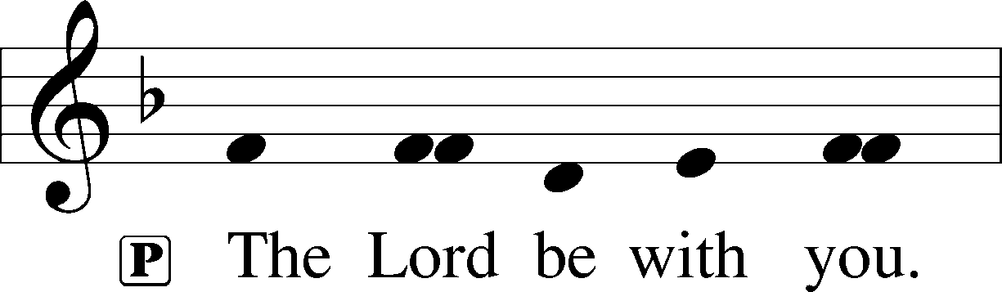

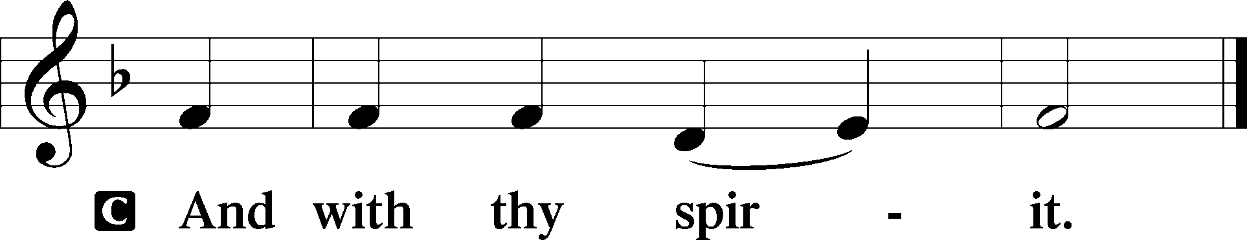

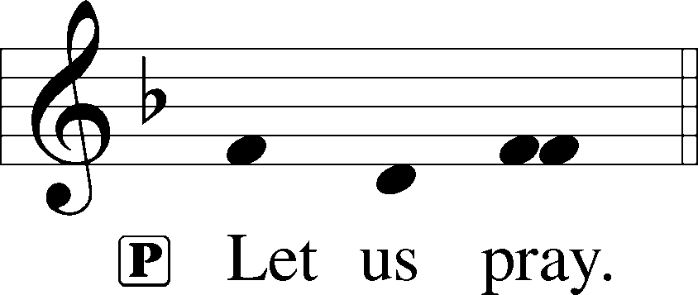

P Almighty God, our heavenly Father, Your mercies are new every morning; and though we deserve only punishment, You receive us as Your children and provide for all our needs of body and soul. Grant that we may heartily acknowledge Your merciful goodness, give thanks for all Your benefits, and serve You in willing obedience; through Jesus Christ, Your Son, our Lord, who lives and reigns with You and the Holy Spirit, one God, now and forever.

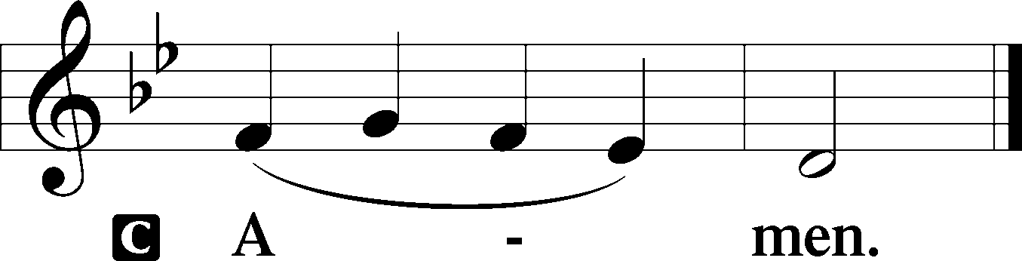

Old Testament Reading Numbers 21:4–9

4From Mount Hor they set out by the way to the Red Sea, to go around the land of Edom. And the people became impatient on the way. 5And the people spoke against God and against Moses, “Why have you brought us up out of Egypt to die in the wilderness? For there is no food and no water, and we loathe this worthless food.” 6Then the Lord sent fiery serpents among the people, and they bit the people, so that many people of Israel died. 7And the people came to Moses and said, “We have sinned, for we have spoken against the Lord and against you. Pray to the Lord, that he take away the serpents from us.” So Moses prayed for the people. 8And the Lord said to Moses, “Make a fiery serpent and set it on a pole, and everyone who is bitten, when he sees it, shall live.” 9So Moses made a bronze serpent and set it on a pole. And if a serpent bit anyone, he would look at the bronze serpent and live.

A This is the Word of the Lord.

C **Thanks be to God.**

Epistle Ephesians 2:1–10

1And you were dead in the trespasses and sins 2in which you once walked, following the course of this world, following the prince of the power of the air, the spirit that is now at work in the sons of disobedience— 3among whom we all once lived in the passions of our flesh, carrying out the desires of the body and the mind, and were by nature children of wrath, like the rest of mankind. 4But God, being rich in mercy, because of the great love with which he loved us, 5even when we were dead in our trespasses, made us alive together with Christ—by grace you have been saved— 6and raised us up with him and seated us with him in the heavenly places in Christ Jesus, 7so that in the coming ages he might show the immeasurable riches of his grace in kindness toward us in Christ Jesus. 8For by grace you have been saved through faith. And this is not your own doing; it is the gift of God, 9not a result of works, so that no one may boast. 10For we are his workmanship, created in Christ Jesus for good works, which God prepared beforehand, that we should walk in them.

A This is the Word of the Lord.

C **Thanks be to God.**

Holy Gospel John 3:14–21

P The Holy Gospel according to St. John, the third chapter.

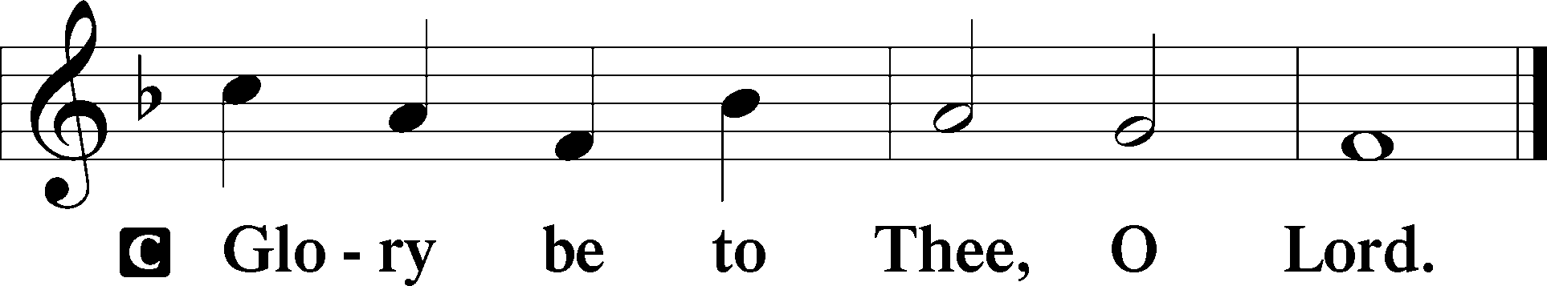

14[Jesus said:] “As Moses lifted up the serpent in the wilderness, so must the Son of Man be lifted up, 15that whoever believes in him may have eternal life.

16“For God so loved the world, that he gave his only Son, that whoever believes in him should not perish but have eternal life. 17For God did not send his Son into the world to condemn the world, but in order that the world might be saved through him. 18Whoever believes in him is not condemned, but whoever does not believe is condemned already, because he has not believed in the name of the only Son of God. 19And this is the judgment: the light has come into the world, and people loved the darkness rather than the light because their deeds were evil. 20For everyone who does wicked things hates the light and does not come to the light, lest his deeds should be exposed. 21But whoever does what is true comes to the light, so that it may be clearly seen that his deeds have been carried out in God.”

P This is the Gospel of the Lord.

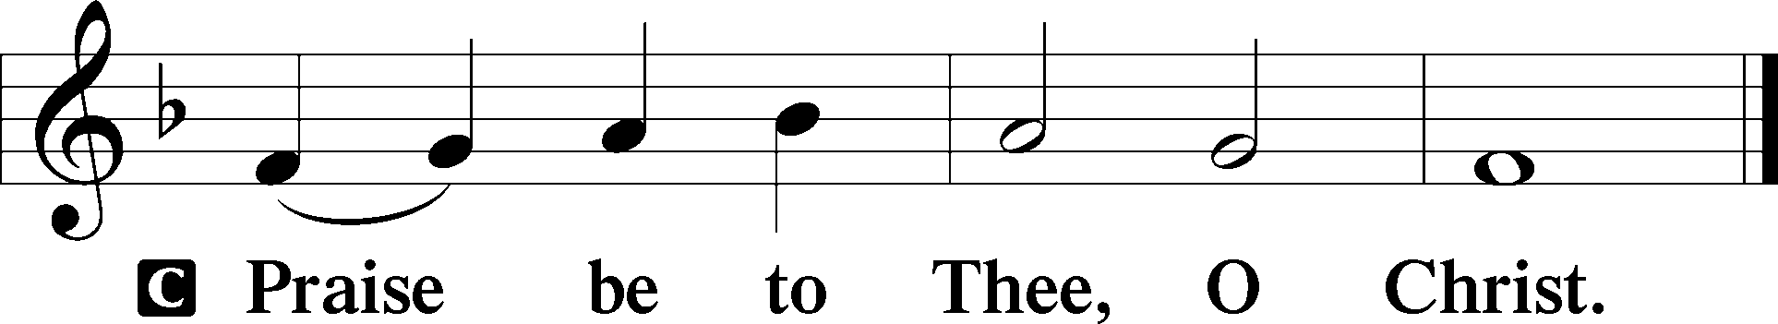

Nicene Creed

C **I believe in one God,**

**the Father Almighty,**

**maker of heaven and earth**

**and of all things visible and invisible.**

**And in one Lord Jesus Christ,**

**the only-begotten Son of God,**

**begotten of His Father before all worlds,**

**God of God, Light of Light,**

**very God of very God,**

**begotten, not made,**

**being of one substance with the Father,**

**by whom all things were made;**

**who for us men and for our salvation came down from heaven**

**and was incarnate by the Holy Spirit of the virgin Mary**

**and was made man;**

**and was crucified also for us under Pontius Pilate.**

**He suffered and was buried.**

**And the third day He rose again according to the Scriptures**

**and ascended into heaven**

**and sits at the right hand of the Father.**

**And He will come again with glory to judge both the living and the dead,**

**whose kingdom will have no end.**

**And I believe in the Holy Spirit,**

**the Lord and giver of life,**

**who proceeds from the Father and the Son,**

**who with the Father and the Son together is worshiped and glorified,**

**who spoke by the prophets.**

**And I believe in one holy Christian and apostolic Church,**

**I acknowledge one Baptism for the remission of sins,**

**and I look for the resurrection of the dead**

**and the life** T **of the world to come. Amen.**

Children’s Message Walking in the Light

702 My Faith Looks Up to Thee

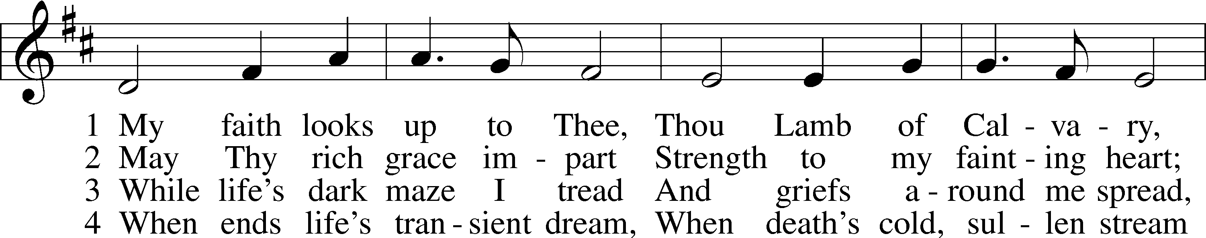

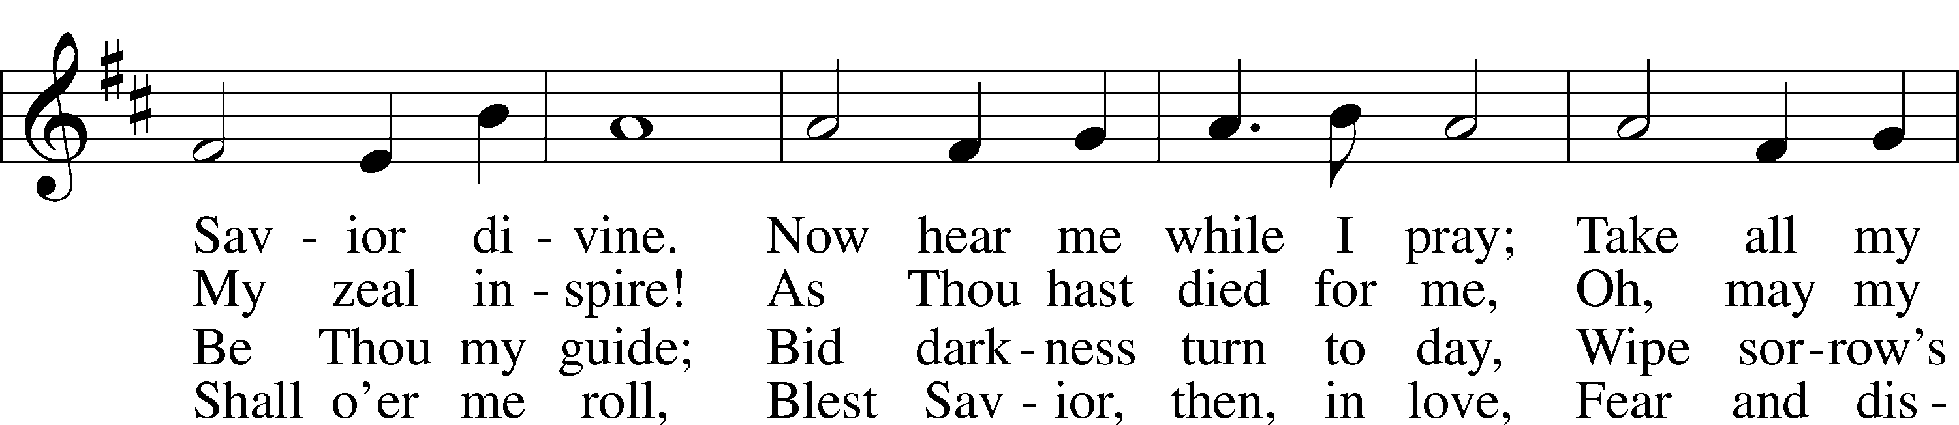

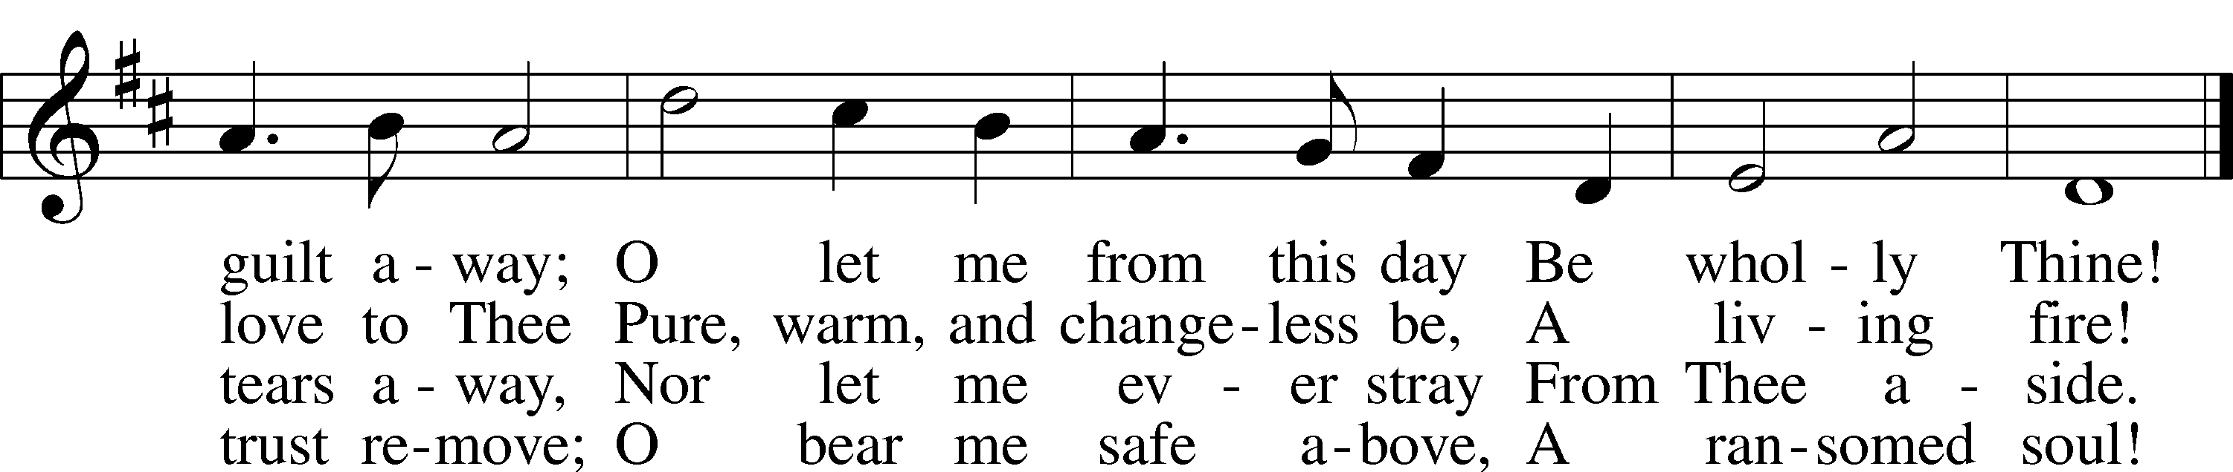

Text and tune: Public domain

Sermon God’s Workmanship to Walk in Christ (Ephesians 2:1-10)

P The peace of God, which passes all understanding, keep your hearts and minds in Christ Jesus.

C **Amen.**

Offertory LSB 192

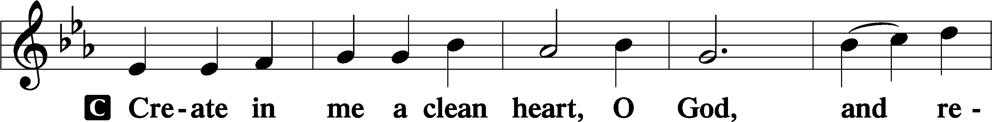

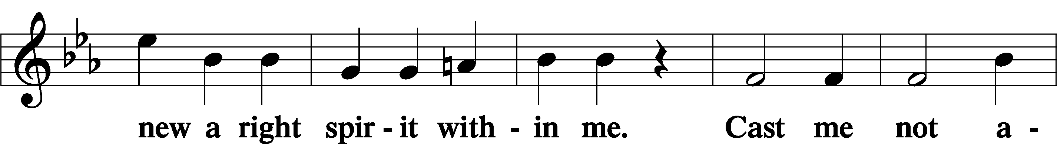

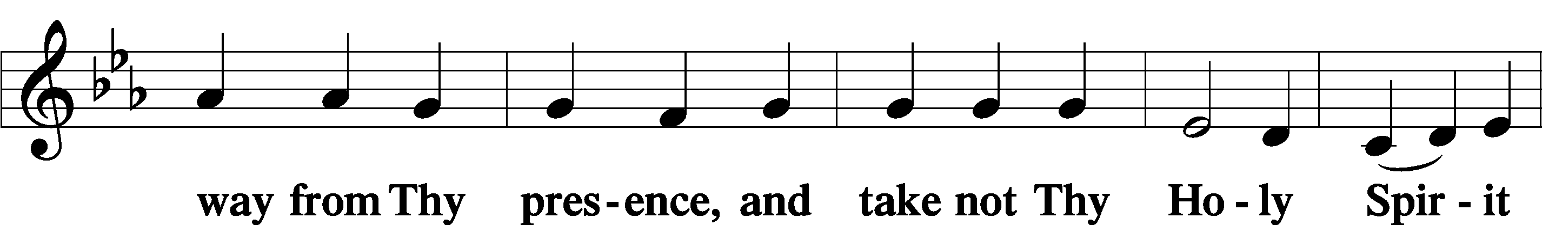

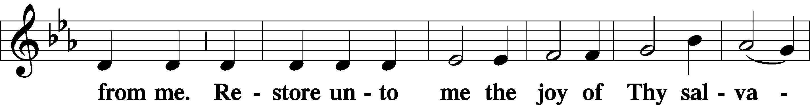

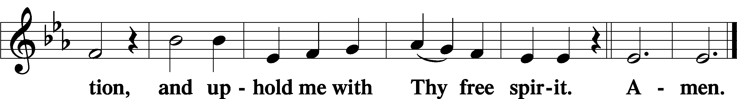

Offering

Prayer of the Church

# Service of the Sacrament

Preface LSB 194







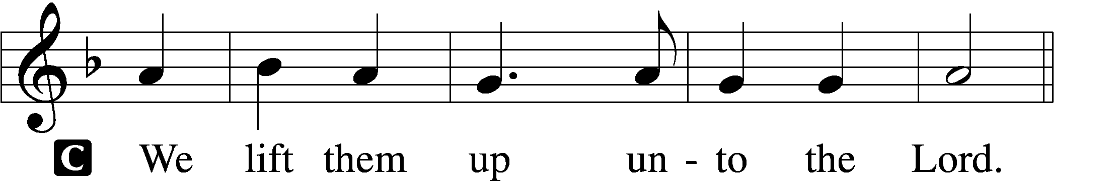

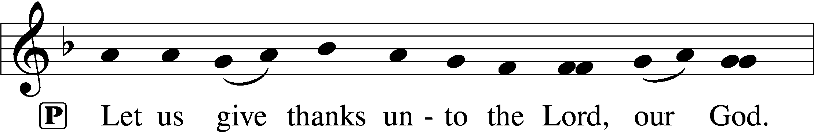

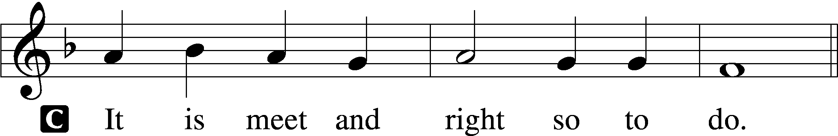

P It is truly meet, right, and salutary that we should at all times and in all places give thanks to You, holy Lord, almighty Father, everlasting God, through Jesus Christ, our Lord, who overcame the assaults of the devil and gave His life as a ransom for many that with cleansed hearts we might be prepared joyfully to celebrate the paschal feast in sincerity and truth. Therefore with angels and archangels and with all the company of heaven we laud and magnify Your glorious name, evermore praising You and saying:

Sanctus LSB 195

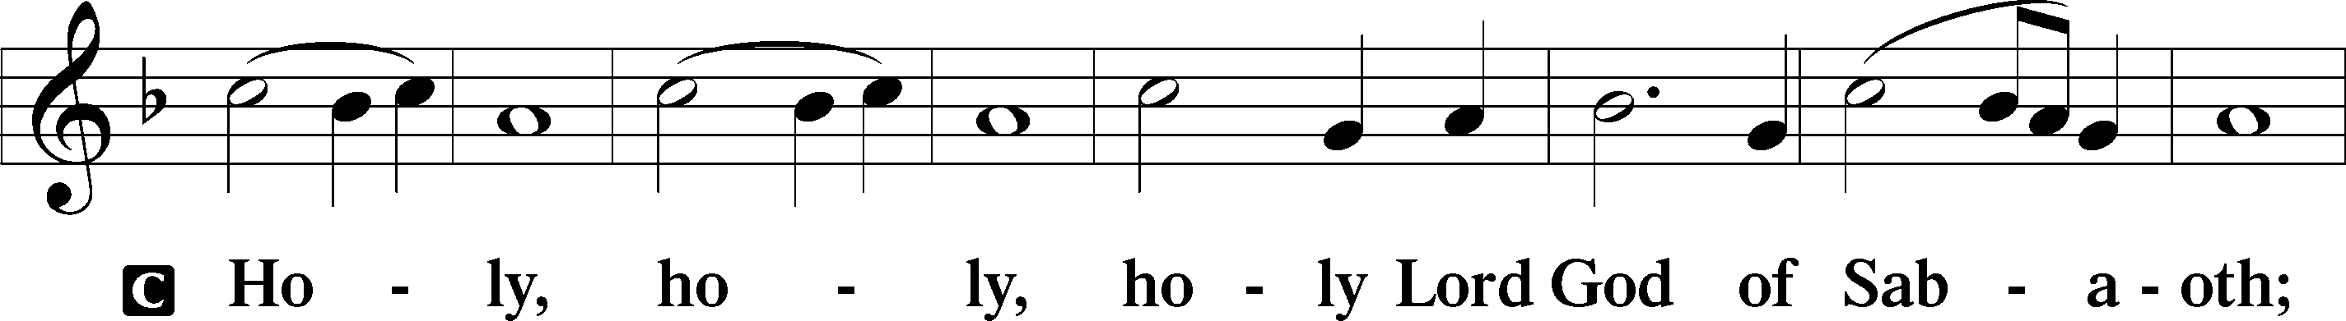

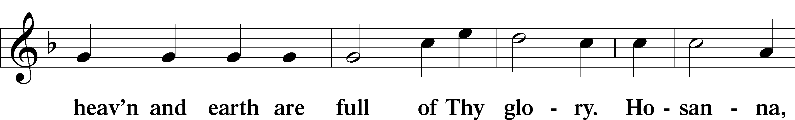

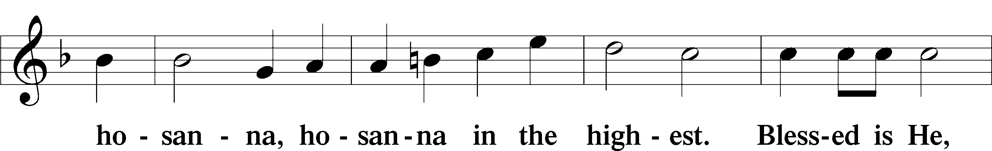

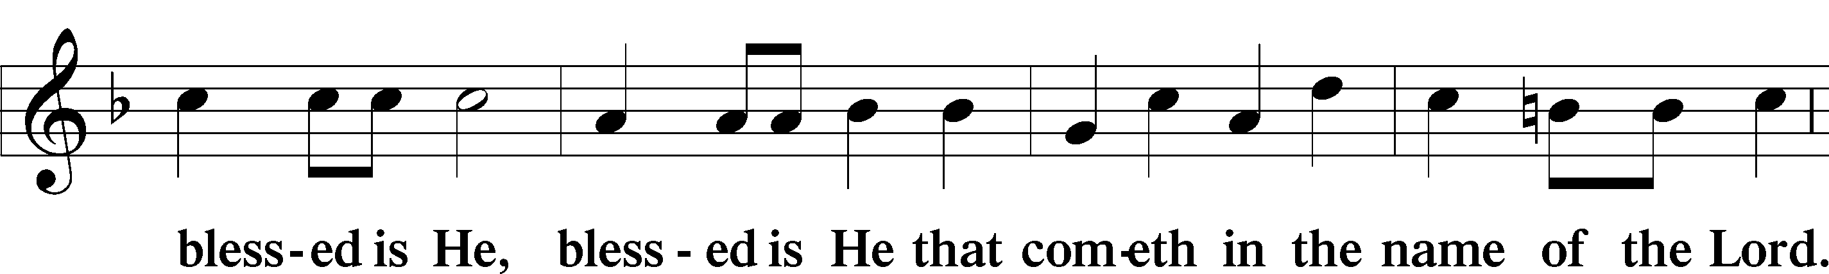

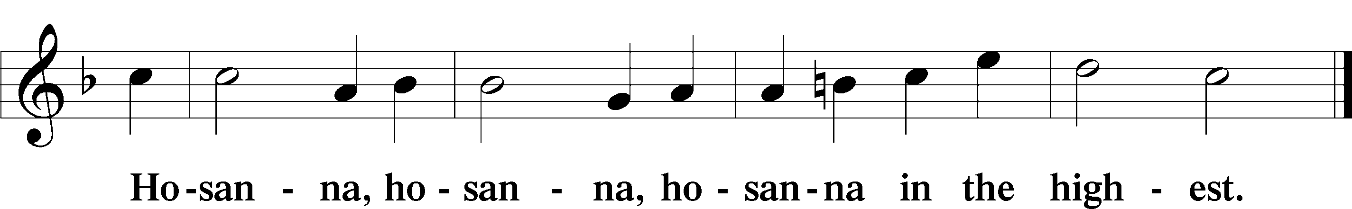

Lord’s Prayer LSB 196

C **Our Father who art in heaven, hallowed be Thy name,**

**Thy kingdom come,**

**Thy will be done on earth as it is in heaven;**

**give us this day our daily bread;**

**and forgive us our trespasses as we forgive those who trespass against us;**

**and lead us not into temptation,**

**but deliver us from evil.**

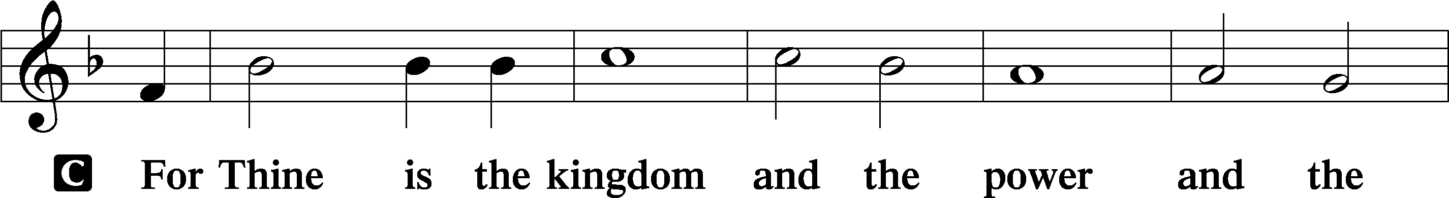

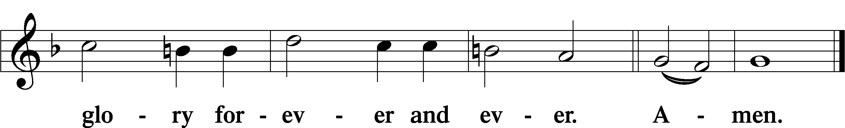

The Words of Our Lord LSB 197

P Our Lord Jesus Christ, on the night when He was betrayed, took bread, and when He had given thanks, He broke it and gave it to the disciples and said: “Take, eat; this is My T body, which is given for you. This do in remembrance of Me.”

In the same way also He took the cup after supper, and when He had given thanks, He gave it to them, saying: “Drink of it, all of you; this cup is the new testament in My T blood, which is shed for you for the forgiveness of sins. This do, as often as you drink it, in remembrance of Me.”

Pax Domini LSB 197

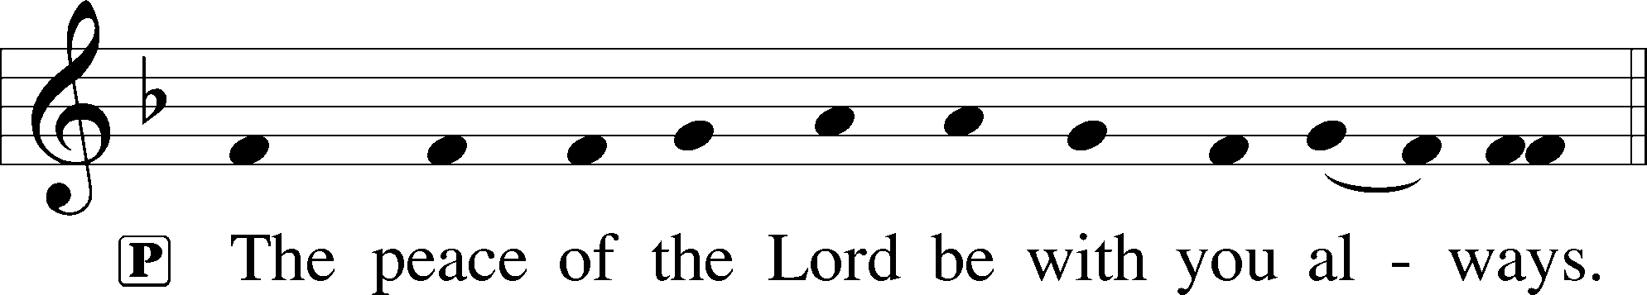

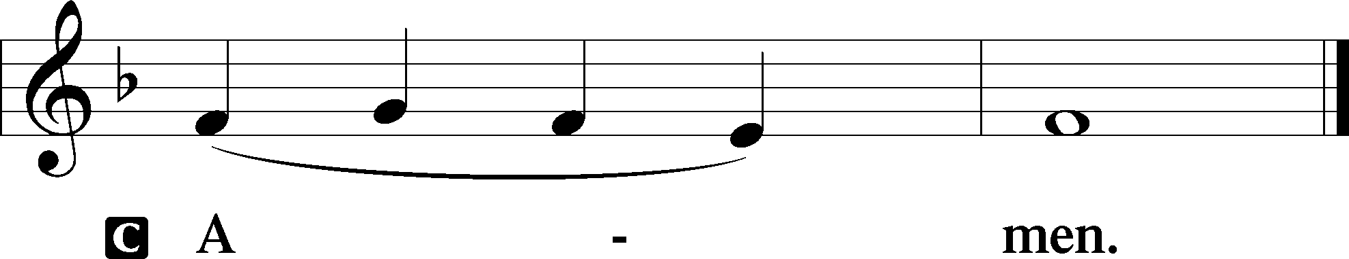

Agnus Dei LSB 198

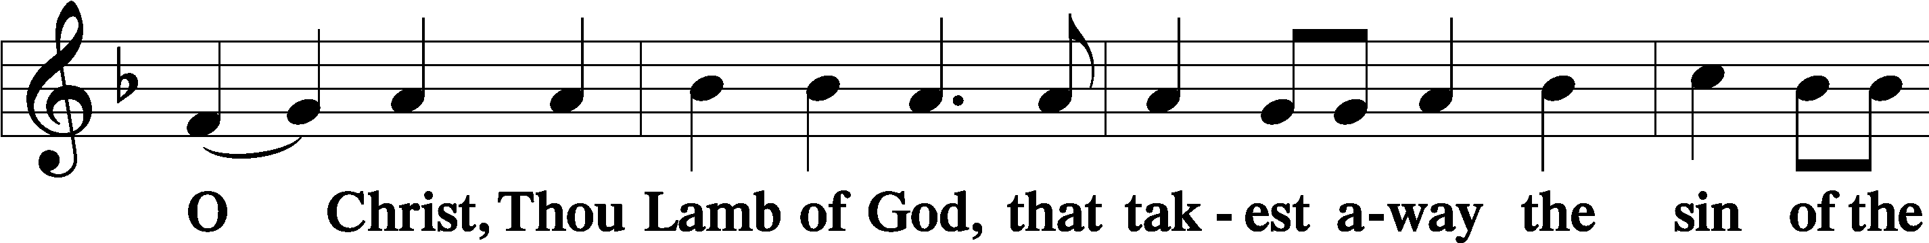

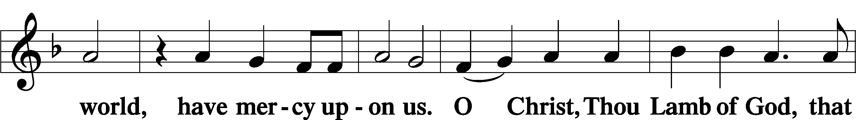

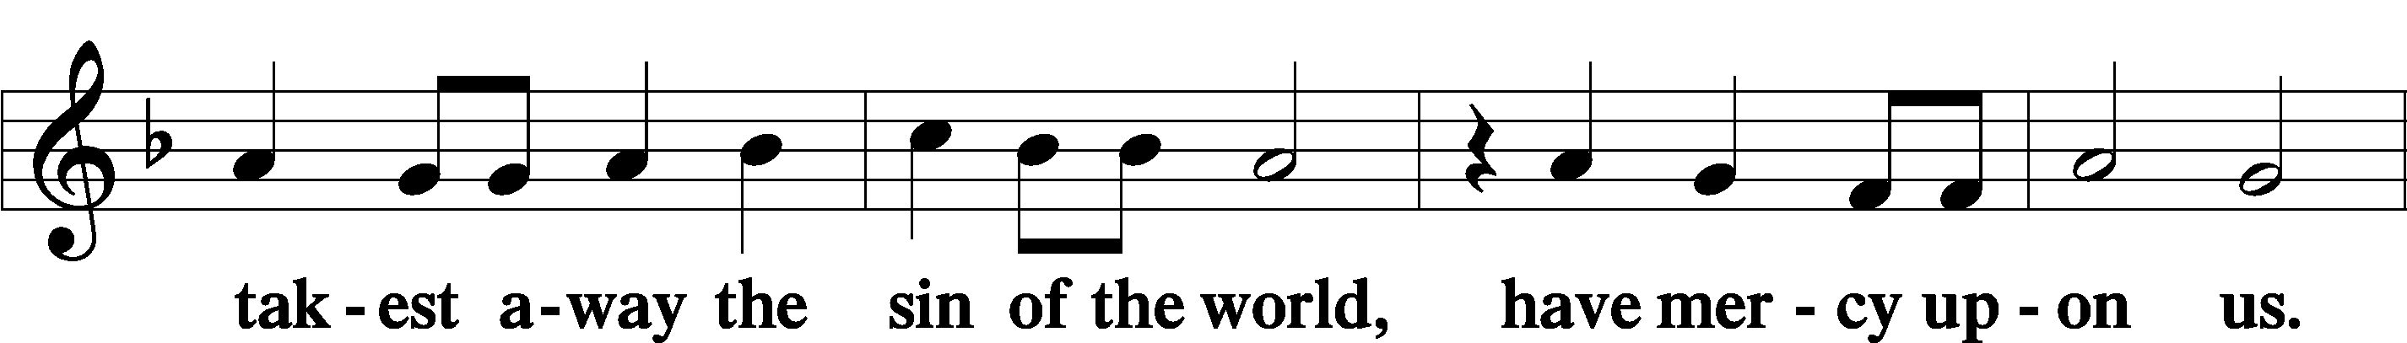

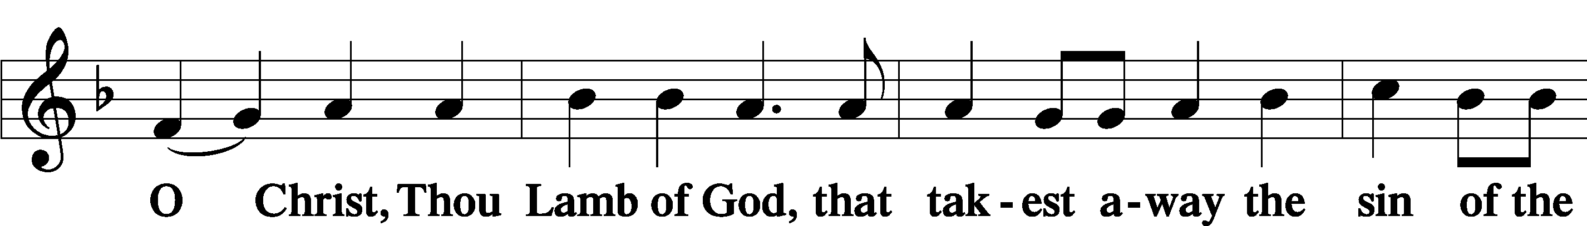

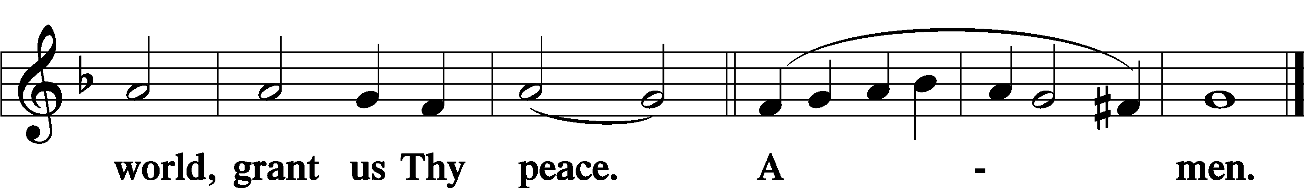

Distribution

625 Lord Jesus Christ, Life-Giving Bread

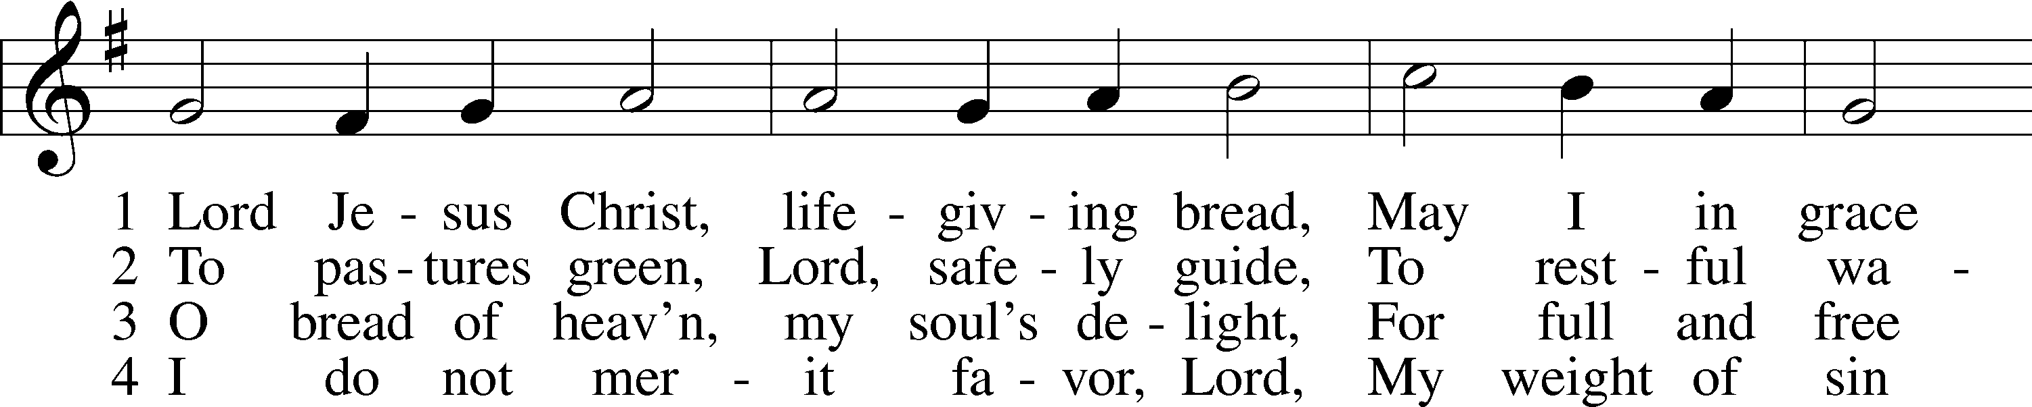

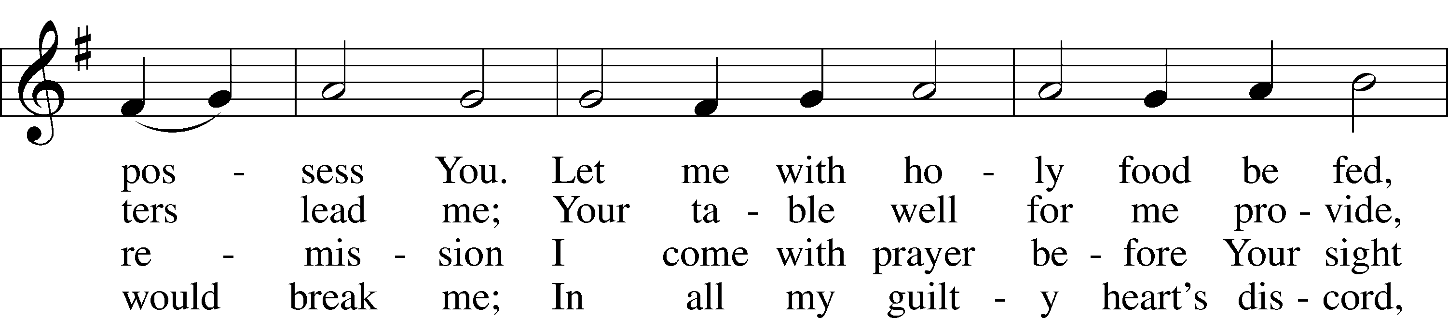

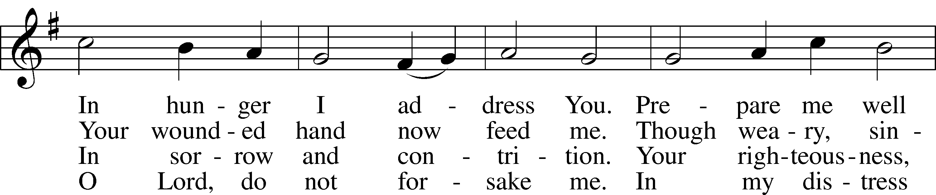

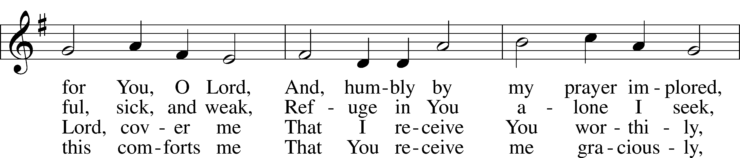

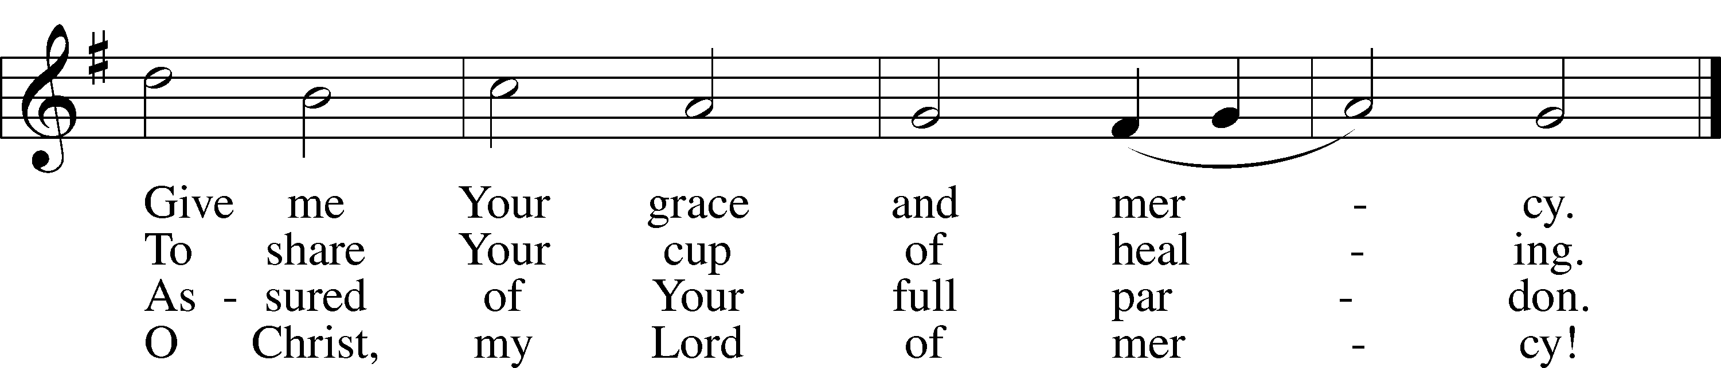

Text and tune: Public domain

626 Come, Let Us Eat

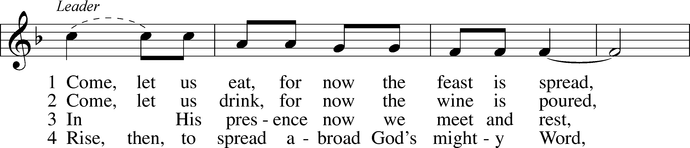

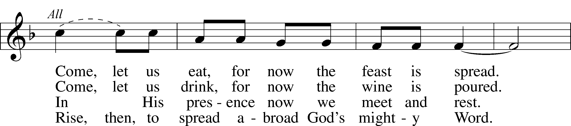

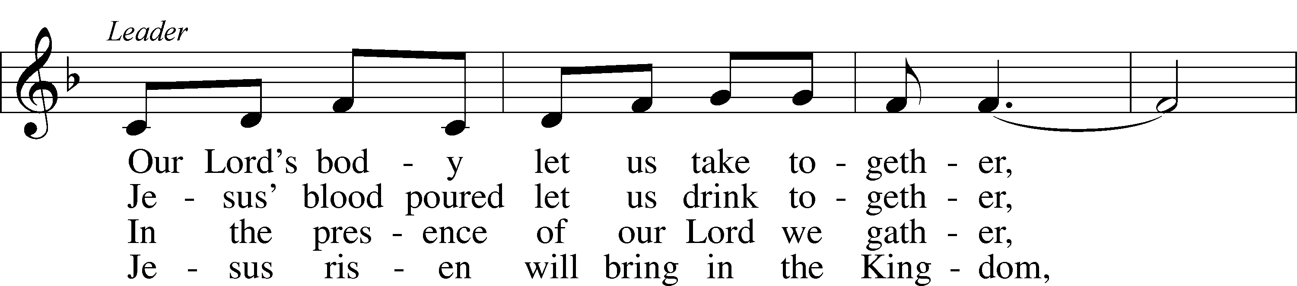

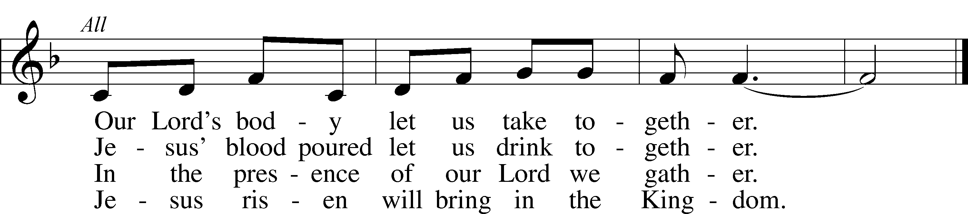

Tune and text: © Lutheran World Federation. Used by permission: LSB Hymn License no. 110005047

Text (st. 4): © 1972 Augsburg Fortress. Used by permission: LSB Hymn License no. 110005047

Nunc Dimittis LSB 199

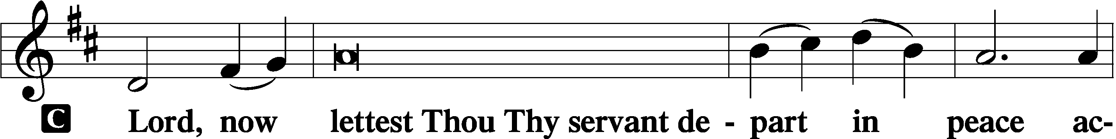

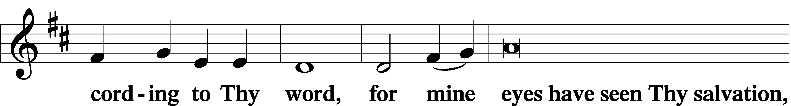

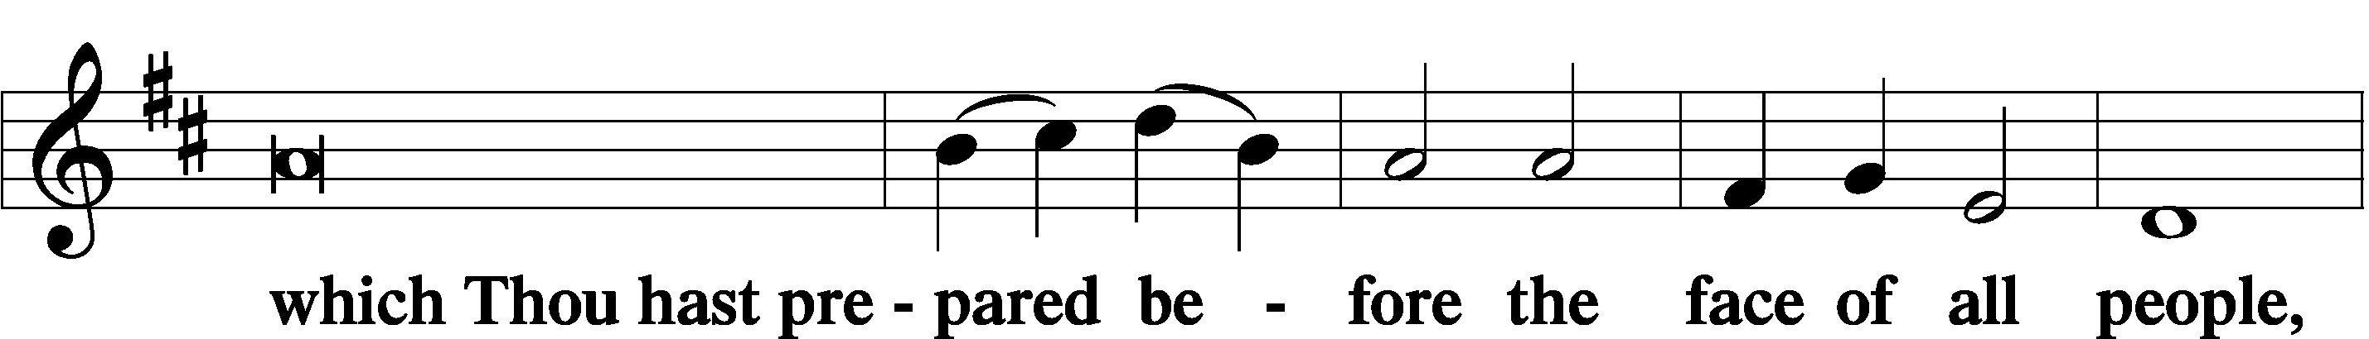

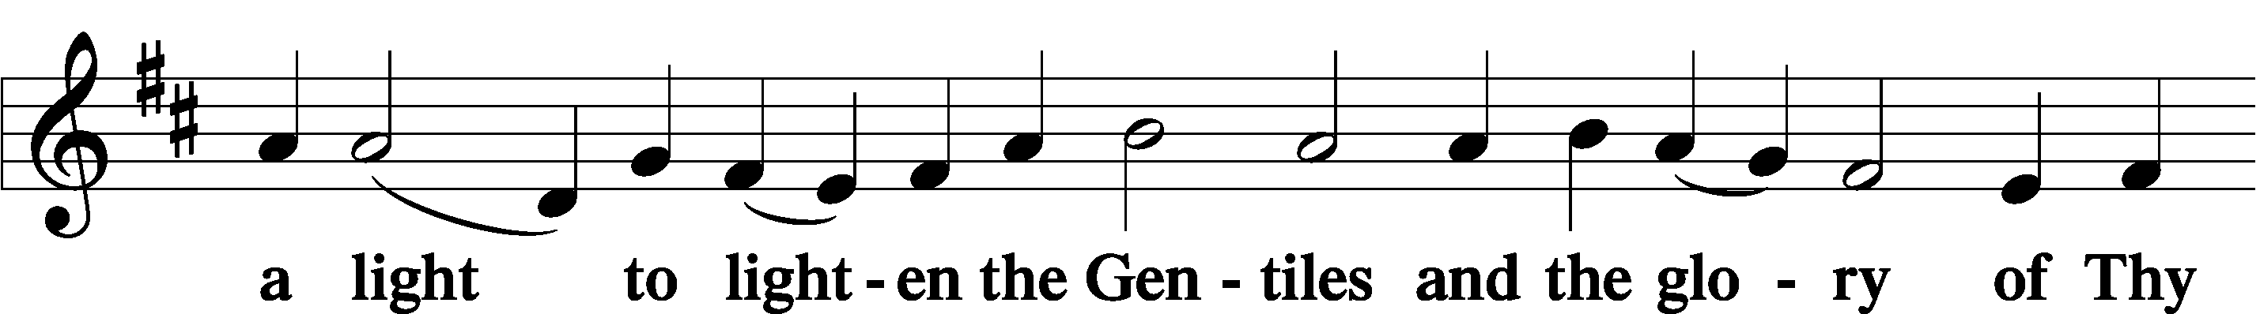

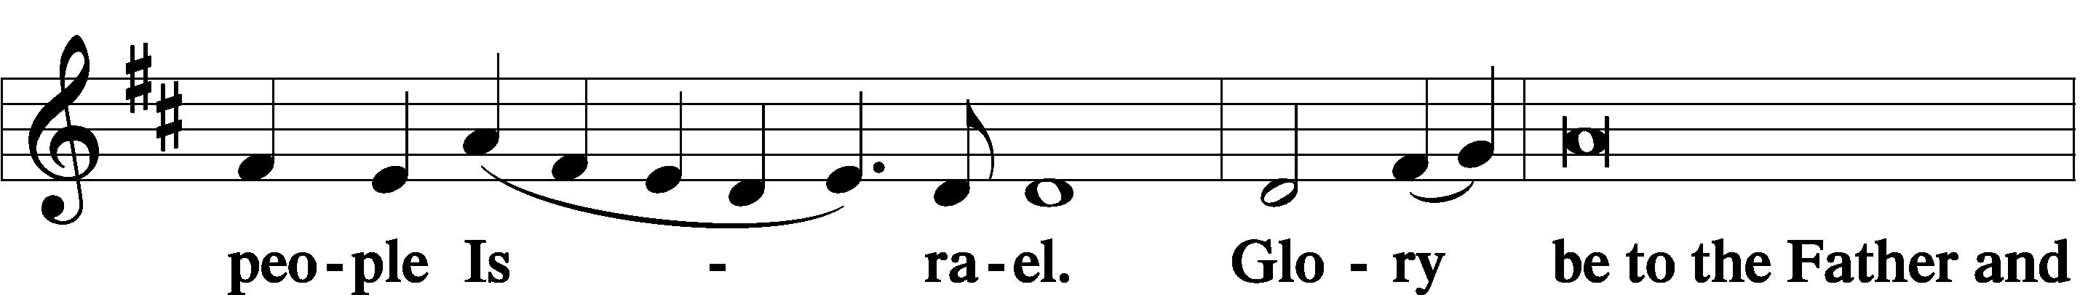

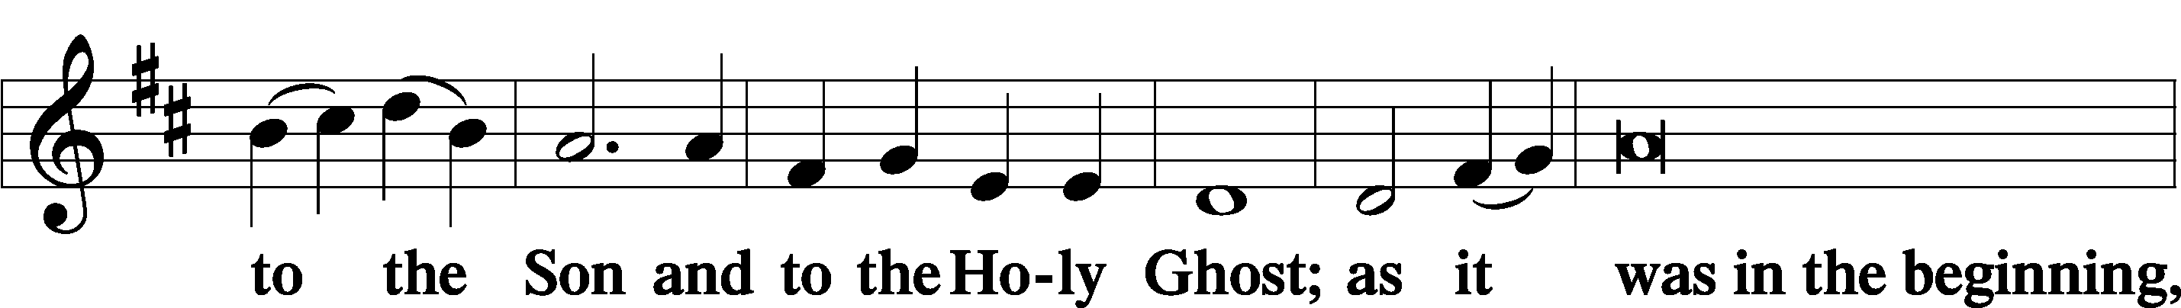

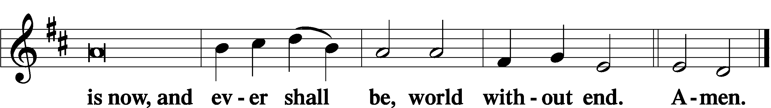

Thanksgiving LSB 200

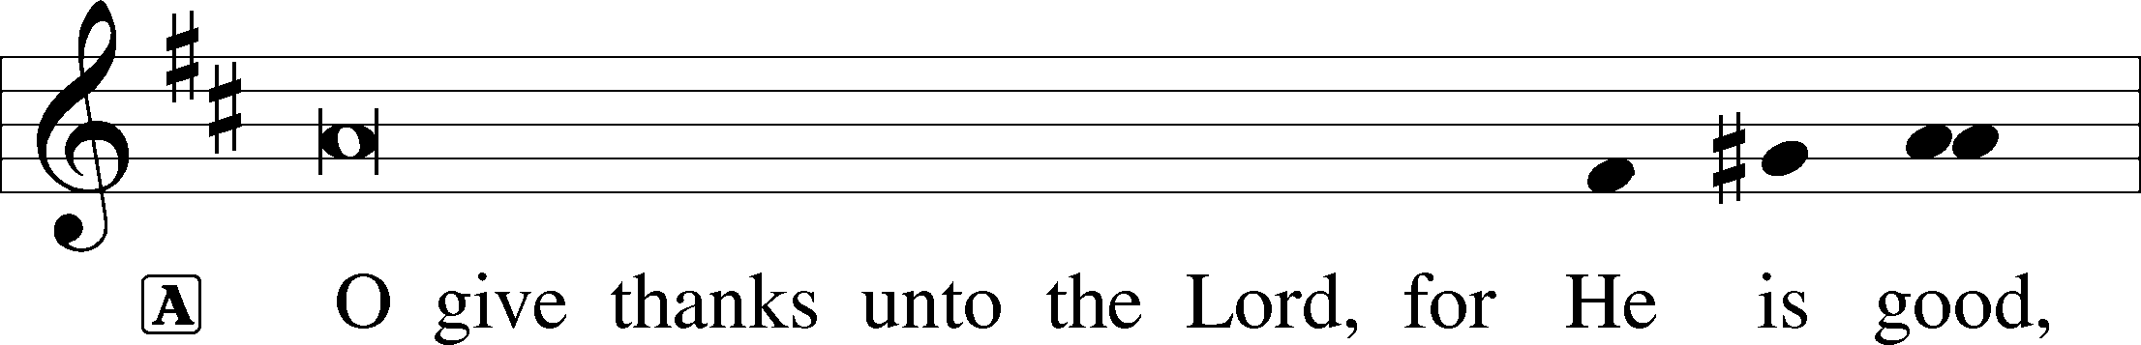

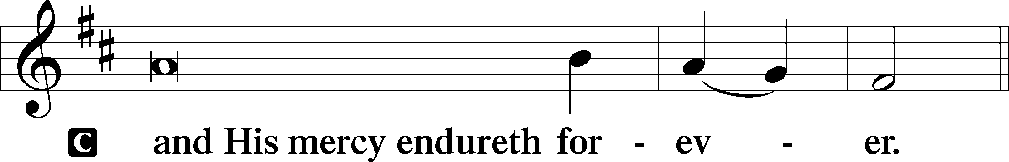

A Let us pray.

We give thanks to You, almighty God, that You have refreshed us through this salutary gift, and we implore You that of Your mercy You would strengthen us through the same in faith toward You and in fervent love toward one another; through Jesus Christ, Your Son, our Lord, who lives and reigns with You and the Holy Spirit, one God, now and forever.

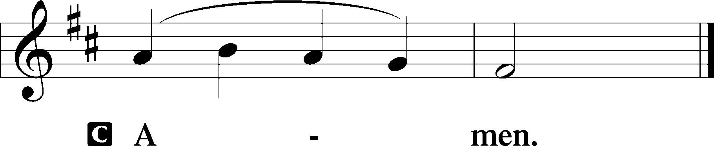

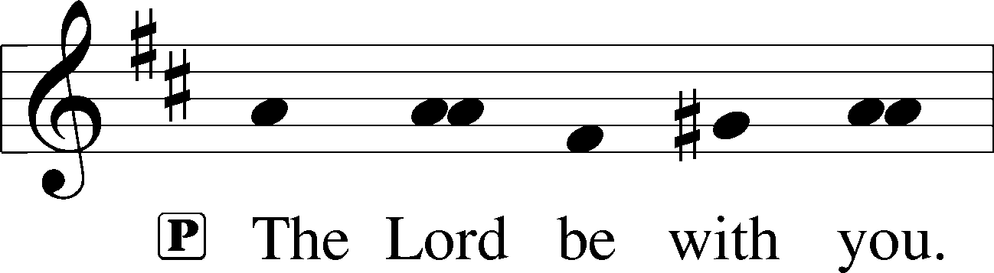

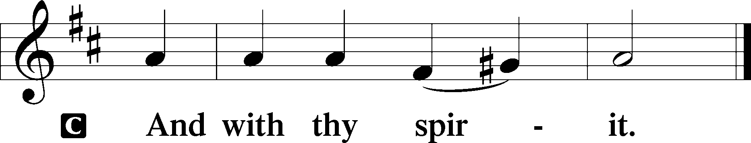

Benedicamus LSB 202

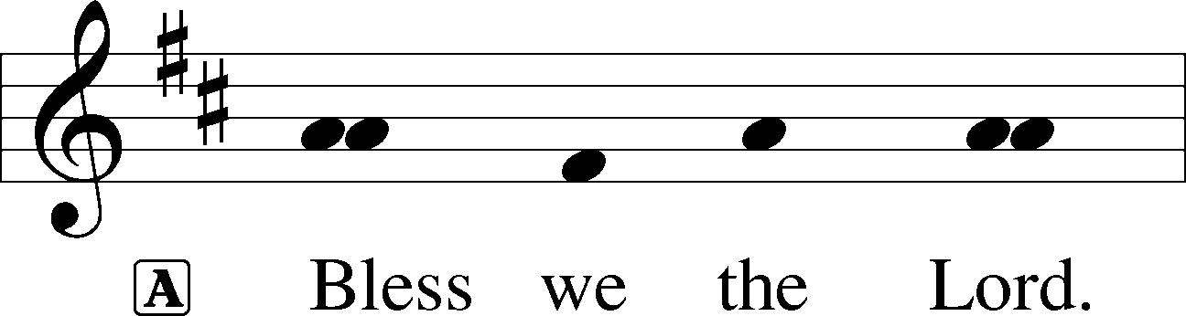

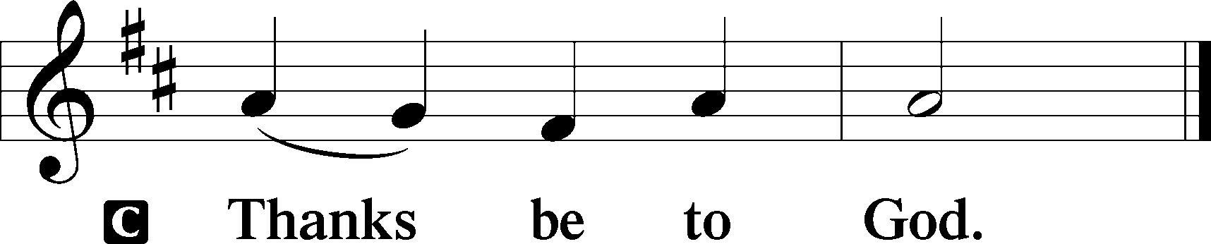

Benediction LSB 202

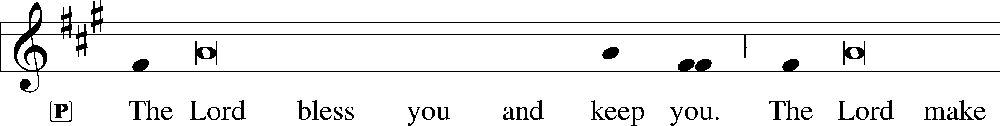

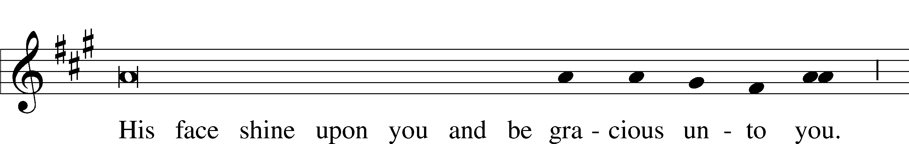

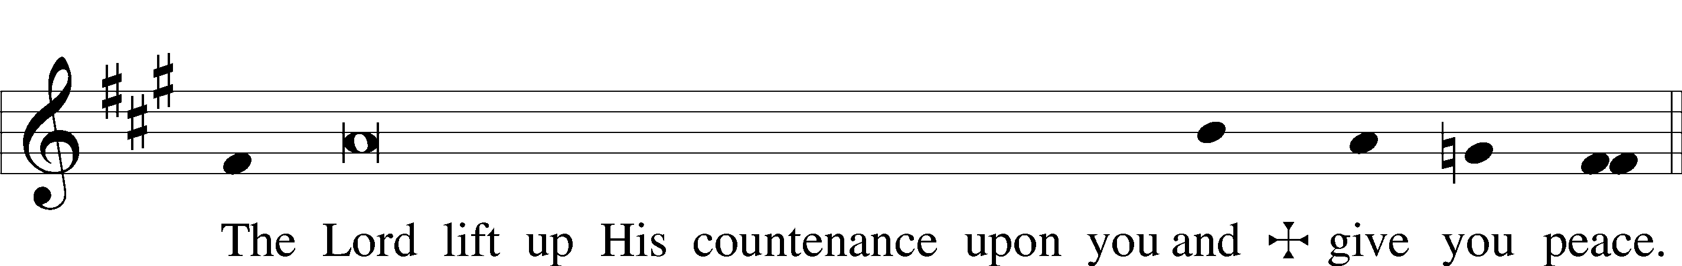

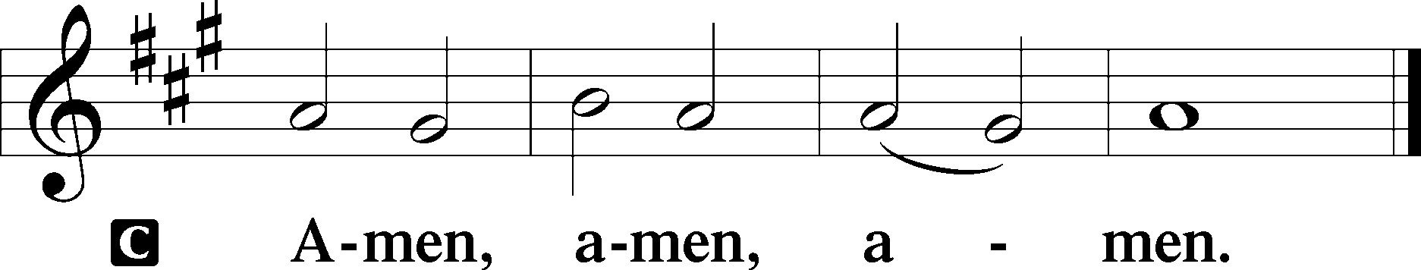

918 Guide Me, O Thou Great Redeemer

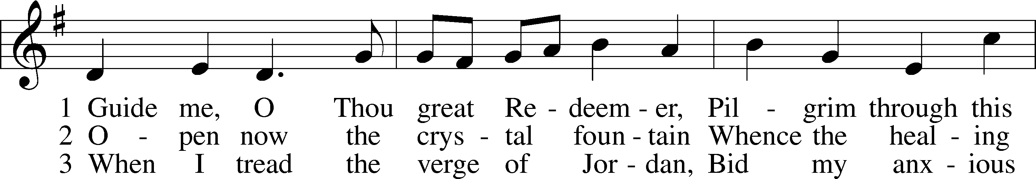

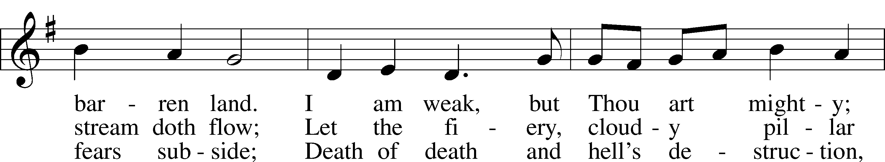

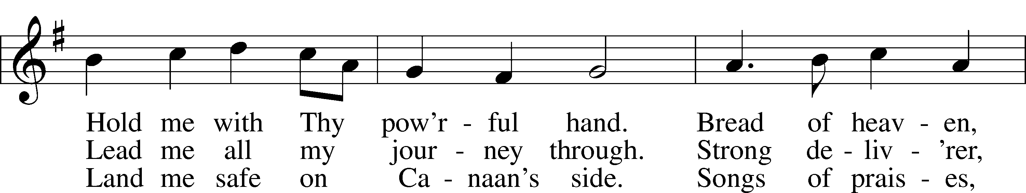

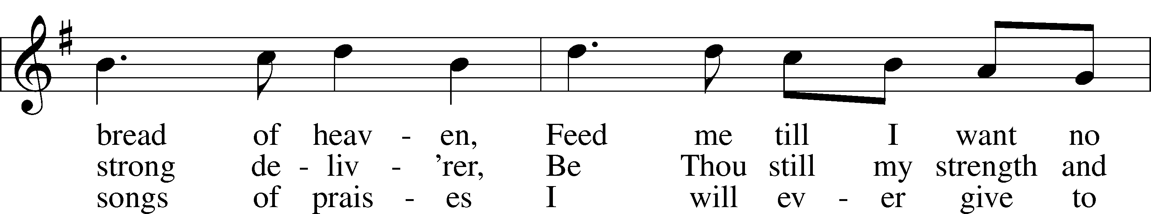

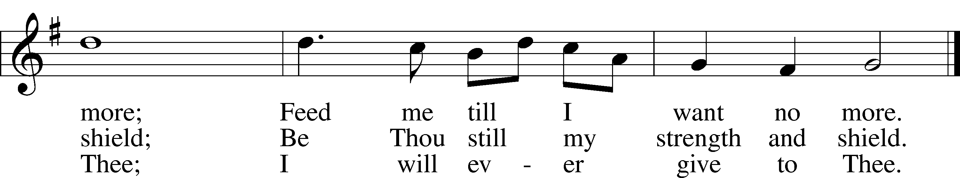

Text and tune: Public domain

Acknowledgments

Divine Service, Setting Three from Lutheran Service Book

Unless otherwise indicated, Scripture quotations are from the ESV® Bible (The Holy Bible, English Standard Version®), copyright © 2001 by Crossway, a publishing ministry of Good News Publishers. Used by permission. All rights reserved.

Created by Lutheran Service Builder © 2021 Concordia Publishing House.