Fifth Sunday in Lent
Christ’s Perfect Obedience
Hebrews 5:1-10

March 21, 2021

Messiah Lutheran Church
Lutheran Church-Missouri Synod
4102 Trinity River Dr., Corpus Christi, Texas 78410

Pastor: Rev. Scott E. Herbert

Church Phone: 361-387-7748 Email: mlc@stx.rr.com
Church Fax: 361-767-1768 Website: www.messiahlcms-cc.org
Pastor Phone: 469-693-9683 Pastor Email: chirev59@gmail.com
WELCOME TO MESSIAH!

We are glad you are here to receive what God is doing for you during Divine Service. Please sign our Guest Book located near the front door. Feel free to converse quietly until the organ prelude begins. If you are looking for a church home, please talk to the Pastor at the door. We would love to have you join us.

Preparing for Service

As we journey through this Lenten season and the days of Holy Week, we find Jesus teaching His disciples and the crowds. He warns them about the scribes and Pharisees, religious leaders of the time. Jesus says these leaders are hypocritical. They do not practice what they preach. They burden others with the heaviest forms of the law but refuse to do anything they command their hearers to do. Consider how different Jesus is from these leaders. When Jesus instructs us to love others, He shows us how, most especially in His willingness to go to the cross and die for us and our salvation.
DIVINE SERVICE Setting Three
Confession and Absolution

435 Come to Calvary’s Holy Mountain
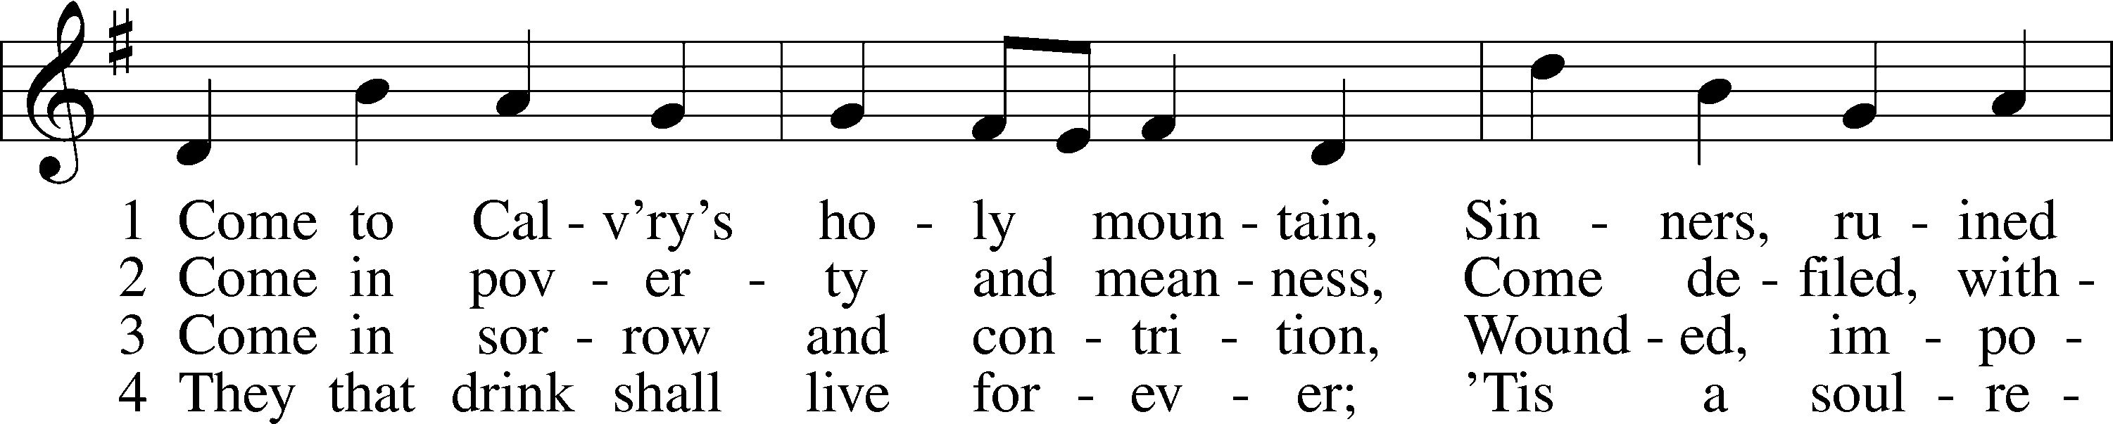
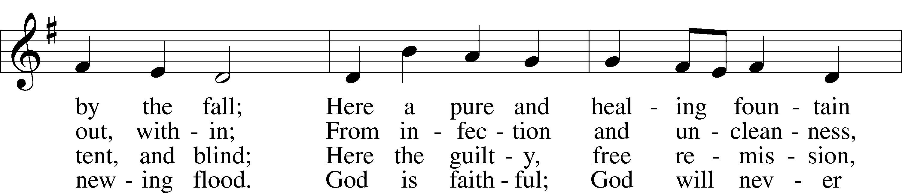
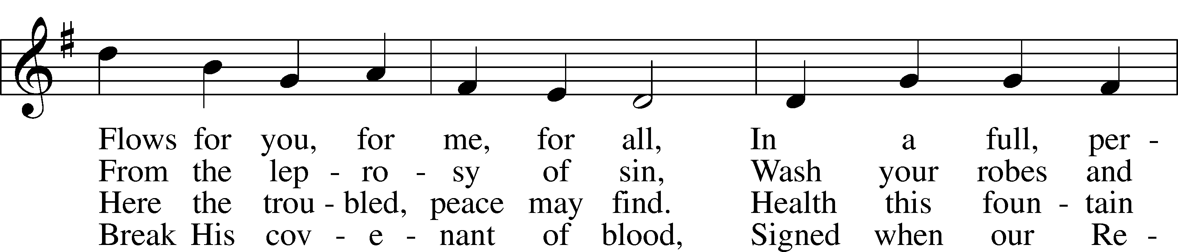
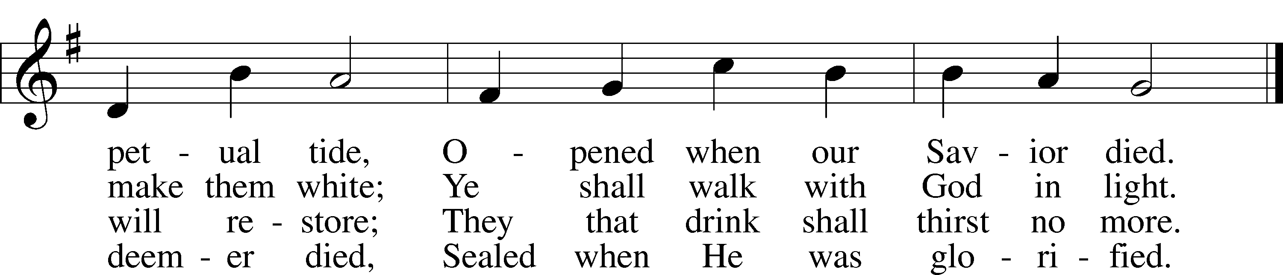
Text and tune: Public domain

P In the name of the Father and of the T Son and of the Holy Spirit.
C Amen.

P Beloved in the Lord! Let us draw near with a true heart and confess our sins unto God our Father, beseeching Him in the name of our Lord Jesus Christ to grant us forgiveness.

P Our help is in the name of the Lord,
C who made heaven and earth.
P I said, I will confess my transgressions unto the Lord,
C and You forgave the iniquity of my sin.

P O almighty God, merciful Father,
C I, a poor, miserable sinner, confess unto You all my sins and iniquities with which I have ever offended You and justly deserved Your temporal and eternal punishment. But I am heartily sorry for them and sincerely repent of them, and I pray You of Your boundless mercy and for the sake of the holy, innocent, bitter sufferings and death of Your beloved Son, Jesus Christ, to be gracious and merciful to me, a poor, sinful being.

P Upon this your confession, I, by virtue of my office, as a called and ordained servant of the Word, announce the grace of God unto all of you, and in the stead and by the command of my Lord Jesus Christ I forgive you all your sins in the name of the Father and of the T Son and of the Holy Spirit.
C Amen.

Service of the Word
Introit Psalm 116:1–4, 8; antiphon: Psalm 43:1
Vindicate me, O God,
and defend my cause against an ungodly people,
from the deceitful and unjust man deliver me!
I love the Lord, because he has heard
my voice and my pleas for mercy.
Because he inclined his ear to me,
therefore I will call on him as long as I live.
The snares of death encompassed me;
the pangs of Sheol laid hold on me;
I suffered distress and anguish.
Then I called on the name of the Lord:
“O Lord, I pray, deliver my soul!”
For you have delivered my soul from death,
my eyes from tears, my feet from stumbling.
Vindicate me, O God,
and defend my cause against an ungodly people,
from the deceitful and unjust man deliver me!
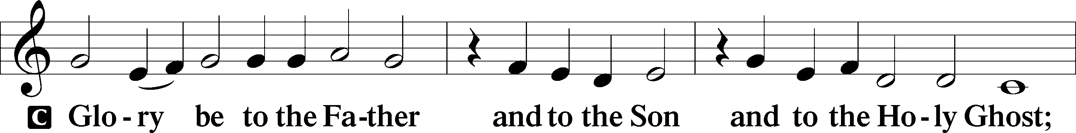
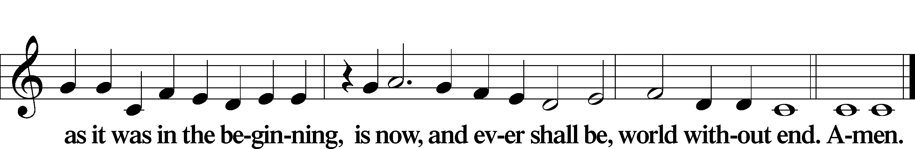

Kyrie LSB 186
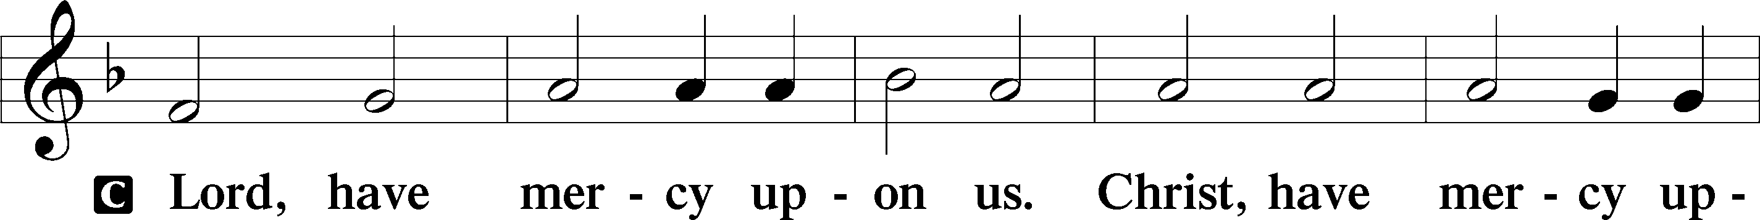
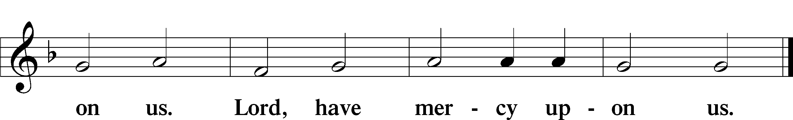

Salutation and Collect of the Day
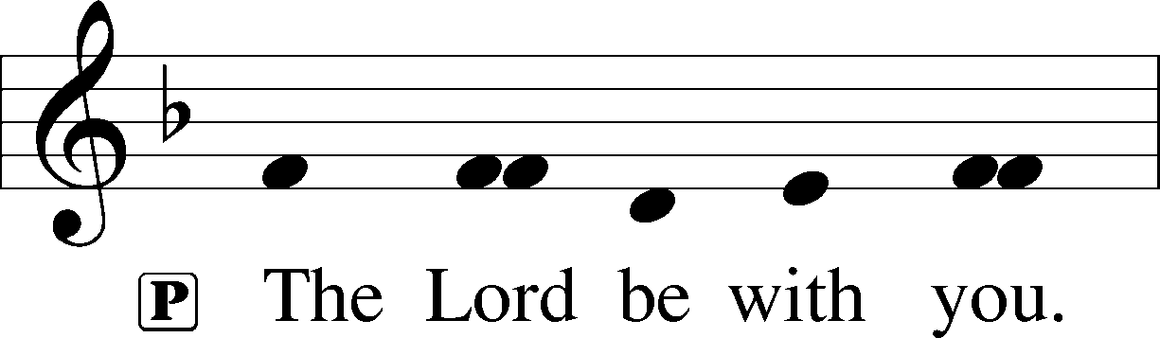
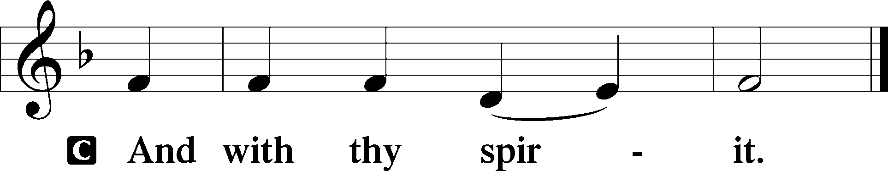

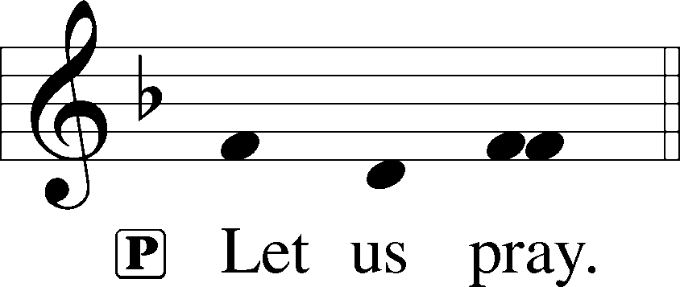

P Almighty God, by Your great goodness mercifully look upon Your people that we may be governed and preserved evermore in body and soul; through Jesus Christ, Your Son, our Lord, who lives and reigns with You and the Holy Spirit, one God, now and forever.
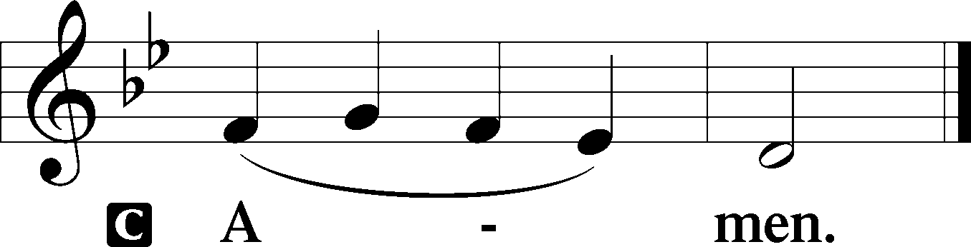
Old Testament Reading Jeremiah 31:31–34
31“Behold, the days are coming, declares the Lord, when I will make a new covenant with the house of Israel and the house of Judah, 32not like the covenant that I made with their fathers on the day when I took them by the hand to bring them out of the land of Egypt, my covenant that they broke, though I was their husband, declares the Lord. 33But this is the covenant that I will make with the house of Israel after those days, declares the Lord: I will put my law within them, and I will write it on their hearts. And I will be their God, and they shall be my people. 34And no longer shall each one teach his neighbor and each his brother, saying, ‘Know the Lord,’ for they shall all know me, from the least of them to the greatest, declares the Lord. For I will forgive their iniquity, and I will remember their sin no more.”

A This is the Word of the Lord.
C Thanks be to God.

Epistle Hebrews 5:1–10
1Every high priest chosen from among men is appointed to act on behalf of men in relation to God, to offer gifts and sacrifices for sins. 2He can deal gently with the ignorant and wayward, since he himself is beset with weakness. 3Because of this he is obligated to offer sacrifice for his own sins just as he does for those of the people. 4And no one takes this honor for himself, but only when called by God, just as Aaron was.
5So also Christ did not exalt himself to be made a high priest, but was appointed by him who said to him, “You are my Son,
today I have begotten you”;
6as he says also in another place, “You are a priest forever,
after the order of Melchizedek.”
7In the days of his flesh, Jesus offered up prayers and supplications, with loud cries and tears, to him who was able to save him from death, and he was heard because of his reverence. 8Although he was a son, he learned obedience through what he suffered. 9And being made perfect, he became the source of eternal salvation to all who obey him, 10being designated by God a high priest after the order of Melchizedek.

A This is the Word of the Lord.
C Thanks be to God.

Holy Gospel Mark 10:32–45
P The Holy Gospel according to St. Mark, the tenth chapter.

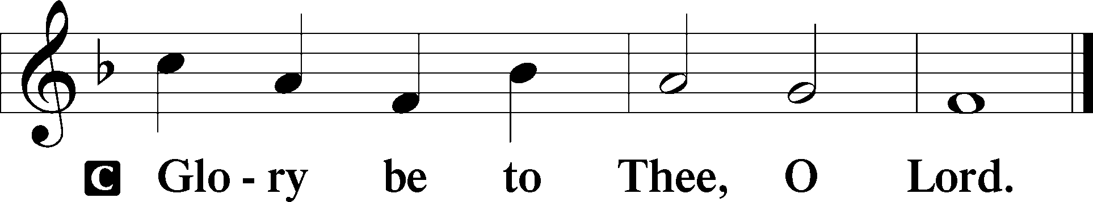

32And they were on the road, going up to Jerusalem, and Jesus was walking ahead of them. And they were amazed, and those who followed were afraid. And taking the twelve again, he began to tell them what was to happen to him, 33saying, “See, we are going up to Jerusalem, and the Son of Man will be delivered over to the chief priests and the scribes, and they will condemn him to death and deliver him over to the Gentiles. 34And they will mock him and spit on him, and flog him and kill him. And after three days he will rise.”
35And James and John, the sons of Zebedee, came up to him and said to him, “Teacher, we want you to do for us whatever we ask of you.” 36And he said to them, “What do you want me to do for you?” 37And they said to him, “Grant us to sit, one at your right hand and one at your left, in your glory.” 38Jesus said to them, “You do not know what you are asking. Are you able to drink the cup that I drink, or to be baptized with the baptism with which I am baptized?” 39And they said to him, “We are able.” And Jesus said to them, “The cup that I drink you will drink, and with the baptism with which I am baptized, you will be baptized, 40but to sit at my right hand or at my left is not mine to grant, but it is for those for whom it has been prepared.” 41And when the ten heard it, they began to be indignant at James and John. 42And Jesus called them to him and said to them, “You know that those who are considered rulers of the Gentiles lord it over them, and their great ones exercise authority over them. 43But it shall not be so among you. But whoever would be great among you must be your servant, 44and whoever would be first among you must be slave of all. 45For even the Son of Man came not to be served but to serve, and to give his life as a ransom for many.”

P This is the Gospel of the Lord.

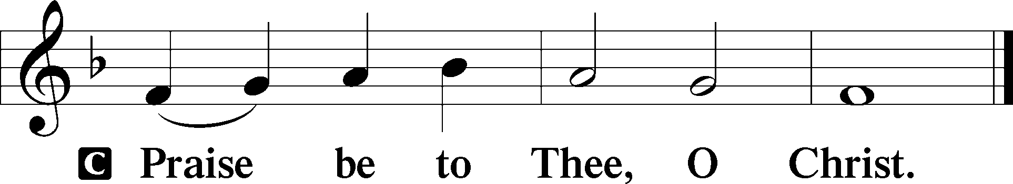

Nicene Creed
C I believe in one God,
the Father Almighty,
maker of heaven and earth
and of all things visible and invisible.

And in one Lord Jesus Christ,
the only-begotten Son of God,
begotten of His Father before all worlds,
God of God, Light of Light,
very God of very God,
begotten, not made,
being of one substance with the Father,
by whom all things were made;
who for us men and for our salvation came down from heaven
and was incarnate by the Holy Spirit of the virgin Mary
and was made man;
and was crucified also for us under Pontius Pilate.
He suffered and was buried.
And the third day He rose again according to the Scriptures
and ascended into heaven
and sits at the right hand of the Father.
And He will come again with glory to judge both the living and the dead, whose kingdom will have no end.

And I believe in the Holy Spirit,
the Lord and giver of life,
who proceeds from the Father and the Son,
who with the Father and the Son together is worshiped and glorified,
who spoke by the prophets.
And I believe in one holy Christian and apostolic Church,
I acknowledge one Baptism for the remission of sins,
and I look for the resurrection of the dead
and the life T of the world to come. Amen.

Children’s Message The Power of His Love

430 My Song Is Love Unknown
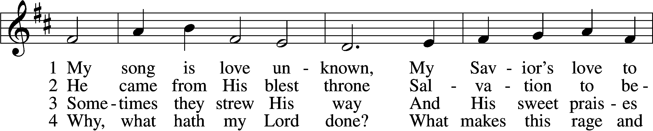
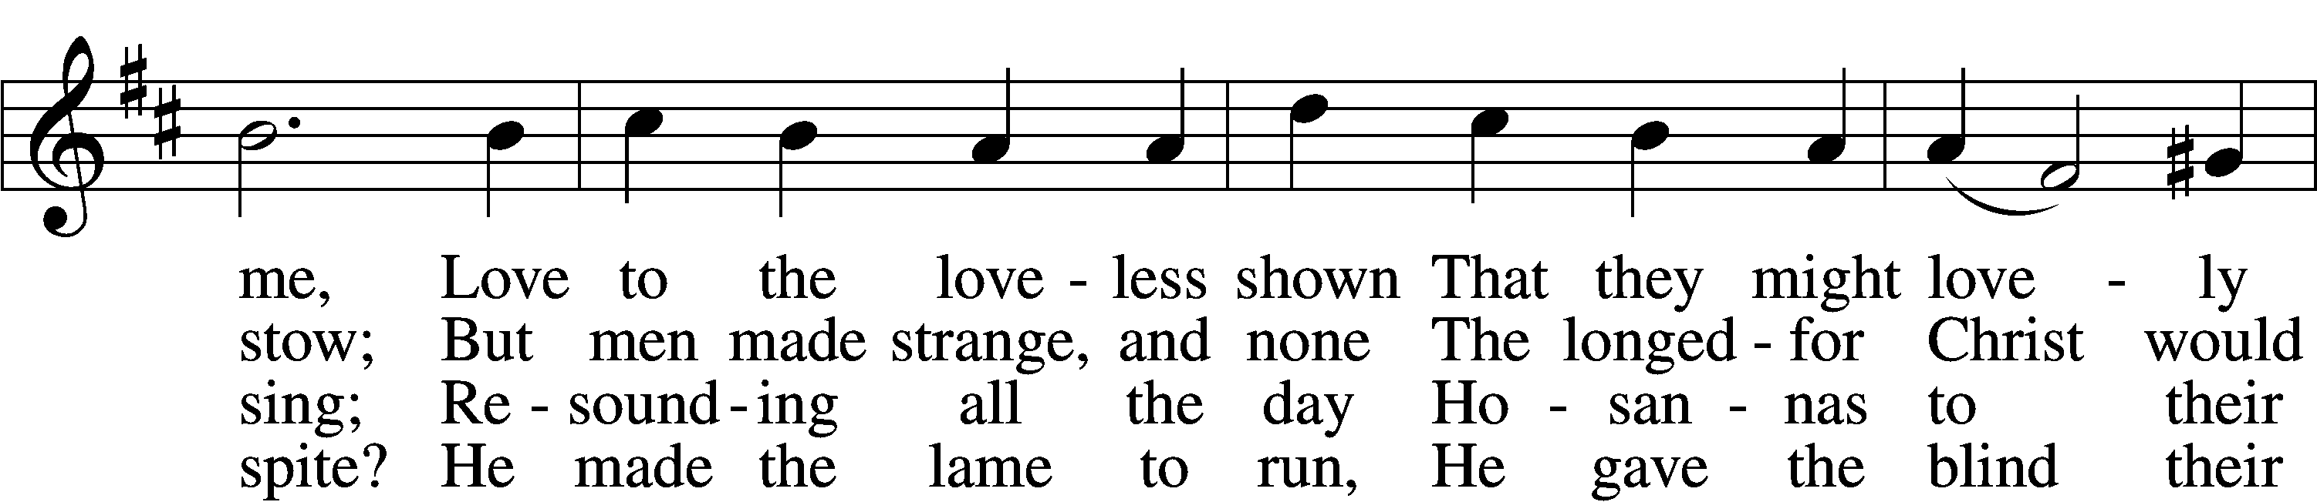
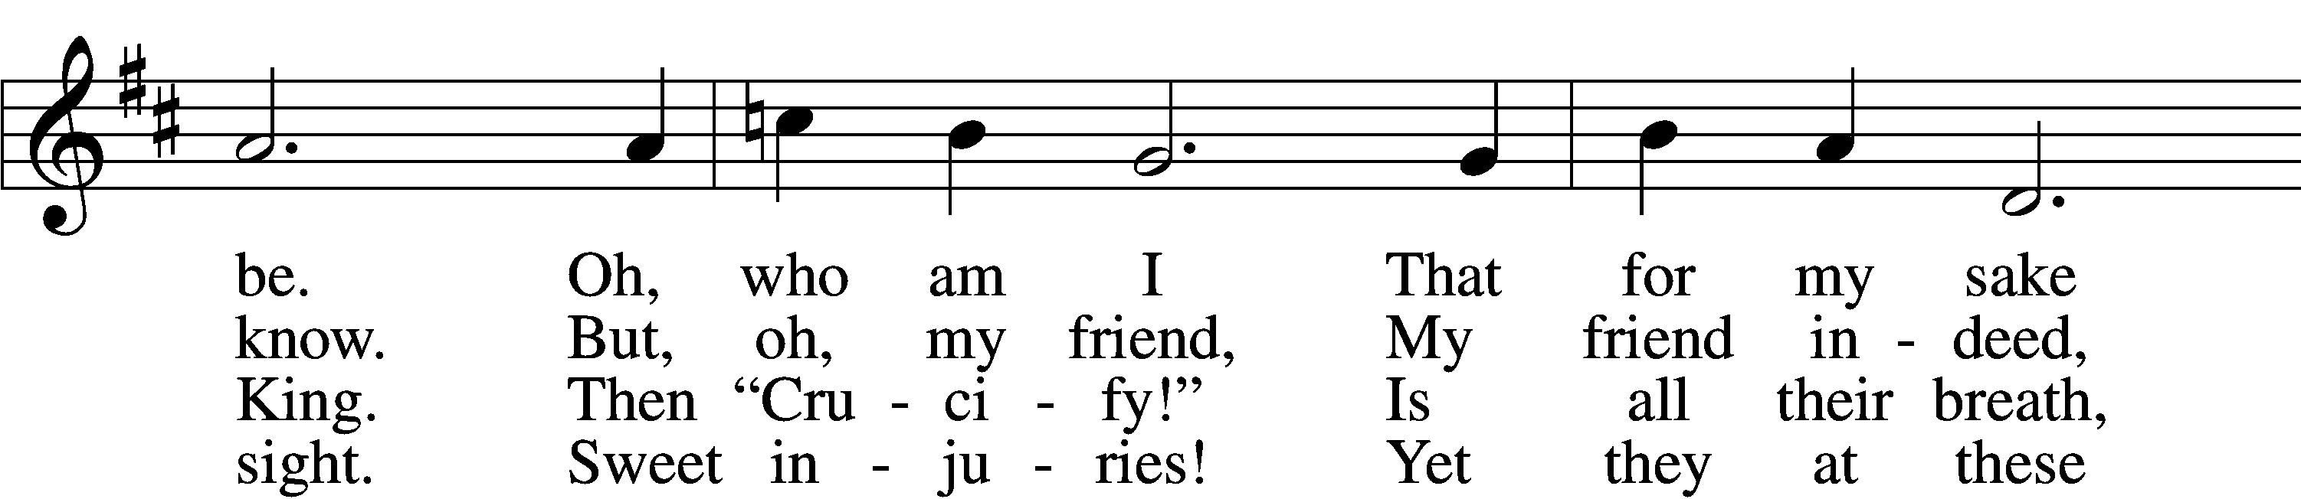
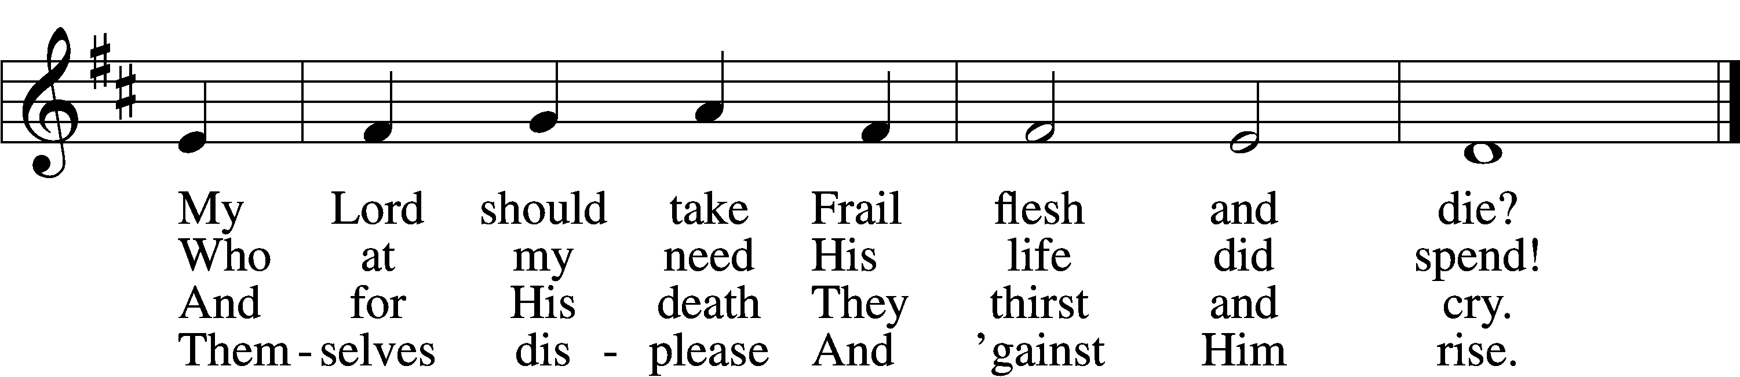
Tune: © John Ireland Trust. Used by permission: LSB Hymn License no. 110005047
Text: Public domain

Sermon Christ’s Perfect Obedience (Hebrews 5:1-10)

P The peace of God, which passes all understanding, keep your hearts and minds in Christ Jesus.
C Amen.

Offertory LSB 192
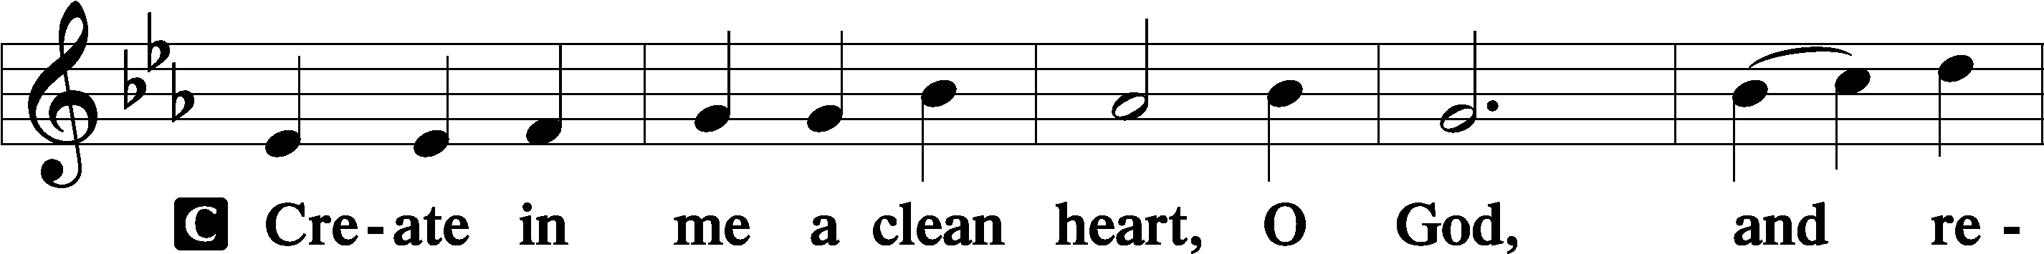
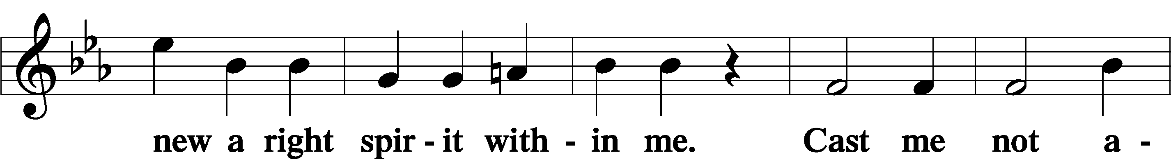
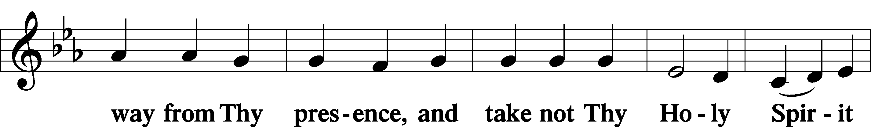
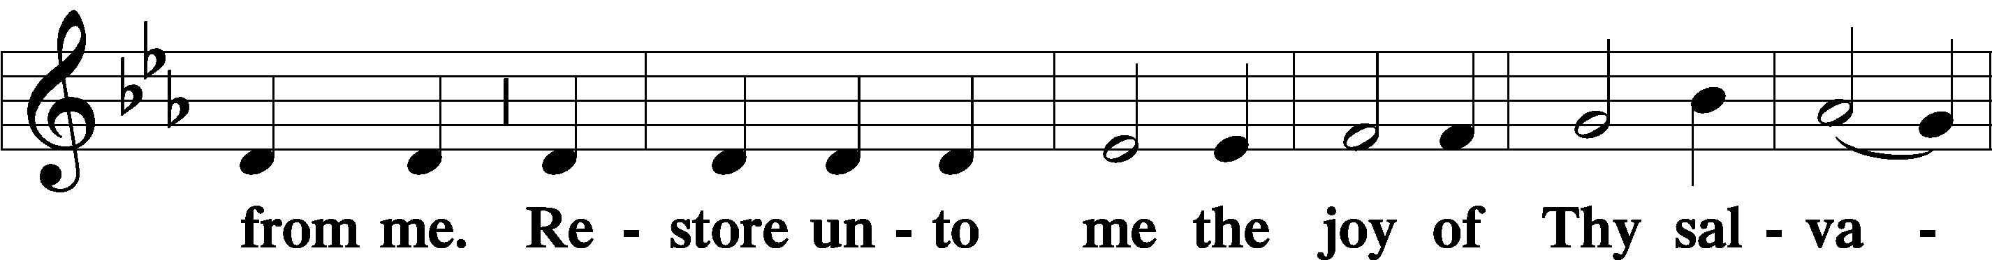
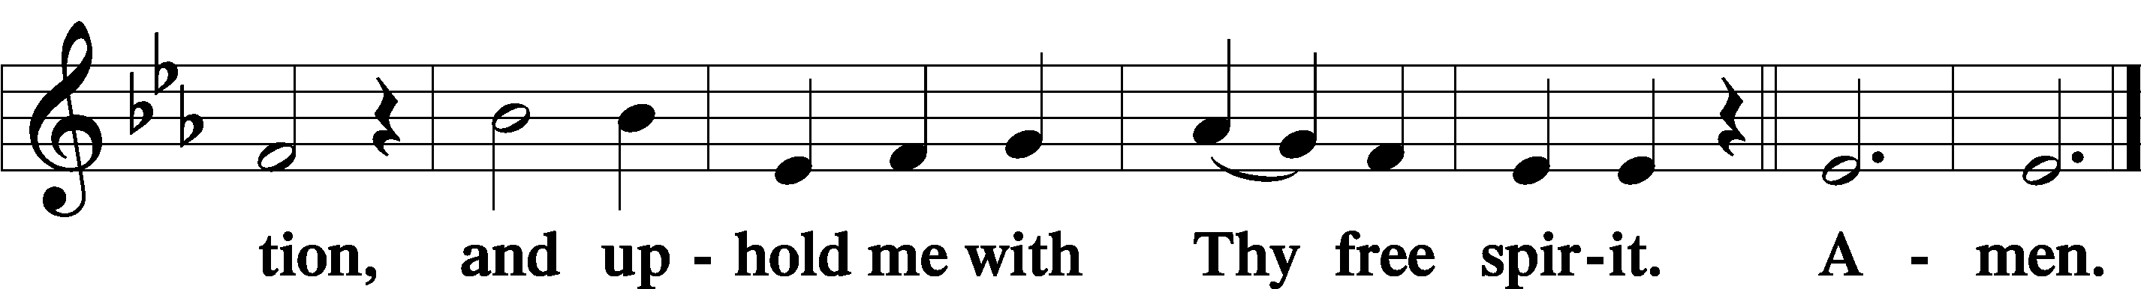

Offering

Prayer of the Church

Service of the Sacrament
Preface LSB 194

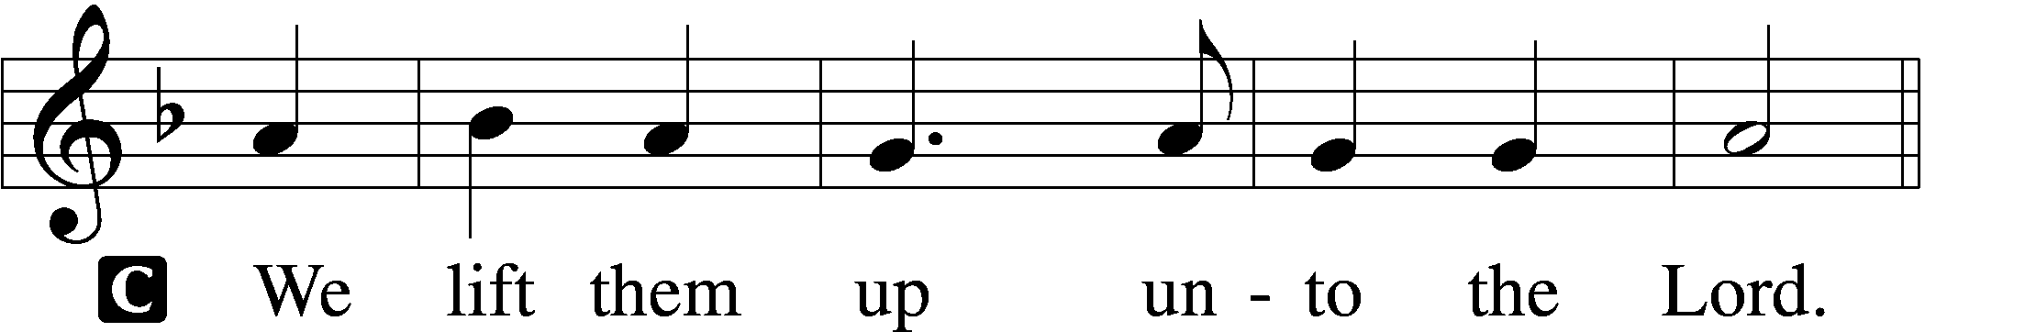

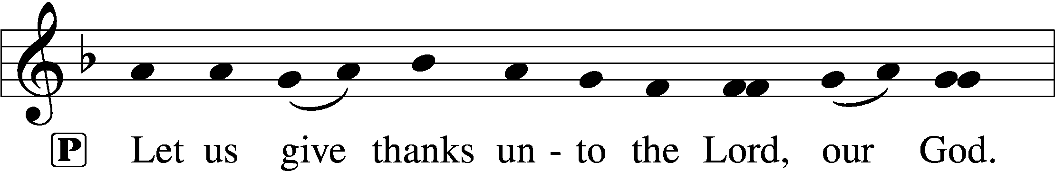
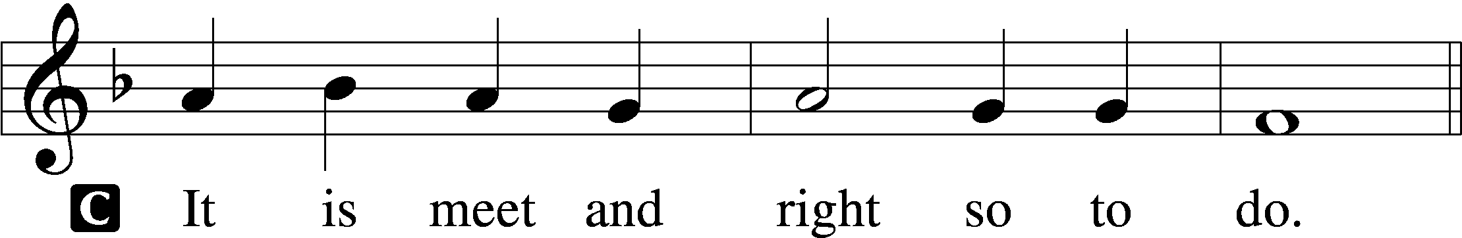

P It is truly meet, right, and salutary that we should at all times and in all places give thanks to You, holy Lord, almighty Father, everlasting God, through Jesus Christ, our Lord, who overcame the assaults of the devil and gave His life as a ransom for many that with cleansed hearts we might be prepared joyfully to celebrate the paschal feast in sincerity and truth. Therefore with angels and archangels and with all the company of heaven we laud and magnify Your glorious name, evermore praising You and saying:

Sanctus LSB 195
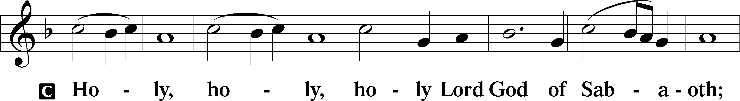
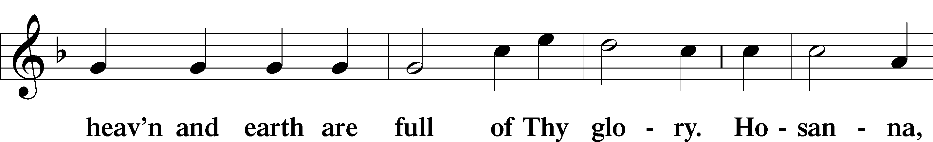
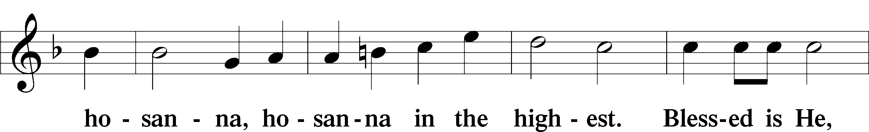
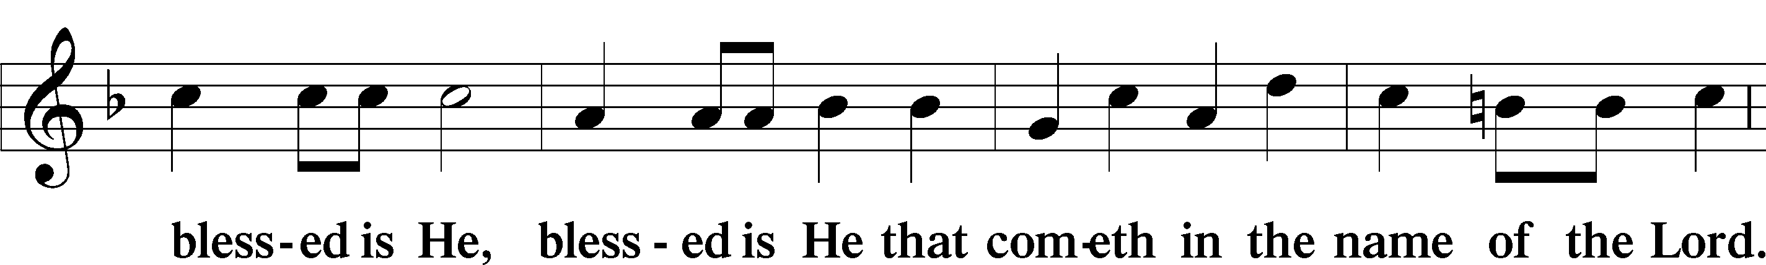
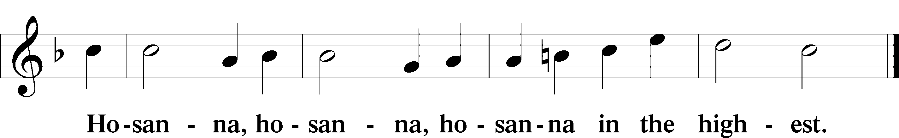

Lord’s Prayer LSB 196
C Our Father who art in heaven, hallowed be Thy name,
Thy kingdom come,
Thy will be done on earth as it is in heaven;
give us this day our daily bread;
and forgive us our trespasses as we forgive those who trespass against us;
and lead us not into temptation,
but deliver us from evil.
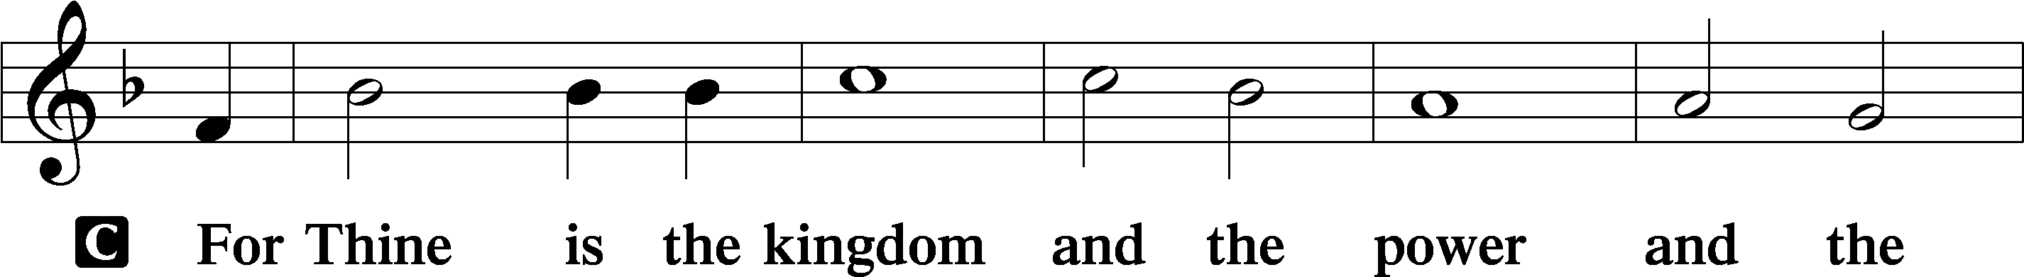
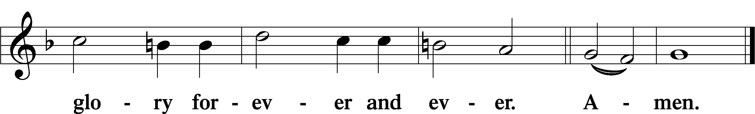

The Words of Our Lord LSB 197
P Our Lord Jesus Christ, on the night when He was betrayed, took bread, and when He had given thanks, He broke it and gave it to the disciples and said: “Take, eat; this is My T body, which is given for you. This do in remembrance of Me.”

In the same way also He took the cup after supper, and when He had given thanks, He gave it to them, saying: “Drink of it, all of you; this cup is the new testament in My T blood, which is shed for you for the forgiveness of sins. This do, as often as you drink it, in remembrance of Me.”

Pax Domini LSB 197
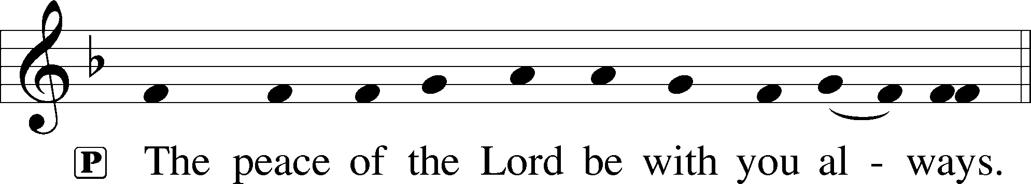

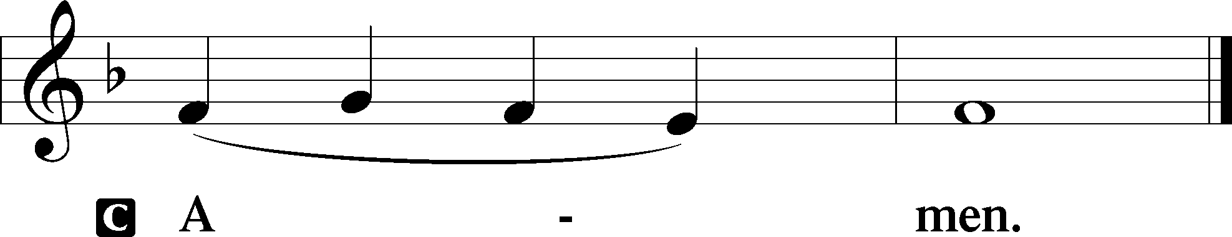

Agnus Dei LSB 198
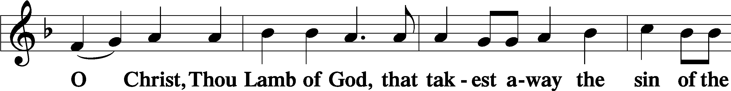
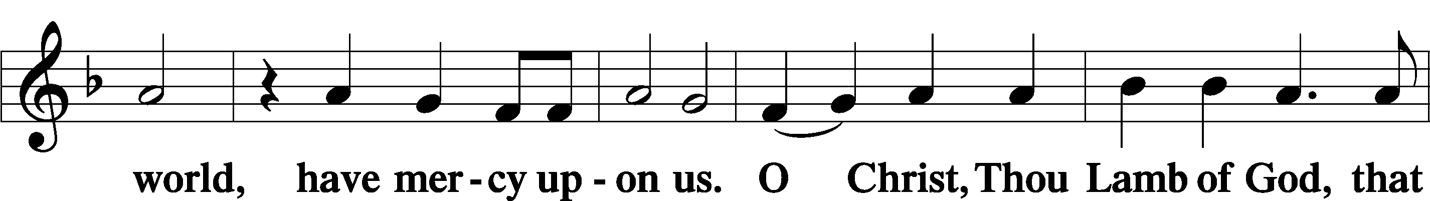
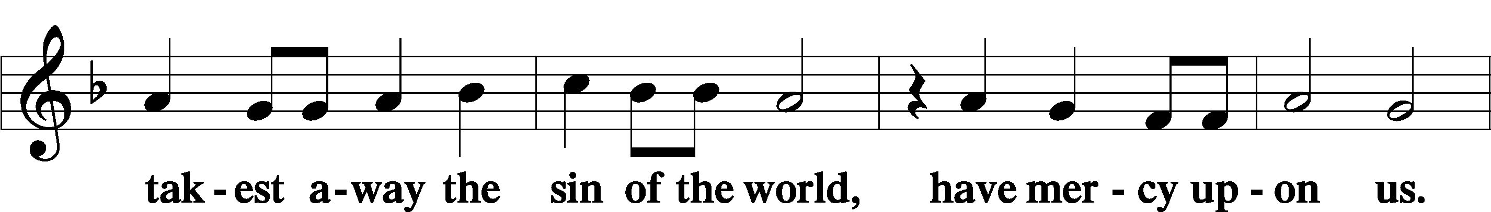
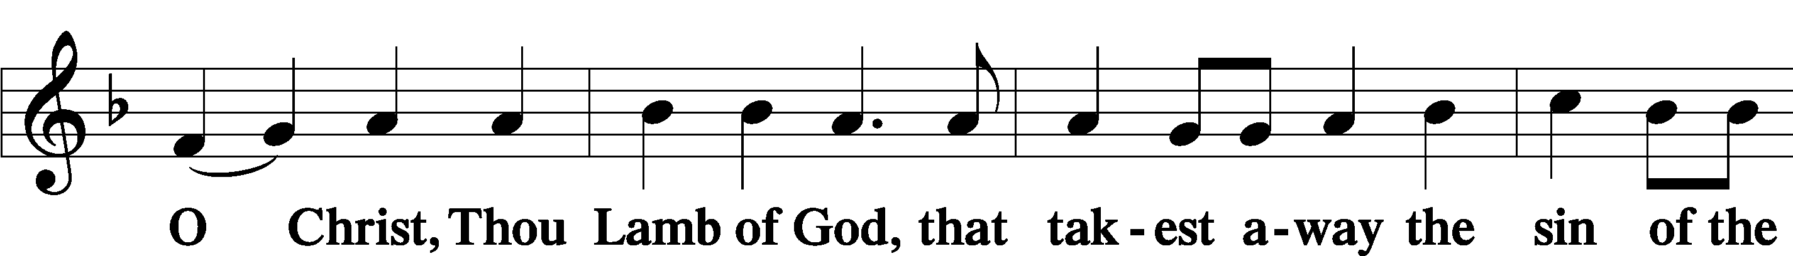
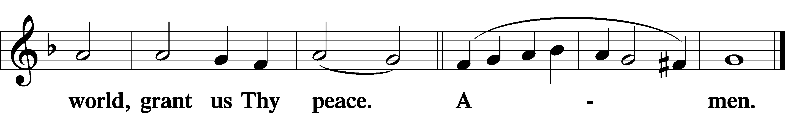

Distribution

627 Jesus Christ, Our Blessed Savior
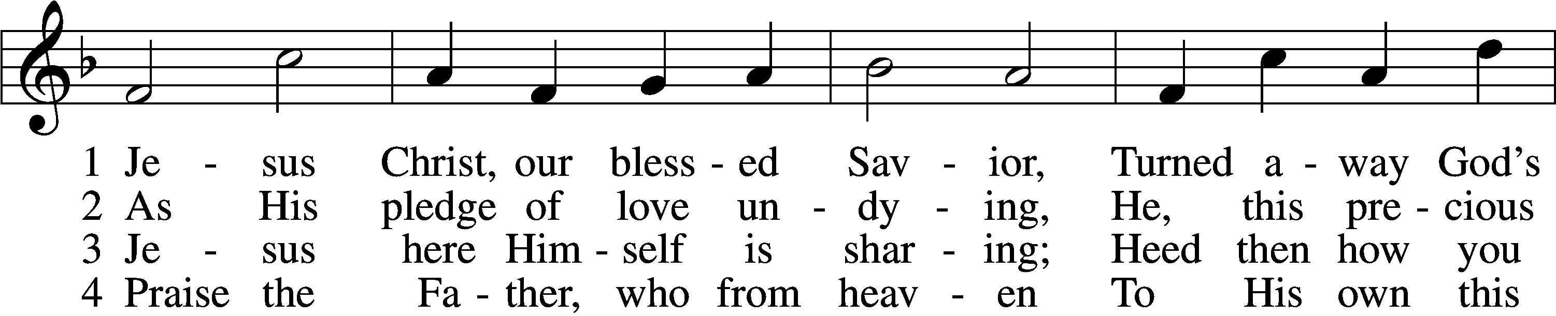
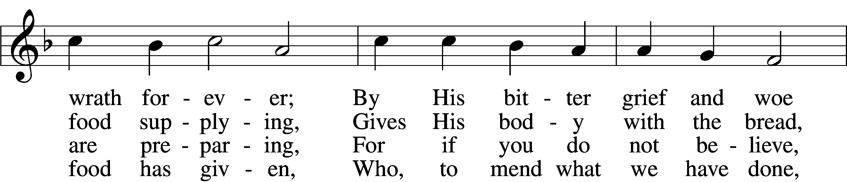
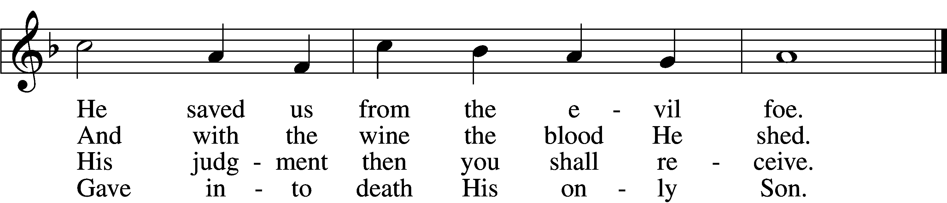

5 Firmly hold with faith unshaken
That this food is to be taken
By the sick who are distressed,
By hearts that long for peace and rest.

6 Agony and bitter labor
Were the cost of God’s high favor;
Do not come if you suppose
You need not Him who died and rose.

7 Christ says: “Come, all you that labor,
And receive My grace and favor:
Those who feel no pain or ill
Need no physician’s help or skill.

8 “For what purpose was My dying
If not for your justifying?
And what use this precious food
If you yourself were pure and good?”

9 If your heart this truth professes
And your mouth your sin confesses,
You will be your Savior’s guest,
Be at His banquet truly blest.

10 Let this food your faith so nourish
That its fruit of love may flourish
And your neighbor learn from you
How much God’s wondrous love can do.
Text (sts. 1–2, 4–5, 7, 9) and tune: Public domain
Text (sts. 3, 6, 8, 10): © 1980 and 2006 Concordia Publishing House. Used by permission: LSB Hymn License no. 110005047

P The body and blood of our Lord Jesus Christ strengthen and preserve you in body and soul to life everlasting. Depart T in peace.
C Amen.
Nunc Dimittis LSB 199
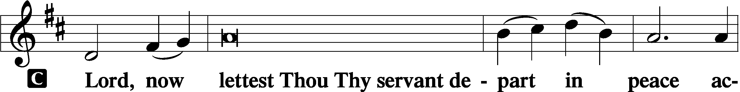

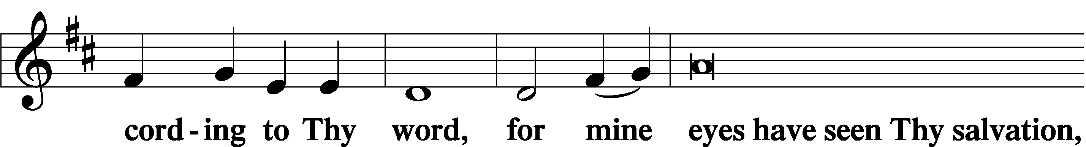

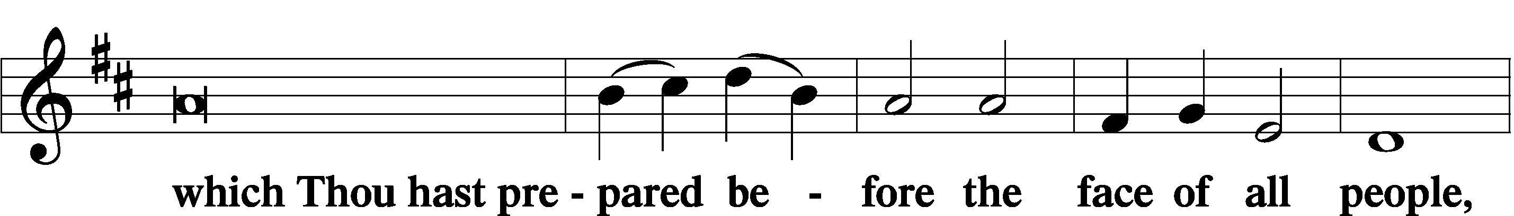

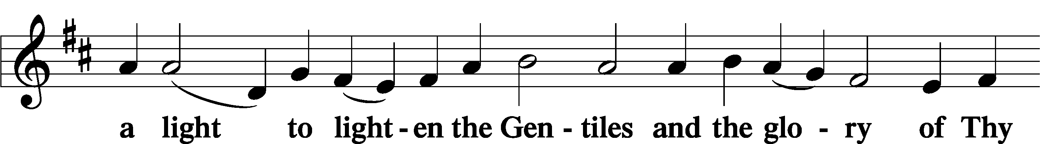

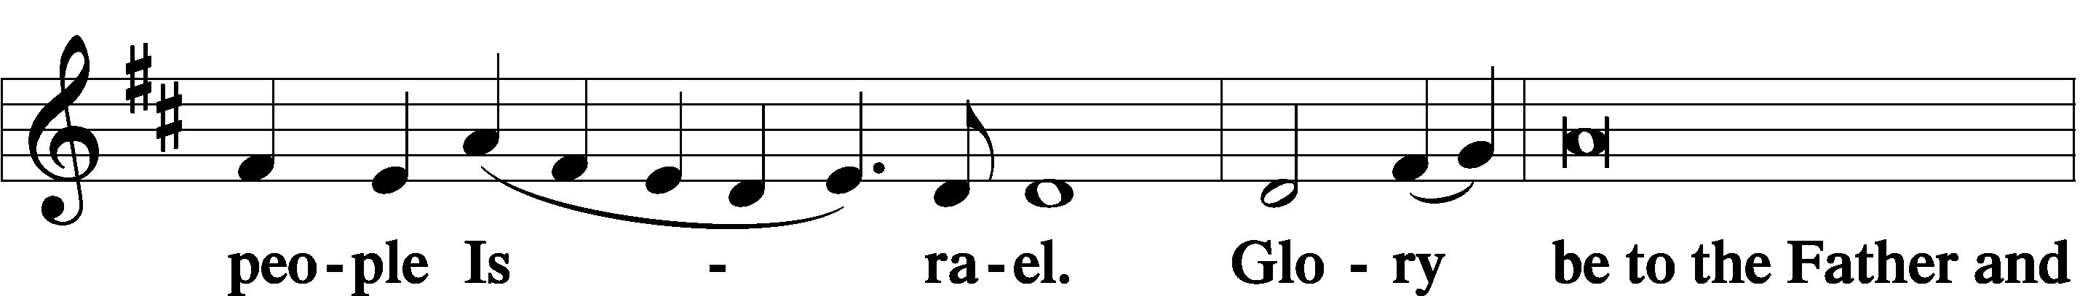

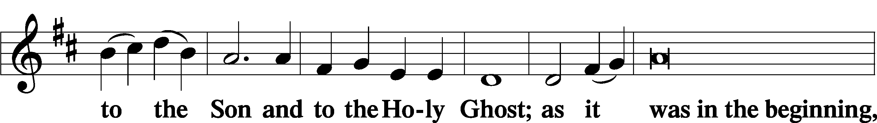

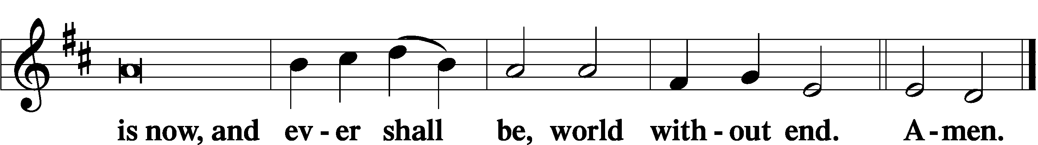

Thanksgiving LSB 200
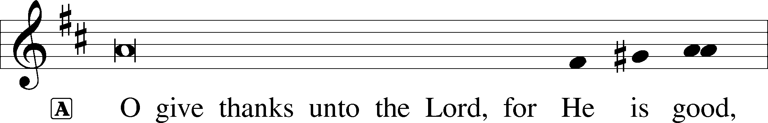

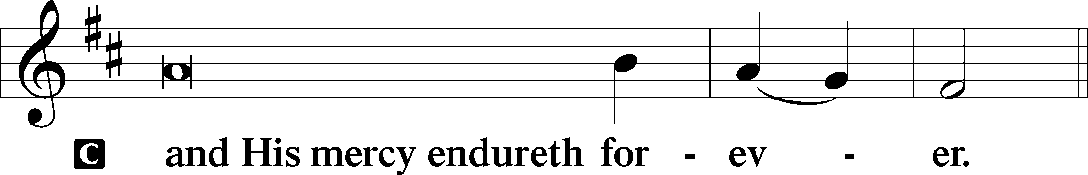

P Let us pray. O God the Father, the fountain and source of all goodness, who in loving-kindness sent Your only-begotten Son into the flesh, we thank You that for His sake You have given us pardon and peace in this Sacrament, and we ask You not to forsake Your children but always to rule our hearts and minds by Your Holy Spirit that we may be enabled constantly to serve You; through Jesus Christ, Your Son, our Lord, who lives and reigns with You and the Holy Spirit, one God, now and forever.
C Amen.

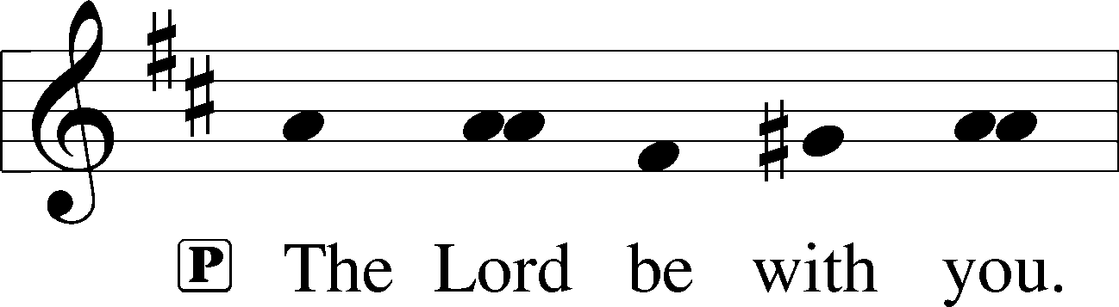

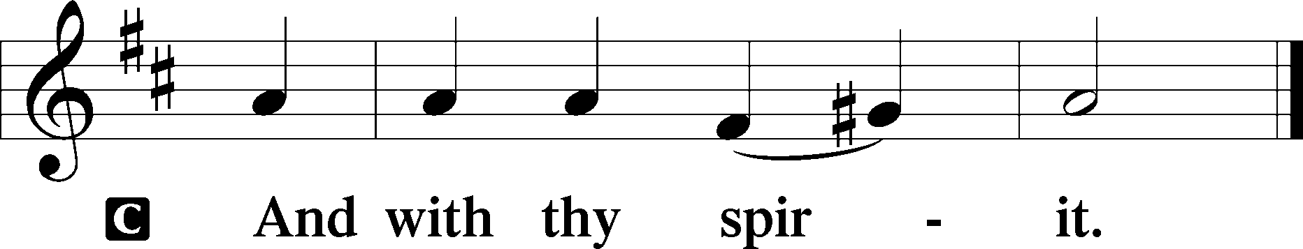

Benedicamus LSB 202
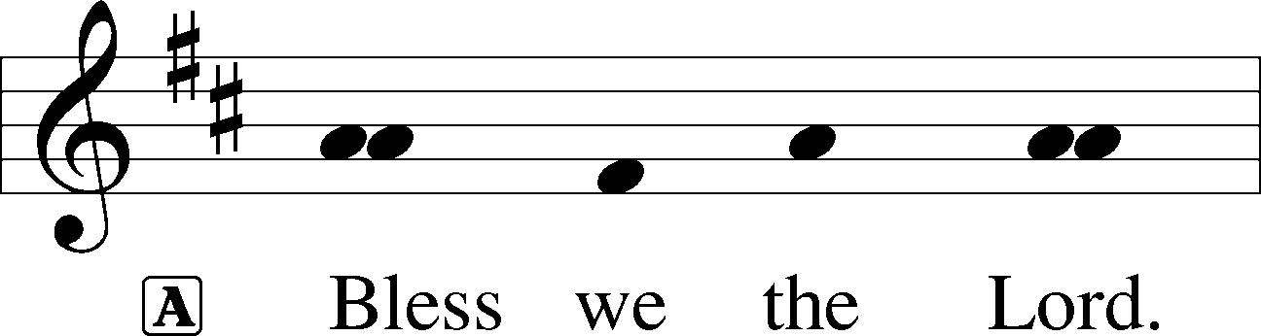

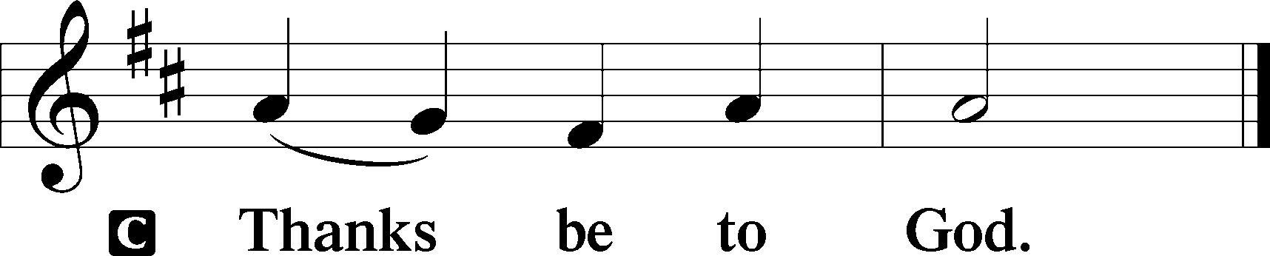

Benediction LSB 202
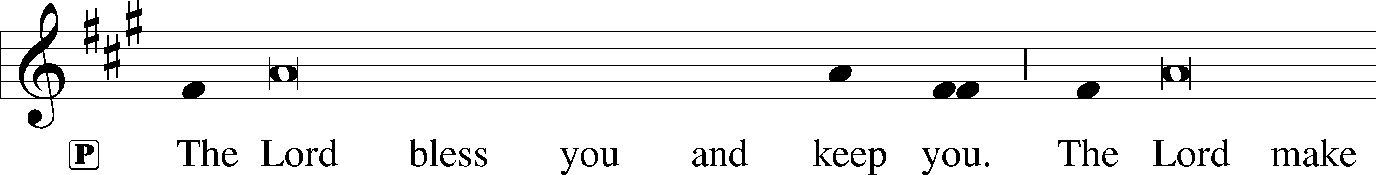
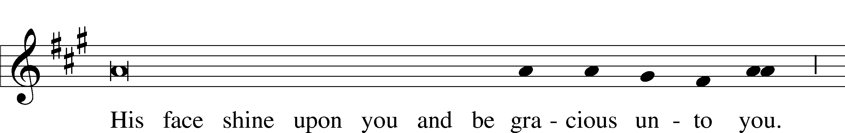
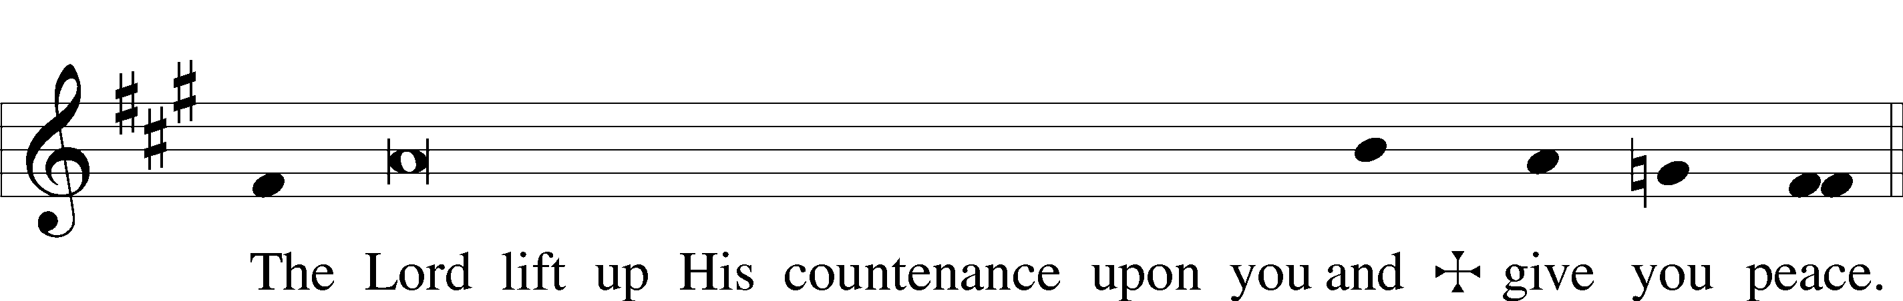

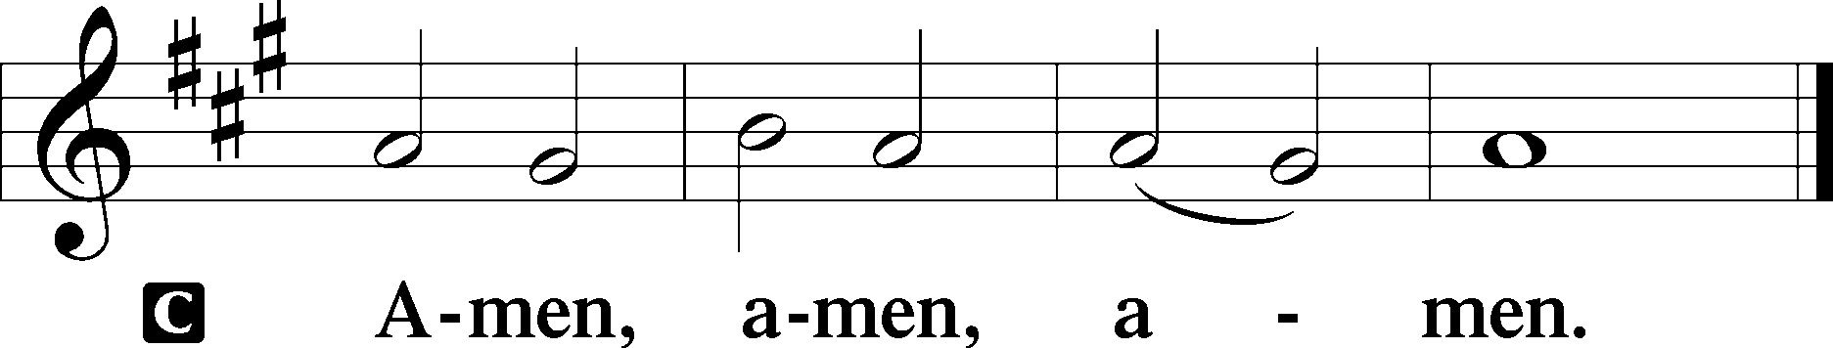

857 Lord, Help Us Walk Your Servant Way
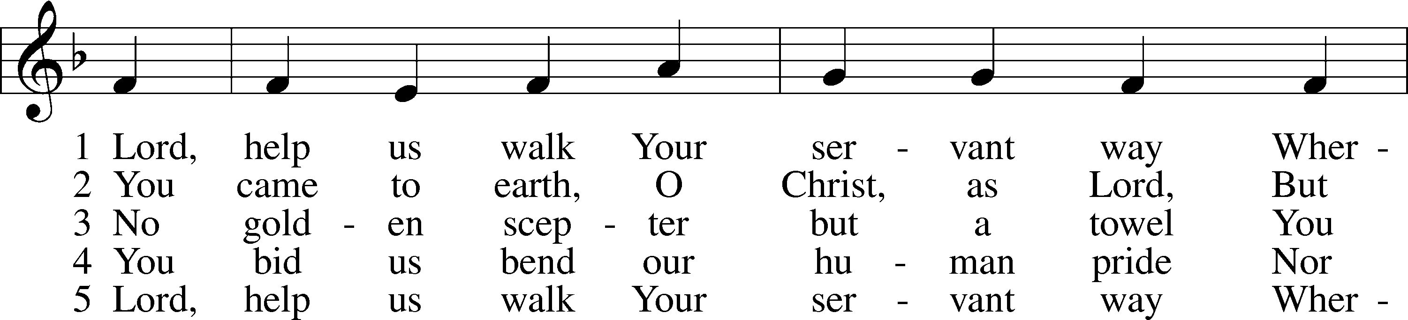
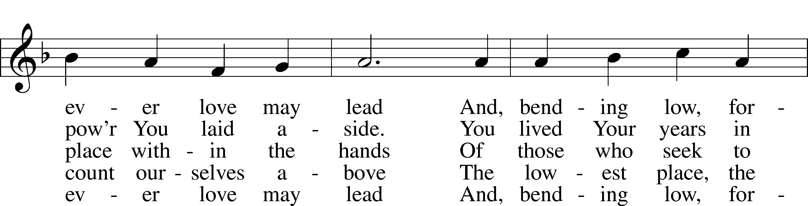
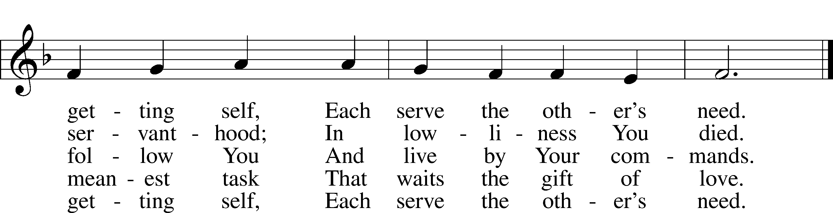
Tune: Public domain
Text: © 1997 GIA Publications, Inc. Used by permission: LSB Hymn License no. 110005047

Acknowledgments
Divine Service, Setting Three from Lutheran Service Book
Unless otherwise indicated, Scripture quotations are from the ESV® Bible (The Holy Bible, English Standard Version®), copyright © 2001 by Crossway, a publishing ministry of Good News Publishers. Used by permission. All rights reserved.
Created by Lutheran Service Builder © 2021 Concordia Publishing House.

March 21 “We affirm again and again that God handmade all people and Jesus died for all people. And that means ALL lives are valuable and equally loved.” Michelle Bauman, Director of Y4Life for Lutherans For Life – A Life Quote from Lutherans For Life • lutheransforlife.org

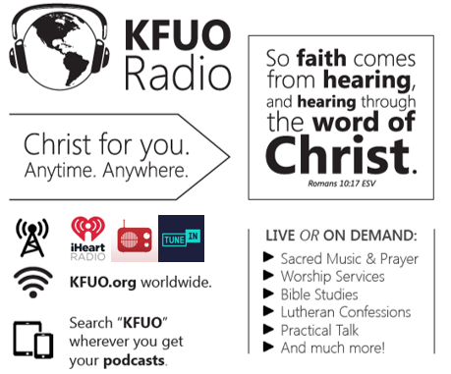

This week on KFUO.org, study Mark 14 on Sharper Iron (weekdays at 8:00 a.m. CT), dig into Colossians 1-3 on Thy Strong Word (weekdays at 11:00 a.m. CT), and worship in Midweek Lenten Service and organ recital on 3/24 at 11:00 a.m. CT. Find your favorite programs on demand at kfuo.org or wherever you get your podcasts.

Gifts of Time and Treasure
“And my God will meet all your needs according to His glorious
riches in Christ Jesus.” Philippians 4:19

LAST WEEK’S OFFERINGS LAST WEEK’S ATTENDANCE
Midweek 3/3 $ 226.00
General Fund $ 1,305.00 Service 26
Needed Weekly $ 4,669.00 Communed 22
Adult Bible Study $ 6.00
Memorial –Floyd Hoff $ 50.00

The Lord’s Week

Today 8:45 am – Bible Studies for all ages
(Mar. 21st) 10:00 am – Divine Service
11:30 am – Confirmation

Wednesday 10:00 am – Women’s Bible Study
7:00 pm – Lenten Service

Next Sunday 8:45 am – Bible Studies for all ages
(Mar. 28th) 10:00 am – Divine Service
11:45 am – Confirmation

In His Service

Elder: Jim Bounds
Usher:
Acolytes: Whitney Larson
Organist: Sharon Shrader
Alter: Devereaux Brewer
Flowers:

