**Palm Sunday**

**Jesus Christ is God!**

Philippians 2:5-11

**March 28, 2021**

**Messiah Lutheran Church**

**Lutheran Church-Missouri Synod**

4102 Trinity River Dr., Corpus Christi, Texas 78410

**Pastor:**  **Rev. Scott E. Herbert**

Church Phone: 361-387-7748 Email: mlc@stx.rr.com

Church Fax: 361-767-1768 Website: [www.messiahlcms-cc.org](http://www.messiahlcms-cc.org)

Pastor Phone: 469-693-9683 Pastor Email: [chirev59@gmail.com](mailto:chirev59@gmail.com)

**WELCOME TO MESSIAH!**

We are glad you are here to receive what God is doing for you during Divine Service. Please sign our Guest Book located near the front door. Feel free to converse quietly until the organ prelude begins. If you are looking for a church home, please talk to the Pastor at the door. We would love to have you join us.

**Preparing for Service**

***The Son of David Ascends His Throne and Reigns in Love from His Cross***

The Son of David comes in gentle humility, *“sitting on a donkey’s colt,”* yet as the King of Israel *“in the name of the Lord”* (John 12:13–15). He comes to be lifted up in glory on the cross in order to cast out *“the ruler of this world”* and draw all people to Himself (John 12:23–32). The Church is thus called to *“rejoice greatly,”* because her King comes with salvation, and *“he shall speak peace to the nations”* (Zech. 9:9–10). As He is anointed *“beforehand for burial”* (Mark 14:8), He also ascends His royal throne as *“the King of the Jews”* by way of His Passion (Mark 15:2, 17–19, 26). He goes *“as it is written of him,”* wherefore *“you will see the Son of Man seated at the right hand of Power”* (Mark 14:21, 62). For the glory of God is love, which crescendos in the humble obedience and voluntary self-sacrifice of the Son of God for the salvation of sinners. So, God the Father has *“highly exalted him and bestowed on him the name that is above every name”* (Phil. 2:9), that He might reign over us in love with the forgiveness of His cross.

# PREPARATION

Procession of Palms

Greeting

P The grace of our Lord T Jesus Christ and the love of God and the communion of the Holy Spirit be with you all.

C **Amen.**

P Blessed is He who comes in the name of the Lord.

C **Hosanna to the Son of David.**

Collect

P Let us pray.

Most merciful God, as the people of Jerusalem, with palms in their hands, gathered to greet Your dearly beloved Son when He came into His Holy City, grant that we may ever hail Him as our King and, when He comes again, may go forth to meet Him with trusting and steadfast hearts and follow Him in the way that leads to eternal life; through the same Jesus Christ, our Lord, who lives and reigns with You and the Holy Spirit, one God, now and forever.

C **Amen.**

Holy Gospel John 12:12–19

P The Holy Gospel according to St. John, the twelfth chapter.

C **Glory to You, O Lord.**

12The next day the large crowd that had come to the feast heard that Jesus was coming to Jerusalem. 13So they took branches of palm trees and went out to meet him, crying out, “Hosanna! Blessed is he who comes in the name of the Lord, even the King of Israel!” 14And Jesus found a young donkey and sat on it, just as it is written,

15“Fear not, daughter of Zion;  
behold, your king is coming,  
 sitting on a donkey’s colt!”

16His disciples did not understand these things at first, but when Jesus was glorified, then they remembered that these things had been written about him and had been done to him. 17The crowd that had been with him when he called Lazarus out of the tomb and raised him from the dead continued to bear witness. 18The reason why the crowd went to meet him was that they heard he had done this sign. 19So the Pharisees said to one another, “You see that you are gaining nothing. Look, the world has gone after him.”

P This is the Gospel of the Lord.

C **Praise to You, O Christ.**

P Let us go forth in peace

C **in the name of the Lord.**

442 All Glory, Laud, and Honor

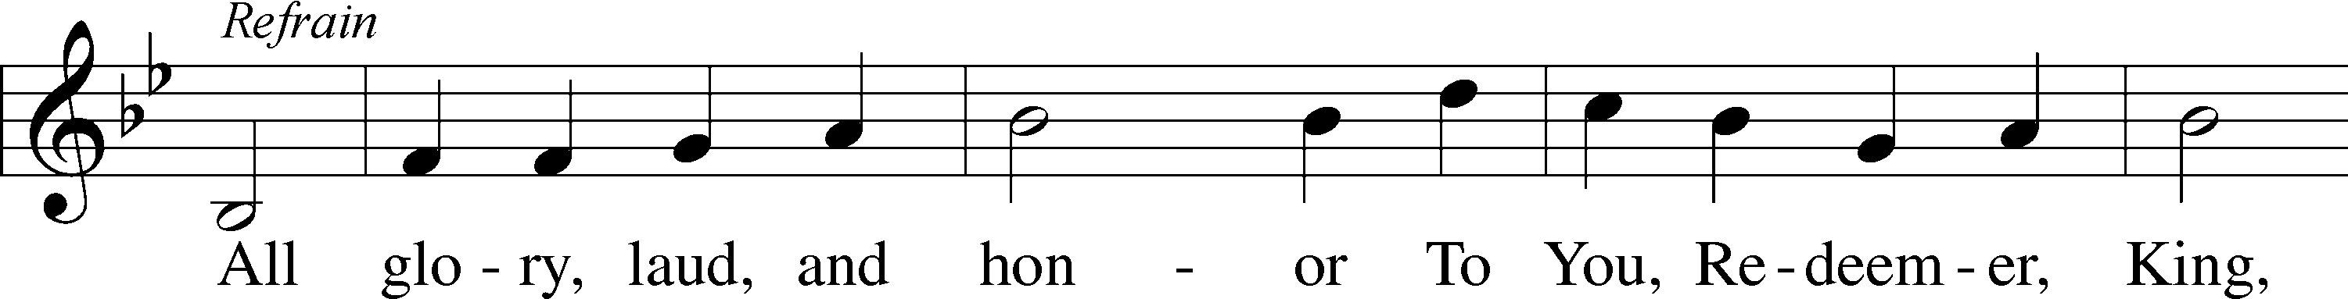

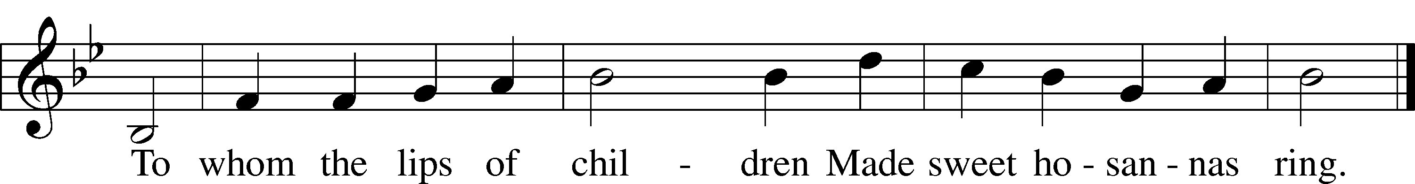

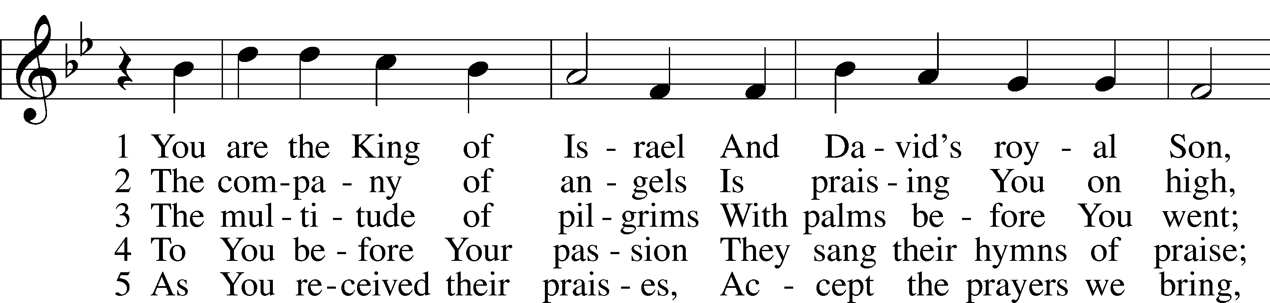

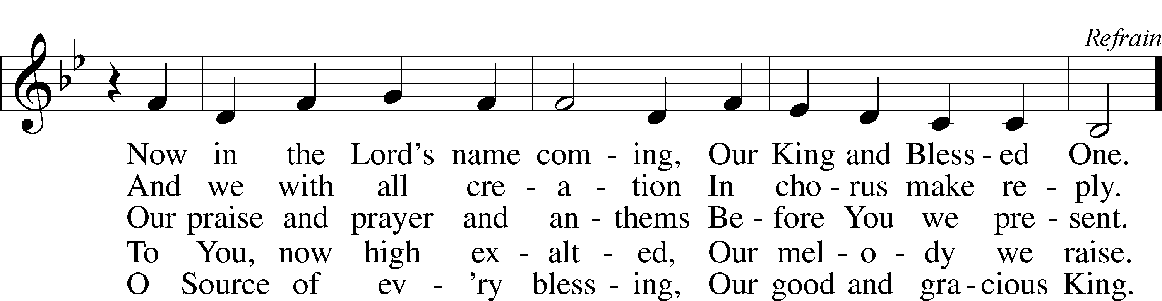

Tune and text: Public domain

P Blessed is He who comes in the name of the Lord.

C **Hosanna in the highest.**

# WORD

Prayer of the Day

P Let us pray.

Almighty and everlasting God, You sent Your Son, our Savior Jesus Christ, to take upon Himself our flesh and to suffer death upon the cross. Mercifully grant that we may follow the example of His great humility and patience and be made partakers of His resurrection; through the same Jesus Christ, our Lord, who lives and reigns with You and the Holy Spirit, one God, now and forever.

C **Amen.**

Old Testament Reading Zechariah 9:9–12

9Rejoice greatly, O daughter of Zion!  
 Shout aloud, O daughter of Jerusalem!  
behold, your king is coming to you;  
 righteous and having salvation is he,  
humble and mounted on a donkey,  
 on a colt, the foal of a donkey.  
10I will cut off the chariot from Ephraim  
 and the war horse from Jerusalem;  
and the battle bow shall be cut off,  
 and he shall speak peace to the nations;  
his rule shall be from sea to sea,  
 and from the River to the ends of the earth.

11As for you also, because of the blood of my covenant with

you, I will set your prisoners free from the waterless pit.  
12Return to your stronghold, O prisoners of hope;  
 today I declare that I will restore to you double.

L This is the Word of the Lord.

C **Thanks be to God.**

Psalm Psalm 118:19–29; antiphon: v. 26

19Open to me the gates of righteousness,  
 **that I may enter through them and give thanks to the Lord.**20This is the gate of the Lord;  
 **the righteous shall enter through it.**21I thank you that you have answered me  
 **and have become my salvation.**22The stone that the builders rejected  
 **has become the cornerstone.**23This is the Lord’s doing;  
 **it is marvelous in our eyes.**24This is the day that the Lord has made;  
 **let us rejoice and be glad in it.**

25Save us, we pray, O Lord!  
 **O Lord, we pray, give us success!**

26Blessèd is he who comes in the name of the Lord!  
 **We bless you from the house of the Lord.**27The Lord is God,  
 **and he has made his light to shine upon us.**Bind the festal sacrifice with cords,  
 **up to the horns of the altar!**

28You are my God, and I will give thanks to you;  
 **you are my God; I will extol you.**29Oh give thanks to the Lord, for he is good;  
 **for his steadfast love endures forever!**

Epistle Philippians 2:5–11

5Have this mind among yourselves, which is yours in Christ Jesus, 6who, though he was in the form of God, did not count equality with God a thing to be grasped, 7but made himself nothing, taking the form of a servant, being born in the likeness of men. 8And being found in human form, he humbled himself by becoming obedient to the point of death, even death on a cross. 9Therefore God has highly exalted him and bestowed on him the name that is above every name, 10so that at the name of Jesus every knee should bow, in heaven and on earth and under the earth, 11and every tongue confess that Jesus Christ is Lord, to the glory of God the Father.

L This is the Word of the Lord.

C **Thanks be to God.**

Verse Philippians 2:8b

He humbled himself by becoming obedient to the point of death, even death on a cross.

Holy Gospel John 12:20–43

P The Passion of our Lord and Savior Jesus Christ according to the Holy Evangelist St. John.

C **Glory to You, O Lord.**

20Now among those who went up to worship at the feast were some Greeks. 21So these came to Philip, who was from Bethsaida in Galilee, and asked him, “Sir, we wish to see Jesus.” 22Philip went and told Andrew; Andrew and Philip went and told Jesus. 23And Jesus answered them, “The hour has come for the Son of Man to be glorified. 24Truly, truly, I say to you, unless a grain of wheat falls into the earth and dies, it remains alone; but if it dies, it bears much fruit. 25Whoever loves his life loses it, and whoever hates his life in this world will keep it for eternal life. 26If anyone serves me, he must follow me; and where I am, there will my servant be also. If anyone serves me, the Father will honor him.

27“Now is my soul troubled. And what shall I say? ‘Father, save me from this hour’? But for this purpose I have come to this hour. 28Father, glorify your name.” Then a voice came from heaven: “I have glorified it, and I will glorify it again.” 29The crowd that stood there and heard it said that it had thundered. Others said, “An angel has spoken to him.” 30Jesus answered, “This voice has come for your sake, not mine. 31Now is the judgment of this world; now will the ruler of this world be cast out. 32And I, when I am lifted up from the earth, will draw all people to myself.” 33He said this to show by what kind of death he was going to die. 34So the crowd answered him, “We have heard from the Law that the Christ remains forever. How can you say that the Son of Man must be lifted up? Who is this Son of Man?” 35So Jesus said to them, “The light is among you for a little while longer. Walk while you have the light, lest darkness overtake you. The one who walks in the darkness does not know where he is going. 36While you have the light, believe in the light, that you may become sons of light.”

When Jesus had said these things, he departed and hid himself from them. 37Though he had done so many signs before them, they still did not believe in him, 38so that the word spoken by the prophet Isaiah might be fulfilled:

“Lord, who has believed what he heard from us,  
 and to whom has the arm of the Lord been revealed?”

39Therefore they could not believe. For again Isaiah said,

40“He has blinded their eyes and hardened their heart,  
lest they see with their eyes, and understand with their heart, and turn, and I would heal them.”

41Isaiah said these things because he saw his glory and spoke of him. 42Nevertheless, many even of the authorities believed in him, but for fear of the Pharisees they did not confess it, so that they would not be put out of the synagogue; 43for they loved the glory that comes from man more than the glory that comes from God.

P This is the Gospel of the Lord.

C **Praise to You, O Christ.**

Children’s Message King and Lord of our Life

532 The Head That Once Was Crowned with Thorns

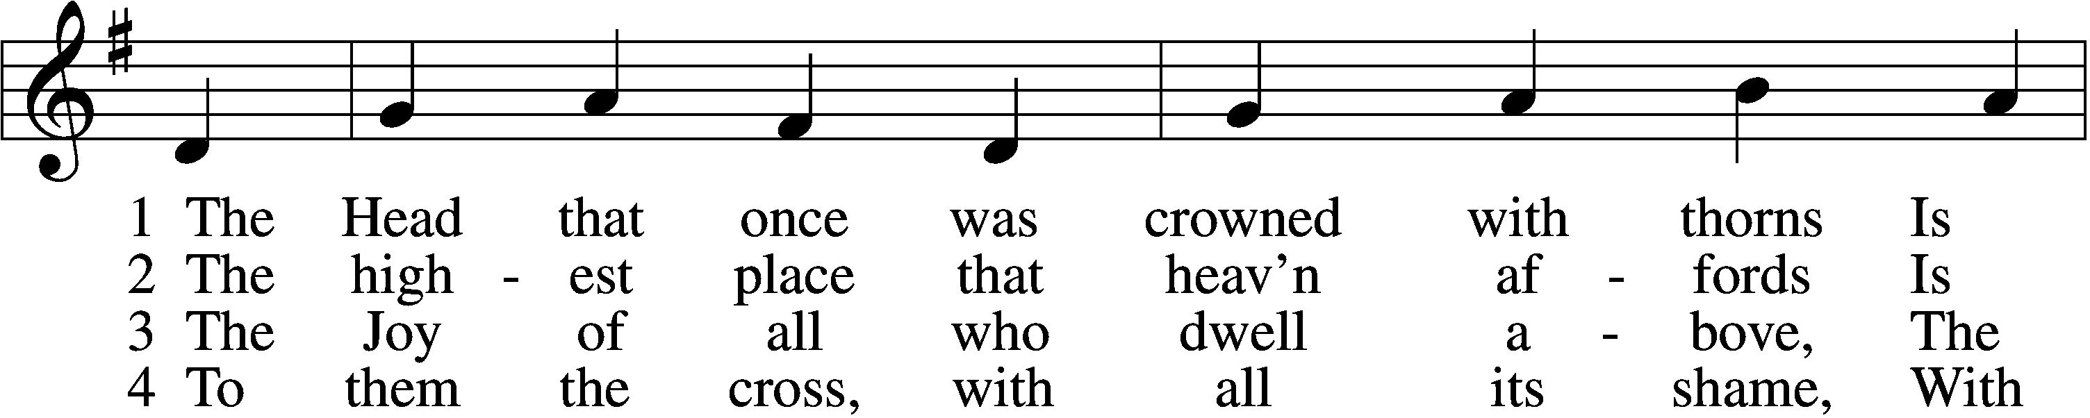

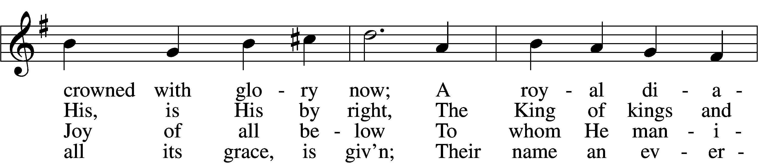

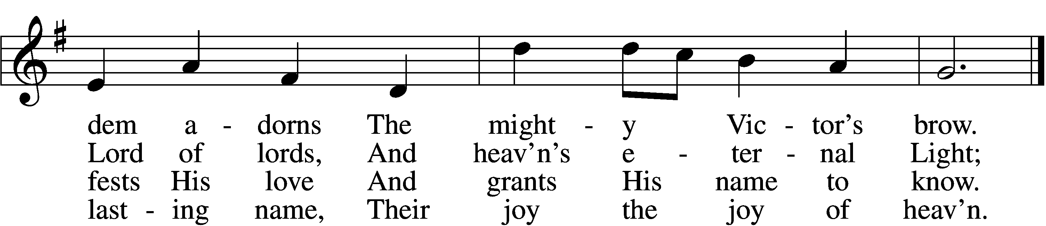

5 They suffer with their Lord below,  
 They reign with Him above,  
Their profit and their joy to know  
 The myst’ry of His love.

6 The cross He bore is life and health,  
 Though shame and death to Him:  
His people’s hope, His people’s wealth,  
 Their everlasting theme.

Text and tune: Public domain

Sermon Jesus Christ is God! (Philippians 2:5-11)

Creed

C **I believe in one God,**

**the Father Almighty,**

**maker of heaven and earth**

**and of all things visible and invisible.**

**And in one Lord Jesus Christ,**

**the only-begotten Son of God,**

**begotten of His Father before all worlds,**

**God of God, Light of Light,**

**very God of very God,**

**begotten, not made,**

**being of one substance with the Father,**

**by whom all things were made;**

**who for us men and for our salvation came down from heaven**

**and was incarnate by the Holy Spirit of the virgin Mary**

**and was made man;**

**and was crucified also for us under Pontius Pilate.**

**He suffered and was buried.**

**And the third day He rose again according to the Scriptures**

**and ascended into heaven**

**and sits at the right hand of the Father.**

**And He will come again with glory to judge both the living and the dead,**

**whose kingdom will have no end.**

**And I believe in the Holy Spirit,**

**the Lord and giver of life,**

**who proceeds from the Father and the Son,**

**who with the Father and the Son together is worshiped and glorified,**

**who spoke by the prophets.**

**And I believe in one holy Christian and apostolic Church,**

**I acknowledge one Baptism for the remission of sins,**

**and I look for the resurrection of the dead**

**and the life** T **of the world to come. Amen.**

Prayer of the Church

P Let us pray for the whole people of God in Christ Jesus and for all people according to their needs.

Almighty God, we give thanks for all Your goodness with which You bless Your whole creation. Above all, however, we give You thanks that You sent Your only-begotten Son into our flesh to be our true King, Your Suffering Servant whose death delivers us and all believers from sin, death, and hell. Give us Your grace that we be faithful in our walk and in our hope, love, and worship. Lord, in Your mercy,

C **hear our prayer.**

P Inspire Your whole Church throughout the world to rightly hear and follow Jesus, our eternal King and Lord, in humble faith with thanksgiving. Give wisdom and grace to all pastors that they give themselves to a living and lively proclamation of Your Law and Gospel through which You work true, saving repentance and faith in many. Lord, in Your mercy,

C **hear our prayer.**

P Give Your grace, forgiveness, wisdom, blessing, and guidance to all who bear the offices of government in our nation and throughout the world. Lead them to the faithful exercise of their authority for peace and justice, and for the defense and liberty of all people, especially the most vulnerable. Lord, in Your mercy,

C **hear our prayer.**

P Give peace, patience, comfort, and healing to all who suffer illness or adversity or who are in need. Deliver all who endure persecution for faith in Christ. Lord, in Your mercy,

C **hear our prayer.**

P We remember with thanksgiving those who have loved and served You in Your Church on earth, who now rest from their labors. Keep us in fellowship with all Your saints and bring us at last to the joys of Your heavenly kingdom. Lord, in Your mercy,

C **hear our prayer.**

P Into Your hands, O Lord, we commend all for whom we pray, trusting in Your mercy; through Your Son, Jesus Christ, our Lord.

C **Amen.**

Offertory

422 On My Heart Imprint Your Image

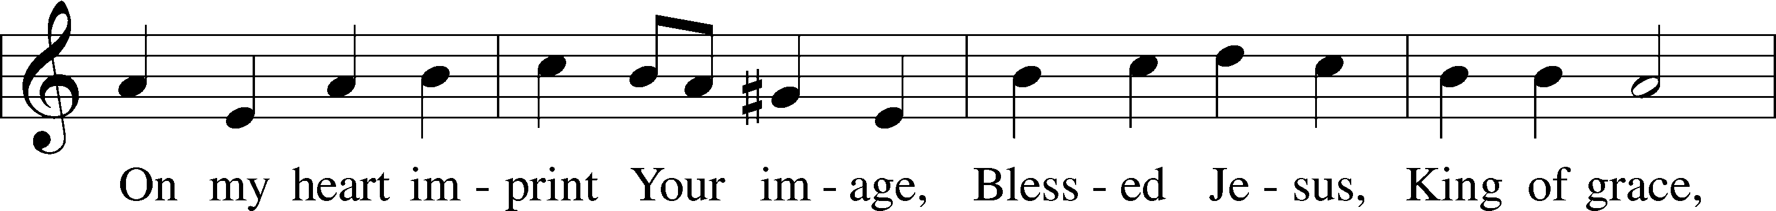

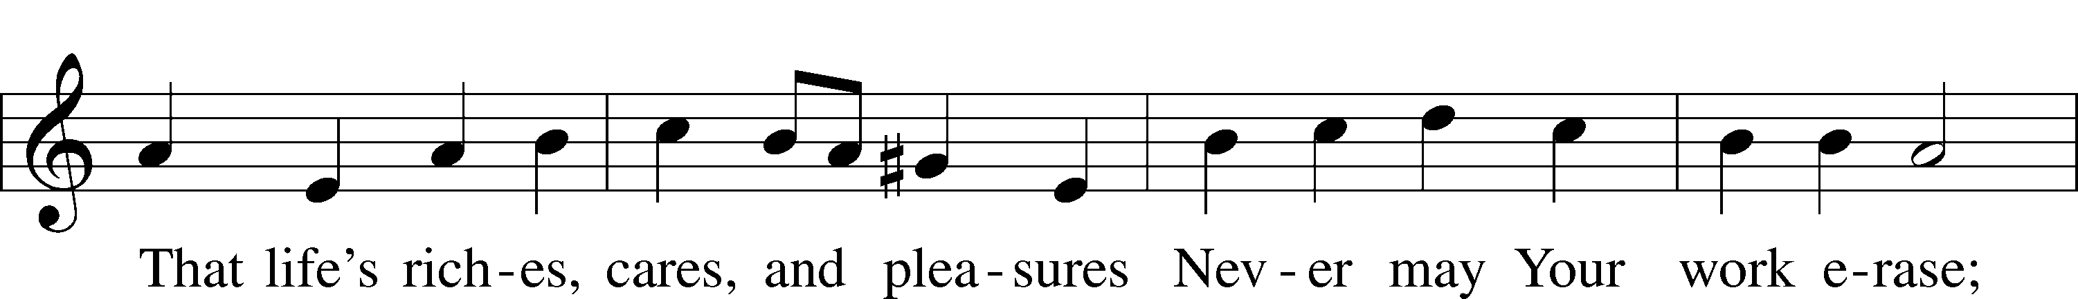

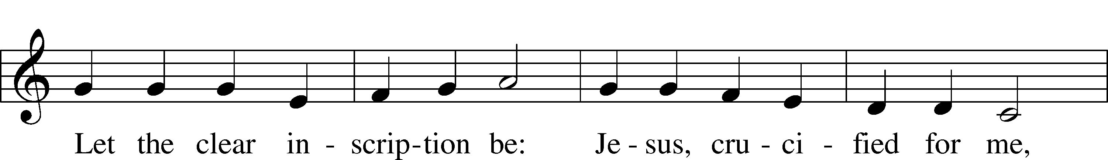

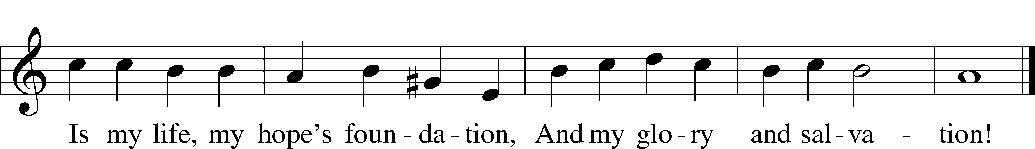

Text and tune: Public domain

# SACRAMENT

Preface and Proper Preface

P The Lord be with you.

C **And also with you.**

P Lift up your hearts.

C **We lift them to the Lord.**

P Let us give thanks to the Lord our God.

C **It is right to give Him thanks and praise.**

P It is truly good, right, and salutary that we should at all times and in all places give thanks to You, holy Lord, almighty Father, everlasting God, through Jesus Christ, our Lord, who accomplished the salvation of mankind by the tree of the cross that, where death arose, there life also might rise again and that the serpent who overcame by the tree of the garden might likewise by the tree of the cross be overcome. Therefore with angels and archangels and with all the company of heaven we laud and magnify Your glorious name, evermore praising You and saying:

961 Sanctus

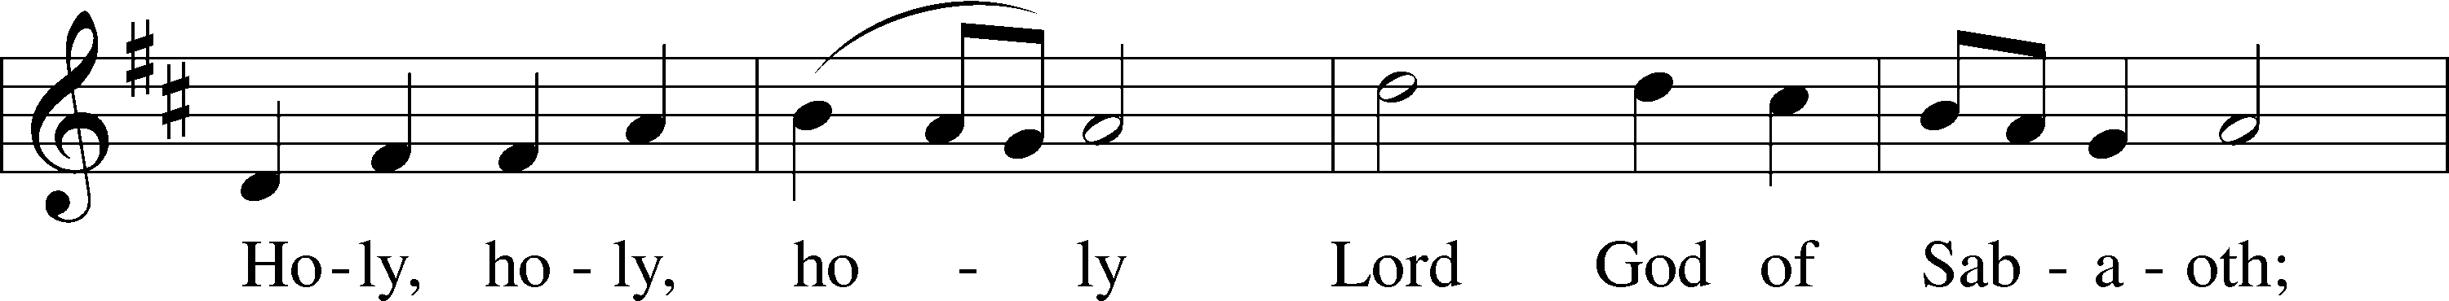

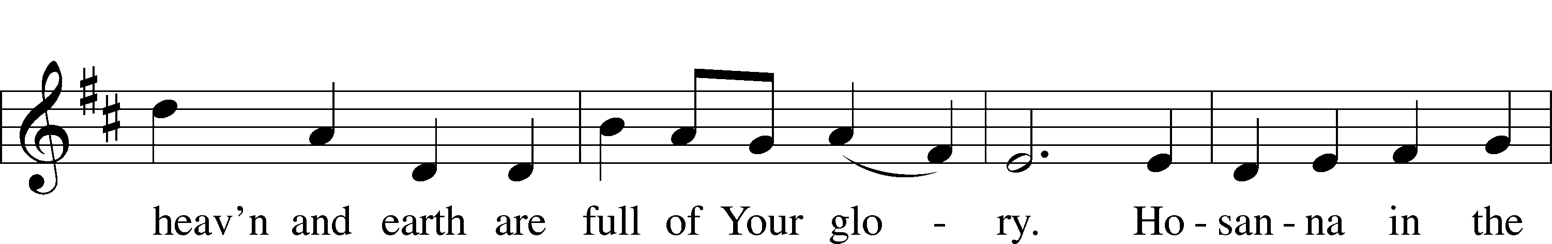

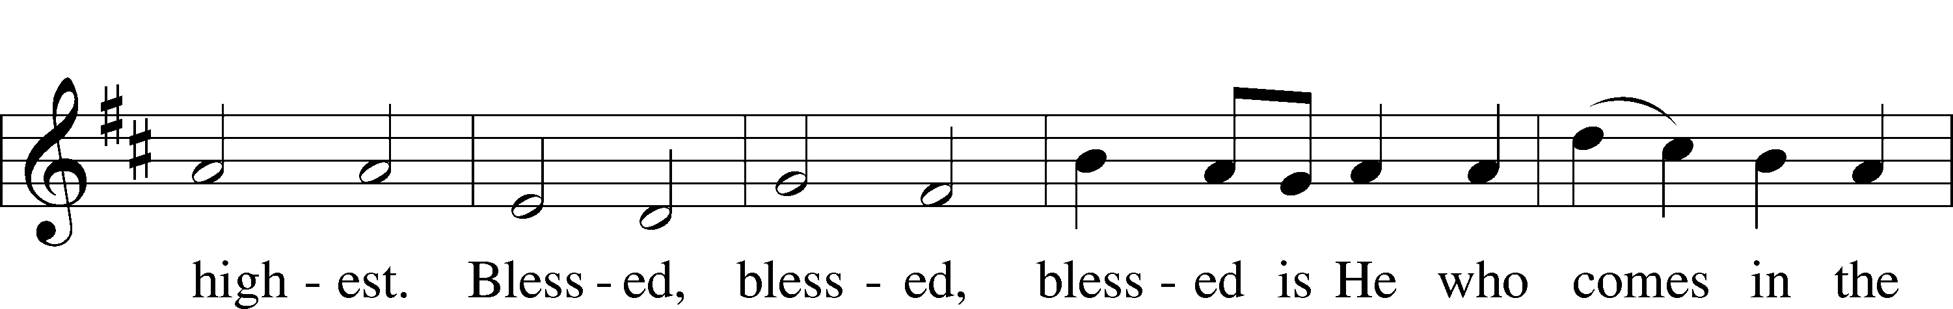

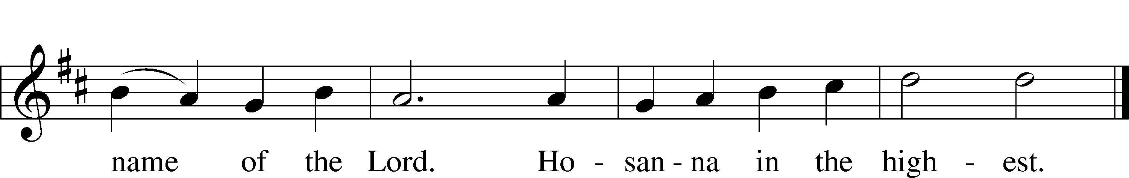

Text: © 1975 International Consultation on English Texts. Used by permission: LSB Hymn License no. 110005047

Tune: © 2006 Concordia Publishing House. Used by permission: LSB Hymn License no. 110005047

Prayer of Thanksgiving

P Blessed are You, Lord of heaven and earth, for You have had mercy on those whom You created and sent Your only-begotten Son into our flesh to bear our sin and be our Savior. With repentant joy we receive the salvation accomplished for us by the all-availing sacrifice of His body and His blood on the cross.

By His triumphant entry into Jerusalem, He reached the goal of His substitutionary death, that by the offering of His own body and blood on the cross, all who believe in Him may share His triumph over sin and death.

We give You thanks for the redemption You have prepared for us through Jesus Christ. Grant us Your Holy Spirit that we may faithfully eat and drink of the fruits of His cross and receive the blessings of forgiveness, life, and salvation that come to us in His body and blood.

C **Amen.**

Words of Our Lord and Proclamation of Christ

P Our Lord Jesus Christ, on the night when He was betrayed, took bread, and when He had given thanks, He broke it and gave it to the disciples and said: “Take, eat; this is My T body, which is given for you. This do in remembrance of Me.”

In the same way also He took the cup after supper, and when He had given thanks, He gave it to them, saying: “Drink of it, all of you; this cup is the new testament in My T blood, which is shed for you for the forgiveness of sins. This do, as often as you drink it, in remembrance of Me.”

P As often as we eat this bread and drink this cup, we proclaim the Lord’s death until He comes.

C **Amen. Come, Lord Jesus.**

P O Lord Jesus Christ, only Son of the Father, in giving us Your body and blood to eat and to drink, You lead us to remember and confess Your holy cross and passion, Your blessed death, Your rest in the tomb, Your resurrection from the dead, Your ascension into heaven, and Your coming for the final judgment. So remember us in Your kingdom and teach us to pray:

Lord's Prayer

C **Our Father who art in heaven,**

**hallowed be Thy name,**

**Thy kingdom come,**

**Thy will be done on earth**

**as it is in heaven;**

**give us this day our daily bread;**

**and forgive us our trespasses**

**as we forgive those who trespass against us;**

**and lead us not into temptation,**

**but deliver us from evil.**

**For Thine is the kingdom**

**and the power and the glory**

**forever and ever. Amen.**

Pax Domini

P The peace of the Lord be with you always.

C **Amen.**

962 Agnus Dei — I

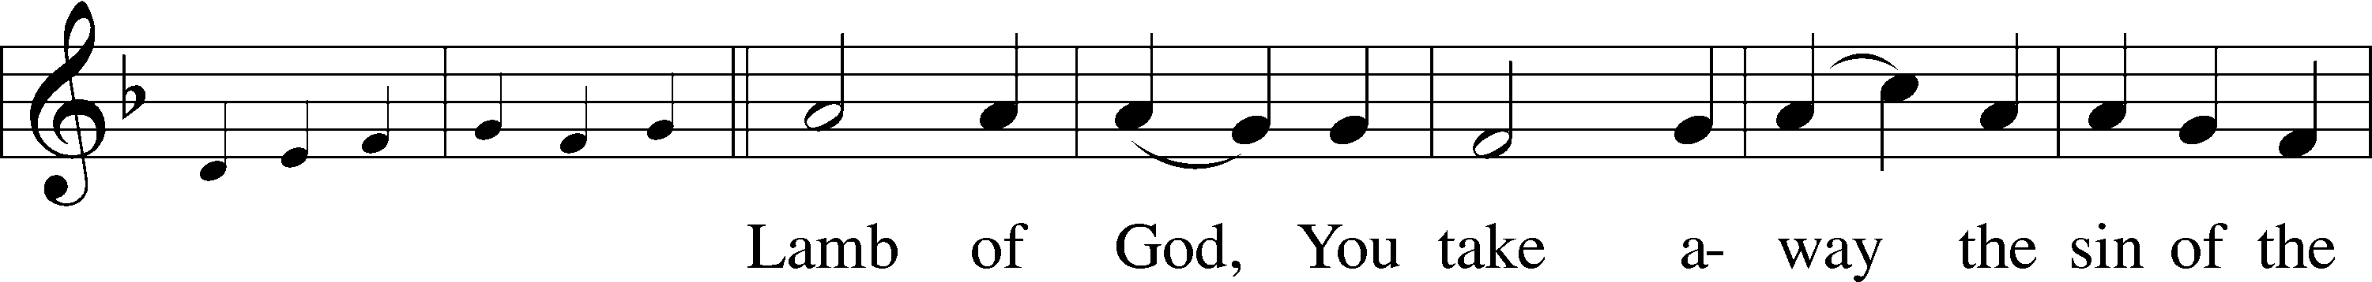

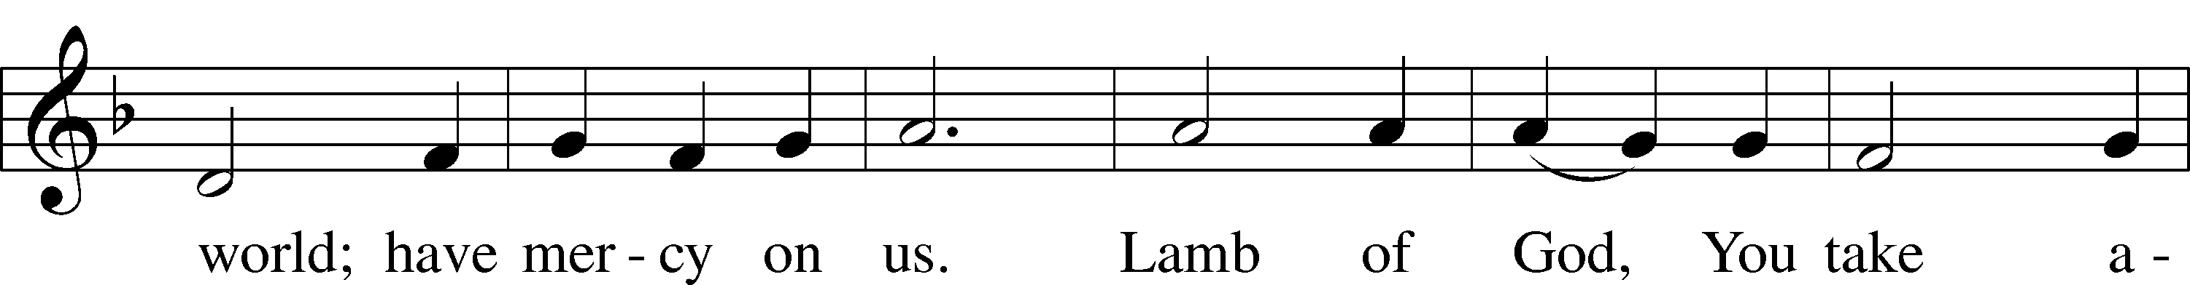

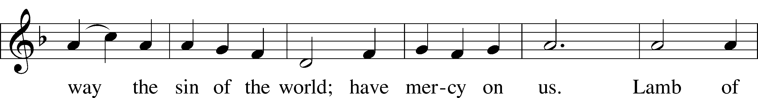

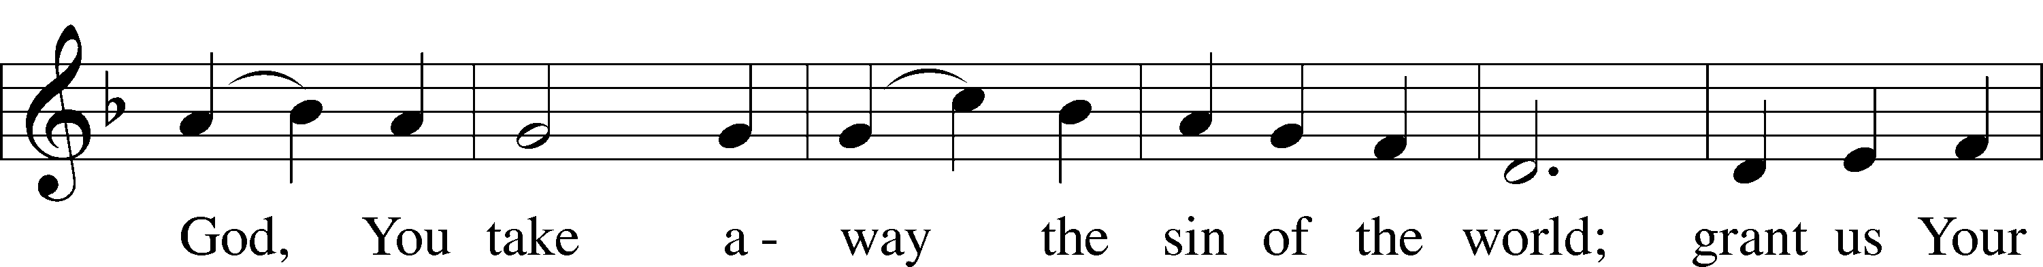

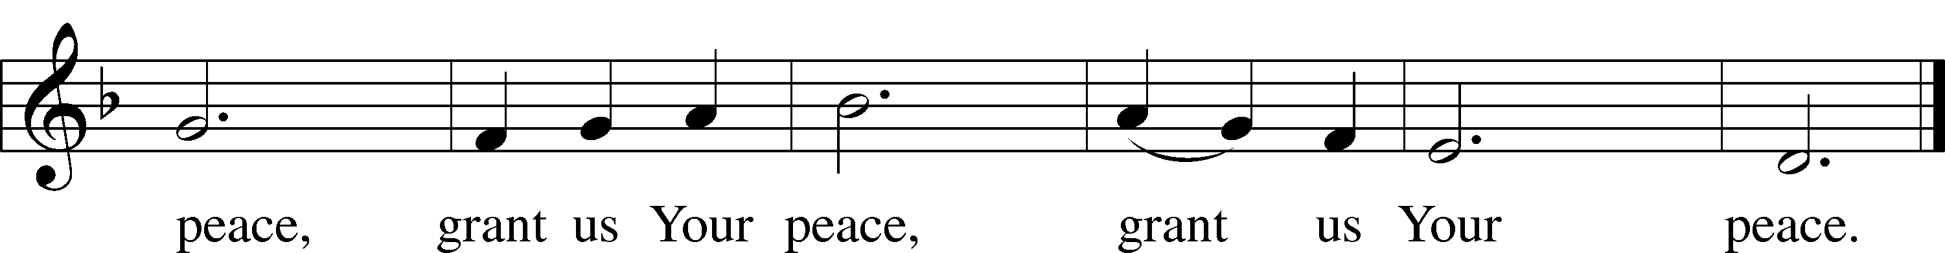

Text: © 1975 International Consultation on English Texts. Used by permission: LSB Hymn License no. 110005047

Tune: © 2001 Paul D. Weber. Used by permission: LSB Hymn License no. 110005047

Distribution

# Distribution Hymns

455 The Royal Banners Forward Go

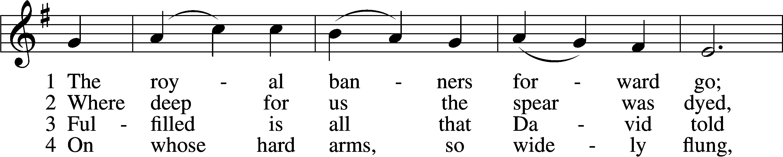

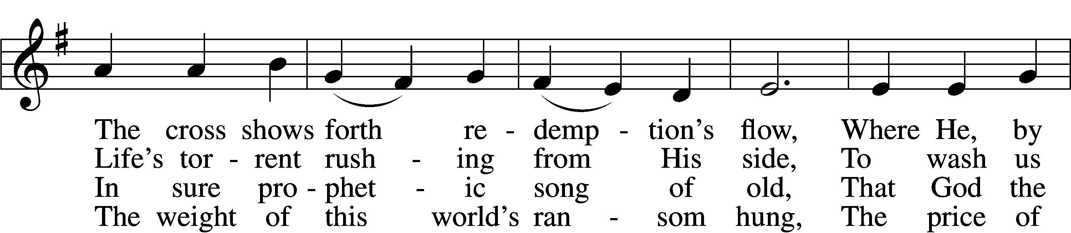

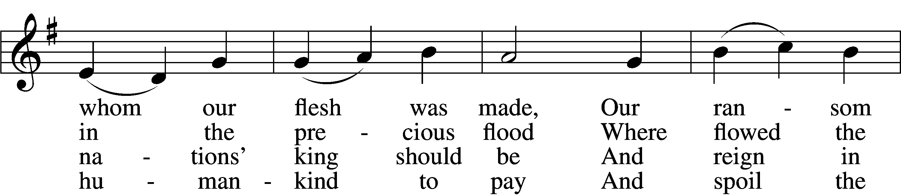

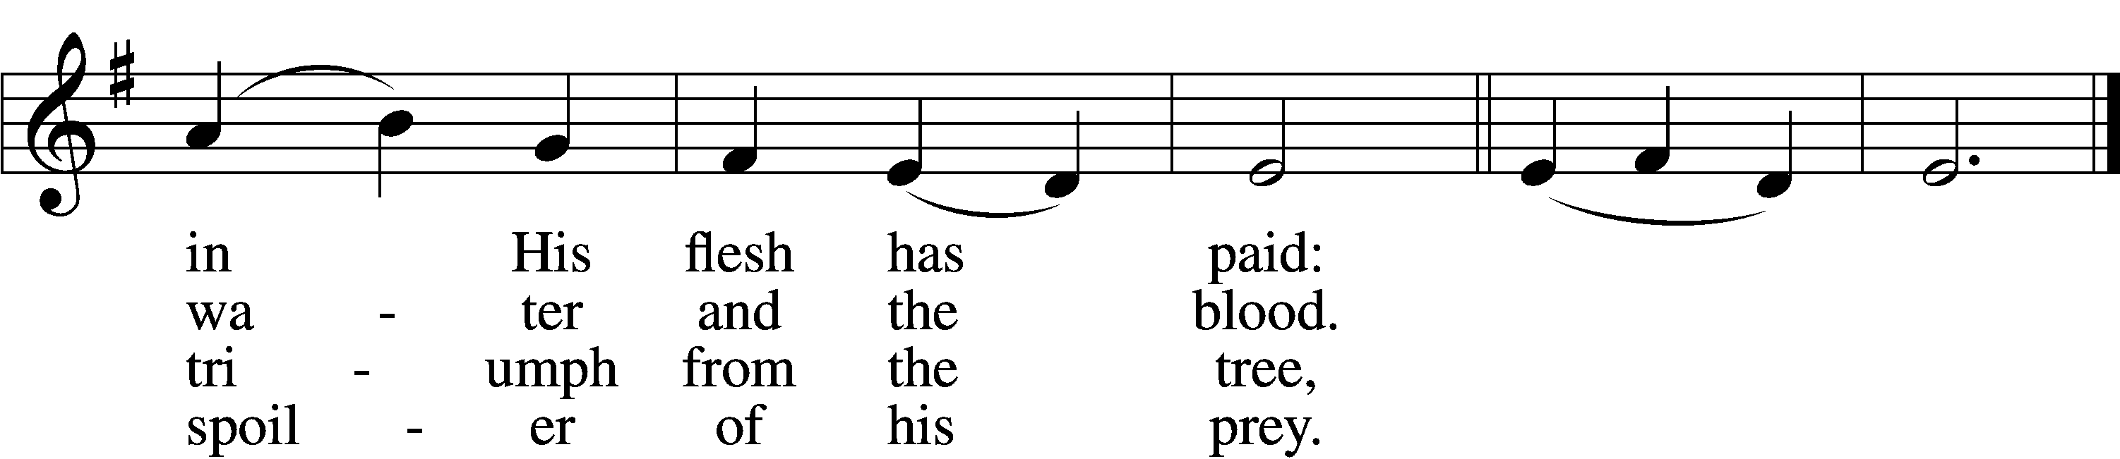

5 O tree of beauty, tree most fair,  
Ordained those holy limbs to bear:  
Gone is thy shame, each crimsoned bough  
Proclaims the King of Glory now.

D 6 To Thee, eternal Three in One,  
Let homage meet by all be done;  
As by the cross Thou dost restore,  
So guide and keep us evermore.  
Amen.

Tune: © 2003 Paul D. Weber. Used by permission: LSB Hymn License no. 110005047

Text: Public domain

628 Your Table I Approach

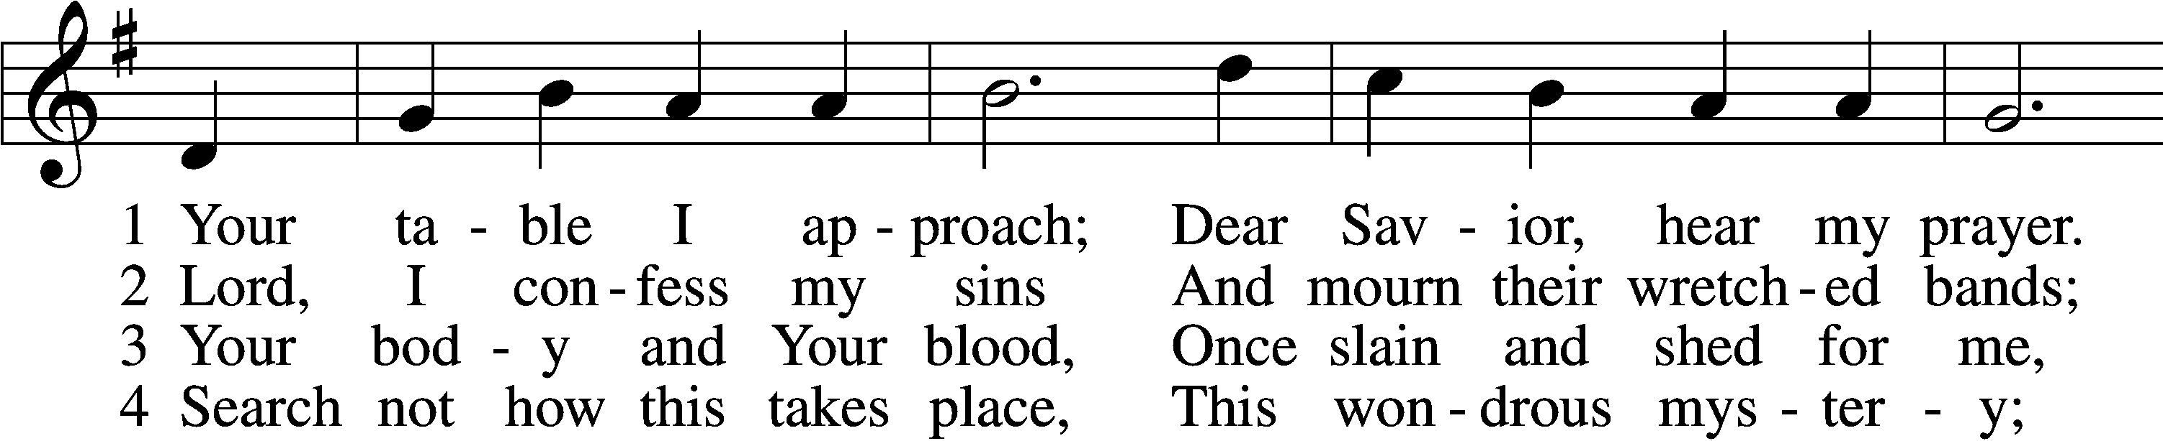

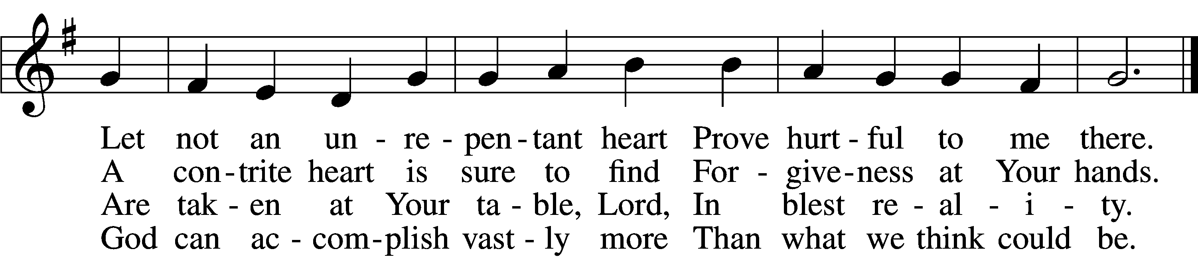

5 O grant, most blessèd Lord,  
 That earth and hell combined  
May not about this sacrament  
 Raise doubt within my mind.

6 Oh, may I never fail  
 To thank You day and night  
For Your true body and true blood,  
 O God, my peace and light.

Text and tune: Public domain

Dissmisal and Blessing

937 Lord, Bid Your Servant Go in Peace

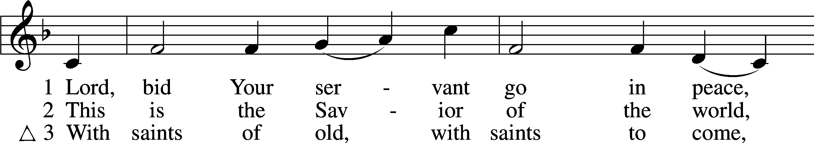

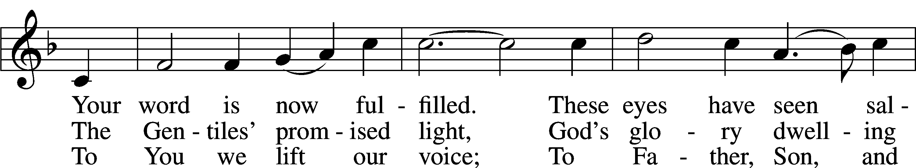

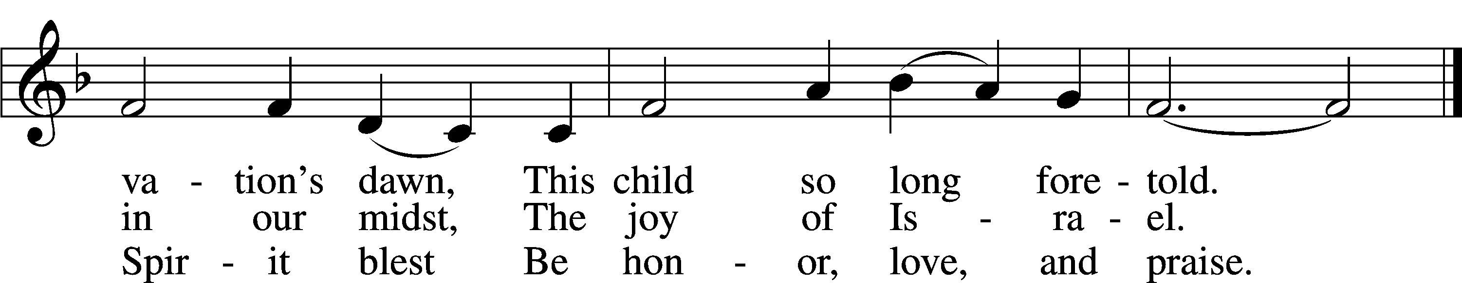

Text (sts. 1–2): © 1969, 1989 OCP Publications; (st. 3): © 2006 Concordia Publishing House. Used by permission: LSB Hymn License no. 110005047

Tune: Public domain

Post-Communion Thanksgiving and Benediction

P Let us pray.  
We give thanks to You, almighty God, for the gift of forgiveness won by Your Son’s offering on the cross and for the strengthening of our souls and bodies by His body and blood. Go with us now, and keep us steadfast in Your Word through the blessed days of this great and Holy Week and to our eternal life with Him, who lives and reigns with You and the Holy Spirit, one God, now and forever.

C **Amen.**

P The Lord bless you and keep you.

The Lord make His face shine on you and be gracious to you.

The Lord look upon you with favor and T give you peace.

C **Amen.**

441 Ride On, Ride On in Majesty

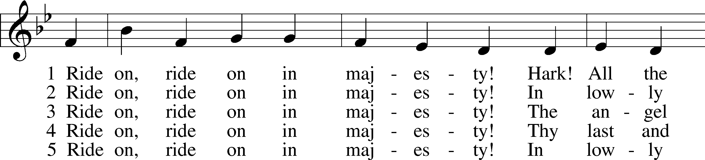

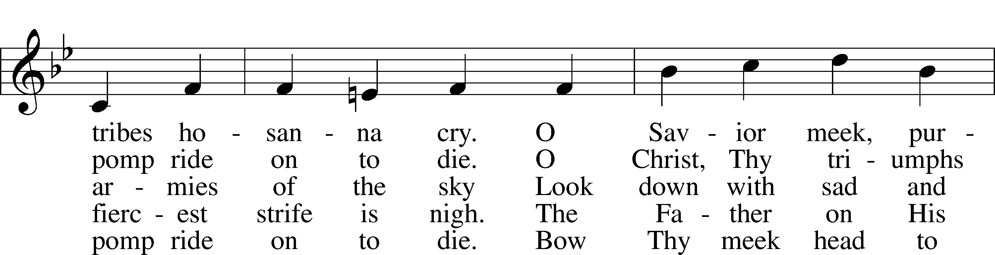

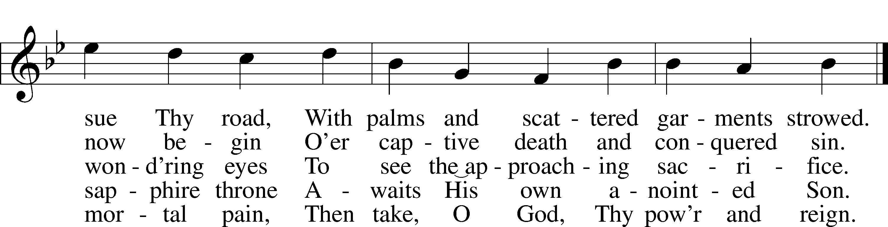

Tune and text: Public domain

Creative Worship for the Lutheran Parish, Series B, Quarter 2. Copyright © 2020 Concordia Publishing House. All rights reserved. Used by permission.

Acknowledgments

Unless otherwise indicated, Scripture quotations are from the ESV® Bible (The Holy Bible, English Standard Version®), copyright © 2001 by Crossway, a publishing ministry of Good News Publishers. Used by permission. All rights reserved.

Created by Lutheran Service Builder © 2021 Concordia Publishing House.

**March 28**“Good Friday shows us—in case there was any doubt before—that something is wrong with the world, something worth mourning deeply … There will be a time when God wipes all of these tears from our eyes. We are not there yet, but we can surely take heart in the knowledge that God is close to the brokenhearted.” *Derek Caldwell – A Life Quote from Lutherans For Life • lutheransforlife.org*

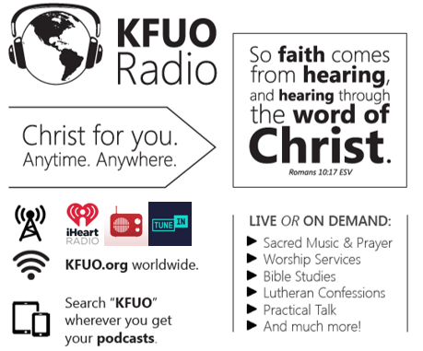

**This week on KFUO.org,**join us for Tre Ore service from 12:00 – 3:00 p.m. CT on Good Friday 4/2, hear special Maundy Thursday edition of Joy! on 4/1 and Good Friday edition on 4/2 at 1:00 p.m. CT, and begin studying 1 Thessalonians on Thy Strong Word (weekdays at 11:00 a.m. CT). Find programs on demand at kfuo.org or wherever you get your podcasts.

**Gifts of Time and Treasure**

*“And my God will meet all your needs according to His glorious*

*riches in Christ Jesus.”*  ***Philippians 4:19***

**LAST WEEK’S OFFERINGS**  **LAST WEEK’S ATTENDANCE**

**Lent 3/17** $ **242.00 15**

General Fund $ 3,235.27 Service 56

Needed Weekly $ 4,669.00 Communed 43

Adult Bible Study $ 7.00

Children’s SS/Mission $ 14.00

Benevolence fund $ 15.00

**The Lord’s Week**

Today 8:45 am – Bible Studies for all ages

**(Mar. 28th)** 10:00 am – Divine Service

11:30 am – Confirmation

Thursday 7:00 pm – **Maundy Thursday**

Friday 7:00 pm – **Tenebrae Service**

Next Sunday **7:00 am** – **Sunrise Service**

**(Apr. 4st)** 8:45 am – Bible Studies for all ages

10:00 am – **Easter Sunday Service**

– Egg Hunt following the Service

**In His Service**

Elder: Jim Bounds

Usher:

Acolytes: Whitney Larson

Organist: Sharon Shrader

Alter: Devereaux Brewer

Flowers: