Third Sunday in Lent
Divine Service, Setting Three
“Christ Crucified!”
1 Corinthians 1:18-31

March 7, 2021

Messiah Lutheran Church
Lutheran Church-Missouri Synod
4102 Trinity River Dr., Corpus Christi, Texas 78410

Pastor: Rev. Scott E. Herbert

Church Phone: 361-387-7748 Email: mlc@stx.rr.com
Church Fax: 361-767-1768 Website: www.messiahlcms-cc.org
Pastor Phone: 469-693-9683 Pastor Email: chirev59@gmail.com

WELCOME TO MESSIAH!
We are glad you are here to receive what God is doing for you during Divine Service. Please fill out a guest card located in your bulletin or sign the Guest Book near the front door. Feel free to converse quietly until the organ prelude begins. If you are looking for a church home, please talk to the Pastor at the door. We would love to have you join us.

Preparing for Service
The Crucified and Risen Body of Jesus Is the True Temple of the Lord

The Lord rescues His people, Israel, “out of the land of Egypt, out of the house of slavery” (Ex. 20:2) and makes His gracious covenant with them, defined by the Ten Commandments. Since He has become their God by His grace, they shall be His people, having “no other gods” before Him (Ex. 20:3). He is “jealous” for them as a husband for his wife and as a father for his children. He has named them with His name and called them to rest in Him (Ex. 20:5–9). The incarnate Son, Christ Jesus, is likewise jealous for His Father’s house, because it is to be a place of divine grace and Sabbath rest for His people, and not “a house of trade” (John 2:16–17). His zeal consumes Him as He gives up “the temple of his body” to the destruction of the cross, but in three days He raises it up again to be the true temple forever (John 2:17–21). By His crucifixion He cleanses the entire household, and in His resurrection, He becomes “wisdom from God, righteousness and sanctification and redemption” (1 Cor. 1:30).
DIVINE SERVICE Setting Three
Confession and Absolution

427 In the Cross of Christ I Glory
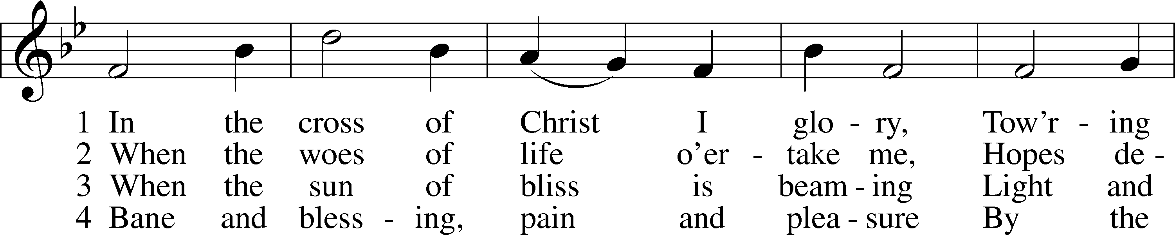
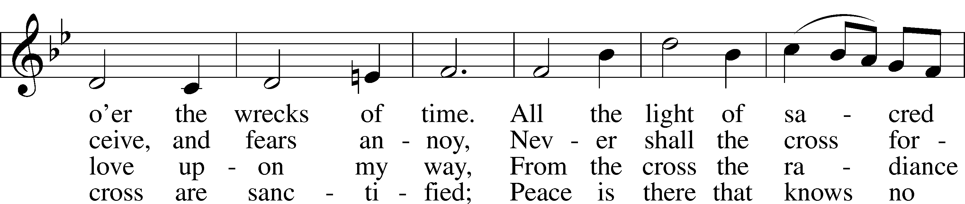
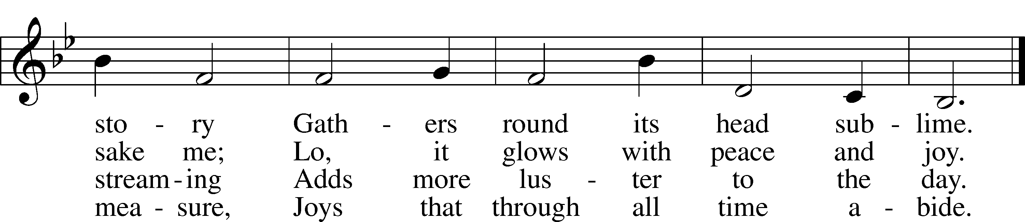
Tune and text: Public domain

P In the name of the Father and of the T Son and of the Holy Spirit.
C Amen.

P Beloved in the Lord! Let us draw near with a true heart and confess our sins unto God our Father, beseeching Him in the name of our Lord Jesus Christ to grant us forgiveness.

P Our help is in the name of the Lord,
C who made heaven and earth.
P I said, I will confess my transgressions unto the Lord,
C and You forgave the iniquity of my sin.

P O almighty God, merciful Father,

C I, a poor, miserable sinner, confess unto You all my sins and iniquities with which I have ever offended You and justly deserved Your temporal and eternal punishment. But I am heartily sorry for them and sincerely repent of them, and I pray You of Your boundless mercy and for the sake of the holy, innocent, bitter sufferings and death of Your beloved Son, Jesus Christ, to be gracious and merciful to me, a poor, sinful being.

P Upon this your confession, I, by virtue of my office, as a called and ordained servant of the Word, announce the grace of God unto all of you, and in the stead and by the command of my Lord Jesus Christ I forgive you all your sins in the name of the Father and of the T Son and of the Holy Spirit.
C Amen.

Service of the Word
Introit Psalm 69:14–16; antiphon: v. 9
For zeal for your house has consumed me,
and the reproaches of those who reproach you have fallen on me.
Deliver me from sinking in the mire;
let me be delivered from my enemies and from the deep waters.
Let not the flood sweep over me, or the deep swallow me up,
or the pit close its mouth over me.
Answer me, O Lord, for your steadfast love is good;
according to your abundant mercy, turn to me.
For zeal for your house has consumed me,
and the reproaches of those who reproach you have fallen on me.

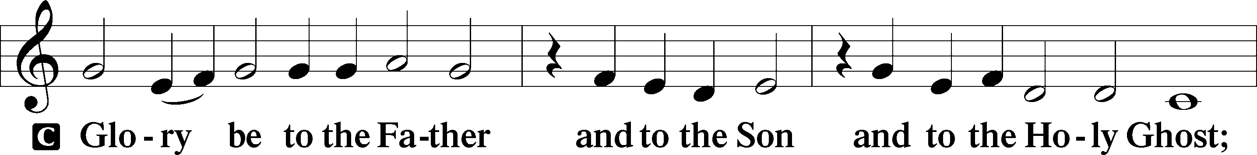
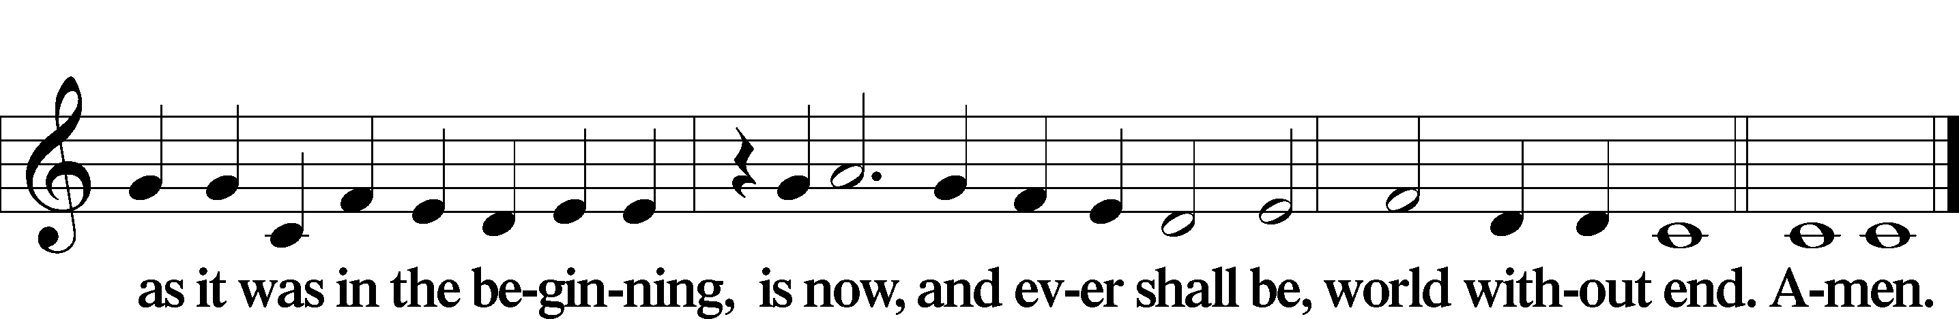

Kyrie LSB 186
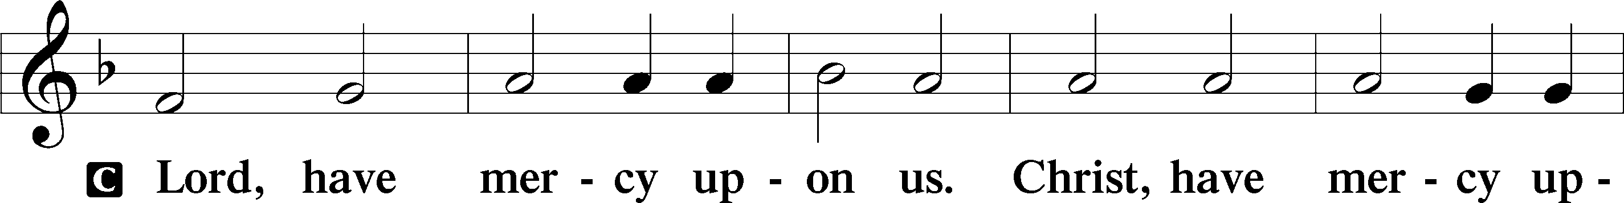
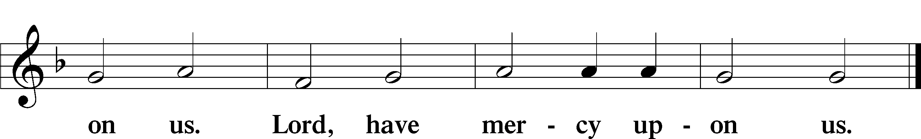

Salutation and Collect of the Day
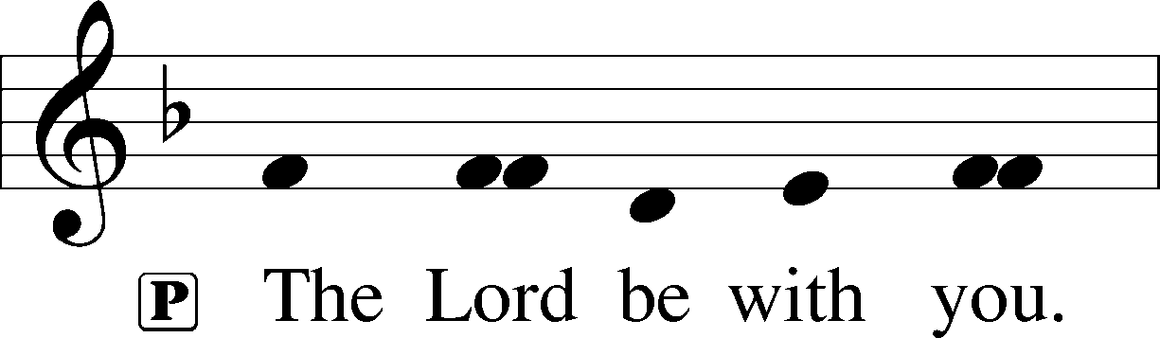
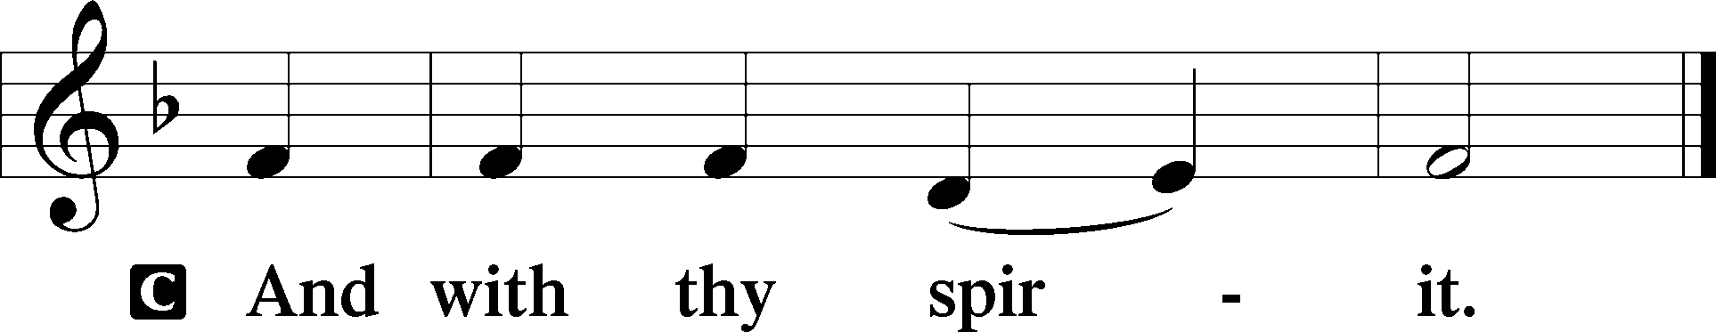

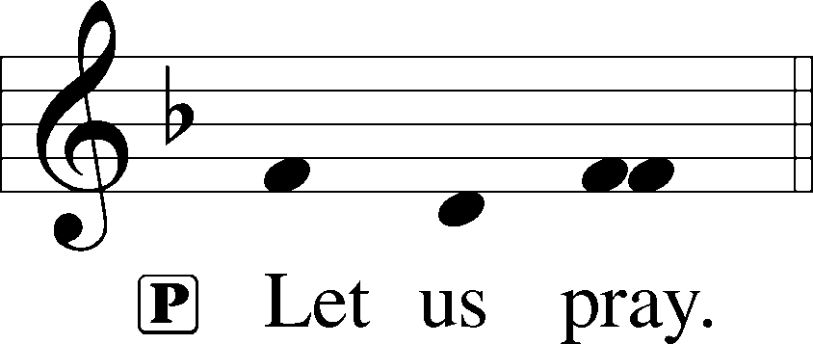

P O God, whose glory it is always to have mercy, be gracious to all who have gone astray from Your ways and bring them again with penitent hearts and steadfast faith to embrace and hold fast the unchangeable truth of Your Word; through Jesus Christ, Your Son, our Lord, who lives and reigns with You and the Holy Spirit, one God, now and forever.

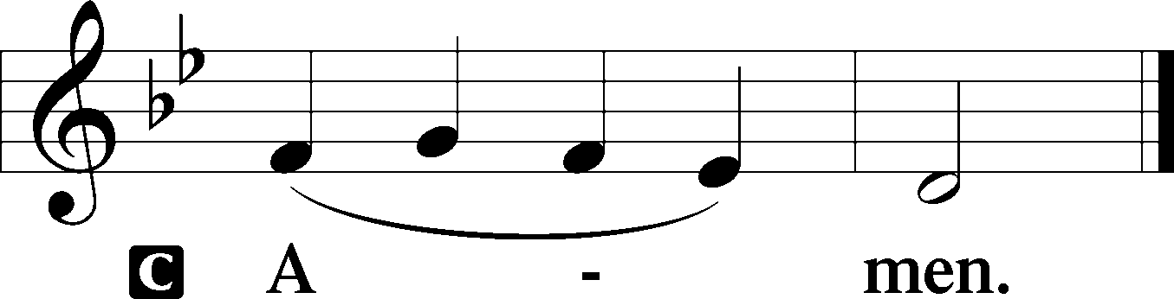

Old Testament Reading Exodus 20:1–17
1And God spoke all these words, saying,
2“I am the Lord your God, who brought you out of the land of Egypt, out of the house of slavery.
3“You shall have no other gods before me.
4“You shall not make for yourself a carved image, or any likeness of anything that is in heaven above, or that is in the earth beneath, or that is in the water under the earth. 5You shall not bow down to them or serve them, for I the Lord your God am a jealous God, visiting the iniquity of the fathers on the children to the third and the fourth generation of those who hate me, 6but showing steadfast love to thousands of those who love me and keep my commandments.
7“You shall not take the name of the Lord your God in vain, for the Lord will not hold him guiltless who takes his name in vain.
8“Remember the Sabbath day, to keep it holy. 9Six days you shall labor, and do all your work, 10but the seventh day is a Sabbath to the Lord your God. On it you shall not do any work, you, or your son, or your daughter, your male servant, or your female servant, or your livestock, or the sojourner who is within your gates. 11For in six days the Lord made heaven and earth, the sea, and all that is in them, and rested the seventh day. Therefore the Lord blessed the Sabbath day and made it holy.
12“Honor your father and your mother, that your days may be long in the land that the Lord your God is giving you.
13“You shall not murder.
14“You shall not commit adultery.
15“You shall not steal.
16“You shall not bear false witness against your neighbor.
17“You shall not covet your neighbor’s house; you shall not covet your neighbor’s wife, or his male servant, or his female servant, or his ox, or his donkey, or anything that is your neighbor’s.”

A This is the Word of the Lord.
C Thanks be to God.
Epistle 1 Corinthians 1:18–31
18The word of the cross is folly to those who are perishing, but to us who are being saved it is the power of God. 19For it is written,
“I will destroy the wisdom of the wise,
and the discernment of the discerning I will thwart.”
20Where is the one who is wise? Where is the scribe? Where is the debater of this age? Has not God made foolish the wisdom of the world? 21For since, in the wisdom of God, the world did not know God through wisdom, it pleased God through the folly of what we preach to save those who believe. 22For Jews demand signs and Greeks seek wisdom, 23but we preach Christ crucified, a stumbling block to Jews and folly to Gentiles, 24but to those who are called, both Jews and Greeks, Christ the power of God and the wisdom of God. 25For the foolishness of God is wiser than men, and the weakness of God is stronger than men.
26For consider your calling, brothers: not many of you were wise according to worldly standards, not many were powerful, not many were of noble birth. 27But God chose what is foolish in the world to shame the wise; God chose what is weak in the world to shame the strong; 28God chose what is low and despised in the world, even things that are not, to bring to nothing things that are, 29so that no human being might boast in the presence of God. 30He is the source of your life in Christ Jesus, whom God made our wisdom and our righteousness and sanctification and redemption. 31Therefore, as it is written, “Let the one who boasts, boast in the Lord.”

A This is the Word of the Lord.
C Thanks be to God.

Holy Gospel John 2:13–22
P The Holy Gospel according to St. John, the second chapter.

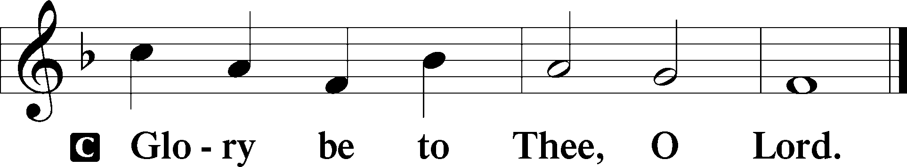
13The Passover of the Jews was at hand, and Jesus went up to Jerusalem. 14In the temple he found those who were selling oxen and sheep and pigeons, and the money-changers sitting there. 15And making a whip of cords, he drove them all out of the temple, with the sheep and oxen. And he poured out the coins of the money-changers and overturned their tables. 16And he told those who sold the pigeons, “Take these things away; do not make my Father’s house a house of trade.” 17His disciples remembered that it was written, “Zeal for your house will consume me.”
18So the Jews said to him, “What sign do you show us for doing these things?” 19Jesus answered them, “Destroy this temple, and in three days I will raise it up.” 20The Jews then said, “It has taken forty-six years to build this temple, and will you raise it up in three days?” 21But he was speaking about the temple of his body. 22When therefore he was raised from the dead, his disciples remembered that he had said this, and they believed the Scripture and the word that Jesus had spoken.

P This is the Gospel of the Lord.

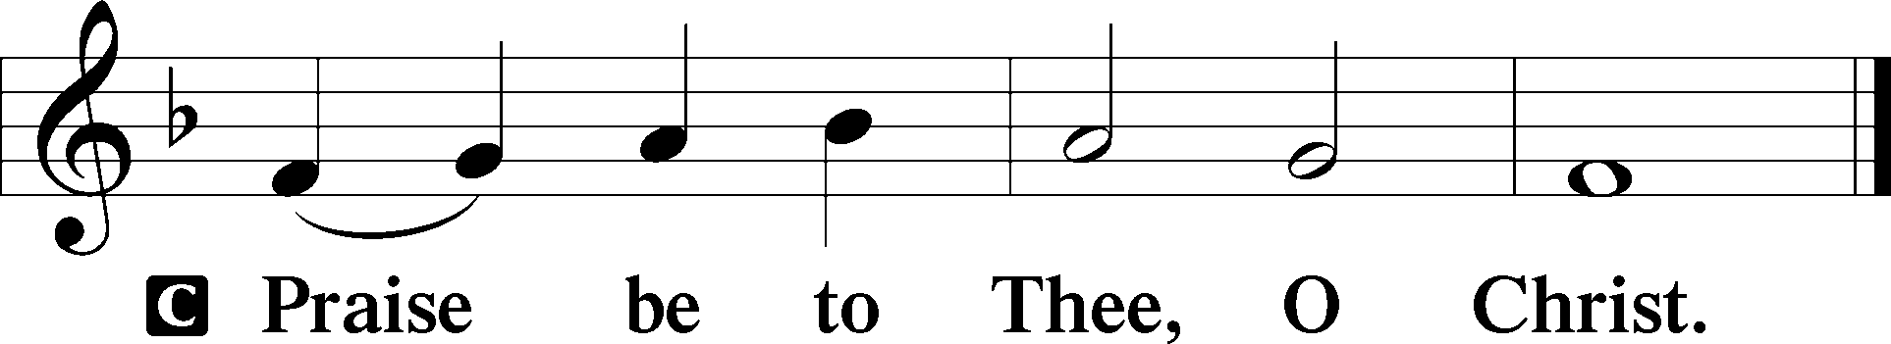

Nicene Creed
C I believe in one God,
the Father Almighty,
maker of heaven and earth
and of all things visible and invisible.

And in one Lord Jesus Christ,
the only-begotten Son of God,
begotten of His Father before all worlds,
God of God, Light of Light,
very God of very God,
begotten, not made,
being of one substance with the Father,
by whom all things were made;
who for us men and for our salvation came down from heaven
and was incarnate by the Holy Spirit of the virgin Mary
and was made man;
and was crucified also for us under Pontius Pilate.
He suffered and was buried.
And the third day He rose again according to the Scriptures
and ascended into heaven
and sits at the right hand of the Father.
And He will come again with glory to judge both the living and the dead,
whose kingdom will have no end.

And I believe in the Holy Spirit,
the Lord and giver of life,
who proceeds from the Father and the Son,
who with the Father and the Son together is worshiped and glorified,
who spoke by the prophets.
And I believe in one holy Christian and apostolic Church,
I acknowledge one Baptism for the remission of sins,
and I look for the resurrection of the dead
and the life T of the world to come. Amen.

Children’s Message Guidance from God

428 Cross of Jesus, Cross of Sorrow
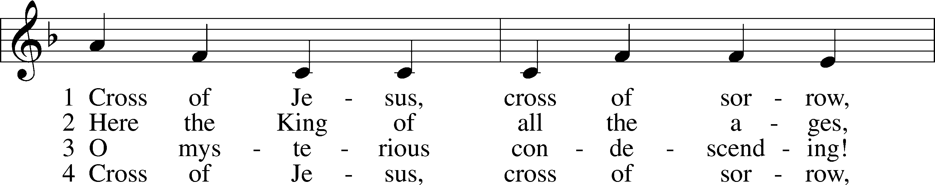
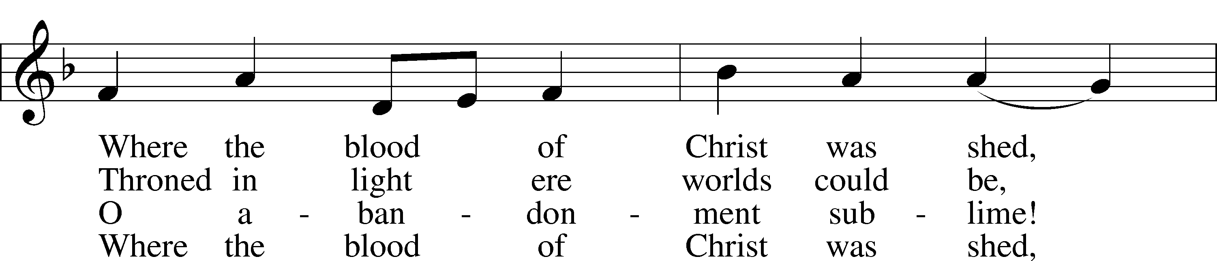
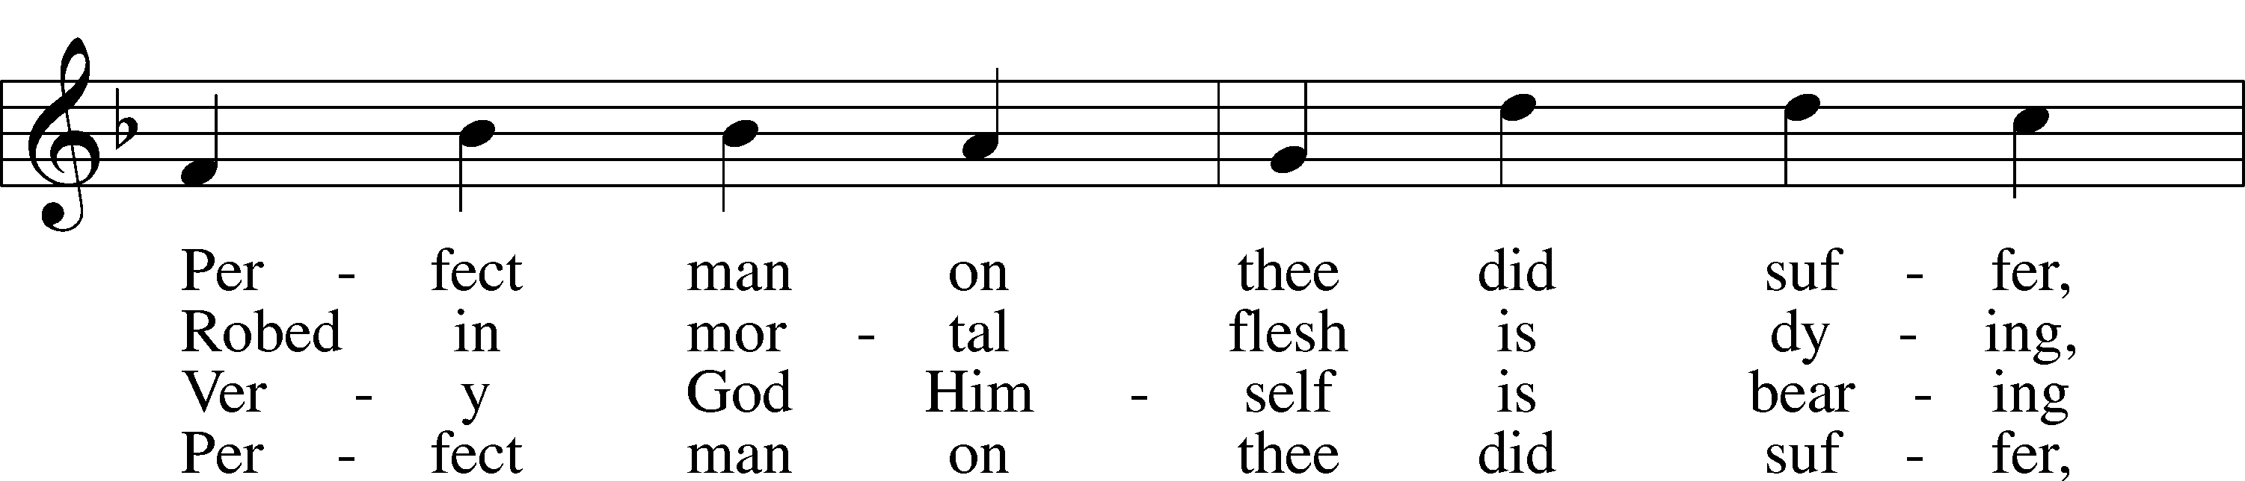
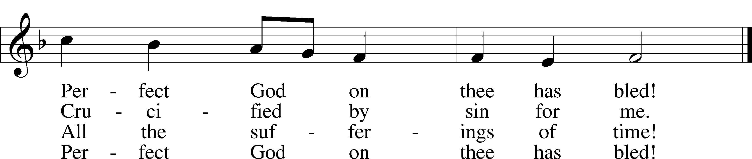
Tune and text: Public domain

Sermon Christ Crucified! (1 Corinthians 1:18-31)

P The peace of God, which passes all understanding, keep your hearts and minds in Christ Jesus.
C Amen.

Offertory LSB 192
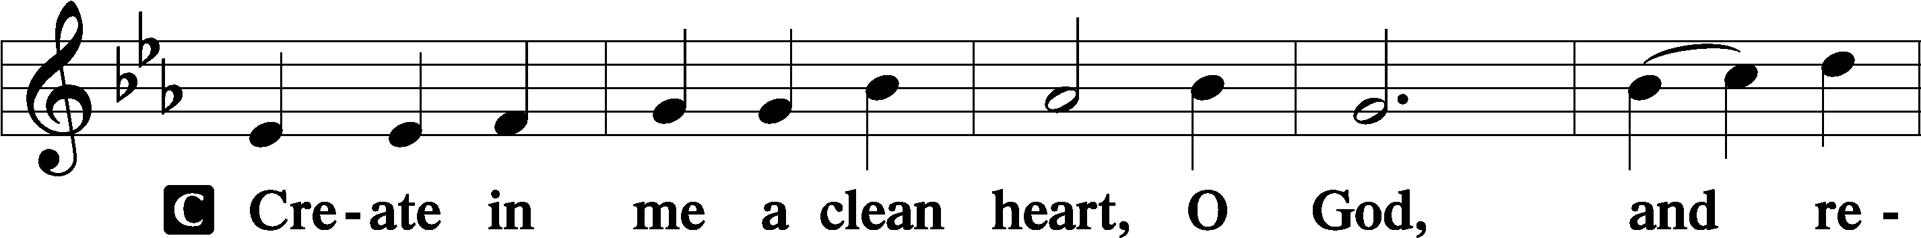
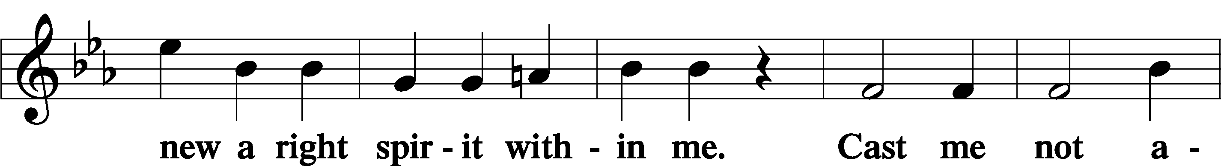
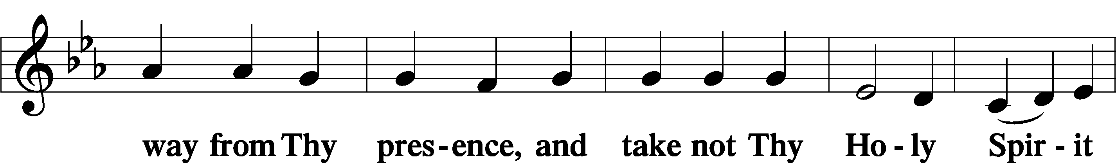
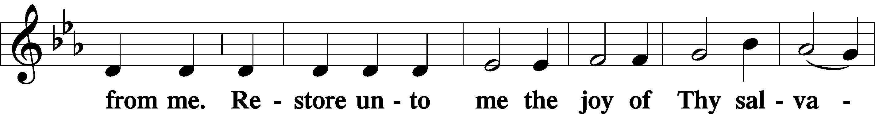
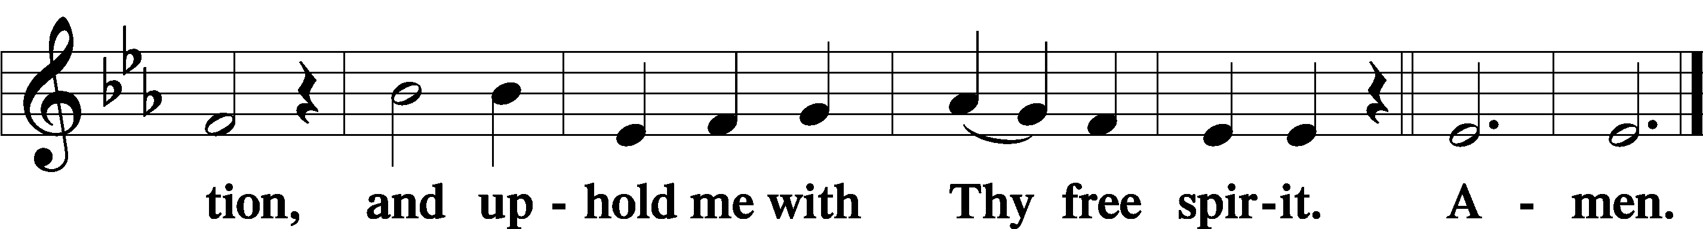

Prayer of the Church

Service of the Sacrament
Preface LSB 194
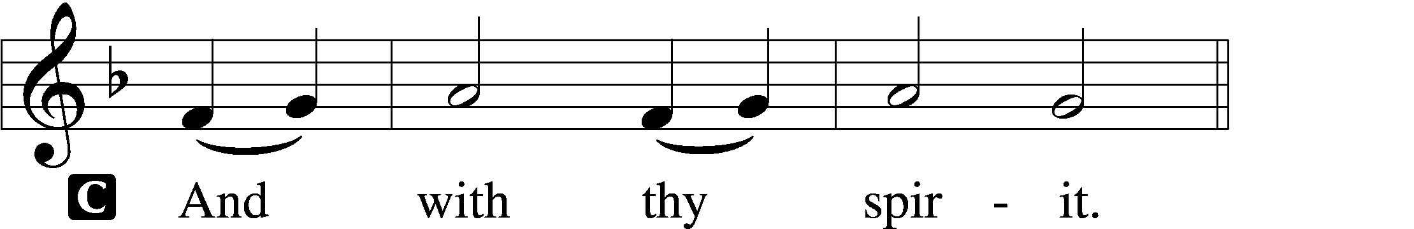

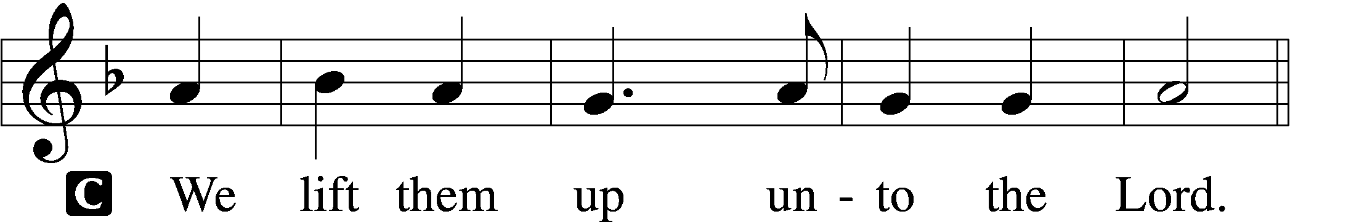

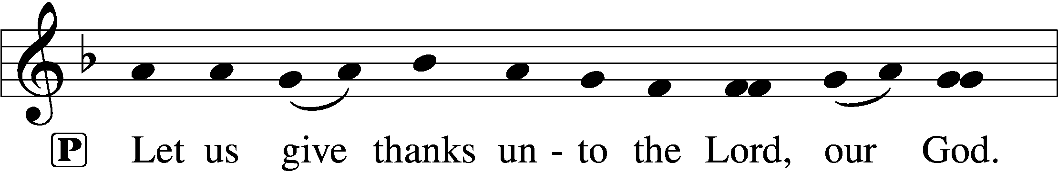
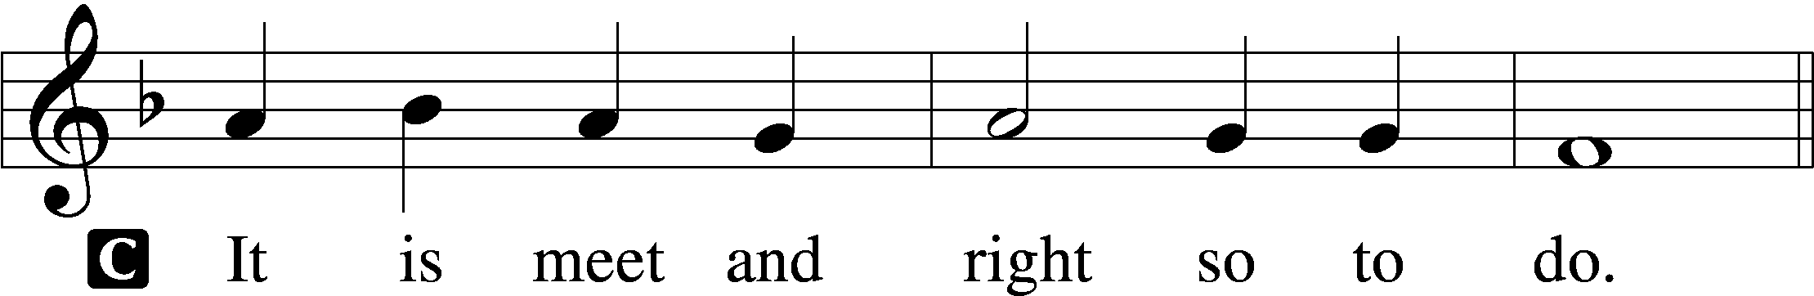

P It is truly meet, right, and salutary that we should at all times and in all places give thanks to You, holy Lord, almighty Father, everlasting God, through Jesus Christ, our Lord, who overcame the assaults of the devil and gave His life as a ransom for many that with cleansed hearts we might be prepared joyfully to celebrate the paschal feast in sincerity and truth. Therefore with angels and archangels and with all the company of heaven we laud and magnify Your glorious name, evermore praising You and saying:

Sanctus LSB 195
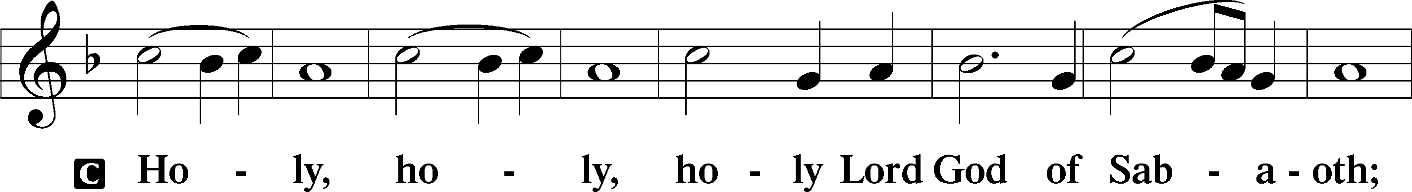
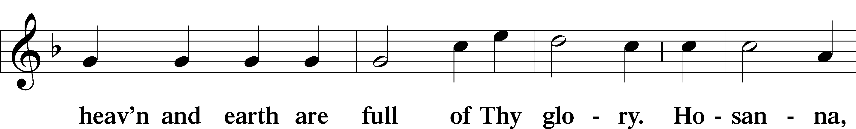
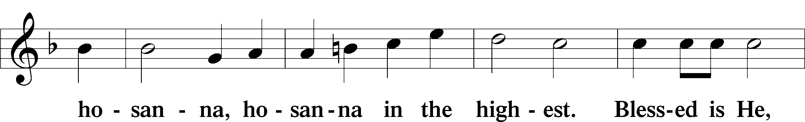
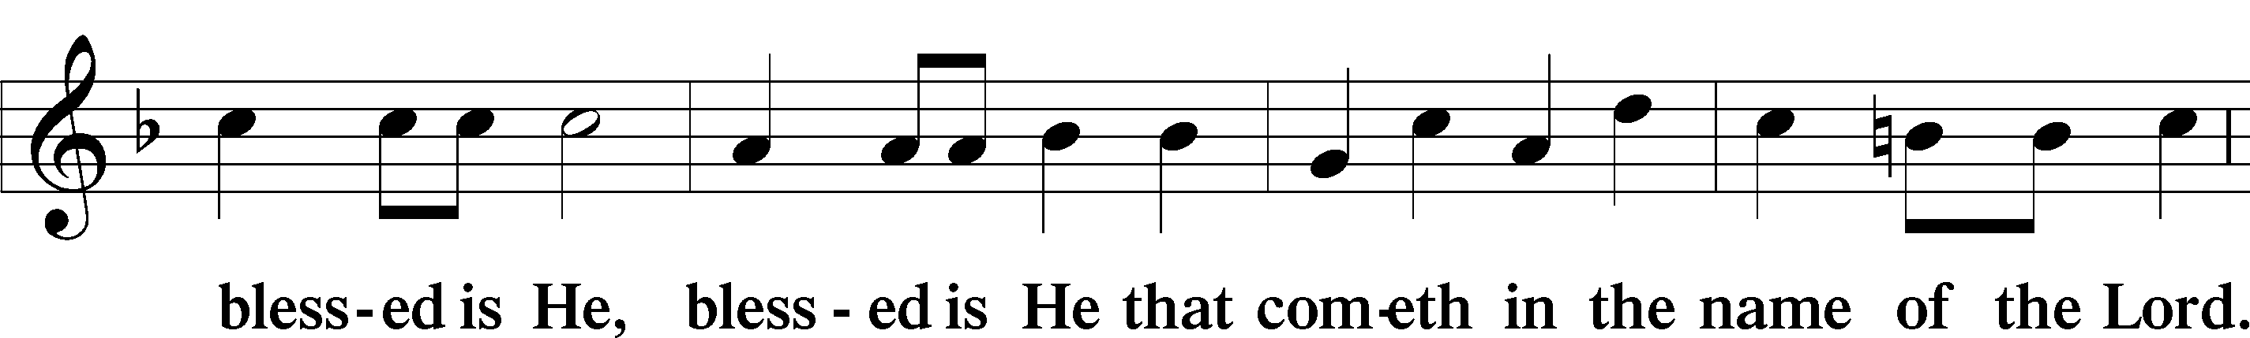
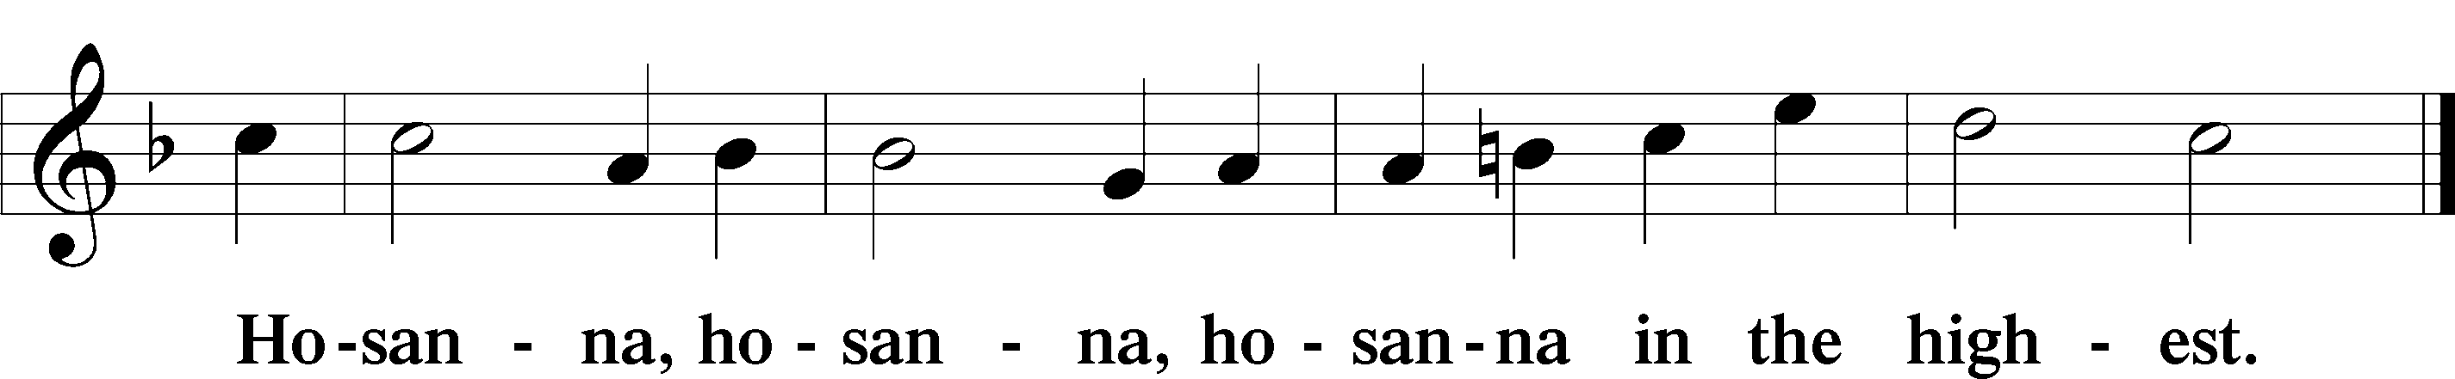

Lord’s Prayer LSB 196
C Our Father who art in heaven,
hallowed be Thy name,
Thy kingdom come,
Thy will be done on earth as it is in heaven;
give us this day our daily bread;
and forgive us our trespasses as we forgive those who trespass against us;
and lead us not into temptation,
but deliver us from evil.
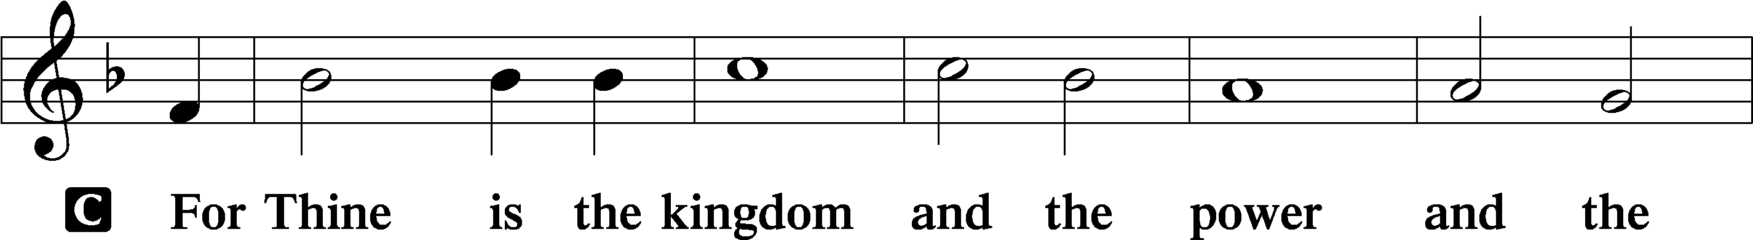
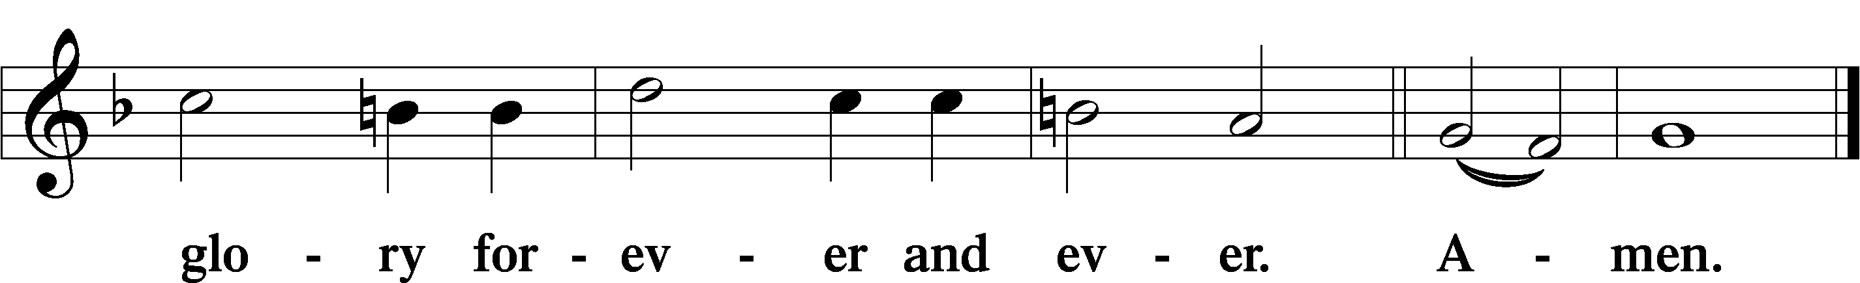

The Words of Our Lord LSB 197
P Our Lord Jesus Christ, on the night when He was betrayed, took bread, and when He had given thanks, He broke it and gave it to the disciples and said: “Take, eat; this is My T body, which is given for you. This do in remembrance of Me.”

In the same way also He took the cup after supper, and when He had given thanks, He gave it to them, saying: “Drink of it, all of you; this cup is the new testament in My T blood, which is shed for you for the forgiveness of sins. This do, as often as you drink it, in remembrance of Me.”

Pax Domini LSB 197
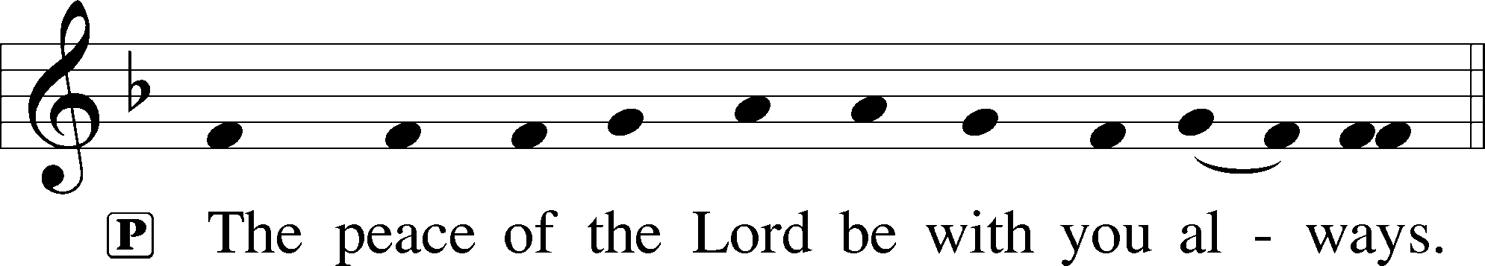

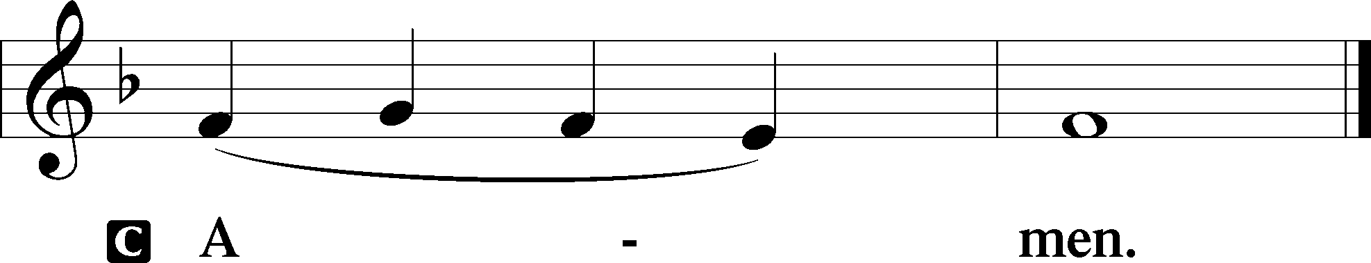

Agnus Dei LSB 198
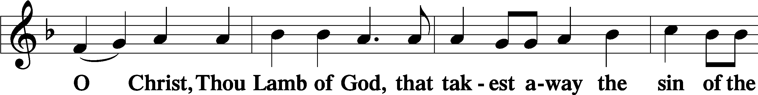
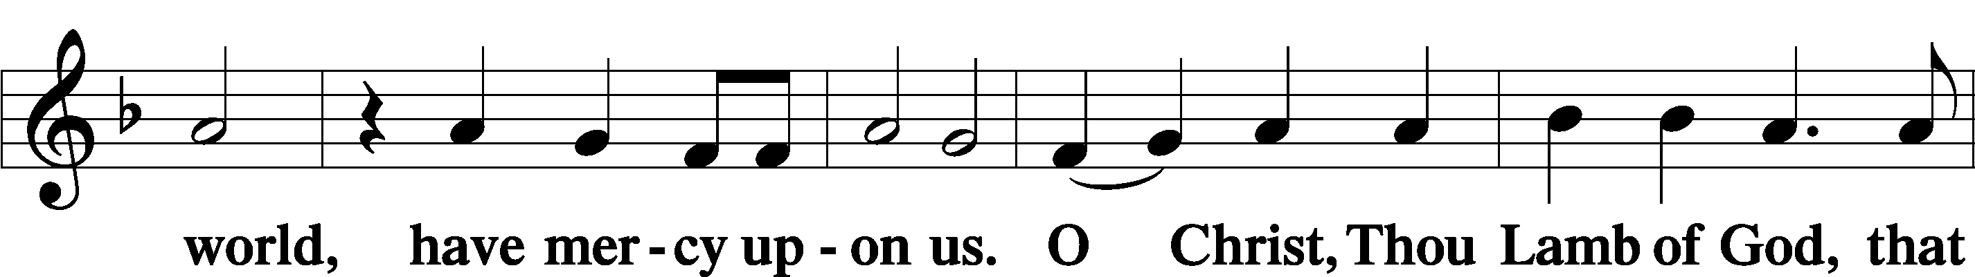
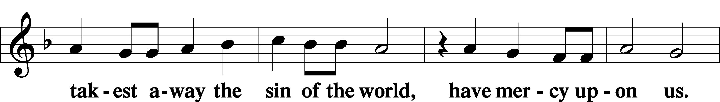
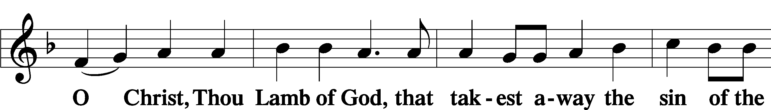
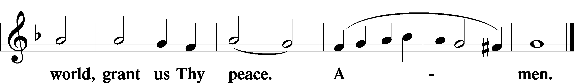

Distribution

Take, eat; this is the true body of our Lord and Savior Jesus Christ, given into death for your sins.
Amen.

Take, drink; this is the true blood of our Lord and Savior Jesus Christ, shed for the forgiveness of your sins.
Amen.

P The body and blood of our Lord Jesus Christ strengthen and preserve you in body and soul to life everlasting. Depart T in peace.
C Amen.

624 The Infant Priest Was Holy Born
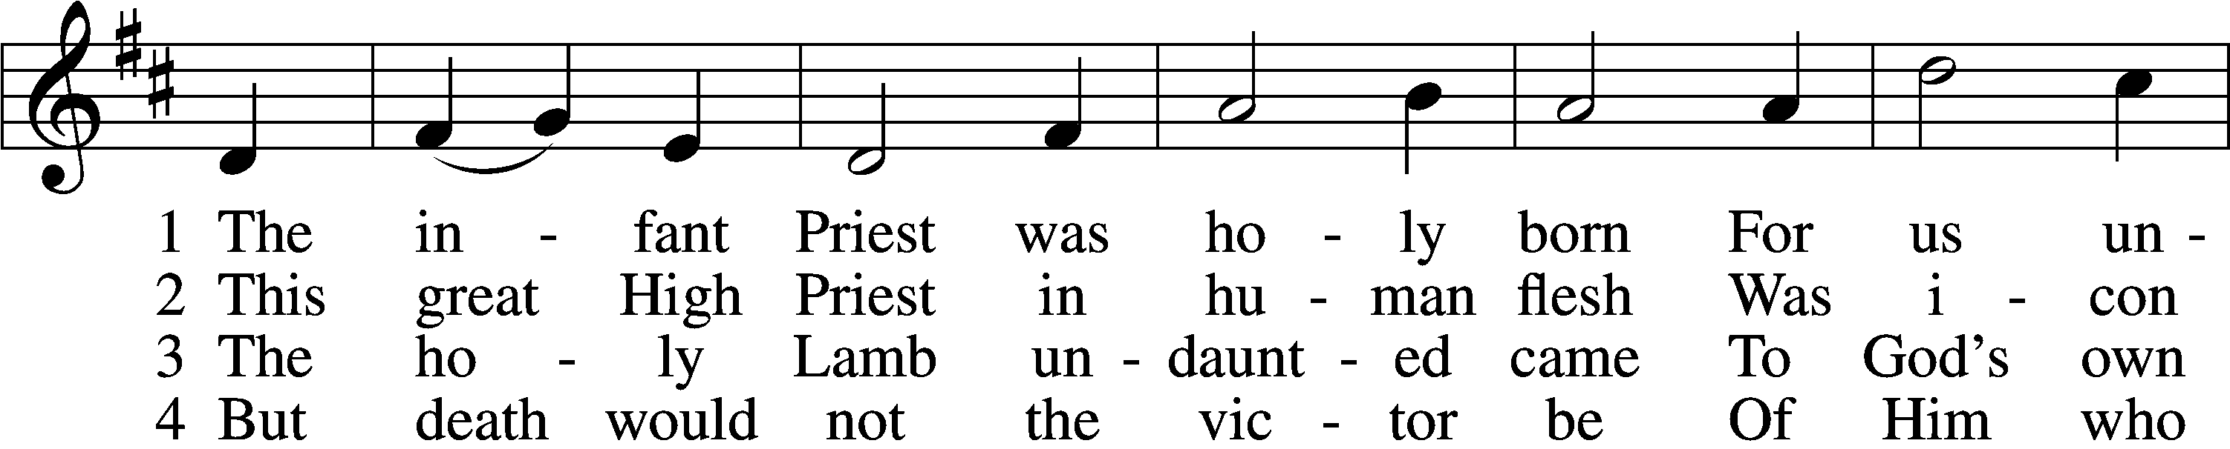
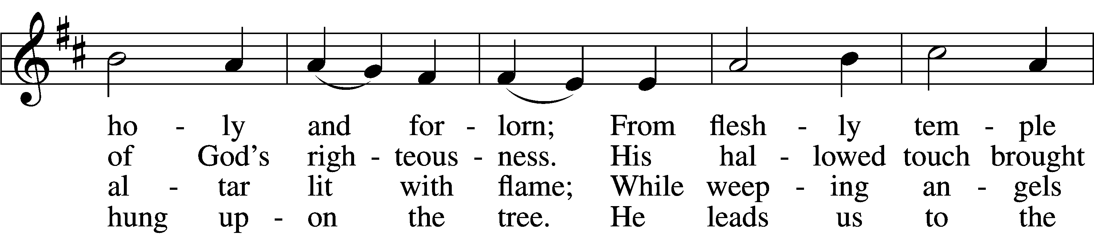
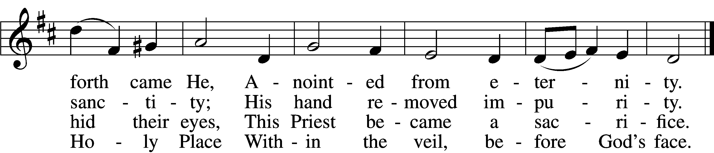

5 The veil is torn, our Priest we see,
As at the rail on bended knee
Our hungry mouths from Him receive
The bread of immortality.

6 The body of God’s Lamb we eat,
A priestly food and priestly meat;
On sin-parched lips the chalice pours
His quenching blood that life restores.

7 With cherubim and seraphim
Our voices join the endless hymn,
And “Holy, holy, holy” sing
To Christ, God’s Lamb, our Priest and King.
Text: © 1997, 2003 Chad L. Bird. Used by permission: LSB Hymn License no. 110005047
Tune: Public domain

Nunc Dimittis LSB 199
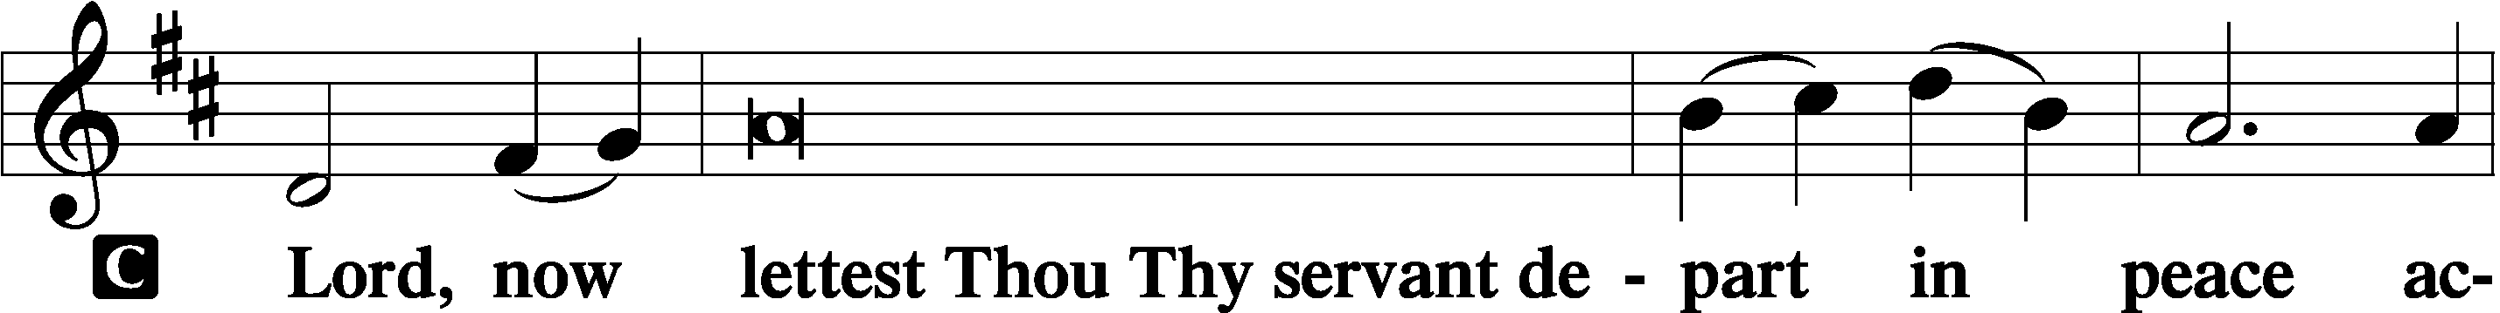
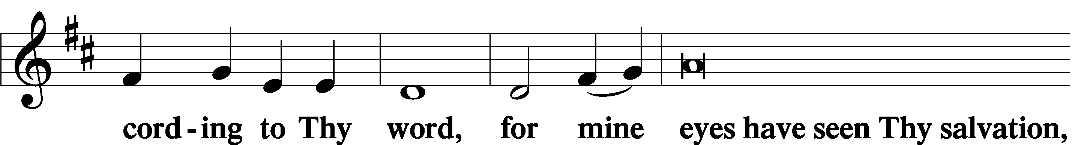

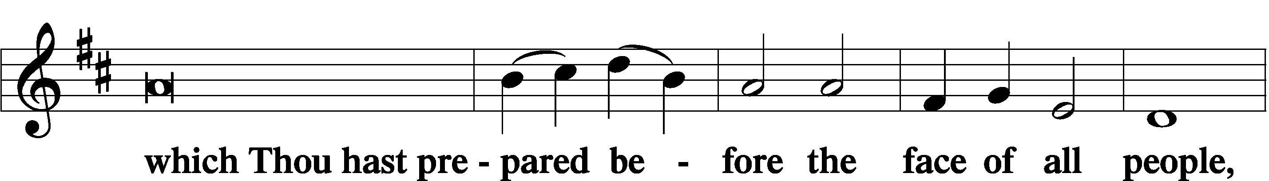

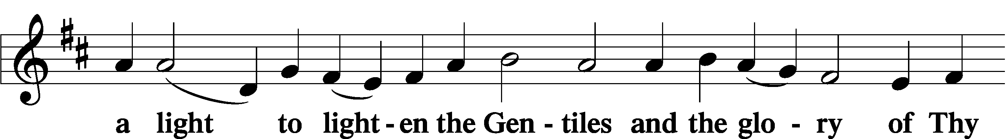

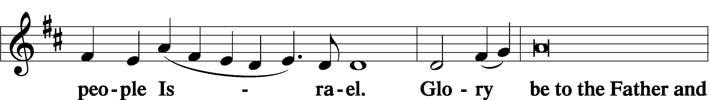

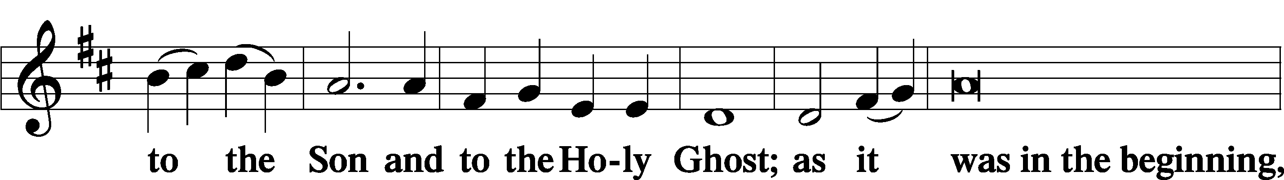

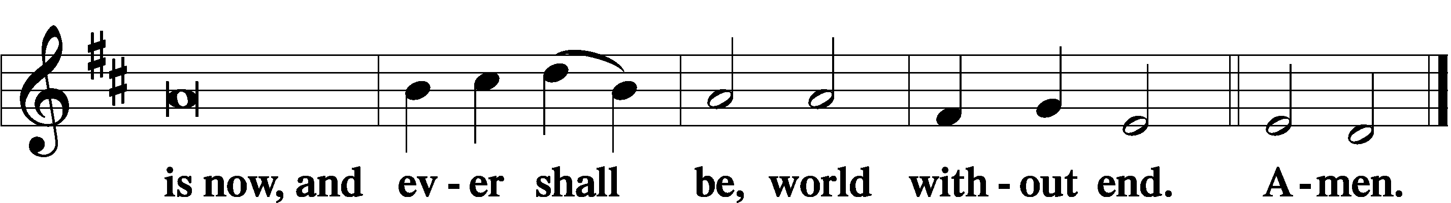

Thanksgiving LSB 200
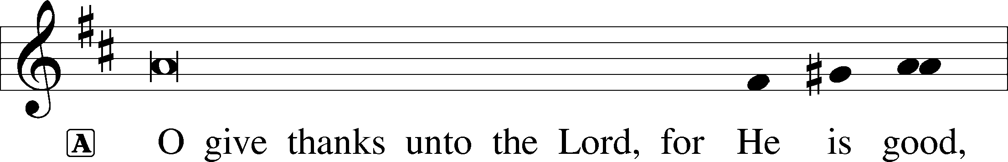

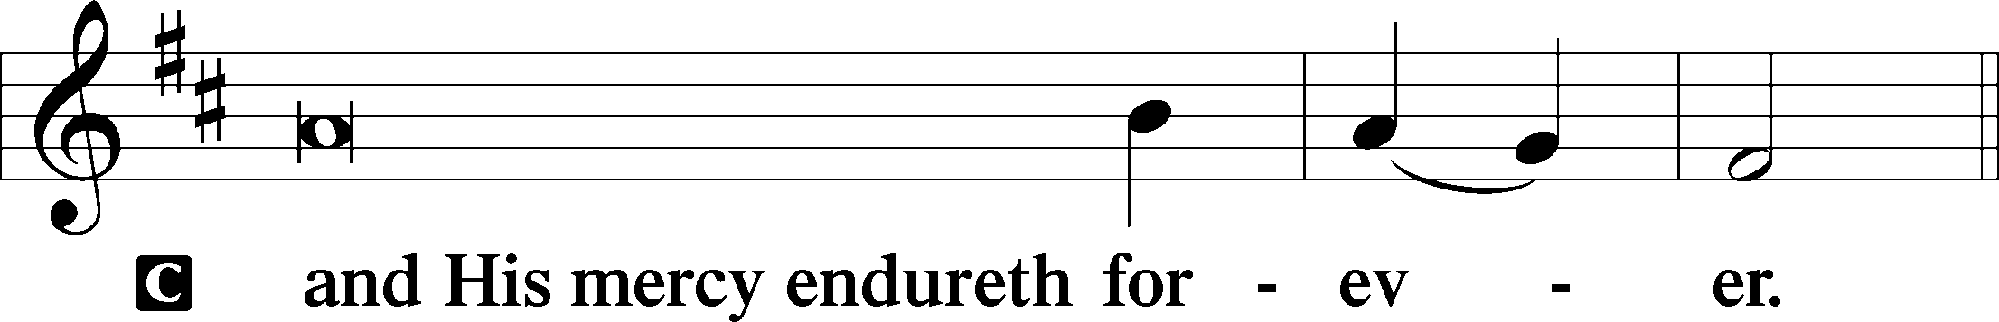

A Let us pray.
We give thanks to You, almighty God, that You have refreshed us through this salutary gift, and we implore You that of Your mercy You would strengthen us through the same in faith toward You and in fervent love toward one another; through Jesus Christ, Your Son, our Lord, who lives and reigns with You and the Holy Spirit, one God, now and forever.

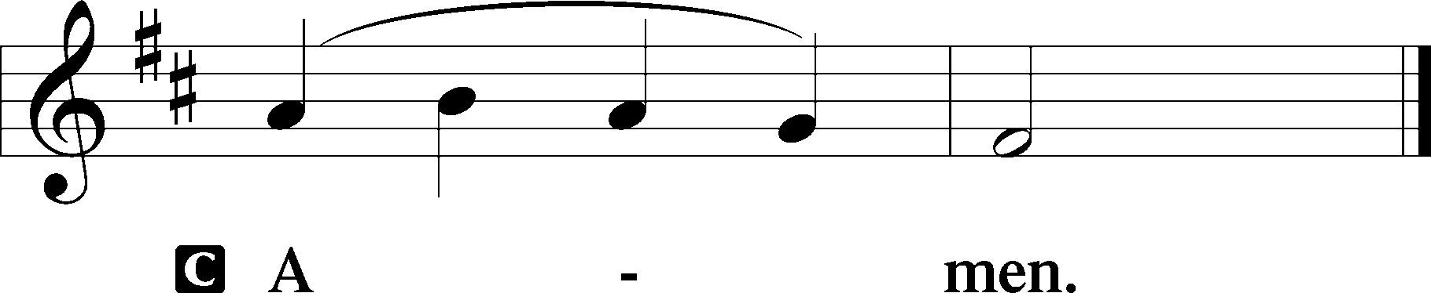

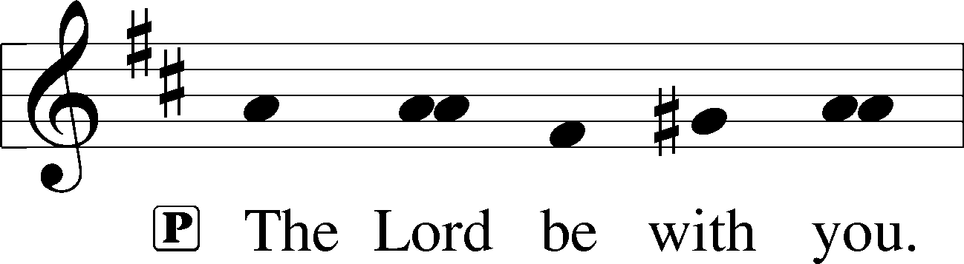

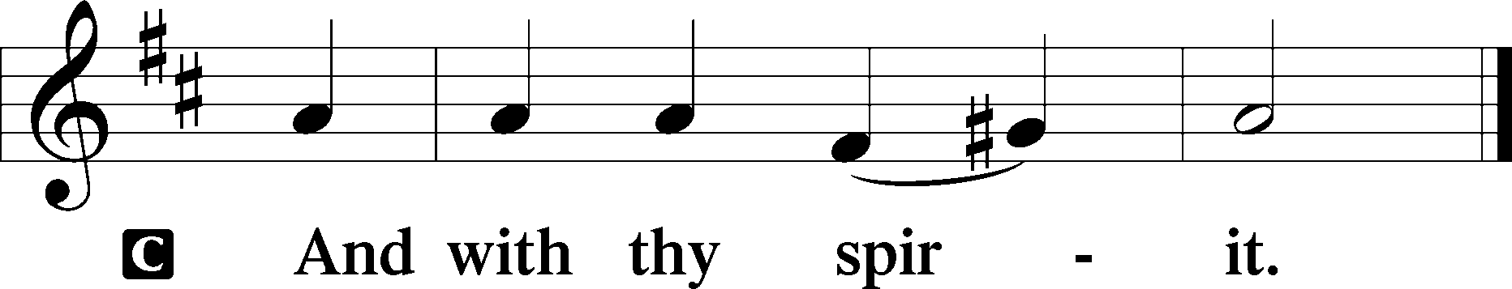

Benedicamus and Benediction LSB 202
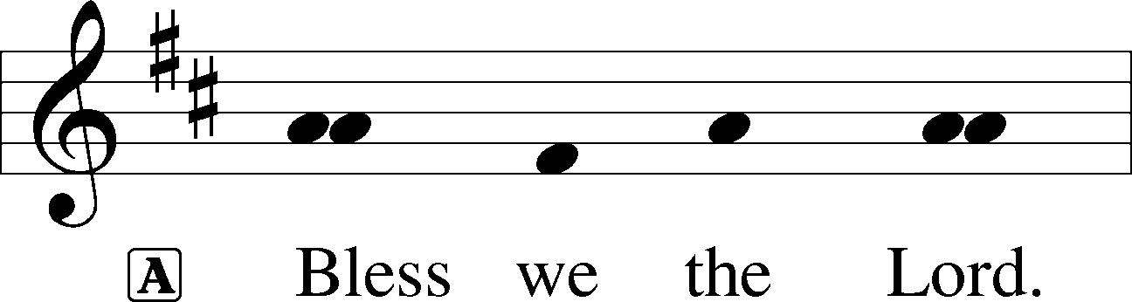

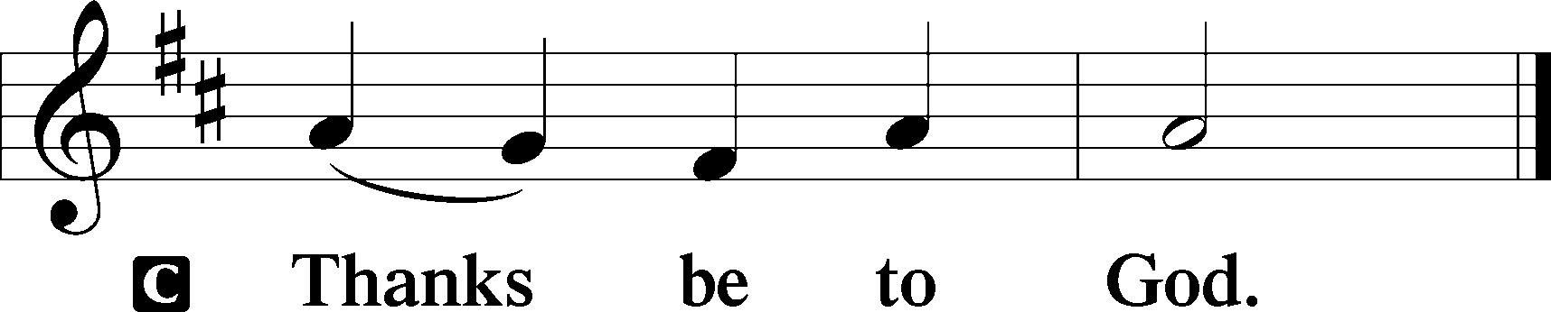

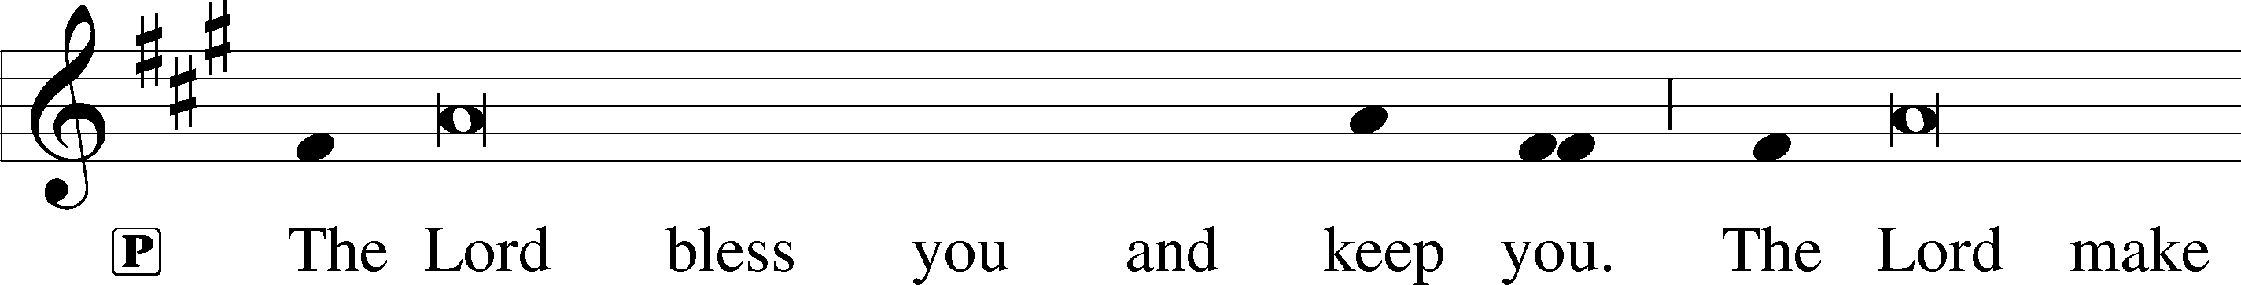
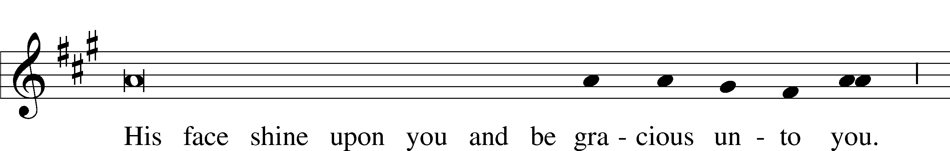
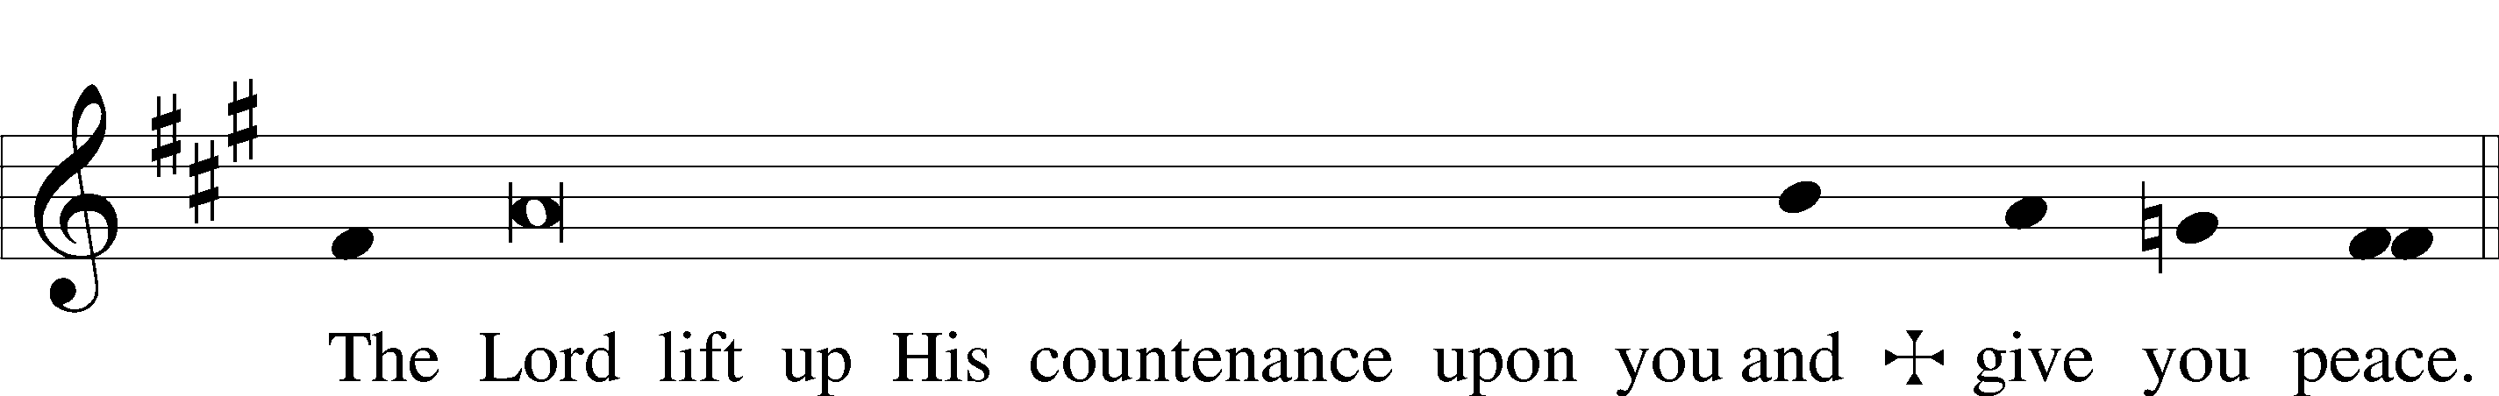

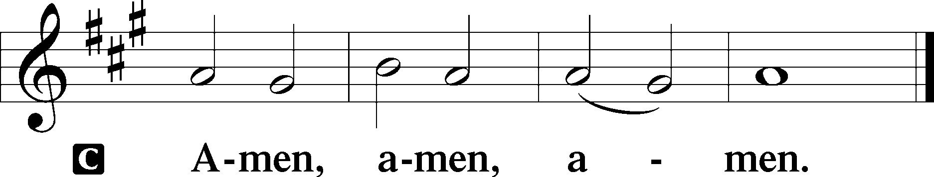

850 God of Grace and God of Glory
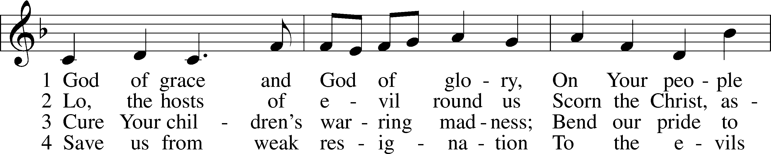
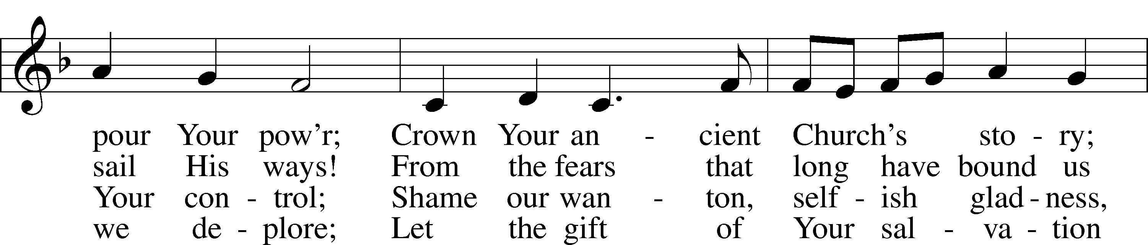
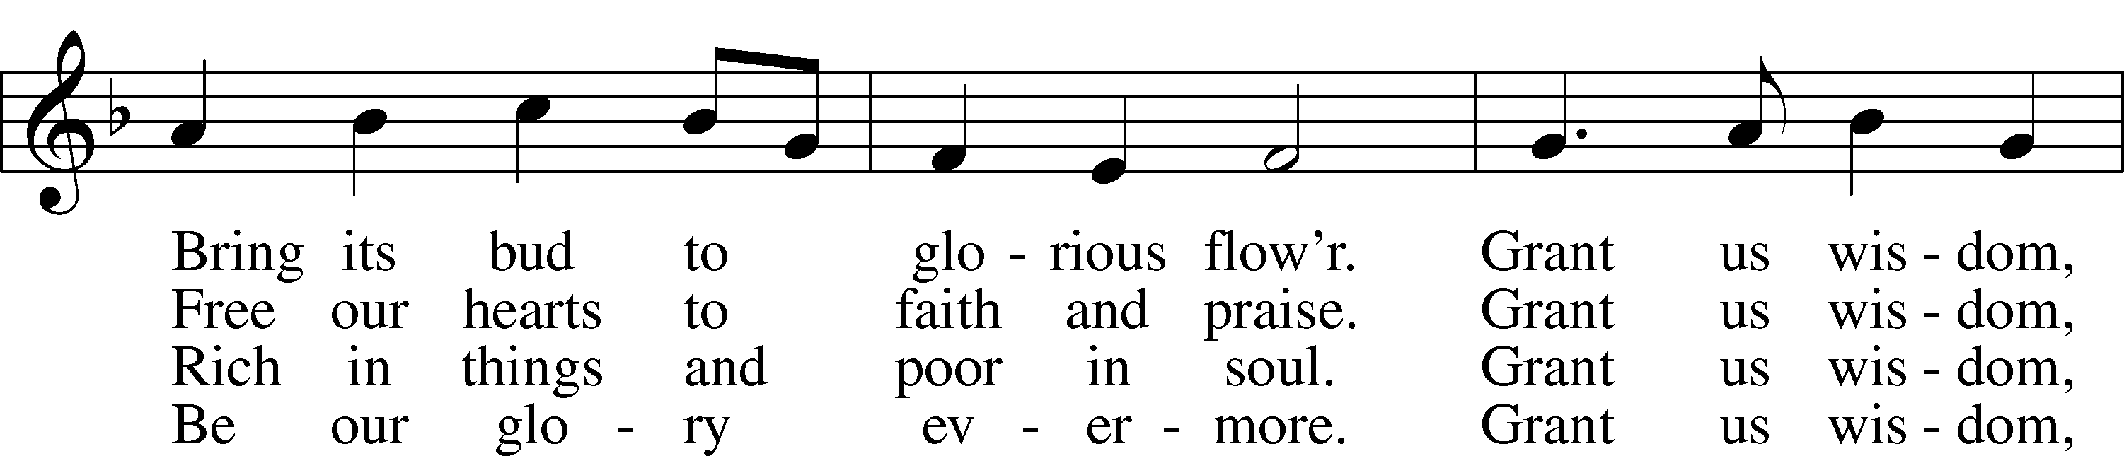
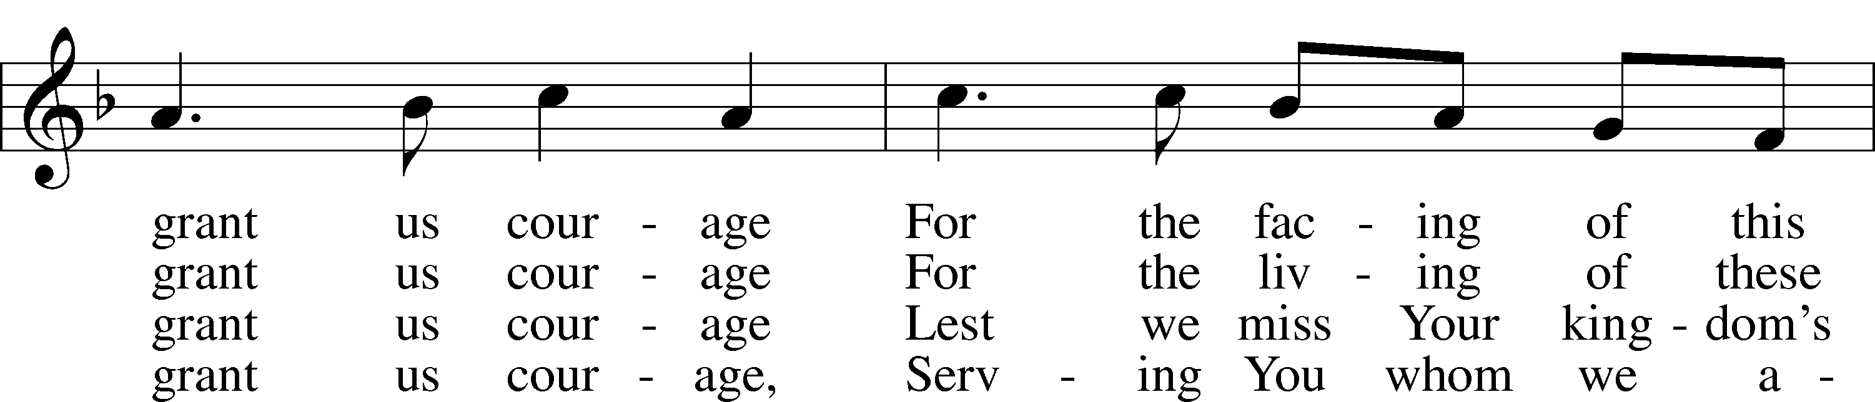
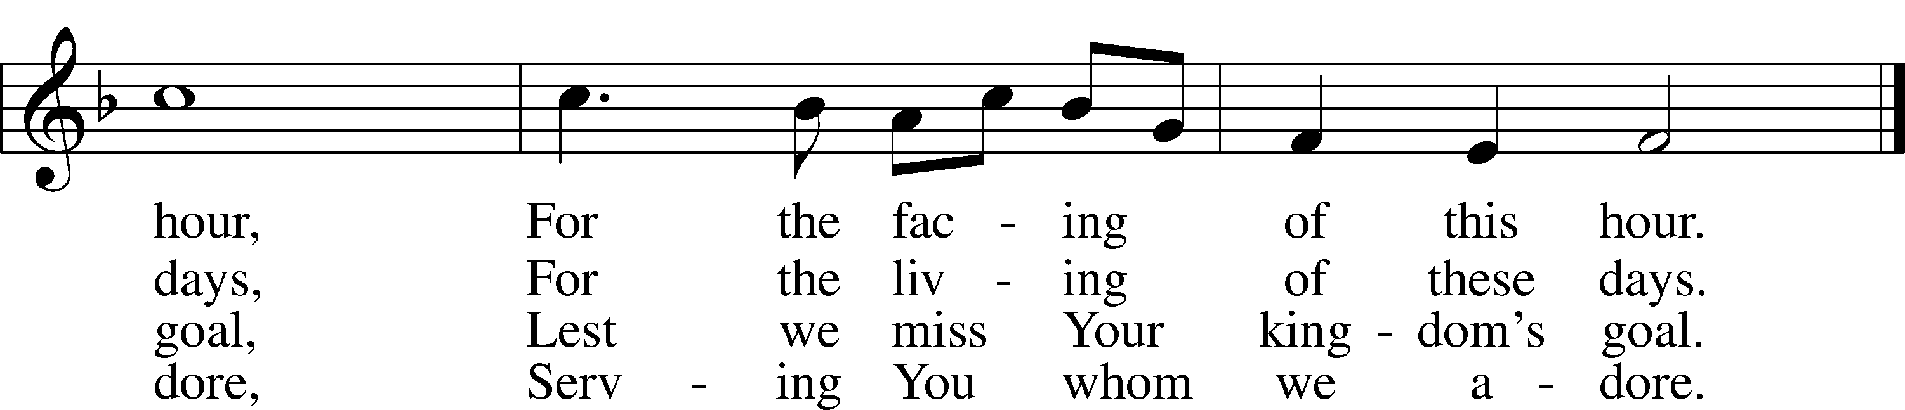
Text and tune: Public domain

Acknowledgments
Divine Service, Setting Three from Lutheran Service Book
Unless otherwise indicated, Scripture quotations are from the ESV® Bible (The Holy Bible, English Standard Version®), copyright © 2001 by Crossway, a publishing ministry of Good News Publishers. Used by permission. All rights reserved.
Created by Lutheran Service Builder © 2021 Concordia Publishing House.

This week on KFUO.org, begin the book of Philippians on Thy Strong Word (weekdays at 11:00 a.m. CT), hear Midweek Lenten service and organ recital on 3/10 at 11:00 a.m. CT, and hear practical application of our Lutheran Confessions on Concord Matters (3/9 at 2:00 p.m. CT). Find your favorite programs on demand at kfuo.org or wherever you get your podcasts.

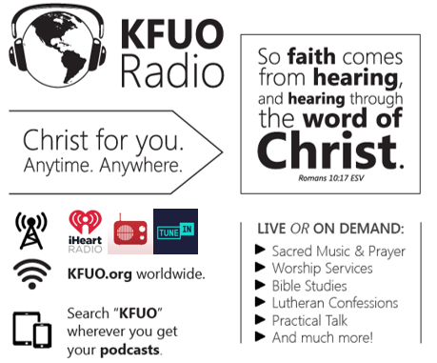

March 7 “Whether you are five or 35 or 65, there will be days when it seems to you that God has dropped it. When that happens, when the darkness threatens to close in on you, just go back to the simple truth that God taught you in your youth. Go back to the Word of Light, the Word that is Christ. ‘Jesus loves me, this I know, for the Bible tells me so.’ That will lighten the way for you, for us all.” Rev. Dr. Dale A. Meyer, The Lutheran Hour – A Life Quote from Lutherans For Life • Lutheransforlife.org
Gifts of Time and Treasure
“And my God will meet all your needs according to His glorious
riches in Christ Jesus.” Philippians 4:19

LAST WEEK’S OFFERINGS LAST WEEK’S ATTENDANCE
Midweek 2/24 $ 307.00 ~30
General Fund $ 2,962.00 Service 50
Needed Weekly $ 4,669.00 Communed 42
Adult Bible Study $ 6.00
Children’s SS/Mission $ 11.00

The Lord’s Week

Today 8:45 am – Bible Studies for all ages
(Feb. 28th) 10:00 am – Divine Service
11:30 am – Confirmation

Monday 6:00 pm – Elder Meeting

Wednesday 10:00 am – Women’s Bible Study
7:00 pm – Lenten Service

Next Sunday 8:45 am – Bible Studies for all ages
(Mar. 7th) 10:00 am – Divine Service
11:45 am – Confirmation

In His Service

Elder: Robert Kunkel
Usher:
Acolytes: Whitney Larson
Organist: Sharon Schrader
Alter: Devereaux Brewer
Flowers:

