**All Saints’ Day**

**“We are God’s Children NOW”**

I John 3:1-3

**November 1, 2020**

**Messiah Lutheran Church**

**Lutheran Church-Missouri Synod**

4102 Trinity River Dr., Corpus Christi, Texas 78410

**Pastor:**  **Rev. Scott E. Herbert**

Church Phone: 361-387-7748 Email: mlc@stx.rr.com

Church Fax: 361-767-1768 Website: [www.messiahlcms-cc.org](http://www.messiahlcms-cc.org)

Pastor Phone: 469-693-9683 Pastor Email: chirev59@gmail.com

**WELCOME TO MESSIAH!**

We are glad you are here to receive what God is doing for you during Divine Service. Please sign our Guest Book located near the front door. Feel free to converse quietly until the organ prelude begins. If you are looking for a church home, please talk to the Pastor at the door. We would love to have you join us.

**Preparing for Service**

# ***Saints Are Blessed in the Eternal Presence of Christ***

# *“A great multitude … from all tribes and peoples and languages”* cry out, *“Salvation belongs to our God who sits on the throne”* (Rev. 7:9–10). Faith-filled saints from every place and time with unified voices eternally magnify the Lamb of God. As His beloved children, we, too, *“shall see him as he is”* (1 John 3:2). Joined with the throng of angels and myriad saints, we shall *“serve him day and night in his temple”* (Rev. 7:15). In our earthly tension vacillating between saint and sinner, faith and doubt, sacred and profane, we earnestly seek Jesus to calm our fears, comfort our spirits and forgive our sins. The Holy Spirit, through faith in Christ, propels us forward to our eternal home, fortifying us in Word and Sacrament. In the midst of our constant struggle as believers, we need to be blessed. And so we are. The poor in spirit, the meek, the hungry, the thirsty, the merciful, the pure and the persecuted are all blessed, and we will most certainly inherit the kingdom of heaven (Matt. 5:1–12).

# Confession and Absolution

907 God Himself Is Present

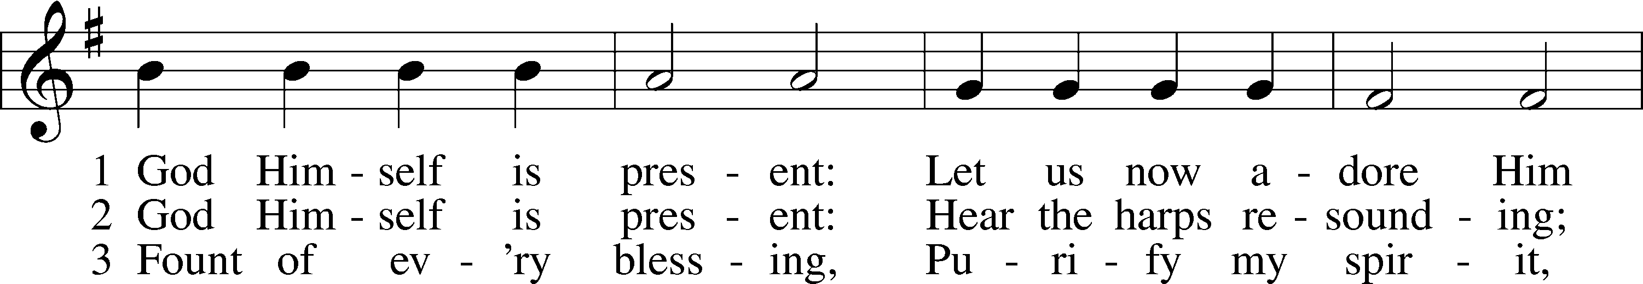

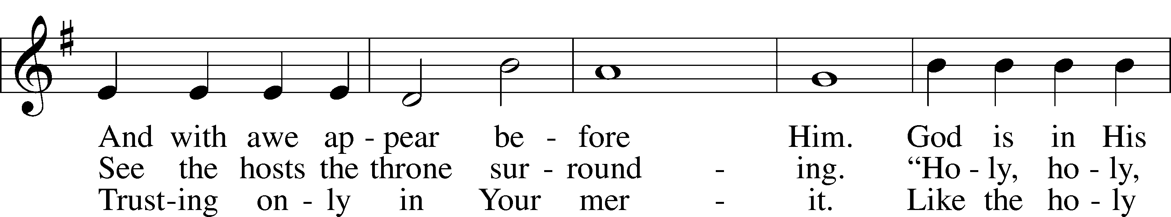

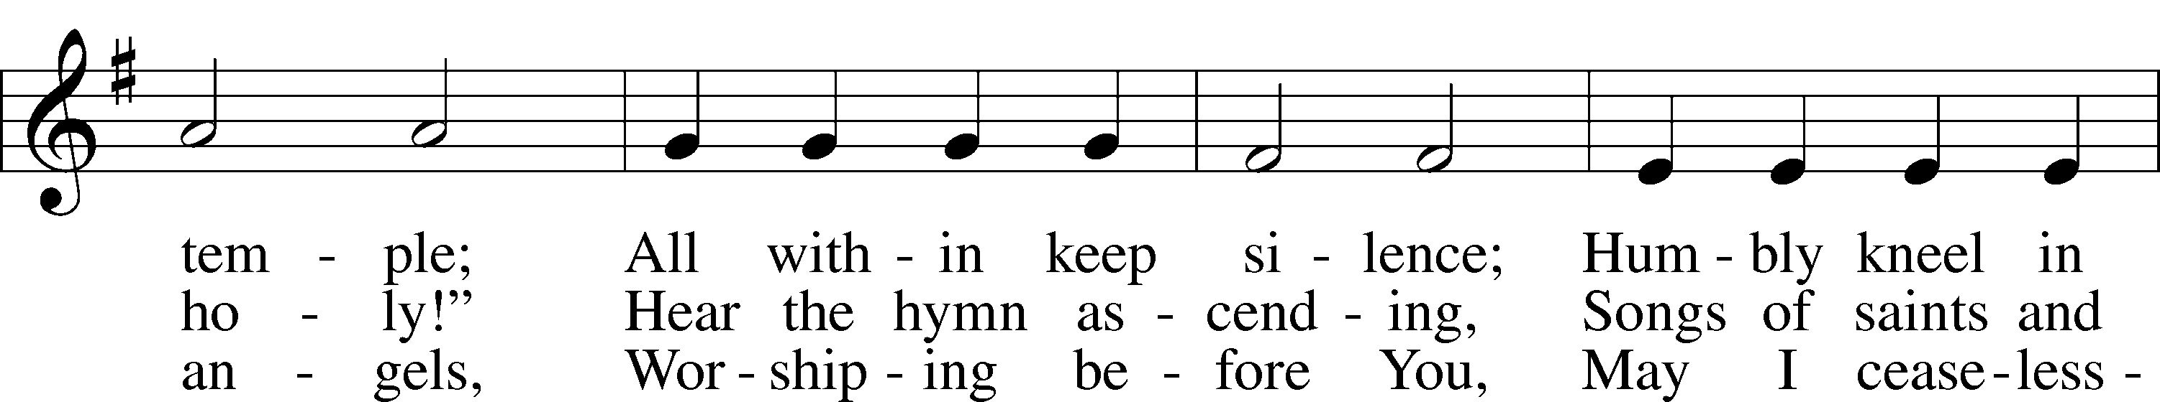

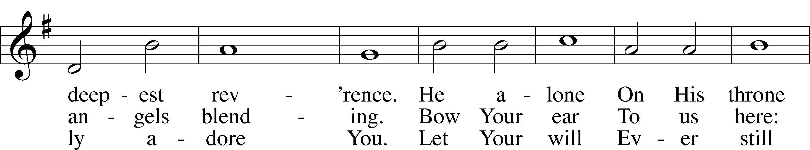

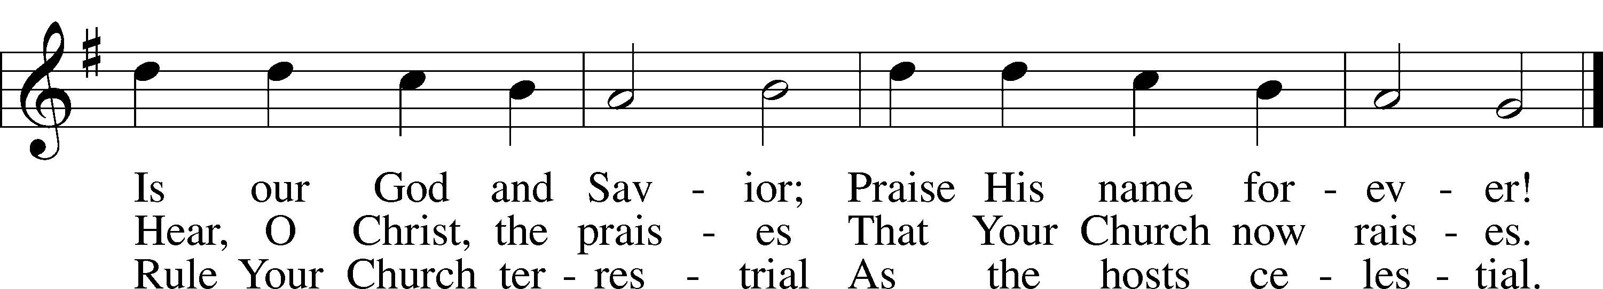

P In the name of the Father and of the T Son and of the Holy Spirit.

C **Amen.**

P If we say we have no sin, we deceive ourselves, and the truth is not in us.

C **But if we confess our sins, God, who is faithful and just, will forgive our sins and cleanse us from all unrighteousness.**

P Let us then confess our sins to God our Father.

C **Most merciful God, we confess that we are by nature sinful and unclean. We have sinned against You in thought, word, and deed, by what we have done and by what we have left undone.**

**We have not loved You with our whole heart; we have not loved our neighbors as ourselves. We justly deserve Your present and eternal punishment. For the sake of Your Son, Jesus Christ, have mercy on us. Forgive us, renew us, and lead us, so that we may delight in Your will and walk in Your ways to the glory of Your holy name. Amen.**

P Almighty God in His mercy has given His Son to die for you and for His sake forgives you all your sins. As a called and ordained servant of Christ, and by His authority, I therefore forgive you all your sins in the name of the Father and of the T Son and of the Holy Spirit.

C **Amen.**

# Service of the Word

Introit Psalm 31:1, 3, 5; antiphon: Revelation 7:14b

These are the ones coming out of the great tribulation.  
 **They have washed their robes and made them white in the blood of the Lamb.**In you, O Lord, do I take refuge; let me never be put to shame;  
 **in your righteousness deliver me.**For you are my rock and my fortress;  
 **and for your name’s sake you lead me and guide me.**Into your hand I commit my spirit;  
 **you have redeemed me, O Lord, faithful God.  
Glory be to the Father and to the T Son and to the Holy Spirit;**  
**as it was in the beginning, is now, and will be forever. Amen.**

Kyrie LSB 152



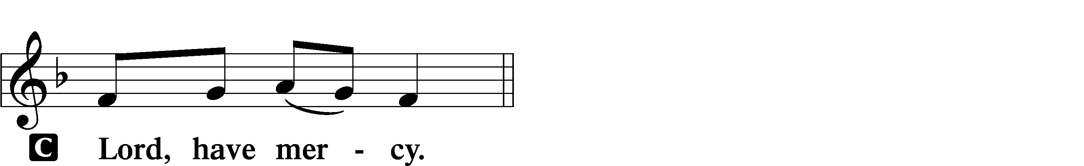

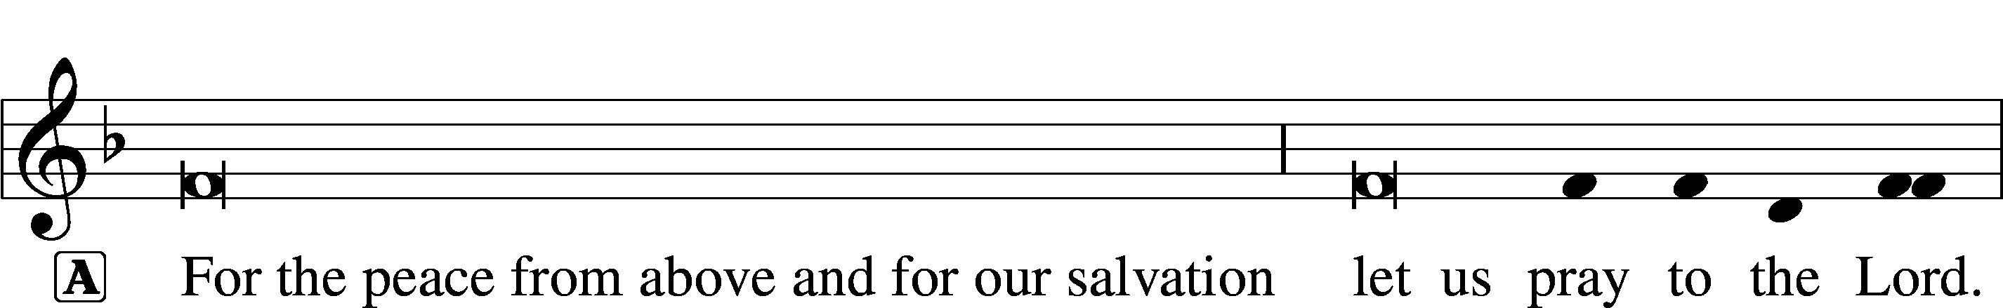



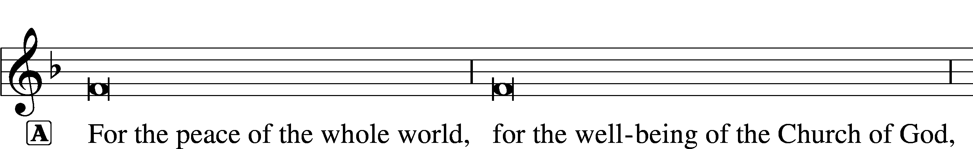



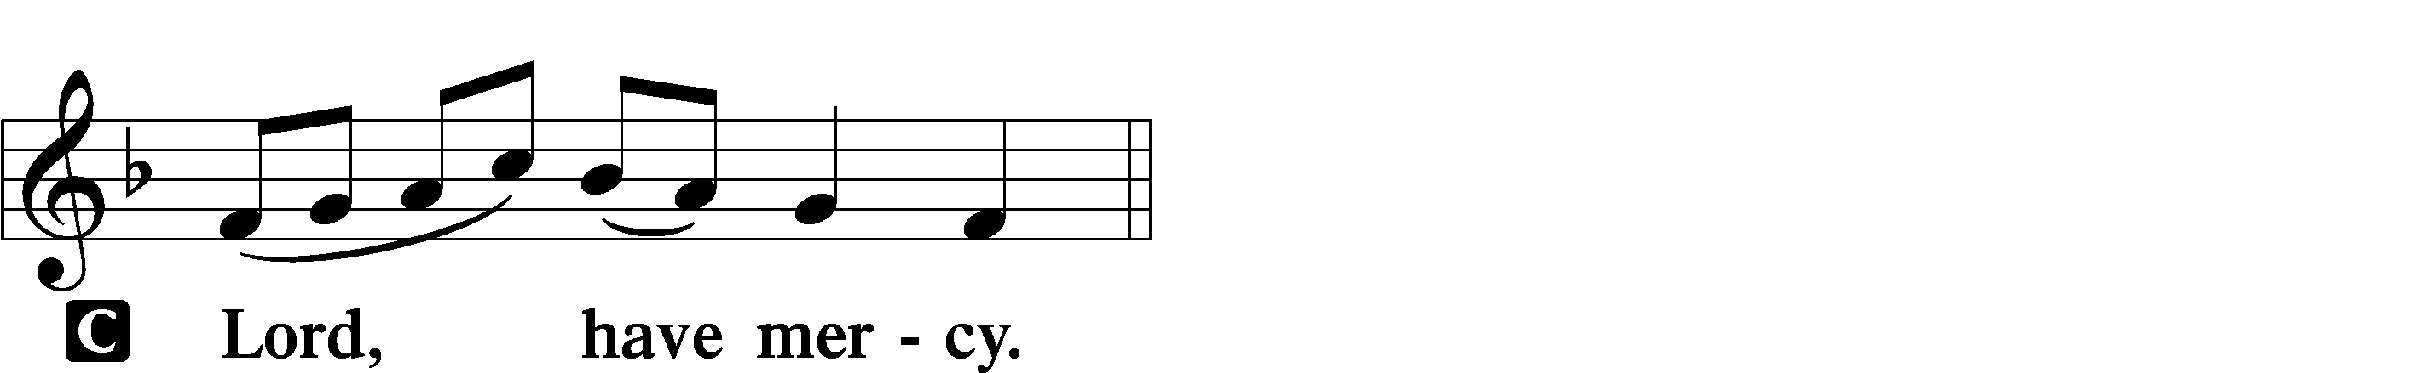

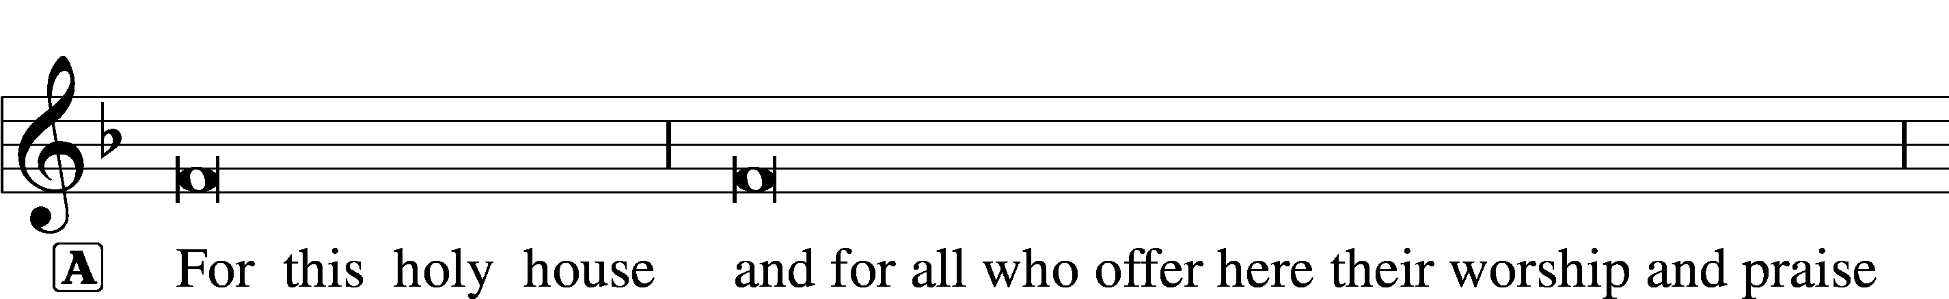



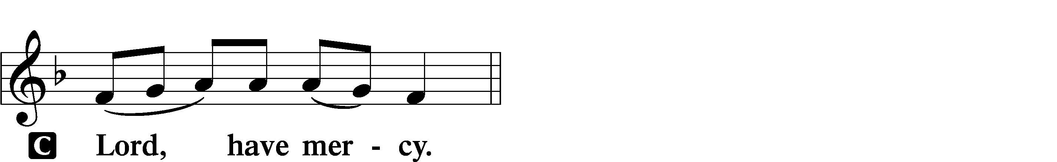





This Is the Feast LSB 155

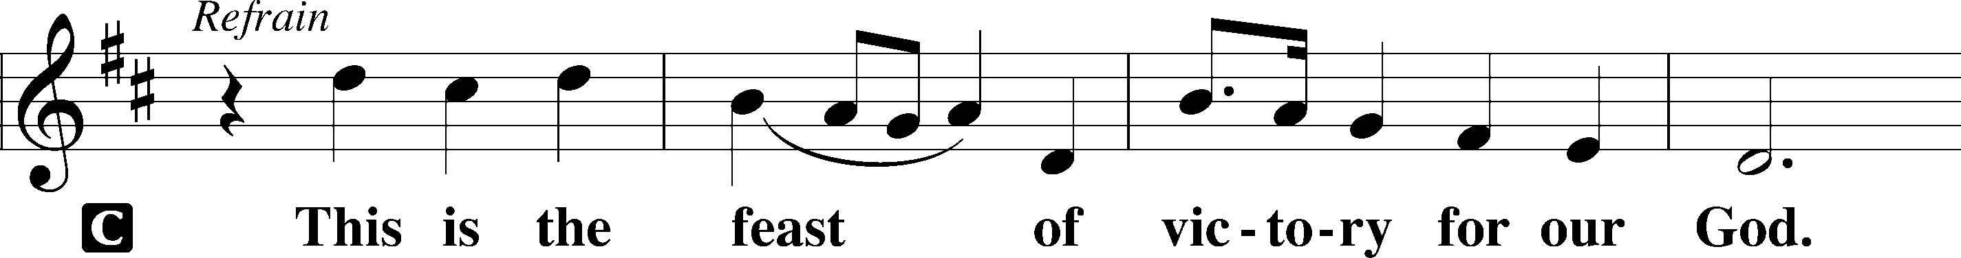

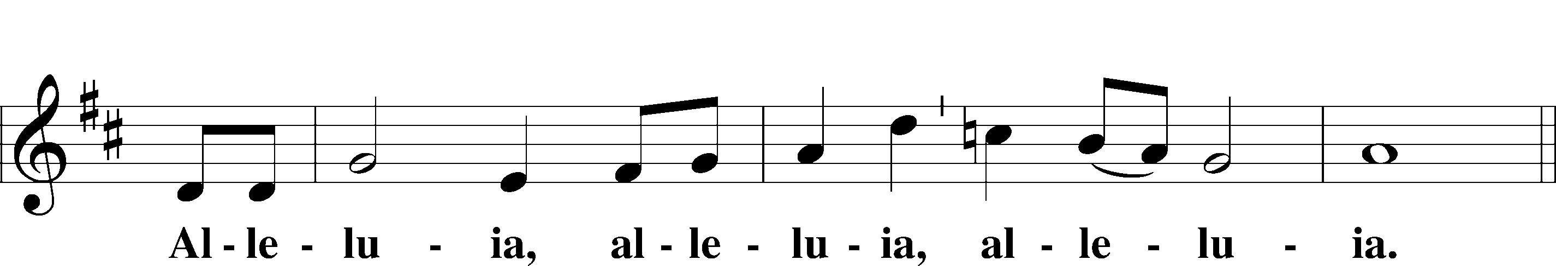

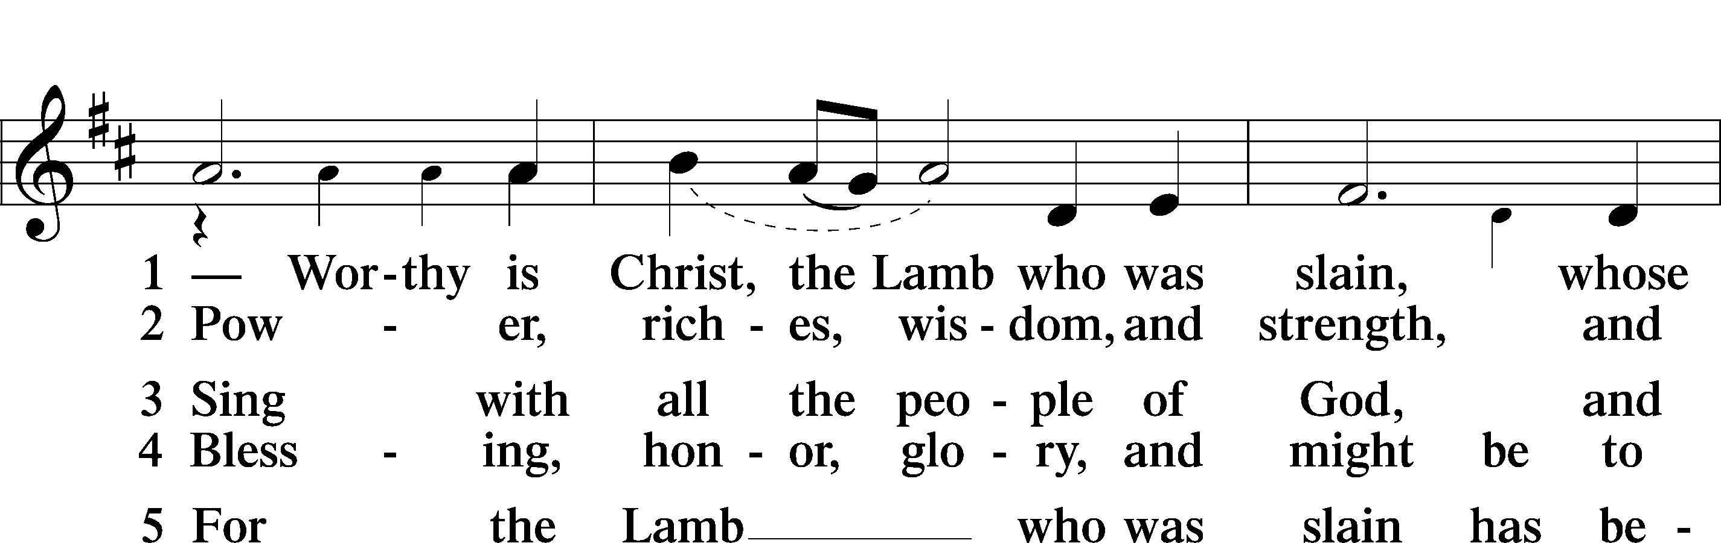

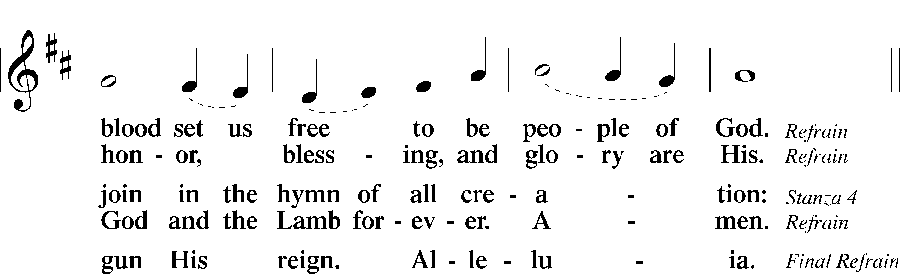

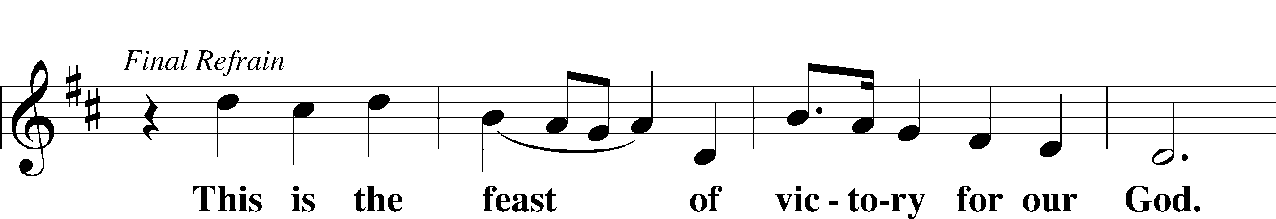

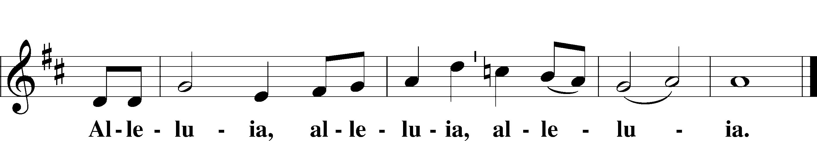

Salutation and Collect of the Day

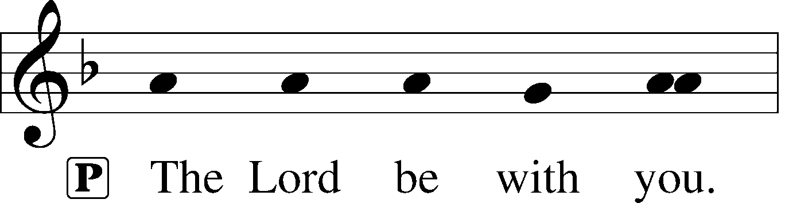

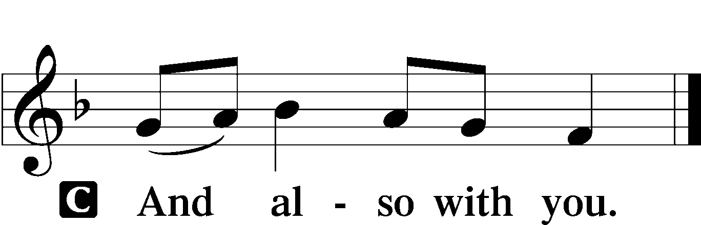

P Let us pray.

Almighty and everlasting God, You knit together Your faithful people of all times and places into one holy communion, the mystical body of Your Son, Jesus Christ. Grant us so to follow Your blessed saints in all virtuous and godly living that, together with them, we may come to the unspeakable joys You have prepared for those who love You; through Jesus Christ, our Lord, who lives and reigns with You and the Holy Spirit, one God, now and forever.

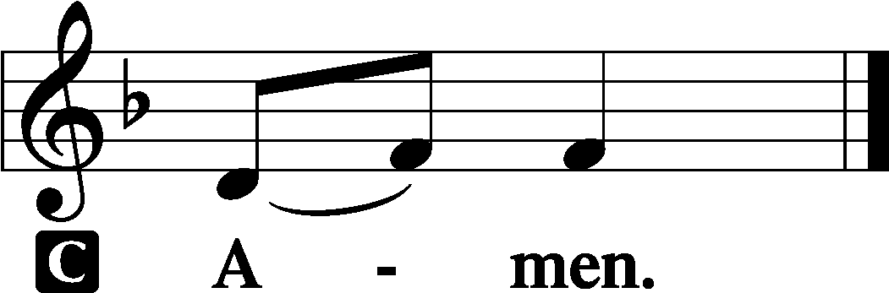

First Reading Revelation 7:2–17

2Then I saw another angel ascending from the rising of the sun, with the seal of the living God, and he called with a loud voice to the four angels who had been given power to harm earth and sea, 3saying, “Do not harm the earth or the sea or the trees, until we have sealed the servants of our God on their foreheads.” 4And I heard the number of the sealed, 144,000, sealed from every tribe of the sons of Israel:

512,000 from the tribe of Judah were sealed,  
12,000 from the tribe of Reuben,  
12,000 from the tribe of Gad,  
612,000 from the tribe of Asher,  
12,000 from the tribe of Naphtali,  
12,000 from the tribe of Manasseh,  
712,000 from the tribe of Simeon,  
12,000 from the tribe of Levi,  
12,000 from the tribe of Issachar,  
812,000 from the tribe of Zebulun,  
12,000 from the tribe of Joseph,  
12,000 from the tribe of Benjamin were sealed.

9After this I looked, and behold, a great multitude that no one could number, from every nation, from all tribes and peoples and languages, standing before the throne and before the Lamb, clothed in white robes, with palm branches in their hands 10and crying out with a loud voice, “Salvation belongs to our God who sits on the throne, and to the Lamb!” 11And all the angels were standing around the throne and around the elders and the four living creatures, and they fell on their faces before the throne and worshiped God, 12saying, “Amen! Blessing and glory and wisdom and thanksgiving and honor and power and might be to our God forever and ever! Amen.”

13Then one of the elders addressed me, saying, “Who are these, clothed in white robes, and from where have they come?” 14 I said to him, “Sir, you know.” And he said to me, “These are the ones coming out of the great tribulation. They have washed their robes and made them white in the blood of the Lamb. 15“Therefore they are before the throne of God, and serve him day and night in his temple; and he who sits on the throne will shelter them with his presence.  
16They shall hunger no more, neither thirst anymore;  
 the sun shall not strike them, nor any scorching heat.  
17For the Lamb in the midst of the throne will be their shepherd, and he will guide them to springs of living water,  
and God will wipe away every tear from their eyes.”

A This is the Word of the Lord.

C **Thanks be to God.**

Epistle 1 John 3:1–3

1See what kind of love the Father has given to us, that we should be called children of God; and so we are. The reason why the world does not know us is that it did not know him. 2Beloved, we are God’s children now, and what we will be has not yet appeared; but we know that when he appears we shall be like him, because we shall see him as he is. 3And everyone who thus hopes in him purifies himself as he is pure.

A This is the Word of the Lord.

C **Thanks be to God.**

Alleluia and Verse LSB 156

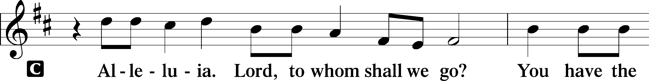

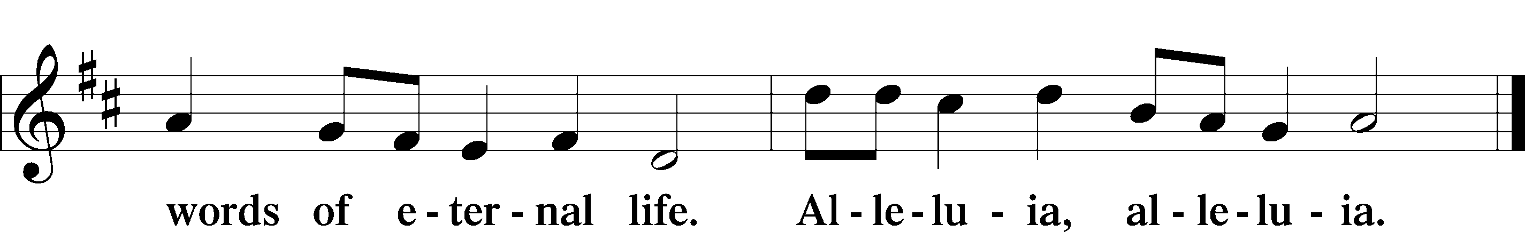

Holy Gospel Matthew 5:1–12

P The Holy Gospel according to St. Matthew, the fifth chapter.

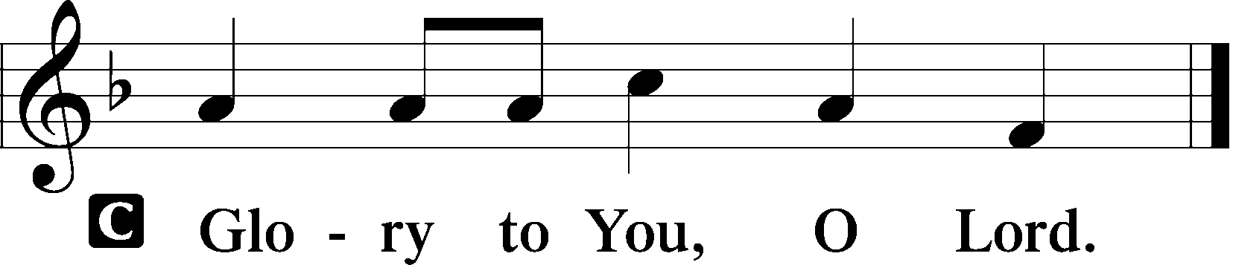

1Seeing the crowds, [Jesus] went up on the mountain, and when he sat down, his disciples came to him.

2And he opened his mouth and taught them, saying:

3“Blessed are the poor in spirit, for theirs is the kingdom of heaven.

4“Blessed are those who mourn, for they shall be comforted.

5“Blessed are the meek, for they shall inherit the earth.

6“Blessed are those who hunger and thirst for righteousness, for they shall be satisfied.

7“Blessed are the merciful, for they shall receive mercy.

8“Blessed are the pure in heart, for they shall see God.

9“Blessed are the peacemakers, for they shall be called sons of God.

10“Blessed are those who are persecuted for righteousness’ sake, for theirs is the kingdom of heaven.

11“Blessed are you when others revile you and persecute you and utter all kinds of evil against you falsely on my account. 12Rejoice and be glad, for your reward is great in heaven, for so they persecuted the prophets who were before you.”

P This is the Gospel of the Lord.

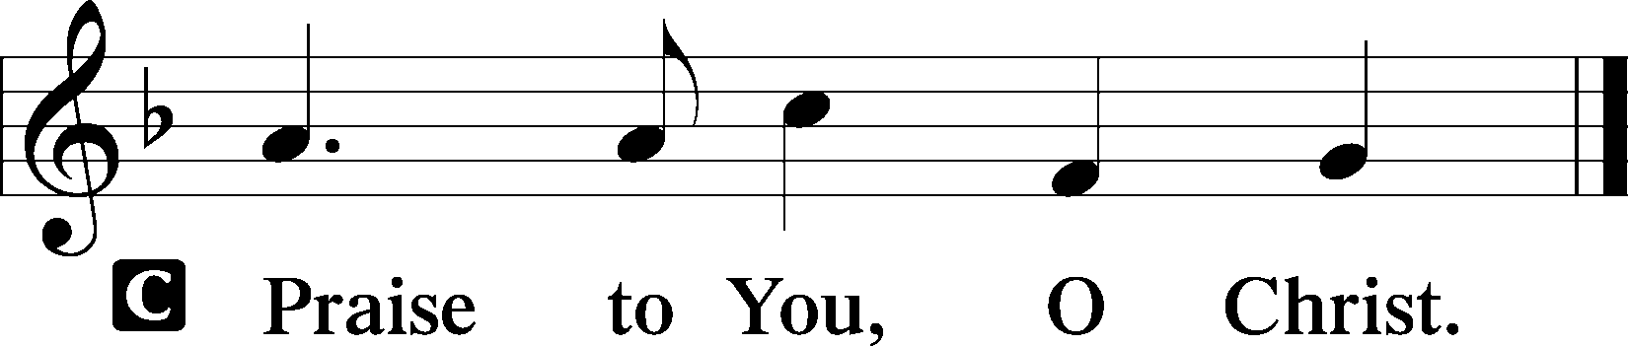

Children’s Message The ‘Bee-Attitudes’

700 Love Divine, All Loves Excelling

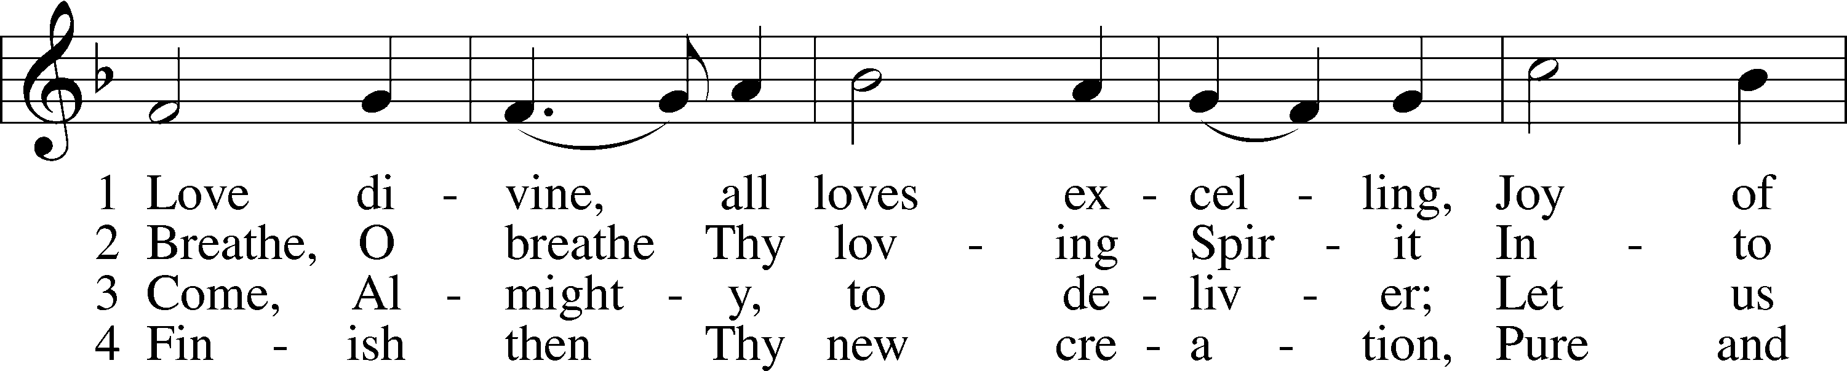

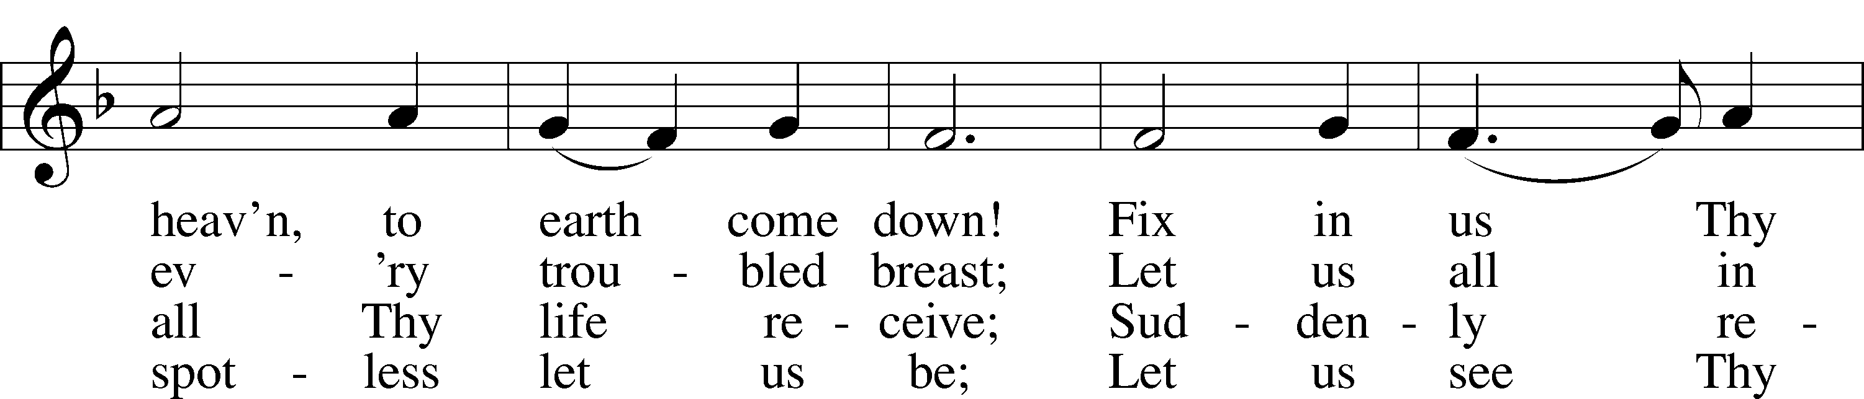

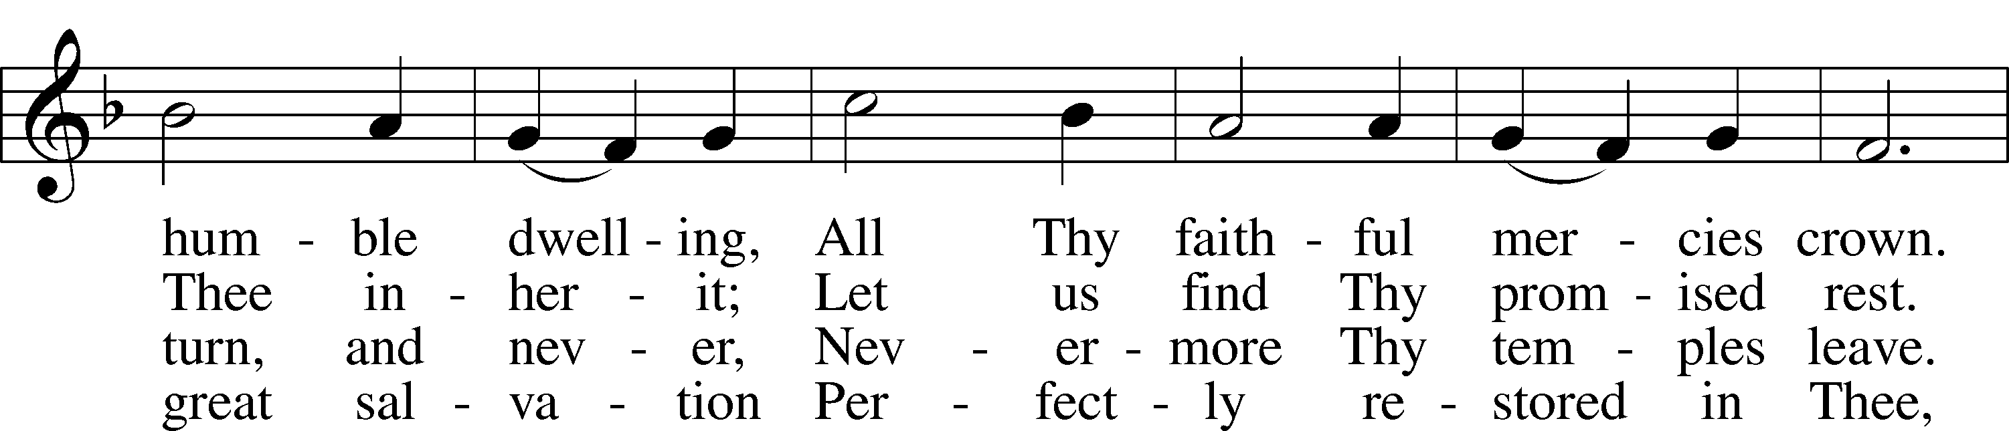

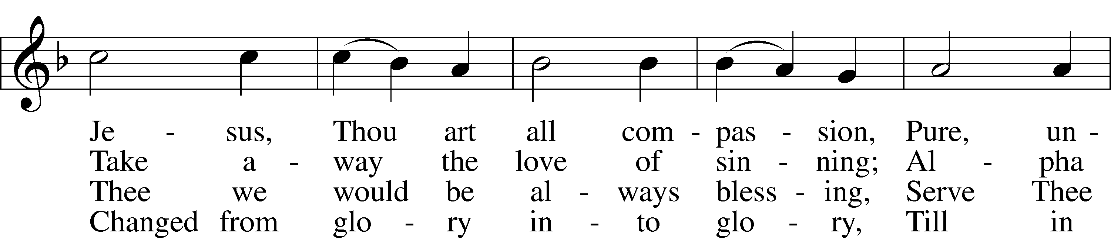

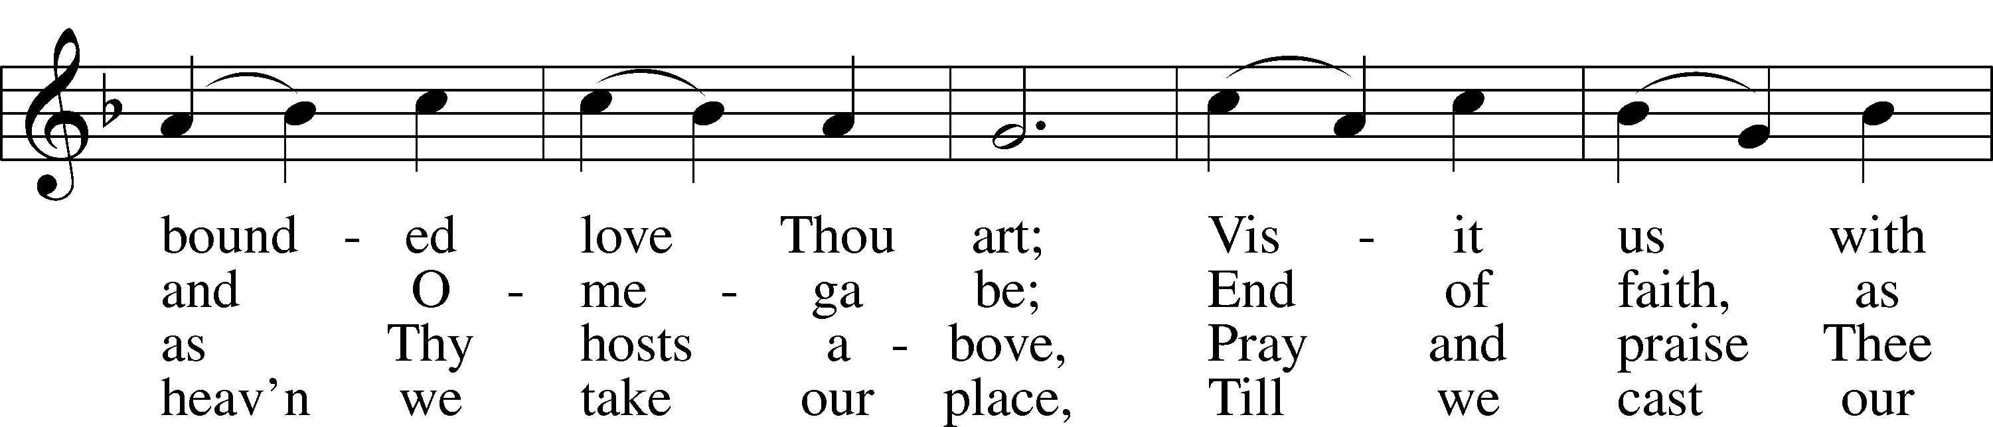

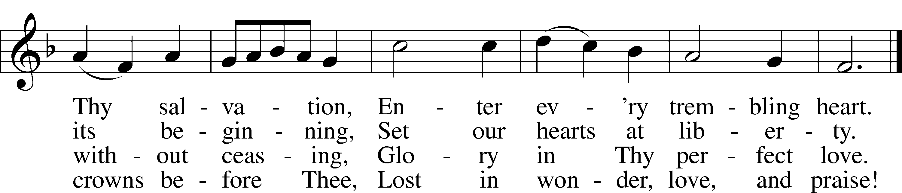

Tune and text: Public domain

Sermon We Are God’s Children NOW!

Apostles’ Creed

C **I believe in God, the Father Almighty,**

**maker of heaven and earth.**

**And in Jesus Christ, His only Son, our Lord,**

**who was conceived by the Holy Spirit,**

**born of the virgin Mary,**

**suffered under Pontius Pilate,**

**was crucified, died and was buried.**

**He descended into hell.**

**The third day He rose again from the dead.**

**He ascended into heaven**

**and sits at the right hand of God the Father Almighty.**

**From thence He will come to judge the living and the dead.**

**I believe in the Holy Spirit,**

**the holy Christian Church,**

**the communion of saints,**

**the forgiveness of sins,**

**the resurrection of the body,**

**and the life** T **everlasting. Amen.**

Prayer of the Church

P Let us remember with thanksgiving those who have gone before us with the sign of faith, for they were created by God to offer Him praise and thanksgiving forever. God gave new life to them through Holy Baptism, nourished them in the company of His people at His Holy Table, and in His mercy summoned them to His eternal presence so that they continue to serve Him forever.

T Allen Diamond T

T Ernestine Hoff T

T John Sims T

P In joyful expectation of the resurrection to life eternal, we remember before You, O Lord, those relatives, friends, and fellow members of this congregation who have gone before us in faith. We offer thanksgiving for the gift of faith and hold fast to the certainty of Your promise that where You are, there Your servants shall be also.

Let us pray for the whole people of God in Christ Jesus and for all people according to their needs. We pray for the Church, asking that its members grow in love for You and for one another. Lord, in Your mercy,

C **hear our prayer.**

P Celebrating our lives together as saints, we pray for the fellowship we enjoy as God’s holy people, asking that You strengthen us to bring the sacrifices of pure hearts and worship God in His sanctuary with joy. Lord, in Your mercy,

C **hear our prayer.**

P Thankful for the saints among us in these days, we pray for those who serve in leadership positions in our Synod, district, and local congregation, asking God to bless their work among us as they set examples of devotion and dedication in Jesus’ name. Lord, in Your mercy,

C **hear our prayer.**

P Confident that Your care for the saints knows no limits, Lord, we make our petitions for the sick, the sorrowing, and all who are in need of our prayers. Heal them according to Your good and gracious will. Lord, in Your mercy,

C **hear our prayer.**

P Reflecting on the journey of life we make together as the saints below, we pray for the youngest among us, the infants and children, and also for the most senior of saints, those who have been blessed with extended lives on earth. Give us love to cherish the company of all God’s people and seek to bring a sense of caring to all those around us. Lord, in Your mercy,

C **hear our prayer.**

P With thankfulness for the land in which we live, we ask Your blessing on our nation, its leaders, and all who work for security and a sense of community in our world and in our lives. Grant that we cherish the freedoms we enjoy and do all in our power to maintain the public good and promote peace and harmony. Lord, in Your mercy,

C **hear our prayer.**

P Into Your hands, O Lord, we commend all for whom we pray, trusting in Your mercy through Your Son, Jesus Christ, our Lord.

C **Amen.**

Offertory LSB 159

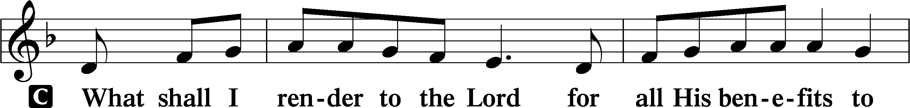

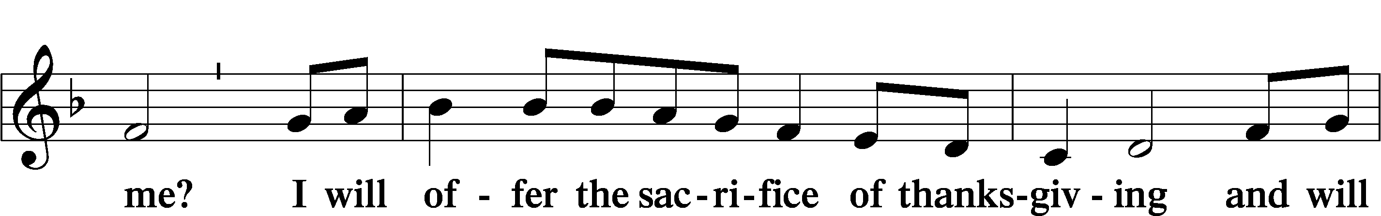

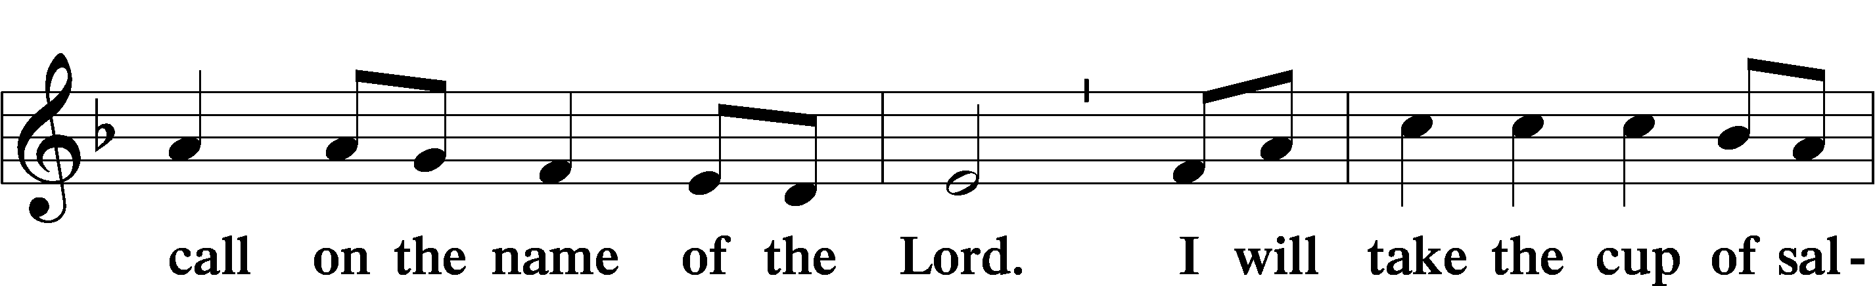

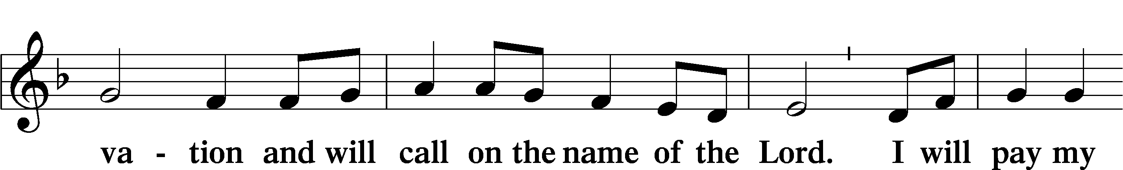

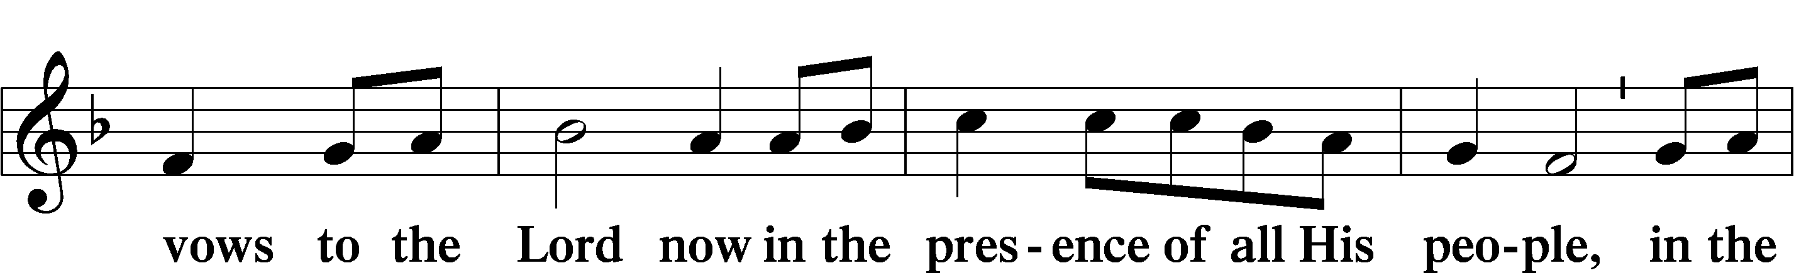

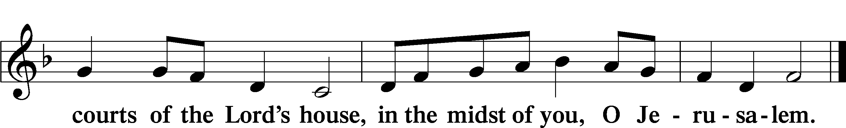

# Service of the Sacrament

Preface LSB 160











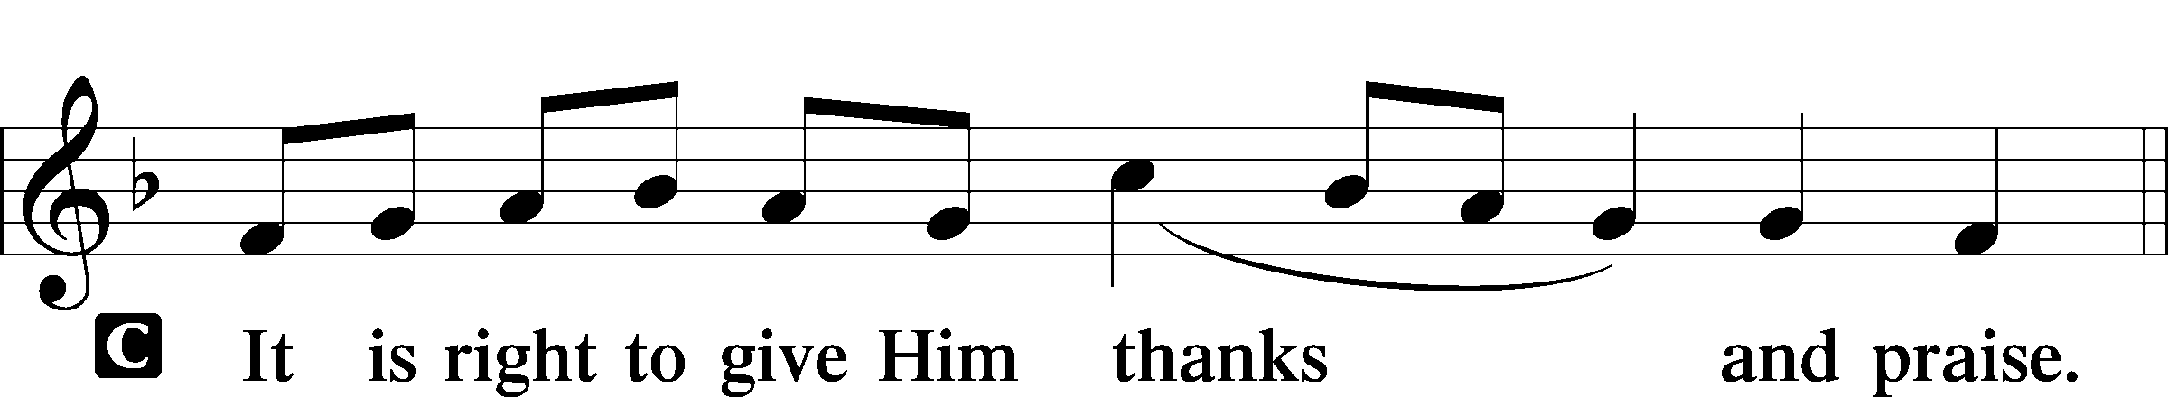

P It is truly good, right, and salutary that we should at all times and in all places give thanks to You, holy Lord, almighty Father, everlasting God. In the communion of all Your saints gathered into the one body of Your Son, You have surrounded us with so great a cloud of witnesses that we, encouraged by their faith and strengthened by their fellowship, may run with perseverance the race that is set before us and, together with them, receive the crown of glory that does not fade away. Therefore with angels and archangels and with all the company of heaven we laud and magnify Your glorious name, evermore praising You and saying:

Sanctus LSB 161

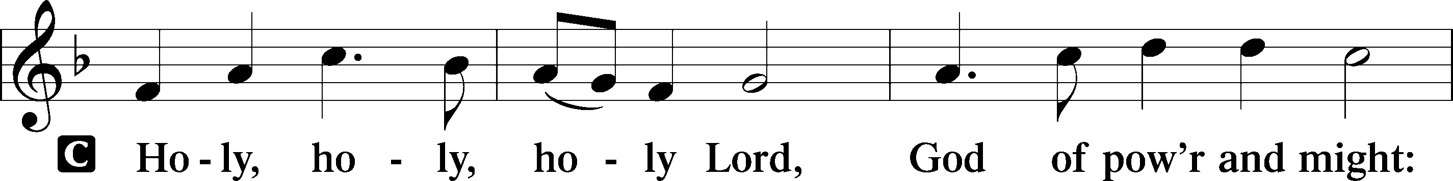

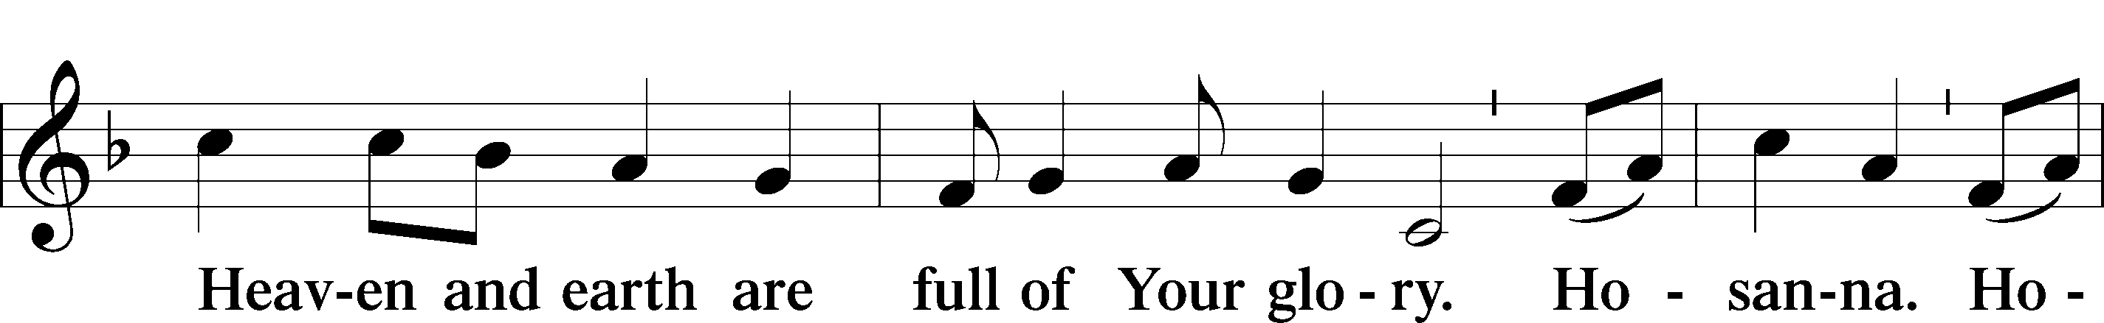

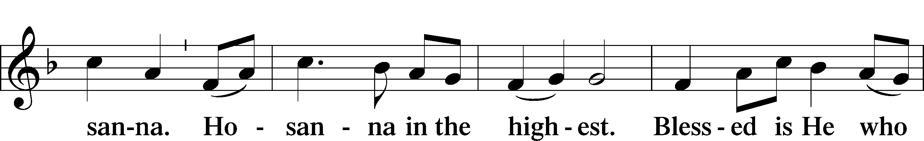

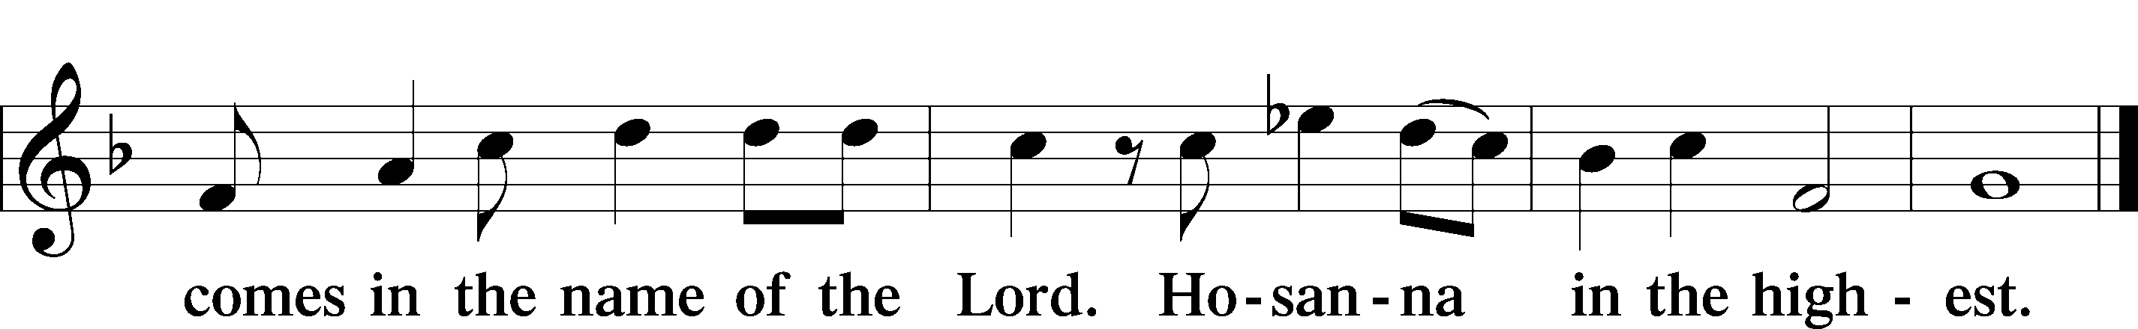

Prayer of Thanksgiving LSB 161

P Blessed are You, Lord of heaven and earth, for You have had mercy on those whom You created and sent Your only-begotten Son into our flesh to bear our sin and be our Savior. With repentant joy we receive the salvation accomplished for us by the all-availing sacrifice of His body and His blood on the cross.

Gathered in the name and the remembrance of Jesus, we beg You, O Lord, to forgive, renew, and strengthen us with Your Word and Spirit. Grant us faithfully to eat His body and drink His blood as He bids us do in His own testament. Gather us together, we pray, from the ends of the earth to celebrate with all the faithful the marriage feast of the Lamb in His kingdom, which has no end. Graciously receive our prayers; deliver and preserve us. To You alone, O Father, be all glory, honor, and worship, with the Son and the Holy Spirit, one God, now and forever.

C **Amen.**

The Words of Our Lord

P Our Lord Jesus Christ, on the night when He was betrayed, took bread, and when He had given thanks, He broke it and gave it to the disciples and said: “Take, eat; this is My T body, which is given for you. This do in remembrance of Me.”

In the same way also He took the cup after supper, and when He had given thanks, He gave it to them, saying: “Drink of it, all of you; this cup is the new testament in My T blood, which is shed for you for the forgiveness of sins. This do, as often as you drink it, in remembrance of Me.”

P As often as we eat this bread and drink this cup, we proclaim the Lord’s death until He comes.

C **Amen. Come, Lord Jesus.**

P O Lord Jesus Christ, only Son of the Father, in giving us Your body and blood to eat and to drink, You lead us to remember and confess Your holy cross and passion, Your blessed death, Your rest in the tomb, Your resurrection from the dead, Your ascension into heaven, and Your coming for the final judgment. So remember us in Your kingdom and teach us to pray:

Lord’s Prayer

C **Our Father who art in heaven,**

**hallowed be Thy name,**

**Thy kingdom come,**

**Thy will be done on earth**

**as it is in heaven;**

**give us this day our daily bread;**

**and forgive us our trespasses**

**as we forgive those**

**who trespass against us;**

**and lead us not into temptation,**

**but deliver us from evil.**

**For Thine is the kingdom**

**and the power and the glory**

**forever and ever. Amen.**

Pax Domini LSB 163

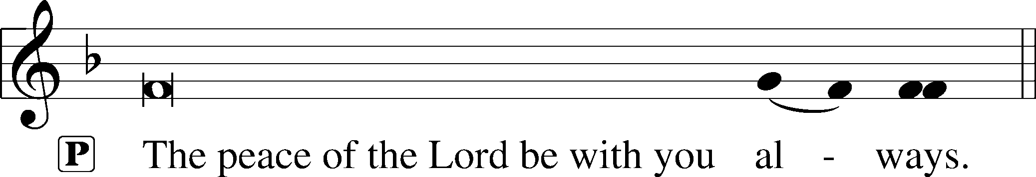



Agnus Dei LSB 163

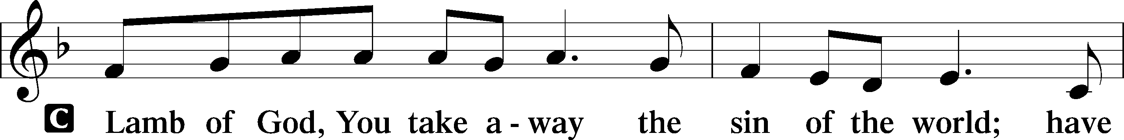

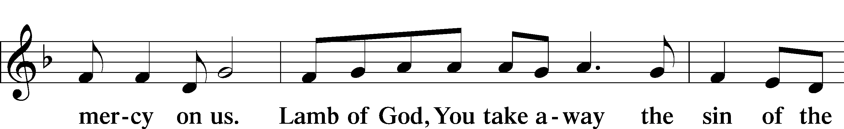

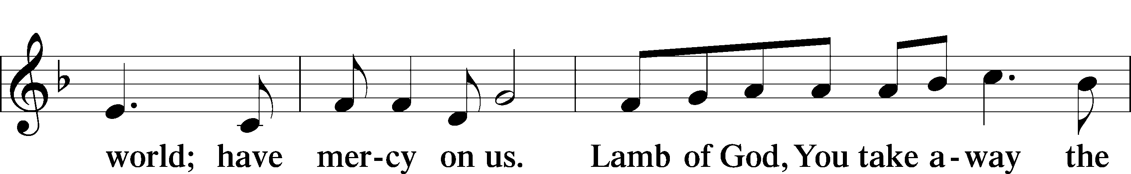

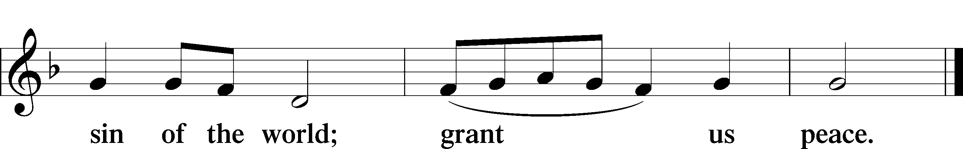

Distribution

676 Behold a Host, Arrayed in White Tune and Text: Public Domain

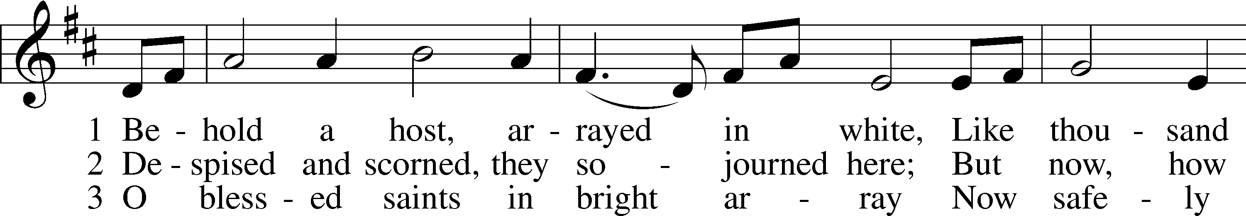

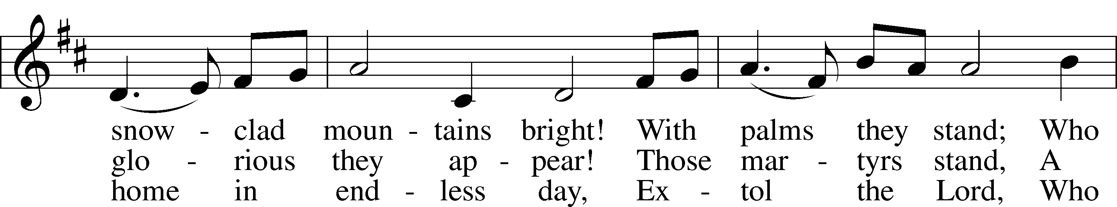

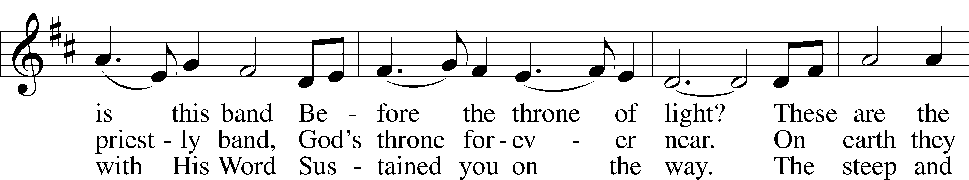

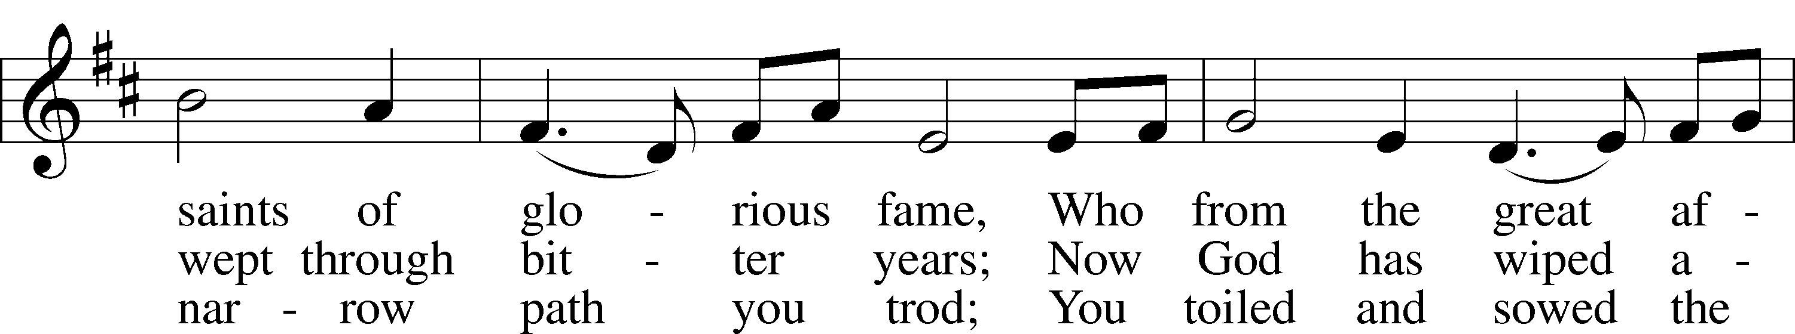

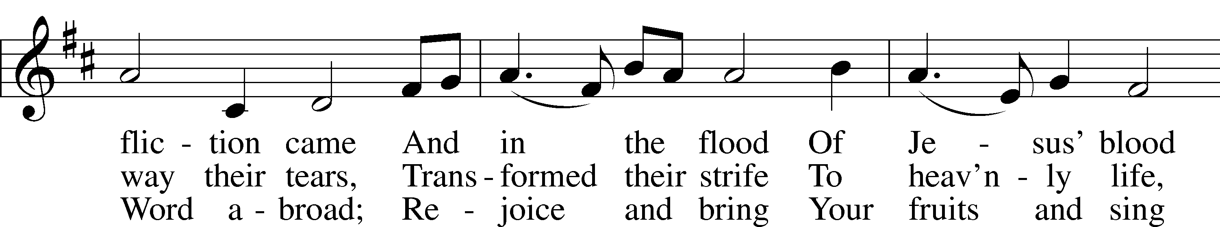

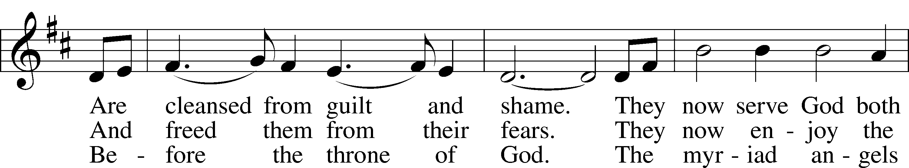

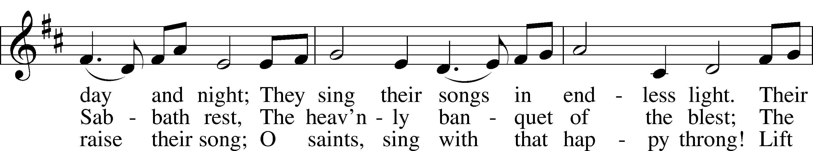

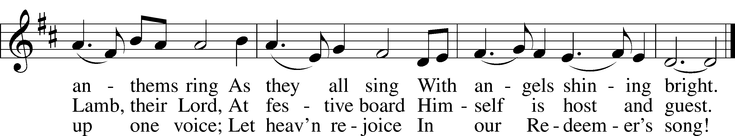

Thank the Lord LSB 164

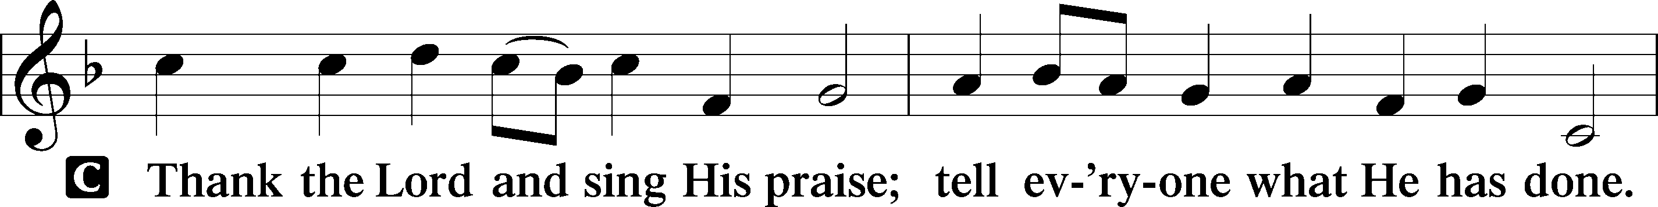

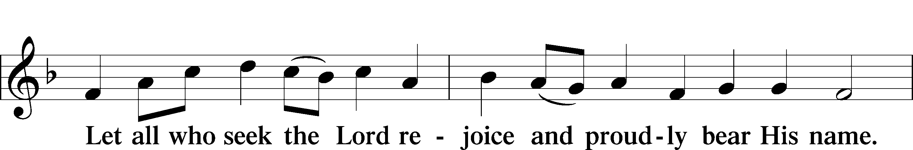

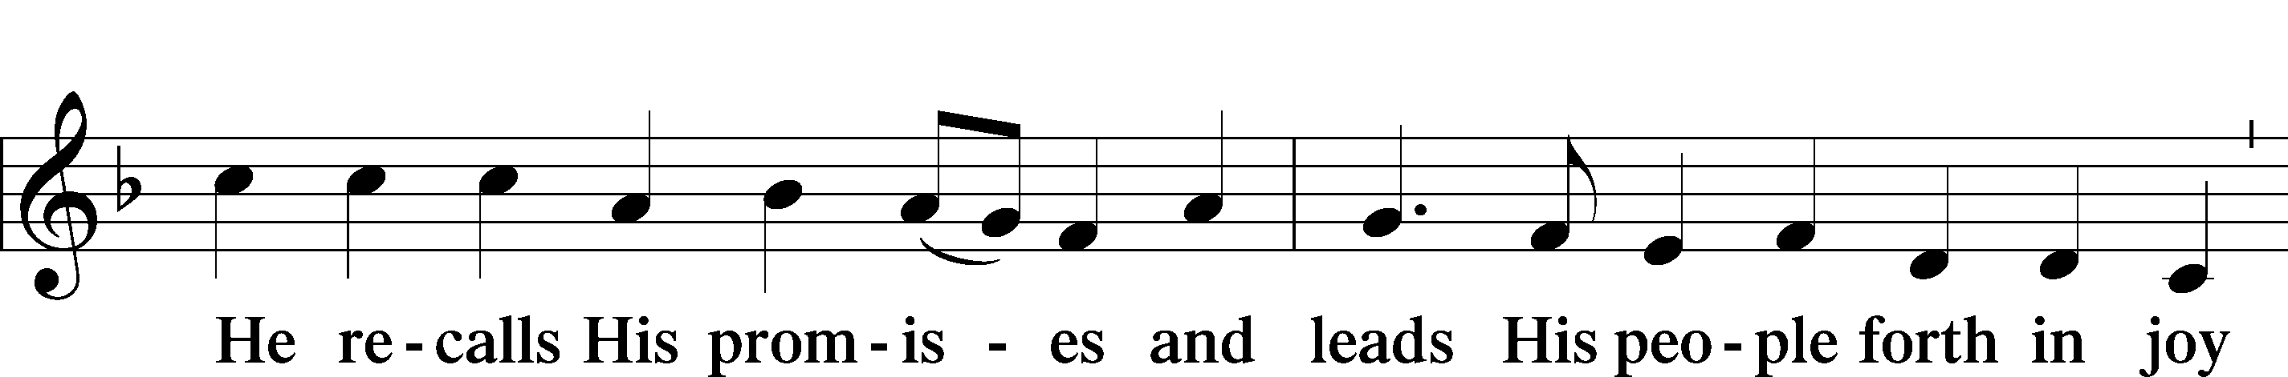

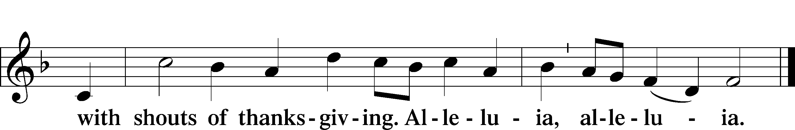

Post-Communion Collect

A Let us pray.

Gracious God, our heavenly Father, You have given us a foretaste of the feast to come in the Holy Supper of Your Son’s body and blood. Keep us firm in the true faith throughout our days of pilgrimage that, on the day of His coming, we may, together with all Your saints, celebrate the marriage feast of the Lamb in His kingdom which has no end; through Jesus Christ, Your Son, our Lord, who lives and reigns with You and the Holy Spirit, one God, now and forever.

C **Amen.**

Benediction LSB 166

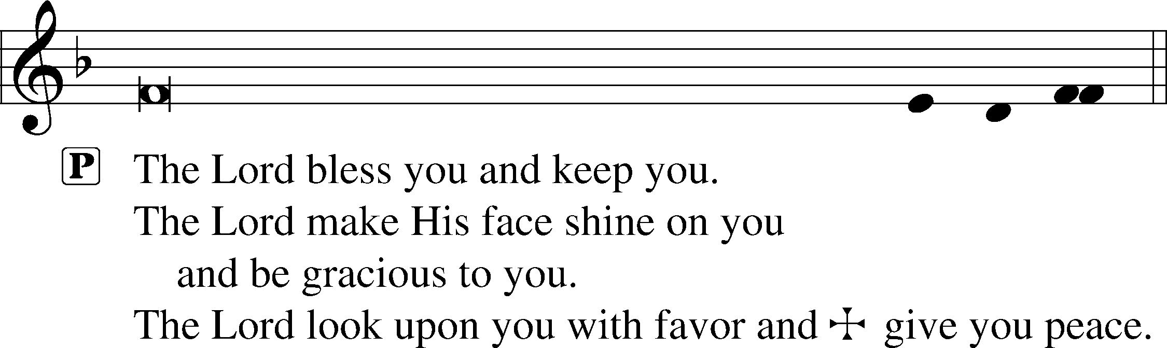



677 For All the Saints

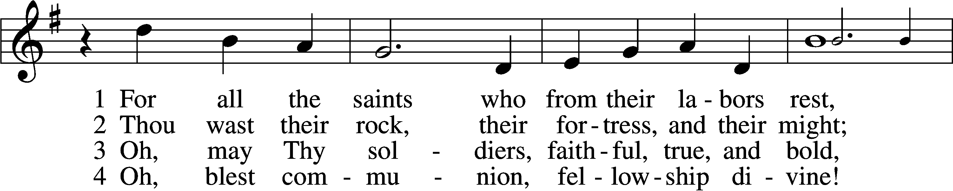

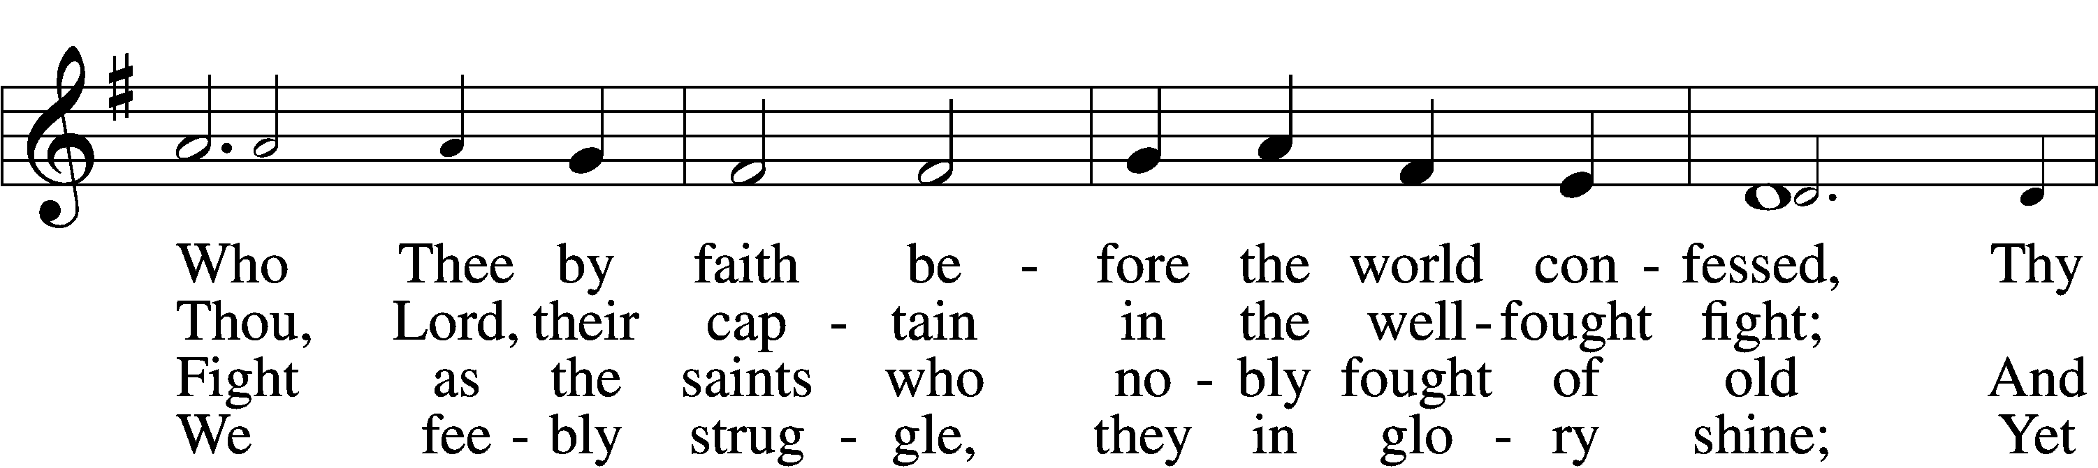

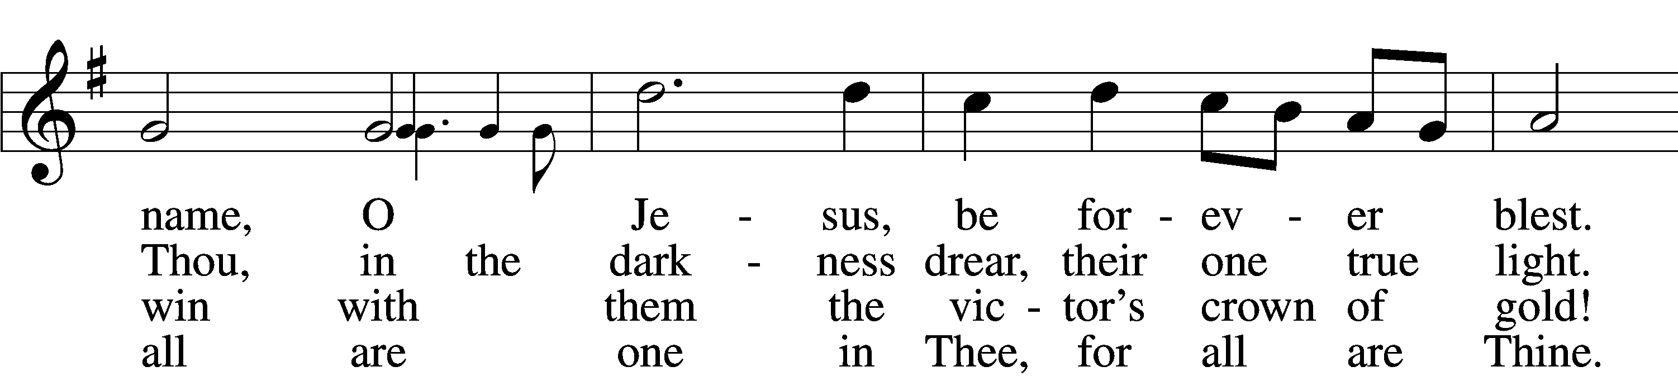

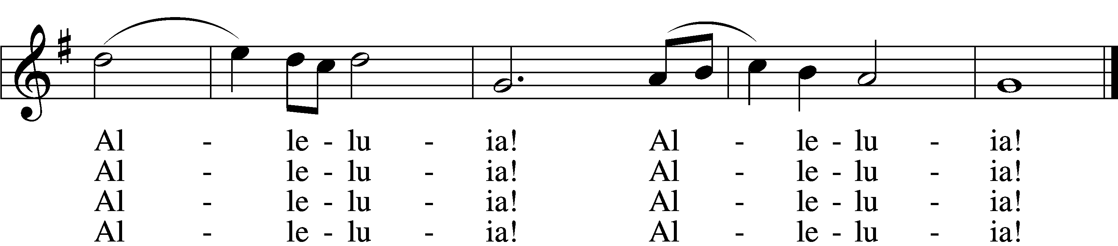

5 And when the fight is fierce, the warfare long,  
Steals on the ear the distant triumph song,  
And hearts are brave again, and arms are strong.  
 Alleluia! Alleluia!

D 8 From earth’s wide bounds, from ocean’s farthest coast,  
Through gates of pearl streams in the countless host,  
Singing to Father, Son, and Holy Ghost:  
 Alleluia! Alleluia!

Tune and text: Public domain

Acknowledgments

Divine Service, Setting One from Lutheran Service Book

Unless otherwise indicated, Scripture quotations are from the ESV® Bible (The Holy Bible, English Standard Version®), copyright © 2001 by Crossway, a publishing ministry of Good News Publishers. Used by permission. All rights reserved.

Created by Lutheran Service Builder © 2018 Concordia Publishing House.

**Gifts of Time and Treasure**

***“For where your treasure is, there your heart will be also.”***

***Matthew 6:21***

**LAST WEEK’S OFFERINGS**  **LAST WEEK’S ATTENDANCE**

General Fund $ 1,966.76 Service 46

Needed Weekly $ 3,963.38 Communed 39

Adult Bible Study $ 6.00

Children’s SS/Mission $ 5.00

Benevolence $ 1.00

**The Lord’s Week**

Today 8:45 am – Bible Studies for all ages

**(Nov. 1st)** 10:00 am – Divine Service

11:30 am – Confirmation

Tuesday 9:00 am – MDO

Wednesday 10:00 am – Women’s Bible Study

Thursday 9:00 am – MDO

Next Sunday 8:45 am –Bible Studies for all ages

**(Nov. 8th)** 10:00 am – Divine Service

11:30 am – Confirmation

**In His Service**

Elder: Robert Kunkel (1st Sun. of every mo.)

Organist: Sharon Schrader

Acolytes: Parker Bluntzer, Cody Wilson

Alter: Laura Lopez