**Twenty-Fourth Sunday after Pentecost—Proper 28**

**“Encourage & Build-Up”**

1 Thessalonians 5:1-11

**November 15, 2020**

**Messiah Lutheran Church**

**Lutheran Church-Missouri Synod**

4102 Trinity River Dr., Corpus Christi, Texas 78410

**Pastor:**  **Rev. Scott E. Herbert**

Church Phone: 361-387-7748 Email: mlc@stx.rr.com

Church Fax: 361-767-1768 Website: [www.messiahlcms-cc.org](http://www.messiahlcms-cc.org)

Pastor Phone: 469-693-9683 Pastor Email: chirev59@gmail.com

**WELCOME TO MESSIAH!**

We are glad you are here to receive what God is doing for you during Divine Service. Please sign our Guest Book located near the front door. Feel free to converse quietly until the organ prelude begins. If you are looking for a church home, please talk to the Pastor at the door. We would love to have you join us.

**Preparing for Service**

***The Gospel Prepares Us for Our Heavenly Bridegroom’s Coming***

The Day of the Lord is *“darkness, and not light”* (Amos 5:18, 20) for all who trust in their own righteousness and piety. The Lord will not accept their *“burnt offerings and grain offerings,”* nor will He look upon their *“peace offerings”* (Amos 5:22). Instead, He desires a heart of faith that trusts in Him, which lets *“justice roll down like waters, and righteousness like an ever-flowing stream”* (Amos 5:24) in love for the neighbor. In order for the “lamps” of our lives to burn brightly with such love, we must be filled with the “oil” of forgiveness through faith in our Bridegroom, Jesus Christ (Matt. 25:1–4). Therefore, as we await His coming, wisdom directs us *“to the dealers”* (Matt. 25:9), that is, to the ministers of His Gospel. Thus, we wait upon the Lord, and we *“encourage one another with these words”* (1 Thess. 4:18). Waking or sleeping, we are prepared to meet Him when He comes *“with a cry of command, with the voice of an archangel, and with the sound of the trumpet of God,”* and *“we will always be with the Lord”* (1 Thess. 4:16, 17).

# Confession and Absolution

338 Come, Thou Long-Expected Jesus

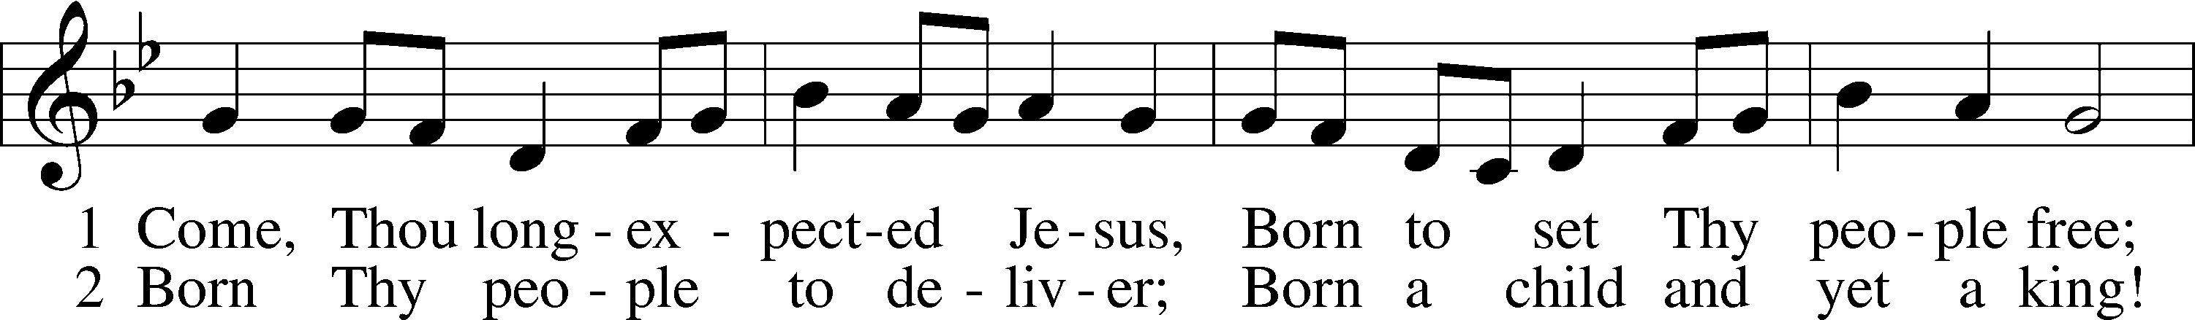

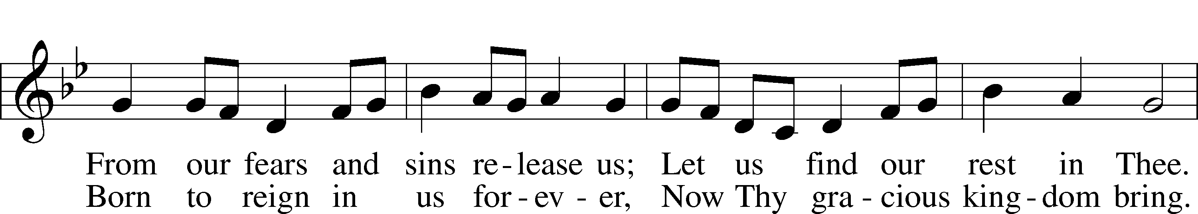

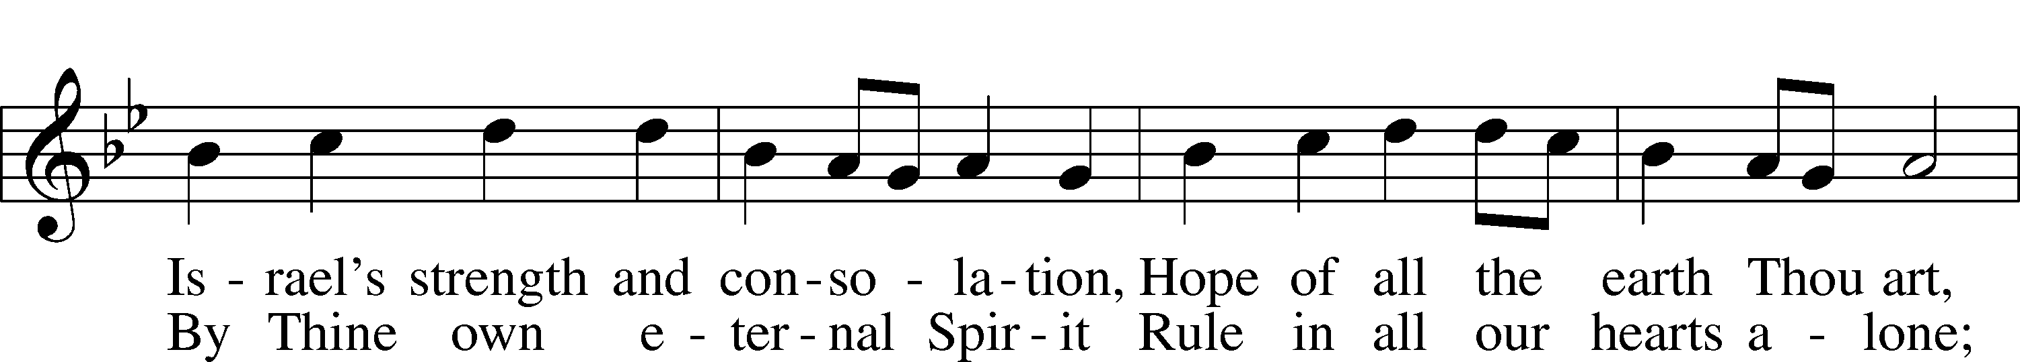

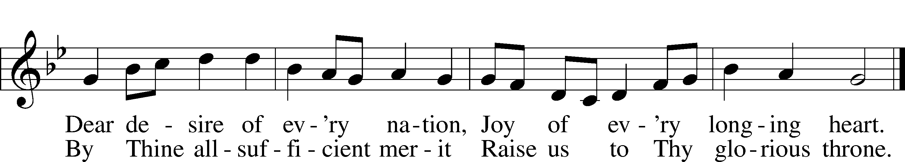

Text and tune: Public domain

P In the name of the Father and of the T Son and of the Holy Spirit.

C **Amen.**

P If we say we have no sin, we deceive ourselves, and the truth is not in us.

C **But if we confess our sins, God, who is faithful and just, will forgive our sins and cleanse us from all unrighteousness.**

P Let us then confess our sins to God our Father.

C **Most merciful God, we confess that we are by nature sinful and unclean. We have sinned against You in thought, word, and deed, by what we have done and by what we have left undone. We have not loved You with our whole heart; we have not loved our neighbors as ourselves. We justly deserve Your present and eternal punishment. For the sake of Your Son, Jesus Christ, have mercy on us. Forgive us, renew us, and lead us, so that we may delight in Your will and walk in Your ways to the glory of Your holy name. Amen.**

P Almighty God in His mercy has given His Son to die for you and for His sake forgives you all your sins. As a called and ordained servant of Christ, and by His authority, I therefore forgive you all your sins in the name of the Father and of the T Son and of the Holy Spirit.

C **Amen.**

# Service of the Word

Introit Psalm 143:2, 5–6, 10–11; antiphon: v. 1

Hear my prayer, O Lord; give ear to my pleas for mercy!  
 **In your faithfulness answer me, in your righteousness!**Enter not into judgment with your servant,  
 **for no one living is righteous before you.**I remember the days of old;

I meditate on all that you have done;  
 **I ponder the work of your hands.**I stretch out my hands to you;  
 **my soul thirsts for you like a parched land.**Teach me to do your will, for you are my God!  
 **Let your good Spirit lead me on level ground!**For your name’s sake, O Lord, preserve my life!  
 **In your righteousness bring my soul out of trouble!  
Glory be to the Father and to the Son and to the Holy Spirit;**  
**as it was in the beginning, is now, and will be forever. Amen.**  
Hear my prayer, O Lord; give ear to my pleas for mercy!  
 In your faithfulness answer me, in your righteousness!

Kyrie LSB 152





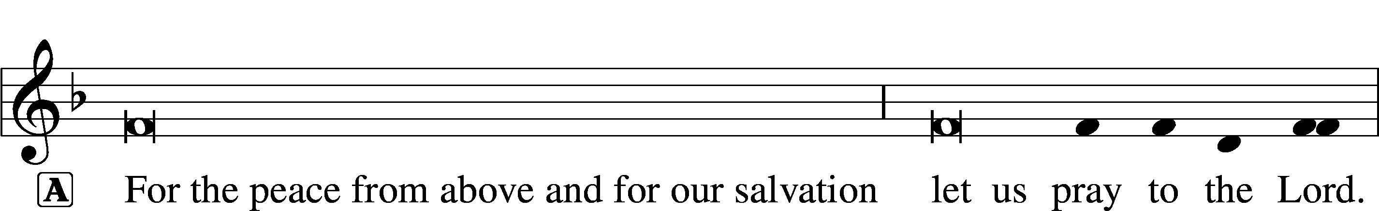



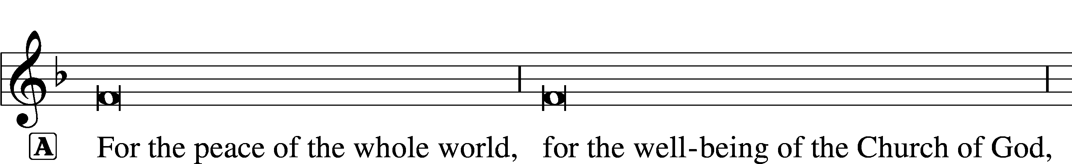





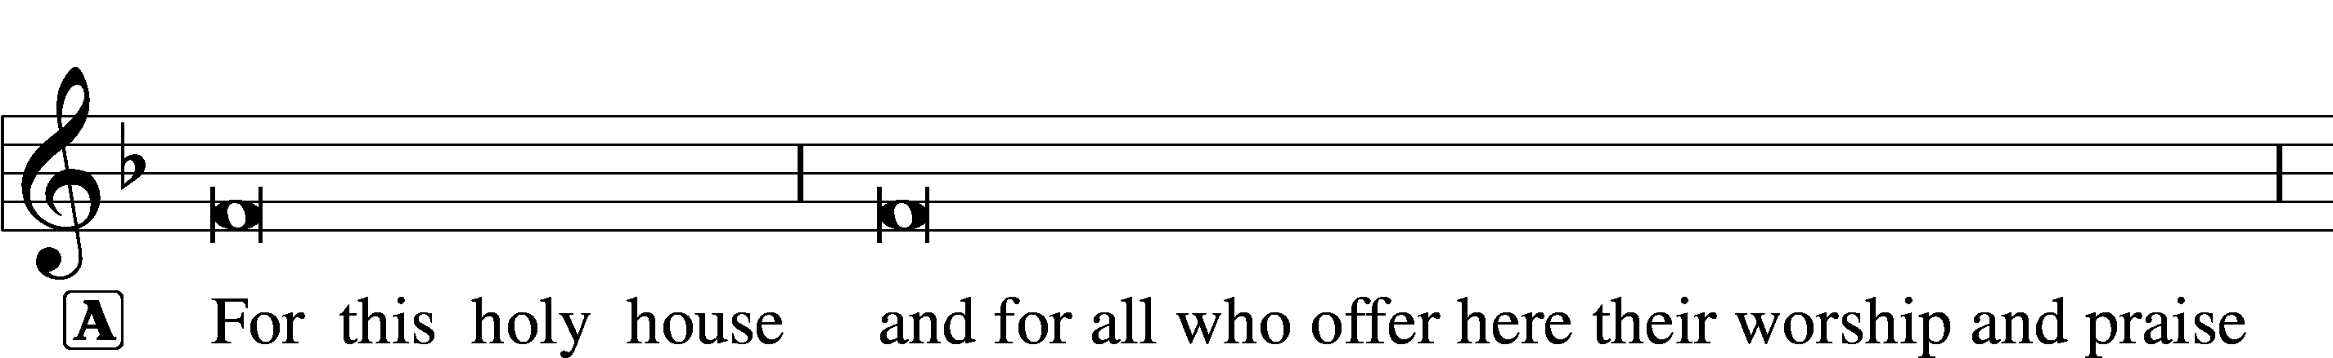









This Is the Feast LSB 155

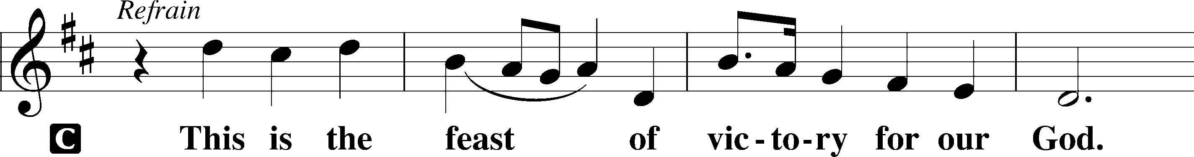

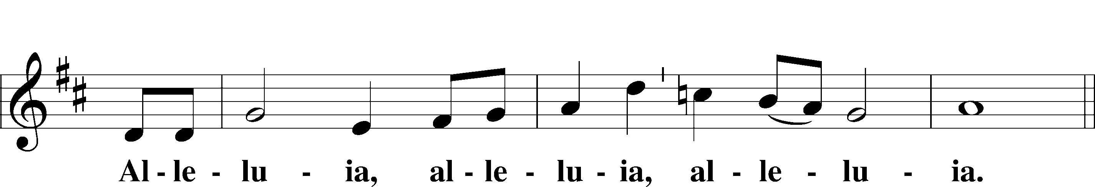

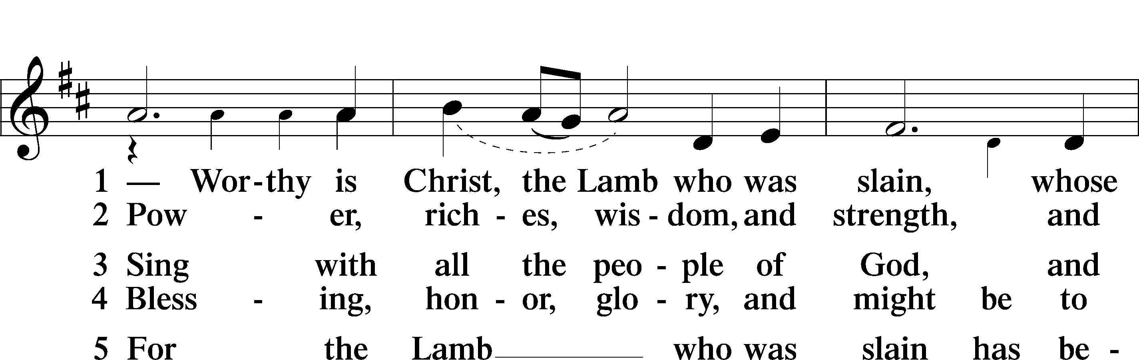

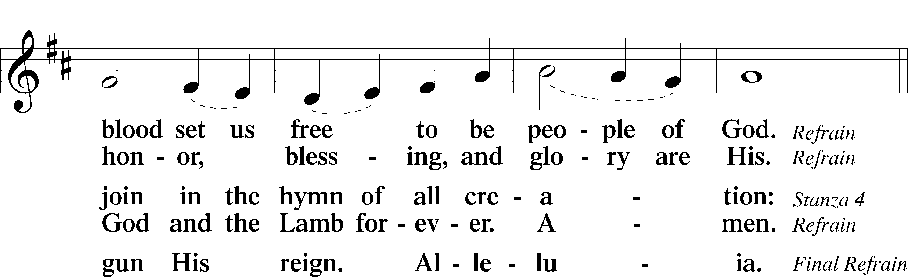

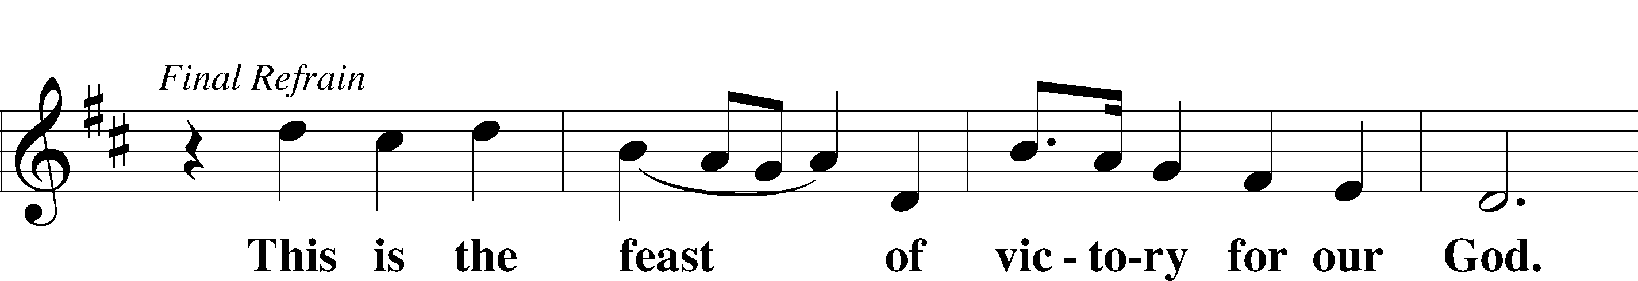

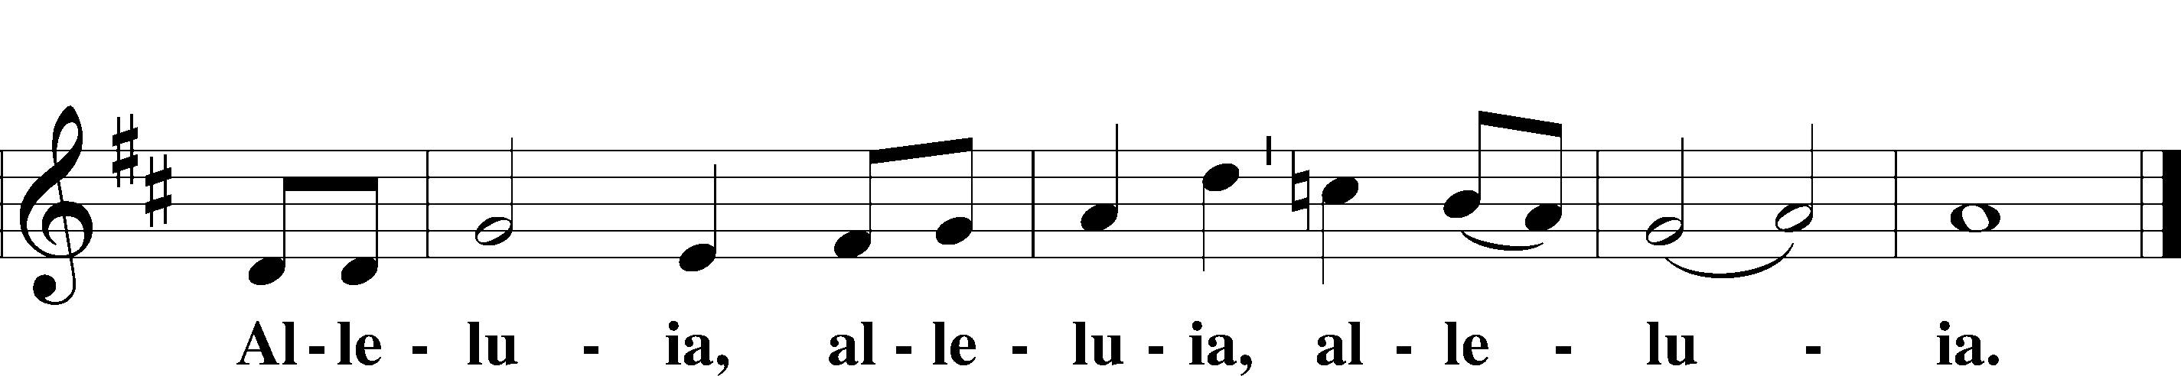

Salutation and Collect of the Day

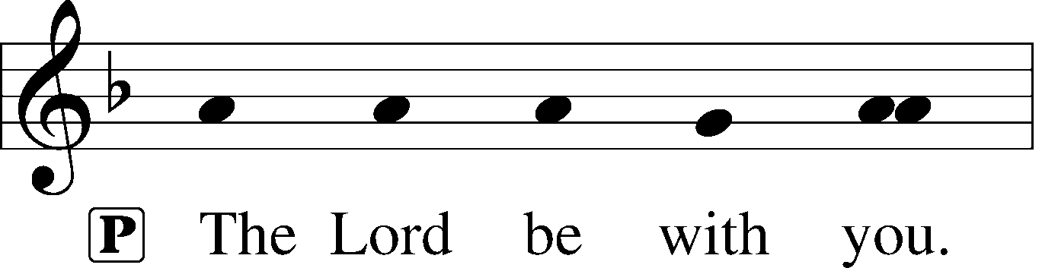

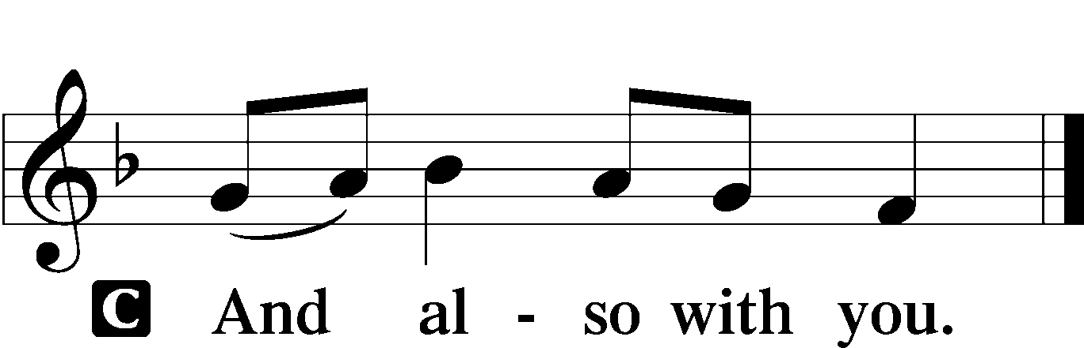

P Let us pray.

Almighty and ever-living God, You have given exceedingly great and precious promises to those who trust in You. Dispel from us the works of darkness and grant us to live in the light of Your Son, Jesus Christ, that our faith may never be found wanting; through the same Jesus Christ, our Lord, who lives and reigns with You and the Holy Spirit, one God, now and forever.

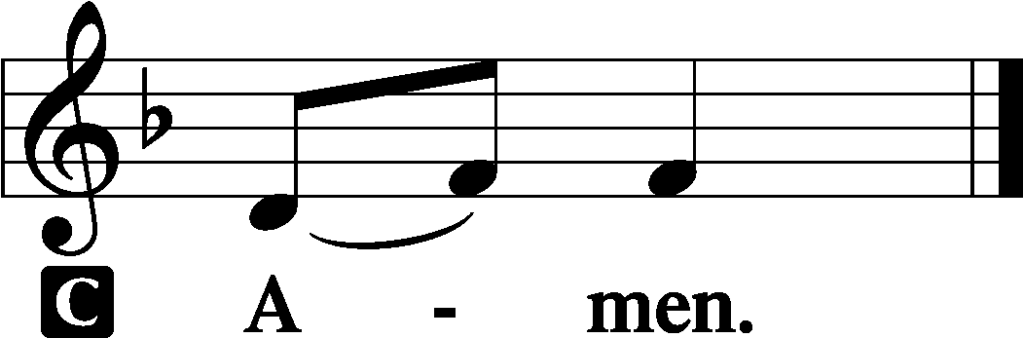

Old Testament Reading Zephaniah 1:7–16

7Be silent before the Lord God!  
 For the day of the Lord is near;  
the Lord has prepared a sacrifice  
 and consecrated his guests.  
8And on the day of the Lord’s sacrifice—  
“I will punish the officials and the king’s sons  
 and all who array themselves in foreign attire.  
9On that day I will punish  
 everyone who leaps over the threshold,  
and those who fill their master’s house  
 with violence and fraud.  
10“On that day,” declares the Lord,  
 “a cry will be heard from the Fish Gate,  
a wail from the Second Quarter,  
 a loud crash from the hills.  
11Wail, O inhabitants of the Mortar!  
 For all the traders are no more;  
 all who weigh out silver are cut off.  
12At that time I will search Jerusalem with lamps,  
 and I will punish the men  
who are complacent,  
 those who say in their hearts,  
‘The Lord will not do good,  
 nor will he do ill.’  
13Their goods shall be plundered,  
 and their houses laid waste.  
Though they build houses,  
 they shall not inhabit them;  
though they plant vineyards,  
 they shall not drink wine from them.”  
14The great day of the Lord is near,  
 near and hastening fast;  
the sound of the day of the Lord is bitter;  
 the mighty man cries aloud there.  
15A day of wrath is that day,  
 a day of distress and anguish,  
a day of ruin and devastation,  
 a day of darkness and gloom,  
a day of clouds and thick darkness,  
 16a day of trumpet blast and battle cry  
against the fortified cities  
 and against the lofty battlements.

A This is the Word of the Lord.

C **Thanks be to God.**

Epistle 1 Thessalonians 5:1–11

1Now concerning the times and the seasons, brothers, you have no need to have anything written to you. 2For you yourselves are fully aware that the day of the Lord will come like a thief in the night. 3While people are saying, “There is peace and security,” then sudden destruction will come upon them as labor pains come upon a pregnant woman, and they will not escape. 4But you are not in darkness, brothers, for that day to surprise you like a thief. 5For you are all children of light, children of the day. We are not of the night or of the darkness. 6So then let us not sleep, as others do, but let us keep awake and be sober. 7For those who sleep, sleep at night, and those who get drunk, are drunk at night. 8But since we belong to the day, let us be sober, having put on the breastplate of faith and love, and for a helmet the hope of salvation. 9For God has not destined us for wrath, but to obtain salvation through our Lord Jesus Christ, 10who died for us so that whether we are awake or asleep we might live with him. 11Therefore encourage one another and build one another up, just as you are doing.

A This is the Word of the Lord.

C **Thanks be to God.**

Alleluia and Verse LSB 156

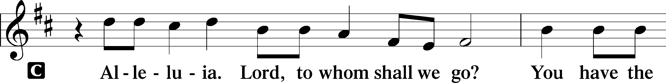

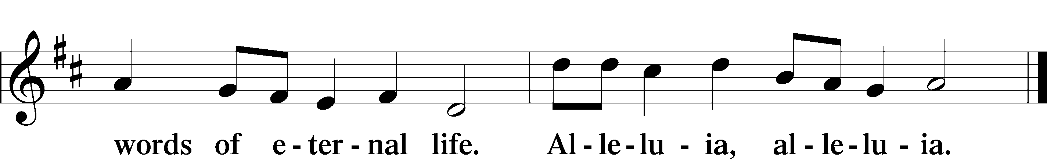

Holy Gospel Matthew 25:14–30

P The Holy Gospel according to St. Matthew, the twenty-fifth chapter.

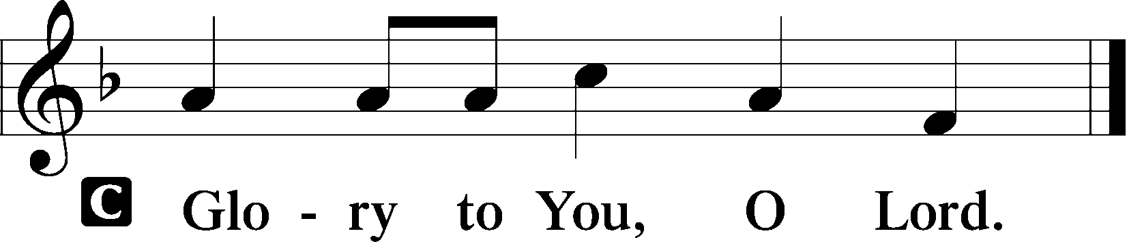

14[Jesus said:] “For it will be like a man going on a journey, who called his servants and entrusted to them his property. 15To one he gave five talents, to another two, to another one, to each according to his ability. Then he went away. 16He who had received the five talents went at once and traded with them, and he made five talents more. 17So also he who had the two talents made two talents more. 18But he who had received the one talent went and dug in the ground and hid his master’s money. 19Now after a long time the master of those servants came and settled accounts with them. 20And he who had received the five talents came forward, bringing five talents more, saying, ‘Master, you delivered to me five talents; here I have made five talents more.’ 21His master said to him, ‘Well done, good and faithful servant. You have been faithful over a little; I will set you over much. Enter into the joy of your master.’ 22And he also who had the two talents came forward, saying, ‘Master, you delivered to me two talents; here I have made two talents more.’ 23His master said to him, ‘Well done, good and faithful servant. You have been faithful over a little; I will set you over much. Enter into the joy of your master.’ 24He also who had received the one talent came forward, saying, ‘Master, I knew you to be a hard man, reaping where you did not sow, and gathering where you scattered no seed, 25so I was afraid, and I went and hid your talent in the ground. Here you have what is yours.’ 26But his master answered him, ‘You wicked and slothful servant! You knew that I reap where I have not sowed and gather where I scattered no seed? 27Then you ought to have invested my money with the bankers, and at my coming I should have received what was my own with interest. 28So take the talent from him and give it to him who has the ten talents. 29For to everyone who has will more be given, and he will have an abundance. But from the one who has not, even what he has will be taken away. 30And cast the worthless servant into the outer darkness. In that place there will be weeping and gnashing of teeth.’”

P This is the Gospel of the Lord.

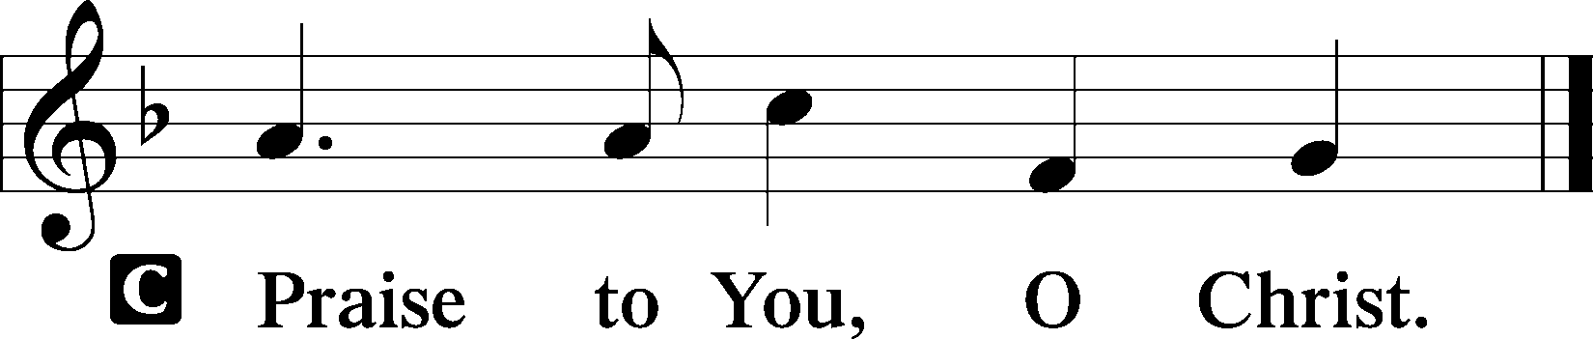

Children’s Message “The Parable of the Talents”

508 The Day Is Surely Drawing Near

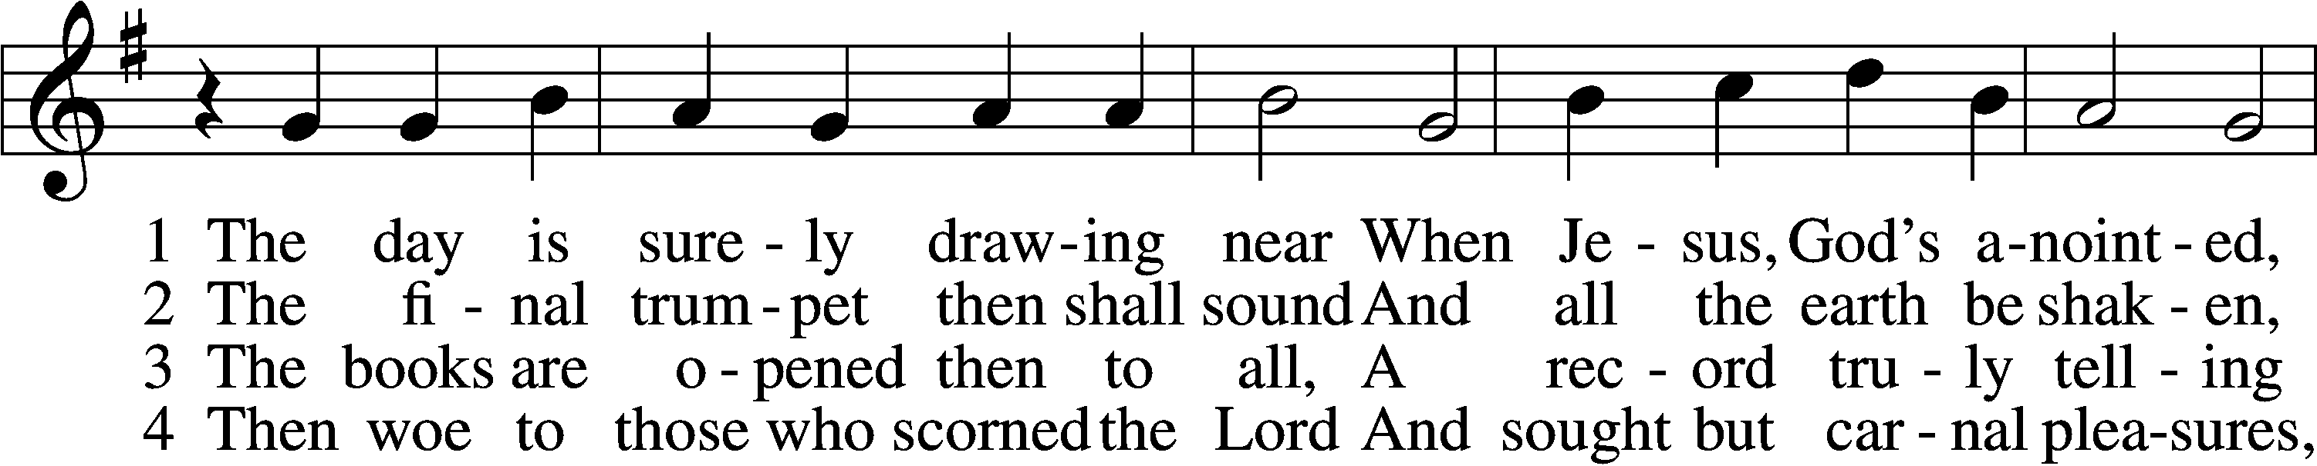

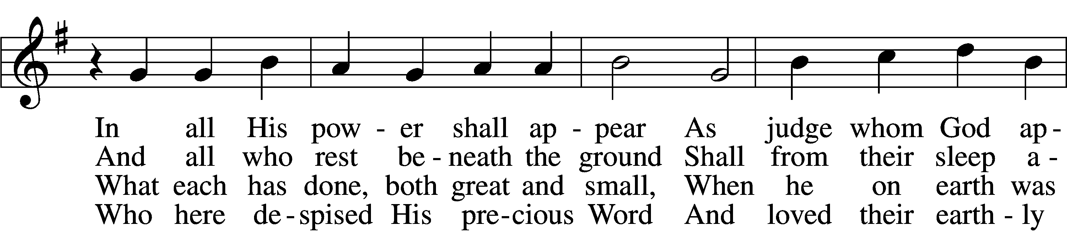

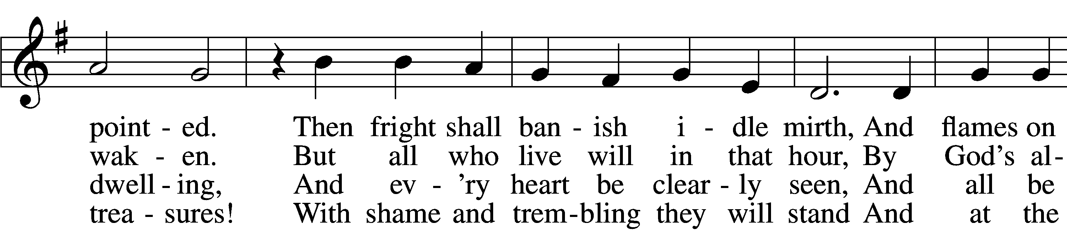

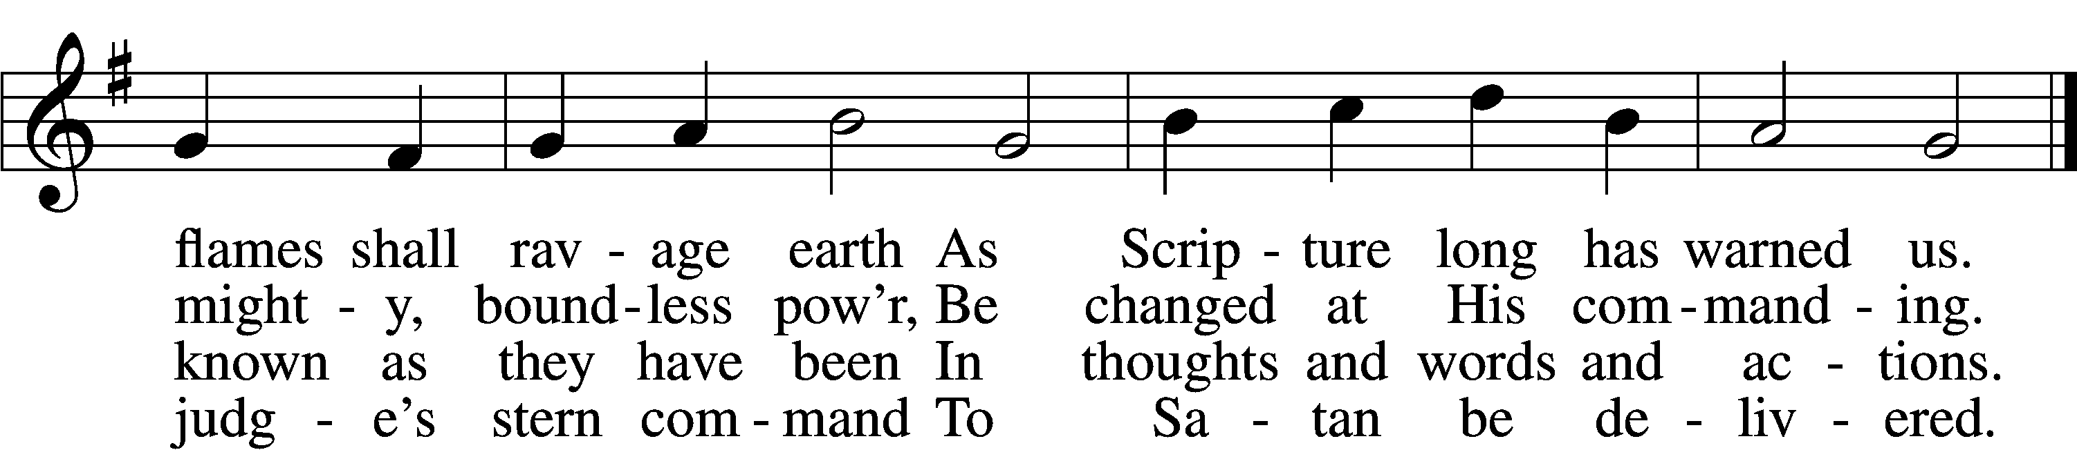

Text and tune: Public domain

Sermon “Encourage & Build-Up”

Apostles’ Creed

C **I believe in God, the Father Almighty,**

**maker of heaven and earth.**

**And in Jesus Christ, His only Son, our Lord,**

**who was conceived by the Holy Spirit,**

**born of the virgin Mary,**

**suffered under Pontius Pilate,**

**was crucified, died and was buried.**

**He descended into hell.**

**The third day He rose again from the dead.**

**He ascended into heaven**

**and sits at the right hand of God the Father Almighty.**

**From thence He will come to judge the living and the dead.**

**I believe in the Holy Spirit,**

**the holy Christian Church,**

**the communion of saints,**

**the forgiveness of sins,**

**the resurrection of the body,**

**and the life** T **everlasting. Amen.**

Prayer of the Church

Offertory LSB 159

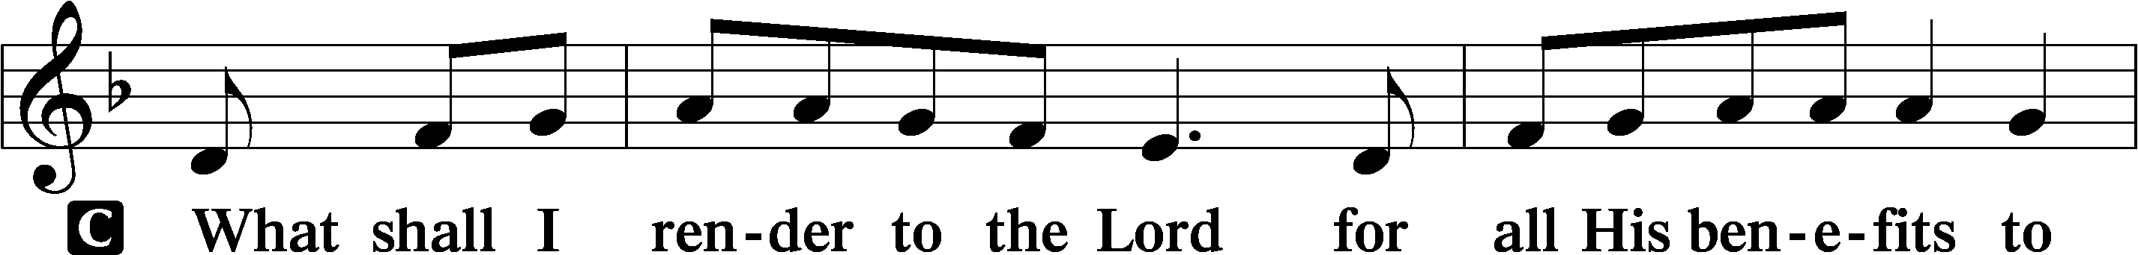

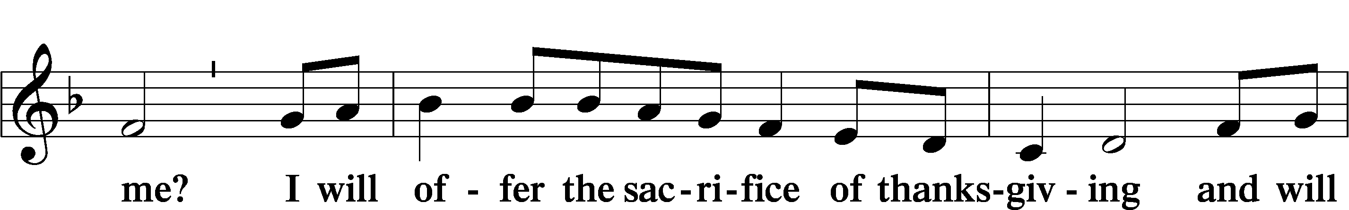

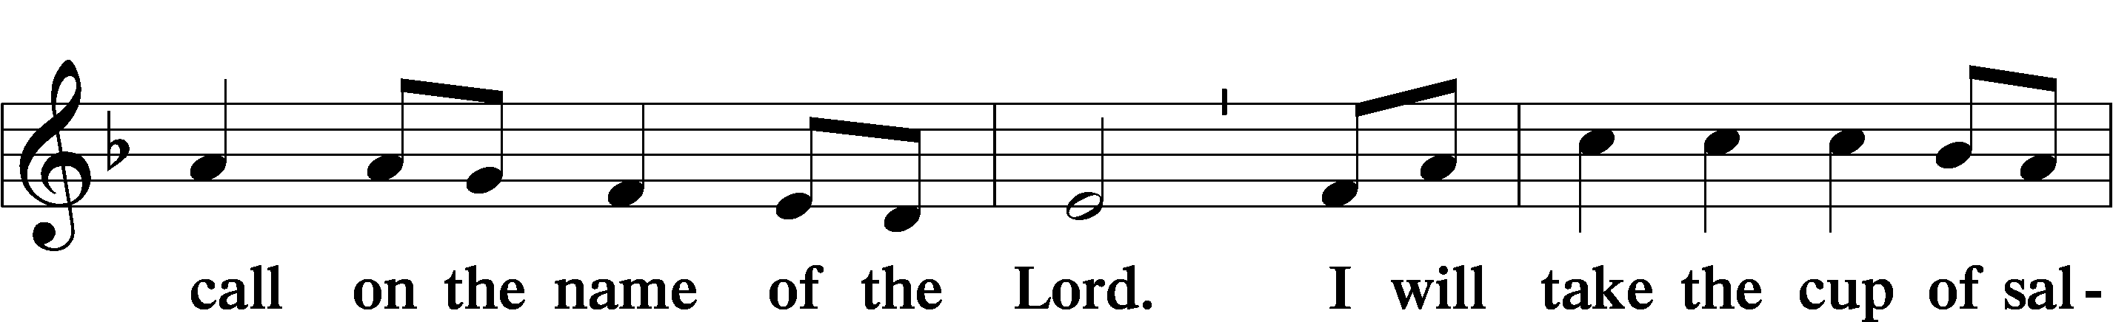

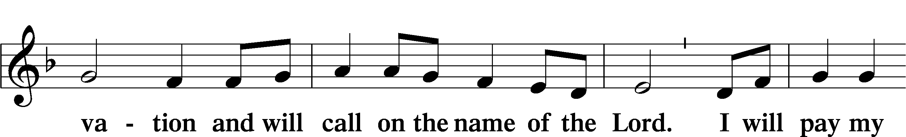

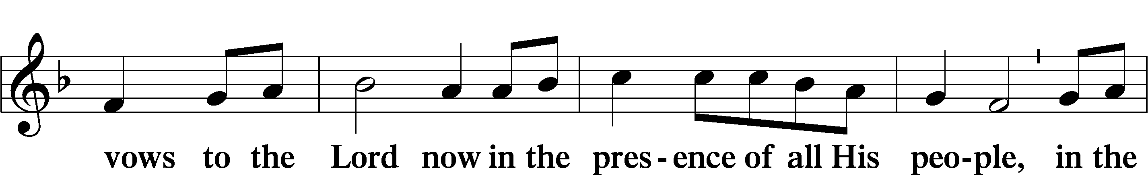

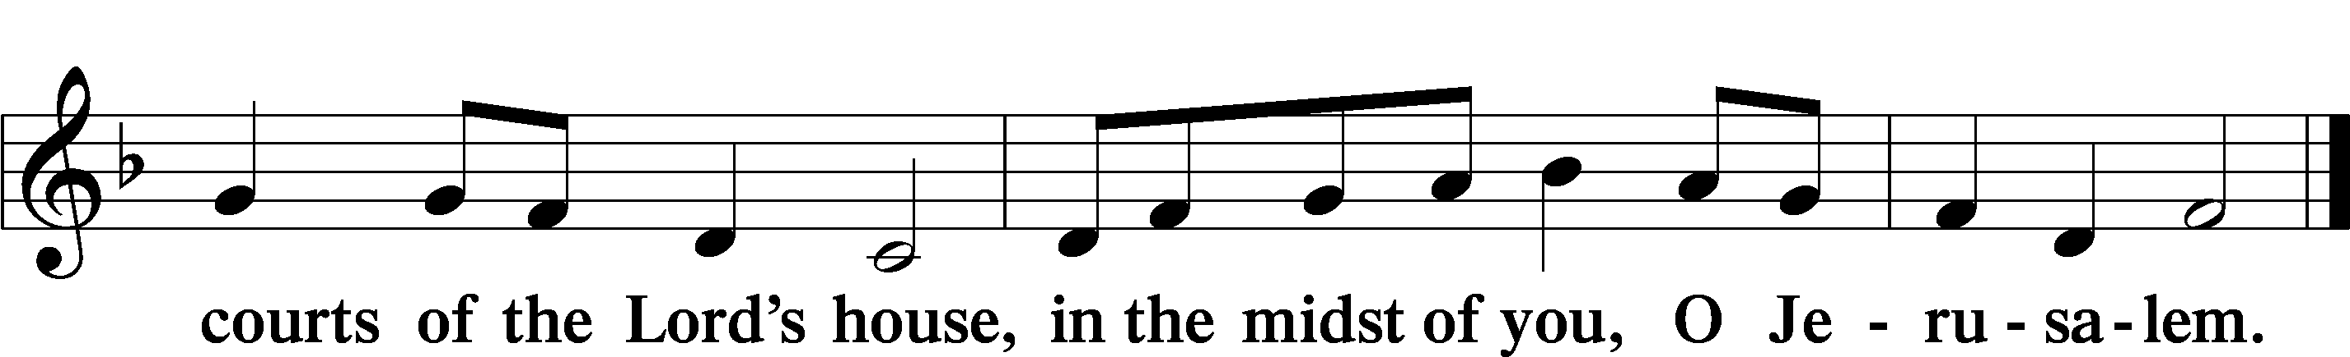

# Service of the Sacrament

Preface LSB 160











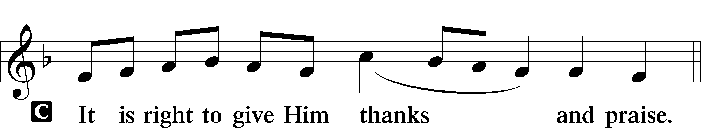

P It is truly good, right, and salutary that we should at all times and in all places give thanks to You, holy Lord, almighty Father, everlasting God, through Jesus Christ, our Lord, who, having created all things, took on human flesh and was born of the virgin Mary. For our sake He died on the cross and rose from the dead to put an end to death, thus fulfilling Your will and gaining for You a holy people. Therefore with angels and archangels and with all the company of heaven we laud and magnify Your glorious name, evermore praising You and saying:

Sanctus LSB 161

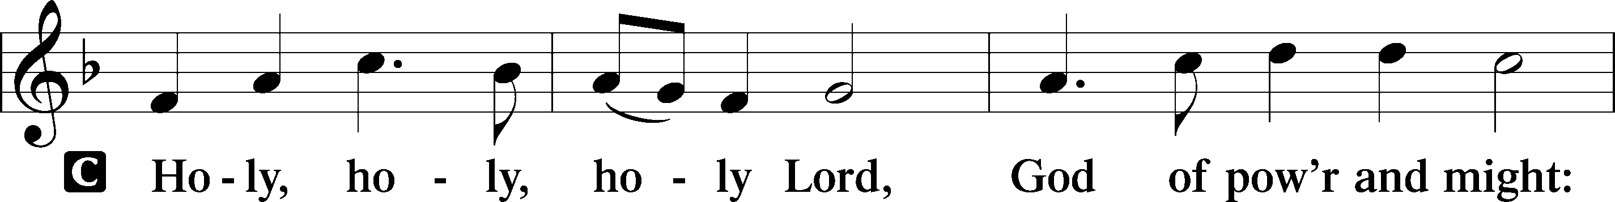

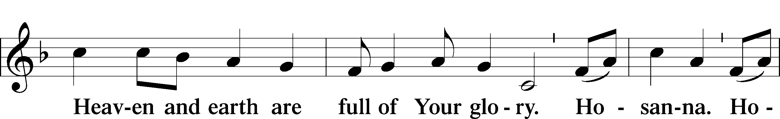

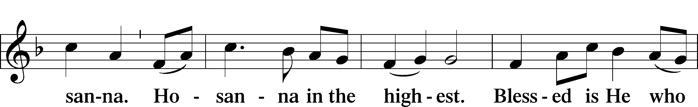

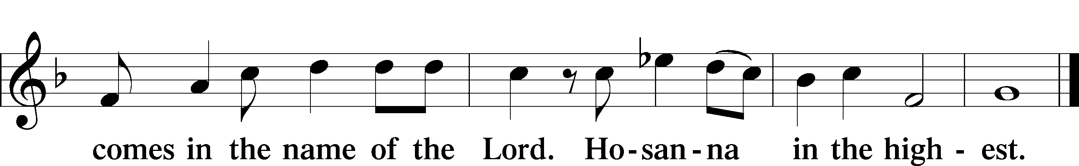

The Words of Our Lord

P Our Lord Jesus Christ, on the night when He was betrayed, took bread, and when He had given thanks, He broke it and gave it to the disciples and said: “Take, eat; this is My T body, which is given for you. This do in remembrance of Me.”

In the same way also He took the cup after supper, and when He had given thanks, He gave it to them, saying: “Drink of it, all of you; this cup is the new testament in My T blood, which is shed for you for the forgiveness of sins. This do, as often as you drink it, in remembrance of Me.”

Lord’s Prayer

C **Our Father who art in heaven,**

**hallowed be Thy name,**

**Thy kingdom come,**

**Thy will be done on earth**

**as it is in heaven;**

**give us this day our daily bread;**

**and forgive us our trespasses**

**as we forgive those**

**who trespass against us;**

**and lead us not into temptation, but deliver us from evil.**

**For Thine is the kingdom**

**and the power and the glory**

**forever and ever. Amen.**

Pax Domini LSB 163

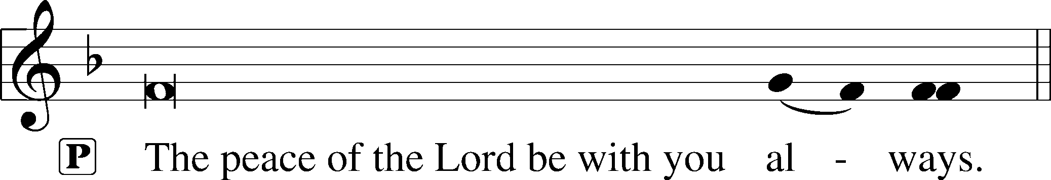



Agnus Dei LSB 163

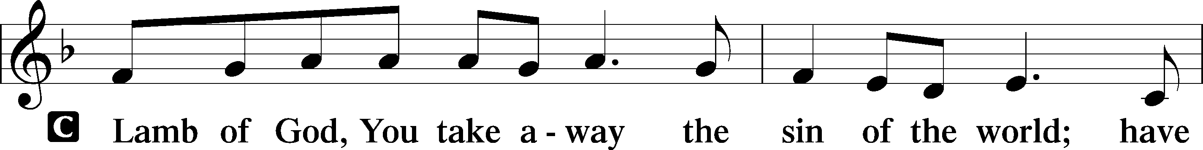

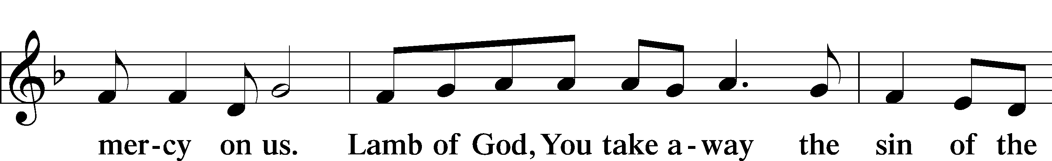

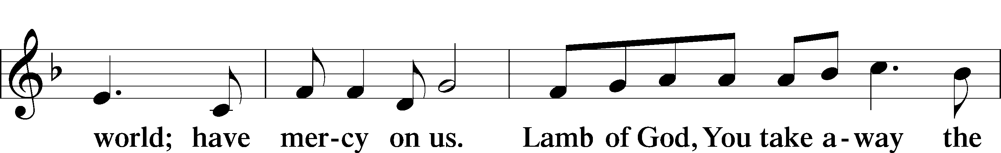

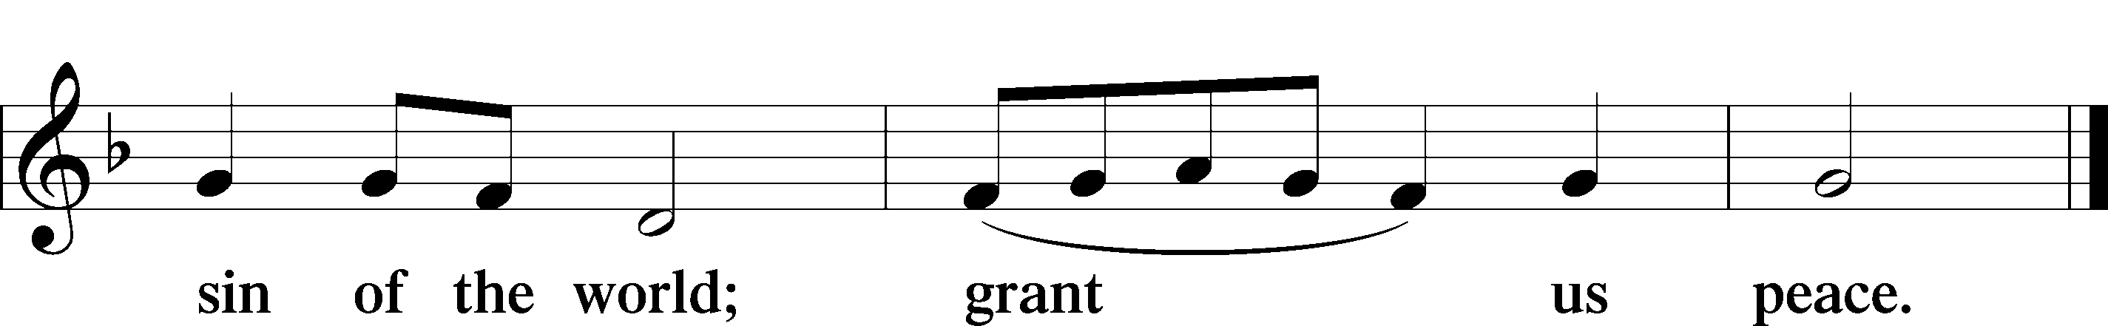

Distribution

627 Jesus Christ, Our Blessed Savior

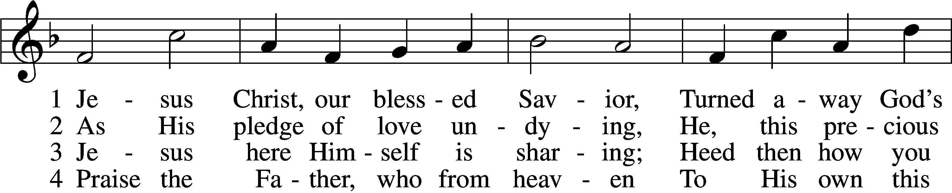

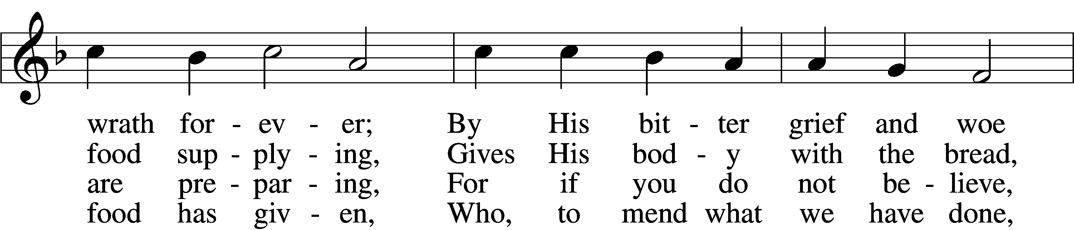

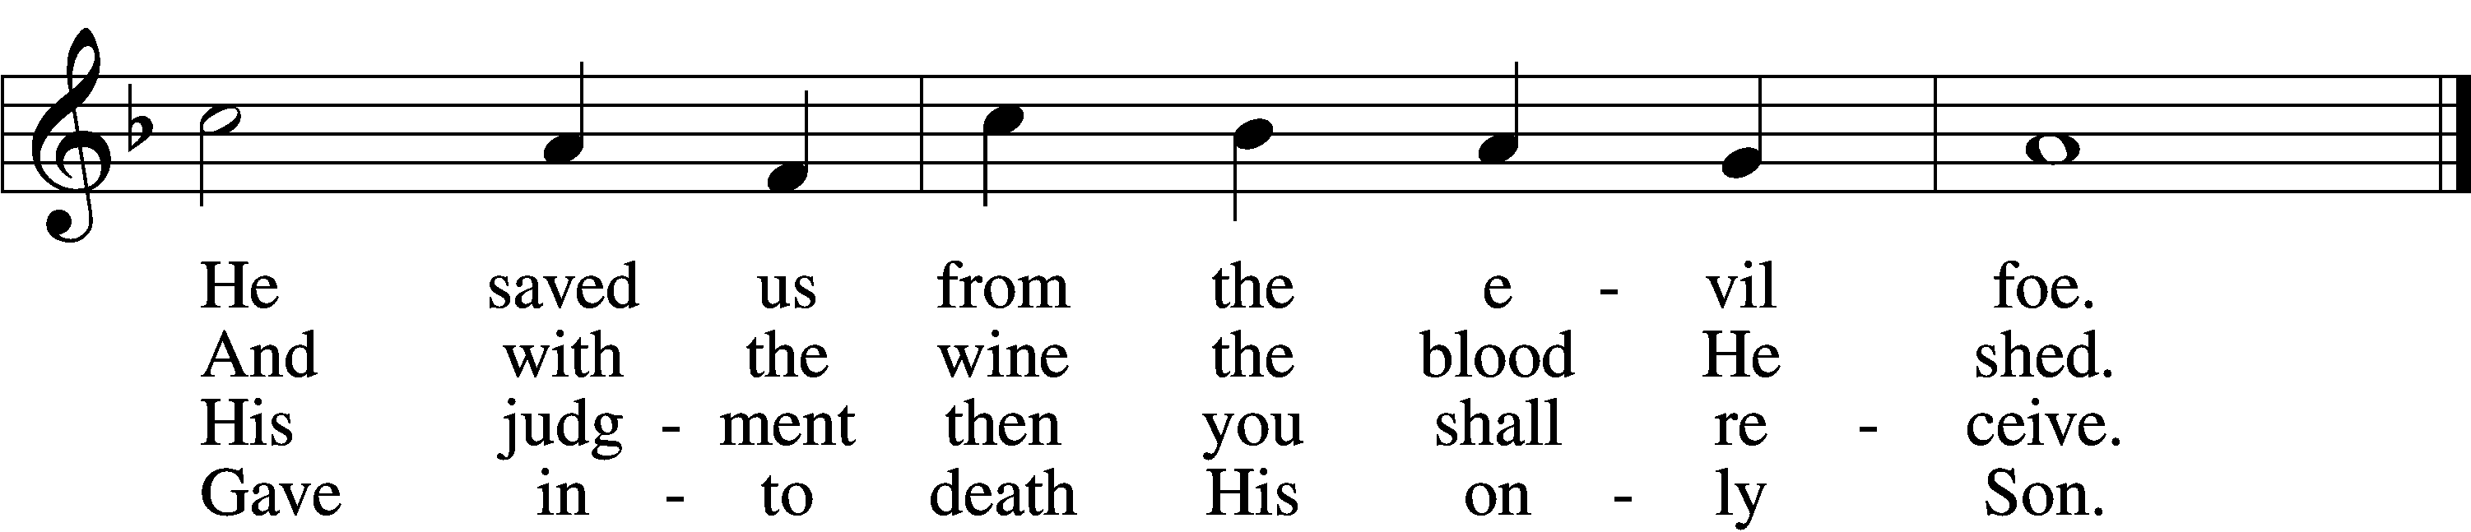

5 Firmly hold with faith unshaken  
That this food is to be taken  
By the sick who are distressed,  
By hearts that long for peace and rest.

9 If your heart this truth professes  
And your mouth your sin confesses,  
You will be your Savior’s guest,  
Be at His banquet truly blest.

10 Let this food your faith so nourish  
That its fruit of love may flourish  
And your neighbor learn from you  
How much God’s wondrous love can do.

Text (sts. 1–2, 4–5, 7, 9) and tune: Public domain

Text (sts. 3, 6, 8, 10): © 1980 and 2006 Concordia Publishing House. Used by permission: LSB Hymn License no. 110005047

Thank the Lord LSB 164

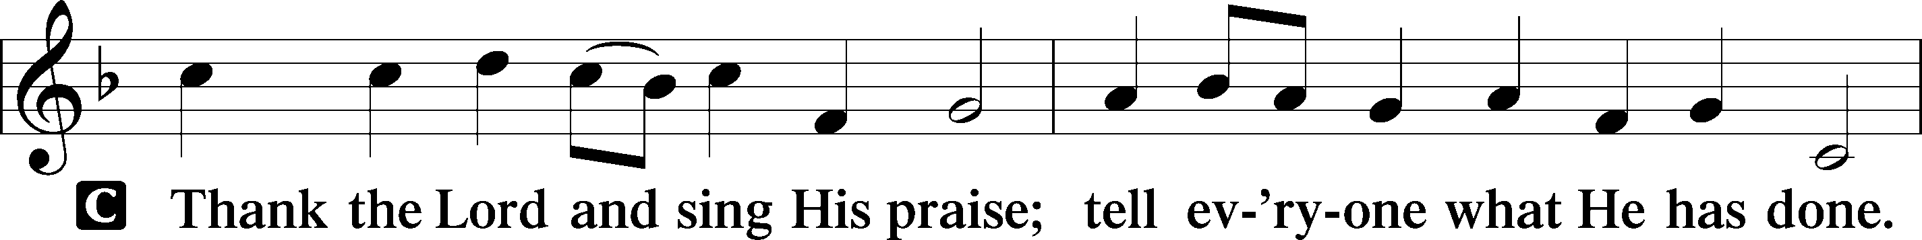

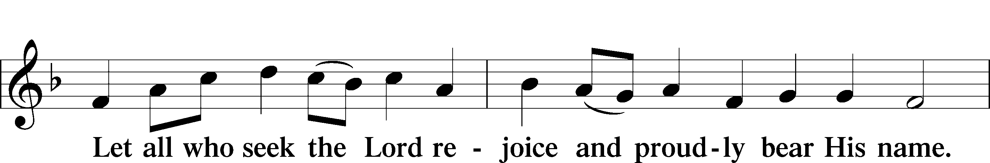

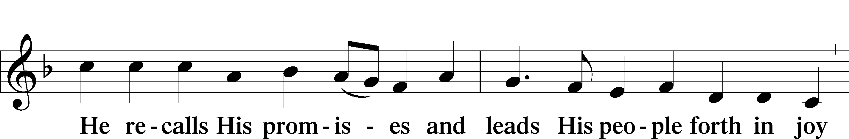

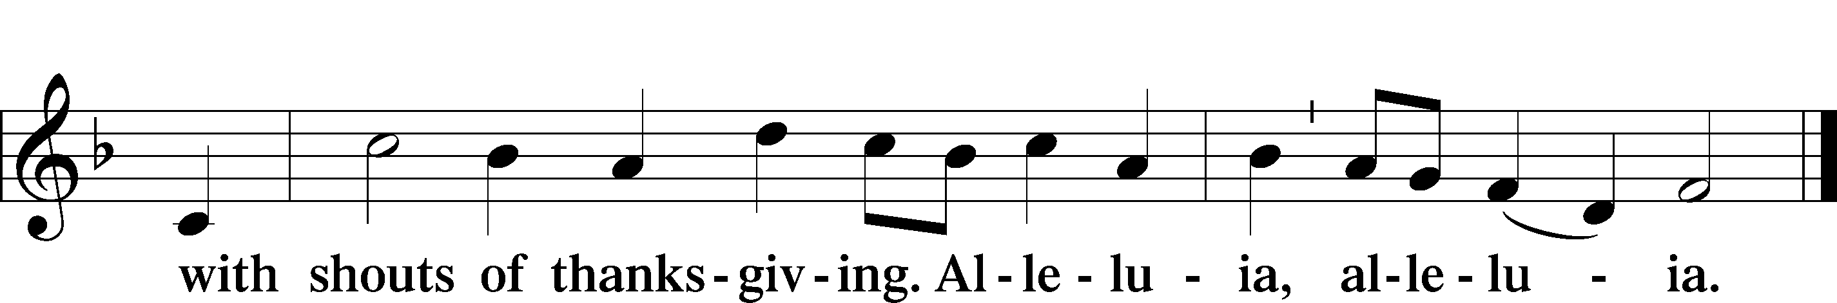

Post-Communion Collect

A Let us pray.

We give thanks to You, almighty God, that You have refreshed us through this salutary gift, and we implore You that of Your mercy You would strengthen us through the same in faith toward You and in fervent love toward one another; through Jesus Christ, Your Son, our Lord, who lives and reigns with You and the Holy Spirit, one God, now and forever.



Benediction LSB 166

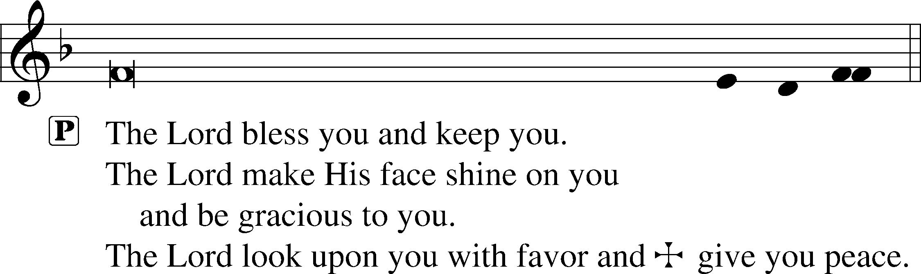



783 Take My Life and Let It Be

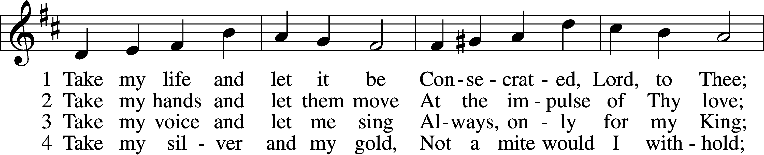

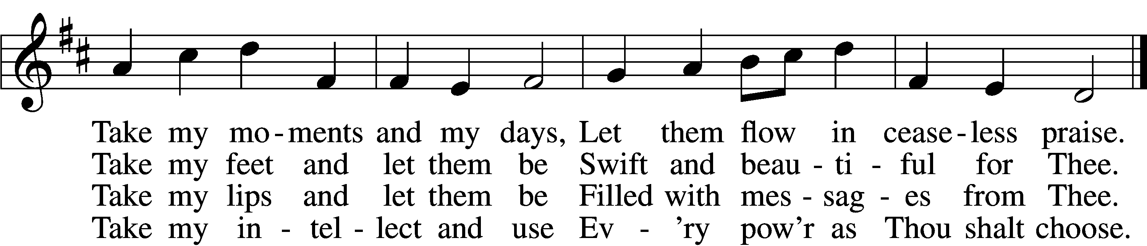

5 Take my will and make it Thine,  
It shall be no longer mine;  
Take my heart, it is Thine own,  
It shall be Thy royal throne.

6 Take my love, my Lord, I pour  
At Thy feet its treasure store;  
Take myself, and I will be  
Ever, only, all for Thee.

Tune and text: Public domain

Acknowledgments

Divine Service, Setting One from Lutheran Service Book

Unless otherwise indicated, Scripture quotations are from the ESV® Bible (The Holy Bible, English Standard Version®), copyright © 2001 by Crossway, a publishing ministry of Good News Publishers. Used by permission. All rights reserved.

Created by Lutheran Service Builder © 2018 Concordia Publishing House.

**Life Quote for Sunday, November 15:** “To be sure, our God Father does not give the vocation of a large family to everyone. (And, of course, any quantity of family and offspring He bestows is a great benefit.) But we need not despise proliferation the way the world does. Indeed, we may appreciate and assist our brothers and sisters who engage in this holy (and delightful!) calling. And we may also raise our young ones to cherish procreation and adoption more than any personal preferences or material possessions. The blessings of children always outweigh even the burdens!” *Rev. Michael W. Salemink, Executive Director of Lutherans For Life – A Life Quote from Lutherans For Life •* [*www.lutheransforlife.org*](http://www.lutheransforlife.org)

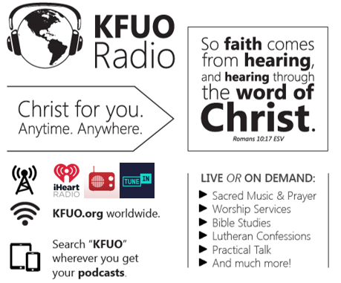

**This week on KFUO.org,** finish 2 Timothy and begin Titus on Sharper Iron’s “The Word is Trustworthy” series (weekdays at 8:00 a.m. CT), study a curious theological topic on Cross Defense (11/16 at 2:00 p.m. CT), consider how our Lutheran Confessions tie into our life in the church on Concord Matters (11/17 at 2:00 p.m. CT), and continue studying 2 Samuel on Thy Strong Word (weekdays at 11:00 a.m. CT). Find these programs on demand at kfuo.org or wherever you get your podcasts!

**Gifts of Time and Treasure**

***“Whatever you do, work heartily for the Lord…”***

***Matthew 6:21***

**LAST WEEK’S OFFERINGS**  **LAST WEEK’S ATTENDANCE**

General Fund $ 11,217.00 Service 58

Needed Weekly $ 3,963.38 Communed 50

Adult Bible Study $ 11.00

Children’s SS/Mission $ 10.00

**The Lord’s Week**

Today 8:45 am – Bible Studies for all ages

**(Nov. 15th)** 10:00 am – Divine Service

11:15 am – Voter’s Meeting

11:30 am – Confirmation

Tuesday 9:00 am – MDO

Wednesday 10:00 am – Women’s Bible Study

Thursday 9:00 am – MDO

Next Sunday 8:45 am –Bible Studies for all ages

**(Nov. 22th)** 10:00 am – Divine Service

11:15 am – Voter’s Meeting

11:30 am – Confirmation

**In His Service**

Elder: John Polen

Organist: Sharon Schrader

Acolytes: Parker Bluntzer, Cody Wilson

Alter: Devereaux Brewer

Flowers: Laura & Ed Lopez- Judy Kunkel